This proposal outlines the design and development of a modern, responsive website for Dipholoholo Security. The website will establish a strong online presence, showcase the company’s comprehensive security services, and communicate professionalism, reliability, and operational readiness to potential clients.

The solution will feature a clean, intuitive design, fast load times, and full responsiveness across all devices, ensuring a seamless user experience while providing a secure and scalable digital foundation for future growth.
Security Website

Proposal for: Dipholoholo Pty Ltd
Project: Security Website
Focus: Business-Oriented Digital Presence for a Security Company
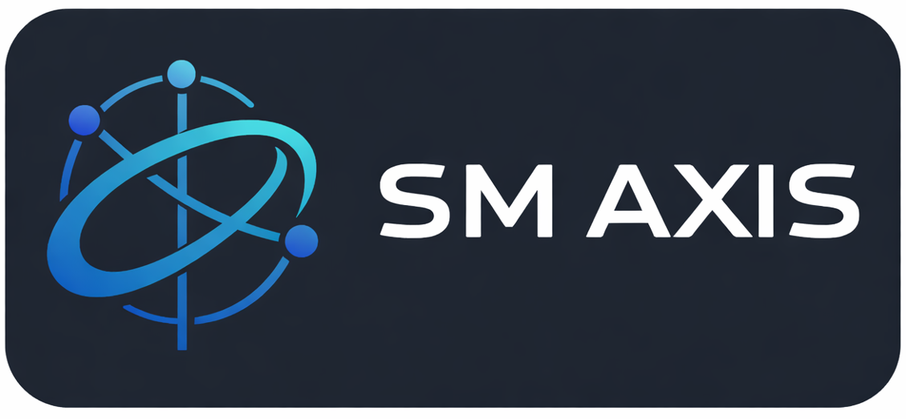
 | https://www.smaxis.co.za
 | s.mbele@outlook.com
 | +27 62 768 0710
 | SM AXIS (PTY) LTD (2025/552021/07)

Website Development Proposal

1. Executive Summary
This proposal presents the design and development of a modern, responsive corporate website for Dipholoholo Security, a professional security services provider offering manned guarding, advanced surveillance, access control systems and security assessment services.

The website will serve as a digital representation of Dipholoholo Security’s professionalism, reliability and technological capability. It will clearly communicate service offerings, highlight competitive advantages and provide a trusted platform for potential clients to engage, request quotations and make informed decisions.

The solution focuses on clean design, strong user experience, responsive performance and scalability to support future business growth.
________________________________________
2. Problem Statement
In today’s security industry, clients expect service providers to maintain a strong digital presence that reflects operational readiness, professionalism and trust. Currently, without a fully optimised and modern website, Dipholoholo Security risks limited online visibility and reduced credibility among prospective clients.
The absence of a structured, professional website can result in:
- Reduced client trust and brand authority
- Difficulty showcasing advanced security capabilities
- Missed business opportunities due to limited enquiry channels
- Inability to clearly differentiate services in a competitive market
A modern website is required to address these challenges and position Dipholoholo Security as a leading security solutions provider.

3. Project Goals
The objectives of this project are to:
- Establish a strong, professional online presence for Dipholoholo Security
- Clearly communicate all security services and capabilities
- Reinforce trust, reliability and industry expertise
- Improve client engagement and enquiry conversion
- Ensure optimal performance across desktop, tablet and mobile devices
- Provide a scalable platform for future expansion and enhancements

4. Deliverables and Scope
Included Deliverables
- Final Responsive website pages:
Home
About Dipholoholo Security
Services
- Manned Guarding
- Advanced CCTV & Surveillance
- Access Control Systems
- Security Assessment & Planning
Why Choose Us
Contact Us (with enquiry form)

- Design & User Experience
  - Modern, security-focused visual identity
  - Clean and professional layout
  - Clear content structure with strong call-to-action elements
- Animations & Visual Enhancements
  - Subtle motion animations for sections and page transitions
  - Interactive hover effects
  - Visual emphasis on service features and benefits
- Navigation & Functionality
  - Intuitive navigation menu
  - Clear access to services and contact points
  - Optimised performance and fast load times
- Icons & Visual Assets
  - Professional service icons (guarding, CCTV, access control, assessments)
  - Consistent visual language aligned with the security industry
- Deployment & Handover
  - Deployment to a live hosting environment
  - Final quality assurance testing
  - Handover documentation and basic maintenance guidance
- Exclusions (Out of Scope)
  - Advanced backend systems (e.g. CRM, booking portals)
  - Online payment or e-commerce functionality
  - Ongoing content creation after launch
  - Hosting, domainand long-term maintenance costs (unless separately agreed)

5. Technical Specifications
- The website will be built using the following technology stack:
  - Frontend Framework: React
  - Styling: Modern CSS / Tailwind CSS
  - Hosting & Deployment: Cloud-based platform (e.g. Vercel)
  - Version Control: Git & GitHub

Key Technical Benefits:
  - Fully responsive, mobile-first design
  - High performance and fast loading speeds
  - Secure, scalable architecture
  - Easy future upgrades and content expansion
  - Reliable cloud deployment and uptime
________________________________________
6. Implementation Plan
Phase 1: Planning & Design
  - Requirement analysis and confirmation
  - Sitemap and information architecture
  - Design mockups and visual direction approval

Phase 2: Development
  - Frontend development of all website pages
  - Implementation of animations and UI elements
  - Responsive layout optimisation
Phase 3: Testing & Refinement
  - Cross-browser and device testing
  - Performance and usability testing
  - Client feedback incorporation

Phase 4: Delivery & Handover
  - Final deployment to live environment
  - Quality assurance sign-off
  - Project handover and completion

7. Project Budget and Timeline
Total Duration: 2 – 4 business days
- Planning & Design: ±½ day
- Development: 1 – 2 days
- Testing & Delivery: ±½ day

Project Budget
- Website Design & Development: Quoted separately
- Any additional features or future enhancements will be quoted independently

8. Next Steps
- Review and approve this proposal
- Confirm project scope and timeline
- Finalise budget and sign-off
- Provide required content (text, images, branding)
- Commence development:
- Added features according to your specifications
- Review final product
- Optimise SEO, Hosting, Google Crawls
________________________________________

Prepared by:
SM AXIS PTY LTD (2025/552021/07)
