**Maker-Checker**

**Technical Stack:**

**Front End UI:** Angular, Bootstrap

**Middle Tier:** Spring Boot, JPA repository

**Back End:** Postgres DB

**Additional Features:** User authentication using database, REST API calls, Routing

**Angular Project Structure Spring Boot Project Structure**

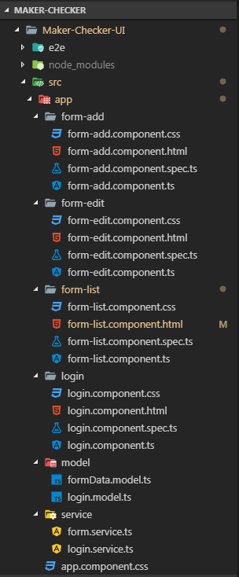 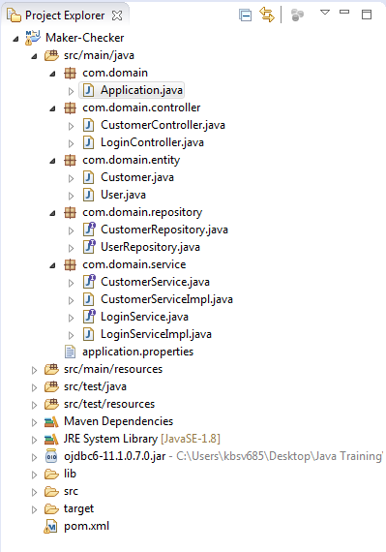

**Screen Shots:**

Login page:

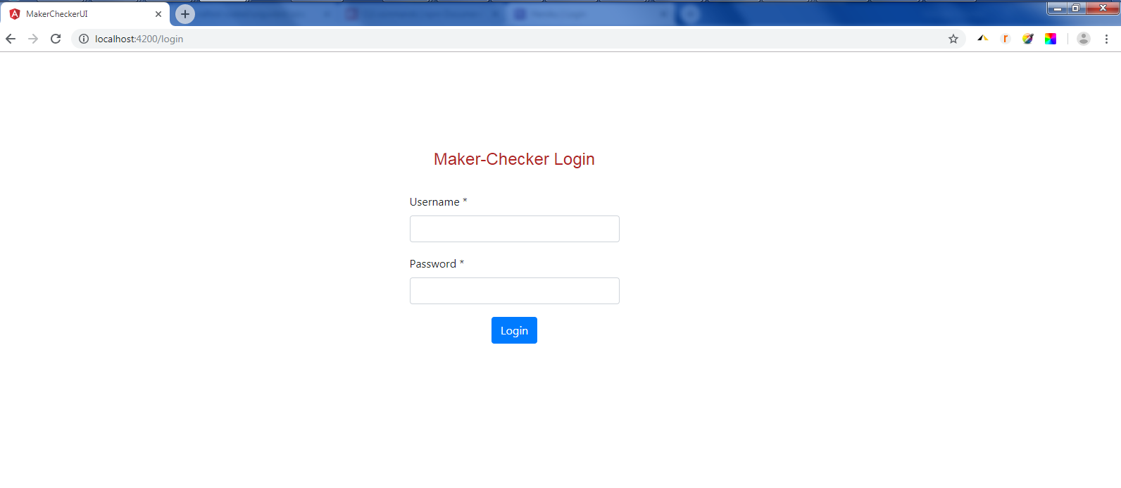

User authentication happens through Angular-REST API-SpringBoot-JPA-Postgres.

Credentials for Maker: cust/cust123

Credentials for Checker: admin/admin123

**Note:** New users can be added at the backend at the database

**Logging in as Maker:** – Displays all the forms from database

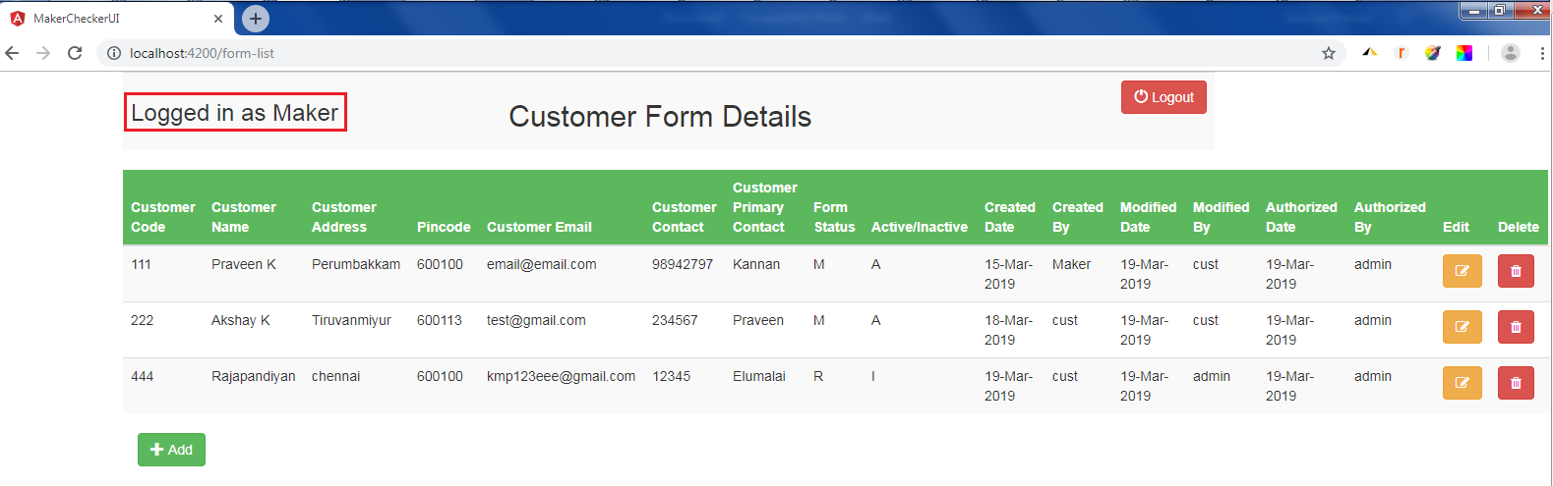

Editing a form:

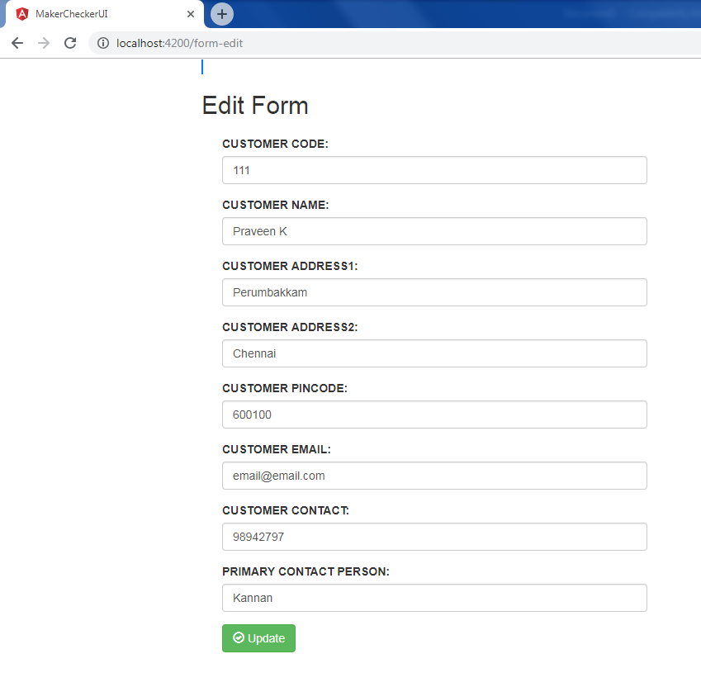

Updating the Customer Name,

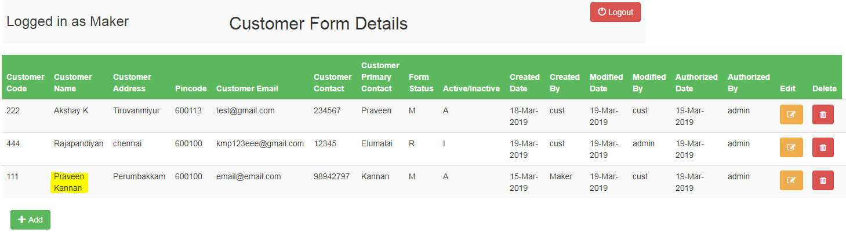

Deleted the customer code 444,

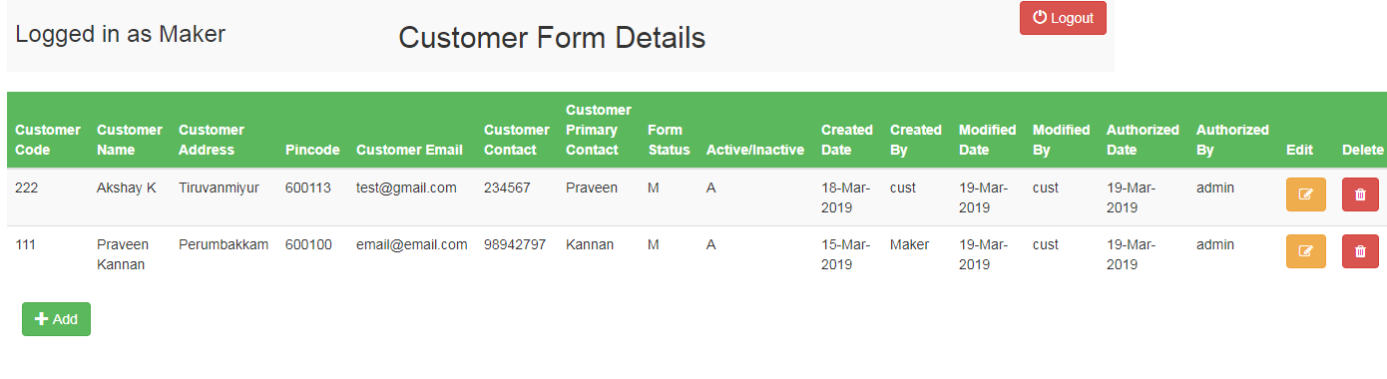

Adding new form:

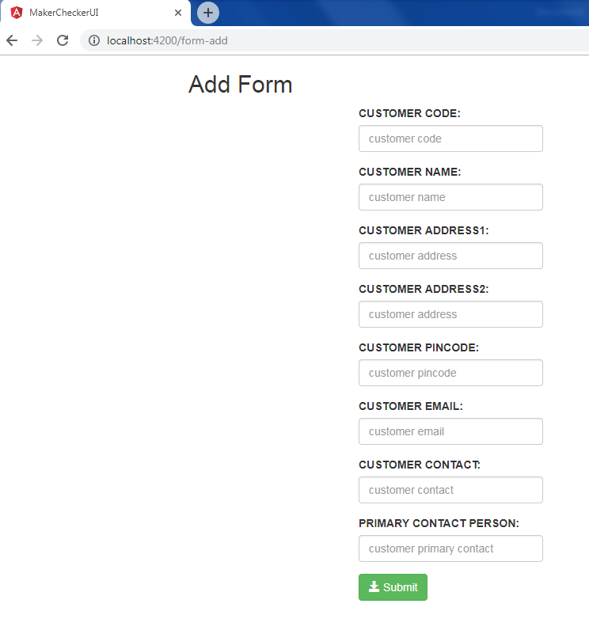

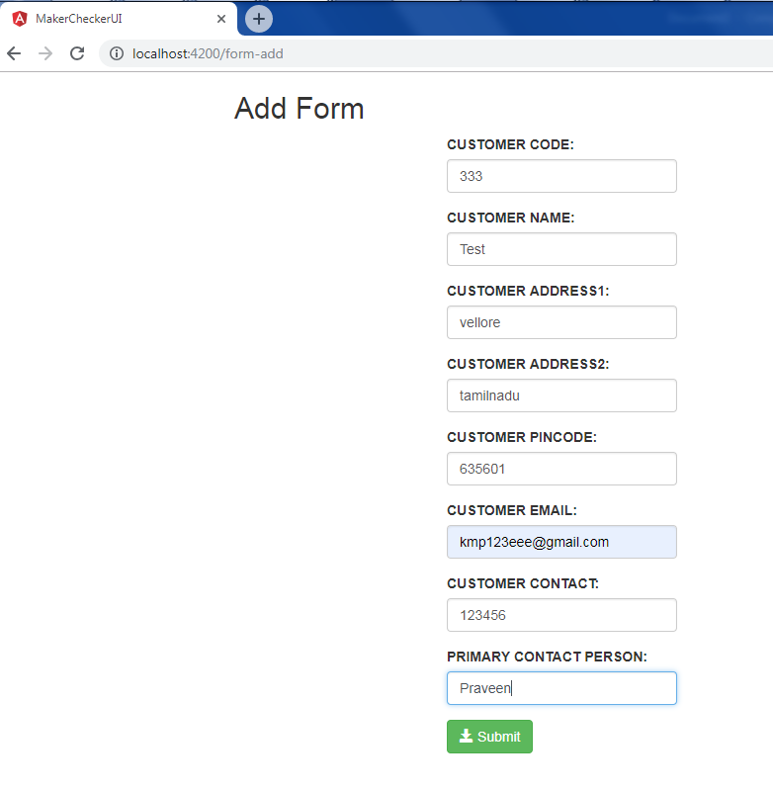

Added new form with status N-new and A-active

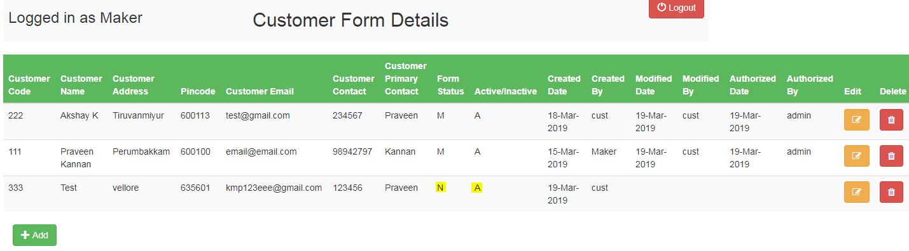

Logout ends the current user and takes you to the login page.

**Logging in as Checker:**

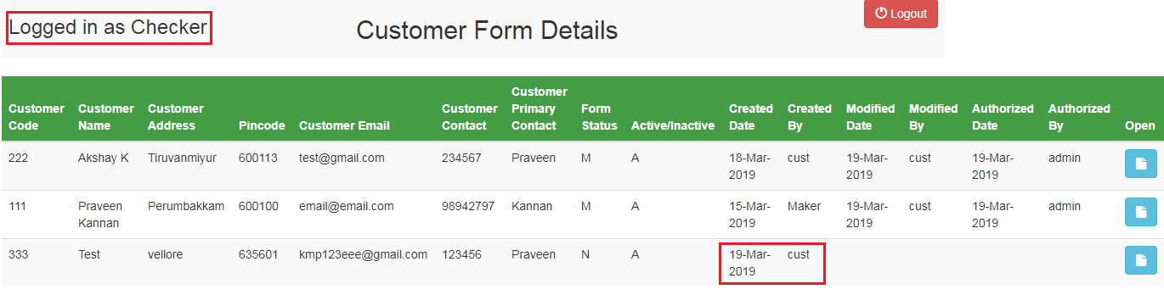

Opening the submitted form:

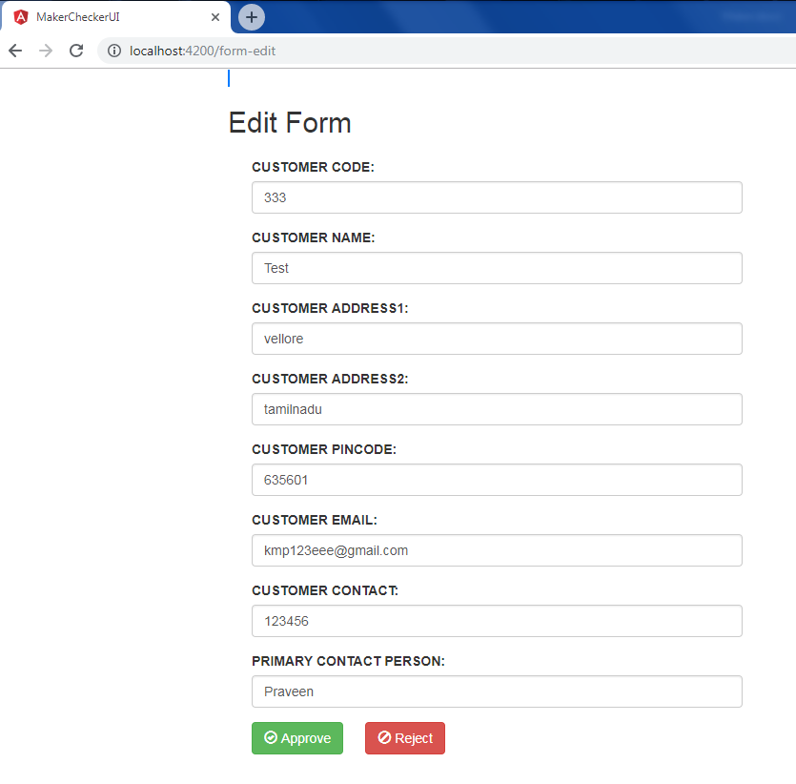

After form approval, the form status updated as A- approved and A-active with the authorized date and authorized by.

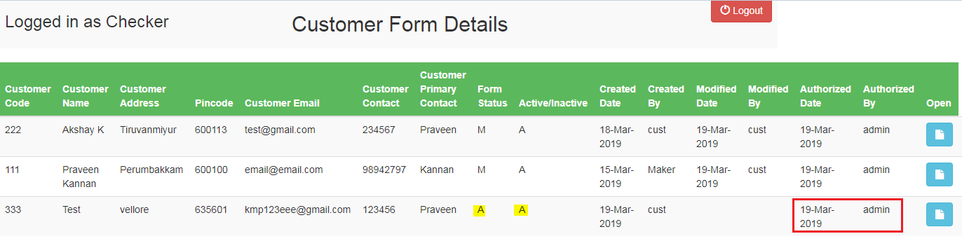

Rejecting the form updates the form status as R-rejected and I- inactive:

