Design Model Report of

Teachy

Version <1.0>

Prepared by

Group Name: 2

|  |
| --- |
| Nguyễn Hữu Nhật Minh |
| Trần Trọng Đạt |
| Nguyễn Trọng Đông |
| Nguyễn Hoàng Hải |
| Cao Xuân Hưng |

|  |  |
| --- | --- |
| Instructor: | Dr. Dang Duc Hanh |
| Course: | Software Engineering 2016 |
| Date: | 04/12/2016 |

Table of Contents

Contents

1. Introduction 4

1.1 Purpose 4

1.2 References 4

2. Design Model 4

2.1 Identify the object classes in the system 4

2.2 Choose the design model. 5

2.2.1 The use case: Login 5

2.2.2 The use case view subjects 6

2.2.3 The use case view ratings 7

2.2.4 The use case rate 8

# 

# Introduction

#### 1.1 Purpose

The purpose of this report is to present a detailed description on the Design Model of the Teacher rating system- Teachy. This document is intended for both the stakeholders and the developers of the system.

#### 1.2 References

The report was completed following the book and documentation recommended and provided by Dr. Dang Duc Hanh including:

* The textbook Software Engineering 9th Edition written by Sommerville
* The series of lectures and slides of Software Engineering Course 2016 provided by Dr. Dang Duc Hanh.

# Design Model

#### 2.1 Identify the object classes in the system

From the requirements documenting steps, we determine what is the object classes in the system. Then, we also identify the attributes and operations or methods for each class from the description of the system requirements documentation.

There are 3 object classes in the system as shown in the following figures.

|  |
| --- |
| User |
| -userID  -Name  -email  -class |
| + getUserID()  + login()  + logout()  + rate()  + viewrating() |

|  |
| --- |
| Subject |
| -subjectID  -Name  -lecturerList |
| + getSubjectID()  + getLecturerList() |

|  |
| --- |
| Lecturer |
| -lecturerID  -Name  -ratings |
| -getLecturerID()  -getRatings() |

#### 2.2 Choose the design model.

In this project, we harness the design models in our system for showing the associations and relationships between the object classes in the system. The design model utilized in this project is **sequence model**, which describe the dynamic structure of the system and show the interactions between the system objects. The model is the bridge connecting the system requirements and the implementation of the project together.

We use UML to describe and visualize the interactions between the objects of the system by deploying the sequence model. Below are the significant use cases of the system where the users play the role of main actors.

##### **2.2.1 The use case: Login**

Description of Use Case:

The users log in to the system using their account and password.

##### 

Figure 1 Login Use Case - Sequence Diagram

First, the users send a login request to the controller, it passes to model to achieve the data from from the database. After that, the model returns the data to the model and then, the controller loads the view with the data retrieved which is the response to the login request.

##### **2.2.2 The use case view subjects**

Description of Use Case:

The users view the list of all subjects.

First, the users send a view subject request to the controller, it asks the model for the subjects data from the database. After that, the model returns the data and the controller loads the view with the data retrieved which is the reply to the view subjects request.

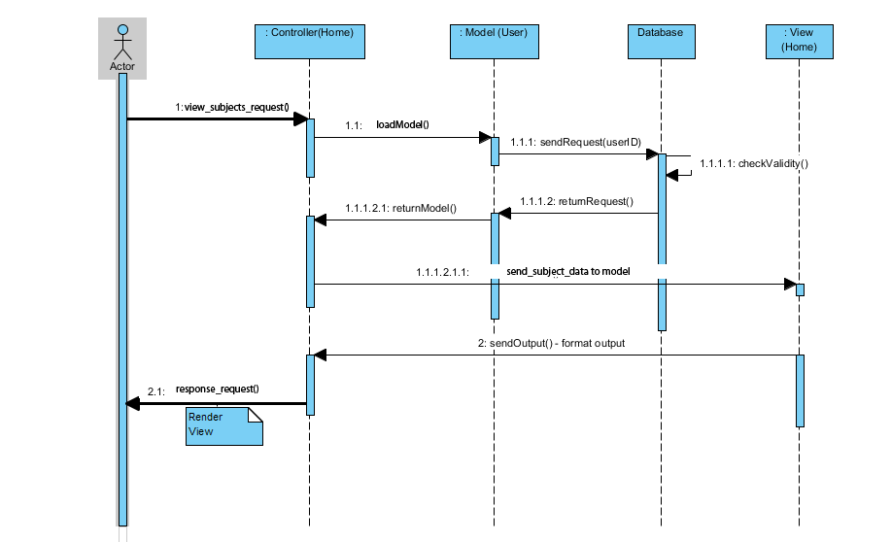

Figure 2 View Subjects Use Case - Sequence Diagram

##### **2.2.3 The use case view ratings**

Description of Use Case:

The users want to view a lecturer’s ratings.

First, the users clink on the lecturer’s name on the list and send a view rating request with the lecturer’s id to the controller, it passes the id to model Lecturer to achieve the data of the lecturer from the database. After that, the model returns the data to the model Lecturer and then, the controller loads the view (Name, picture, ratings) with the data retrieved which is the reply to the request.

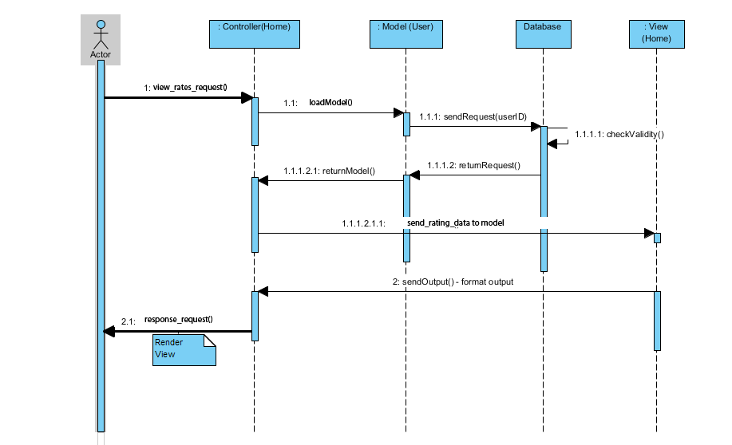

Figure 3 View ratings - Sequence Diagram

##### **2.2.4 The use case rate**

Description of Use Case:

The users want to rate their lecturer.

First, the users send a select rating for each attrubute of the lecturer. Then the users send a send_rating request to the controller by Rate, it achieves the lecturerID, and rating data and passes it to model lecturer to save to data base. After that, the model returns the data to the model altered Lecturer Model and then, the controller loads the view with the data saved to data base which is the reply to the send rating request.

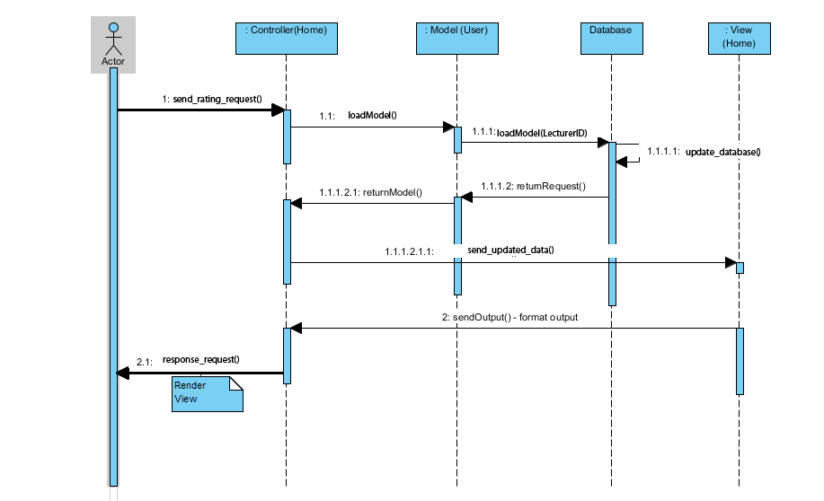

Figure 4 The use case Rate - Sequence Diagram