**RA-UC STRUCTURING AND SPECIFICATION**

**(Group 4)**

**Requirement Analysis for AFC system**

**Use case diagram**

The use case diagram for AFC system is in below figure:

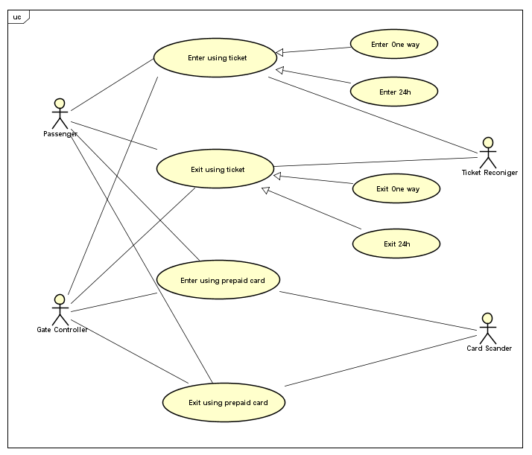

1. **“Enter station using ticket” use case specification**

|  |  |  |  |
| --- | --- | --- | --- |
| **Use case code** | **UC001** | **Use case name** | **Enter station using ticket** |
| **Overview description** | Passenger can use a ticket to enter the platform | | |
| **Actor** | Passenger, Ticket Recognizer, Gate Controller | | |
| **Precondition** | N/A | | |
| **Main flow of events**  **(Success)** | **No.** | **Actor** | **Action** |
| 1 | Passenger | Passenger input barcode to Ticket screen |
| 2 | Ticket Recognizer | Ticket Recognizer read information and send to the system |
| 3 | AFC | Validate ticket and display result |
| 4 | Gate Controller | Request open the gate |
| 5 | Ticket Recognizer | Ticket Recognizer return ticket to the passenger |
| **Alternative flow of events** | **No.** | **Actor** | **Action** |
| 1 | Ticket Recognizer | In the No.2 of main flow if result is unidentified ticket, the AFC system will display invalid message, return the ticket and terminate process. |
| 2 | Ticket Recognizer | In the No.4 of basic of the main flow Passenger pass to the gate but doesn’t take the ticket, an alert will trigger notify to Passenger |
| **Post condition** | None | | |

1. **“Enter station using One-way ticket” use case specification**

|  |  |  |  |
| --- | --- | --- | --- |
| **Use case code** | **UC001** | **Use case name** | **Enter station using One-way ticket** |
| **Overview description** | Passenger can use a ticket to enter the platform | | |
| **Actor** | Passenger, Ticket Recognizer, Gate Controller | | |
| **Precondition** | N/A | | |
| **Main flow of events**  **(Success)** | **No.** | **Actor** | **Action** |
| 1 | Passenger | Passenger input barcode to the Ticket Screen |
| 2 | Ticket Recognizer | Ticket Recognizer read information and send to the system |
| 3 | AFC | Validate one way ticket and dis play result |
| 4 | Gate Controller | Request open the gate |
| 5 | Ticket Recognizer | Ticket Recognizer return ticket to the passenger |
| **Alternative flow of events** | **No.** | **Actor** | **Action** |
| 1 | Ticket Recognizer | In the No.2 of main flow if result is unidentified ticket, the AFC system will display invalid message, return the ticket and terminate process. |
| 2 | Ticket Recognizer | In the No.4 of basic of the main flow Passenger pass to the gate but doesn’t take the ticket, an alert will trigger notify to Passenger |
| **Post condition** | None | | |

1. **“Enter using 24H ticket” use case specification**

|  |  |  |  |
| --- | --- | --- | --- |
| **Use case code** | **UC001** | **Use case name** | **Enter using 24H ticket** |
| **Overview description** | Passenger can use a ticket to enter the platform | | |
| **Actor** | Passenger, Ticket Recognizer, Gate Controller | | |
| **Precondition** | N/A | | |
| **Main flow of events**  **(Success)** | **No.** | **Actor** | **Action** |
| 1 | Passenger | Passenger input barcode to the Ticket Screen |
| 2 | Ticket Recognizer | Ticket Recognizer read information and send to the system |
| 3 | AFC | Validate 24h ticket and display result |
| 4 | Gate Controller | Request open the gate |
| 5 | Ticket Recognizer | Ticket Recognizer return ticket to the passenger |
| **Alternative flow of events** | **No.** | **Actor** | **Action** |
| 1 | Ticket Recognizer | In the No.2 of main flow if result is unidentified ticket, the AFC system will display invalid message, return the ticket and terminate process. |
| 2 | Ticket Recognizer | In the No.4 of basic of the main flow Passenger pass to the gate but doesn’t take the ticket, an alert will trigger notify to Passenger |
| **Post condition** | None | | |

1. **“Exit using ticket” use case specification**

|  |  |  |  |
| --- | --- | --- | --- |
| **Use case code** | **UC001** | **Use case name** | **Exit using ticket** |
| **Overview description** | The system validate ticket and send signal to gate controller when passenger exit the platform | | |
| **Actor** | Passenger, Ticket Recognizer, Gate Controller | | |
| **Precondition** | N/A | | |
| **Main flow of events**  **(Success)** | **No.** | **Actor** | **Action** |
| 1 | Passenger | Passenger put ticket to a slot of the Ticket Recognizer |
| 2 | Ticket Recognizer | Ticket Recognizer read ticket and send to the system |
| 3 | AFC | Validate ticket and display result |
| 4 | Gate Controller | Gate controller request open the gate |
| 5 | Ticket Recognizer | Ticket Recognizer return ticket to the passenger |
| **Alternative flow of events** | **No.** | **Actor** | **Action** |
| 1 | Ticket Recognizer | In the No.2 of main flow if result is unidentified ticket, the AFC system will display invalid message, return the ticket and terminate process. |
| 2 | Ticket Recognizer | In the No.5 of the main flow Passenger doesn’t take the ticket, an alert will trigger notify to Passenger |
| **Post condition** | N/A | | |

1. **“Exit using One way ticket” use case specification**

|  |  |  |  |
| --- | --- | --- | --- |
| **Use case code** | **UC001** | **Use case name** | **Exit using ticket** |
| **Overview description** | The system validate ticket and send signal to gate controller when passenger exit the platform | | |
| **Actor** | Passenger, Ticket Recognizer, Gate Controller | | |
| **Precondition** | N/A | | |
| **Main flow of events**  **(Success)** | **No.** | **Actor** | **Action** |
| 1 | Passenger | Passenger input barcode to the Ticket Screen |
| 2 | Ticket Recognizer | Ticket Recognizer read ticket and send to the system |
| 3 | AFC | Validate one way ticket and display result |
| 4 | Gate Controller | Gate controller request open the gate |
| 5 | Ticket Recognizer | Ticket Recognizer return ticket to the passenger |
| **Alternative flow of events** | **No.** | **Actor** | **Action** |
| 1 | Ticket Recognizer | In the No.2 of main flow if result is unidentified ticket, the AFC system will display invalid message, return the ticket and terminate process. |
| 2 | Ticket Recognizer | In the No.5 of the main flow Passenger doesn’t take the ticket, an alert will trigger notify to Passenger |
| **Post condition** | N/A | | |

1. **“Exit using 24h ticket” use case specification**

|  |  |  |  |
| --- | --- | --- | --- |
| **Use case code** | **UC001** | **Use case name** | **Exit using ticket** |
| **Overview description** | The system validate ticket and send signal to gate controller when passenger exit the platform | | |
| **Actor** | Passenger, Ticket Recognizer, Gate Controller | | |
| **Precondition** | N/A | | |
| **Main flow of events**  **(Success)** | **No.** | **Actor** | **Action** |
| 1 | Passenger | Passenger input barcode to the Ticket Screen |
| 2 | Ticket Recognizer | Ticket Recognizer read ticket and send to the system |
| 3 | AFC | Validate 24 ticket and display result |
| 4 | Gate Controller | Gate controller request open the gate |
| 5 | Ticket Recognizer | Ticket Recognizer return ticket to the passenger |
| **Alternative flow of events** | **No.** | **Actor** | **Action** |
| 1 | Ticket Recognizer | In the No.2 of main flow if result is unidentified ticket, the AFC system will display invalid message, return the ticket and terminate process. |
| 2 | Ticket Recognizer | In the No.5 of the main flow Passenger doesn’t take the ticket, an alert will trigger notify to Passenger |
| **Post condition** | N/A | | |

1. **“Enter using prepaid card” use case specification**

|  |  |  |  |
| --- | --- | --- | --- |
| **Use case code** | **UC001** | **Use case name** | **Enter using prepaid card** |
| **Overview description** | Validate prepaid card and send signal to gate controller (open/not open) when passenger enter to a station using prepaid card. | | |
| **Actor** | Passenger, Card Reader, Gate Controller | | |
| **Precondition** | None | | |
| **Main flow of events**  **(Success)** | **No.** | **Actor** | **Action** |
| 1 | Passenger | Passenger input barcode of prepaid card to the prepaid card screen. |
| 2 | Card Reader | Scan information of prepaid card send to system. |
| 3 | AFC | Validate prepaid card, if information is exactly, system displays the result. |
| 4 | Gate Controller | Gate controller request open the gate. |
| **Alternative flow of events** | **No.** | **Actor** | **Action** |
| 1 | Card Reader | Unidentified the prepaid card. |
| 2 | AFC | The prepaid card is invalid. |
| etc. | … | … |
| **Post condition** | None | | |

1. **“Exit using prepaid card” use case specification**

|  |  |  |  |
| --- | --- | --- | --- |
| **Use case code** | **UC001** | **Use case name** | **Enter using prepaid card** |
| **Overview description** | Validate prepaid card and send signal to gate controller (open/not open) when passenger enter to a station using prepaid card. | | |
| **Actor** | Passenger, Card Reader, Gate Controller | | |
| **Precondition** | None | | |
| **Main flow of events**  **(Success)** | **No.** | **Actor** | **Action** |
| 1 | Passenger | Passenger input barcode of prepaid card to the prepaid card screen. |
| 2 | Card Reader | Scan information of prepaid card send to system. |
| 3 | AFC | Validate prepaid card, if information is exactly, system displays the result. |
| 4 | Gate Controller | Gate controller request open the gate. |
| **Alternative flow of events** | **No.** | **Actor** | **Action** |
| 1 | Card Reader | Unidentified the prepaid card. |
| 2 | AFC | The prepaid card is invalid. |
| etc. | … | … |
| **Post condition** | None | | |