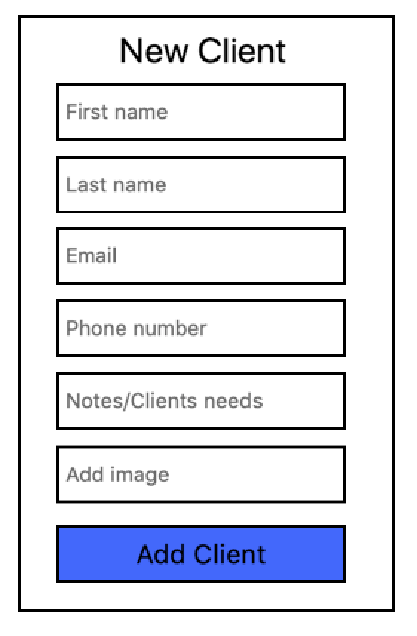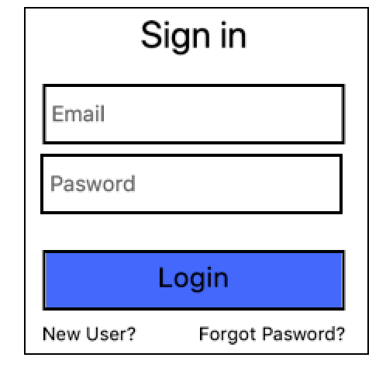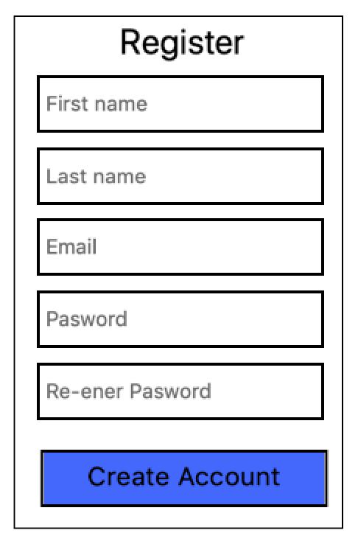

|  |  |
| --- | --- |
| Magnifying glass Name/# | Add |
| Blake D. | |
| Heather E. | |
| Karen S. | |
| Leila O. | |
| Jamie A. | |
| Jessica D. | |

Dashboard

***Today (4/3/19)***



Karen S. – haircut 10 a.m.

Jamie A. – Color 11:15 a.m.

Jessica D – Style 12:30 p.m.

Styles Notes/details

Styles Notes/details

Styles Notes/details

more

*Notes of Client:*

Lorem ipsum..

**Jane Doe**

User Profile

Previous Hairstyles