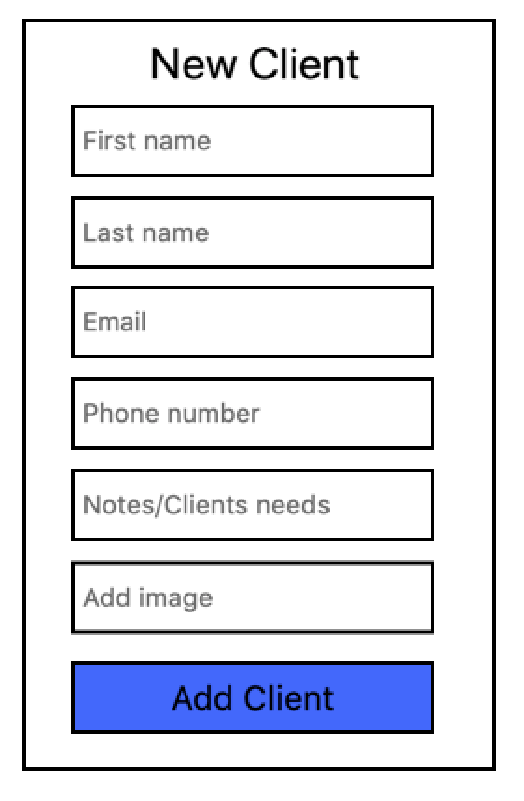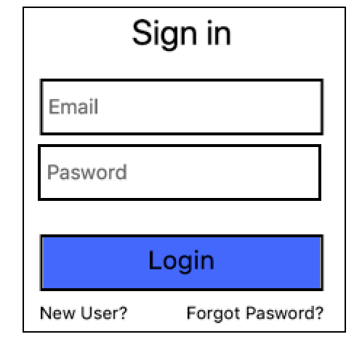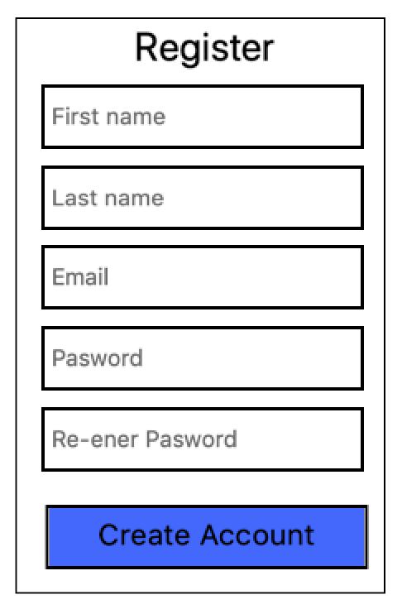

more

*Notes of Client:*

Lorem ipsum..

**Jane Doe**

User Profile

Previous Hairstyles

Styles Notes/details

Profile(jenny)

Styles Notes/details

Styles Notes/details

Previous Hairstyles

Pictures(jenny)

Save picture to client profile

(harnoor)

View Pics/ take notes(harnoor)

Camera Module (harnoor)

Clients(Andres)

Dashboard (andres)