Campus Ride Management Platform
Design Document
Real-Time Campus Mobility and Ride Management Platform

Technology Stack
Java 21 · Spring Boot 3 · PostgreSQL · React + TypeScript + Vite · WebSocket/STOMP · Leaflet / OpenStreetMap

1. Problem Understanding
IIT Roorkee's large campus depends on e-rickshaws for last-mile mobility. Without centralized coordination, passengers have limited visibility into available drivers, drivers have limited visibility into demand, and ride state changes are hard to track.
- Centralize passenger ride requests, driver availability, ride assignment, lifecycle tracking, and feedback.
- Use real-time communication to synchronize request, assignment, status, availability, and driver location changes.
- Keep the system maintainable for a small team while preserving the core engineering concerns of ride-hailing systems.

2. System Architecture
The platform follows a three-tier architecture: React SPA frontend, Spring Boot REST/WebSocket backend, and PostgreSQL persistence layer.
Layer | Technology | Responsibility
Frontend | React 18, TypeScript, Vite, Leaflet | Role-specific dashboards, forms, map rendering, local session storage, STOMP client.
Backend API | Java 21, Spring Boot 3, Spring Security | REST endpoints, validation, JWT-authenticated API access, business workflow orchestration.
Real-Time | Spring WebSocket + STOMP | Topic-based updates for ride requests, assignment, lifecycle, driver availability, dashboard, and GPS events.
Database | PostgreSQL, JPA/Hibernate | Durable storage for users, profiles, vehicles, rides, rejections, ratings, and campus locations.

2.1 Component Interaction
- HTTP REST is used for request/response operations such as login, profile updates, ride creation, lifecycle actions, dashboard queries, and ratings.
- WebSocket/STOMP on /ws is used for push events. The current security config permits /ws, while REST endpoints are protected by JWT. Production hardening can add authenticated WebSocket handshakes.
- Vite proxies /api and /ws to the backend on localhost:8099 during local development.

3. Database Schema
Hibernate ddl-auto update creates and evolves tables during development. The schema separates shared identity from passenger and driver details, and keeps ride history, rejections, ratings, and campus locations in separate tables.
Table | Key Columns | Notes
users | id, name, email unique, phone, passwordHash, role, createdAt | Base identity for passenger and driver accounts.
passenger_profiles | id, user_id unique FK, campusAddress | Passenger-specific profile extension.
driver_profiles | id, user_id unique FK, licenseNumber, verificationDocument, verificationStatus, availabilityStatus, averageRating, ratingCount, currentLatitude/currentLongitude | Driver verification, availability, rating summary, and live GPS state.
vehicles | id, driver_id unique FK, vehicleNumber, vehicleType, capacity | One vehicle record per driver.
rides | id, passenger_id FK, driver_id nullable FK, pickupLocation, destination, pickup/destination lat/lng, status, requestedAt, acceptedAt, startedAt, completedAt, cancelledAt, version | Central ride lifecycle record. Pickup/destination are stored as names and coordinates, not campus_location foreign keys.
ride_rejections | id, ride_id FK, driver_id FK, rejectedAt, unique(ride_id, driver_id) | Prevents rides rejected by a driver from repeatedly appearing to that same driver.
campus_locations | id, name unique, category, latitude, longitude | Editable campus points used to seed ride coordinates.
ratings | id, ride_id unique FK, passenger_id FK, driver_id FK, score, feedback, createdAt | One passenger rating per completed ride.

4. Entity Relationship Diagram
The ERD below reflects the implemented JPA relationships. Rides point to users for passenger and driver. Campus locations are lookup/seed data for coordinates, not ride foreign keys.
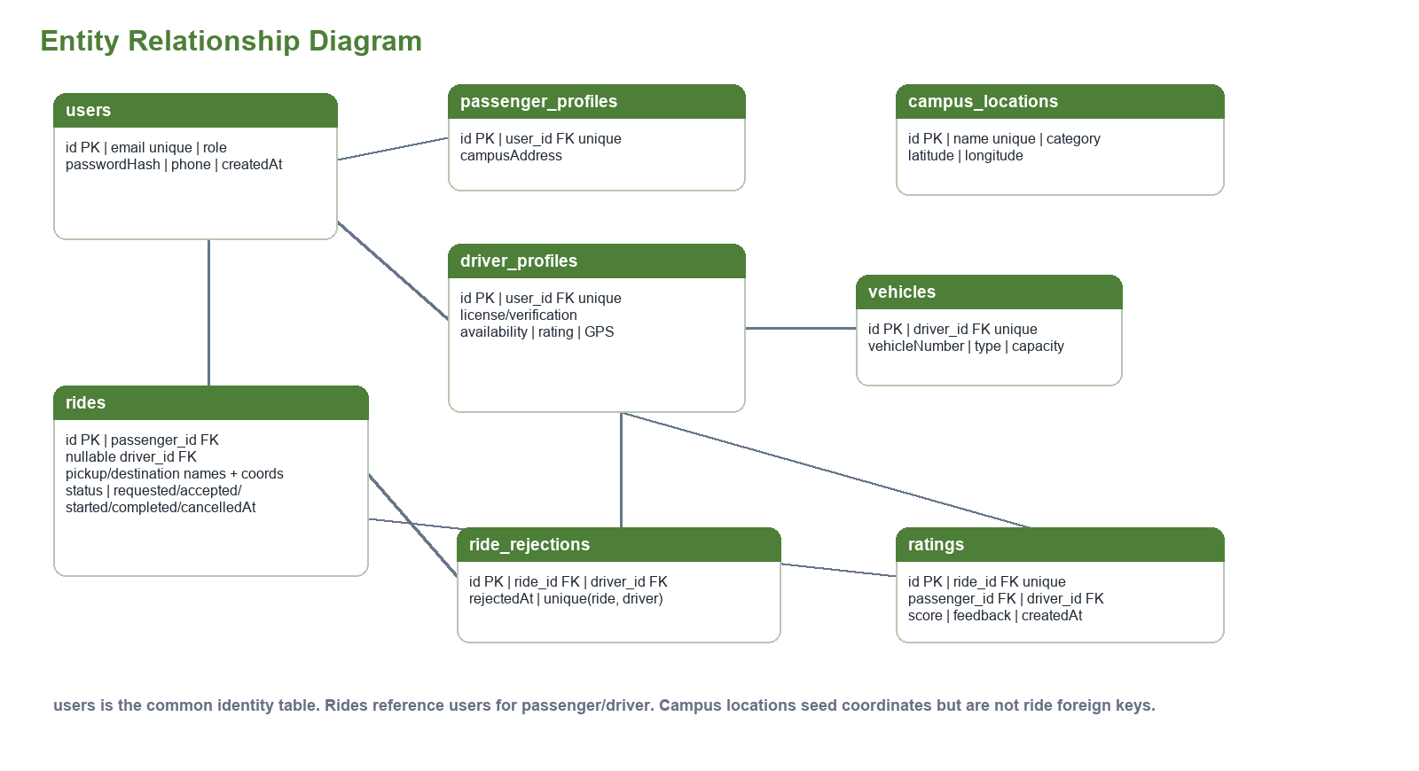

5. API Overview
Method | Endpoint | Purpose
POST | /api/auth/register/passenger | Register passenger and return JWT.
POST | /api/auth/register/driver | Register driver, vehicle, verification profile, and return JWT.
POST | /api/auth/login | Authenticate user and return JWT.
GET/PUT | /api/users/me | Read or update authenticated user profile.
POST | /api/drivers/availability/online | Set driver ONLINE, or BUSY if already assigned.
POST | /api/drivers/availability/offline | Set driver OFFLINE when no active ride exists.
GET | /api/drivers/available | List currently ONLINE drivers.
GET | /api/drivers/requests | List requested rides not rejected by this driver.
GET | /api/drivers/dashboard | Return active ride, stats, ride history, ratings, and chart data.
POST | /api/drivers/location | Store driver GPS and broadcast location events.
GET | /api/locations | Return campus pickup/destination points.
POST/GET | /api/rides, /api/rides/my | Create ride and fetch user ride history.
GET | /api/rides/{rideId} | Return a ride visible to participant or requested driver pool.
POST | /api/rides/{id}/accept|reject|start|complete|cancel | Ride assignment and lifecycle transitions.
POST | /api/ratings | Submit rating/feedback for a completed ride.

5.1 WebSocket Topics (STOMP)
- /topic/rides/requests, /topic/rides/{rideId}, and /topic/rides/{rideId}/driver-location publish ride request, ride status, and ride-specific location events.
- /topic/users/{userId}/notifications sends per-user passenger/driver ride notifications.
- /topic/drivers/availability and /topic/drivers/location publish driver pool and GPS updates.
- /topic/drivers/{driverId}/dashboard pushes assigned ride and dashboard updates to the driver.

6. Design Decisions
Decision | Reason
WebSocket/STOMP over polling | Push updates are better for ride requests, assignment notifications, availability changes, and live driver movement.
Pessimistic row lock on ride acceptance | acceptRide uses findByIdForUpdate inside a transaction. If the ride is no longer REQUESTED or already has a driver, the backend returns a bad-request error.
JWT stateless REST authentication | REST APIs are protected by JWT and BCrypt password hashes. Current /ws endpoint is permitted; production can authenticate the handshake.
Simple React state | useState/useEffect are enough for the current app; adding Redux/Zustand would add overhead without clear benefit.
Leaflet/OpenStreetMap | No billing/API key burden; supports campus pickup, destination, and assigned driver markers.
Database-backed campus locations | Coordinates can be corrected in PostgreSQL/pgAdmin without changing frontend code.
Driver GPS throttling | Frontend sends location when enough time or movement has passed, roughly 10 seconds or 12 meters, avoiding noisy updates.

7. Feature Completeness Summary
Feature | Status
User authentication, JWT, role-based REST access | Done
Passenger and driver registration/profile management | Done
Driver vehicle and verification information | Done
Driver availability: OFFLINE, ONLINE, BUSY | Done
Ride request, accept, reject, start, complete, cancel | Done
Single-driver assignment using DB locking | Done
Ride lifecycle: REQUESTED, ACCEPTED, IN_PROGRESS, COMPLETED, CANCELLED | Done
Driver dashboard with summary cards, chart, history, ratings | Done
Ratings and written feedback | Done
Live map with Leaflet/OpenStreetMap | Done
Driver GPS tracking and realtime marker updates | Done
Ride scheduling, digital payments, demand analytics, demand forecasting | Not implemented yet / future optional scope

