|  |
| --- |
| **SOUTHERN CROSS UNIVERSITY** |

**ASSIGNMENT COVER SHEET**

For use with online submission of assignments

Please complete all of the following details and then make this sheet the **first page of each file of your assignment – do not send it as a separate document.**

Your assignments must be submitted as either **Word documents, text documents with .rtf extension or as .pdf documents**. If you wish tosubmit in any other file format please discuss this with your lecturer well before theassignment submission date.

|  |  |
| --- | --- |
| Student Name: | **Sinia Akter Eva** |
| Student ID No.: | **23607303** |
| Unit Name: | **Database Systems** |
| Unit Code: | **CSC72001** |
| Tutor’s name: |  |
| Assignment No.: | **Assessment 2** |
| Assignment Title: | **Student Enrolment Database** |
| Due date: | **23.12.2020** |
| Date submitted: | **22.12.2020** |

Declaration:

*I have read and understand the Rules Relating to Awards (*[*Rule 3 Section 18 – Academic Misconduct Including Plagiarism*](http://policies.scu.edu.au/view.current.php?id=00140#s18)*) as contained in the SCU Policy Library. I understand the penalties that apply for plagiarism and agree to be bound by these rules. The work I am submitting electronically is entirely my own work.*

|  |  |
| --- | --- |
| Signed:  Sinia Akter Eva |  |
| Date: |  |

22.12.2020

ASSESSMENT TWO

REPORT

BY

Sinia Akter Eva

# Table of contents:

**Contents**

Table of contents: **3**

Entity Relationship Diagram **4**

**Part A: Analysis** **5**

Client Business Rules 5

Assumptions Made 5

Naming Conventions 6

Data Types Chosen 7

**Part B: Testing Queries** **14**

B.6.1 Workshop Enrolment List 14

B.6.2 Workshop Count List 15

B.6.3 Student Transcripts 16

B.6.4 Student Assessment Totals 17

# **Entity Relationship Diagram**

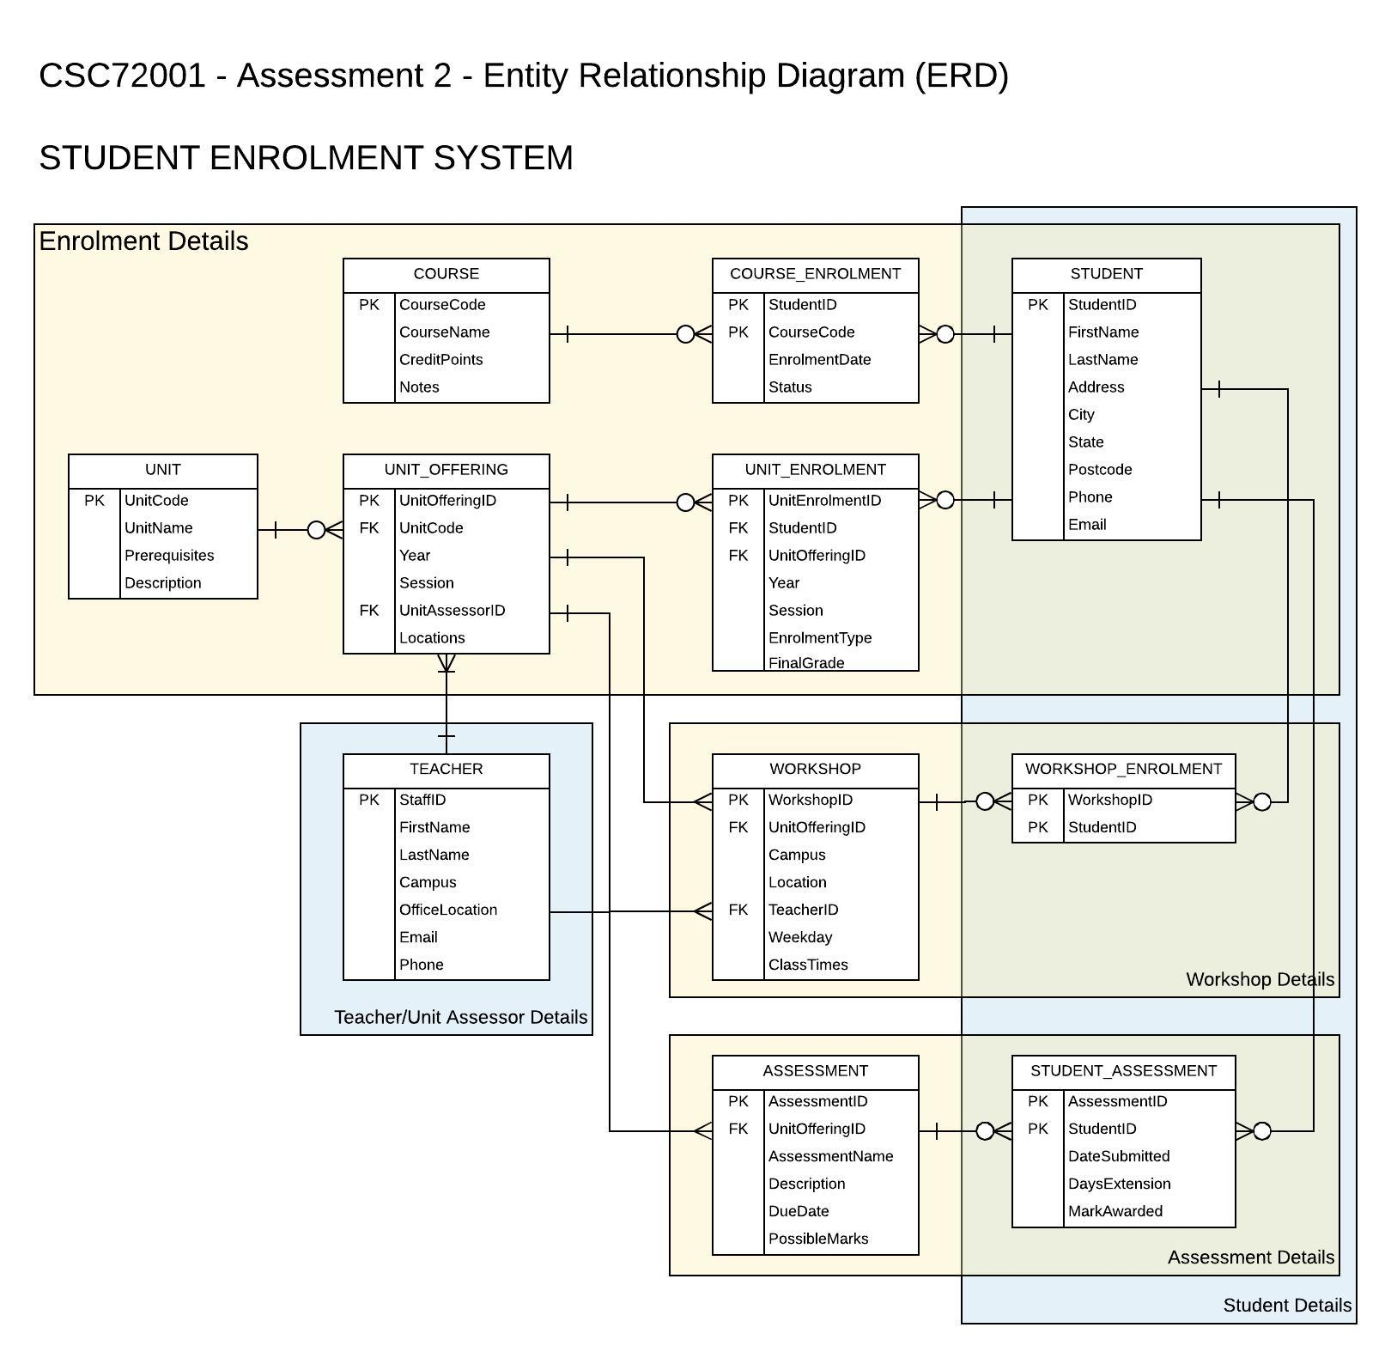

# **Part A: Analysis**

## **Client Business Rules**

* A student can be enrolled in one course. So there are 34 rows in the course_enrolment table.
* A course can be taken by one or more students.
* A student can be enrolled in one or more units.
* A teacher can be assigned in one or more units.
* Every offered unit can have one or more workshops.
* A student can be enrolled in one or more workshops.
* Each offered unit can be assigned to one or more assessments.
* One or more assessments can be assigned to one student.

## **Assumptions Made**

I have made this relational database using the provided ERD diagram. Here I have used 11 tables . All the attributes of each table is taken from the provided ERD diagram.Using ‘Client Provided Sample Data’ I have chosen the datatype of each attribute. There is some sample data in the provided excel sheet. They are relevant but they are not sufficient for my database. In order to acquire 5-10 rows for each given query execution, I have to add many more relevant data using the idea of provided sample data. There are only 17 students in the sample data excel sheet. I have added more 17 students and unique StudentIDs for them. As the first,second and fourth query want data from 2019(Attribute ‘Year’ is used in UNIT_ENROLEMNT and UNT_OFFERING table), I have added more data using 2019 year than other years such as 2018 and 2017.

There are only 24 units in the given excel sheet. I have collected other 24 unit names from our university website. All the unit names are relevant. So there are a total of 48 units in our database.

There are a total 206 tuples in the UNIT_ENROLMENT table. All of my added data is relevant. All 34 students can be enrolled in more than one unit. For good results in queries, I have used ‘Year’=2019 and ‘Session’=3 in more rows. If the unitofferingID, year and session from UNIT_OFFERING table are matched with these fields from UNT_ENROLMENT table, then the corresponding row is retrieved.

There are a total 268 rows in the WORKSHOP table. So total 268 workshops are added in the workshop table. The 48th offered unit has got the most number of workshops which is 32. Other offered units have a minimum number of one workshop. Here I have made two individual attributes for ‘ClassTimeStart’ and ‘ClassTimeEnd’. I think this enhances our database system. In the Query time I have performed ‘concat’ operation for these attributes.

There are a lot of assessments in the ASSESSMENT table. Each offered unit has got a minimum one assessment. In this case, the maximum number of assessments assigned to an offered unit is 5.

Now the final table is the STUDENT_ASSESSMENT table. All 34 students got assessments. Minimum number of assessments assigned to a student is 3 and maximum is 10.

For generating marks, I have written a code which automatically generates marks for every assessment. They are totally relevant. There is a PossibleMarks attribute in the ASSESSMENT table. My code doesn’t exceed the total marks range. Here I assume a minimum number for every assessment of students.

## **Naming Conventions**

To keep consistency, the database will use strict naming conventions that will allow easy implementation and maintenance of the database when completed. The following conventions apply:

* Upper case format is used in table names.
* The first letter of each meaningful word of ‘attribute name’ is uppercase.
* lower case format is used in ‘database name’.
* The first letter of each meaningful word of ‘aliases’ is uppercase.
* Underscore is used in ‘table name’.
* Underscore and uppercase format are used in constraints names.

## **Data Types Chosen**

There are 11 tables in my database. The name of my database is ‘seva10’. Using the provided ERD diagram, I have made all these tables. In the ‘Student’ table, there are nine attributes. All data types are relevant with the fields. The following table is showing all attributes's datatype,primary key,foreign key, default and null from left column to right column.

|  |  |  |  |  |  |
| --- | --- | --- | --- | --- | --- |
| **STUDENT** | | | | | |
| **Attribute** | **Data Type** | **Primary Key** | **Foreign Key** | **Default** | **Null** |
| StudentID | int(11) | Yes | No | None | No |
| FirstName | varchar(100) | No | No | None | No |
| LastName | varchar(100) | No | No | None | No |
| Address | varchar(100) | No | No | Null | Yes |
| City | varchar(100) | No | No | Null | Yes |
| State | varchar(100) | No | No | Null | Yes |
| PostCode | varchar(100) | No | No | Null | Yes |
| Phone | varchar(100) | No | No | Null | Yes |
| Email | varchar(100) | NO | No | Null | Yes |

In the ‘Unit’ table, there are 4 attributes. All data types are relevant with the fields. The following table is showing all attributes's datatype,primary key,foreign key, default and null from left column to right column.

|  |  |  |  |  |  |
| --- | --- | --- | --- | --- | --- |
| **UNIT** | | | | | |
| **Attribute** | **Data Type** | **Primary Key** | **Foreign Key** | **Default** | **Null** |
| UnitCode | varchar(100) | Yes | No | None | No |
| UnitName | varchar(200) | No | No | None | No |
| Prerequisites | varchar(100) | No | No | None | No |
| Description | varchar(200) | No | No | Null | Yes |

In the ‘Teacher’ table, there are 7 attributes. All data types are relevant with the fields. The following table is showing all attributes's datatype,primary key,foreign key, default and null from left column to right column.

|  |  |  |  |  |  |
| --- | --- | --- | --- | --- | --- |
| **TEACHER** | | | | | |
| **Attribute** | **Data Type** | **Primary Key** | **Foreign Key** | **Default** | **Null** |
| StaffID | int(11) | Yes | No | None | No |
| FirstName | varchar(100) | No | No | None | No |
| LastName | varchar(100) | No | No | None | No |
| Campus | varchar(100) | No | No | Null | Yes |
| OfficeLocation | varchar(100) | No | No | Null | Yes |
| Email | varchar(100) | No | No | Null | Yes |
| Phone | int(11) | No | No | Null | Yes |

In the ‘Course_enrolment’ table, there are 4 attributes. All data types are relevant with the fields. The following table is showing all attributes's datatype,primary key,foreign key, default and null from left column to right column.

|  |  |  |  |  |  |
| --- | --- | --- | --- | --- | --- |
| **COURSE_ENROLMENT** | | | | | |
| **Attribute** | **Data Type** | **Primary Key** | **Foreign Key** | **Default** | **Null** |
| StudentID | int(11) | Yes | Yes | None | No |
| CourseCode | int(11) | Yes | Yes | None | No |
| EnrolmentDate | date | No | No | Null | Yes |
| Status | varchar(100) | No | No | Null | Yes |

In the ‘Course’ table, there are 4 attributes. All data types are relevant with the fields. The following table is showing all attributes's datatype,primary key,foreign key, default and null from left column to right column.

|  |  |  |  |  |  |
| --- | --- | --- | --- | --- | --- |
| **COURSE** | | | | | |
| **Attribute** | **Data Type** | **Primary Key** | **Foreign Key** | **Default** | **Null** |
| CourseCode | int(11) | Yes | No | None | No |
| CourseName | varchar(100) | No | No | None | No |
| CreditPoints | int(8) | No | No | Null | Yes |
| Notes | varchar(100) | No | No | Null | Yes |

In the ‘Unit_offering’ table, there are 6 attributes. All data types are relevant with the fields. The following table is showing all attributes's datatype,primary key,foreign key, default and null from left column to right column.

|  |  |  |  |  |  |
| --- | --- | --- | --- | --- | --- |
| **UNIT_OFFERING** | | | | | |
| **Attribute** | **Data Type** | **Primary Key** | **Foreign Key** | **Default** | **Null** |
| UnitOfferingID | int(8) | Yes | No | None | No |
| UnitCode | varchar(100) | No | Yes | Null | Yes |
| Year | int(8) | Yes | No | None | No |
| Session | int(8) | Yes | No | None | No |
| UnitAssessorID | int(11) | No | Yes | Null | Yes |
| Locations | varchar(100) | Yes | No | Null | Yes |

In the ‘unit_enrolment’ table, there are 7 attributes. All data types are relevant with the fields. The following table is showing all attributes's datatype,primary key,foreign key, default and null from left column to right column.

|  |  |  |  |  |  |
| --- | --- | --- | --- | --- | --- |
| **UNIT_ENROLMENT** | | | | | |
| **Attribute** | **Data Type** | **Primary Key** | **Foreign Key** | **Default** | **Null** |
| UnitEnrolmentID | int(8) | Yes | No | None | No |
| StudentID | int(8) | No | Yes | None | No |
| UnitOfferingID | int(8) | No | Yes | None | No |
| Year | int(8) | No | No | None | No |
| Session | int(8) | No | No | None | No |
| EnrolmentType | int(8) | No | No | None | No |
| FinalGrade | int(8) | No | No | Null | Yes |

In the ‘Workshop’ table, there are 8 attributes. All data types are relevant with the fields. The following table is showing all attributes's datatype,primary key,foreign key, default and null from left column to right column.

|  |  |  |  |  |  |
| --- | --- | --- | --- | --- | --- |
| **WORKSHOP** | | | | | |
| **Attribute** | **Data Type** | **Primary Key** | **Foreign Key** | **Default** | **Null** |
| WorkshopID | int(8) | Yes | No | None | No |
| UnitOfferingID | int(8) | No | Yes | Null | Yes |
| Campus | varchar(100) | No | No | Null | Yes |
| Location | varchar(100) | No | No | Null | Yes |
| TeacherID | int(8) | No | Yes | Null | Yes |
| Weekday | varchar(100) | No | No | Null | Yes |
| ClassTimeStart | varchar(100) | No | No | Null | Yes |
| ClassTimeEnd | varchar(100) | Yes | No | Null | Yes |

In the ‘workshop_enrolemnt’ table, there are 2 attributes. All data types are relevant with the fields. The following table is showing all attributes's datatype,primary key,foreign key, default and null from left column to right column.

|  |  |  |  |  |  |
| --- | --- | --- | --- | --- | --- |
| **WORKSHOP_ENROLMENT** | | | | | |
| **Attribute** | **Data Type** | **Primary Key** | **Foreign Key** | **Default** | **Null** |
| WorkshopID | int(8) | Yes | Yes | None | No |
| StudentID | int(8) | Yes | Yes | None | No |

In the ‘Assessment’ table, there are 6 attributes. All data types are relevant with the fields. The following table is showing all attributes's datatype,primary key,foreign key, default and null from left column to right column.

|  |  |  |  |  |  |
| --- | --- | --- | --- | --- | --- |
| **ASSESSMENT** | | | | | |
| **Attribute** | **Data Type** | **Primary Key** | **Foreign Key** | **Default** | **Null** |
| AssessmentID | int(8) | Yes | No | None | No |
| UnitOfferingID | int(8) | No | Yes | Null | Yes |
| AssessmentName | int(8) | No | No | None | No |
| Description | int(8) | No | No | Null | Yes |
| DueDate | int(8) | No | No | Null | Yes |
| PossibleMarks | int(8) | No | No | Null | Yes |

In the ‘Student_Assessment’ table, there are five attributes. All data types are relevant with the fields. The following table is showing all attributes's datatype,primary key,foreign key, default and null from left column to right column.

|  |  |  |  |  |  |
| --- | --- | --- | --- | --- | --- |
| **STUDENT_ASSESSMENT** | | | | | |
| **Attribute** | **Data Type** | **Primary Key** | **Foreign Key** | **Default** | **Null** |
| AssessmentID | int(11) | Yes | Yes | None | No |
| StudentID | int(11) | Yes | Yes | None | No |
| DateSubmitted | date | No | No | Null | Yes |
| DaysExtension | int(11) | No | No | Null | Yes |
| MarkAwarded | decimal(5,2) | No | No | Null | Yes |

# **Part B: Testing Queries**

## **B.6.1 Workshop Enrolment List**

Query:

select ue.session,uo.unitcode,u.unitname,concat (s.FirstName,' ',s.LastName) as 'Student Name',we.studentid,w.Campus,w.Weekday,concat(t.FirstName,' ',t.LastName)as 'Teacher Name',concat(w.ClassTimeStart,'-',w.ClassTimeEnd)as 'Class Time' from STUDENT s INNER join UNIT_ENROLMENT ue on(s.StudentID=ue.StudentID) INNER JOIN UNIT_OFFERING uo on(ue.UnitOfferingID=uo.UnitOfferingID)INNER join WORKSHOP w on(uo.UnitOfferingID=w.UnitOfferingID)INNER JOIN WORKSHOP_ENROLMENT we ON(we.StudentID=s.StudentID and we.WorkshopID=w.WorkshopID)inner join UNIT u inner JOIN TEACHER t on(t.StaffID=w.TeacherID) WHERE (ue.Session=3 and ue.Year=2019) and s.FirstName=(SELECT STUDENT.FirstName from STUDENT where STUDENT.StudentID=s.StudentID)and s.LastName=(SELECT STUDENT.LastName from STUDENT where STUDENT.StudentID=s.StudentID) and u.UnitName=(SELECT UNIT.UnitName from UNIT WHERE uo.UnitCode=UNIT.UnitCode)and t.FirstName=(select TEACHER.FirstName from TEACHER WHERE TEACHER.StaffID=t.StaffID) and t.LastName=(SELECT TEACHER.LastName from TEACHER where t.StaffID=TEACHER.StaffID) GROUP by we.StudentID,u.UnitName ORDER by uo.UnitCode asc,w.Campus asc,w.Weekday asc,w.ClassTimeStart asc,s.LastName asc,s.FirstName asc

Result:

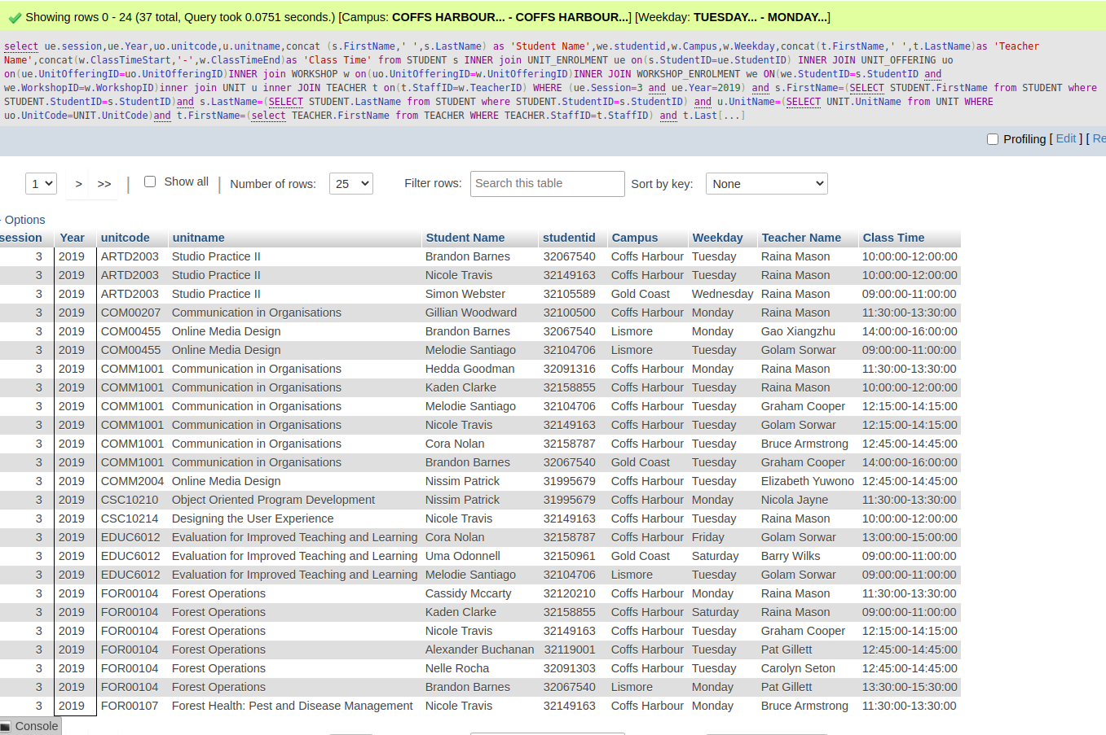

## **B.6.2 Workshop Count List**

Query:

select ue.session,uo.unitcode,u.unitname,w.campus,concat(t.firstname,' ',t.lastname) as'Teacher Name', count(we.studentID) as'Total Student'from STUDENT s INNER JOIN UNIT_ENROLMENT ue on(ue.StudentID=s.StudentID) INNER join UNIT_OFFERING uo on(uo.UnitOfferingID=ue.UnitOfferingID) INNER JOIN UNIT u on(u.UnitCode=uo.UnitCode)INNER join WORKSHOP w on(w.UnitOfferingID=uo.UnitOfferingID) INNER JOIN WORKSHOP_ENROLMENT we on(we.StudentID=s.StudentID and w.WorkshopID=we.WorkshopID)INNER JOIN TEACHER t on (t.StaffID=w.TeacherID) where ue.Year=2019 and t.FirstName=(SELECT TEACHER.FirstName from TEACHER WHERE TEACHER.StaffID=t.StaffID) and t.LastName=(SELECT TEACHER.LastName from TEACHER WHERE TEACHER.StaffID=t.StaffID) and u.UnitName=(SELECT UNIT.UnitName FROM UNIT WHERE UNIT.UnitCode=u.UnitCode) GROUP by ue.Session,uo.UnitCode order by ue.Session asc,uo.UnitCode asc,w.Campus asc,w.Weekday asc,w.ClassTimeStart asc

Result:

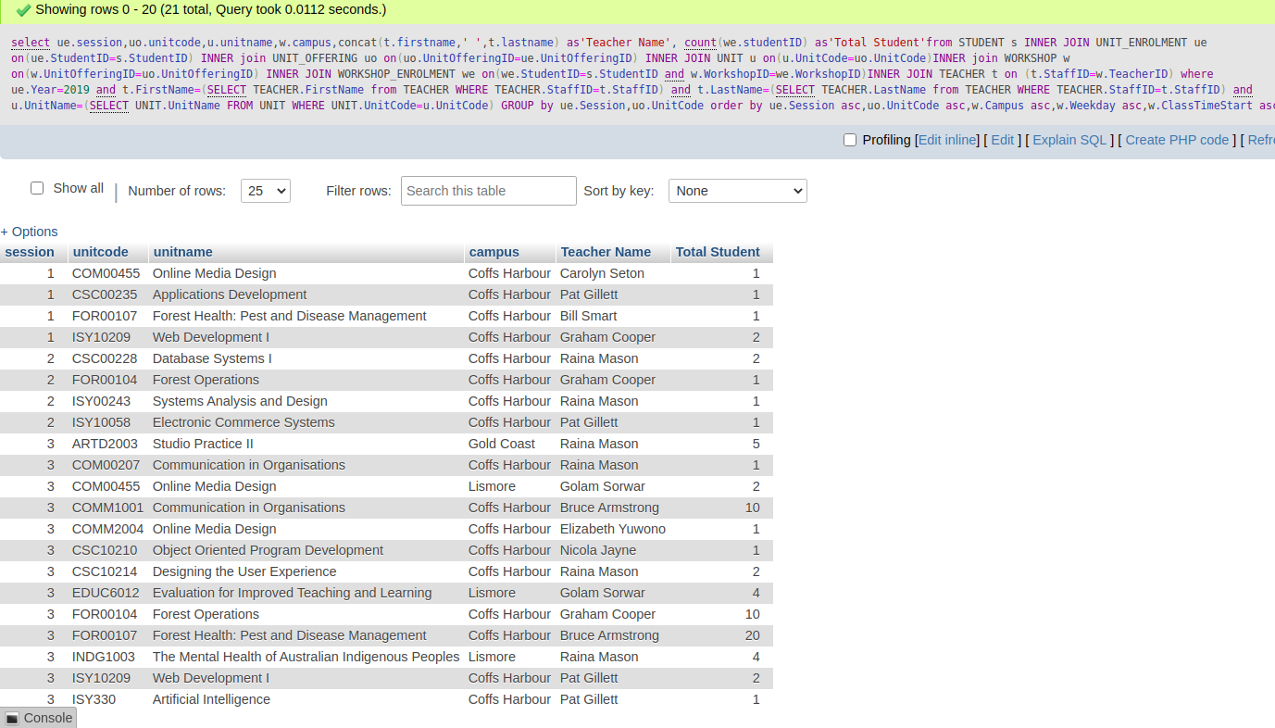

## **B.6.3 Student Transcripts**

Query:

select ue.studentid,concat(s.FirstName,' ',s.LastName) as 'Student Name',ue.year,ue.session,u.unitname from STUDENT s INNER JOIN UNIT_ENROLMENT ue on(s.StudentID=ue.StudentID) INNER join UNIT_OFFERING uo on(uo.UnitOfferingID=ue.UnitOfferingID)INNER JOIN UNIT u on(u.UnitCode=uo.UnitCode) where u.UnitName=(SELECT u.UnitName from UNIT WHERE u.UnitCode=UNIT.UnitCode) and s.FirstName=(select s.FirstName from STUDENT WHERE s.StudentID=STUDENT.StudentID) and s.lastName=(select s.lastName from STUDENT WHERE s.StudentID=STUDENT.StudentID) GROUP by ue.StudentID,u.UnitCode

Result:

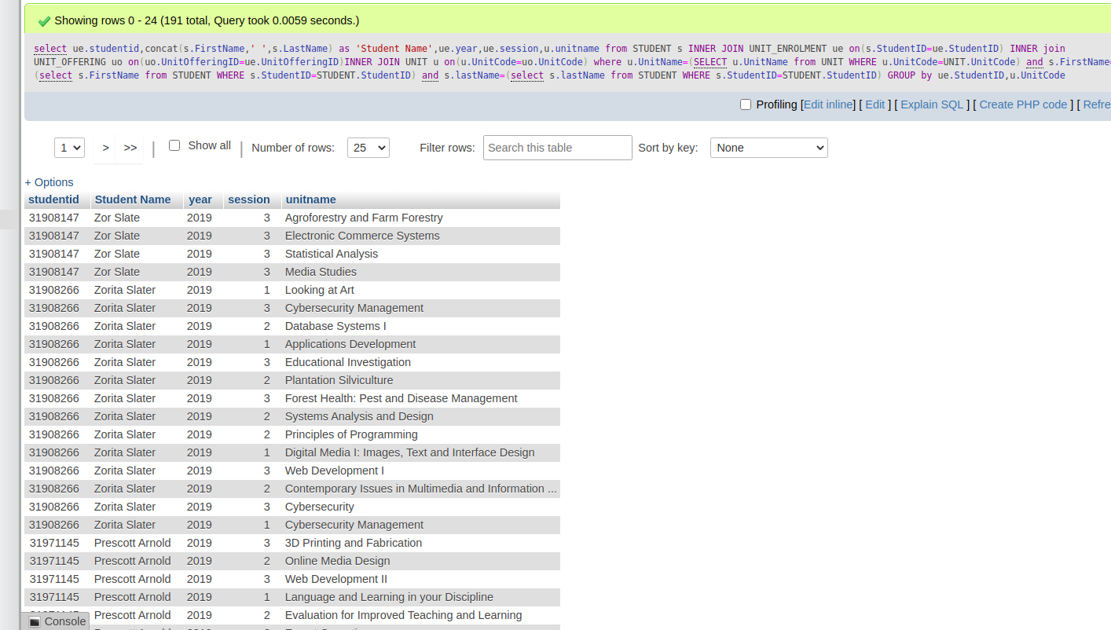

## **B.6.4 Student Assessment Totals**

Query:

select sa.studentid, concat(s.firstname,' ',s.lastname) as 'StudentName', f.grade,uo.unitcode,u.unitname,sum(sa.MarkAwarded)as'Marks' from STUDENT s INNER join select sa.studentid, concat(s.firstname,' ',s.lastname) as 'StudentName', ue.FinalGrade,uo.unitcode,u.unitname,sum(sa.MarkAwarded)as'Marks' from STUDENT s INNER join UNIT_ENROLMENT ue on(s.StudentID=ue.StudentID) INNER join UNIT_OFFERING uo on(uo.UnitOfferingID=ue.UnitOfferingID ) INNER join UNIT u on(u.UnitCode=uo.UnitCode) INNER join ASSESSMENT a on(a.UnitOfferingID=uo.UnitOfferingID) INNER join STUDENT_ASSESSMENT sa on(sa.AssessmentID=a.AssessmentID and sa.StudentID=s.StudentID) where uo.year=2019 and s.FirstName=(SELECT STUDENT.FirstName from STUDENT where sa.StudentID=STUDENT.StudentID) and s.LastName=(SELECT STUDENT.LastName from STUDENT where sa.StudentID=STUDENT.StudentID) GROUP by sa.StudentID,uo.UnitCode order by s.lastname asc ,s.firstname asc ,ue.session asc ,uo.unitcode asc

Result:

