* Prompt for amount, interest rate and no. of years and calculate simple interest.

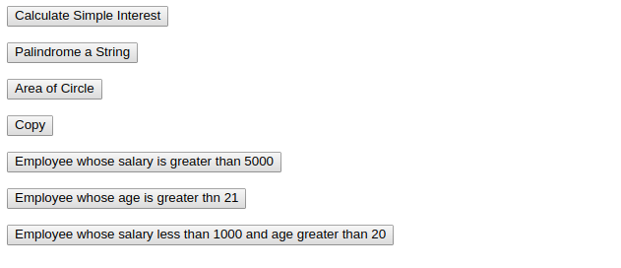

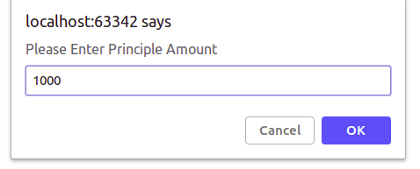

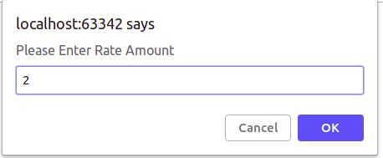

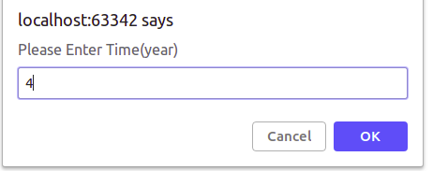

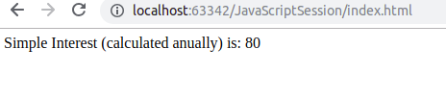

* is palindrome string

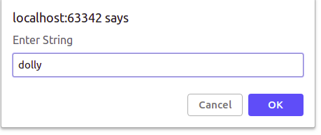

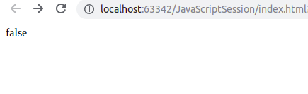

* Area of circle

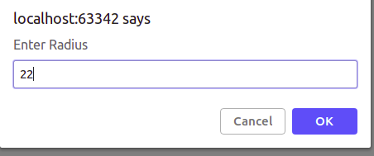

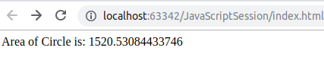

* Copy information of one object to another and log it to console.

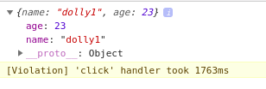

* create a list of objects of Employee with info as follow :
  1. Name, age, salary ,DOB

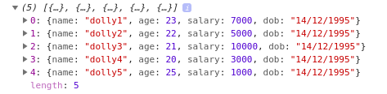

* 1. filter all employees with salary greater than 5000

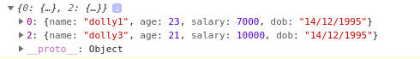

* 1. group employee on the basis of their age

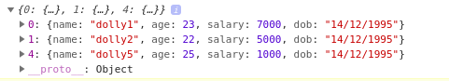

* 1. fetch employees with salary less than 1000 and age greater than 20. Then give them an increment 5 times their salary.

