1. Git Setup<https://confluence.atlassian.com/bitbucket/set-up-git-744723531.html>

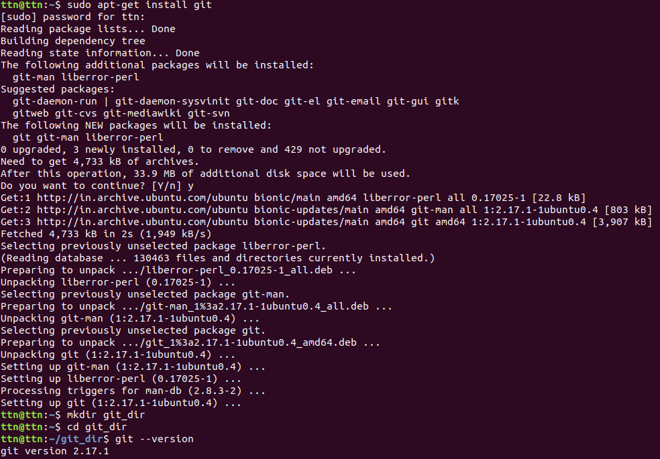





1. Initialize a Git Repository

and

1. Add files to the repository

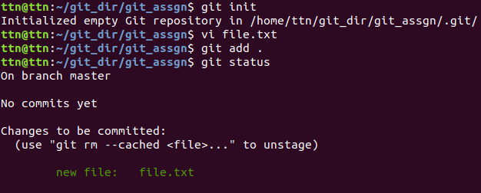

4.Unstage 1 file

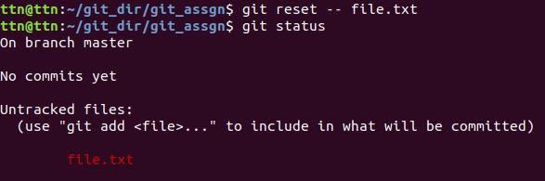

5.Commit the file



6.Add a remote

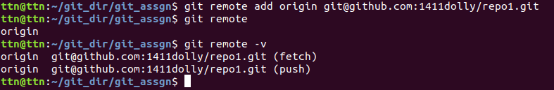

7.Undo changes to a particular file





8.Push changes to Github

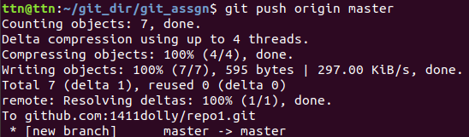

9.Clone the repository

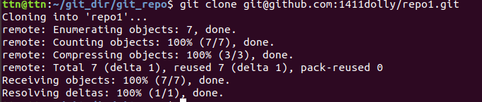

10.Add changes to one of the copies and pull the changes in the other.

Git add .

Git commit

Git push origin master

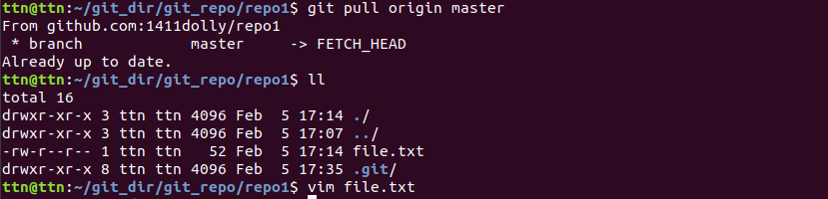

11.Check differences between a file and its staged version

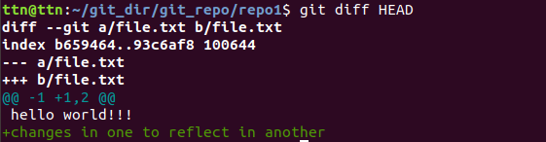

12.Ignore a few files to be checked in

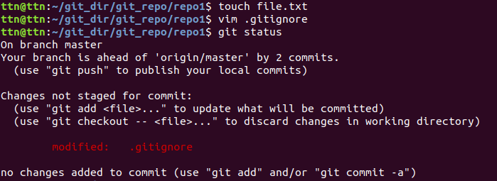

13.Create a new branch.



14.Diverge them with commits

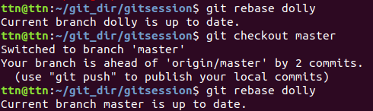

15.Edit the same file at the same line on both branches and commit

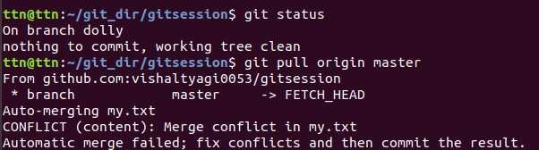

16.Try merging and resolve merge conflicts

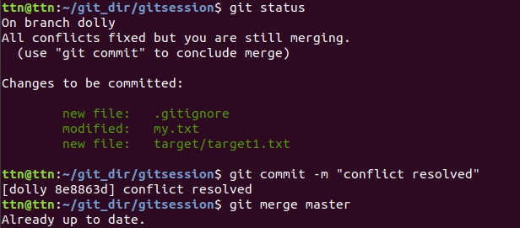

17.Stash the changes and pop them

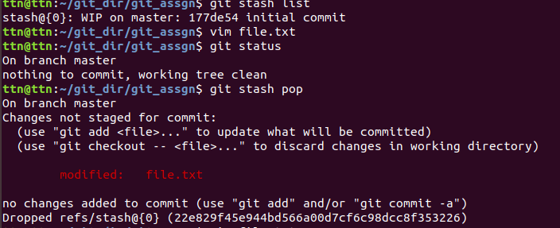

18.Add the following code to your .bashrc file : color_prompt="yes"  
 parse_git_branch() {  
 git branch 2> /dev/null | sed -e '/^[^*]/d' -e 's/* \(.*\)/(\1)/'  
 }  
 if [ "$color_prompt" = yes ]; then  
 PS1='\u@\h\[\033[00m\]:\[\033[01;34m\]\W\[\033[01;31m\] $(parse_git_branch)\[\033[00m\]\$ '  
 else  
 PS1='\u@\h:\W $(parse_git_branch)\$ '  
 fi  
 unset color_prompt force_color_prompt

