Problem Statement: There can be multiple customers, who can place multiple orders on the site. Now a sales person can handle these orders will distribute into multiple sales persons (One order will be assign to one salesperson only). So a sales person can have multiple orders of multiple customers

1. Create Database



2.Design Schema

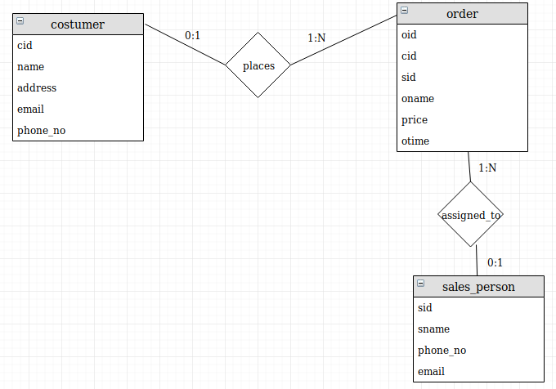

3. Create tables

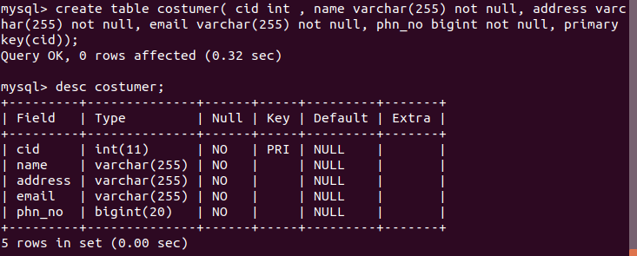

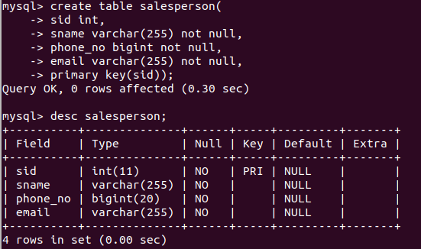

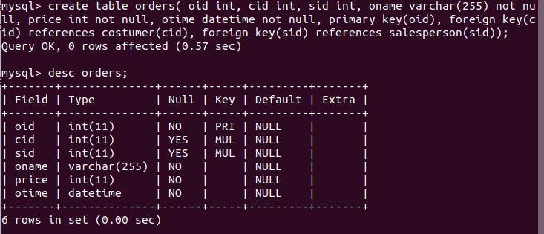

4. Insert sample data

Costumer:

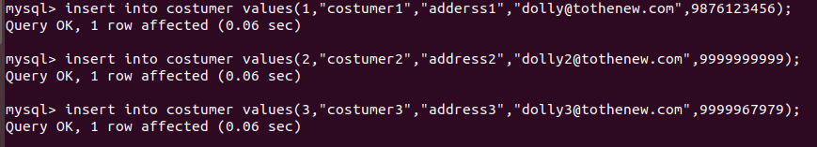

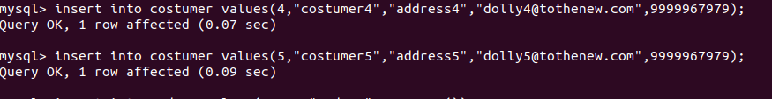

salesperson:

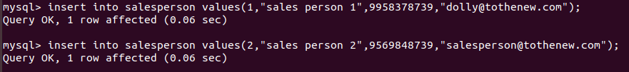

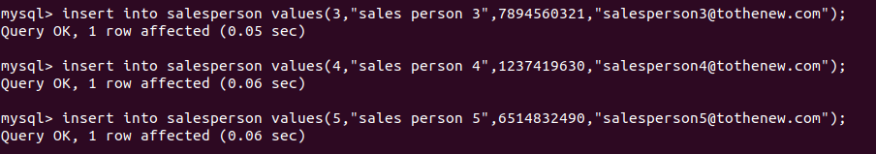

Orders:



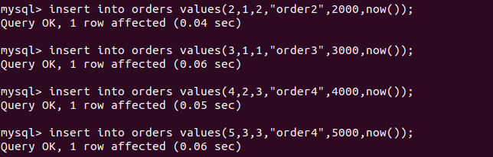

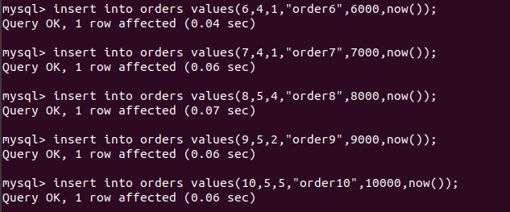

5. Find the sales person have multiple orders.

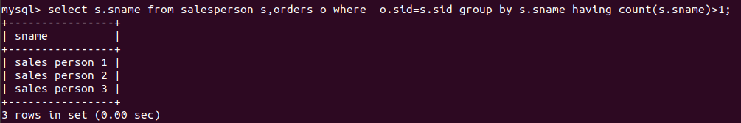

6. Find the all sales person details along with order details

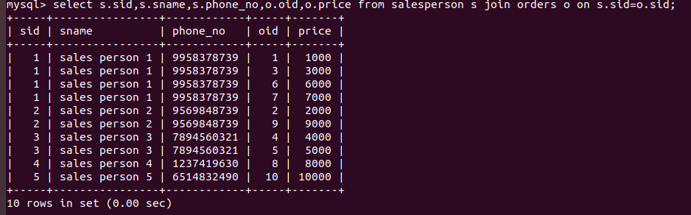

7. Create index

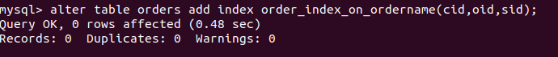

8. How to show index on a table

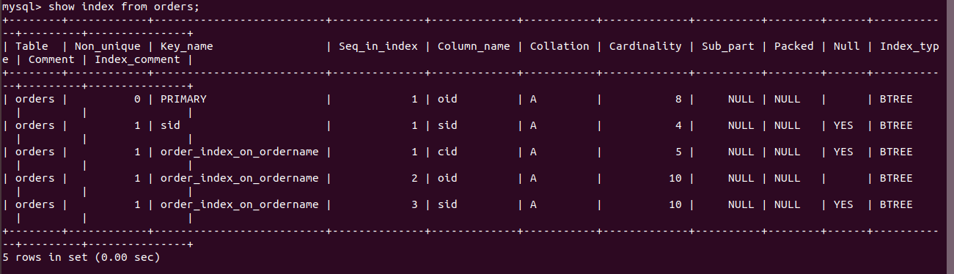

9. Find the order number, sale person name, along with the customer to whom that order belongs to

