Task Proposal

Meeting Date for the Proposal

03/03/25

Task Code

WP8 T2

Task Version

V1

Task Members

*Task Lead:*

Jonathan Wong

*Supporting Members:*

*Members:*

Task Description

*Initial Task Goal(s):*

Create an initial motor test file and present moving arm to supervisor

*How this Task links overall to the WP:*

Will be the basis of how the motors will be controlled

Task Results

*What was delivered:*

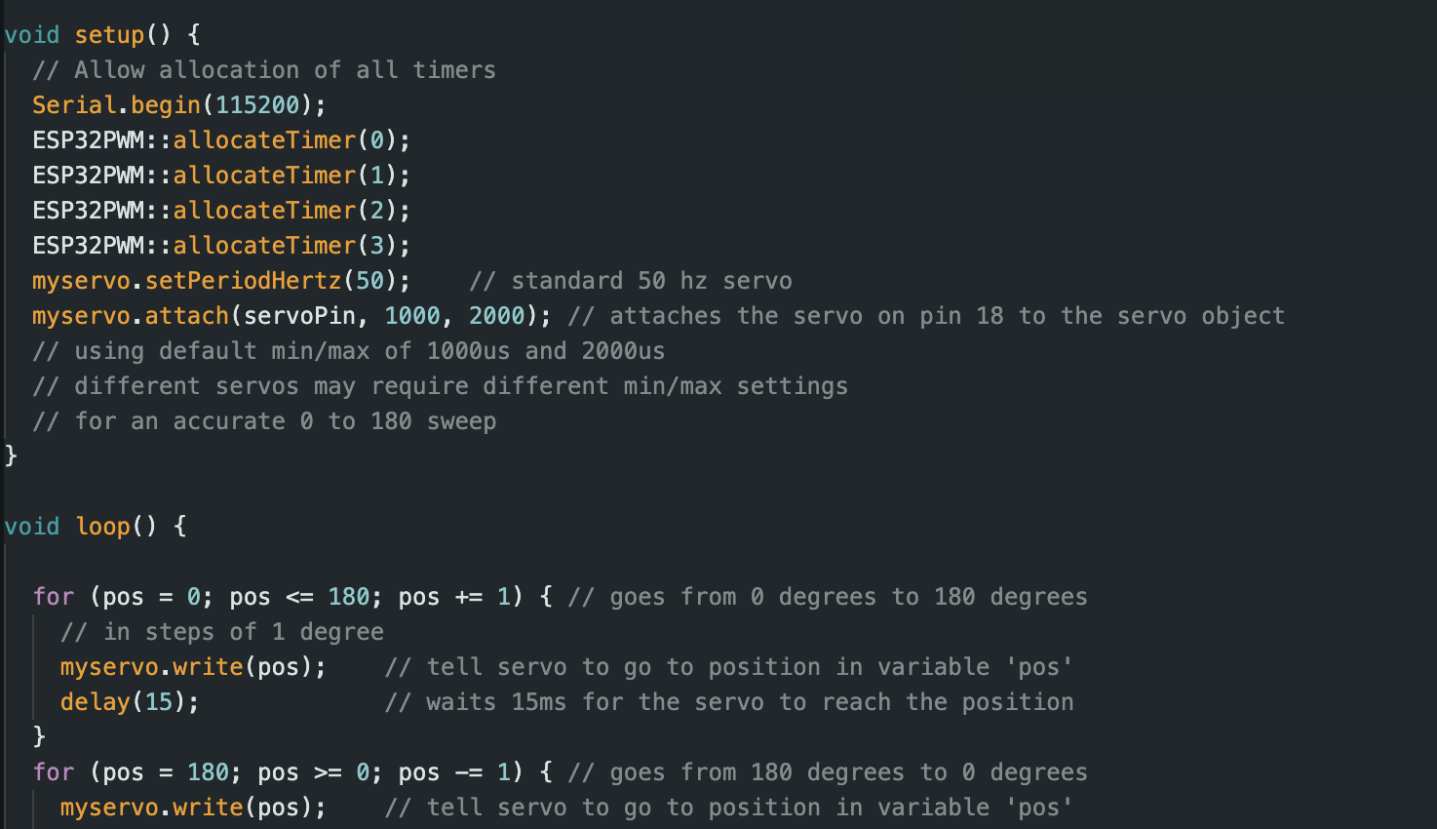Figure 1: Single motor test code

Test code had some issues with the software simulation environment so was tested physically. Initially tested motors individually to check functionality of all motors. Some issues had with uploading to esp, but solved when baud rate changed to 115200. Test file to move all motors using the PCA9685 was created and tested with the fully built grasper. Motors were able to move but limits were not set on the motors, so it was trying to move beyond the joint limits of the chassis.

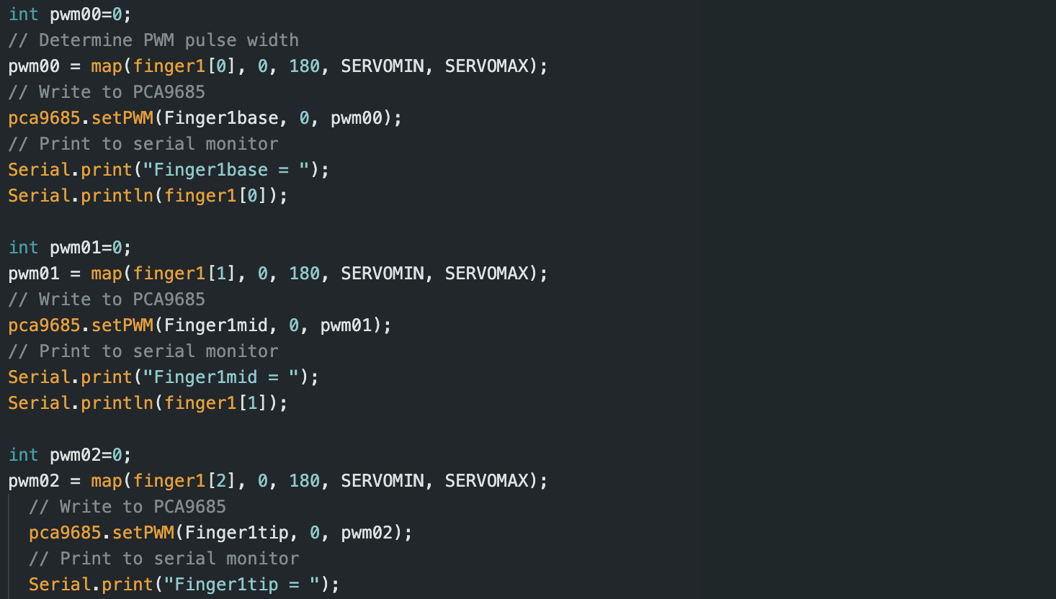Figure 2: All motor test file

*Why we think this approach will work:*

Supporting Task Research and Supervisor Notes

*Why have you completed the task this way:*

*What previous research or methodology did you use to complete this task and why:*

*References:*

Reference anything using IEEE style:<https://www.mybib.com/tools/ieee-citation-generator>

*What points were mentioned by the supervisor related to this task (if any):*

Agreement

*Which team members agree/disagree with the results/approach for this Task:*

|  |  |  |  |  |  |  |  |
| --- | --- | --- | --- | --- | --- | --- | --- |
| Member | Stephanie  Buchanan | Ismail Hendryx | Kautilya  Chappidi | Jonathon Wong | Daniel Pawlak | Mohammed Islam | Gallad Isse |
| Agree( ) or Disagree( ) | ( ) | ( ) | ( ) | ( ) | ( ) | ( ) | ( ) |

*Who Disagrees and why:*

Put down the name of the person who disagrees followed by comments