# Task Proposal

## Meeting Date for the Proposal

19/03/2025

## Task Code

WP8T3

## Task Version

V1

Task Members

*Task Lead:*

Jonathan Wong

*Supporting Members:*

*Members:*

Task Description

*Initial Task Goal(s):*

Full assembly and functionality of electronic circuit

*How this Task links overall to the WP:*

This will be how the grasper will move

Task Results

*What was delivered:*

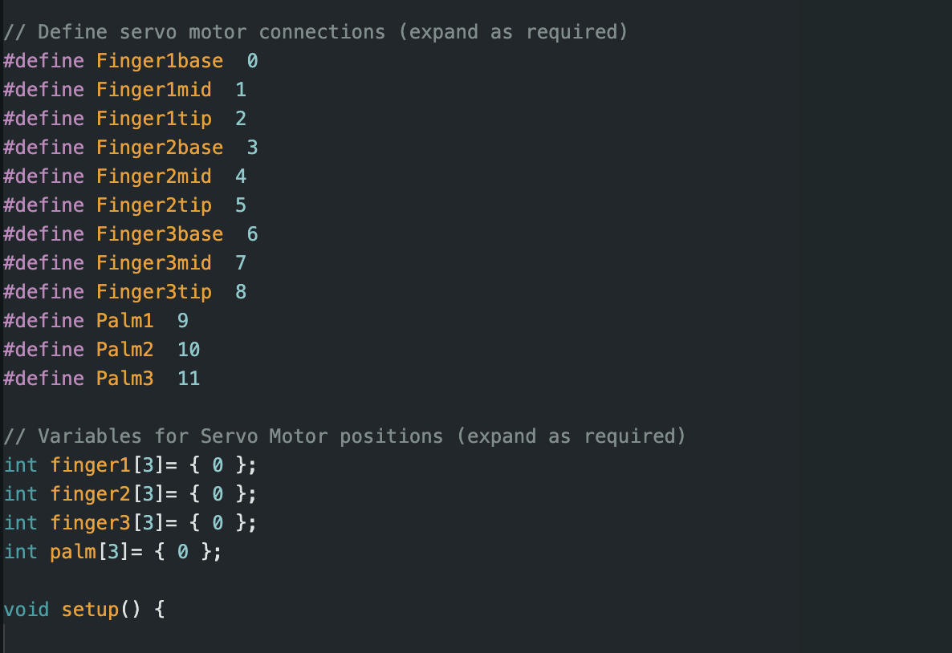Figure 1: Revised motor code from test code

The PCA9685 was wired into every motor including the palm motors, and the ground wire for the board was connected to the breadboard. The SDA and SCL wires were connected directly to the esp, and the 3.3 V wire from the esp connects to the board power, while the 5V wire connects to the motor power. The ground wire on the esp was connected to the breadboard. The motor test file was modified for the use in the final prototype. The variables were made to take input angles for how much the motors would move, and a separate file to calibrate the motors back to the zero position was created from this. The initial prototype was partially disassembled for motor calibration and then put back together.

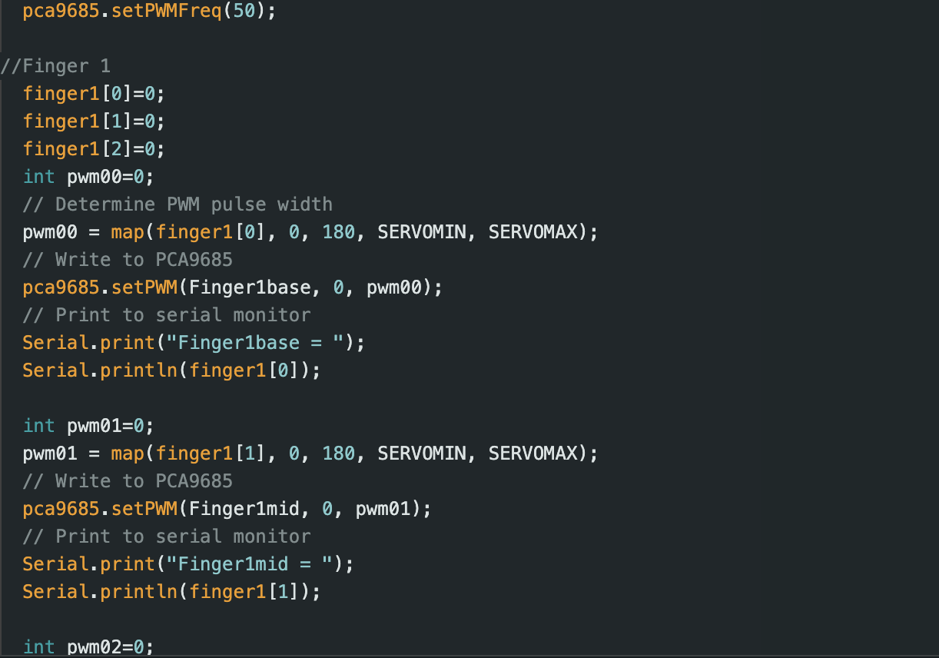Figure 2 Motor Calibration Code

### *Why we think this approach will work:*

## Supporting Task Research and Supervisor Notes

### *Why have you completed the task this way:*

### *What previous research or methodology did you use to complete this task and why:*

### *References:*

Reference anything using IEEE style: <https://www.mybib.com/tools/ieee-citation-generator>

*What points were mentioned by the supervisor related to this task (if any):*

## Agreement

### *Which team members agree/disagree with the results/approach for this Task:*

|  |  |  |  |  |  |  |  |
| --- | --- | --- | --- | --- | --- | --- | --- |
| Member | Stephanie  Buchanan | Ismail Hendryx | Kautilya  Chappidi | Jonathon Wong | Daniel Pawlak | Mohammed Islam | Gallad Isse |
| Agree( ) or Disagree( ) | ( ) | ( ) | ( ) | ( ) | ( ) | ( ) | ( ) |

### *Who Disagrees and why:*

Put down the name of the person who disagrees followed by comments