Task Proposal

Meeting Date for the Proposal
12/14/24

Task Code
WP1 ST2

Task Version
e.g. Version 1

Task Members

Task Lead:
Kautilya Reddy Chappidi

Supporting Members:
Gallad Isse

Members:
(If there is no task lead)

Task Description
Find Irregular Debris Type

Initial Task Goal(s):
- Find Pre-existing Models of Irregular shaped Shape Debris for the grasper

How this Task links overall to the WP:
Will makes sure that project deliverable is capable of grasping Edge case scenarios where in most cases are Broken off parts that are irregularly shaped.

Task Results
Found a few preexisting models of flat irregularly shaped objects of units 6x6 and 3x6 units on each side. These models can be scaled up or down to simulate various types of space debris. And can be prototyped quickly using FDM 3D Printing.

What was delivered:
The Following 12 models were found at https://cults3d.com/en/3d-model/game/space-debris-templates

Why we think this approach will work:
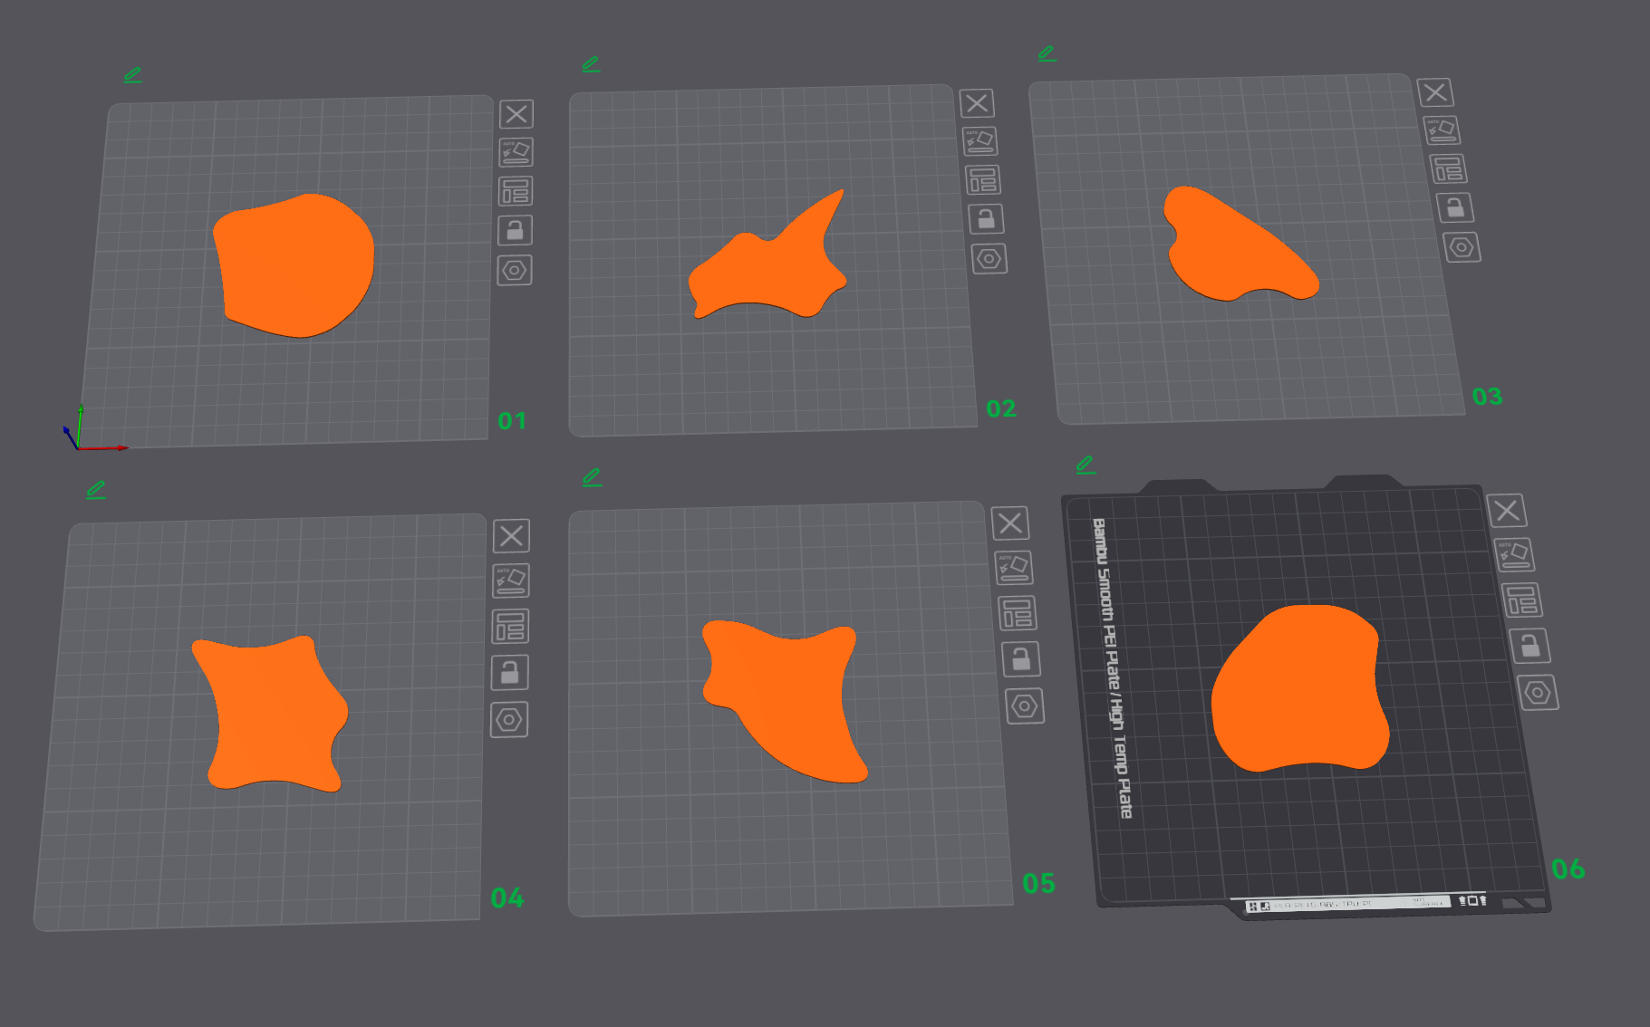
Figure 1: 3x3
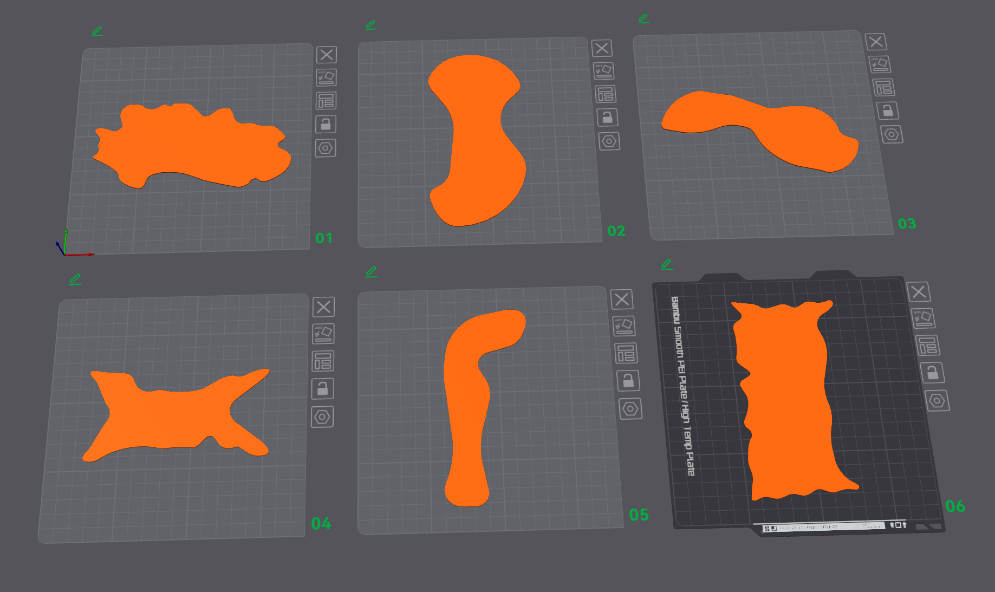
Figure 2: 6x6
Attach at least two images to our shared folder with the task code. Use the following format:Supporting Task Research and Supervisor Notes

Why have you completed the task this way:
The shapes can be generated as well using any Parametric CAD Software like Fusion 360 or Solidworks. But I found this template from an online 3d Model archive which seemed to fit the description of flat irregularly shaped objects. OpenSCAD will be the primary method of model generation in future iterations.

What previous research or methodology did you use to complete this task and why:
N/A

References:
[1]
tincan3, “Space Debris Templates,” Cults 3D, Oct. 08, 2024. https://cults3d.com/en/3d-model/game/space-debris-templates (accessed Dec. 14, 2024).
‌What points were mentioned by the supervisor related to this task (if any):

Agreement

Which team members agree/disagree with the results/approach for this Task:
Member | Stephanie  Buchanan | Ismail Hendryx | Kautilya  Chappidi | Jonathon Wong | Daniel Pawlak | Mohammed Islam | Gallad Isse
Agree( ) or Disagree( ) | e.g. ( ) | e.g. ( )

Who Disagrees and why:
Put down the name of the person who disagrees followed by comments

