**惠普软件班实训项目课件**

主讲：汤燕

* Git 总结
* 项目演示
* 需求分析
* 数据库设计
* 实训报告

# 需求分析基本知识

## 生活中需求的种类

陌陌、快播、微信的摇一摇、附近的人等有没有满足大家交友的需求？有些软件甚至铤而走险屡禁不止。

淘宝、天猫、京东、当当、拼多多满足大家购物的需求。

QQ秀、各种钻、微博、朋友圈晒、点赞等满足的是虚荣心等。

不管多么高深的技术，最终是为了解决客户的需求。如果离开使用场景来讨论哪个技术好哪个技术坏是没有意义的。

## 真实需求和伪需求

产品的构思初期，我们会罗列尽可能多需求，也会收集到很多需求。但有些需求是伪需求，有些需求也不具备实现价值，那我们如何做判断呢？

每天有无数产品诞生，也有无数产品陨落，很多时候会谈到一个原因，没有把握住用户需求，吸引不了用户。那如何把握住用户需求呢？

各种各样的需求，如何毫无克制地加载功能去满足用户，最终也会导致产品变得臃肿和失去核心定位。那怎么提炼呢？

你们的需求是什么呢？ 考上研究生 好的工作。

需求分析一定要抓住痛点。

## 一般是哪些人在做需求分析

我们需要把这些需求都列出来，分析客户的痛点，排出需求的优先级。一般是哪些人再做需求呢？大公司一般有需求分析工程师，或者项目经历、或者产品经历。小公司一般就是技术人员上。

## 需求分析一般在哪些地方

1. 有时候是客户到你们公司来，客户上门。
2. 你们到客户公司。
3. 也可能是茶馆或者酒店。
4. 也可能在工厂车间或者子公司等。

需求分析之前最好准备一些笔记本或者录音笔，实在不行用手机也可以。

因为好记性不如烂笔头。需求分析之前最好是把同行的软件或者竞争对手的软件都拿来分析一下。另外预估一下客户的需求，可能有哪些需求，你们有没有成功案例。

以医疗为例讲解。

如何问客户的问题？小型项目问办事员就可以了，大型项目要跟公司的各部分人员沟通。

一般情况下不要绕过办事员跟对方的上级领导沟通.

预算是多少？一开始就要把钱要够，否则客户会觉得你的价格经常变动，需求分析写好后，报的价格也是根据需求的功能报的，如果需求变更可能会导致价格变更。

期望开发周期多长？ 需求分析时间要充足，分析要彻底，特别是大中型项目。

引导客户、给客户推荐自己熟悉的技术，成熟的技术，适合客户的技术。

有没有参考的软件或者网站？

假设已经做好了，你觉得应该是什么样子？哪些人用？

对设计效果是否有较高的要求？

需求分析一般要做多少次？

需求分析是否要收费？

需求报告如何写？

什么是项目的拓扑图或者思维导图。（xmind软件）

需求分析确认后才开始做。

中途改需求很痛苦，有的项目还没做完就要全部重新做。

需求分析的结果就是能根据需求绘制草图（原型图）、能设计数据库表结构。

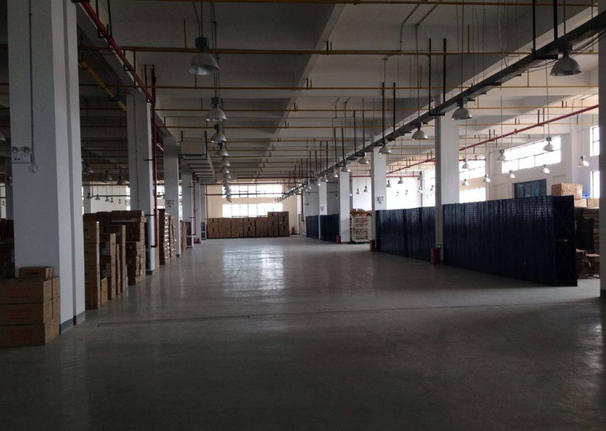

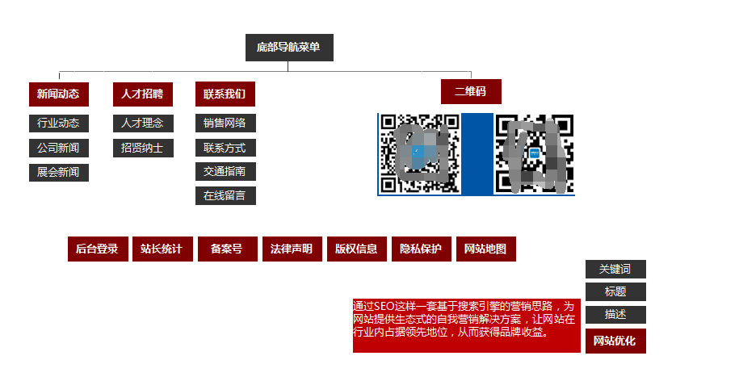

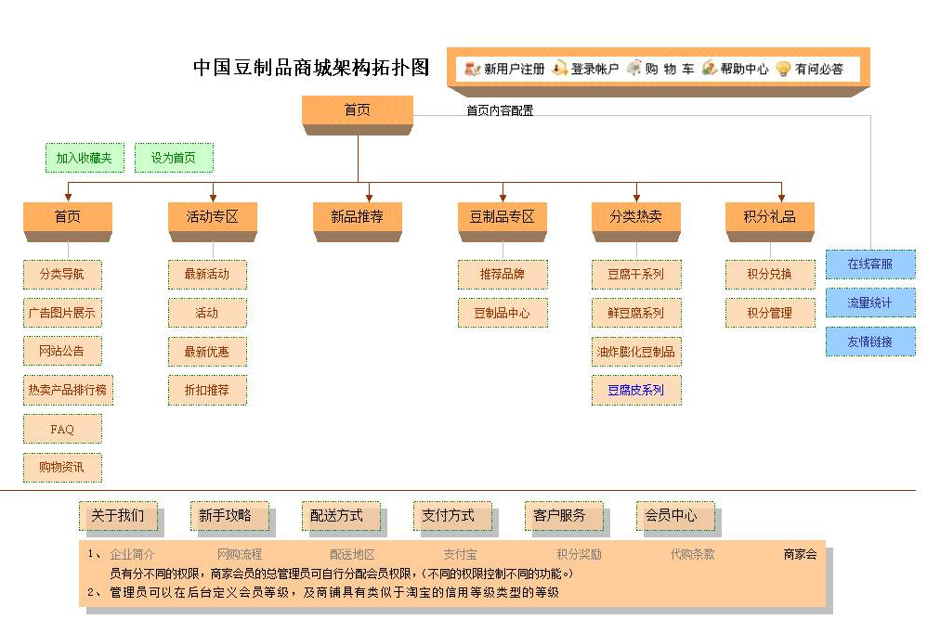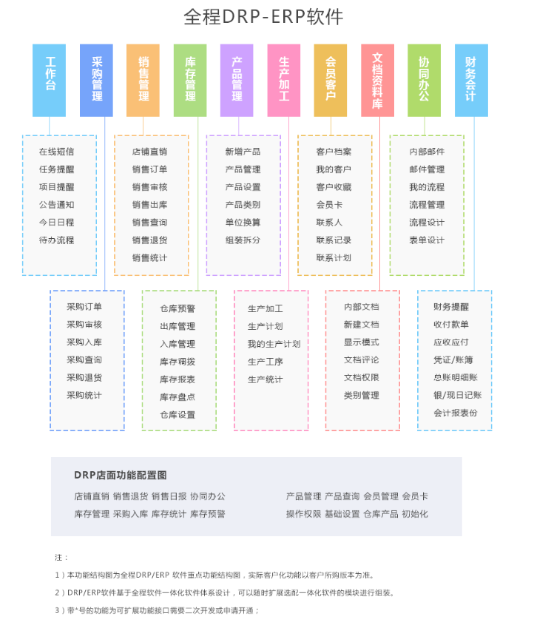

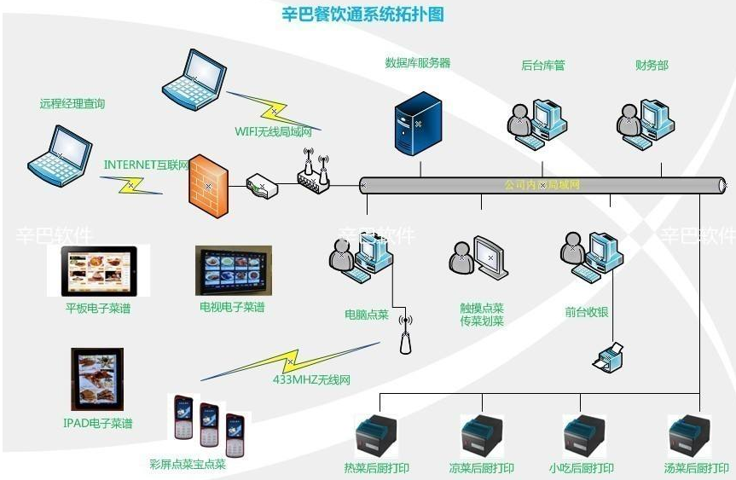

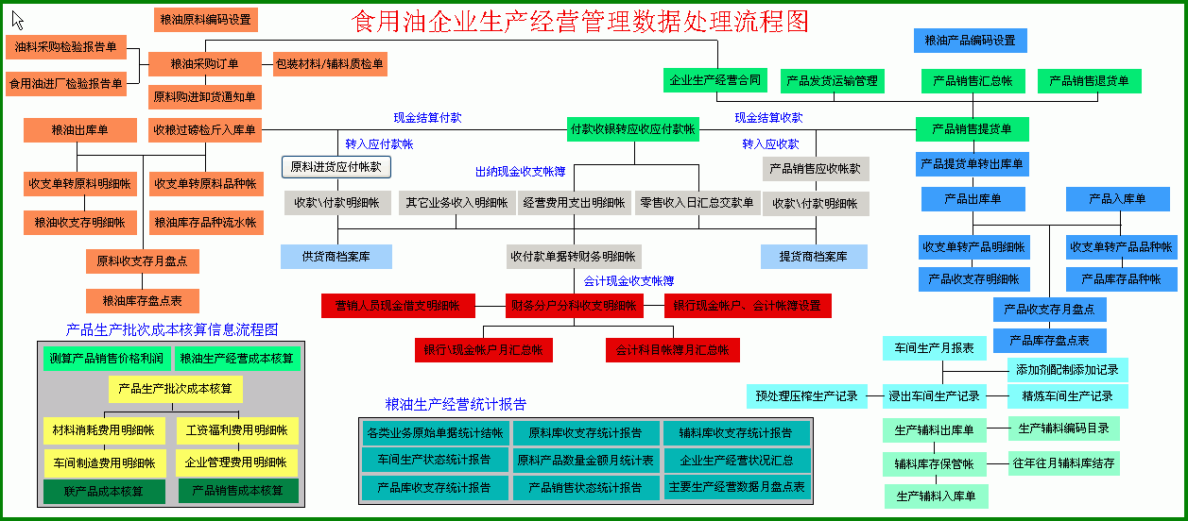

什么是蓝图？

什么是概要设计？

什么是详细需求？

# 进销存系统

## 什么是进销存系统

系统的主要功能价值在于优化整个进销存环节，帮助企业管理仓库、采购、销售等方面，是一款以进销存管理为核心的软件，适用于规模一般的中小型商贸企业；

进销存系统一般都是做实体经济的公司需要。

## 哪些企业需要进销存系统

## 什么是ERP系统

ERP同样也是一套系统，被称为ERP系统，ERP系统是一套完整的管理系统，除了包含进销存功能外，还包含生产管理、财务管理、出纳管理、固定资产管理，支持管理多部门、多机构，系统的价值主要体现是优化企业内部管理，库存和审核管理的细节更多。

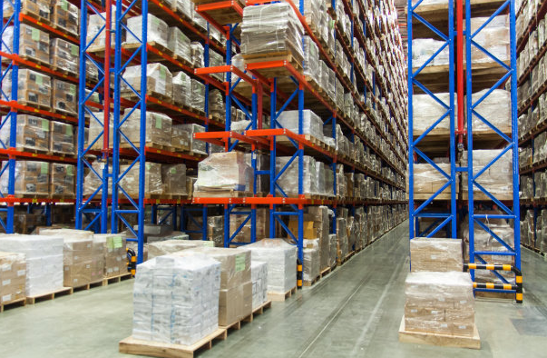

什么是SAP？

什么是OA？

## 哪些企业需要用到

进销存系统是一个通用的系统，很多企业都需要用到。

超市、摩托车配件公司、粮油厂、酒厂、书店、网上商城、电脑厂、肥料厂、鞭炮厂、冷冻厂、个体户店、文具店等…

比如：XXX进水器公司。

比如：XXX中小型超市。

比如：XXX家具商场。

比如：兴华书店。

比如：优衣库。

比如：XX矿泉水代理商

比如：XX酒厂

比如：XX化肥公司

比如：XX摩托车配件公司

比如：XX汽车配件公司

进销存软件需求很大。

## 进销存系统主要是解决的问题

客户的商品越来越多，不停在进货、不停的销售、如果没有系统，客户就不清楚现在哪些货卖得好，哪些货卖得不好，该进哪些货，该退哪些货，也不知道库存情况，到底是赚钱还是亏本了，赚了多少？亏了多少等。

进销存要解决的核心问题就是查询库存。

每进货一次就记录一次，每出库一次，也增加一条出库记录，这样每个商品或者每批商品什么时候入库的、什么时候出库的，价格多少，都有记录，剩下的就是查询和统计问题。

仓库、门店有一个还是多个？

商品都有哪些类别？是否包含子类别？

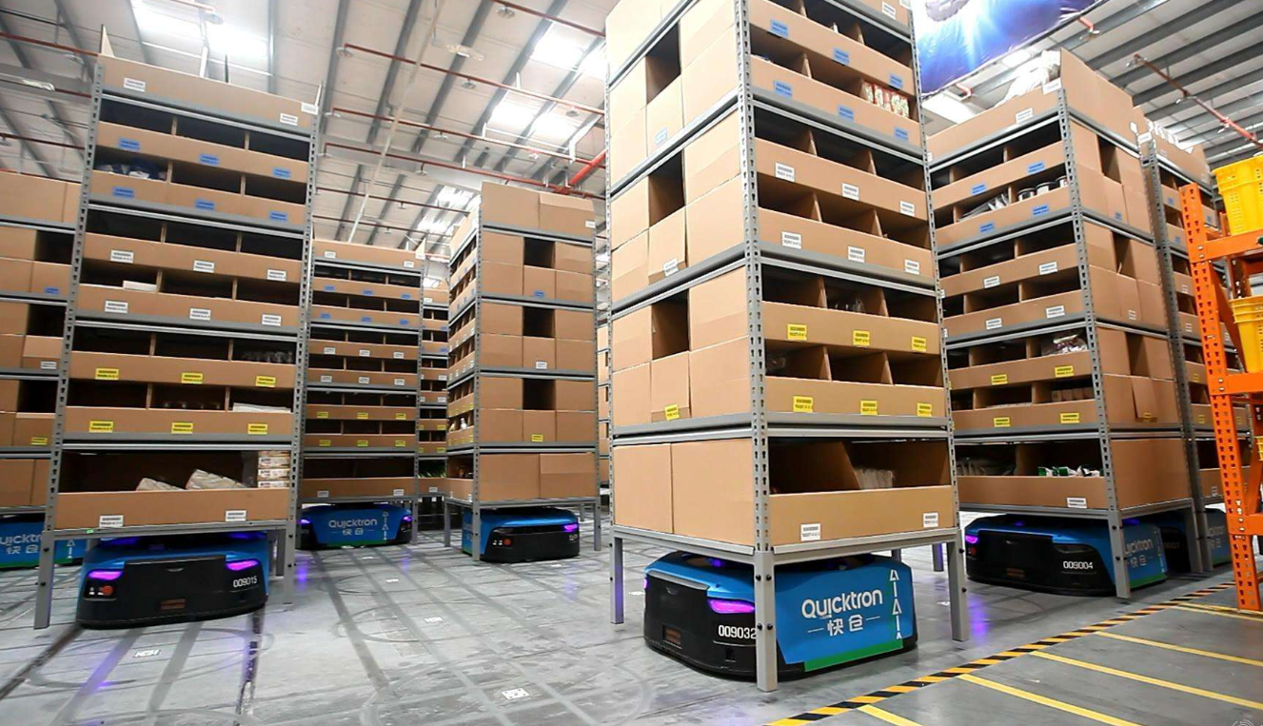

## 技术选型

本次实训项目采用java语言来开发。后端语言目前为止，我们学过了java和python，选择的原则就是选择自己熟悉的语言，java语言特别适合做B-S类型的大中型系统。

数据库采用开源免费的Mysql 5.7版本，也是我们平时用得最多得版本。

开发工具使用Eclipse。

服务器Tomcat.

权限管理采用基于角色的权限管理。

商品分类采用无限级商品分类。

报表部分采用百度的Echarts组件来完成。

如果UI能采用BOOTSTRAP或者EasyUI就更好了（不做强制要求）。

整个项目代码使用github进行托管。

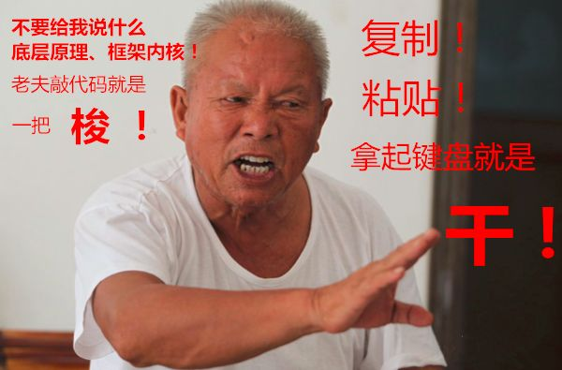

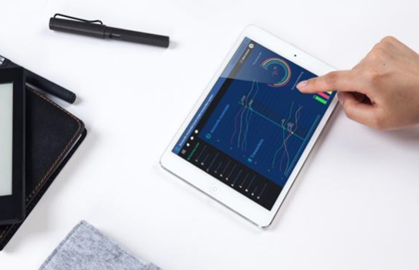

# 进销存项目演示

这是项目初步一看跟我们之前的项目界面区别不大。

对于经济型适用型客户，一套系统，界面可以用很多个客户，可以用很多年，只要功能满足就OK，更加看重方便适用。

对于高端客户，需要单独定制界面。

说说这个项目的特色：

1、实现了商品无限级分类功能。

2、实现了基于角色的权限管理（不同的人管理不同的功能，方便扩展）。

3、为每个商品生成了二维码。方便后续使用扫扫描枪或者手机APP扫码。

4、项目中使用了百度的echart报表库，你们通过本次实训可以学会报表的制作。

5、项目包含了java操作数据库的CRUD，实现查询功能，解决了中文查询的乱码问题。

6、广泛使用了左右嵌入式布局的方式。

7、分页包含了jquery、前端表单验证、组合查询、ajax、百度编辑器、图片上传、servlet、json等技术，对过去学过的知识是一种回顾。

**自己先把项目搭建起来，先看一看。**

# 本次实训要求

实训的要求：

1. 本次实训是一个完整的进销存项目，包括：

需求分析文档（必须包含数据字典）、项目代码、数据库、PPT。

1. 每个小组不超过5个人。
2. 每个人都要交作品，但是同一个小组成员可以相同。
3. 老师作为客户跟每个小组单独做需求分析，满足某个企业、事业单位或者某个组织的进销存管理需求，形成需求分析报告，文档化。（给大家看看为写的文档）
4. 项目可以每个小组单独开发，也可以在为的基础项目上进行二次开发。
5. 要有多种报表格式，条形图、饼状图、折现图、表格等。
6. 增加盘点功能。
7. 项目要答辩。

# 本次实训目的

1. 了解项目开发的全过程，掌握项目开发过程中的新名词，学习需求分析。
2. 通过项目开发进一步巩固和整理前面三年学过的技术知识。
3. 为毕业设计做准备。（此难度能满足毕业设计项目）
4. 为面试做准备。这个就是面试的项目经验。
5. 提高大家编写文档的能力（毕业论文格式排版要求也比较严格）。
6. 接触一些小工具。
7. 本套代码未经授权，不得用于商业用途。

需求分析可以利用多种工具共同完成。

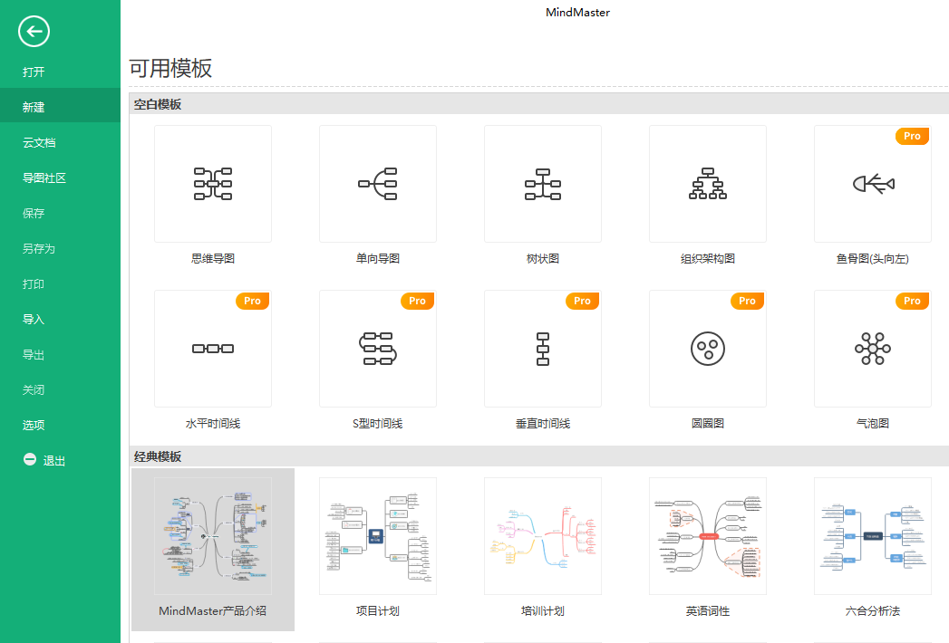

# 数据库设计

数据库名：myerp

表名：tbdealer

|  |  |  |  |  |  |  |  |  |  |  |  |  |  |  |  |  |  |  |  |  |  |  |  |  |  |  |  |  |  |  |  |  |  |  |  |  |  |  |  |  |  |  |  |  |  |  |  |  |  |  |  |  |  |  |  |  |  |  |  |  |  |  |  |  |  |  |  |  |  |  |  |  |  |  |  |  |  |
| --- | --- | --- | --- | --- | --- | --- | --- | --- | --- | --- | --- | --- | --- | --- | --- | --- | --- | --- | --- | --- | --- | --- | --- | --- | --- | --- | --- | --- | --- | --- | --- | --- | --- | --- | --- | --- | --- | --- | --- | --- | --- | --- | --- | --- | --- | --- | --- | --- | --- | --- | --- | --- | --- | --- | --- | --- | --- | --- | --- | --- | --- | --- | --- | --- | --- | --- | --- | --- | --- | --- | --- | --- | --- | --- | --- | --- | --- |
| |  |  |  |  |  |  |  |  |  |  |  | | --- | --- | --- | --- | --- | --- | --- | --- | --- | --- | --- | | 序号 | 列名 | 数据类型 | 长度 | 小数位 | 标识 | 主键 | 外键 | 允许空 | 默认值 | 说明 | | 1 | id | int | 11 |  | 是 | 是 |  | 否 |  | auto_increment | | 2 | companyname | varchar | 255 |  |  |  |  | 是 |  |  | | 3 | name | varchar | 255 |  |  |  |  | 是 |  |  | | 4 | tel | varchar | 255 |  |  |  |  | 是 |  |  | | 5 | address | varchar | 255 |  |  |  |  | 是 |  |  | | 6 | memo | varchar | 255 |  |  |  |  | 是 |  |  | |

表名：tbguestbook

|  |  |  |  |  |  |  |  |  |  |  |  |  |  |  |  |  |  |  |  |  |  |  |  |  |  |  |  |  |  |  |  |  |  |  |  |  |  |  |  |  |  |  |  |  |  |  |  |  |  |  |  |  |  |  |  |  |  |  |  |  |  |  |  |  |  |  |  |  |  |  |  |  |  |  |  |  |  |
| --- | --- | --- | --- | --- | --- | --- | --- | --- | --- | --- | --- | --- | --- | --- | --- | --- | --- | --- | --- | --- | --- | --- | --- | --- | --- | --- | --- | --- | --- | --- | --- | --- | --- | --- | --- | --- | --- | --- | --- | --- | --- | --- | --- | --- | --- | --- | --- | --- | --- | --- | --- | --- | --- | --- | --- | --- | --- | --- | --- | --- | --- | --- | --- | --- | --- | --- | --- | --- | --- | --- | --- | --- | --- | --- | --- | --- | --- |
| |  |  |  |  |  |  |  |  |  |  |  | | --- | --- | --- | --- | --- | --- | --- | --- | --- | --- | --- | | 序号 | 列名 | 数据类型 | 长度 | 小数位 | 标识 | 主键 | 外键 | 允许空 | 默认值 | 说明 | | 1 | id | int | 11 |  | 是 | 是 |  | 否 |  | auto_increment | | 2 | username | varchar | 255 |  |  |  |  | 是 |  |  | | 3 | tel | varchar | 255 |  |  |  |  | 是 |  |  | | 4 | contents | varchar | 255 |  |  |  |  | 是 |  |  | | 5 | createtime | varchar | 255 |  |  |  |  | 是 |  |  | | 6 | isshow | varchar | 255 |  |  |  |  | 是 |  |  | |

表名：tbinout

|  |  |  |  |  |  |  |  |  |  |  |  |  |  |  |  |  |  |  |  |  |  |  |  |  |  |  |  |  |  |  |  |  |  |  |  |  |  |  |  |  |  |  |  |  |  |  |  |  |  |  |  |  |  |  |  |  |  |  |  |  |  |  |  |  |  |  |  |  |  |  |  |  |  |  |  |  |  |  |  |  |  |  |  |  |  |  |  |  |  |  |  |  |  |  |  |  |  |  |  |  |  |  |  |  |  |  |  |  |  |  |  |  |  |  |  |  |  |  |  |  |  |  |  |  |  |  |  |  |  |  |  |  |
| --- | --- | --- | --- | --- | --- | --- | --- | --- | --- | --- | --- | --- | --- | --- | --- | --- | --- | --- | --- | --- | --- | --- | --- | --- | --- | --- | --- | --- | --- | --- | --- | --- | --- | --- | --- | --- | --- | --- | --- | --- | --- | --- | --- | --- | --- | --- | --- | --- | --- | --- | --- | --- | --- | --- | --- | --- | --- | --- | --- | --- | --- | --- | --- | --- | --- | --- | --- | --- | --- | --- | --- | --- | --- | --- | --- | --- | --- | --- | --- | --- | --- | --- | --- | --- | --- | --- | --- | --- | --- | --- | --- | --- | --- | --- | --- | --- | --- | --- | --- | --- | --- | --- | --- | --- | --- | --- | --- | --- | --- | --- | --- | --- | --- | --- | --- | --- | --- | --- | --- | --- | --- | --- | --- | --- | --- | --- | --- | --- | --- | --- | --- | --- |
| |  |  |  |  |  |  |  |  |  |  |  | | --- | --- | --- | --- | --- | --- | --- | --- | --- | --- | --- | | 序号 | 列名 | 数据类型 | 长度 | 小数位 | 标识 | 主键 | 外键 | 允许空 | 默认值 | 说明 | | 1 | id | int | 11 |  | 是 | 是 |  | 否 |  | auto_increment | | 2 | opttype | int | 11 |  |  |  |  | 是 |  |  | | 3 | proid | int | 11 |  |  |  |  | 是 |  |  | | 4 | pronum | varchar | 255 |  |  |  |  | 是 |  |  | | 5 | proname | varchar | 50 |  |  |  |  | 是 |  |  | | 6 | protype | varchar | 255 |  |  |  |  | 是 |  |  | | 7 | proimgurl | varchar | 300 |  |  |  |  | 是 |  |  | | 8 | prooldnum | int | 11 |  |  |  |  | 是 |  |  | | 9 | proaddnum | int | 11 |  |  |  |  | 是 |  |  | | 10 | unitname | varchar | 255 |  |  |  |  | 是 |  |  | | 11 | ctime | varchar | 255 |  |  |  |  | 是 |  |  | |

表名：tbmenubar

|  |  |  |  |  |  |  |  |  |  |  |  |  |  |  |  |  |  |  |  |  |  |  |  |  |  |  |  |  |  |  |  |  |  |  |  |  |  |  |  |  |  |  |  |  |  |  |  |  |  |  |  |  |  |  |  |  |  |  |  |  |  |  |  |  |  |  |  |  |  |  |  |  |  |  |  |  |  |  |  |  |  |  |  |  |  |  |  |  |  |  |  |  |  |  |  |  |  |  |  |  |  |  |  |  |  |  |  |  |  |  |
| --- | --- | --- | --- | --- | --- | --- | --- | --- | --- | --- | --- | --- | --- | --- | --- | --- | --- | --- | --- | --- | --- | --- | --- | --- | --- | --- | --- | --- | --- | --- | --- | --- | --- | --- | --- | --- | --- | --- | --- | --- | --- | --- | --- | --- | --- | --- | --- | --- | --- | --- | --- | --- | --- | --- | --- | --- | --- | --- | --- | --- | --- | --- | --- | --- | --- | --- | --- | --- | --- | --- | --- | --- | --- | --- | --- | --- | --- | --- | --- | --- | --- | --- | --- | --- | --- | --- | --- | --- | --- | --- | --- | --- | --- | --- | --- | --- | --- | --- | --- | --- | --- | --- | --- | --- | --- | --- | --- | --- | --- | --- |
| |  |  |  |  |  |  |  |  |  |  |  | | --- | --- | --- | --- | --- | --- | --- | --- | --- | --- | --- | | 序号 | 列名 | 数据类型 | 长度 | 小数位 | 标识 | 主键 | 外键 | 允许空 | 默认值 | 说明 | | 1 | id | int | 11 |  | 是 | 是 |  | 否 |  | auto_increment | | 2 | MenuName | varchar | 100 |  |  |  |  | 是 |  |  | | 3 | ParentID | int | 11 |  |  |  |  | 是 |  |  | | 4 | depth | int | 11 |  |  |  |  | 是 |  |  | | 5 | ParentPath | varchar | 100 |  |  |  |  | 是 |  |  | | 6 | Href | varchar | 100 |  |  |  |  | 是 |  |  | | 7 | Target | varchar | 100 |  |  |  |  | 是 |  |  | | 8 | OrderList | int | 11 |  |  |  |  | 是 |  |  | | 9 | Visible | int | 11 |  |  |  |  | 是 |  |  | |

表名：tbnews

|  |  |  |  |  |  |  |  |  |  |  |  |  |  |  |  |  |  |  |  |  |  |  |  |  |  |  |  |  |  |  |  |  |  |  |  |  |  |  |  |  |  |  |  |  |  |  |  |  |  |  |  |  |  |  |  |  |  |  |  |  |  |  |  |  |  |  |  |  |  |  |  |  |  |  |  |  |  |  |  |  |  |  |  |  |  |  |  |  |
| --- | --- | --- | --- | --- | --- | --- | --- | --- | --- | --- | --- | --- | --- | --- | --- | --- | --- | --- | --- | --- | --- | --- | --- | --- | --- | --- | --- | --- | --- | --- | --- | --- | --- | --- | --- | --- | --- | --- | --- | --- | --- | --- | --- | --- | --- | --- | --- | --- | --- | --- | --- | --- | --- | --- | --- | --- | --- | --- | --- | --- | --- | --- | --- | --- | --- | --- | --- | --- | --- | --- | --- | --- | --- | --- | --- | --- | --- | --- | --- | --- | --- | --- | --- | --- | --- | --- | --- | --- |
| |  |  |  |  |  |  |  |  |  |  |  | | --- | --- | --- | --- | --- | --- | --- | --- | --- | --- | --- | | 序号 | 列名 | 数据类型 | 长度 | 小数位 | 标识 | 主键 | 外键 | 允许空 | 默认值 | 说明 | | 1 | id | int | 11 |  | 是 | 是 |  | 否 |  | auto_increment | | 2 | title | varchar | 100 |  |  |  |  | 是 |  |  | | 3 | author | varchar | 100 |  |  |  |  | 是 |  |  | | 4 | contents | text |  |  |  |  |  | 是 |  |  | | 5 | createtime | varchar | 100 |  |  |  |  | 是 |  |  | | 6 | typeid | varchar | 11 |  |  |  |  | 是 |  |  | | 7 | source | varchar | 20 |  |  |  |  | 是 |  |  | |

表名：tborderhead

|  |  |  |  |  |  |  |  |  |  |  |  |  |  |  |  |  |  |  |  |  |  |  |  |  |  |  |  |  |  |  |  |  |  |  |  |  |  |  |  |  |  |  |  |  |  |  |  |  |  |  |  |  |  |  |  |  |  |  |  |  |  |  |  |  |  |  |  |  |  |  |  |  |  |  |  |  |  |  |  |  |  |  |  |  |  |  |  |  |  |  |  |  |  |  |  |  |  |  |  |  |  |  |  |  |  |  |  |  |  |  |  |  |  |  |  |  |  |  |  |  |  |
| --- | --- | --- | --- | --- | --- | --- | --- | --- | --- | --- | --- | --- | --- | --- | --- | --- | --- | --- | --- | --- | --- | --- | --- | --- | --- | --- | --- | --- | --- | --- | --- | --- | --- | --- | --- | --- | --- | --- | --- | --- | --- | --- | --- | --- | --- | --- | --- | --- | --- | --- | --- | --- | --- | --- | --- | --- | --- | --- | --- | --- | --- | --- | --- | --- | --- | --- | --- | --- | --- | --- | --- | --- | --- | --- | --- | --- | --- | --- | --- | --- | --- | --- | --- | --- | --- | --- | --- | --- | --- | --- | --- | --- | --- | --- | --- | --- | --- | --- | --- | --- | --- | --- | --- | --- | --- | --- | --- | --- | --- | --- | --- | --- | --- | --- | --- | --- | --- | --- | --- | --- | --- |
| |  |  |  |  |  |  |  |  |  |  |  | | --- | --- | --- | --- | --- | --- | --- | --- | --- | --- | --- | | 序号 | 列名 | 数据类型 | 长度 | 小数位 | 标识 | 主键 | 外键 | 允许空 | 默认值 | 说明 | | 1 | id | int | 11 |  | 是 | 是 |  | 否 |  | auto_increment | | 2 | orderid | varchar | 255 |  |  |  |  | 是 |  |  | | 3 | sname | varchar | 255 |  |  |  |  | 是 |  |  | | 4 | stel | varchar | 255 |  |  |  |  | 是 |  |  | | 5 | saddress | varchar | 255 |  |  |  |  | 是 |  |  | | 6 | sumprice | decimal | 11 | 0 |  |  |  | 是 | 0 |  | | 7 | memberid | int | 11 |  |  |  |  | 是 |  |  | | 8 | ctime | varchar | 255 |  |  |  |  | 是 |  |  | | 9 | ptime | varchar | 255 |  |  |  |  | 是 |  |  | | 10 | memo | varchar | 255 |  |  |  |  | 是 |  |  | |

表名：tborderitems

|  |  |  |  |  |  |  |  |  |  |  |  |  |  |  |  |  |  |  |  |  |  |  |  |  |  |  |  |  |  |  |  |  |  |  |  |  |  |  |  |  |  |  |  |  |  |  |  |  |  |  |  |  |  |  |  |  |  |  |  |  |  |  |  |  |  |  |  |  |  |  |  |  |  |  |  |  |  |  |  |  |  |  |  |  |  |  |  |  |
| --- | --- | --- | --- | --- | --- | --- | --- | --- | --- | --- | --- | --- | --- | --- | --- | --- | --- | --- | --- | --- | --- | --- | --- | --- | --- | --- | --- | --- | --- | --- | --- | --- | --- | --- | --- | --- | --- | --- | --- | --- | --- | --- | --- | --- | --- | --- | --- | --- | --- | --- | --- | --- | --- | --- | --- | --- | --- | --- | --- | --- | --- | --- | --- | --- | --- | --- | --- | --- | --- | --- | --- | --- | --- | --- | --- | --- | --- | --- | --- | --- | --- | --- | --- | --- | --- | --- | --- | --- |
| |  |  |  |  |  |  |  |  |  |  |  | | --- | --- | --- | --- | --- | --- | --- | --- | --- | --- | --- | | 序号 | 列名 | 数据类型 | 长度 | 小数位 | 标识 | 主键 | 外键 | 允许空 | 默认值 | 说明 | | 1 | id | int | 11 |  | 是 | 是 |  | 否 |  | auto_increment | | 2 | orderid | varchar | 255 |  |  |  |  | 是 |  |  | | 3 | proid | int | 11 |  |  |  |  | 是 |  |  | | 4 | proname | varchar | 255 |  |  |  |  | 是 |  |  | | 5 | price | decimal | 10 | 0 |  |  |  | 是 |  |  | | 6 | procount | int | 11 |  |  |  |  | 是 |  |  | | 7 | imgurl | varchar | 500 |  |  |  |  | 是 |  |  | |

表名：tbproduct

|  |  |  |  |  |  |  |  |  |  |  |  |  |  |  |  |  |  |  |  |  |  |  |  |  |  |  |  |  |  |  |  |  |  |  |  |  |  |  |  |  |  |  |  |  |  |  |  |  |  |  |  |  |  |  |  |  |  |  |  |  |  |  |  |  |  |  |  |  |  |  |  |  |  |  |  |  |  |  |  |  |  |  |  |  |  |  |  |  |  |  |  |  |  |  |  |  |  |  |  |  |  |  |  |  |  |  |  |  |  |  |  |  |  |  |  |  |  |  |  |  |  |  |  |  |  |  |  |  |  |  |  |  |
| --- | --- | --- | --- | --- | --- | --- | --- | --- | --- | --- | --- | --- | --- | --- | --- | --- | --- | --- | --- | --- | --- | --- | --- | --- | --- | --- | --- | --- | --- | --- | --- | --- | --- | --- | --- | --- | --- | --- | --- | --- | --- | --- | --- | --- | --- | --- | --- | --- | --- | --- | --- | --- | --- | --- | --- | --- | --- | --- | --- | --- | --- | --- | --- | --- | --- | --- | --- | --- | --- | --- | --- | --- | --- | --- | --- | --- | --- | --- | --- | --- | --- | --- | --- | --- | --- | --- | --- | --- | --- | --- | --- | --- | --- | --- | --- | --- | --- | --- | --- | --- | --- | --- | --- | --- | --- | --- | --- | --- | --- | --- | --- | --- | --- | --- | --- | --- | --- | --- | --- | --- | --- | --- | --- | --- | --- | --- | --- | --- | --- | --- | --- | --- |
| |  |  |  |  |  |  |  |  |  |  |  | | --- | --- | --- | --- | --- | --- | --- | --- | --- | --- | --- | | 序号 | 列名 | 数据类型 | 长度 | 小数位 | 标识 | 主键 | 外键 | 允许空 | 默认值 | 说明 | | 1 | id | int | 11 |  | 是 | 是 |  | 否 |  | auto_increment | | 2 | proname | varchar | 255 |  |  |  |  | 是 |  |  | | 3 | pronum | varchar | 255 |  |  |  |  | 是 |  |  | | 4 | typeid | int | 11 |  |  |  |  | 是 |  |  | | 5 | price | decimal | 10 | 0 |  |  |  | 是 |  |  | | 6 | brief | varchar | 255 |  |  |  |  | 是 |  |  | | 7 | descriptions | text |  |  |  |  |  | 是 |  |  | | 8 | address | varchar | 255 |  |  |  |  | 是 |  |  | | 9 | procount | int | 11 |  |  |  |  | 是 | 0 |  | | 10 | imgurl | varchar | 255 |  |  |  |  | 是 |  |  | | 11 | procodeurl | varchar | 255 |  |  |  |  | 是 |  |  | |

表名：tbrolehasmenu

|  |  |  |  |  |  |  |  |  |  |  |  |  |  |  |  |  |  |  |  |  |  |  |  |  |  |  |  |  |  |  |  |  |  |  |  |  |  |  |  |  |  |  |  |  |  |  |  |  |  |  |  |  |  |  |  |  |  |  |  |  |  |  |  |  |  |  |
| --- | --- | --- | --- | --- | --- | --- | --- | --- | --- | --- | --- | --- | --- | --- | --- | --- | --- | --- | --- | --- | --- | --- | --- | --- | --- | --- | --- | --- | --- | --- | --- | --- | --- | --- | --- | --- | --- | --- | --- | --- | --- | --- | --- | --- | --- | --- | --- | --- | --- | --- | --- | --- | --- | --- | --- | --- | --- | --- | --- | --- | --- | --- | --- | --- | --- | --- |
| |  |  |  |  |  |  |  |  |  |  |  | | --- | --- | --- | --- | --- | --- | --- | --- | --- | --- | --- | | 序号 | 列名 | 数据类型 | 长度 | 小数位 | 标识 | 主键 | 外键 | 允许空 | 默认值 | 说明 | | 1 | id | int | 11 |  | 是 | 是 |  | 否 |  | auto_increment | | 2 | roleid | int | 11 |  |  |  |  | 是 |  |  | | 3 | rolename | varchar | 255 |  |  |  |  | 是 |  |  | | 4 | menuid | int | 11 |  |  |  |  | 是 |  |  | | 5 | menuname | varchar | 255 |  |  |  |  | 是 |  |  | |

表名：tbroles

|  |  |  |  |  |  |  |  |  |  |  |  |  |  |  |  |  |  |  |  |  |  |  |  |  |  |  |  |  |  |  |  |  |  |  |  |  |  |  |  |  |  |  |  |  |
| --- | --- | --- | --- | --- | --- | --- | --- | --- | --- | --- | --- | --- | --- | --- | --- | --- | --- | --- | --- | --- | --- | --- | --- | --- | --- | --- | --- | --- | --- | --- | --- | --- | --- | --- | --- | --- | --- | --- | --- | --- | --- | --- | --- | --- |
| |  |  |  |  |  |  |  |  |  |  |  | | --- | --- | --- | --- | --- | --- | --- | --- | --- | --- | --- | | 序号 | 列名 | 数据类型 | 长度 | 小数位 | 标识 | 主键 | 外键 | 允许空 | 默认值 | 说明 | | 1 | id | int | 11 |  | 是 | 是 |  | 否 |  | auto_increment | | 2 | rolename | varchar | 50 |  |  |  |  | 是 |  |  | | 3 | memo | varchar | 255 |  |  |  |  | 是 |  |  | |

表名：tbsaleorderhead

|  |  |  |  |  |  |  |  |  |  |  |  |  |  |  |  |  |  |  |  |  |  |  |  |  |  |  |  |  |  |  |  |  |  |  |  |  |  |  |  |  |  |  |  |  |  |  |  |  |  |  |  |  |  |  |  |  |  |  |  |  |  |  |  |  |  |  |  |  |  |  |  |  |  |  |  |  |  |  |  |  |  |  |  |  |  |  |  |  |  |  |  |  |  |  |  |  |  |  |  |  |  |  |  |  |  |  |  |  |  |  |  |  |  |  |  |  |  |  |  |  |  |
| --- | --- | --- | --- | --- | --- | --- | --- | --- | --- | --- | --- | --- | --- | --- | --- | --- | --- | --- | --- | --- | --- | --- | --- | --- | --- | --- | --- | --- | --- | --- | --- | --- | --- | --- | --- | --- | --- | --- | --- | --- | --- | --- | --- | --- | --- | --- | --- | --- | --- | --- | --- | --- | --- | --- | --- | --- | --- | --- | --- | --- | --- | --- | --- | --- | --- | --- | --- | --- | --- | --- | --- | --- | --- | --- | --- | --- | --- | --- | --- | --- | --- | --- | --- | --- | --- | --- | --- | --- | --- | --- | --- | --- | --- | --- | --- | --- | --- | --- | --- | --- | --- | --- | --- | --- | --- | --- | --- | --- | --- | --- | --- | --- | --- | --- | --- | --- | --- | --- | --- | --- | --- |
| |  |  |  |  |  |  |  |  |  |  |  | | --- | --- | --- | --- | --- | --- | --- | --- | --- | --- | --- | | 序号 | 列名 | 数据类型 | 长度 | 小数位 | 标识 | 主键 | 外键 | 允许空 | 默认值 | 说明 | | 1 | id | int | 11 |  | 是 | 是 |  | 否 |  | auto_increment | | 2 | orderid | varchar | 255 |  |  |  |  | 是 |  |  | | 3 | sname | varchar | 255 |  |  |  |  | 是 |  |  | | 4 | stel | varchar | 255 |  |  |  |  | 是 |  |  | | 5 | saddress | varchar | 255 |  |  |  |  | 是 |  |  | | 6 | sumprice | decimal | 11 | 0 |  |  |  | 是 | 0 |  | | 7 | memberid | int | 11 |  |  |  |  | 是 |  |  | | 8 | ctime | varchar | 255 |  |  |  |  | 是 |  |  | | 9 | ptime | varchar | 255 |  |  |  |  | 是 |  |  | | 10 | memo | varchar | 255 |  |  |  |  | 是 |  |  | |

表名：tbsaleorderitems

|  |  |  |  |  |  |  |  |  |  |  |  |  |  |  |  |  |  |  |  |  |  |  |  |  |  |  |  |  |  |  |  |  |  |  |  |  |  |  |  |  |  |  |  |  |  |  |  |  |  |  |  |  |  |  |  |  |  |  |  |  |  |  |  |  |  |  |  |  |  |  |  |  |  |  |  |  |  |  |  |  |  |  |  |  |  |  |  |  |
| --- | --- | --- | --- | --- | --- | --- | --- | --- | --- | --- | --- | --- | --- | --- | --- | --- | --- | --- | --- | --- | --- | --- | --- | --- | --- | --- | --- | --- | --- | --- | --- | --- | --- | --- | --- | --- | --- | --- | --- | --- | --- | --- | --- | --- | --- | --- | --- | --- | --- | --- | --- | --- | --- | --- | --- | --- | --- | --- | --- | --- | --- | --- | --- | --- | --- | --- | --- | --- | --- | --- | --- | --- | --- | --- | --- | --- | --- | --- | --- | --- | --- | --- | --- | --- | --- | --- | --- | --- |
| |  |  |  |  |  |  |  |  |  |  |  | | --- | --- | --- | --- | --- | --- | --- | --- | --- | --- | --- | | 序号 | 列名 | 数据类型 | 长度 | 小数位 | 标识 | 主键 | 外键 | 允许空 | 默认值 | 说明 | | 1 | id | int | 11 |  | 是 | 是 |  | 否 |  | auto_increment | | 2 | orderid | varchar | 255 |  |  |  |  | 是 |  |  | | 3 | proid | int | 11 |  |  |  |  | 是 |  |  | | 4 | proname | varchar | 255 |  |  |  |  | 是 |  |  | | 5 | price | decimal | 10 | 0 |  |  |  | 是 |  |  | | 6 | procount | int | 11 |  |  |  |  | 是 |  |  | | 7 | imgurl | varchar | 500 |  |  |  |  | 是 |  |  | |

表名：tbshoppingcar

|  |  |  |  |  |  |  |  |  |  |  |  |  |  |  |  |  |  |  |  |  |  |  |  |  |  |  |  |  |  |  |  |  |  |  |  |  |  |  |  |  |  |  |  |  |  |  |  |  |  |  |  |  |  |  |  |  |  |  |  |  |  |  |  |  |  |  |  |  |  |  |  |  |  |  |  |  |  |  |  |  |  |  |  |  |  |  |  |  |  |  |  |  |  |  |  |  |  |  |  |
| --- | --- | --- | --- | --- | --- | --- | --- | --- | --- | --- | --- | --- | --- | --- | --- | --- | --- | --- | --- | --- | --- | --- | --- | --- | --- | --- | --- | --- | --- | --- | --- | --- | --- | --- | --- | --- | --- | --- | --- | --- | --- | --- | --- | --- | --- | --- | --- | --- | --- | --- | --- | --- | --- | --- | --- | --- | --- | --- | --- | --- | --- | --- | --- | --- | --- | --- | --- | --- | --- | --- | --- | --- | --- | --- | --- | --- | --- | --- | --- | --- | --- | --- | --- | --- | --- | --- | --- | --- | --- | --- | --- | --- | --- | --- | --- | --- | --- | --- | --- |
| |  |  |  |  |  |  |  |  |  |  |  | | --- | --- | --- | --- | --- | --- | --- | --- | --- | --- | --- | | 序号 | 列名 | 数据类型 | 长度 | 小数位 | 标识 | 主键 | 外键 | 允许空 | 默认值 | 说明 | | 1 | id | int | 11 |  | 是 | 是 |  | 否 |  | auto_increment | | 2 | sessionid | varchar | 32 |  |  |  |  | 是 |  |  | | 3 | proname | varchar | 255 |  |  |  |  | 是 |  |  | | 4 | proid | int | 11 |  |  |  |  | 是 |  |  | | 5 | procount | int | 11 |  |  |  |  | 是 |  |  | | 6 | ctime | varchar | 255 |  |  |  |  | 是 |  |  | | 7 | imgurl | varchar | 255 |  |  |  |  | 是 |  |  | | 8 | price | decimal | 10 | 0 |  |  |  | 是 | 0 |  | |

表名：tbsupplier

|  |  |  |  |  |  |  |  |  |  |  |  |  |  |  |  |  |  |  |  |  |  |  |  |  |  |  |  |  |  |  |  |  |  |  |  |  |  |  |  |  |  |  |  |  |  |  |  |  |  |  |  |  |  |  |  |  |  |  |  |  |  |  |  |  |  |  |
| --- | --- | --- | --- | --- | --- | --- | --- | --- | --- | --- | --- | --- | --- | --- | --- | --- | --- | --- | --- | --- | --- | --- | --- | --- | --- | --- | --- | --- | --- | --- | --- | --- | --- | --- | --- | --- | --- | --- | --- | --- | --- | --- | --- | --- | --- | --- | --- | --- | --- | --- | --- | --- | --- | --- | --- | --- | --- | --- | --- | --- | --- | --- | --- | --- | --- | --- |
| |  |  |  |  |  |  |  |  |  |  |  | | --- | --- | --- | --- | --- | --- | --- | --- | --- | --- | --- | | 序号 | 列名 | 数据类型 | 长度 | 小数位 | 标识 | 主键 | 外键 | 允许空 | 默认值 | 说明 | | 1 | id | int | 11 |  | 是 | 是 |  | 否 |  | auto_increment | | 2 | companyname | varchar | 255 |  |  |  |  | 是 |  |  | | 3 | name | varchar | 255 |  |  |  |  | 是 |  |  | | 4 | tel | varchar | 255 |  |  |  |  | 是 |  |  | | 5 | address | varchar | 255 |  |  |  |  | 是 |  |  | |

表名：tbtype

|  |  |  |  |  |  |  |  |  |  |  |  |  |  |  |  |  |  |  |  |  |  |  |  |  |  |  |  |  |  |  |  |  |  |  |  |  |  |  |  |  |  |  |  |  |  |  |  |  |  |  |  |  |  |  |  |  |  |  |  |  |  |  |  |  |  |  |  |  |  |  |  |  |  |  |  |  |  |
| --- | --- | --- | --- | --- | --- | --- | --- | --- | --- | --- | --- | --- | --- | --- | --- | --- | --- | --- | --- | --- | --- | --- | --- | --- | --- | --- | --- | --- | --- | --- | --- | --- | --- | --- | --- | --- | --- | --- | --- | --- | --- | --- | --- | --- | --- | --- | --- | --- | --- | --- | --- | --- | --- | --- | --- | --- | --- | --- | --- | --- | --- | --- | --- | --- | --- | --- | --- | --- | --- | --- | --- | --- | --- | --- | --- | --- | --- |
| |  |  |  |  |  |  |  |  |  |  |  | | --- | --- | --- | --- | --- | --- | --- | --- | --- | --- | --- | | 序号 | 列名 | 数据类型 | 长度 | 小数位 | 标识 | 主键 | 外键 | 允许空 | 默认值 | 说明 | | 1 | id | int | 11 |  | 是 | 是 |  | 否 |  | auto_increment | | 2 | typename | varchar | 255 |  |  |  |  | 是 |  |  | | 3 | parentname | varchar | 255 |  |  |  |  | 是 |  |  | | 4 | parentid | int | 11 |  |  |  |  | 是 |  |  | | 5 | fullpath | varchar | 255 |  |  |  |  | 是 |  |  | | 6 | levelnum | int | 11 |  |  |  |  | 是 |  |  | |

表名：tbuserhasrole

|  |  |  |  |  |  |  |  |  |  |  |  |  |  |  |  |  |  |  |  |  |  |  |  |  |  |  |  |  |  |  |  |  |  |  |  |  |  |  |  |  |  |  |  |  |  |  |  |  |  |  |  |  |  |  |  |  |  |  |  |  |  |  |  |  |  |  |
| --- | --- | --- | --- | --- | --- | --- | --- | --- | --- | --- | --- | --- | --- | --- | --- | --- | --- | --- | --- | --- | --- | --- | --- | --- | --- | --- | --- | --- | --- | --- | --- | --- | --- | --- | --- | --- | --- | --- | --- | --- | --- | --- | --- | --- | --- | --- | --- | --- | --- | --- | --- | --- | --- | --- | --- | --- | --- | --- | --- | --- | --- | --- | --- | --- | --- | --- |
| |  |  |  |  |  |  |  |  |  |  |  | | --- | --- | --- | --- | --- | --- | --- | --- | --- | --- | --- | | 序号 | 列名 | 数据类型 | 长度 | 小数位 | 标识 | 主键 | 外键 | 允许空 | 默认值 | 说明 | | 1 | id | int | 11 |  | 是 | 是 |  | 否 |  | auto_increment | | 2 | userid | int | 11 |  |  |  |  | 是 |  |  | | 3 | username | varchar | 255 |  |  |  |  | 是 |  |  | | 4 | roleid | int | 11 |  |  |  |  | 是 |  |  | | 5 | rolename | varchar | 255 |  |  |  |  | 是 |  |  | |

表名：tbusers

|  |  |  |  |  |  |  |  |  |  |  |  |  |  |  |  |  |  |  |  |  |  |  |  |  |  |  |  |  |  |  |  |  |  |  |  |  |  |  |  |  |  |  |  |  |  |  |  |  |  |  |  |  |  |  |  |  |  |  |  |  |  |  |  |  |  |  |  |  |  |  |  |  |  |  |  |  |  |  |  |  |  |  |  |  |  |  |  |  |  |  |  |  |  |  |  |  |  |  |  |
| --- | --- | --- | --- | --- | --- | --- | --- | --- | --- | --- | --- | --- | --- | --- | --- | --- | --- | --- | --- | --- | --- | --- | --- | --- | --- | --- | --- | --- | --- | --- | --- | --- | --- | --- | --- | --- | --- | --- | --- | --- | --- | --- | --- | --- | --- | --- | --- | --- | --- | --- | --- | --- | --- | --- | --- | --- | --- | --- | --- | --- | --- | --- | --- | --- | --- | --- | --- | --- | --- | --- | --- | --- | --- | --- | --- | --- | --- | --- | --- | --- | --- | --- | --- | --- | --- | --- | --- | --- | --- | --- | --- | --- | --- | --- | --- | --- | --- | --- | --- |
| |  |  |  |  |  |  |  |  |  |  |  | | --- | --- | --- | --- | --- | --- | --- | --- | --- | --- | --- | | 序号 | 列名 | 数据类型 | 长度 | 小数位 | 标识 | 主键 | 外键 | 允许空 | 默认值 | 说明 | | 1 | id | int | 11 |  | 是 | 是 |  | 否 |  | auto_increment | | 2 | username | varchar | 20 |  |  |  |  | 是 |  |  | | 3 | password | varchar | 20 |  |  |  |  | 是 |  |  | | 4 | truename | varchar | 20 |  |  |  |  | 是 |  |  | | 5 | tel | varchar | 255 |  |  |  |  | 是 |  |  | | 6 | memo | varchar | 255 |  |  |  |  | 是 |  |  | | 7 | creatorid | int | 11 |  |  |  |  | 是 |  |  | | 8 | createtime | varchar | 255 |  |  |  |  | 是 |  |  | |

表名：v_product

|  |  |  |  |  |  |  |  |  |  |  |  |  |  |  |  |  |  |  |  |  |  |  |  |  |  |  |  |  |  |  |  |  |  |  |  |  |  |  |  |  |  |  |  |  |  |  |  |  |  |  |  |  |  |  |  |  |  |  |  |  |  |  |  |  |  |  |  |  |  |  |  |  |  |  |  |  |  |  |  |  |  |  |  |  |  |  |  |  |  |  |  |  |  |  |  |  |  |  |  |  |  |  |  |  |  |  |  |  |  |  |  |  |  |  |  |  |  |  |  |  |  |  |  |  |  |  |  |  |  |  |  |  |  |  |  |  |  |  |  |  |  |  |  |  |  |  |  |  |  |  |  |  |  |  |  |  |  |  |  |  |  |  |  |  |  |
| --- | --- | --- | --- | --- | --- | --- | --- | --- | --- | --- | --- | --- | --- | --- | --- | --- | --- | --- | --- | --- | --- | --- | --- | --- | --- | --- | --- | --- | --- | --- | --- | --- | --- | --- | --- | --- | --- | --- | --- | --- | --- | --- | --- | --- | --- | --- | --- | --- | --- | --- | --- | --- | --- | --- | --- | --- | --- | --- | --- | --- | --- | --- | --- | --- | --- | --- | --- | --- | --- | --- | --- | --- | --- | --- | --- | --- | --- | --- | --- | --- | --- | --- | --- | --- | --- | --- | --- | --- | --- | --- | --- | --- | --- | --- | --- | --- | --- | --- | --- | --- | --- | --- | --- | --- | --- | --- | --- | --- | --- | --- | --- | --- | --- | --- | --- | --- | --- | --- | --- | --- | --- | --- | --- | --- | --- | --- | --- | --- | --- | --- | --- | --- | --- | --- | --- | --- | --- | --- | --- | --- | --- | --- | --- | --- | --- | --- | --- | --- | --- | --- | --- | --- | --- | --- | --- | --- | --- | --- | --- | --- | --- | --- | --- | --- | --- |
| |  |  |  |  |  |  |  |  |  |  |  | | --- | --- | --- | --- | --- | --- | --- | --- | --- | --- | --- | | 序号 | 列名 | 数据类型 | 长度 | 小数位 | 标识 | 主键 | 外键 | 允许空 | 默认值 | 说明 | | 1 | id | int | 11 |  |  |  |  | 否 | 0 |  | | 2 | proname | varchar | 255 |  |  |  |  | 是 |  |  | | 3 | pronum | varchar | 255 |  |  |  |  | 是 |  |  | | 4 | typeid | int | 11 |  |  |  |  | 是 |  |  | | 5 | price | decimal | 10 | 0 |  |  |  | 是 |  |  | | 6 | brief | varchar | 255 |  |  |  |  | 是 |  |  | | 7 | descriptions | text |  |  |  |  |  | 是 |  |  | | 8 | address | varchar | 255 |  |  |  |  | 是 |  |  | | 9 | procount | int | 11 |  |  |  |  | 是 | 0 |  | | 10 | imgurl | varchar | 255 |  |  |  |  | 是 |  |  | | 11 | procodeurl | varchar | 255 |  |  |  |  | 是 |  |  | | 12 | levelnum | int | 11 |  |  |  |  | 是 |  |  | | 13 | typename | varchar | 255 |  |  |  |  | 是 |  |  | | 14 | fullpath | varchar | 255 |  |  |  |  | 是 |  |  | |

作业：

1、每个小组确定好进销存系统运行场景，就是这个系统用于什么行业。

2、每个小组完成一份需求分析文档。

3、文档中必须包括项目背景、功能模块思维导图、详细设计、数据字典。

项目技术整体回顾，无限级分类思想和功能模块讲解。

面试题讲解。

蓝图 概要设计 详细需求 开发环境 测试环境 生产环境