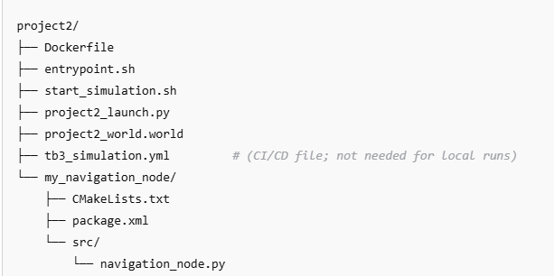
docker build -t tb3_sim .
From 1st terminal:
Option 1: One-line command
powershell
Copy
docker run --rm -it --name tb3_rviz -e DISPLAY=host.docker.internal:0 -e QT_QPA_PLATFORM=xcb tb3_sim rviz2
Option 2: Using PowerShell line continuation
docker run --rm -it `
--name tb3_rviz `
-e DISPLAY=host.docker.internal:0 `
-e QT_QPA_PLATFORM=xcb `
tb3_sim rviz2

From 2nd terminal:
docker exec -it tb3_rviz bash
source /opt/ros/humble/setup.bash
export DISPLAY=host.docker.internal:0
export QT_QPA_PLATFORM=xcb
rviz2 -l
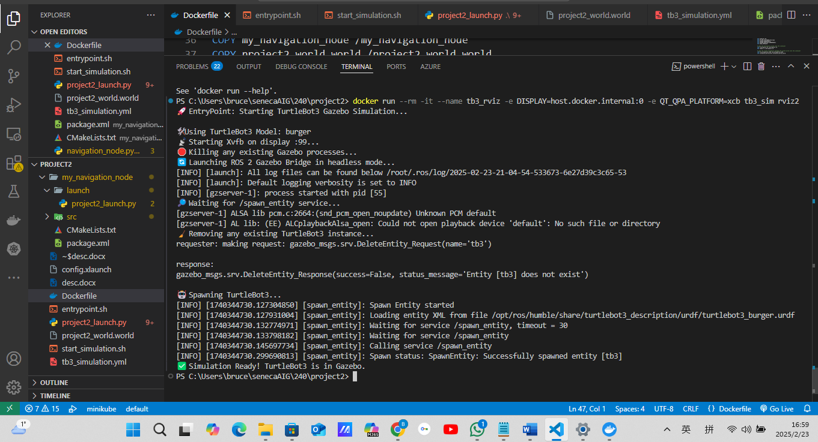
C:\Users\bruce\senecaAIG\240\project2> docker run --rm -it --name tb3_rviz -e DISPLAY=host.docker.internal:0 -e QT_QPA_PLATFORM=xcb tb3_sim rviz2 🚀 EntryPoint: Starting TurtleBot3 Gazebo Simulation... 🛠️ Using TurtleBot3 Model: burger 📡 Starting Xvfb on display :99... 🛑 Killing any existing Gazebo processes... 🔄 Launching ROS 2 Gazebo Bridge in headless mode... [INFO] [launch]: All log files can be found below /root/.ros/log/2025-02-23-21-04-54-533673-6e27d39c3c65-53 [INFO] [launch]: Default logging verbosity is set to INFO [INFO] [gzserver-1]: process started with pid [55] 🔎 Waiting for /spawn_entity service... [gzserver-1] ALSA lib pcm.c:2664:(snd_pcm_open_noupdate) Unknown PCM default [gzserver-1] AL lib: (EE) ALCplaybackAlsa_open: Could not open playback device 'default': No such file or directory 🧹 Removing any existing TurtleBot3 instance... requester: making request: gazebo_msgs.srv.DeleteEntity_Request(name='tb3') response: gazebo_msgs.srv.DeleteEntity_Response(success=False, status_message='Entity [tb3] does not exist')

To interact with a running container (e.g. to get a shell prompt) while the simulation is running, you can open a new shell session inside that container using the docker exec command. For example, open a new PowerShell or Ubuntu terminal and run:
docker exec -it tb3_rviz bash
This will give you an interactive bash shell inside the running container, allowing you to type commands, inspect processes, or troubleshoot without stopping the simulation.

Additional Tips
- Multiple Sessions:
You can have multiple interactive sessions in the same container simultaneously.
- Overriding the Entrypoint:
If you want the container to start with a shell instead of the simulation, you can override the entrypoint during container startup:
bash
Copy
docker run --rm -it --name tb3_rviz -e DISPLAY=host.docker.internal:0 -e QT_QPA_PLATFORM=xcb --entrypoint bash tb3_sim
This is useful if you want to experiment or troubleshoot before launching the simulation.
Using docker exec is the standard way to "attach" to a running container without interrupting its primary process. Let me know if you need any further help!

Maintenance:
list non-running container

ChatGPT said:
To list non-running (stopped) Docker containers, use the following command:
docker ps -a --filter "status=exited"

🔥 How to Free Up Space

1️⃣ Remove Unused Build Cache (2.6GB)
docker builder prune -a
- This will delete all intermediate build layers that are no longer needed.

2️⃣ Remove Unused Images (5.7GB)
Check if any of these images are unused (ACTIVE = 0 means no running containers). To remove all unused images:
docker image prune -a
Or, remove specific images:
sh
CopyEdit
docker rmi tb3_sim tangbr/project3_1212 tangbr/salary-pred

3️⃣ Remove Unused Volumes (1.187GB)
sh
CopyEdit
docker volume prune
- This will delete all unused Docker volumes.

4️⃣ Remove Everything Unused (Images, Containers, Build Cache, Volumes)
sh
CopyEdit
docker system prune -a --volumes
⚠️ Warning: This will delete all stopped containers, unused images, build cache, and unused volumes.

✅ Final Check
After cleanup, re-run:
sh
CopyEdit
docker system df
to verify how much space has been freed.
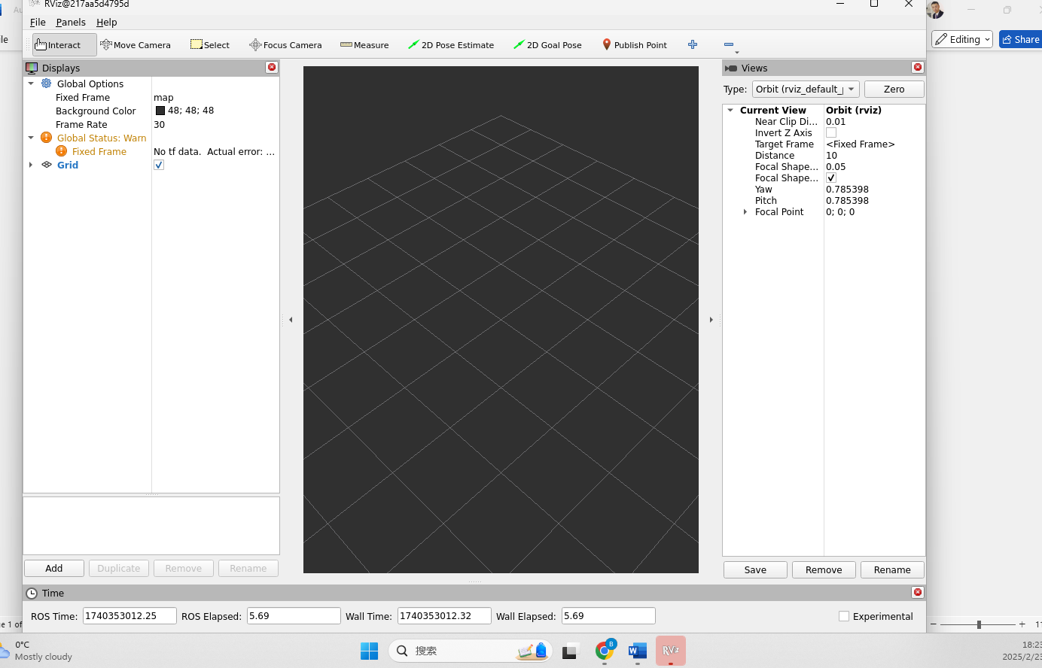
Below is a solution to keep visual persistent:
1.
docker run -it --name tb3_rviz --network host `
-e DISPLAY=host.docker.internal:0 `
-e QT_QPA_PLATFORM=xcb `
tb3_sim bash

2. From 2nd terminal:

docker exec -it tb3_rviz bash
source /opt/ros/humble/setup.bash
export DISPLAY=host.docker.internal:0
export QT_QPA_PLATFORM=xcb
rviz2 -l

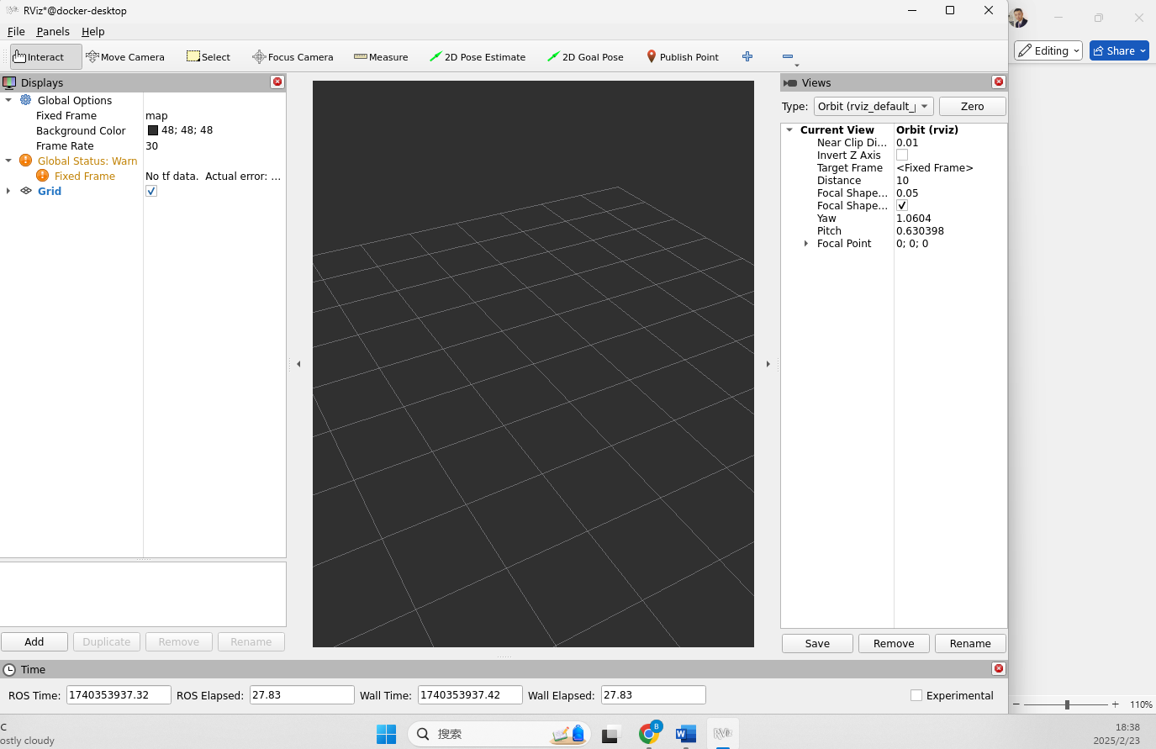
1. What command did you use to create a ROS 2 package?
To create a ROS 2 package, the user typically runs the ros2 pkg create command. However, the files are not explicitly shown that this command was used. From the CMakeLists.txt and package.xml, it seems that the package my_navigation_node was created manually or by following a standard package creation process. The package is configured to use ament_cmake for building, with dependencies like rclpy, geometry_msgs, std_msgs, and nav_msgs specified.
2. Explain why and how you used ROS messages in your program.
ROS messages are used to facilitate communication between nodes in a ROS-based system. In the case of the project2, geometry_msgs and nav_msgs are used for robot navigation, providing essential messages like Twist (for controlling robot movement) and NavSatFix (for navigation data). These messages are used to send data between different nodes, such as the navigation node controlling the robot's movement and other systems that need information like position or velocity.
3. How do you verify that your ROS 2 node is publishing messages correctly?
To verify that a ROS 2 node is publishing messages correctly, you can use the ros2 topic echo command to subscribe to the topic being published by the node. In this case, the node is likely publishing to a topic like /cmd_vel (used for robot velocity commands). For example:
ros2 topic echo /cmd_vel
This command shows the messages being published to that topic, allowing you to confirm if the node is publishing the correct data.
4. Describe the steps to launch Gazebo and your ROS 2 node simultaneously.
To launch Gazebo and the ROS 2 node simultaneously, the user can use a combination of Docker and a launch file. First, Gazebo is launched via a custom entry point (entrypoint.sh), which starts the simulation in headless mode. The steps in the entry point involve starting Xvfb for the virtual display and then launching Gazebo using ros2 launch with the gazebo_ros package. The ROS 2 node is then spawned using a launch file like project2_launch.py, which calls Gazebo to load the simulation environment and then spawns the TurtleBot3 model. The launch file or the custom script like start_simulation.sh runs the container and starts both Gazebo and the ROS 2 node inside the Docker container.
These steps ensure that both the simulation and the navigation node are running concurrently, allowing the user to interact with the robot in the Gazebo environment.

