Structure:
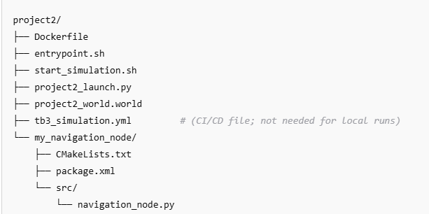
docker build -t tb3_sim .
From 1st terminal:
Option 1: One-line command
powershell
Copy
docker run --rm -it --name tb3_rviz -e DISPLAY=host.docker.internal:0 -e QT_QPA_PLATFORM=xcb tb3_sim rviz2
Option 2: Using PowerShell line continuation
docker run --rm -it `
--name tb3_rviz `
-e DISPLAY=host.docker.internal:0 `
-e QT_QPA_PLATFORM=xcb `
tb3_sim rviz2

From 2nd terminal:
docker exec -it tb3_rviz bash
source /opt/ros/humble/setup.bash
export DISPLAY=host.docker.internal:0
export QT_QPA_PLATFORM=xcb
rviz2 -l
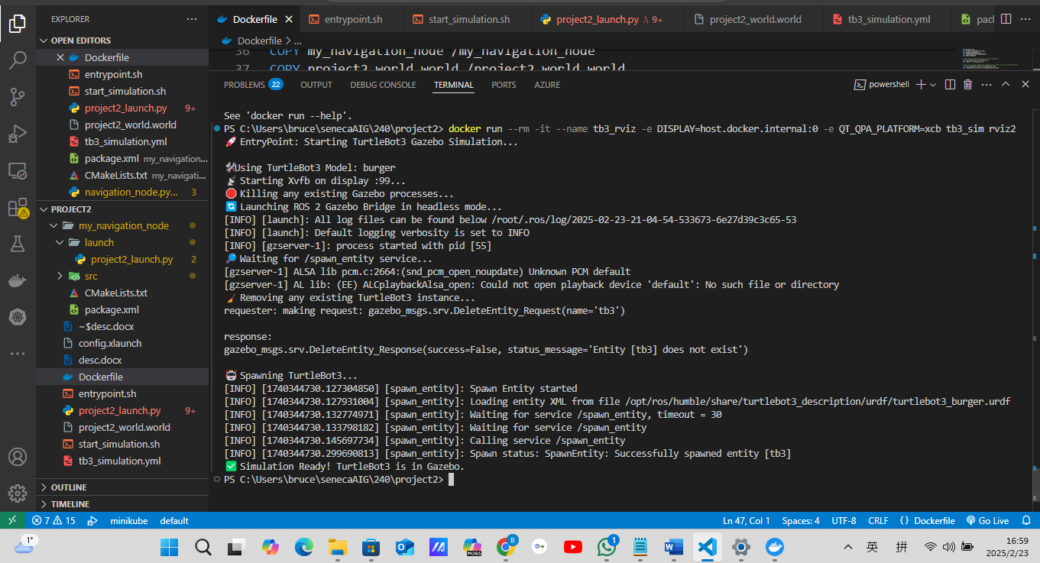
C:\Users\bruce\senecaAIG\240\project2> docker run --rm -it --name tb3_rviz -e DISPLAY=host.docker.internal:0 -e QT_QPA_PLATFORM=xcb tb3_sim rviz2 🚀 EntryPoint: Starting TurtleBot3 Gazebo Simulation... 🛠️ Using TurtleBot3 Model: burger 📡 Starting Xvfb on display :99... 🛑 Killing any existing Gazebo processes... 🔄 Launching ROS 2 Gazebo Bridge in headless mode... [INFO] [launch]: All log files can be found below /root/.ros/log/2025-02-23-21-04-54-533673-6e27d39c3c65-53 [INFO] [launch]: Default logging verbosity is set to INFO [INFO] [gzserver-1]: process started with pid [55] 🔎 Waiting for /spawn_entity service... [gzserver-1] ALSA lib pcm.c:2664:(snd_pcm_open_noupdate) Unknown PCM default [gzserver-1] AL lib: (EE) ALCplaybackAlsa_open: Could not open playback device 'default': No such file or directory 🧹 Removing any existing TurtleBot3 instance... requester: making request: gazebo_msgs.srv.DeleteEntity_Request(name='tb3') response: gazebo_msgs.srv.DeleteEntity_Response(success=False, status_message='Entity [tb3] does not exist')

To interact with a running container (e.g. to get a shell prompt) while the simulation is running, you can open a new shell session inside that container using the docker exec command. For example, open a new PowerShell or Ubuntu terminal and run:
docker exec -it tb3_rviz bash
This will give you an interactive bash shell inside the running container, allowing you to type commands, inspect processes, or troubleshoot without stopping the simulation.

Additional Tips
- Multiple Sessions:
You can have multiple interactive sessions in the same container simultaneously.
- Overriding the Entrypoint:
If you want the container to start with a shell instead of the simulation, you can override the entrypoint during container startup:
bash
Copy
docker run --rm -it --name tb3_rviz -e DISPLAY=host.docker.internal:0 -e QT_QPA_PLATFORM=xcb --entrypoint bash tb3_sim
This is useful if you want to experiment or troubleshoot before launching the simulation.
Using docker exec is the standard way to "attach" to a running container without interrupting its primary process. Let me know if you need any further help!

Maintenance:
list non-running container

ChatGPT said:
To list non-running (stopped) Docker containers, use the following command:
docker ps -a --filter "status=exited"

🔥 How to Free Up Space

1️⃣ Remove Unused Build Cache (2.6GB)
docker builder prune -a
- This will delete all intermediate build layers that are no longer needed.

2️⃣ Remove Unused Images (5.7GB)
Check if any of these images are unused (ACTIVE = 0 means no running containers). To remove all unused images:
docker image prune -a
Or, remove specific images:
sh
CopyEdit
docker rmi tb3_sim tangbr/project3_1212 tangbr/salary-pred

3️⃣ Remove Unused Volumes (1.187GB)
sh
CopyEdit
docker volume prune
- This will delete all unused Docker volumes.

4️⃣ Remove Everything Unused (Images, Containers, Build Cache, Volumes)
sh
CopyEdit
docker system prune -a --volumes
⚠️ Warning: This will delete all stopped containers, unused images, build cache, and unused volumes.

✅ Final Check
After cleanup, re-run:
sh
CopyEdit
docker system df
to verify how much space has been freed.
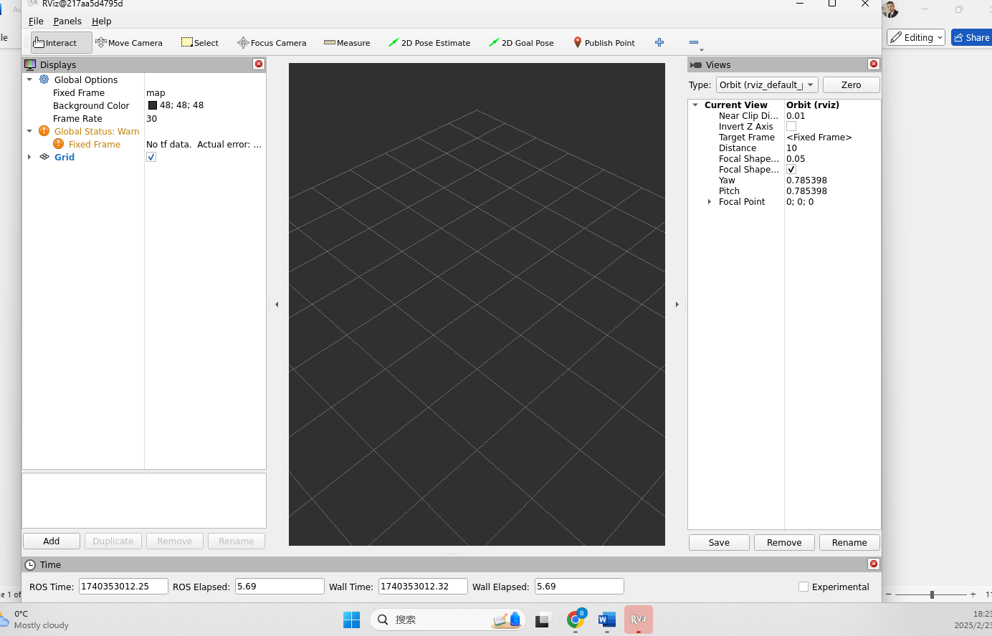
Below is a solution to keep visual persistent:
1.
docker run -it --name tb3_rviz --network host `
-e DISPLAY=host.docker.internal:0 `
-e QT_QPA_PLATFORM=xcb `
tb3_sim bash

2. From 2nd terminal:

docker exec -it tb3_rviz bash
source /opt/ros/humble/setup.bash
export DISPLAY=host.docker.internal:0
export QT_QPA_PLATFORM=xcb
rviz2 -l

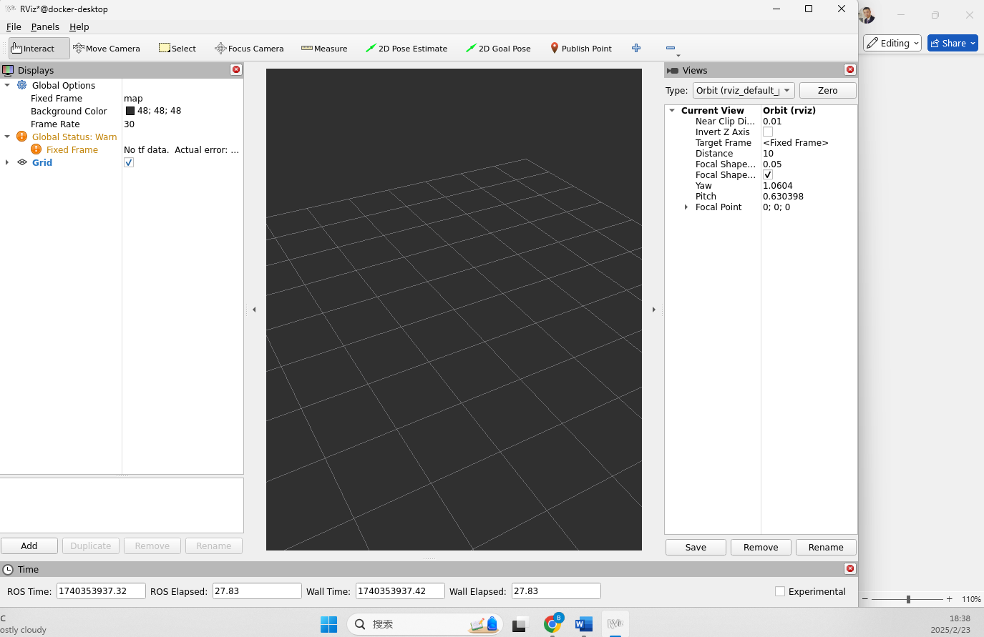

1. How did you create the custom room environment in Gazebo?
To create the custom room environment in Gazebo, I started by designing the world with walls and a floor. I created a custom .world file for Gazebo, which describes the layout. In this case, I used SDF (Simulation Description Format) to add models like walls, a ground plane, and the Sun. I added four walls to form a room, and the project2_world.world file includes all the specifications for the room's dimensions and positioning. Then, I just loaded that world in Gazebo and launched it alongside the robot!

2. Describe the process of setting up the ROS 2 workspace and creating the package.
Setting up the ROS 2 workspace was pretty straightforward. I created a workspace using the colcon build tool and then created a package within it using the ROS 2 CLI. I specified the package name and dependencies, like rclpy, geometry_msgs, and nav_msgs, and then set up the basic structure of the package with a CMakeLists.txt and package.xml. This package included the ROS 2 node that handles navigation logic for the robot.

3. How did you implement the navigation strategy in your node?
For the navigation strategy, I used ROS 2 to control the robot’s movement. In my ROS node, I created a publisher for the /cmd_vel topic (the velocity command topic) using the Twist message type, which controls linear and angular velocities. I then programmed the node to publish movement commands at regular intervals to move the robot forward, and I used the timer to stop it after a certain time. The logic of the node was based on continuously publishing motion commands to navigate within the environment.

4. What challenges did you face with making the robot move diagonally, and how did you overcome them?
Making the robot move diagonally was tricky because I needed to control both the linear and angular velocities simultaneously. The challenge was getting the right balance between the linear.x (forward) and angular.z (rotation) velocities so that the robot would move diagonally instead of just turning or going straight. I adjusted the velocities by tuning them to find the right combination and then tested them in the simulation. Once I found the right values, the robot could move diagonally like I wanted!

5. How do you verify that your ROS 2 node is functioning correctly?
To verify that my ROS 2 node was working properly, I used a couple of methods. First, I checked if the node was successfully publishing messages by running ros2 topic echo /cmd_vel to see if it was sending velocity commands. I also used ros2 topic list to confirm that the node was active and publishing to the correct topics. Finally, I monitored the robot’s movement in Gazebo to make sure it was following the commands, like moving in the right direction or stopping after the set time. If everything looked good in the simulation, I knew the node was functioning as expected!

