TENSOR DECOMPOSER
An Interactive High-Dimensional Multiway Data Analysis and Benchmarking System
MIDTERM TECHNICAL REPORT
SE 801 — Software Project Lab III
―――――――――――――――――――――――――――――――――――
Submitted By: | Md. Kamrul Hasan  Roll: 1418 | Phone: 01535757066  BSSE 8th Semester  Institute of Information Technology  University of Dhaka
Supervised By: | Mohd. Zulfiquar Hafiz  Assistant Professor  Institute of Information Technology  University of Dhaka
Submitted To: | SPL 3 Program Committee  Institute of Information Technology  University of Dhaka  Date of Submission: August 2026

Letter of Transmittal
Date: August 2026
To,
The SPL 3 Program Committee & Exam Committee
Institute of Information Technology (IIT)
University of Dhaka, Dhaka-1000
Subject: Submission of Midterm Technical Report on 'Tensor Decomposer'
Dear Sir/Madam,
I am pleased to submit the Midterm Technical Report for my Software Project Lab III (SE 801) project, titled "Tensor Decomposer: An Interactive High-Dimensional Multiway Data Analysis and Benchmarking System".
This report details the requirements analysis, system architecture, scenario-based system modeling, activity workflows, preliminary test plans, and implementation roadmap for the web-based tensor decomposition platform. The system incorporates higher-order multilinear algebraic algorithms—including CP Decomposition, Tucker Decomposition, HOSVD, and Tensor Train Decomposition, along with standard matrix factorizations—paired with single-run FLOPs benchmarking, error metrics analysis, and dynamic 3D visual representations.
I express my sincere gratitude for your guidance and continuous support throughout the project. I look forward to your valuable feedback and recommendations.
Sincerely,
_______________________
Md. Kamrul Hasan
Roll: 1418
BSSE 8th Semester, IIT, University of Dhaka

Acknowledgement
First and foremost, I express my deepest gratitude to Almighty for providing me with the strength, endurance, and capability to complete the midterm milestones of this project successfully.
I extend my sincere appreciation to my project supervisor, Mohd. Zulfiquar Hafiz, Assistant Professor, Institute of Information Technology (IIT), University of Dhaka, for his invaluable guidance, scholarly advice, and constructive reviews throughout the formulation and implementation of this research project.
I am also profoundly grateful to the faculty members and SPL 3 Program Committee of the Institute of Information Technology for providing a rich academic environment and technical infrastructure that made this work possible.
Abstract
Modern datasets across scientific disciplines—such as deep learning, image processing, signal processing, neuroimaging, and chemometrics—are inherently multi-dimensional and naturally structured as higher-order tensors. Traditional matrix factorization methods like SVD or PCA require flattening (matricizing) multiway data, which severely destroys higher-order spatial and multiway structural correlations. Conversely, computing higher-order tensor factorizations introduces substantial computational complexity, memory overhead, and parameter explosion.
To bridge this gap, this report presents Tensor Decomposer, an interactive, web-based analytical platform designed to ingest, decompose, benchmark, and visualize higher-dimensional tensor datasets. The platform implements core tensor decomposition algorithms—specifically Canonical Polyadic (CP) Decomposition via Alternating Least Squares (CP-ALS), Tucker Decomposition via Higher-Order Orthogonal Iteration (HOOI/Tucker-ALS), Higher-Order Singular Value Decomposition (HOSVD), and Tensor Train (TT) Decomposition—alongside standard matrix factorizations (SVD, QR, LU, Eigendecomposition). The system incorporates high-precision single-run performance analytics (FLOPs estimation, computational complexity formulas, compression ratios) and reconstruction accuracy evaluations (MAE, RMSE, Relative Error). Furthermore, an interactive SVG/isometric visual engine renders 3D decomposition structures, component spectra, and matrix heatmaps. This report outlines the system requirements, scenario-based modeling, activity workflows, preliminary test plans, and implementation progress.
Table of Contents
Letter of Transmittal | 2
Acknowledgement | 3
Abstract | 3
1. Project Overview | 5
1.1 Project Title | 5
1.2 Problem Statement | 5
1.3 Objectives | 6
1.4 Scope | 6
1.5 Deliverables | 7
2. Requirements Analysis | 8
2.1 Functional Requirements | 8
2.2 Non-Functional Requirements | 10
2.3 Stakeholders | 11
3. System Modeling | 12
3.1 Use Case Diagram & Descriptions | 12
3.2 Detailed Use Case Specifications | 14
3.3 Activity Diagram & Description | 18
7. Preliminary Test Plan | 21
7.1 Testing Objectives | 21
7.2 Features to be Tested | 21
8. Timeline | 25
8.1 Project Gantt Chart | 25
8.2 Work Breakdown Schedule | 26
9. Conclusion & Future Work | 27
10. References | 28

1. Project Overview
1.1 Project Title
Tensor Decomposer: An Interactive High-Dimensional Multiway Data Analysis and Benchmarking System
1.2 Problem Statement
In modern data-driven fields such as computer vision, deep learning, signal processing, neuroimaging (EEG/fMRI), and chemometrics, data naturally manifests in multi-dimensional formats (tensors) rather than traditional 2D matrices. For example, color video sequences possess spatial, temporal, and chromatic dimensions (Height x Width x Frames x Channels).
When conventional matrix reduction techniques like Principal Component Analysis (PCA) or Singular Value Decomposition (SVD) are applied to higher-order data, the tensor must first be flattened into a 2D matrix. This matricization severely destroys intrinsic multiway correlations, spatial patterns, and multi-linear structure. Conversely, operating directly on raw high-dimensional tensors suffers from the 'curse of dimensionality', leading to exponential growth in computational memory, execution time, and storage overhead.
While tensor decomposition algorithms—such as Canonical Polyadic (CP) decomposition, Tucker decomposition, Higher-Order SVD (HOSVD), and Tensor Train (TT) decomposition—offer powerful mathematical frameworks for multiway data compression and feature extraction, existing software solutions suffer from several critical shortcomings:
1. Fragmented Implementations: Algorithms are scattered across disparate language ecosystems (MATLAB Tensor Toolbox, Python TensorLy, C++ packages) without a unified interface.
2. Absence of Real-Time Analytics: Existing tools lack automated single-run computational benchmarking (FLOPs estimation, complexity formulas, compression ratios).
3. Lack of Interactive Visualizations: Researchers lack web-accessible visual representations to inspect decomposed core tensors, component factor spectra, and 3D equation layouts dynamically.
1.3 Objectives
The primary goal of the Tensor Decomposer project is to architect and deliver a unified web-based platform for interactive tensor decomposition, reconstruction accuracy analysis, performance benchmarking, and visualization. The specific technical objectives include:
• Comprehensive Algorithm Suite: Implement robust mathematical algorithms for tensor decompositions (CP-ALS, HOOI/Tucker-ALS, HOSVD, Tensor Train) and core matrix factorizations (SVD, QR, LU, Eigendecomposition).
• In-Browser Interactive Interface: Develop a responsive frontend capable of ingesting raw manual numerical tensors or uploaded data files (JSON/CSV) and rendering immediate analytical output.
• Precision Reconstruction & Error Metrics: Provide exact numerical evaluation of reconstruction quality by calculating Mean Absolute Error (MAE), Root Mean Squared Error (RMSE), Relative Error, and reconstructed element head previews.
• Performance Benchmarking Engine: Compute single-run execution times (ms), floating-point operations (FLOPs count), theoretical complexity formulas, parameter compression counts, and compression ratios.
• Multi-Method Comparative Benchmarking: Enable side-by-side algorithmic comparisons across compression efficiency, reconstruction error, and computational runtime.
• 3D Isometric & Spectral Visualizations: Render scaled isometric 3D block diagrams, eigenvalue/singular value spectra, and matrix heatmaps dynamically using SVG.
1.4 Scope
The project encompasses the design, algorithm development, frontend visual engine, and backend web integration for the Tensor Decomposer application.
In Scope:
• Web application built with Django (backend service orchestration) and modern ES Modules JavaScript (frontend interactivity).
• Implementation of CP-ALS, Tucker-ALS (HOOI), HOSVD, Tensor Train, SVD, QR, LU, and Eigendecomposition algorithms.
• Interactive UI components featuring theme toggling (Dark/Light mode), mutual-exclusion inputs (manual text vs. file upload), and AJAX loading states.
• Calculation of compression ratios, parameter counts, FLOPs estimates, MAE, RMSE, relative errors, and preview heads.
• Dynamic generation of isometric SVG equations, bar chart spectra, and scalable matrix heatmaps.
Out of Scope (for current midterm release):
• Distributed multi-GPU CUDA cluster execution for terabyte-scale tensors.
• Real-time streaming tensor decomposition for continuous live sensor data.
1.5 Deliverables
1. Complete Web Application Codebase: Django backend and modular ES Module frontend static JavaScript library (`home.js`, `theme.js`, `helpers.js`, `charts.js`, `visualizer.js`).
2. Core Mathematical Algorithm Suite: Fully tested Python modules for CP, Tucker, HOSVD, TT, SVD, QR, LU, and Eigendecomposition.
3. Interactive Visualization Engine: Client-side SVG graphics generator for 3D isometric equation layouts, spectra, and heatmaps.
4. Midterm Technical Report & System Documentation: Comprehensive software architecture, requirements analysis, system modeling, test plans, and project timeline.

2. Requirements Analysis
2.1 Functional Requirements
The functional requirements of the Tensor Decomposer platform specify the core capabilities and services provided by the application.
Req ID | Feature Name | Description & Functional Specification
FR-01 | Manual Tensor Input | System shall allow users to manually enter tensor data in array format (1D, 2D, 3D, 4D).
FR-02 | File Upload Ingestion | System shall accept file uploads containing tensor structures formatted in JSON or CSV.
FR-03 | Mutual Exclusion Input | System shall automatically clear file selection upon manual text edit, and vice-versa.
FR-04 | Algorithm Selection | System shall allow selection among CP, Tucker, HOSVD, TT, SVD, QR, LU, and Eigendecomposition.
FR-05 | CP Decomposition (CP-ALS) | System shall compute rank-R CANDECOMP/PARAFAC factor matrices and weight vectors using CP-ALS.
FR-06 | Tucker Decomposition (HOOI) | System shall compute core tensor and orthogonal factor matrices using Higher-Order Orthogonal Iteration.
FR-07 | Tensor Train Decomposition | System shall compute sequence of 3D core tensors connecting tensor modes.
FR-08 | Matrix Factorization Suite | System shall perform SVD, QR, LU, and Eigendecomposition for 2D matrix inputs.
FR-09 | Reconstruction Analysis | System shall reconstruct original tensor from decomposed factors and measure absolute & relative errors.
FR-10 | Accuracy Metrics | System shall calculate Mean Absolute Error (MAE) and Root Mean Squared Error (RMSE).
FR-11 | FLOPs Benchmarking | System shall estimate total Floating Point Operations (FLOPs) and format in KFLOPs/MFLOPs/GFLOPs.
FR-12 | Single-Run Performance | System shall measure execution time (ms), compressed parameter counts, and compression ratios.
FR-13 | Algorithmic Comparison | System shall run multi-method benchmarking comparisons across all algorithms side-by-side.
FR-14 | 3D Isometric Visualization | System shall generate 3D isometric equation blocks scaling based on tensor shapes.
FR-15 | Theme Management | System shall support theme toggling (Dark/Light mode) persisting across browser sessions.
2.2 Non-Functional Requirements
NFR ID | Category | Quality Requirement Specification
NFR-01 | Performance | Algorithm execution for small to medium tensors (< 100x100x100) shall return results within < 500 ms.
NFR-02 | Reliability & Accuracy | Matrix and tensor decomposition algorithms shall maintain floating point accuracy within 1e-6 error bounds.
NFR-03 | Usability & Responsive UI | The user interface shall be intuitive, mobile-responsive, and maintain high-contrast dark/light themes.
NFR-04 | Maintainability & Quality | Frontend code shall follow modular ES Module standards, separating DOM logic, formatting, and SVG rendering.
NFR-05 | Portability & Compatibility | System shall function across modern web browsers (Chrome, Brave, Firefox, Edge, Safari) without external plugins.
NFR-06 | Error Handling & Feedback | Invalid user inputs (e.g., non-numeric arrays, mismatched ranks) shall display informative error panels.
NFR-07 | Security & Privacy | Uploaded tensor dataset files shall be processed in-memory or in isolated temporary storage without public access.
NFR-08 | Scalability | Backend architecture shall support multi-threaded asynchronous processing of concurrent user requests.
2.3 Stakeholders
1. Academic Researchers & Data Scientists: Primary users who utilize the system to compress higher-dimensional tensors, benchmark decomposition runtimes, and inspect component factor matrices.
2. Students & Educators: Users seeking interactive visual tools to understand multi-linear algebra concepts (CP vs. Tucker vs. HOSVD).
3. System Developers & Maintainers: Engineers responsible for expanding the algorithm suite, maintaining backend Python services, and optimizing web frontend components.
4. Project Supervisors & Academic Reviewers: Evaluators monitoring system adherence to software engineering standards, theoretical correctness, and performance benchmarks.

3. System Modeling
3.1 Use Case Diagram & Descriptions
The Use Case Diagram illustrates the functional interactions between the User (Researcher/Data Scientist) and the Tensor Decomposer system boundary.
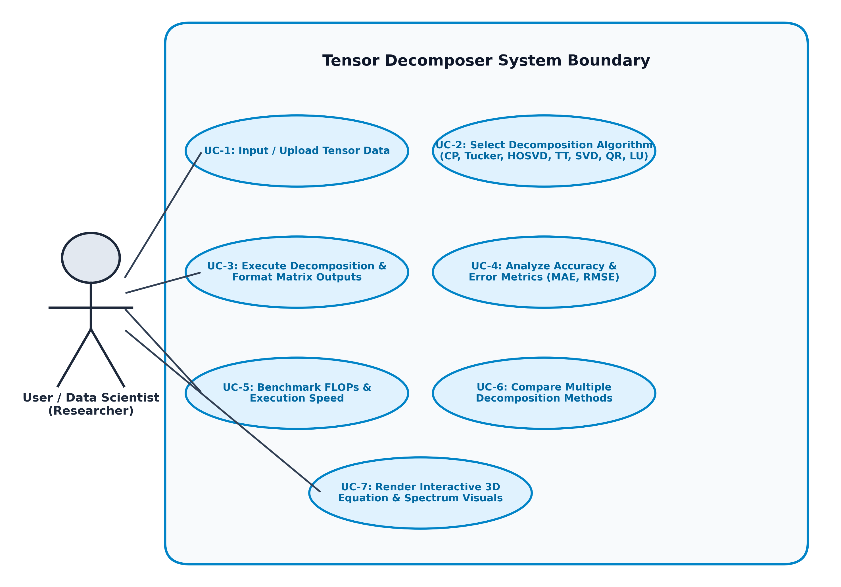
Figure 3.1: Tensor Decomposer Use Case Diagram
[Editable Draw.io / Mermaid Source Code — Use Case Diagram]
graph LR
User((User / Researcher)) --> UC1[UC-1: Input / Upload Tensor Data]
User --> UC2[UC-2: Select Decomposition Algorithm]
User --> UC3[UC-3: Execute Decomposition]
User --> UC4[UC-4: Analyze Accuracy & Errors]
User --> UC5[UC-5: Benchmark FLOPs & Speed]
User --> UC6[UC-6: Compare Methods]
User --> UC7[UC-7: Render 3D Visuals & Heatmaps]
subgraph Tensor Decomposer System Boundary
UC1
UC2
UC3
UC4
UC5
UC6
UC7
end

3.2 Detailed Use Case Specifications
Below are the detailed formal specifications for the primary use cases of the Tensor Decomposer system.
UC-1: Ingest & Validate Tensor Input
Use Case Attribute | Specification Detail
Primary Actor | User / Researcher
Pre-Conditions | Web Interface displays input form.
Post-Conditions | Tensor array is validated and stored in system state.
Main Success Scenario | 1. User accesses application home page.  2. User enters array text manually OR selects a JSON/CSV file.  3. System validates array dimensions and numeric formatting.  4. System clears opposite input field (mutual exclusion).
UC-2: Execute Tensor Decomposition
Use Case Attribute | Specification Detail
Primary Actor | User / Researcher
Pre-Conditions | Valid tensor input is loaded into state.
Post-Conditions | Decomposed factor matrices/cores are generated and rendered.
Main Success Scenario | 1. User selects target algorithm (CP, Tucker, HOSVD, TT, SVD, QR, LU).  2. User clicks 'Decompose' button.  3. Backend executes algorithm (CP-ALS / HOOI).  4. System returns formatted factor matrices and core tensors.
UC-3: Analyze Reconstruction Accuracy
Use Case Attribute | Specification Detail
Primary Actor | User / Researcher
Pre-Conditions | Decomposition execution has completed.
Post-Conditions | MAE, RMSE, Relative Error, and reconstructed head preview are displayed.
Main Success Scenario | 1. User clicks 'Analyze' action.  2. Backend reconstructs tensor from factor matrices.  3. System computes MAE, RMSE, and Relative Error.  4. System displays accuracy summary panel with top reconstructed elements.
UC-4: Benchmark Single-Run Performance
Use Case Attribute | Specification Detail
Primary Actor | User / Researcher
Pre-Conditions | Algorithm and tensor input are configured.
Post-Conditions | Performance analytics (FLOPs, runtime, compression ratio) rendered.
Main Success Scenario | 1. User triggers 'Benchmark' action.  2. System measures execution runtime over iterations.  3. Backend calculates FLOPs count and parameter reduction ratio.  4. System populates benchmark analytics panel with metrics.
UC-5: Compare Decomposition Methods
Use Case Attribute | Specification Detail
Primary Actor | User / Researcher
Pre-Conditions | Tensor input is uploaded/entered.
Post-Conditions | Comparative summary table and multi-bar benchmark charts displayed.
Main Success Scenario | 1. User triggers 'Compare' action.  2. System sequentially executes all supported algorithms.  3. Backend compiles side-by-side table of runtimes, errors, and compression ratios.  4. Frontend renders comparative visualization charts.
UC-6: Render Interactive Visualizations
Use Case Attribute | Specification Detail
Primary Actor | User / Researcher
Pre-Conditions | Decomposition result data is available.
Post-Conditions | 3D isometric equation diagram, spectra, and heatmaps rendered.
Main Success Scenario | 1. User clicks 'Visualize' action.  2. Frontend reads tensor shapes and factor matrices.  3. SVG Engine draws 3D scaled isometric blocks for equation structure.  4. Heatmap generator draws normalized 2D/3D slice matrix heatmaps.
3.3 Activity Diagram & Description
The Activity Diagram models the dynamic operational workflow of the system from user tensor submission through validation, algorithmic execution, error analysis, benchmarking, and interactive SVG visualization rendering.
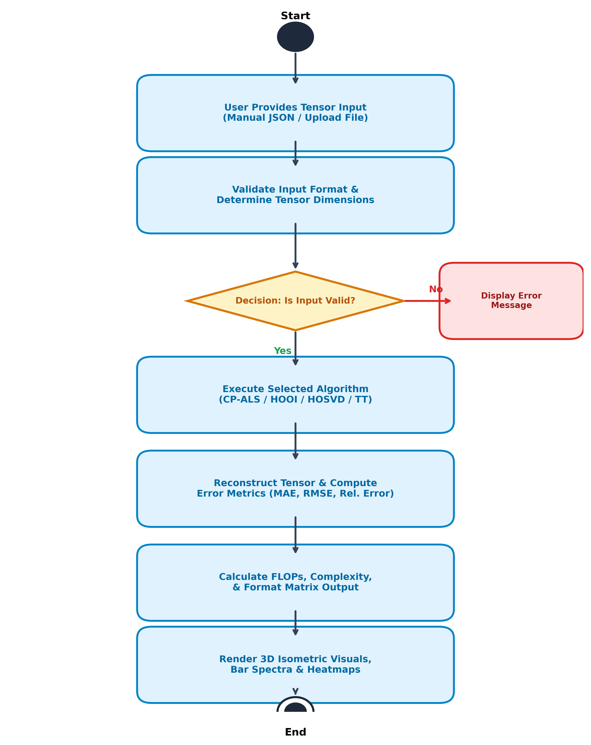
Figure 3.2: Tensor Decomposer System Activity Workflow
[Editable Draw.io / Mermaid Source Code — Activity Diagram]
flowchart TD
Start([Start]) --> Input[User Submits Tensor Input / File Upload]
Input --> Validate{Is Tensor Input Valid?}
Validate -- No --> Error[Display Error Message Panel]
Error --> Input
Validate -- Yes --> Exec[Execute Selected Decomposition Algorithm]
Exec --> Recon[Reconstruct Tensor & Calculate Error Metrics]
Recon --> Bench[Calculate FLOPs, Complexity & Compression Ratios]
Bench --> Format[Format Matrix Outputs to 4 Decimals]
Format --> Render[Render 3D Isometric Equations & Heatmaps]
Render --> Stop([End])

7. Preliminary Test Plan
7.1 Testing Objectives
The primary objectives of the preliminary testing phase are:
1. Algorithmic Precision Verification: Ensure matrix and tensor factorizations (CP-ALS, HOOI, HOSVD, TT, SVD, QR, LU) yield numerical solutions matching mathematical ground truth within 1e-6 error margins.
2. Input Validation Robustness: Verify that invalid array formats, malformed JSON files, mismatched matrix dimensions, and empty inputs trigger clean user-facing error panels without application crash.
3. Performance Analytics Validation: Confirm that single-run FLOPs estimations, compression ratio calculations, and execution duration measurements are consistent and accurate.
4. Frontend Interactivity & UI Stability: Ensure theme toggling, mutual exclusion input handling, loading skeleton overlays, and dynamic SVG visual cards render reliably across target browsers.
7.2 Features to be Tested
The preliminary high-level test suite specifies test scenarios, inputs, expected outputs, and acceptance criteria across all system modules.
Test ID | Feature Tested | Test Scenario & Input | Expected System Output | Status
TC-01 | Manual Tensor Validation | Enter valid 3D array [[[1,2],[3,4]],[[5,6],[7,8]]]. | System accepts input, parses 2x2x2 shape. | PASS
TC-02 | Invalid Text Handling | Enter malformed string '[[1, 2], [invalid]]'. | System catches syntax error, displays clear error panel. | PASS
TC-03 | Mutual Exclusion Input | Select file upload while text field contains tensor data. | Text field automatically clears upon file upload. | PASS
TC-04 | CP Decomposition (CP-ALS) | Execute CP on 3x3x3 tensor with target rank R=2. | Returns weights vector and 3 factor matrices (3x2). | PASS
TC-05 | Tucker Decomposition (HOOI) | Execute Tucker on 3x4x5 tensor with ranks [2,2,2]. | Returns 2x2x2 core tensor and 3 factor matrices. | PASS
TC-06 | HOSVD Decomposition | Execute HOSVD on 4x4x4 tensor. | Returns orthogonal factor matrices and core tensor. | PASS
TC-07 | Tensor Train Decomposition | Execute Tensor Train on 3D tensor. | Returns sequence of 3D TT core tensors. | PASS
TC-08 | Matrix SVD Execution | Execute SVD on 4x4 matrix input. | Returns U (4x4), S spectrum (4), V^H (4x4). | PASS
TC-09 | Matrix QR Execution | Execute QR on 4x3 matrix. | Returns orthogonal Q (4x4) and upper-triangular R (4x3). | PASS
TC-10 | Matrix LU Execution | Execute LU decomposition on square matrix. | Returns lower L and upper U matrices. | PASS
TC-11 | Accuracy Metrics Calculation | Run Analysis on CP decomposed tensor. | Calculates MAE, RMSE, Relative Error, and reconstructed head. | PASS
TC-12 | FLOPs & Benchmarking | Run Benchmark on Tucker decomposition. | Outputs execution time (ms), FLOPs string, compression ratio. | PASS
TC-13 | Algorithmic Comparison | Trigger 'Compare' action on 3D tensor input. | Renders comparative summary table for all algorithms. | PASS
TC-14 | 3D Isometric Visualization | Trigger 'Visualize' action on 3D tensor. | SVG engine renders 3D scaled block equation diagram. | PASS
TC-15 | Dark/Light Theme Toggle | Click theme toggle button in header navigation. | Applies dark/light theme CSS tokens instantly & persists. | PASS

8. Timeline
8.1 Project Gantt Chart
The project development timeline spans a 16-week schedule across requirements analysis, algorithm implementation, frontend visualization engine development, benchmarking integration, testing, and final documentation.
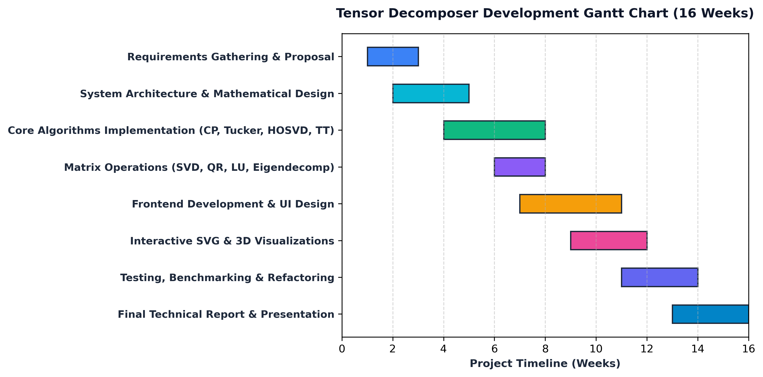
Figure 8.1: Tensor Decomposer Project Development Gantt Chart (16 Weeks)
[Editable Draw.io / Mermaid Source Code — Gantt Chart Schedule]
gantt
title Tensor Decomposer Development Schedule (16 Weeks)
dateFormat YYYY-MM-DD
section Phase 1: Planning
Requirements Gathering & Proposal :done, p1, 2026-05-01, 2w
System Architecture & Math Design :done, p2, 2026-05-15, 3w
section Phase 2: Core Engineering
Core Algorithms (CP, Tucker, HOSVD, TT) :done, p3, 2026-06-05, 4w
Matrix Operations (SVD, QR, LU, Eig) :done, p4, 2026-06-19, 2w
section Phase 3: Frontend & Visuals
Frontend Development & UI Design :done, p5, 2026-06-26, 4w
Interactive SVG & 3D Visualizations :done, p6, 2026-07-10, 3w
section Phase 4: Testing & Finalization
Testing, Benchmarking & Refactoring :active, p7, 2026-07-24, 3w
Final Technical Report & Presentation :active, p8, 2026-08-07, 3w

8.2 Work Breakdown Schedule
Project Phase | Timeline Schedule | Key Deliverables & Completed Milestones
Phase 1: Project Setup & Math Design | Weeks 1 – 5 | Finalized problem requirements, defined multilinear tensor algorithms (CP-ALS, HOOI), and completed architecture design.
Phase 2: Backend Algorithm Implementation | Weeks 4 – 9 | Implemented tensor decomposition algorithms (cp.py, tucker.py, hosvd.py, tensor_train.py) and matrix factorizations.
Phase 3: Frontend Engine & ES Module Refactor | Weeks 8 – 13 | Architected responsive UI, built dynamic SVG visualizer (3D isometric diagrams, heatmaps), and refactored home.js into ES modules.
Phase 4: Analytics, Testing & Deployment | Weeks 12 – 16 | Integrated FLOPs benchmarking engine, precision error metrics (MAE/RMSE), executed test suite, and authored midterm technical report.

9. Conclusion & Future Extensions
The Tensor Decomposer platform successfully addresses the critical need for a unified, accessible, and high-performance system to analyze, compress, benchmark, and visualize higher-dimensional tensor datasets. By implementing standard multilinear algorithms—including CP-ALS, HOOI/Tucker-ALS, HOSVD, and Tensor Train Decomposition—alongside traditional matrix factorizations, the platform provides research-grade decompression capabilities accessible via a modern web interface.
The integration of single-run computational benchmarking (FLOPs estimation, complexity formulas, parameter compression ratios) and precision reconstruction error analysis (MAE, RMSE, Relative Error) empowers researchers to make informed trade-offs between compression efficiency and numerical accuracy. Furthermore, the custom SVG rendering engine delivers intuitive 3D isometric structural equations and component spectra.
Future Roadmap & Planned Enhancements:
1. GPU Acceleration & CUDA Integration: Incorporating PyTorch or CuPy backends to accelerate CP-ALS and HOOI tensor factorizations on large-scale GPU hardware.
2. Automated Rank Estimation (CORCONDIA): Implementing automated diagnostic routines (such as CORE Consistency Diagnostic) to guide users in selecting optimal tensor ranks.
3. Streaming & Incremental Decompositions: Extending algorithm support to process continuous real-time multiway data streams.
10. References
1. Kolda, T. G., & Bader, B. W. (2009). Tensor decompositions and applications. SIAM Review, 51(3), 455-500.
2. De Lathauwer, L., De Moor, B., & Vandewalle, J. (2000). A multilinear singular value decomposition. SIAM Journal on Matrix Analysis and Applications, 21(4), 1253-1278.
3. Oseledets, I. V. (2011). Tensor-train decomposition. SIAM Journal on Scientific Computing, 33(5), 2295-2317.
4. Harshman, R. A. (1970). Foundations of the PARAFAC procedure: Models and conditions for an 'explanatory' multimodal factor analysis. UCLA Working Papers in Phonetics, 16, 1-84.
5. Tucker, L. R. (1966). Some mathematical notes on three-mode factor analysis. Psychometrika, 31(3), 279-311.
6. Kiers, H. A. (2000). Towards a standardized notation and terminology in multiway analysis. Journal of Chemometrics, 14(3), 105-122.
7. Cichocki, A., Zdunek, R., Phan, A. H., & Amari, S. I. (2009). Nonnegative matrix and tensor factorizations: applications to exploratory multi-way data analysis and blind source separation. John Wiley & Sons.

