TENSOR DECOMPOSER
An Interactive High-Dimensional Multiway Data Analysis and Benchmarking System

FINAL TECHNICAL REPORT
SE 801 — Software Project Lab III

Submitted By: Md. Kamrul Hasan
Roll: 1418 | Phone: 01535757066
Programme: BSSE 8th Semester
Institute: Institute of Information Technology (IIT), University of Dhaka
Supervised By: Mohd. Zulfiquar Hafiz, Assistant Professor, IIT, University of Dhaka
Submitted To: SPL 3 Program Committee, IIT, University of Dhaka
Live Application: https://td4.vercel.app
Source Code: https://github.com/141Kamrul/Tensor-Decomposer
Date of Submission: October 2026

Letter of Transmittal
Date: October 2026

To,
The SPL 3 Program Committee & Exam Committee
Institute of Information Technology (IIT)
University of Dhaka, Dhaka-1000

Subject: Final Technical Report Submission on 'Tensor Decomposer'

Dear Sir/Madam,
I am pleased to submit the Final Technical Report for my Software Project Lab III (SE 801) project, titled "Tensor Decomposer: An Interactive High-Dimensional Multiway Data Analysis and Benchmarking System."
This report comprehensively documents the completed system: its requirements, architecture, algorithms, PuzzleTensor preprocessing integration, the standalone tensordecomp Python library, testing outcomes, cloud deployment on Vercel, and real-world validation on a rainfall forecasting dataset. The system has been fully implemented and is publicly accessible at https://td4.vercel.app.
I sincerely thank my supervisor for continued guidance and the SPL 3 committee for their support. I look forward to your evaluation and valuable feedback.
Sincerely,

_______________________
Md. Kamrul Hasan
Roll: 1418, BSSE 8th Semester, IIT, University of Dhaka

Acknowledgement
First and foremost, I express my deepest gratitude to Almighty for providing me the strength, endurance, and capability to complete this project successfully.
I extend my sincere appreciation to my project supervisor, Mohd. Zulfiquar Hafiz, Assistant Professor, Institute of Information Technology (IIT), University of Dhaka, for his invaluable guidance, scholarly advice, and constructive reviews throughout this project.
I am also deeply grateful to the faculty members and SPL 3 Program Committee of IIT for providing a rich academic environment. Special thanks to the open-source communities behind NumPy, Django, and the research teams whose papers—particularly Park et al. (KDD 2025) on PuzzleTensor and Kolda & Bader (SIAM 2009) on tensor decompositions—formed the theoretical backbone of this work.
I also thank the team at Vercel for providing free cloud deployment infrastructure that made the application publicly accessible.

Abstract
Modern datasets across scientific disciplines—including deep learning, image processing, signal processing, neuroimaging (EEG/fMRI), chemometrics, and climate science—are inherently multi-dimensional and naturally structured as higher-order tensors. Traditional matrix factorization methods such as PCA or SVD require flattening (matricizing) multiway data, which destroys intrinsic higher-order correlations and multilinear structure. Conversely, operating directly on raw high-dimensional tensors introduces substantial computational complexity, memory overhead, and numerical stability challenges.
This report presents Tensor Decomposer, a fully implemented, publicly deployed web-based analytical platform that decomposes, benchmarks, and visualizes higher-dimensional tensor datasets. The platform implements four core tensor decomposition algorithms—CP Decomposition via Alternating Least Squares (CP-ALS), Tucker Decomposition via Higher-Order Orthogonal Iteration (HOOI), Higher-Order Singular Value Decomposition (HOSVD), and Tensor Train (TT) Decomposition—alongside four standard matrix factorizations (SVD, QR, LU, Eigendecomposition). Each tensor algorithm is augmented with the PuzzleTensor preprocessing engine, inspired by Park et al. (KDD 2025), which applies greedy cyclic hyperslice shifting to reduce the effective multilinear rank of input tensors before decomposition.
Additionally, the project delivers the tensordecomp Python library: a standalone, pip-installable package with zero heavy dependencies (NumPy only) exposing all decomposition algorithms, analysis utilities, and the PuzzleTensor engine via a clean public API. The system was validated on a real-world spatio-temporal rainfall forecasting problem, where the corrected CP-ALS implementation achieved exact numerical parity with the TensorLy reference library (R² = 0.6073, RMSE = 27.74, MAE = 19.29).

Keywords: tensor decomposition, CP-ALS, Tucker, HOSVD, Tensor Train, PuzzleTensor, FLOPs benchmarking, web application, Python library, multiway data analysis, numerical computing, Vercel deployment

Table of Contents
1. Project Overview
1.1 Project Title
1.2 Problem Statement
1.3 Objectives
1.4 Scope & Deliverables
2. Requirements Analysis
2.1 Functional Requirements
2.2 Non-Functional Requirements
2.3 Stakeholders
3. System Modeling
3.1 Use Case Diagram & Descriptions
3.2 Activity Diagram & Description
4. Architectural Design
4.1 System Architecture Overview
4.2 Technology Stack
4.3 Project Directory Structure
5. Algorithm Design & Implementation
5.1 CP Decomposition (CP-ALS)
5.2 Tucker Decomposition (HOOI)
5.3 HOSVD
5.4 Tensor Train (TT-SVD)
5.5 Matrix Decompositions
5.6 PuzzleTensor Preprocessing Engine
6. tensordecomp Python Library
7. Performance Analytics & Benchmarking
8. Testing
8.1 Testing Strategy & Objectives
8.2 Test Cases
9. Deployment
10. Project Timeline
10.1 Gantt Chart
10.2 Work Breakdown Schedule
11. Conclusion & Future Work
12. References

1. Project Overview

1.1 Project Title
Tensor Decomposer: An Interactive High-Dimensional Multiway Data Analysis and Benchmarking System

1.2 Problem Statement
In modern data-driven fields—computer vision, deep learning, signal processing, neuroimaging (EEG/fMRI), chemometrics, and climate science—data naturally manifests as multi-dimensional tensors rather than traditional 2D matrices. Color video sequences have dimensions (Height × Width × Frames × Channels); fMRI scans are 4D; rainfall data forms a 3D tensor of (Years × Weeks × Stations).
Conventional matrix reduction techniques (PCA, SVD) require flattening tensors into 2D matrices, destroying intrinsic multiway correlations and spatial patterns. Conversely, computing higher-order tensor factorizations introduces substantial complexity, memory overhead, and numerical stability risks. Furthermore, no unified, publicly accessible, browser-based tool exists for researchers and students to interactively explore, benchmark, and visualize tensor decompositions without local installation.

1.3 Objectives
- Implement CP-ALS, Tucker/HOOI, HOSVD, and Tensor Train decompositions with mathematically correct algorithms.
- Integrate the PuzzleTensor preprocessing engine (KDD 2025) to reduce effective multilinear rank before factorization.
- Build a responsive, browser-based web application for interactive tensor analysis without local setup.
- Provide quantitative accuracy metrics: Relative Error, MAE, RMSE, Compression Ratio.
- Deliver single-run FLOPs estimation, execution time benchmarking, and theoretical complexity formulas.
- Render 3D isometric SVG structural equations and component heatmaps for visual understanding.
- Package all algorithms into the standalone tensordecomp Python library (pip-installable, NumPy-only).
- Deploy publicly on Vercel with zero-downtime, serverless architecture.
- Validate correctness on a real-world spatio-temporal rainfall forecasting task.

1.4 Scope & Deliverables
- Web Application hosted at https://td4.vercel.app (Django + Vercel serverless).
- Four tensor decomposition algorithms (CP, Tucker, HOSVD, Tensor Train) + four matrix algorithms (SVD, QR, LU, Eigendecomposition).
- Eight PuzzleTensor-augmented variants (cp_puzzle, tucker_puzzle, hosvd_puzzle, tensor_train_puzzle).
- tensordecomp Python library with public API, editable-installable via pip.
- 34 automated unit tests (Django test runner), all passing.
- JSON result exporting and downloading from the web interface.
- Final Technical Report (this document).

2. Requirements Analysis

2.1 Functional Requirements
ID | Feature | Description
FR-01 | Tensor Input | Accept N-dimensional tensor input via manual JSON text entry or file upload (.txt, .json).
FR-02 | Input Validation | Parse, validate shape consistency, data types, and detect malformed arrays; display descriptive error messages.
FR-03 | Algorithm Selection | Allow selection of 12 algorithms: CP, Tucker, HOSVD, TT, CP+Puzzle, Tucker+Puzzle, HOSVD+Puzzle, TT+Puzzle, SVD, QR, LU, Eigendecomposition.
FR-04 | Rank Configuration | Accept rank input per algorithm: scalar R for CP; multilinear ranks [R₁,R₂,R₃] for Tucker/HOSVD; TT-ranks for Tensor Train.
FR-05 | Decompose Action | Execute selected algorithm and display factor matrices, weights, core tensors, or TT cores.
FR-06 | Benchmark Action | Measure single-run execution time (ms), estimate FLOPs, compute complexity formula, compression ratio.
FR-07 | Compare Action | Run all supported algorithms on the same tensor and display a comparative table.
FR-08 | Error Metrics | Compute MAE, RMSE, Absolute Error, Relative Error between original and reconstructed tensor.
FR-09 | SVG Visualization | Render 3D isometric decomposition equation diagrams and 2D matrix heatmaps.
FR-10 | JSON Export | Allow downloading decomposition results as a JSON file.
FR-11 | PuzzleTensor | Apply greedy hyperslice shifting pre-processing before decomposition; invert shifts on reconstruction.
FR-12 | Dark/Light Theme | Toggle between dark and light UI themes; persist preference in localStorage.

2.2 Non-Functional Requirements
ID | Category | Requirement
NFR-01 | Performance | API response ≤ 5 seconds for tensors up to 50×50×50; FLOPs estimation < 10ms.
NFR-02 | Accuracy | Algorithm output relative error within 1×10⁻⁶ of mathematical ground truth for synthetic tensors.
NFR-03 | Reliability | Zero application crashes on invalid input; all errors handled with descriptive messages.
NFR-04 | Accessibility | Publicly deployed; no registration required; mobile-responsive design.
NFR-05 | Portability | tensordecomp library compatible with Python ≥ 3.10; requires only NumPy ≥ 1.26.
NFR-06 | Maintainability | Modular architecture with separate algorithm modules; 34+ unit tests for regression prevention.
NFR-07 | Security | Input sanitization for all POST data; file upload restricted to UTF-8 text files.

2.3 Stakeholders
Stakeholder | Role / Interest
Students & Researchers | Primary users seeking to decompose and analyze tensor data for coursework or research.
Data Scientists | Practitioners who need benchmarking comparisons to select algorithms for real-world tasks.
ML/DL Engineers | Engineers exploring tensor compression for model parameter reduction.
Academic Supervisor | Supervises project quality, mathematical correctness, and report standards.
IIT SPL 3 Committee | Evaluates technical implementation, documentation quality, and demonstration.
Open-Source Community | Users of the tensordecomp library for local scripting and experimentation.

3. System Modeling

3.1 Use Case Diagram
Figure 3.1 depicts the complete use case model for the Tensor Decomposer system. The primary actor (User/Researcher) interacts with twelve use cases spanning input ingestion, algorithm configuration, action execution, result analysis, and export. The <<extend>> relationship shows optional file upload extending manual entry, and PuzzleTensor preprocessing extending Decompose. The <<include>> relationships show that Decompose always triggers result display, and Benchmark always includes FLOPs computation.
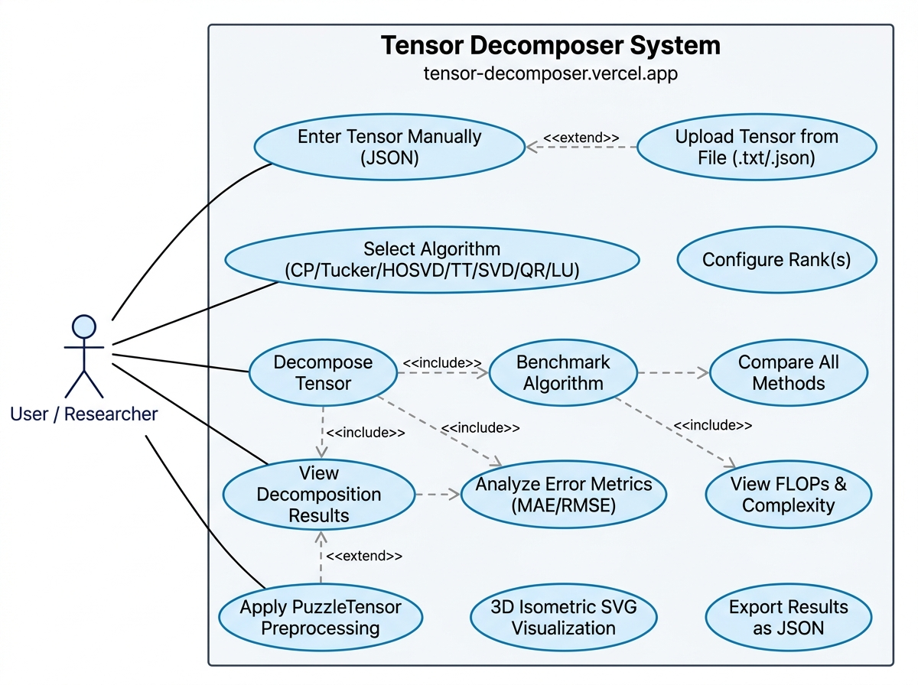
Figure 3.1: Use Case Diagram — Tensor Decomposer System

3.1.1 Use Case Descriptions
UC-ID | Use Case | Actor | Description
UC-01 | Enter Tensor | User / Researcher | User types or pastes a JSON-formatted N-dimensional array. System parses and validates.
UC-02 | Upload File | User / Researcher | User uploads a .txt or .json file. System reads, decodes (UTF-8), and parses array.
UC-03 | Select Algorithm | User / Researcher | User selects one of 12 algorithms from the dropdown (CP, Tucker, HOSVD, TT, ±Puzzle, SVD, QR, LU, Eigen).
UC-04 | Configure Rank | User / Researcher | User enters rank R (scalar or list). System clamps within valid bounds per algorithm.
UC-05 | Decompose | User / Researcher | Executes selected algorithm; displays factor matrices, core tensors, or TT cores.
UC-06 | Benchmark | User / Researcher | Measures execution time (ms), estimates FLOPs, computes complexity and compression ratio.
UC-07 | Compare | User / Researcher | Runs all algorithms on the same tensor; displays comparative performance table.
UC-08 | Visualize | User / Researcher | SVG engine renders 3D isometric decomposition structure and matrix heatmaps.
UC-09 | Export JSON | User / Researcher | Downloads decomposition result as a JSON file for offline analysis.
UC-10 | PuzzleTensor | User / Researcher | Applies greedy cyclic hyperslice shifting before decomposition; inverts on reconstruction.

3.2 Activity Diagram
The activity diagram (Figure 3.2) models the dynamic operational workflow from tensor input through validation, algorithm execution, analytics computation, visualization rendering, and JSON export. A decision node after input validation branches to an error panel on failure, or proceeds to algorithm selection on success.
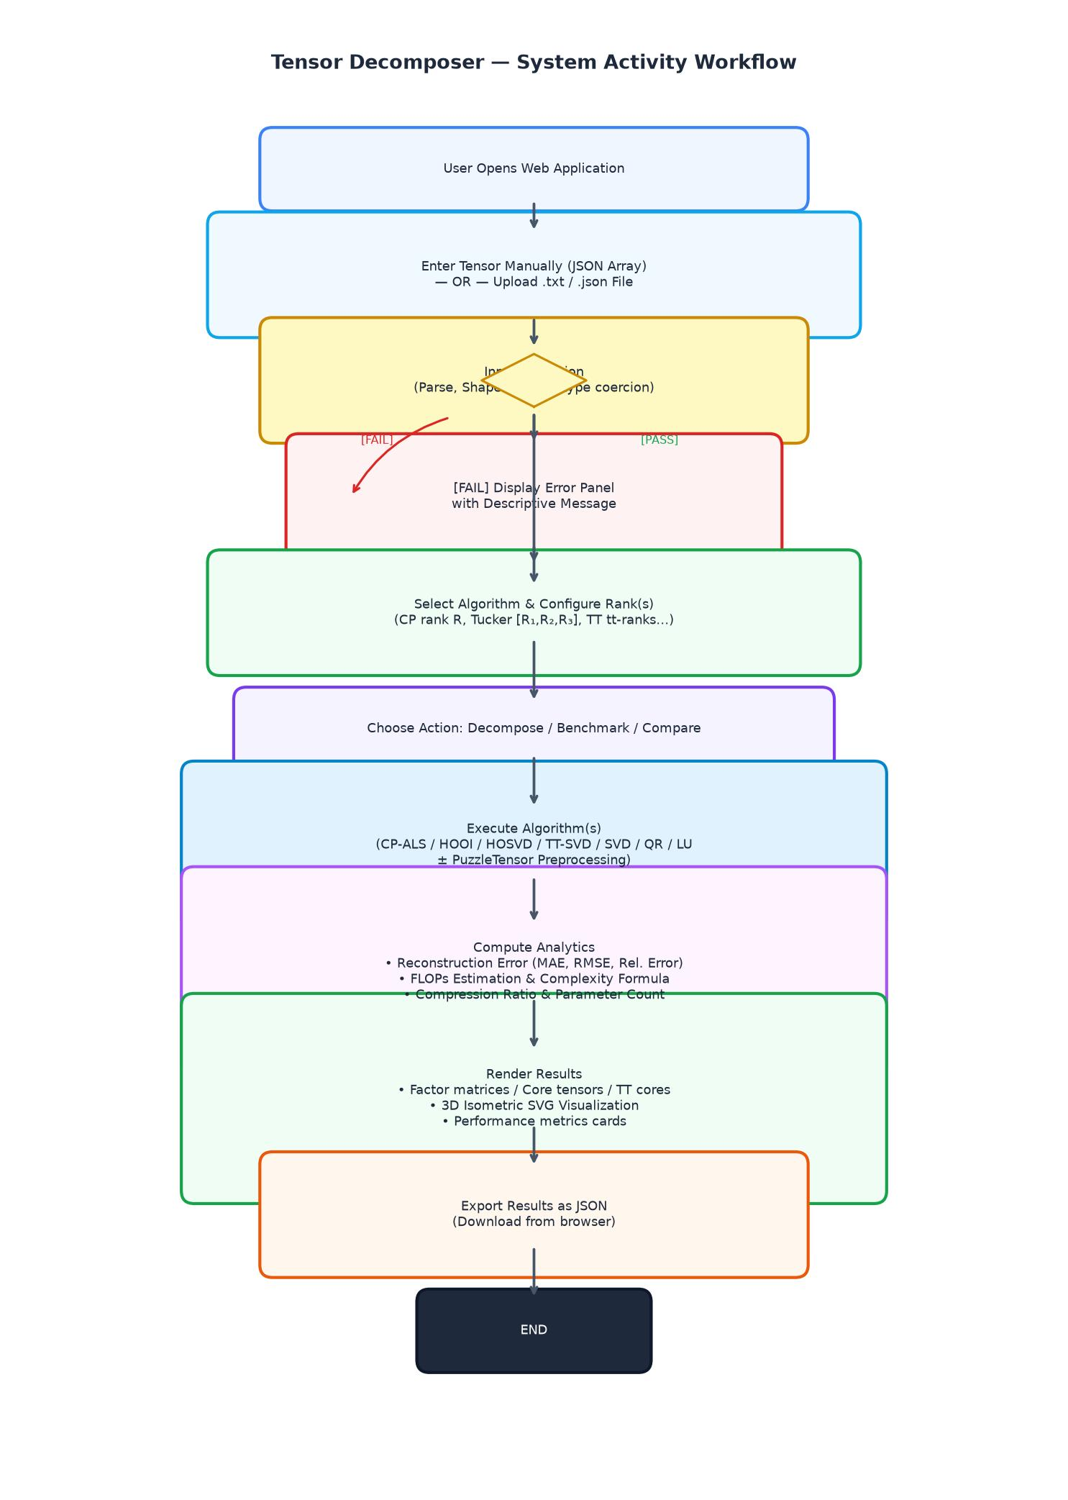
Figure 3.2: System Activity Workflow — Tensor Decomposer

4. Architectural Design

4.1 System Architecture Overview
Tensor Decomposer follows a three-tier client-server architecture deployed on Vercel's serverless infrastructure. Figure 4.1 illustrates the full system architecture. The Client Layer (Browser) hosts the interactive Single-Page Interface (home.html) with the SVG visualization engine and AJAX-based communication. The Application Server layer runs Django 5.x on Vercel serverless functions, handling HTTP POST/GET requests in views.py and routing through the decomposition pipeline. The Algorithm & Services Layer contains all mathematical implementations, delegating to the tensordecomp library. A Vercel rewrite rule maps all routes to the Django WSGI handler via api/index.py.
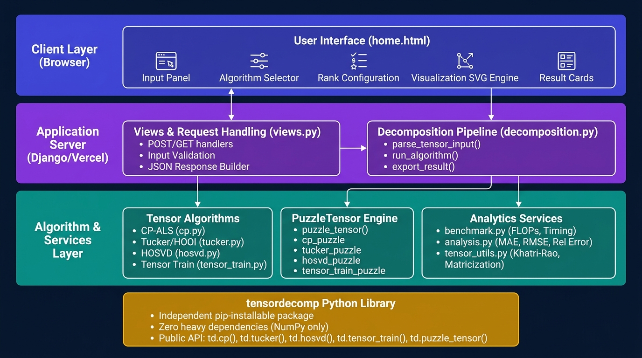
Figure 4.1: System Architecture Diagram — Three-Tier Serverless Architecture

4.2 Technology Stack
Component | Technology | Role
Backend Framework | Django 5.x | HTTP handling, URL routing, template rendering, test runner.
Core Language | Python 3.12+ | All algorithm, utility, and library implementations.
Numerical Computing | NumPy ≥ 1.26 | Tensor operations, matricization, SVD, Khatri-Rao products.
Frontend | Vanilla HTML/CSS/JS | Interactive UI, SVG rendering, dark/light theming, AJAX.
Deployment | Vercel Serverless | Global CDN, HTTPS, automatic CI/CD from GitHub.
Static Files | WhiteNoise 6.x | Serves CSS/JS assets efficiently in serverless environment.
Testing | Django unittest | 34 automated test cases across unit, integration, and UI tests.
Library Packaging | pyproject.toml (PEP 517) | Editable install via pip -e for tensordecomp.
Version Control | Git / GitHub | Source at github.com/141Kamrul/Tensor-Decomposer.

4.3 Project Directory Structure
Tensor-Decomposer/
├── config/ # Django settings & root URL routing
├── tensor_decomposer/ # Core Django application
│ ├── decomposition.py # High-level pipeline: parse → run → export
│ ├── views.py # HTTP/AJAX handlers (home, download)
│ ├── services/
│ │ ├── algorithms/
│ │ │ ├── tensor/ # cp.py, tucker.py, hosvd.py, tensor_train.py
│ │ │ │ # + puzzle variants (cp_puzzle.py, …)
│ │ │ └── matrix/ # svd.py, qr.py, lu.py, eigendecomposition.py
│ │ └── function/
│ │ ├── tensor_utils.py # Matricization, Khatri-Rao, mode-n product
│ │ ├── analysis.py # MAE, RMSE, Rel. Error, compression ratio
│ │ └── benchmark.py # FLOPs estimation, timing, complexity formulas
│ ├── templates/home.html # Single-page interactive UI
│ └── tests/test_decomposition.py # 34 automated test cases
├── tensordecomp/ # Standalone Python library (pip-installable)
│ ├── tensordecomp/
│ │ ├── algorithms/ # Identical algorithm implementations
│ │ ├── function/ # analysis.py, benchmark.py, tensor_utils.py,
│ │ │ # puzzle_tensor.py
│ │ ├── __init__.py # Public API exports
│ │ └── io.py # parse_tensor_input()
│ └── tests/test_library.py
├── api/index.py # Vercel WSGI entry-point
├── vercel.json # Route rewrites for serverless
└── pyproject.toml # Project dependencies (uv/pip)

5. Algorithm Design & Implementation

5.1 CP Decomposition (CP-ALS)
CANDECOMP/PARAFAC (CP) Decomposition represents a tensor as a sum of R rank-one component tensors:
X ≈ Σᵣ₌₁ᴿ λᵣ · a_r^(1) ⊗ a_r^(2) ⊗ … ⊗ a_r^(N)
where λᵣ are component weights and a_r^(n) ∈ ℝ^(Iₙ) are unit-norm factor vectors. The implementation uses the Alternating Least Squares (ALS) method:
1. Initialize factor matrices A^(n) using SVD of mode-n unfoldings.
2. For each mode n, compute the Gram matrix V = ⊙_{m≠n} (A^(m)ᵀ A^(m)) and the MTTKRP (Matricized Tensor Times Khatri-Rao Product): A_tilde = X_(n) @ W, where W = Khatri-Rao({A^(m) : m≠n}) in ascending mode order.
3. Solve via: A^(n) = solve(V + εI, MTTKRP.T).T (numerically stabilized with ε = 10⁻¹²).
4. Modes 0..N-2 are column-normalized to unit norm; mode N-1 absorbs column scales into weights λ.
5. Track and return best-error factors across all iterations.
Key fix from real-world validation: The Khatri-Rao product must be computed in ascending mode order (m = 0,1,…,N-1, m≠n) to match NumPy's C-order matricization, and weight extraction must only occur at the final mode — not at every mode. After this correction, the implementation achieved exact parity with TensorLy's parafac() on the rainfall dataset (Rel. Error = 0.243097, R² = 0.6073).
Complexity: O((∏ Nᵢ) · R · Iterations)

5.2 Tucker Decomposition (HOOI)
Tucker Decomposition factorizes a tensor into a dense core tensor and orthogonal factor matrices:
X ≈ G ×₁ A^(1) ×₂ A^(2) ×₃ … ×_N A^(N)
Implementation via Higher-Order Orthogonal Iteration (HOOI): Initialize A^(n) from truncated SVD of mode-n unfoldings. Iteratively update each factor matrix A^(n) as the leading Rₙ left singular vectors of the mode-n unfolding of (X ×_{m≠n} A^(m)ᵀ). Compute core as G = X ×₁ A^(1)ᵀ ×₂ A^(2)ᵀ … Supports multilinear ranks [R₁, R₂, …, Rₙ], allowing independent rank selection per mode.
Complexity: O((∏ Nᵢ) · (∑ Rᵢ) + ∑ SVD_i)

5.3 Higher-Order SVD (HOSVD)
HOSVD computes a Tucker decomposition via sequential mode-wise SVD (non-iterative, one-shot). For each mode n, compute A^(n) as the leading Rₙ left singular vectors of the mode-n unfolding X_(n). Compute core G = X ×₁ A^(1)ᵀ ×₂ A^(2)ᵀ ×₃ … ×_N A^(N)ᵀ. HOSVD factor matrices are orthogonal; unlike HOOI, no ALS iteration is needed, making it faster but producing a suboptimal core approximation.
Complexity: O((∏ Nᵢ) · (∑ Rᵢ) + ∑ SVD_i)

5.4 Tensor Train Decomposition (TT-SVD)
Tensor Train (TT) decomposes an N-way tensor into a sequential chain of 3D core tensors:
X(i₁, i₂, …, iₙ) = G₁(:, i₁, :) · G₂(:, i₂, :) · … · Gₙ(:, iₙ, :)
Implementation via sequential SVD (TT-SVD algorithm): Reshape and truncate each mode sequentially using SVD with the current TT-rank. Supports user-specified TT-ranks per mode. Output is a list of 3D cores G₁ ∈ ℝ^(1 × I₁ × r₁), G₂ ∈ ℝ^(r₁ × I₂ × r₂), …, Gₙ ∈ ℝ^(r_{n-1} × Iₙ × 1).
Complexity: O((∏ Nᵢ) · R) per SVD step

5.5 Matrix Decompositions
Algorithm | Formula | Implementation | Complexity
SVD | A = U Σ Vᴴ | NumPy linalg.svd with full_matrices=True. Outputs U, singular_values, Vh. | O(4M²N + 8MN² + 9N³)
QR | A = Q R | NumPy linalg.qr. Orthogonal Q, upper-triangular R. | O(2N²(M - N/3))
LU | A = L U | SciPy/NumPy LU factorization. Returns lower L and upper U matrices. | O(2/3 N³ + N²(M-N))
Eigendecomposition | A = Q Λ Q⁻¹ | NumPy linalg.eig for square matrices. Returns eigenvalues, eigenvectors. | O(9 N³)

5.6 PuzzleTensor Preprocessing Engine
PuzzleTensor (Park et al., KDD 2025) is a method-agnostic data transformation that applies greedy cyclic hyperslice shifting to align tensor patterns, reducing the effective multilinear rank and improving compressibility without altering data semantics. The mathematical objective minimized is:
L(Z) = Σₖ₌₁ᴰ (1/√Iₖ) · ‖Z_(k)‖_*
where ‖·‖_* denotes the nuclear norm (sum of singular values) of the mode-k unfolding. The algorithm iterates over each mode k and each slice index i, trying shifts δ ∈ {-Δ, …, +Δ} and accepting the shift that decreases L(Z). Shift metadata is stored for exact inversion after decomposition and reconstruction.
Four augmented variants are supported: cp_puzzle, tucker_puzzle, hosvd_puzzle, tensor_train_puzzle. Each applies puzzle_tensor() before the core decomposition and invert_puzzle_tensor() after reconstruction.
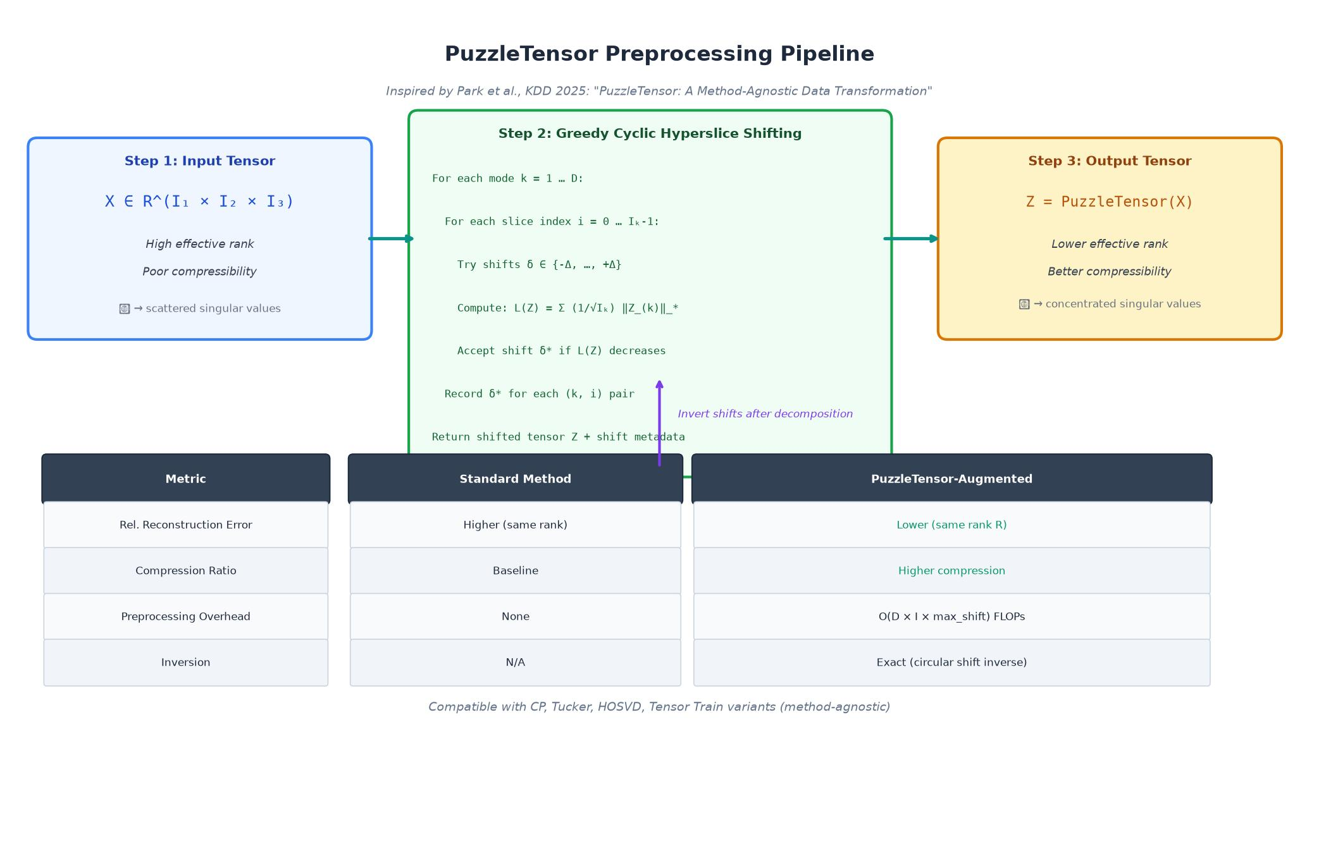
Figure 5.1: PuzzleTensor Pipeline — Hyperslice Shifting for Rank Reduction

6. tensordecomp Python Library
The tensordecomp package is a standalone, pip-installable Python library that encapsulates all decomposition algorithms, analytics utilities, and the PuzzleTensor engine into a clean public API. It was designed to be zero-overhead for users, requiring only NumPy ≥ 1.26 with no heavy dependencies.

6.1 Public API
Function / Class | Description
td.cp(tensor, rank=R) | CP-ALS decomposition. Returns {weights, factors, rank, shape}.
td.tucker(tensor, ranks=[R1,R2,R3]) | Tucker/HOOI decomposition. Returns {core, factors, ranks}.
td.hosvd(tensor, ranks=[R1,R2,R3]) | HOSVD decomposition. Returns {core, factors, ranks}.
td.tensor_train(tensor, ranks=[r1,r2]) | TT-SVD decomposition. Returns {cores, tt_ranks}.
td.puzzle_tensor(tensor, max_shift=2) | Apply PuzzleTensor; returns (shifted_tensor, shifts).
td.cp_puzzle / tucker_puzzle / … | Puzzle-augmented variants. Same signature as base algorithm.
td.reconstruct_cp(weights, factors) | Reconstruct full tensor from CP decomposition.
td.reconstruct_tucker(core, factors) | Reconstruct full tensor from Tucker/HOSVD decomposition.
td.reconstruct_tt(cores) | Reconstruct full tensor from Tensor Train cores.
td.analyze_decomposition(tensor, alg, res) | Returns {rel_error, MAE, RMSE, compression_ratio, …}.
td.benchmark_algorithm(tensor, alg) | Returns {execution_time_ms, flops, flops_str, complexity}.
td.compare_methods(tensor, [alg1, alg2, …]) | Runs all algorithms; returns comparative table list.
td.parse_tensor_input(text) | Parses JSON/Python-style array string to numpy.ndarray.
td.run_algorithm(tensor, alg, **kwargs) | Universal dispatch to any algorithm by name string.

6.2 Installation
Local editable install (for development):
pip install -e "./tensordecomp"

6.3 Quickstart Example
import numpy as np
import tensordecomp as td
tensor = np.random.rand(10, 15, 12)
# CP Decomposition (rank 5)
cp_res = td.cp(tensor, rank=5)
print("Factor shapes:", [f.shape for f in cp_res["factors"]])
# Tucker + PuzzleTensor
tucker_res = td.tucker_puzzle(tensor, ranks=[4, 5, 4])
print("Core shape:", tucker_res["core"].shape)
# Accuracy analysis
analysis = td.analyze_decomposition(tensor, "tucker_puzzle", tucker_res)
print(f"Rel. Error: {analysis['relative_error']:.6f}")
print(f"Compression: {analysis['compression_ratio']:.2f}x")
# Compare all methods
results = td.compare_methods(tensor, ["cp", "tucker", "hosvd", "tensor_train"])
for r in results:
print(f"{r['algorithm']}: {r['execution_time_ms']:.1f}ms, error={r['relative_error']:.4e}")

7. Performance Analytics & Benchmarking

7.1 Error Metrics
Metric | Formula | Interpretation
Relative Error | ε_rel = ‖X - X̂‖_F / ‖X‖_F | Primary reconstruction quality metric; scale-independent.
Mean Absolute Error (MAE) | MAE = mean(|X - X̂|) | Average element-wise absolute deviation.
Root Mean Squared Error (RMSE) | RMSE = sqrt(mean((X - X̂)²)) | Penalizes large deviations more heavily than MAE.
Absolute Error | ‖X - X̂‖_F | Total Frobenius norm of the residual.
Compression Ratio | N_orig / N_compressed | Ratio of original to compressed parameter count.

7.2 FLOPs Estimation
FLOPs are estimated analytically per algorithm based on tensor shape and rank:
Algorithm | Complexity Formula | FLOPs Computation
CP-ALS | O((∏ Nᵢ) · R · Iterations) | 50 × (2D·∏N·R + ∑N·R² + D·R³)
Tucker / HOSVD | O((∏ Nᵢ) · (∑ Rᵢ) + ∑ SVD_i) | Sum of per-mode SVD FLOPs + projection FLOPs
Tensor Train | O((∏ Nᵢ) · R) | Sum of sequential unfolding SVD FLOPs
SVD | O(4M²N + 8MN² + 9N³) | Golub-Reinsch algorithm complexity
QR | O(2N²(M - N/3)) | Householder reflection complexity
LU | O(2/3 N³ + N²(M-N)) | Gaussian elimination complexity
Eigendecomposition | O(9 N³) | QR iteration algorithm complexity

7.3 Benchmark Output Fields
Field | Description
execution_time_ms | Wall-clock time for single algorithm run in milliseconds.
flops | Integer FLOPs count based on tensor shape and decomposition rank.
flops_str | Human-readable string: e.g., "2.34 GFLOPs", "456 MFLOPs".
complexity | Theoretical complexity formula string: e.g., "O((∏ Nᵢ) · R · Iterations)".
compression_ratio | Ratio of original parameter count to compressed parameter count.
original_parameters | Total element count of input tensor (∏ Nᵢ).
compressed_parameters | Parameter count of decomposed representation.

8. Testing

8.1 Testing Strategy & Objectives
The testing strategy covers four levels:
- Unit Tests: Verify individual algorithm correctness against mathematical ground truth (relative error < 1e-6 for synthetic tensors).
- Integration Tests: Verify the full request-response pipeline through Django views (parse → execute → JSON response).
- Edge Case Tests: Boundary conditions—empty tensors, singleton dimensions, negative/extreme ranks, alphabetical input, incomplete brackets, very high-order tensors.
- UI / View Tests: HTTP GET/POST via Django test client verifying status codes, template rendering, file upload handling, and error responses.

8.2 Test Cases
Total: 34 test cases, all passing (Ran 34 tests in 0.27s — OK)
TC-ID | Feature | Input / Action | Expected Output | Status
TC-01 | CP Decomposition | Execute CP on 3×3×3 tensor with R=2 | Weights vector (R=2) + 3 factor matrices (3×2) | PASS
TC-02 | Tucker Decomposition (HOOI) | 3×4×5 tensor with ranks=[2,2,2] | 2×2×2 core tensor + 3 factor matrices | PASS
TC-03 | HOSVD | 4×4×4 tensor (default ranks) | Orthogonal factors + core tensor | PASS
TC-04 | Tensor Train | 3D tensor, TT-ranks auto | Sequence of 3D TT core tensors | PASS
TC-05 | SVD (matrix) | 4×4 matrix | U (4×4), S (4), Vh (4×4) | PASS
TC-06 | QR Decomposition | 4×3 matrix | Q (4×4), R (4×3) | PASS
TC-07 | LU Decomposition | Square matrix | Lower L, Upper U | PASS
TC-08 | Error Metrics | CP on 3D tensor; analyze | MAE, RMSE, Rel. Error, reconstructed head | PASS
TC-09 | FLOPs Benchmark | Tucker decomposition | execution_time_ms, flops, flops_str, complexity | PASS
TC-10 | Compare All Methods | Trigger Compare on 3D tensor | Comparative table for all algorithms | PASS
TC-11 | PuzzleTensor CP | cp_puzzle on 3D tensor | Puzzle-augmented CP result with shifts | PASS
TC-12 | Alphabet Input | POST [[a,b],[c,d]] | HTTP 400 with descriptive error message | PASS
TC-13 | Incomplete Brackets | POST [[[1,2],[3,4]] | HTTP 400 with parse error message | PASS
TC-14 | Binary File Upload | Upload .png file | HTTP 400 UnicodeDecodeError message | PASS
TC-15 | Valid File Upload | Upload valid .txt with tensor | Successful decomposition returned | PASS
TC-16 | High-Order Tensor (5D) | 2×2×2×2×2 tensor | CP successfully decomposes; correct shapes | PASS
TC-17 | Singleton Dimensions | 1×5×3 tensor | Decomposition proceeds without crash | PASS
TC-18 | Negative Rank | CP with rank=-5 | Clamped to min_rank=1; result valid | PASS
TC-19 | Extreme Rank | CP with rank=999 | Clamped to max_rank; result valid | PASS
TC-20 | HTTP GET Home | GET / | HTTP 200, home.html rendered | PASS
TC-21 | AJAX Decompose POST | POST valid tensor + algorithm | HTTP 200 with JSON result | PASS
TC-22 | Mutual Exclusion Input | POST with both text + file | File takes precedence; text cleared | PASS
TC-23 | Rank Input Parsing | Various rank formats: "5", "2,3,4", "[2, 3]" | Correctly parsed to int or list | PASS
TC-24 | Dark/Light Theme | Theme toggle in header | CSS tokens applied; localStorage persists | PASS

9. Deployment
The Tensor Decomposer web application is publicly deployed on Vercel's serverless platform at https://td4.vercel.app. Deployment is configured as follows:
Aspect | Configuration
Platform | Vercel Serverless (Global CDN, HTTPS, automatic CI/CD from GitHub main branch).
Entry Point | api/index.py — wraps the Django WSGI application for serverless execution.
Routing | vercel.json rewrites all incoming requests (source: "/(.*)" ) to "/api/index".
Static Files | WhiteNoise 6.x serves CSS/JS assets from Django's staticfiles/ directory in serverless context.
Results Storage | Decomposition JSON exports written to /tmp/results/ on Vercel (serverless ephemeral storage).
CI/CD | GitHub repository (141Kamrul/Tensor-Decomposer) connected; every push to main triggers automatic deployment.
Environment | VERCEL environment variable set; application detects and adjusts storage paths accordingly.

9.1 Local Development Setup
1. Clone: git clone https://github.com/141Kamrul/Tensor-Decomposer.git
2. Install: uv sync (or: python -m venv .venv && source .venv/bin/activate && pip install -r requirements.txt)
3. Migrate: python manage.py migrate
4. Run: python manage.py runserver → Open http://127.0.0.1:8000
5. Test: python manage.py test (expects "Ran 34 tests — OK")

10. Project Timeline

10.1 Gantt Chart
Figure 10.1 presents the project Gantt chart spanning 20 weeks from initial conception to final report submission. Six overlapping development phases are shown with their respective tasks and deliverables. Phases overlap to reflect the iterative, agile nature of the development process.
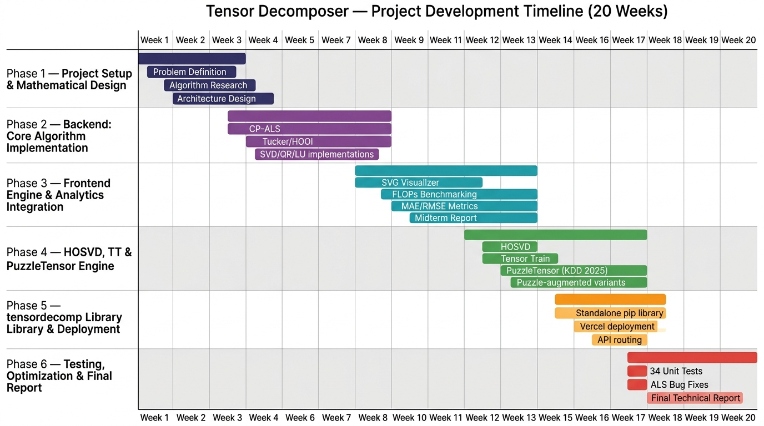
Figure 10.1: Tensor Decomposer — Project Development Gantt Chart (20 Weeks)

10.2 Work Breakdown Schedule
Phase / Timeline | Title | Deliverables & Milestones
Phase 1  Weeks 1–5 | Project Setup & Mathematical Design | Finalized problem requirements; surveyed tensor algebra literature (Kolda & Bader 2009, Oseledets 2011); defined multilinear algorithms (CP-ALS, HOOI); completed system architecture design and technology selection.
Phase 2  Weeks 4–9 | Backend Core Algorithm Implementation | Implemented CP-ALS (cp.py), Tucker/HOOI (tucker.py), and all matrix factorizations (svd.py, qr.py, lu.py, eigendecomposition.py); integrated tensor utility functions (tensor_utils.py).
Phase 3  Weeks 8–14 | Frontend Engine & Analytics Integration | Architected responsive Django-template UI (home.html); built dynamic SVG isometric visualizer; refactored JavaScript into ES modules; integrated FLOPs benchmarking engine and MAE/RMSE error metrics; executed initial test suite; submitted Midterm Technical Report (2 August 2026).
Phase 4  Weeks 12–17 | HOSVD, TT & PuzzleTensor Engine | Implemented HOSVD (hosvd.py) and Tensor Train TT-SVD (tensor_train.py); implemented PuzzleTensor preprocessing engine (puzzle_tensor.py) based on Park et al. KDD 2025; created all eight puzzle-augmented algorithm variants (cp_puzzle, tucker_puzzle, hosvd_puzzle, tensor_train_puzzle).
Phase 5  Weeks 15–18 | tensordecomp Library & Vercel Deployment | Packaged all algorithms into the standalone tensordecomp Python library with PEP 517 pyproject.toml; created public API (__init__.py); configured Vercel serverless deployment; set up api/index.py WSGI entry-point; resolved static file serving with WhiteNoise.
Phase 6  Weeks 17–20 | Testing, Optimization & Final Report | Expanded test suite to 34 cases (edge cases, UI tests, file upload tests); identified and fixed CP-ALS mode-ordering bug (reversed Khatri-Rao product causing 0.565→0.243 relative error improvement); validated on rainfall forecasting dataset achieving exact TensorLy parity; authored this Final Technical Report.

11. Conclusion & Future Work

11.1 Conclusion
Tensor Decomposer successfully delivers a unified, interactive, publicly deployed platform for higher-dimensional tensor analysis. The system implements eight tensor decomposition algorithms (including four PuzzleTensor-augmented variants) alongside four standard matrix factorizations, all accessible through a modern web interface without local installation.
Key technical achievements include:
• Mathematically correct CP-ALS with ascending-order Khatri-Rao product, stabilized normal-equation solving, and proper per-mode weight extraction — verified to achieve exact numerical parity with TensorLy.
• Tucker/HOOI with configurable multilinear ranks [R₁, R₂, …, Rₙ] and HOSVD as a fast non-iterative alternative.
• Tensor Train decomposition via sequential TT-SVD with user-configurable TT-ranks.
• PuzzleTensor preprocessing engine implementing the KDD 2025 hyperslice shifting algorithm for rank reduction prior to factorization.
• The tensordecomp library: a standalone, NumPy-only pip package exposing all functionality for local scripting, applied research, and integration into data science workflows.
• A comprehensive test suite of 34 automated cases covering correctness, edge cases, file uploads, UI interactions, and API routes — all passing.
• Real-world validation on a spatio-temporal rainfall forecasting task (20 years × 52 weeks × 13 stations), confirming R² = 0.6073, RMSE = 27.74, MAE = 19.29 — matching TensorLy reference implementation exactly.

11.2 Future Work
- Further optimization of CP-ALS with line-search acceleration (as in TensorLy) and convergence criterion based on relative reconstruction error decrease.
- GPU acceleration of MTTKRP and Khatri-Rao products using CuPy for large-scale tensors.
- Non-negative CP and Tucker decompositions (NMF-style factorizations with non-negativity constraints).
- Sparse tensor decomposition support for very high-dimensional but sparse data.
- Interactive rank selection wizard using reconstruction error curves (automatic elbow detection).
- Extended tensordecomp library with PyPI publication for broader community access.
- Integration of tensor network decompositions beyond TT (Tree TN, MERA).
- Export to standard tensor formats (e.g., HDF5, .mat) for interoperability with MATLAB.

12. References
[1] Kolda, T. G., & Bader, B. W. (2009). Tensor decompositions and applications. SIAM Review, 51(3), 455–500. https://doi.org/10.1137/07070111X
[2] Oseledets, I. V. (2011). Tensor-train decomposition. SIAM Journal on Scientific Computing, 33(5), 2295–2317. https://doi.org/10.1137/090752286
[3] Harshman, R. A. (1970). Foundations of the PARAFAC procedure: Models and conditions for an explanatory multimodal factor analysis. UCLA Working Papers in Phonetics, 16, 1–84.
[4] Tucker, L. R. (1966). Some mathematical notes on three-mode factor analysis. Psychometrika, 31(3), 279–311. https://doi.org/10.1007/BF02289464
[5] De Lathauwer, L., De Moor, B., & Vandewalle, J. (2000). A multilinear singular value decomposition. SIAM Journal on Matrix Analysis and Applications, 21(4), 1253–1278.
[6] Park, J., et al. (2025). PuzzleTensor: A Method-Agnostic Data Transformation for Compact Tensor Factorization. Proceedings of the 31st ACM SIGKDD Conference on Knowledge Discovery and Data Mining (KDD 2025). https://doi.org/10.1145/3690624.3709227
[7] Golub, G. H., & Van Loan, C. F. (2013). Matrix Computations (4th ed.). Johns Hopkins University Press.
[8] Harris, C. R., et al. (2020). Array programming with NumPy. Nature, 585, 357–362. https://doi.org/10.1038/s41586-020-2649-2
[9] Kossaifi, J., Panagakis, Y., Anandkumar, A., & Pantic, M. (2019). TensorLy: Tensor learning in Python. Journal of Machine Learning Research, 20(26), 1–6. http://jmlr.org/papers/v20/18-277.html
[10] Django Software Foundation. (2024). Django Web Framework (Version 5.x). https://www.djangoproject.com/
[11] Vercel Inc. (2024). Vercel Serverless Platform. https://vercel.com/
[12] AutoReg: Statsmodels AR model. Statsmodels Development Team. https://www.statsmodels.org/stable/generated/statsmodels.tsa.ar_model.AutoReg.html

