音频和视频标签:
1,<embed>播放音频
语法:
<embed src="音频地址" width="200" height="200" autostart="true" loop="true">
</embed>
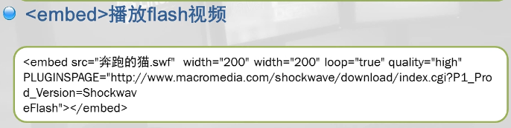
2,<object>标签
作用：可以使用<object>标签来给浏览器加载插件，通过加载的插件来播放音频和视频
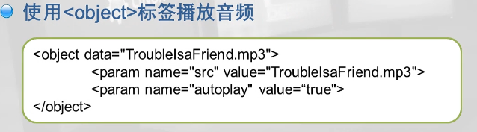
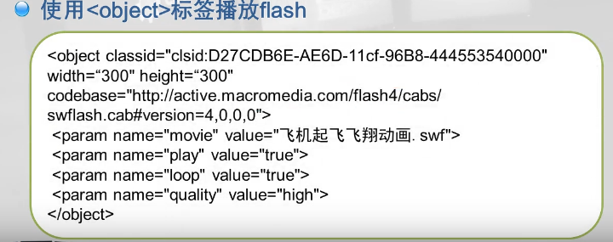

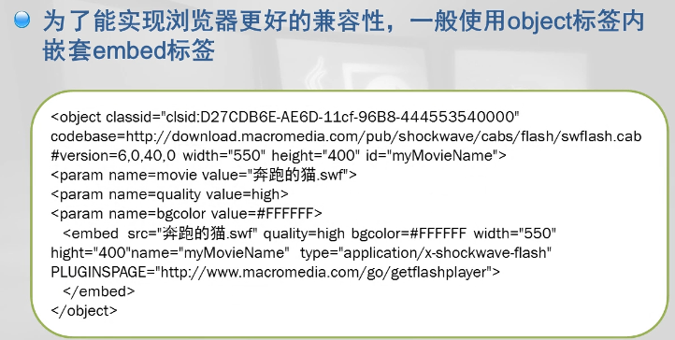
<object classid="clsid:D27CDB6E-AE6D-11cf-96B8-444553540000" codebase="http://download.macromedia.com/pub/shockwave/cabs/flash/swflash.cab#version=6,0,40,0" width="550" height="400" id="myMovieName" >
<param name=movie value="F:/flash5958.swf">
<param name=quality value=hegh>
<embed src="F:/flash5958.swf" quality=high bgcolor=#FFFFF width="550" hight="400" name="myMovieName" type="application/x-shockwave-flash" PLUGINSPAGE="http://www.macromedia.com/go/getflashplayer">
</embed>
</object>

3,<video>视频标签
语法:
<video src="视频路径" controls="controls" autoplay="autoplay设置自动播放" loop="循环播放次数"></video>

4,<audio>音频标签
语法:
<audio src="音频路径" controls="controls设置显示" autoplay="autoplay设置自动播放"></audio>
写法2:兼容性好
<audio controls="controls" autoplay loop>
<source src="mp3格式" type="audio/mpeg">
<source src="ogg格式" type="audio/ogg">
</audio>

