班级 nz244 姓名 兰锐天 学号 247106
实验一 The Harpe Gaming Store Website
一、实验目的
Samantha Goro is the owner of Harpe Gaming, a small board game store in Palmerston North, Manawatu. You have been asked to work on the store's new website, Samantha wants you to write the HTML5 code for the store's home page. Samantha also publishes reviews of new games as a service to her loyal customers. She would also like you to write the HTML5 code for two new reviews that she has written for the Towers and Temple game and the Alliance game. Samantha has already written all the content for the three pages and only requires your help to turn them into HTML5 documents.
二、实验内容
The Final Web Pages:
index.html
hg_towers.html
hg_alliance.html
三、实验结果
核心代码
（index.html）
<!DOCTYPE html>
<html lang="en">
<head>
<!--Author: Lan ruitian
Date: 2026-09-09
Purpose: Harpe Gaming home page - introduces the store
-->
<meta charset="utf-8">
<meta name="keywords" content="harpe gaming, board games, card games, game store, morgantown">
<title>Harpe Gaming</title>
</head>
<body>
<header>
<img src="hg_logo.png" alt="Harpe Gaming logo" />
<img src="F3926BF9ED71F4E373F7CA95B3689370.gif" alt="kunkun" />

<nav>
<ul>
<li><a href="index.html">Home</a></li>
<li><a href="hg_towers.html">Towers and Temples</a></li>
<li><a href="hg_alliance.html">Alliance</a></li>
</ul>
</nav>
</header>
<article>
<h1>Welcome to Harpe Gaming</h1>
<p>We have a <strong>simple philosophy</strong>. It has three main points:</p>
<ul>
<li>Unplug</li>
<li>Interact</li>
<li>Reconnect</li>
</ul>
<p>And that's it. We believe that the best games are the ones that bring people together through shared experiences. With all due respect to our video gamer friends, you can't always get that from a <em>computer screen</em>. Sometimes you need the intimate approach of sitting face-to-face around a common table with the soda and chips at your elbow.</p>

<section>
<h2>Our Store</h2>
<p>We are a local board and card game store located in the heart of Morgantown near the campus. We carry hundreds of games and puzzles, including educational games, family games, card games, historical simulations, role-playing games, and so much more. If you remember a great game from your youth, we probably have it in our antiques collection. If we don't, we know where we can get it.</p>
<p>We're more than just a place to buy games. We celebrate gaming and the company of good friends. Our game room is free for all to use. Sit down, pick out a game from our demo library and start playing. We sponsor tournaments, challenges, and special social events. You'll always find a game to play.</p>
<p>We're always on the lookout for the best new games. We publish periodic reviews of new titles. Just out our reviews of <a href="hg_towers.html">Towers and Temples</a> and <a href="hg_alliance.html">Alliance</a>; both new this month at Harpe Gaming.</p>
</section>

<section>
<h2>Questions?</h2>
<p>Contact us at <a href="mailto:sgreer@example.com/harpe">sgreer@example.com/harpe</a> or call us at <a href="tel:+13045557120">(304) 555-7120</a>.</p>
</section>
</article>

<footer>
<p>Harpe Gaming &copy; 785 Chester Avenue &bull; Morgantown, WV 26502</p>
</footer>

</body>
</html>

（hg_towers.html）
<!DOCTYPE html>
<html lang="en">
<head>
<!--Author: Lan ruitian
Date: 2026-09-09
Purpose: Review page for the board game Towers and Temples
-->

<meta charset="utf-8">
<meta name="keywords" content="towers and temples, board game, review, simulation game, harpe gaming">
<title>Towers and Temples</title>
</head>
<body>
<header>
<img src="hg_logo.png" alt="Harpe Gaming logo" />
<nav>
<ul>
<li><a href="index.html">Home</a></li>
<li><a href="hg_towers.html">Towers and Temples</a></li>
<li><a href="hg_alliance.html">Alliance</a></li>
</ul>
</nav>
</header>
<article>
<h1>Review of Towers and Temples</h1>

<aside>
<img src="hg_towers.png" alt="Towers and Temples board game" />
<dl>
<dt>Game ID</dt>
<dd>bg210</dd>
<dt>List Price</dt>
<dd>$17.73</dd>
<dt>Media</dt>
<dd>Board Game</dd>
<dt>Release Date</dt>
<dd>October 21, 2017</dd>
<dt>Age</dt>
<dd>10+</dd>
<dt>Players</dt>
<dd>2 - 8</dd>
<dt>Time</dt>
<dd>30 - 60 minutes</dd>
</dl>
</aside>

<section>
<h2>Rule an Ancient City</h2>
<p>Towers and Temples is the winner of the 2017 Palmer Medal for Best New Simulation Board Game. Players adopt role cards of characters from ancient Greece and Rome in an attempt to manage the administration of a city. Each role provides a different ability and strategy. However, one role card belongs to a deadly assassin and players must be constantly aware of betrayal and double-cross. This card game provides a ton of enjoyment and can handle up to eight players and expansion packs available for larger parties.</p>
<p>This is a nicely balanced game, where each player must carefully choose his or her roles and the strategies can quickly change with the turn of a card. However the level of randomness is just right and cunning and resourcefulness can overcome bad luck (if given time.) I do not recommend this game unless there are at least 4 players; less than that reduces the intrigue and some of the game appeal.</p>

<h3>Ratings</h3>
<ul>
<li>Entertainment (8/10)</li>
<li>Strategy (9/10)</li>
<li>Innovation (7/10)</li>
<li>Art Work (6/10)</li>
<li>Community Enjoyment (10/10)</li>
<li>Ease of Set Up (9/10)</li>
<li>Play Again (10/10)</li>
<li>OVERALL (8.43/10)</li>
</ul>
</section>

<section>
<h2>Media Reviews</h2>

<blockquote>
<h3>Highly Recommended</h3>
<p>Towers and Temples is a great game. The balance is just about perfect and each player must carefully choose roles each turn. Even though the strategic possibilities are nearly endless, the game is simple to learn. The replay value is high and gets even better when you replace some of the cards with new cards available in the expansion packs.</p>
<p>Rating: <strong>4.5 / 5</strong><br />
<cite>Board Game Review</cite> (<a href="http://www.example.com/bgreview">http://www.example.com/bgreview</a>)</p>
</blockquote>

<blockquote>
<h3>Great Strategic Board Game</h3>
<p>We tested Towers and Temples with everything from 2 to 6 players and we can strongly recommend the game. The different phases of the game are interesting and intriguing, from bluffing and stealing to site construction and planning. With the variety of cards and scenarios, no two games are ever quite the same. It's a great introduction to the world of strategic board games and role playing.</p>
<p>Rating: <strong>5 / 5</strong><br />
<cite>Gamers Shop</cite> (<a href="http://www.example.com/gamersshop">http://www.example.com/gamersshop</a>)</p>
</blockquote>

<blockquote>
<h3>An Incredible Game</h3>
<p>The artwork on the cards and the board is excellent and one of the best around. As for play, this game offers lots of strategy, and there are tough decisions to make every turn. It's not only important to select the character that increases your chances for scoring, but also to anticipate the characters the opponents are likely to select, and then hedge against their availability. This causes a lot of unpredictability and deep strategic thinking. However, it can still be played at a more basic level for younger users.</p>
<p>We had a lot of fun with this game and rate it as Best in its Class. Highly recommended.</p>
<p>Rating: <strong>10 / 10</strong><br />
<cite>Tactics and Trials</cite> (<a href="http://www.example.com/tacticstrials">http://www.example.com/tacticstrials</a>)</p>
</blockquote>
</section>
</article>

<footer>
<p>Harpe Gaming &copy; 785 Chester Avenue &bull; Morgantown, WV 26502</p>
</footer>

</body>
</html>

（hg_alliance.html）
<!DOCTYPE html>
<html lang="en">
<head>
<!--
Author: Lan ruitian
Date: 09/09/2026
Purpose: Review page for the board game Alliance, with game info, rating, and media reviews
-->
<meta charset="utf-8">
<meta name="keywords" content="alliance, board game, review, war game, harpe gaming">
<title>Alliance</title>
</head>
<body>
<header>
<img src="hg_logo.png" alt="Harpe Gaming logo" />
<nav>
<ul>
<li><a href="index.html">Home</a></li>
<li><a href="hg_towers.html">Towers and Temples</a></li>
<li><a href="hg_alliance.html">Alliance</a></li>
</ul>
</nav>
</header>
<article>
<h1>Review of Alliance</h1>

<aside>
<img src="hg_alliance.png" alt="Alliance board game" />
<dl>
<dt>Game ID</dt>
<dd>bg210</dd>
<dt>List Price</dt>
<dd>$22.15</dd>
<dt>Media</dt>
<dd>Board Game</dd>
<dt>Release Date</dt>
<dd>September 14, 2017</dd>
<dt>Age</dt>
<dd>12+</dd>
<dt>Players</dt>
<dd>2 - 6</dd>
<dt>Time</dt>
<dd>60 - 120 minutes</dd>
</dl>
</aside>

<section>
<h2>Decide the Fate of the World</h2>
<p>Alliance challenges you and your opponents to decide the outcome. As one of the world powers battling for supremacy you must lead your country's military drive; but you can't do it alone. You have to form alliances and then betray your allies before they betray you!</p>
<p>Decide where to strike, when to strike, and the intensity of the strike. Will it be a bombing raid, an offshore missile barrage, or an invasion with land forces and tanks? Plan your attack, move into enemy territory with your forces and win the conflict.</p>
<p>The economic destiny of your nation is also at stake. Buy armaments and develop secret weapons from your country's economic funds and natural reserves, but be sure to save something for the future.</p>

<h3>Ratings</h3>
<ul>
<li>Entertainment (7/10)</li>
<li>Strategy (10/10)</li>
<li>Innovation (6/10)</li>
<li>Art Work (5/10)</li>
<li>Community Enjoyment (8/10)</li>
<li>Ease of Set Up (7/10)</li>
<li>Play Again (5/10)</li>
<li>OVERALL (6.86/10)</li>
</ul>
</section>

<section>
<h2>Media Reviews</h2>

<blockquote>
<h3>Tedious and Confusing</h3>
<p>The list of war simulation games is long. All of them share similar features including the formation of temporary Alliance and battles simulated through random draws of a deck or the roll of the die. Alliance offers very little that is new or innovative in that regard.</p>
<p>We found the game to be too drawn-out and confusing. In fact, I dare say we spent more time reading and rereading the rule book than actually playing the game. If you want to read a book on war, we suggest Sun Tzu.</p>
<p>Rating: <strong>1 / 5</strong><br />
<cite>Board Game Review</cite> (<a href="http://www.example.com/bgreview">http://www.example.com/bgreview</a>)</p>
</blockquote>

<blockquote>
<h3>Decent Game but Many are Better</h3>
<p>Alliance is a good war simulation game. We found the game play to be robust and engaging. The rules are long and drawn out but, for anyone with experience in this class of board games, there is little there that's unexpected or difficult. We think the battle simulation cards are some of the best we have encountered.</p>
<p>All of that being said, the competition for this type of game is fierce. There are a lot of established titles with loyal clients. We're not exactly sure where Alliance fits in with that group. It's a good game, but not good enough to draw our attention away from games like Battle Tested and Global Conflict.</p>
<p>Rating: <strong>7 / 10</strong><br />
<cite>Tactics and Trials</cite> (<a href="http://www.example.com/tacticstrials">http://www.example.com/tacticstrials</a>)</p>
</blockquote>

<blockquote>
<h3>Fun and Challenging</h3>
<p>Alliance is fun game and is sure to appeal to war game enthusiasts. We think it offers several new ideas that we're surprised have not been utilized in other simulation games. The card system and the investment options give the game a "real world" feel.</p>
<h4>Things We Liked</h4>
<ul>
<li>Variety of Battle Scenarios</li>
<li>Flexible Rules and Setup</li>
<li>Detail and Historical Accuracy</li>
<li>Wealth of Expansion Packs</li>
</ul>
<h4>Things We Hated</h4>
<ul>
<li>Long and Complicated Rule Book</li>
<li>Setup takes too Long</li>
</ul>
<p>This is a great game for anyone 16 years or older. Younger players may have trouble with the rules and may be bored.</p>
<p>Rating: <strong>4 / 5</strong><br />
<cite>Leisure Room Gamers</cite> (<a href="http://www.example.com/leisureroom">http://www.example.com/leisureroom</a>)</p>
</blockquote>
</section>
</article>

<footer>
<p>Harpe Gaming &copy; 785 Chester Avenue &bull; Morgantown, WV 26502</p>
</footer>

</body>
</html>

运行效果：
（index.html）运行效果
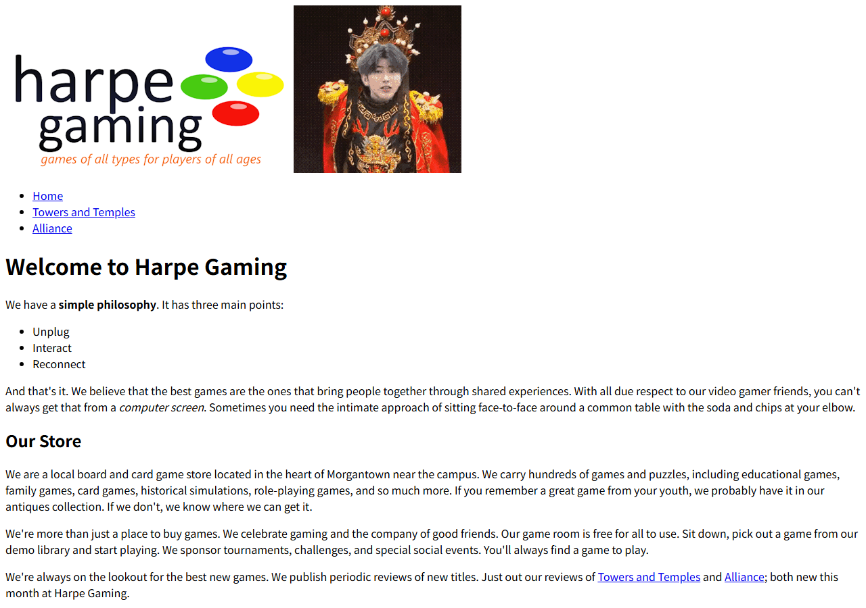
（hg_towers.html）运行效果
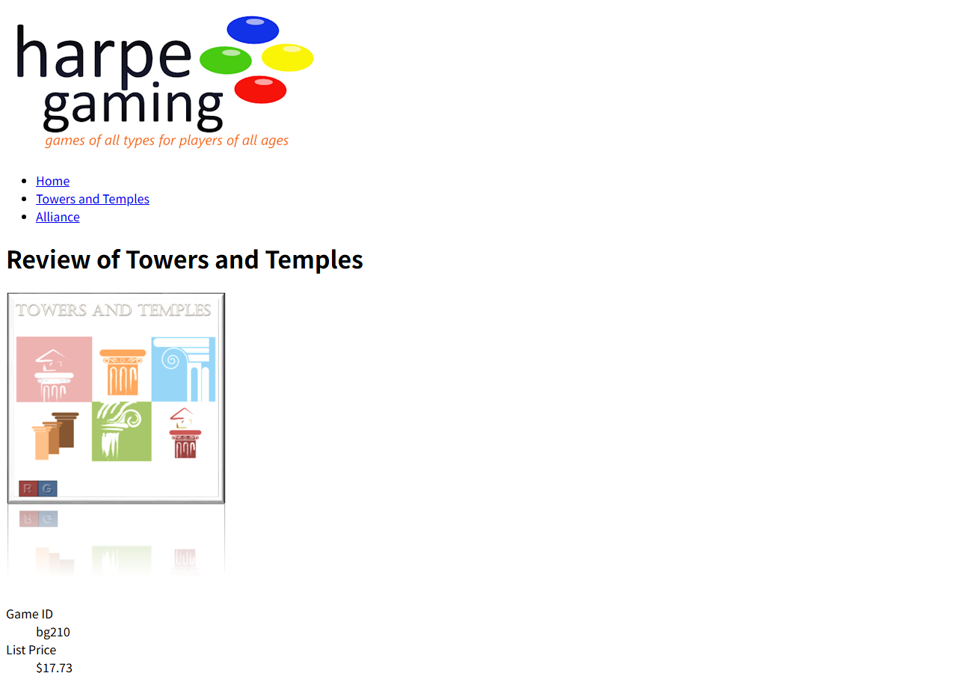
（hg_alliance.html）运行效果


