班级：nz244 姓名：兰锐天 学号：247106

Lab 5 HTML5

- 实验目的
To practice the HTML5 skills you have learned so far
- 实验内容
Exercise 1 – The HTML5 Canvas
Your mission is to recreate the image displayed in the figure. The image features a delightful smiley face and some text, all skillfully drawn using the HTML5 Canvas element and JavaScript.

Exercise 2: HTML5 Geolocation
you will create a webpage that uses the HTML5 Geolocation API to get the client's location and displays this location on the webpage.

Exercise 3: Local Storage Lab: To-Do List with Local Storage
Create a simple to-do list where tasks can be added and removed. The list should be saved in Local Storage so that tasks persist even after the browser is closed
三、实验结果
核心代码：
Exercise 1 - exercise1.html
<!DOCTYPE html>
<html>
<head>
<style>
body { background-color: #90EE90; margin: 0; }
</style>
<meta charset="UTF-8">
<title>Smiley</title>
</head>
<body>
<canvas id="myCanvas" width="800" height="900"></canvas>
<script>
const canvas = document.getElementById('myCanvas');
const ctx = canvas.getContext('2d');
ctx.fillStyle = '#90EE90';
ctx.fillRect(0, 0, canvas.width, canvas.height);

ctx.beginPath();
ctx.arc(400, 400, 300, 0, Math.PI * 2);
ctx.fillStyle = '#FFFF00';
ctx.fill();
ctx.lineWidth = 3;
ctx.strokeStyle = '#000000';
ctx.stroke();

ctx.beginPath();
ctx.arc(300, 300, 25, 0, Math.PI * 2);
ctx.fillStyle = '#000000';
ctx.fill();

ctx.beginPath();
ctx.arc(500, 300, 25, 0, Math.PI * 2);
ctx.fill();

ctx.beginPath();
ctx.moveTo(400, 400);
ctx.lineTo(400, 480);
ctx.lineWidth = 3;
ctx.strokeStyle = '#333333';
ctx.stroke();

ctx.beginPath();
ctx.arc(400, 470, 150, Math.PI * 0.15, Math.PI * 0.85);
ctx.lineWidth = 3;
ctx.strokeStyle = '#333333';
ctx.stroke();

ctx.font = 'bold 42px Arial';
ctx.fillStyle = '#006400';
ctx.textAlign = 'center';
ctx.fillText('The Canvas brought me to life!', 400, 800);

</script>
</body>
</html>
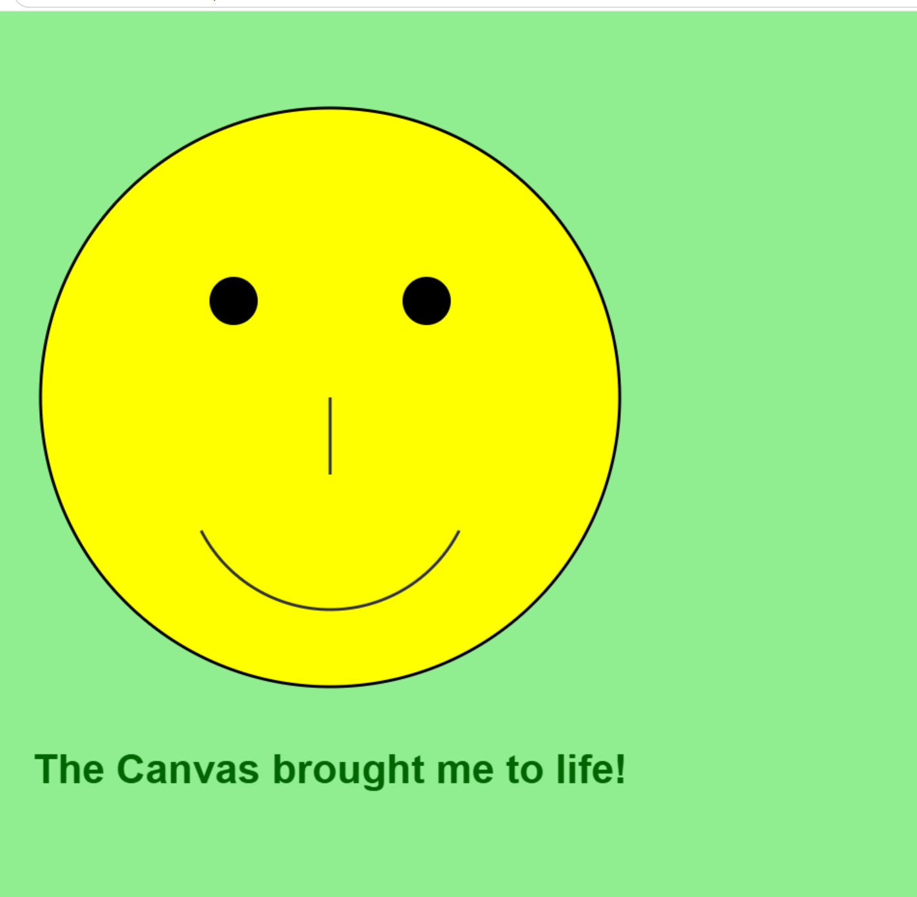
Exercise 2 - geolocation.html
<!DOCTYPE html>
<html>
<head>
<meta charset="UTF-8">
<title>Geolocation</title>
</head>
<body>
<button onclick="getGeolocation()">Get Geolocation</button>
<p id="geolocation"></p>
<script src="geolocation.js"></script>
</body>
</html>
Exercise 2 - geolocation.js
let x = document.getElementById("geolocation");

function getGeolocation() {
if (navigator.geolocation) {
navigator.geolocation.getCurrentPosition(showGeolocation);
} else {
x.innerHTML = "Geolocation is not supported by this browser.";
}
}

function showGeolocation(position) {
let lat = position.coords.latitude;
let lng = position.coords.longitude;
x.innerHTML = "Latitude: " + lat + "<br>Longitude: " + lng;
}
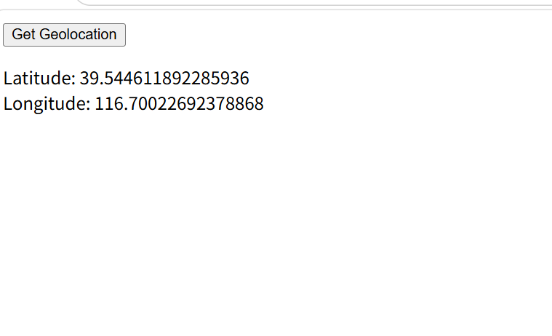
Exercise 3 - todo.html
<!DOCTYPE html>
<html>
<head>
<meta charset="UTF-8">
<title>To-Do List</title>
</head>
<body>
<h2>My To-Do List</h2>
<input type="text" id="taskInput" placeholder="Enter a task...">
<button onclick="addTask()">Add Task</button>
<ul id="taskList"></ul>
<script src="todo.js"></script>
</body>
</html>
Exercise 3 - todo.js
let tasks = JSON.parse(localStorage.getItem("tasks")) || [];

renderTasks();

function renderTasks() {
let ul = document.getElementById('taskList');
ul.innerHTML = "";
for (let i = 0; i < tasks.length; i++) {
let li = document.createElement('li');
li.textContent = tasks[i] + " ";
let delBtn = document.createElement('button');
delBtn.textContent = "Delete";
delBtn.onclick = function() {
deleteTask(i);
};
li.appendChild(delBtn);
ul.appendChild(li);
}
}

function addTask() {
let input = document.getElementById('taskInput');
let taskText = input.value.trim();
if (taskText === "") return;
tasks.push(taskText);
localStorage.setItem("tasks", JSON.stringify(tasks));
renderTasks();
input.value = "";
}

function deleteTask(index) {
tasks.splice(index, 1);
localStorage.setItem("tasks", JSON.stringify(tasks));
renderTasks();
}
