**LAPORAN PRAKTIKUM**

**DASAR PEMROGRAMAN**



**DISUSUN OLEH:**

**EKO RACHMAT SATRIYO (2100018142)**

**SABTU 07.30-KELAS C**

**PROGRAM STUDI TEKNIK INFORMATIKA**

**FAKULTAS TEKNOLOGI INDUSTRI**

**UNIVERSITAS AHMAD DAHLAN**

**DESEMBER 2021**

# PERCOBAAN I

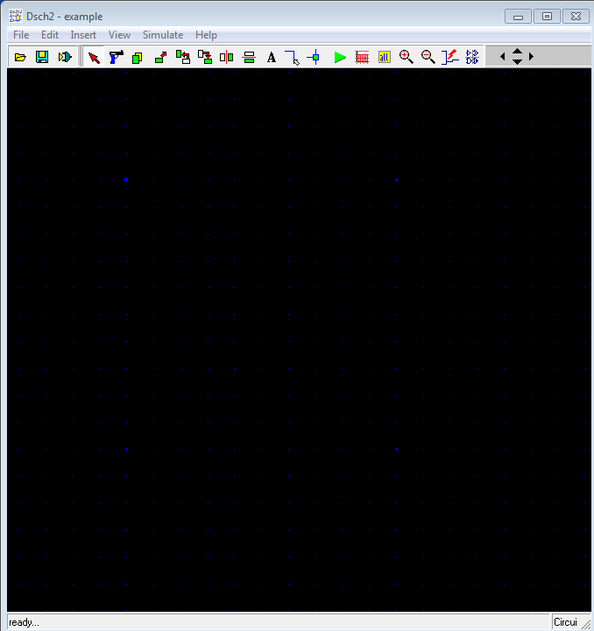

*Dsch2*

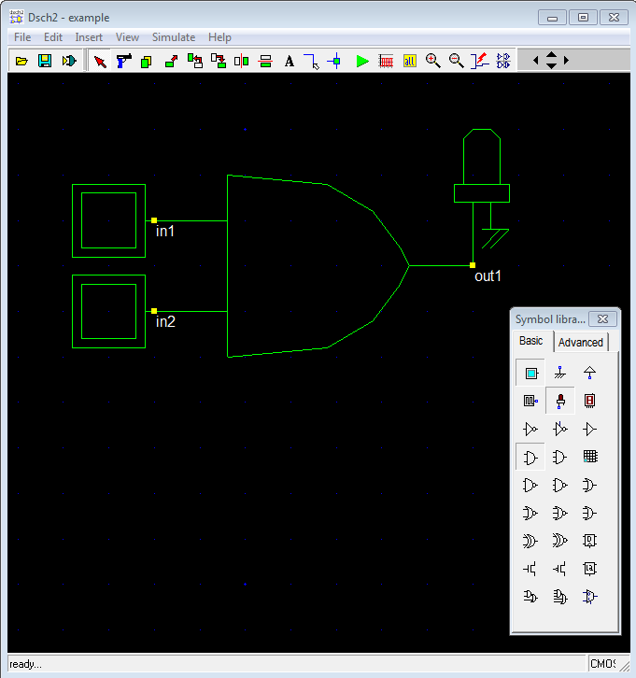

*Langkah b*

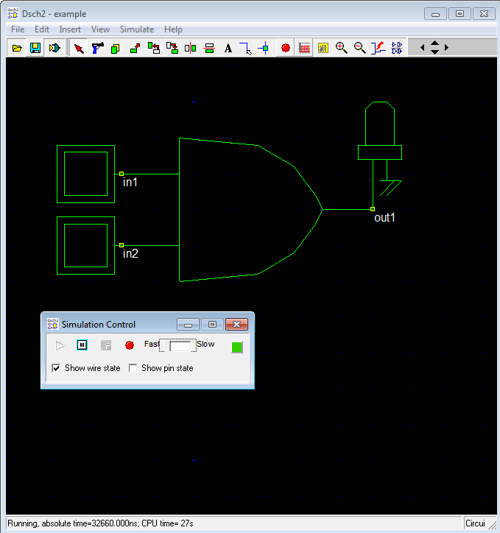

*Langkah c*

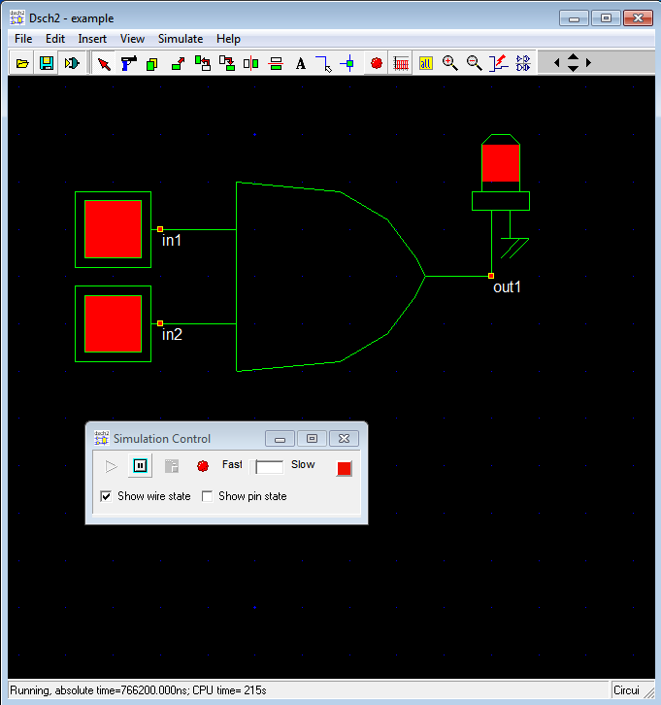

*In 1=1 in2=1 output=1*

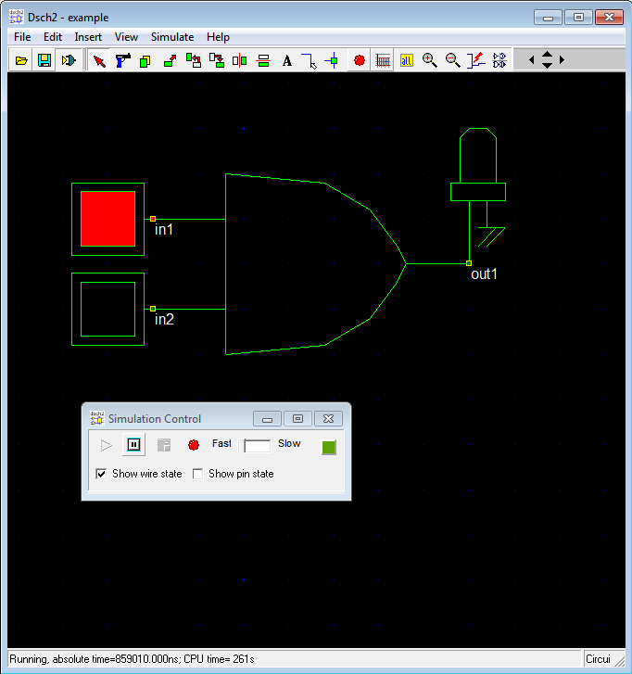

*In 1=1 in2=0 output=0*

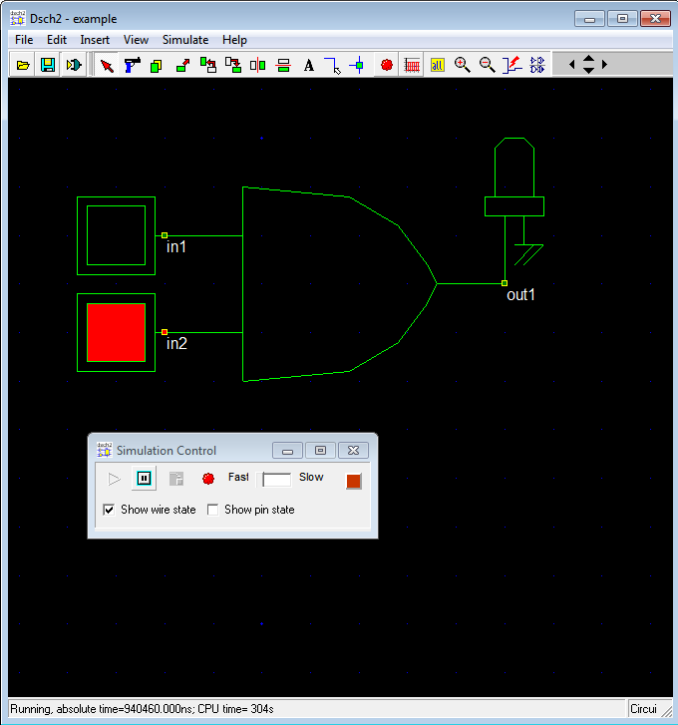

*In 1=0 in2=1 output=0*

*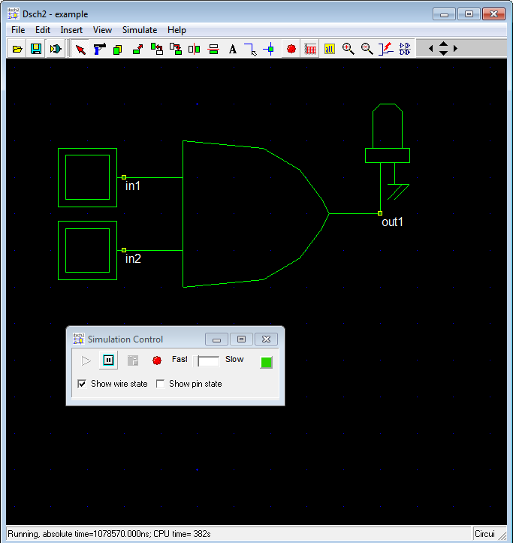In 1=0 in2=0 output=0*

# PERCOBAAN II

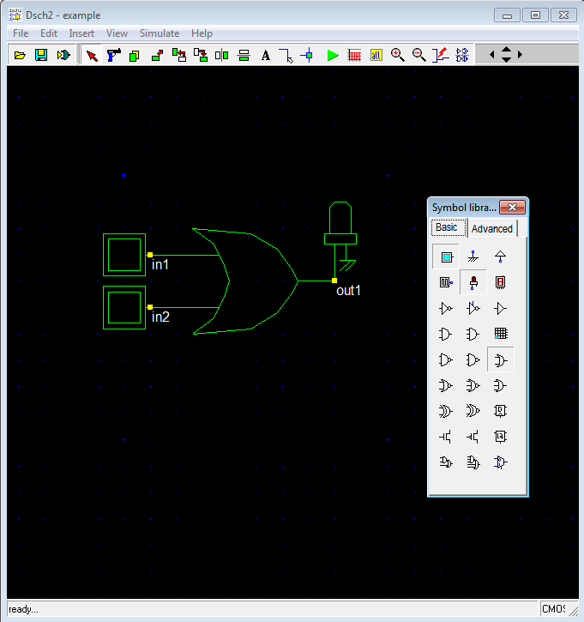

***Membuat rangkaian inputan or 2 inputan***

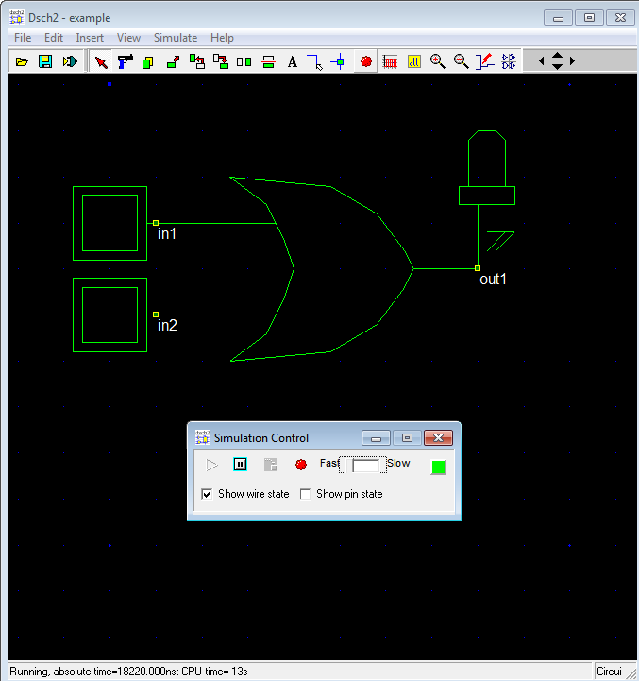

***Menjalankan program***

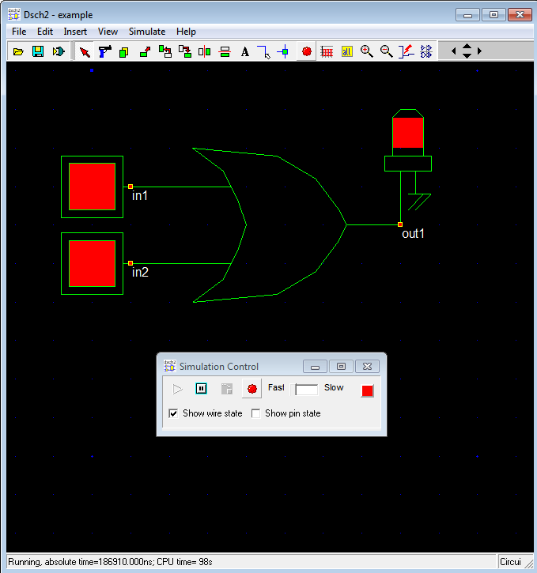

***1***

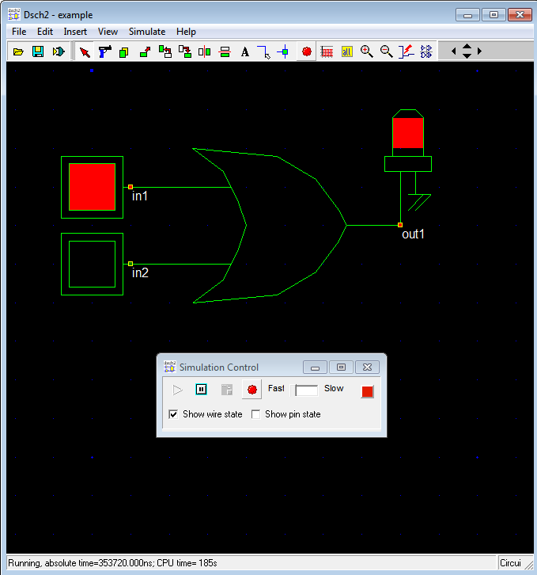

***2***

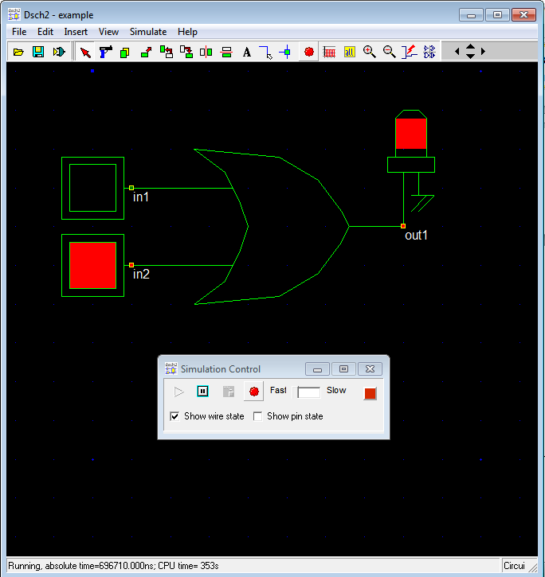

***3***

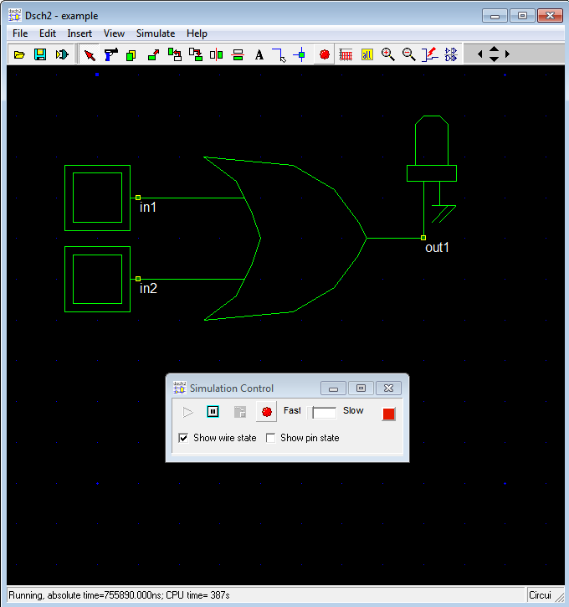

***4***

Hasil dari gambar diatas

|  |  |  |  |
| --- | --- | --- | --- |
| NO | IN1 | IN2 | OUT1 |
| 1 | 1 | 1 | 1 |
| 2 | 1 | 0 | 1 |
| 3 | 0 | 1 | 1 |
| 4 | 0 | 0 | 0 |

Tabel or 2 inputan

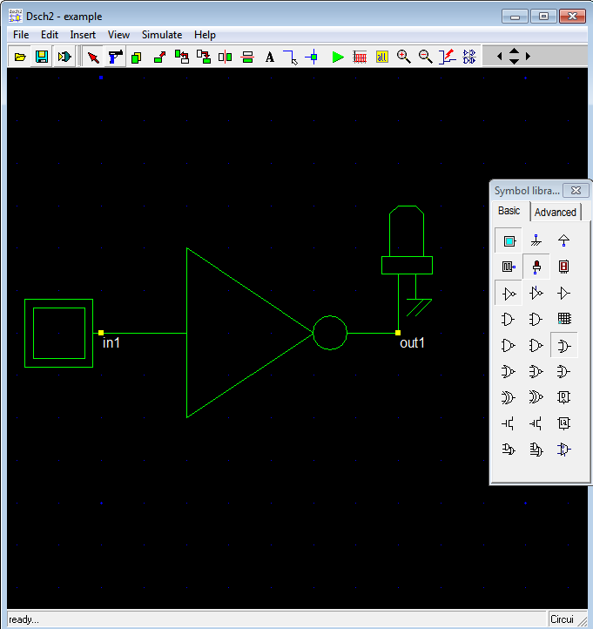

Rakitan not 1 inputan

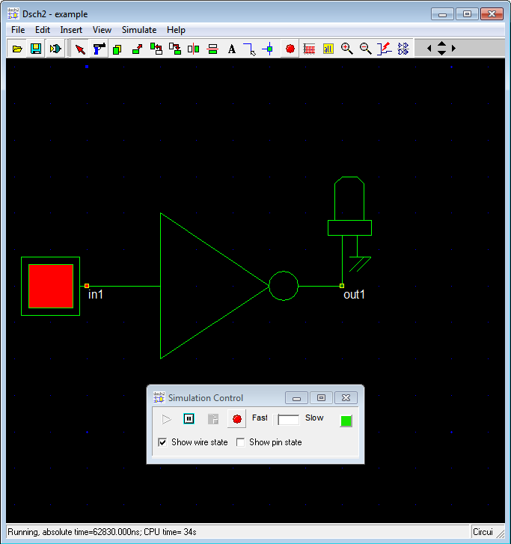

***1***

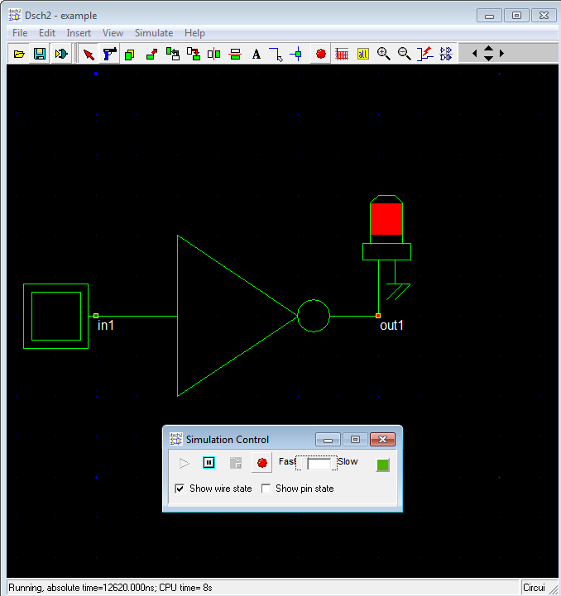

***2***

|  |  |  |
| --- | --- | --- |
| No | In1 | Out1 |
| 1 | 1 | 0 |
| 2 | 0 | 1 |

Tabel not 1 inputan

# PERCOBAAN III

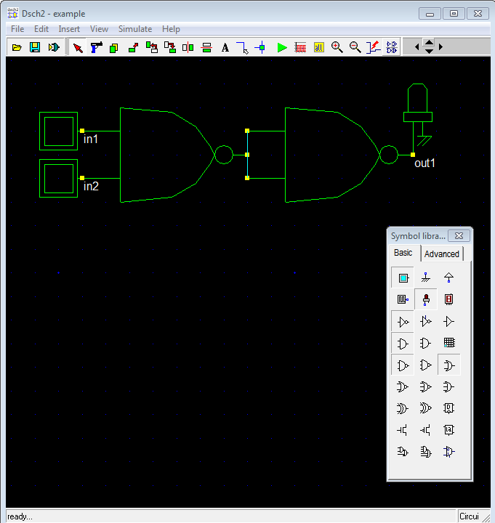

Membuat rangkaian logika

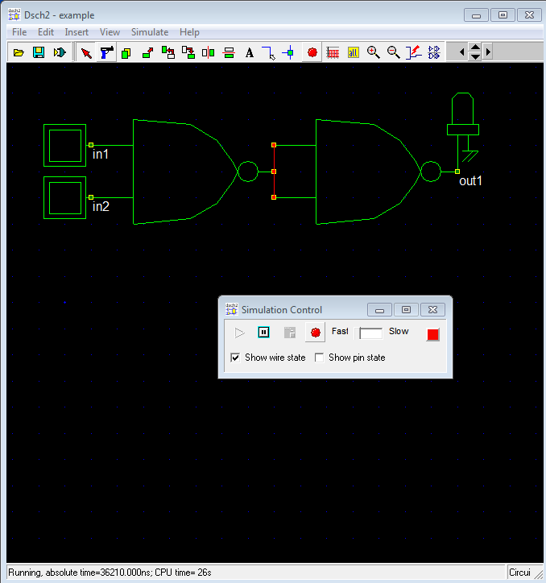

Menjalankan program

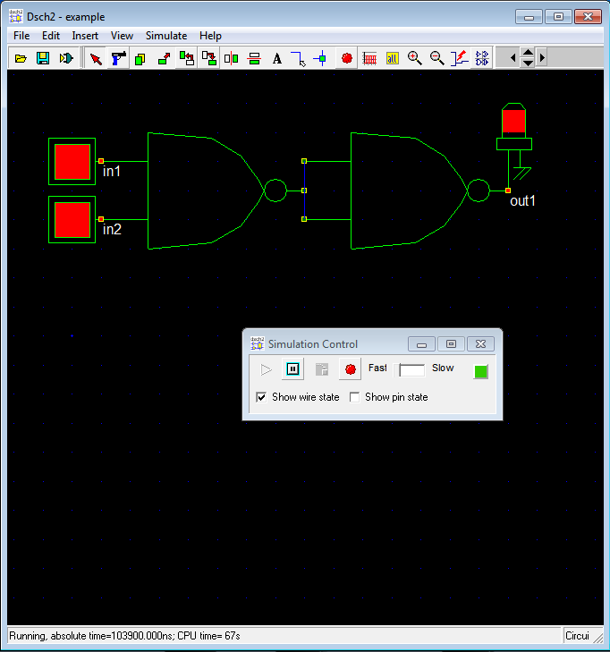

1

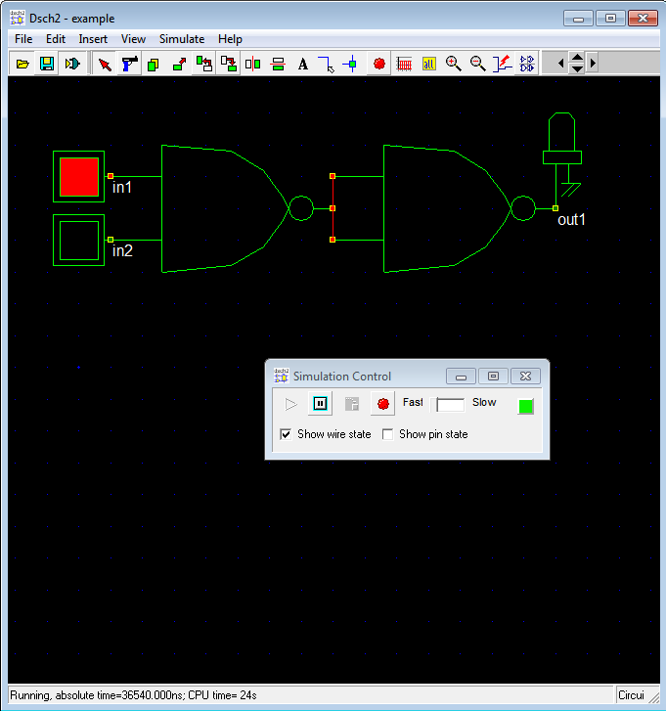

2

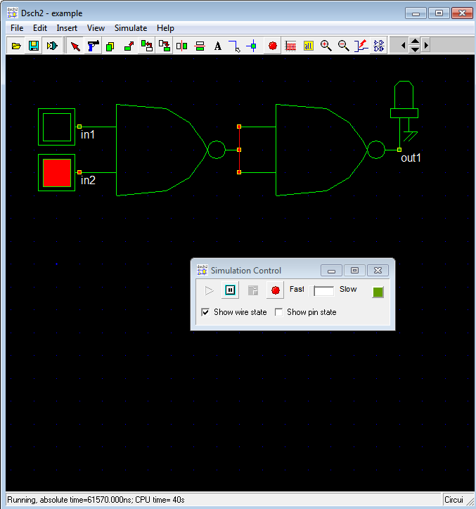

3

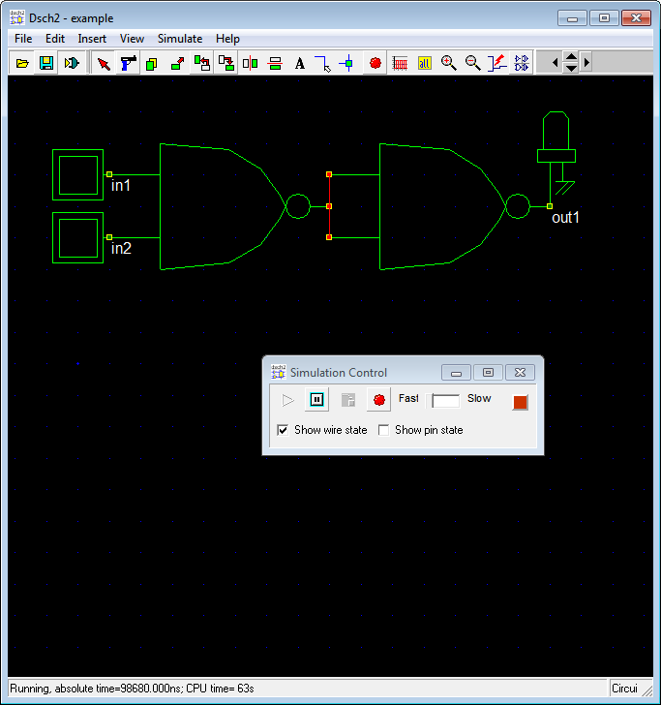

|  |  |  |  |
| --- | --- | --- | --- |
| NO | IN1 | IN2 | OUT1 |
| 1 | 1 | 1 | 1 |
| 2 | 1 | 0 | 0 |
| 3 | 0 | 1 | 0 |
| 4 | 0 | 0 | 0 |

4

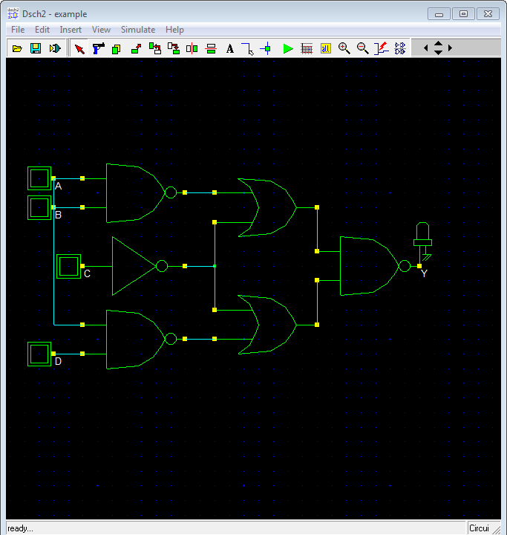

Membuat 4 inputan

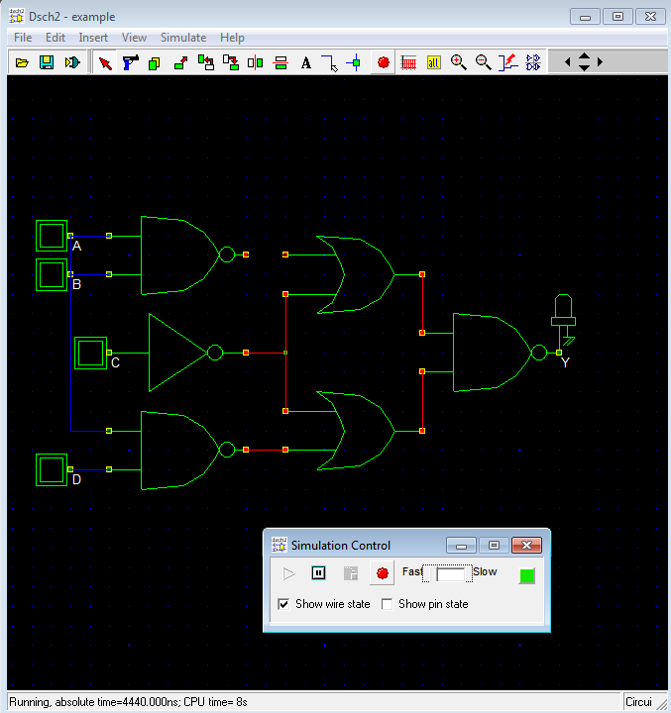

Menjalankan program

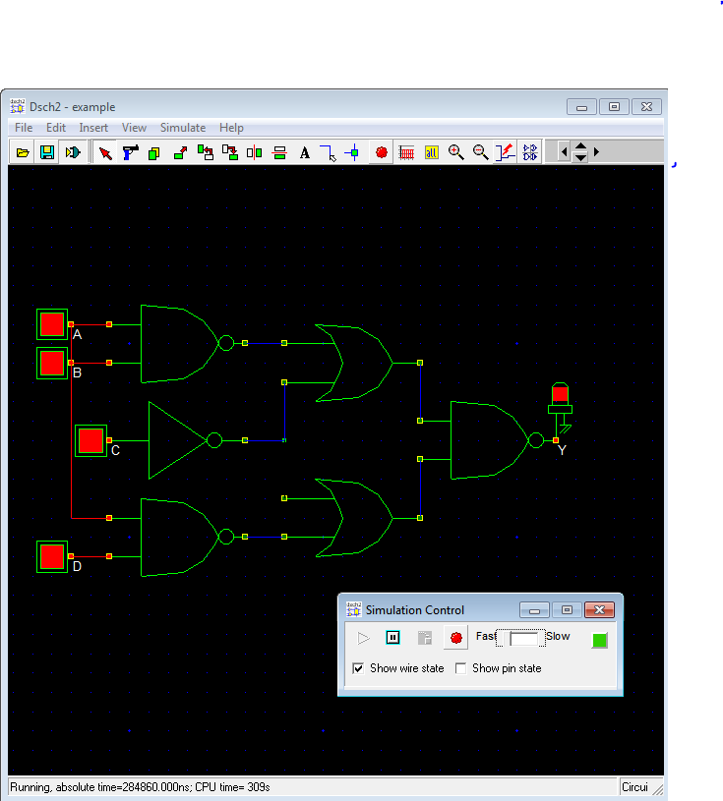

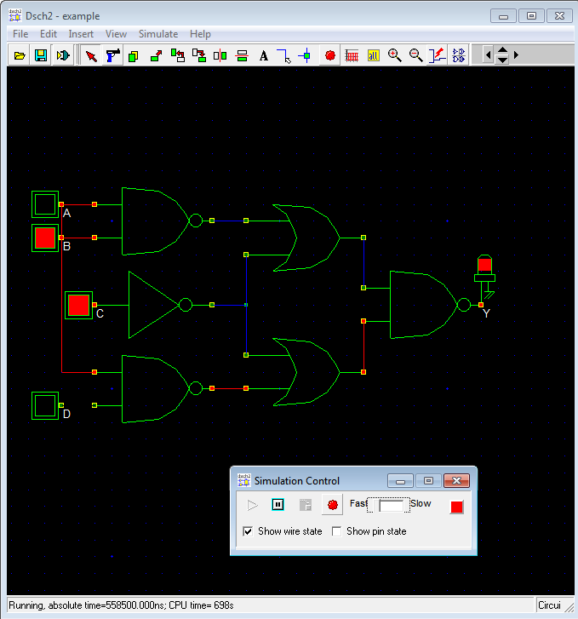

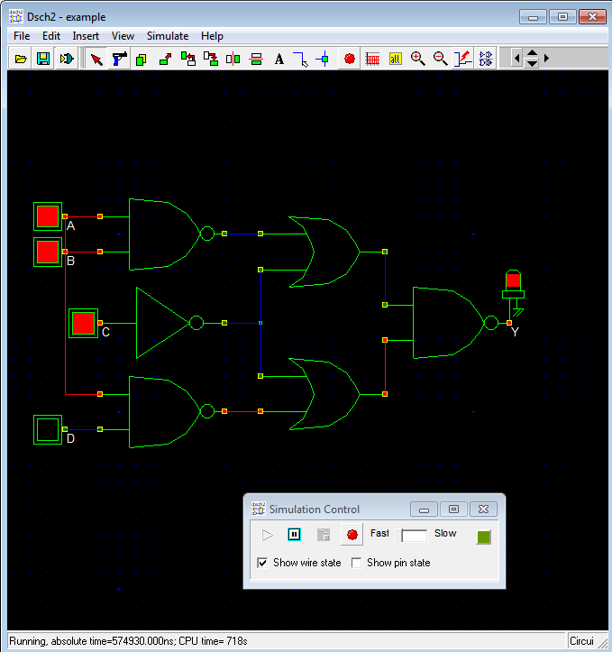

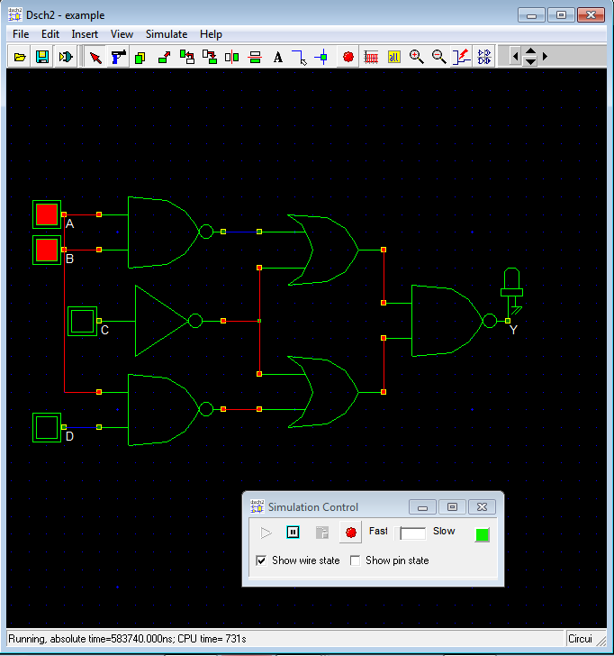

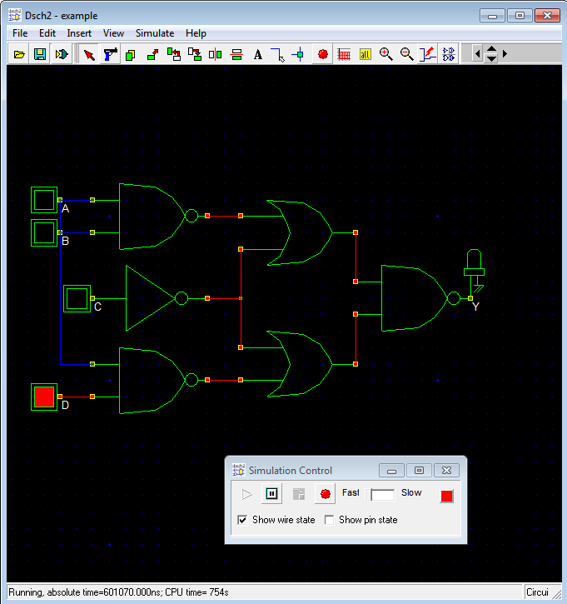

|  |  |  |  |  |
| --- | --- | --- | --- | --- |
| A | B | C | D | Y |
| 1 | 1 | 1 | 1 | 1 |
| 1 | 1 | 1 | 0 | 1 |
| 1 | 1 | 0 | 1 | 0 |
| 1 | 1 | 0 | 0 | 0 |
| 1 | 0 | 1 | 1 | 0 |
| 1 | 0 | 1 | 0 | 0 |
| 1 | 0 | 0 | 1 | 0 |
| 1 | 0 | 0 | 0 | 0 |
| 0 | 1 | 1 | 1 | 1 |
| 0 | 1 | 1 | 0 | 1 |
| 0 | 1 | 0 | 1 | 0 |
| 0 | 1 | 0 | 0 | 0 |
| 0 | 0 | 1 | 1 | 0 |
| 0 | 0 | 1 | 0 | 0 |
| 0 | 0 | 0 | 1 | 0 |
| 0 | 0 | 0 | 0 | 0 |

Tabel 4 inputan