CS 142 Advanced Web Design: CSS and Usability Spring 2014
Peter LeBlanc, Jack Brennan, Brendan McOmber
Blog Diggity!
Version <1.0>

Table Of Contents
Time Log 3
Software Requirements Specifications 4
Introduction 4
Purpose 4
Definitions, acronyms, and abbreviations 4
Overall Description 4
Story Board 5
Assignment requirements 6
Specific requirements 7

Time Log
Estimated time to complete assignment => |  |  |  | ___20__ Hours | 30 hours
Date | Time Spent  (in hours) |  | Description | Author
04/23/14 | 3 |  | Built bootstrap template, make placeholders, repo etc | peter
04/25/14 | 4 |  | Database/php building, error debugging | all
04/28/14 | 4 |  | Group meeting, authoring login/user functionality | all
04/29/14 | 2 |  | Jquery plugin setup, project spec. doc., write user testing scripts | peter
5/01/14 | 4 |  | PHP database stuff | Brendan and Jack
5/02/14 | 2 |  | PHP database cont. | Jack
5/02/14 | 2 |  | First Round of Usability testing | All
5/05/14 | 4 |  | General Clean-up after test | All
5/05/14 | 1 |  | Second Round of Usability Testing | All
5/06/14 | 3 |  | General Clean-up after test | All
 |  |  | <=Total Time Spent

Software Requirements Specifications

Introduction

Purpose
The purpose of this document is to describe the requirement specification for the web site “Blog Diggity!”.
The intended audience for this document is the prospective developers of this site. The goal being that you can give this document to someone and they can make the site without having to ask any questions.
The web site to be created is Blog Diggity! A website where users can create an account, and post any link they like, and see them on the landing page as they are posted. There is no voting system, to make chance the only factor in what content is seen by a given user, unlike competitor sites.

Definitions, acronyms, and abbreviations
HTML – Hypertext markup language – used to define your conent.
PHP – Personal Home Page – language that helps to customize html.
CSS – Cascading Style Sheets – used to define the look of a web site.
Javascript- Scripting language – used to customize site features and look.
jQuery - extension of javascript – used for advanced fucntionality, visual and functional.
Bootstrap – API of CSS rules and Javascript plugins- used to template and format site, simplifying customization of layout.
W3 Validation – refers to both Html and CSS validation tool provided by the W3c.org. the html validator is located at:
http://validator.w3.org/
with the CSS validator located at:
http://jigsaw.w3.org/css-validator/

Overall Description
Blog Diggity! is a website where a user can either browse the front page, with assorted posts from registered users, or submit their own content. This is done in a libertarian fashion, where there is no filter as to what a user can post, as long as it is not illegal or dangerous content. If such a case arises, a user must contact the site administrator to have a post removed.
Registration gives users access to the ability to post content. There is no requirement that a user registers to access a submitted link in the landing page's stream of content.

Story Board
Landing page: users are shown content, and prompted to participate
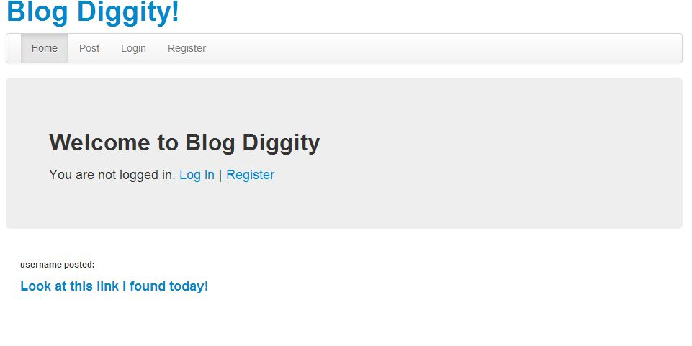
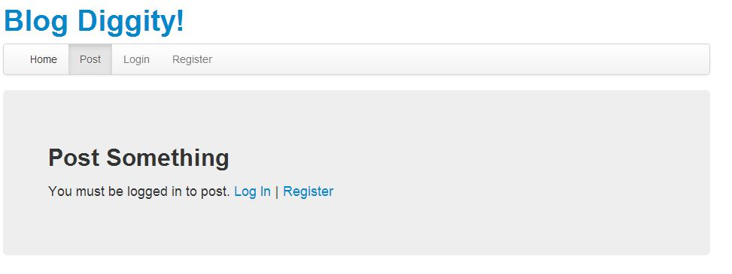
Login Page: when a user lands here, they log in and are redirected to post

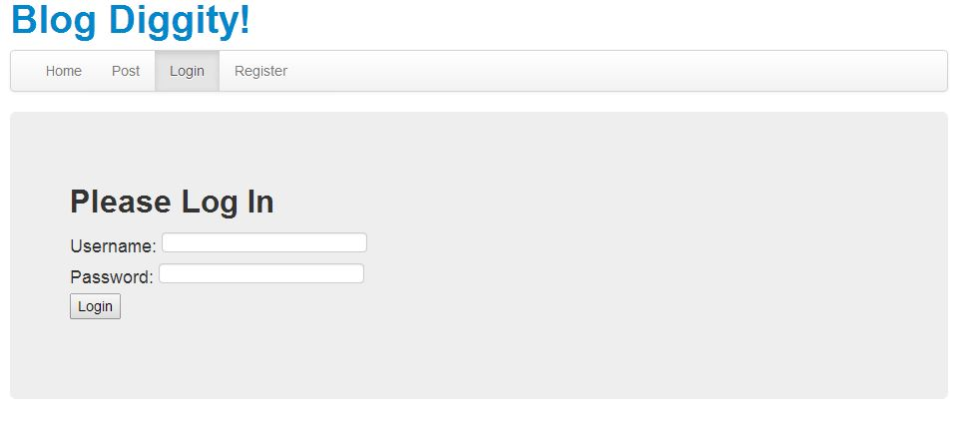
Post Page: This is where a user formats a post to be displayed on the landing page
Registration Page: A user is directed here to sign up to post content.
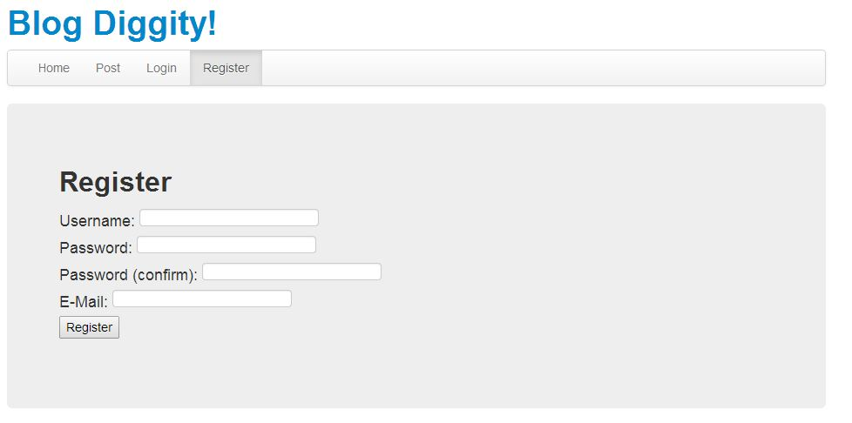

Assignment requirements
- Location – all files will be located in the public folder of your uvm account. The assignment web page and the submit process will detail the exact location. Failure to have your site located in the correct folder by the due dates will result in a zero on the assignment. Be sure to pay attention to the lowercase letters.
- Html Validation – All pages will pass W3C Html validation for html 5.
- CSS Validation – All pages will pass W3C CSS 3.0 validation (twitter bootstrap may be the cause for not passing validation)
- Meta Information – All pages will contain a proper title tag, Meta tags (author, character set and description).
- CSS – all pages will have a linked style sheet. Start off with my sample from the lectures.
- Navigation – All pages will contain navigation to all other pages on the site using an ordered list. Be sure to enclose the navigation in the correct element.
- Browser compatibility - This site will be checked on Firefox, Safari, Chrome and Internet Explorer.
- Responsive - This site will be checked on: http://quirktools.com/screenfly/

Specific requirements
- Posts from registered users are not filtered. Unlike competitor sites, there is no voting system, and content is on a first come, first serve basis.
- Background color: Use bootstrap's default background color to maintain simple elegance.
- Text color: Shades of black and gray permitted. Links are formatted to display with color #0088CC
- Content preview: Hovering over a posted link triggers a jQuery function to display a preview of the external link, for a user's safety.
- Registration: A user can view posted content, but can only contribute to the site after registration.
- Flag a post: There shall be a link to flag any post as a violation of the site's terms, to be forwarded to the site administrator.
- Descriptive Links: Validation will check that each link description is no more than 100 characters, to maintain the layout of the main page.
- Sticky form elements: Registration as well as log in information will be sticky on the form for data queries that do not validate

