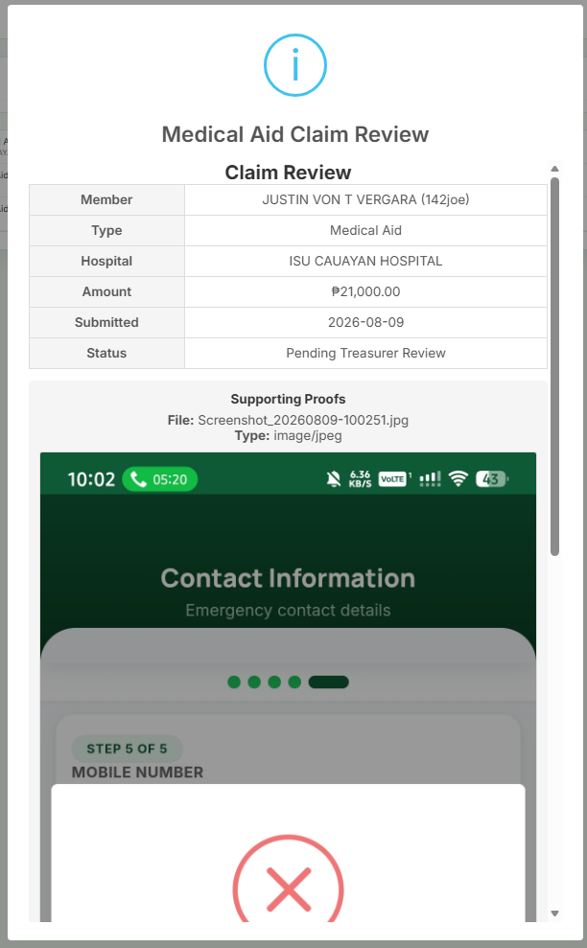
treasurer view when reviewing member sent medical aid
ADD
discharge and admission(if data is available then display, if not then "—")
Reason for hospitalization
Include Bill amount and expected Contribution amount per member on AMOUNT
_{example}
___________________________________________________________________
|AMOUNT | BILL AMOUNT: $AMOUNT / EXPECTED CONTRIBUTION AMOUNT : $AMOUNT |
___________________________________________________________________
_{📋 Updated Table View}
_{Field} | _{Value}
_{Member} | _{JUSTIN VON T VERGARA (142joe)}
_{Type} | _{Medical Aid}
_{Hospital} | _{ISU CAUAYAN HOSPITAL}
_{Reason for Hospitalization} | _{[Reason]}
Admission Date - Discharge Date | [Admission Date] or — Up To [ Discharge Date] or —
_{Amount} | BILL AMOUNT: ₱21,000.00 / EXPECTED CONTRIBUTION AMOUNT PER MEMBER: ₱[Amount]
_{Submitted} | ₂₀₂₆₋₀₈₋₀₉
_{Status} | _{Pending Treasurer Review}
_{💡 Simple Rules}
- Missing Dates: If admission or discharge dates are missing, display —.
- Hospital Reason: Show the reason entered by the member.
- Amount Line: Display both the total bill and the per-member payment side-by-side in the Amount row.

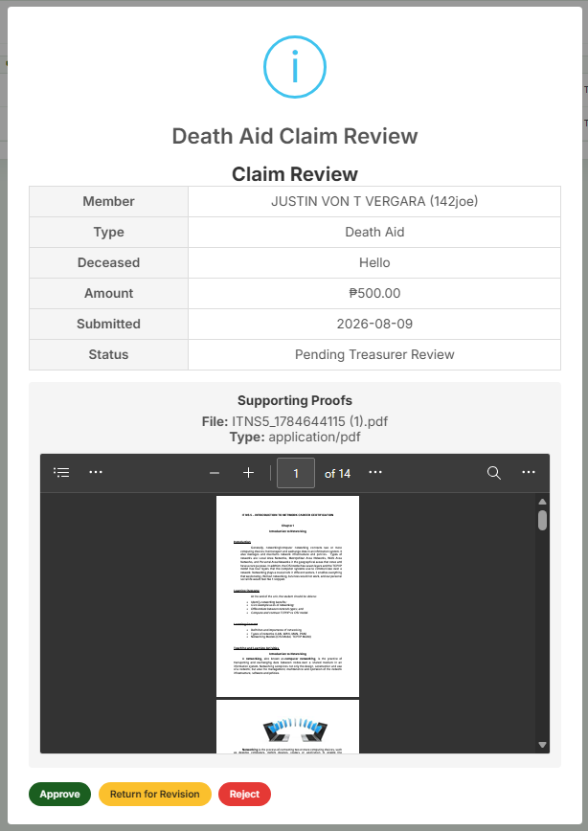
treasurer view when reviewing member sent death aid
ADD
Dateof death
Relationship
Name of deceased
Claimant {auto "member" if member filed and dependant is the deceased}
📋 Updated Table View
Field | Value
Member | JUSTIN VON T VERGARA (142joe)
Claimant | Member
Name of Deceased | [ Full Name ]
Relationship | [ e.g., Spouse / Parent / Child ]
Date of Death | [ YYYY-MM-DD ]
Type | Death Aid
Amount | ₱500.00
Submitted | 2026-08-09
Status | Pending Treasurer Review
💡 Simple Rules
- Claimant: Auto-fills as "Member" if the member is filing for a deceased dependent.
- Deceased Details: Replaces the generic "Deceased" label with Name of Deceased, Relationship, and Date of Death for clear verification.

Auditor
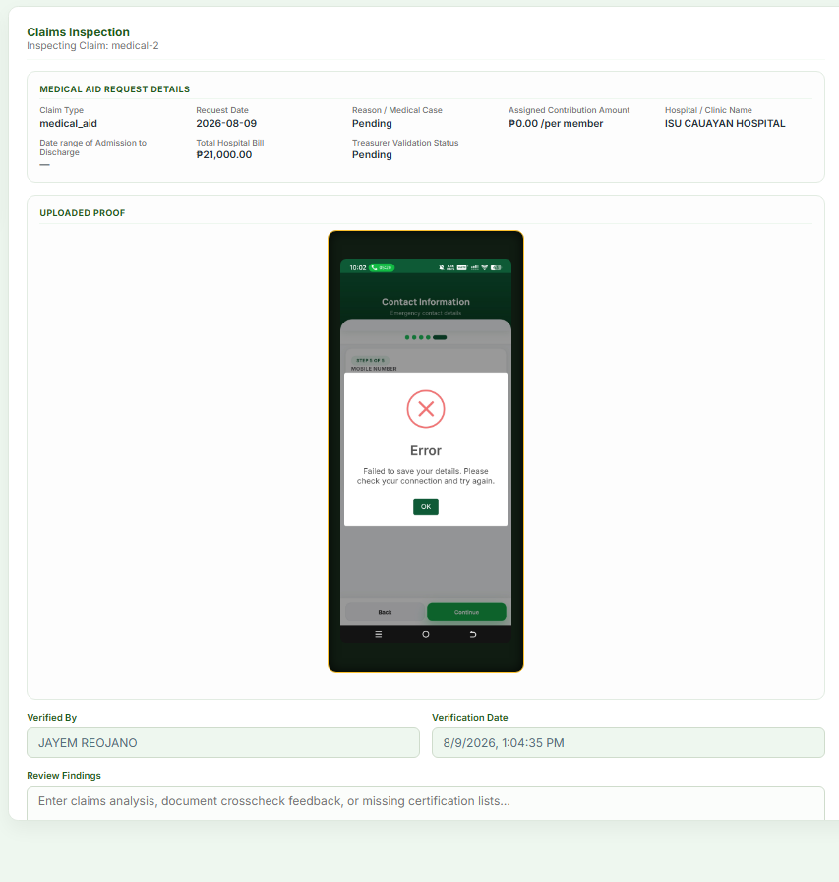

Auditor Claims Inspection panel ISSUE:
1.Assigned Contribution Amount is set to 0.00 per member, should be the correct contribution amount
2.Date of Admission and Discharge is not being displayed
-possible cause and fix: dates of admission and discharge are being stored in separate columns, create a js func to take 2 separate ####-##-## date and combine them in a ####-##-##(admission) to ####-##-##(discharge) format to display on the frontend
3.Remove "treasure validation status: $status"

Claim 1 — "Assigned Contribution Amount = 0.00" — TRUE
Member-submitted medical aid claims store validated_aid_amount=0 (member_views.py:945). The auditor backend serializes it as a string "0.00" (auditor_views.py:469), and the panel JS picks it first in a || chain — a non-empty string "0.00" is truthy, so it never falls through to reqAmount (auditor_views.py:472), which holds the real requested amount:
item.validated_aid_amount || item.reqAmount || item.requested_amount || 0 // "0.00" wins
(static/js/Auditor/aid_inspection_panel.js:80-87)
Fix: either show the policy amount (get_medical_aid_contribution_amount() in policy_constants.py:131) when validated is 0, or make the JS treat "0"/"0.00" as falsy so it falls back to reqAmount.

Claim 2 — "Admission/Discharge dates not displayed" — TRUE, but the proposed fix is INCOMPLETE
The model has both a legacy hospital_date CharField and separate admission_date/discharge_date DateFields (models.py:662, 664-665). Member submissions populate only admission_date/discharge_date (member_views.py:938-939), leaving hospital_date null. The panel reads only item.hospital_date (aid_inspection_panel.js:110-113) → shows "—".
Critical gap in the auditor's proposed fix: a JS function cannot combine two dates it never receives. The auditor backend serialization (auditor_views.py:463-472) sends hospital_date but not admission_date/discharge_date. The fix needs two parts:
1. Backend — add admission_date/discharge_date to the serialized dict in auditor_views.py
2. Frontend — JS combines them into admission to discharge format, falling back to hospital_date for treasurer-encoded claims

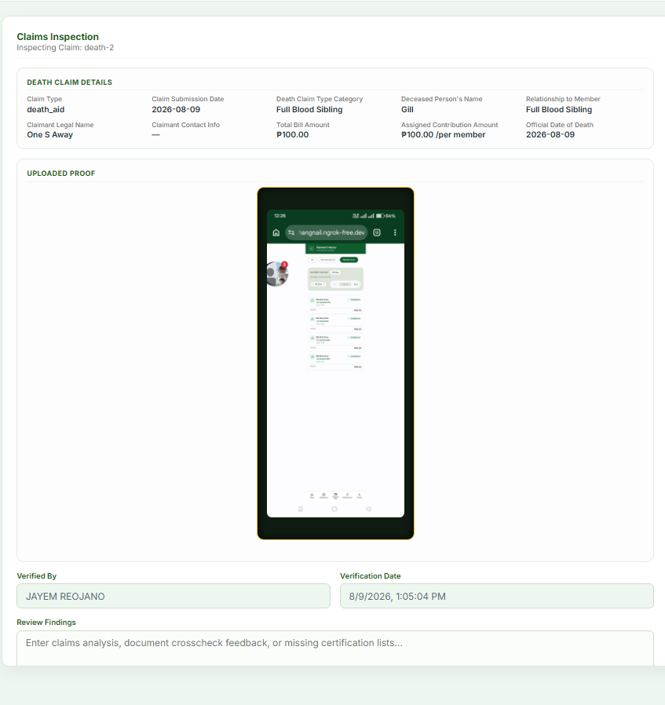
Auditor Claims Inspection panel ISSUE:
For death aid data, it has claim type, claim submission date , death claim type category, deceased persons name, relationship to member, claimants legal name, claimant contact info, total bill amount, assigned contribution amount, official date of death
but claimant contact info displays '—' instead of the member's member.contact_number
and add a js to not display the "total bill amount" when the data is death aid
📌 Auditor Claims Inspection Panel — Death Aid Adjustments
🔴 Issue
- Claimant Contact Info: Currently displays —.
- Fix: Update to fetch and display the member's contact number (member.contact_number).
⚙️ Display Logic Update
- Hide Total Bill Amount: Do not display the Total Bill Amount field when the claim type is Death Aid (death_aid).
📋 Complete Death Aid Field List
- Claim Type
- Claim Submission Date
- Death Claim Type Category
- Deceased Person's Name
- Relationship to Member
- Claimant's Legal Name
- Claimant Contact Info (Displays member.contact_number)
- Assigned Contribution Amount
- Official Date of Death
- ~Total Bill Amount~ (Hidden for Death Aid)

PRESIDENT
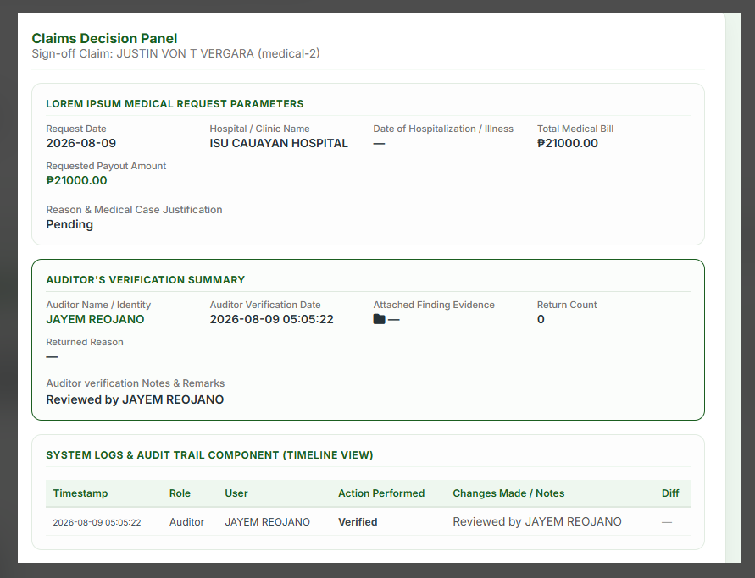
ADD/ISSUE/REMOVE/HIDE
-ISSUE Date of Hospitalization isn’t being displayed
-REMOVE Requested Payout Amount is displaying the bill amount
-ADD Reason for hospitalization isn’t displayed
-ADD Contribution amount per member isn’t displayed
-REMOVE/HIDE SYSTEM LOGS & AUDIT TRAIL COMPONENT
-"Auditor's verification summary" TURN INTO "Auditor Verification"
--KEEP Auditor Name(turn into "Officer Name"), Verification Date, and Auditor Verification Notes and Remark(turn into just "Auditor Note"), REMOVE/HIDE attached finding evidence, return count, returned reason

📌 1. Claim Details Adjustments
- ISSUE: Date of Hospitalization isn’t being displayed
- REMOVE: Requested Payout Amount (currently displaying the bill amount)
- ADD: Reason for hospitalization
- ADD: Contribution amount per member
📌 2. Section Update: Auditor Verification
- RENAME SECTION: Change "Auditor's verification summary" $→$ "Auditor Verification"
Fields to Keep & Rename:
- Auditor Name $→$ Rename to Officer Name
- Verification Date $→$ Keep as Verification Date
- Auditor Verification Notes and Remark $→$ Rename to Auditor Note
Fields to Remove / Hide:
- Attached finding evidence
- Return count
- Returned reason
📌 3. Hidden Components
- REMOVE / HIDE: SYSTEM LOGS & AUDIT TRAIL COMPONENT

TREASURER RECORD CONTRIBUTION
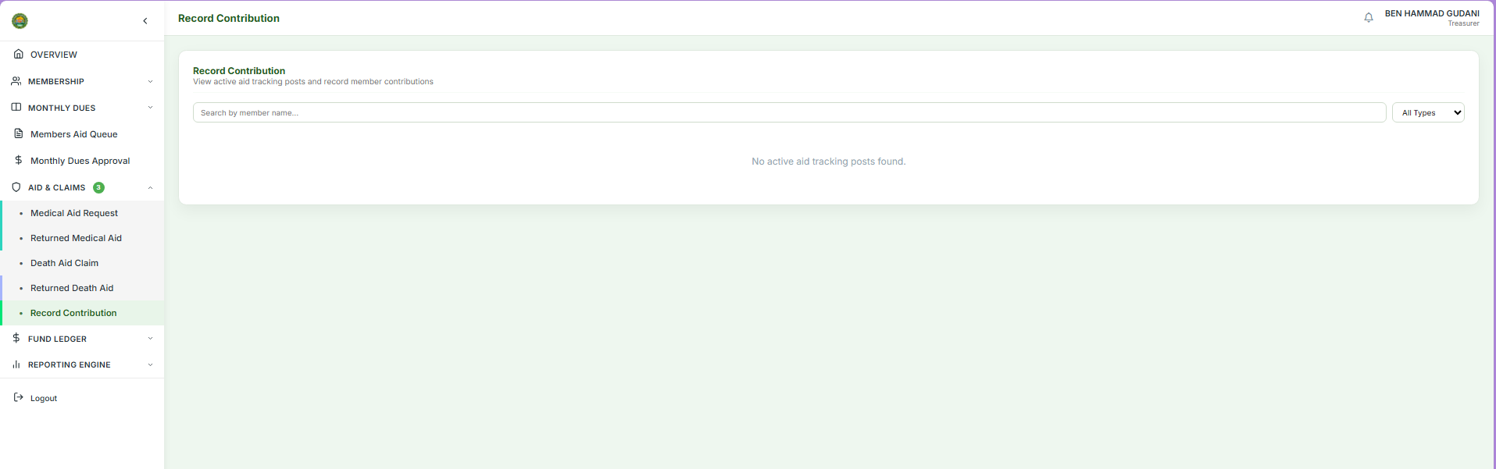
Dot appeared but "No active aid tracking posts found." Displays on Record Contribution, needs to refresh to display,
What works: green dot + count works without page refresh
IT SHOULD: auto display post data cards without page refresh on Record Contribution tab
📌 Record Contribution Tab — Post Auto-Load Issue

🔴 Current Behavior
- Green dot indicator and count update correctly without page refresh.
- Post data cards do not display automatically, showing "No active aid tracking posts found."
- Requires a manual page refresh to show the post data.
🟢 Expected Behavior
- Post data cards should auto-display on the Record Contribution tab as soon as data is available, without requiring a manual page refresh.

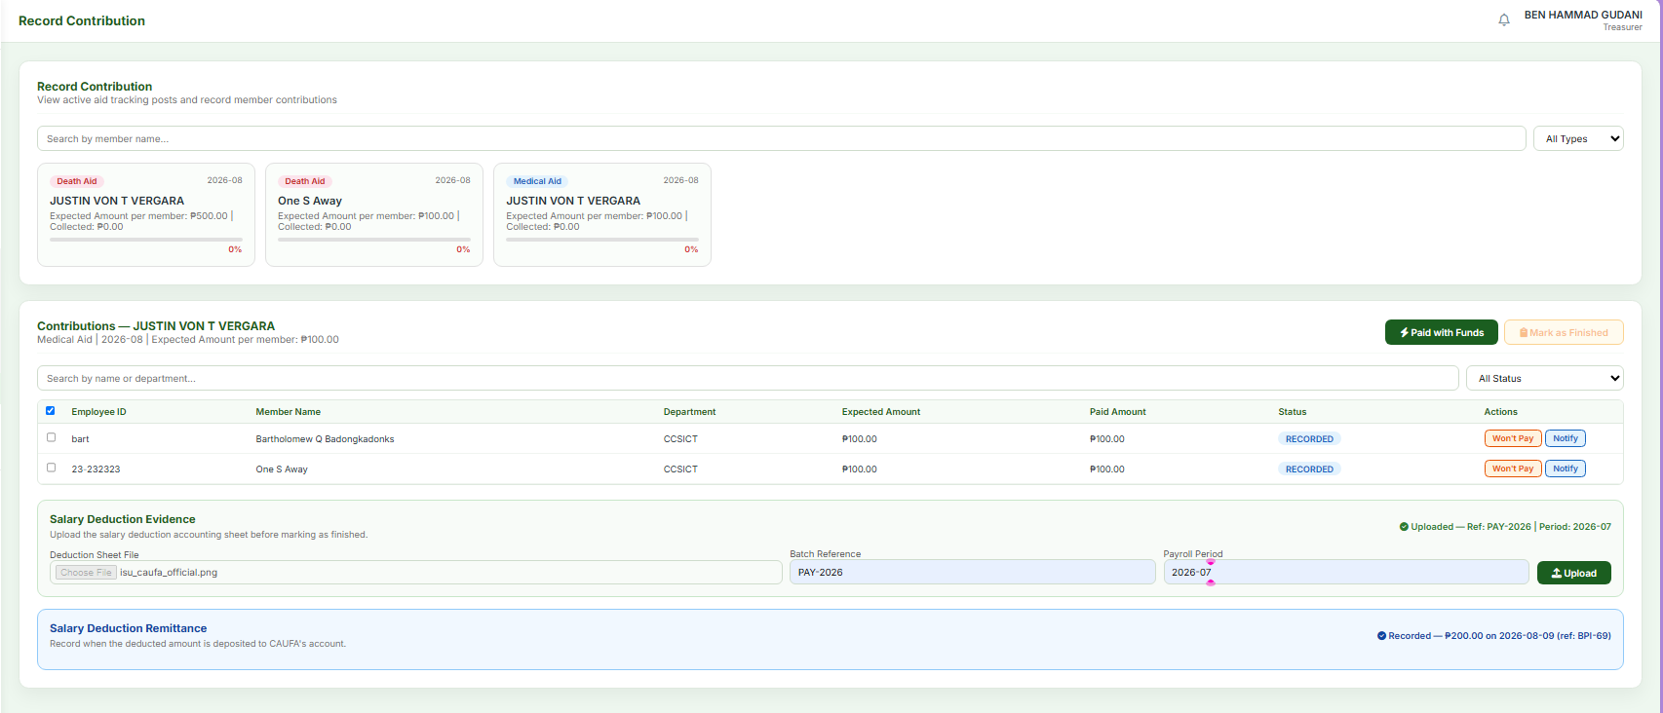
Operation:

User must interact with Salary Deduction Evidence and Salary Deduction Remittance first, the user must fill the Salary Deduction Evidence : Deduction Sheet File | Batch Reference | Payroll Period and Salary Deduction Remittance
After user uploads on Salary Deduction Evidence, the Salary Deduction Evidence "upload" button should be disabled if the user already has an uploaded data
AFTER all of those have been completed, MARK AS FINISHED button should enable automatically without page refresh
After MARK AS FINISHED is CLICKED, and have been verified by auditor and approved by president, the post card should auto update to the RELEASE post and RELEASE button should appear, this whole operation happens without refresh

📌 Operation & Workflow Specifications
🔄 Step-by-Step Flow
1. Required Uploads & Inputs (Prerequisite)
- User must interact with both Salary Deduction Evidence and Salary Deduction Remittance.
- Fill out Salary Deduction Evidence details:
  - Deduction Sheet File
  - Batch Reference
  - Payroll Period
- Upload Salary Deduction Remittance.
- Button Rule: Disable the Salary Deduction Evidence "Upload" button once data is uploaded.
2. Complete Submission
- Automatically enable the "MARK AS FINISHED" button as soon as all required uploads are complete.
3. Verification & Release
- User clicks "MARK AS FINISHED".
- Claim is verified by the Auditor and approved by the President.
- Post card transitions to the RELEASE post.
- The RELEASE button becomes visible.
⚡ Real-Time Behavior (No Page Refresh)

- Auto-Enable: "MARK AS FINISHED" button enables instantly when requirements are met.
- Auto-Update: Post card updates to RELEASE post status immediately upon final approval.
- Auto-Display: RELEASE button appears automatically without manual refresh.

