Monthly Dues Approval Queue
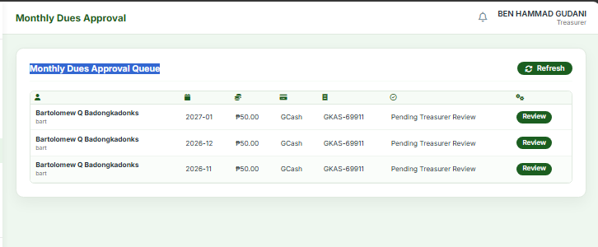
add checkboxes to select all or multiple monthly dues and verify selected
president issue:
Payments Verification: toast pop up saying "you have $count awaiting responses" but actual page doesn’t display data, it doesn’t auto display the data and needs page refresh in order to display data, filtering issue also removes the displayed data

Monthly dues
submit direct payment issue: user selected sept to dec, sept got approved and notified on in app notification, but no emails and the sept selection stayed on request salary deduction exemption

Monthly dues entry by treasurer using by salary deduction should follow treasurer> auditor> president pipeline and it shouldn’t go back to treasurer.
issue: president approved monthly dues salary deduction entry by treasurer goes back to Monthly Dues Approval Queue page
Issue Summary
Title: Monthly Dues Salary Deduction Loop Back After Final Approval
Expected Behavior
The approval pipeline for monthly dues entries via salary deduction must follow a strict, one-way progression:
$$\text{Treasurer}⟶\text{Auditor}⟶\text{President}$$
- Rule: Once approved by the President, the process is complete and must not route back to the Treasurer or re-enter the approval workflow.
Actual Behavior (Bug)
- When the President approves a monthly dues entry, the transaction unexpectedly returns to the Monthly Dues Approval Queue page instead of being finalized.

