# System Objectives

* Simplify process of book lending, returning and reservation by automating part of the process.
* Allow users to perform the following operations without assistance of a clerk:

1. Lending of books.
2. Returning of books.
3. Reservation of books.
4. Searching of books.
5. Register as a user.
6. Update user information.
7. View information of a specific book.

* Track and manage library assets.

# Functional Requirements

1. System
   1. All asset information and system parameters shall be stored at the database as to allow administrators to easily change them.
   2. All operations on database shall require credentials with sufficient security clearance.
   3. Effects of change to the overdue penalty formula shall be applied proactively.
   4. Password field of all users shall be encrypted as to allow administrators to change but not view users’ passwords.
2. Web Terminals
   1. Users shall be able to perform the following operations on web terminals:
      1. Reserve books.
      2. Search for books.
      3. View information of a specific book.
      4. Update user information.
   2. The terminal shall notify user of any books that is expiring soon or expired.
3. Self-service Terminals and Clerk terminals
   1. Users and clerks shall be able to perform the following operations on self-service terminals/clerk terminals:
      1. Lend books.
      2. Return books.
      3. Reserve books.
      4. Search for books.
      5. View information of a specific book.
      6. Register new users.
      7. Update user information.
   2. The terminal shall notify user of any books that is expiring soon or expired.
   3. Clerk shall be able to perform the following operations on clerk terminals:
      1. Registration of books.
   4. Administrators shall have the same clearance to perform operations as a clerk when logged in with a self-service or clerk terminal.
4. Administrative Terminals
   1. Administrative Terminals shall be only accessible in the same network as the database.
   2. Administrative Terminals shall be only accessible by administrator accounts.
   3. Administrators shall be able to directly access the database.
5. Financial Administrative Terminals
   1. Financial Administrators shall be able to perform the following options:
      1. Search for books.
      2. Drop books.
      3. Set book loss penalty of specific books.

# Non-Functional Requirements

1. The system must be able to respond to request without unsustainably queuing up requests under constant load of 1,000,000 simultaneous users.

# UML Diagrams

1. Class Diagram

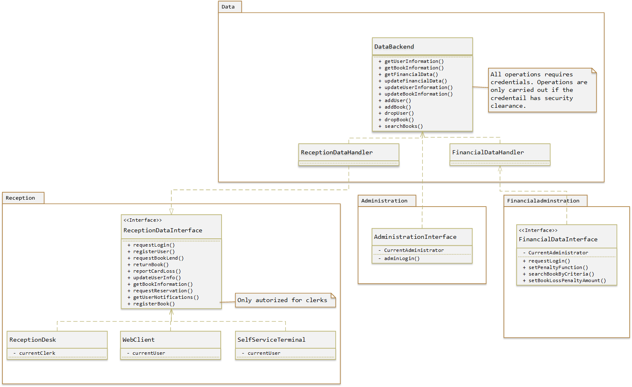

1. Data Flow Diagram
   1. Level 0

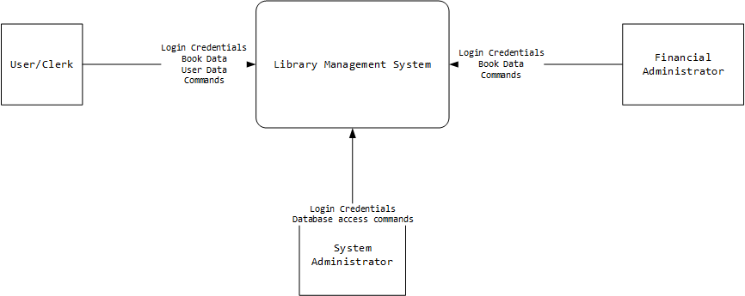

* 1. Level1

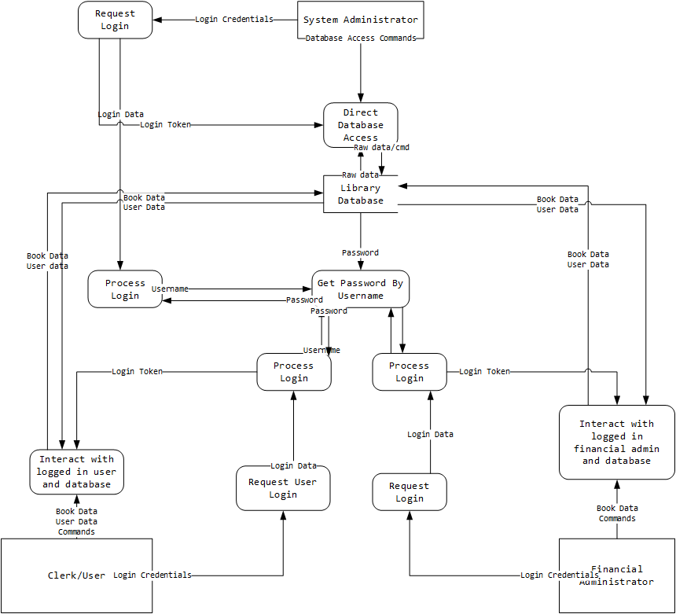

* 1. L2 - Interact with logged in user and database

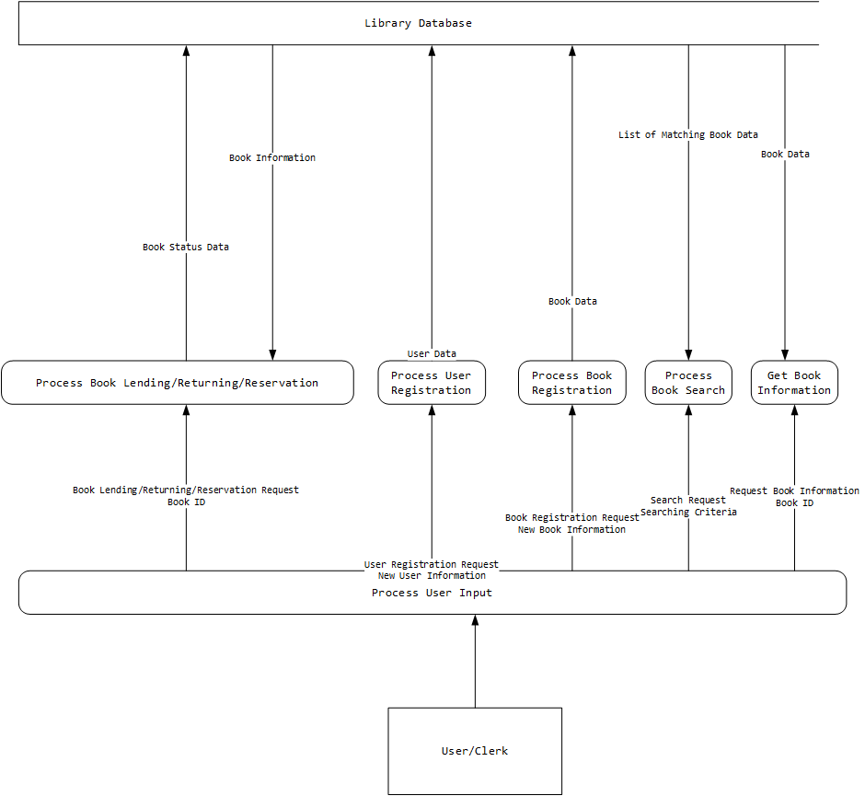

* 1. Interact with Financial Admin

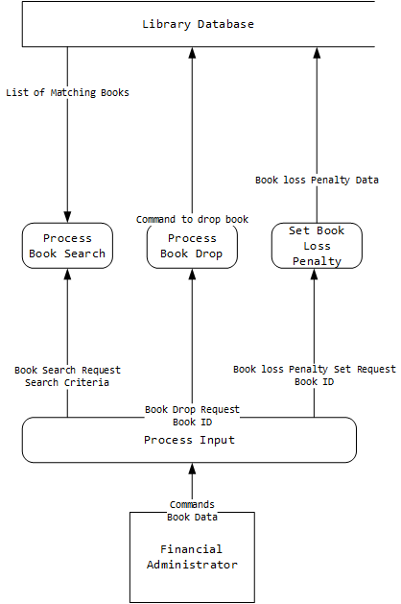

* 1. L3 – Get book information

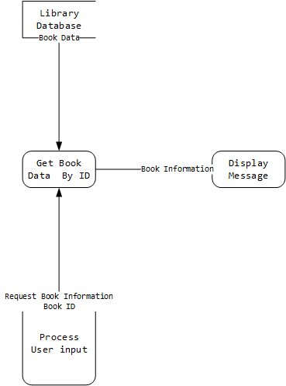

* 1. L3 – Process Book Drop

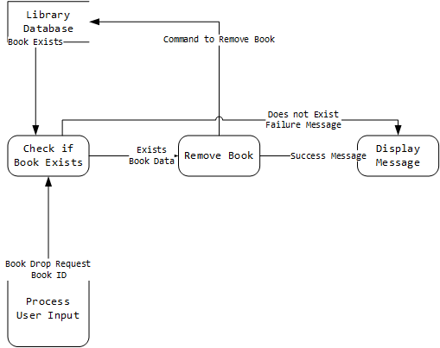

* 1. L3 – Process Book Lending/Returning/Reservation

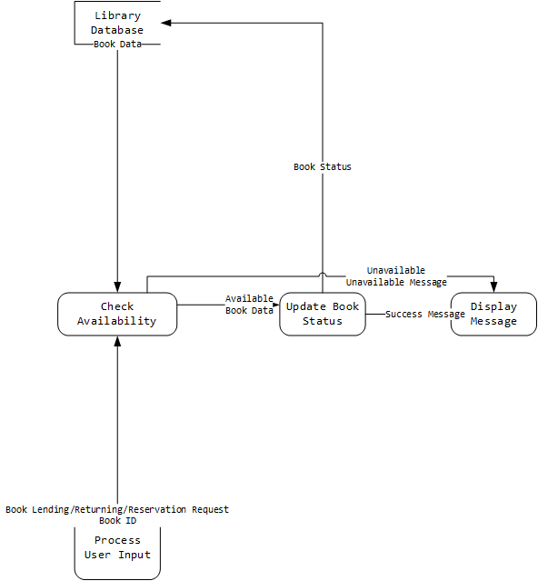

* 1. L3 – Process book registration

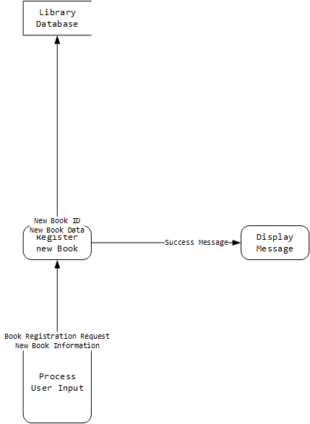

* 1. L3 – Process Book Search

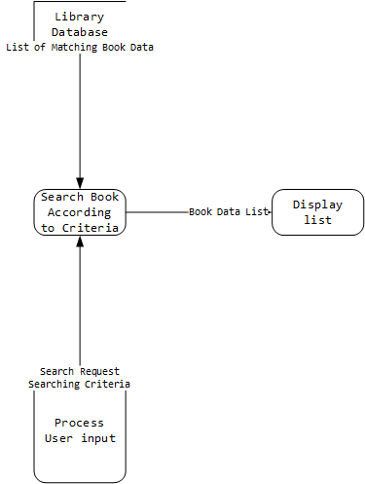

* 1. L3 – Process user registration

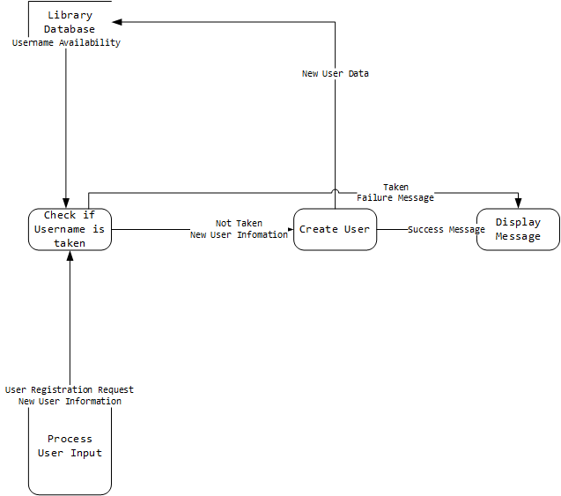

* 1. L3 – Set Book Loss Penalty

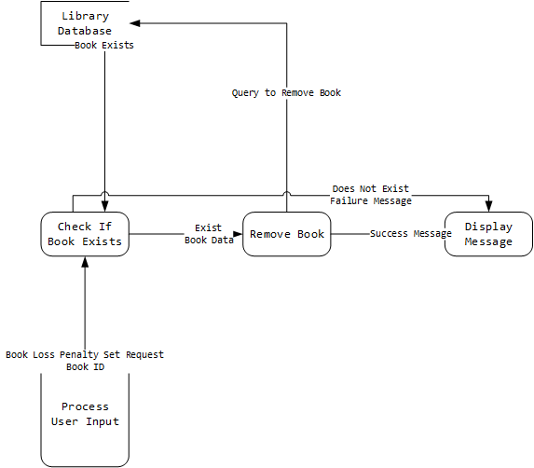

1. State Diagrams (Original diagrams available under Diagrams\StateDiagrams directory)
   1. Client/Self Service Terminals

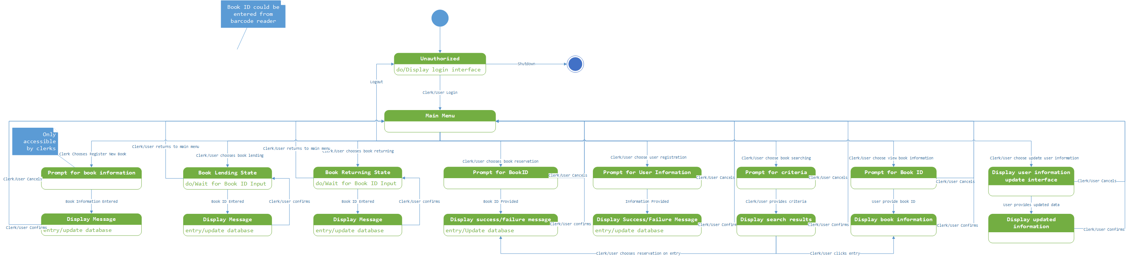

* 1. Financial Administrator Terminal

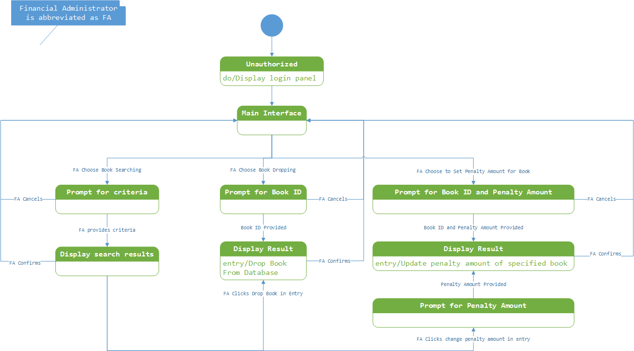

* 1. Web Terminal

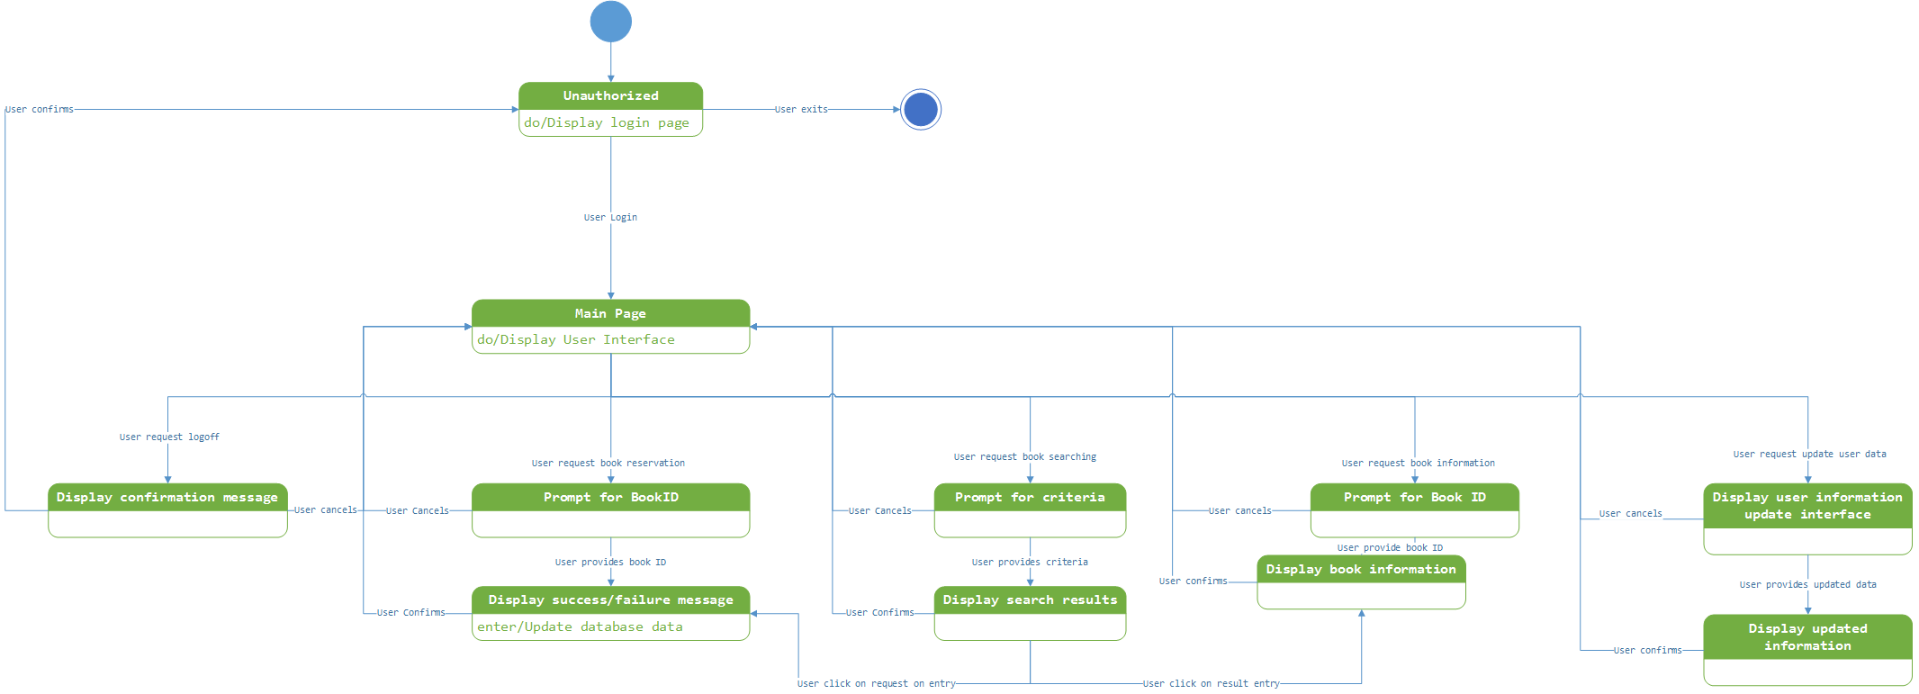

1. Use Case Diagram

