Scope Tutorial > Using Scope Studio

Author: Saveen Reddy

Date: 1/12/2015

**[THIS DOCUMENT IS UNDER MAJOR REVISION]**

# Preparation

1. Install Visual Studio 2013, 2012 or 2010 **Professional** or **Ultimate.**
2. Install **Scope Studio**: <http://aka.ms/ScopeStudioInstall>

You can now begin.

## Scope Studio Does Not Work On an x86 System

* Unfortunate, but true.
* Install it on a 64-bit OS.

# Creating a New Scope Project

Once you have installed Scope Studio, you'll see a new **SCOPE** menu item in Visual Studio

s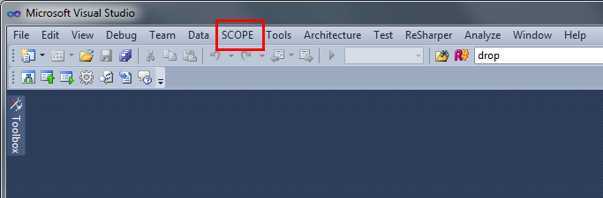

And when you create a new project…

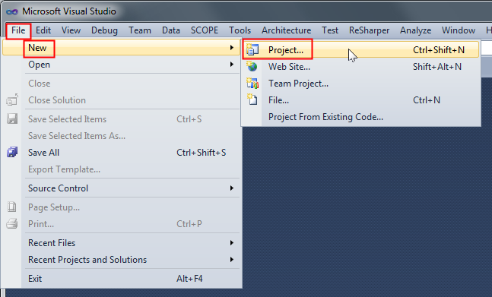

Under **Installed > Templates> Cosmos Scope**, you'll see a a project type called "Scope Application"

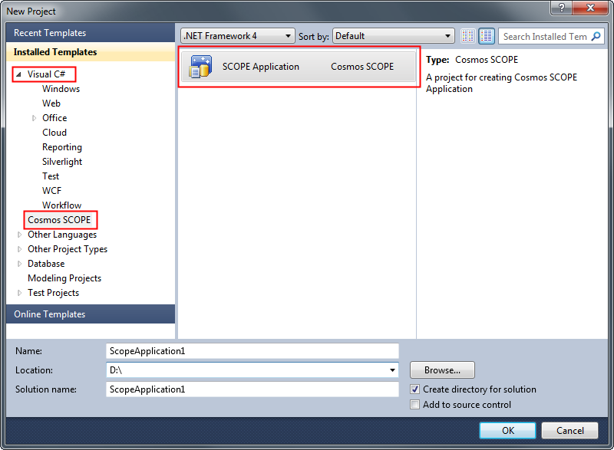

By default you'll get the following:

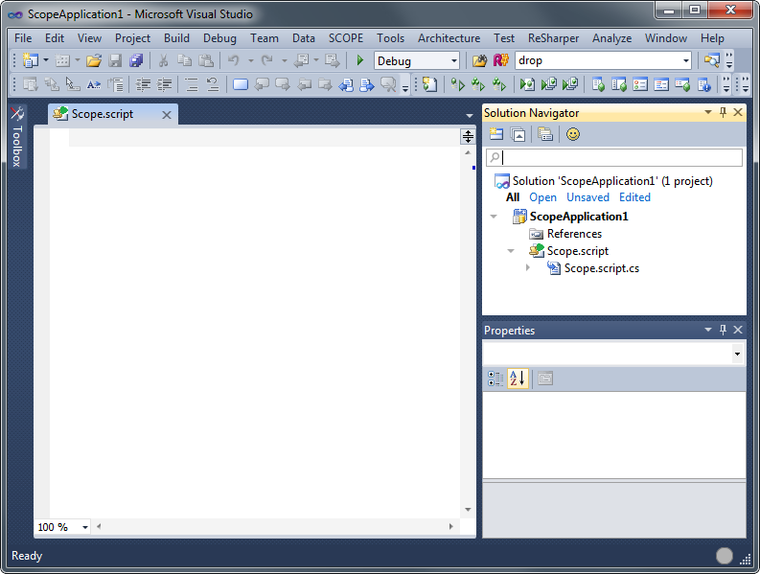

* A new Scope application
* An empty Scope script called "Scope.script"
* a C# code-behind file associated with that script "Scope.script.cs"

## Locally Running a Script

You can run and debug a script locally just as you would a C# project – just hit **F5**, etc.

If you try to run a script and there is an error, you'll get exactly what you expect: the **Error List** window will appear. Let's try running this empty script and you'll see.

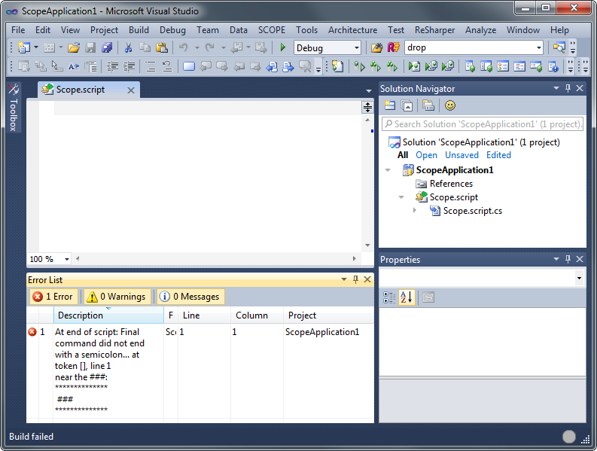

## Problems running the Tutorial Script?

Some users occasionally encounter a strange error: "Could not run the script locally due to internal error". It's unclear what causes this but the fix is straightforward. Just right-click on the script in the **Solution Explorer** and choose **Compile Script**. Things should work fine after that.

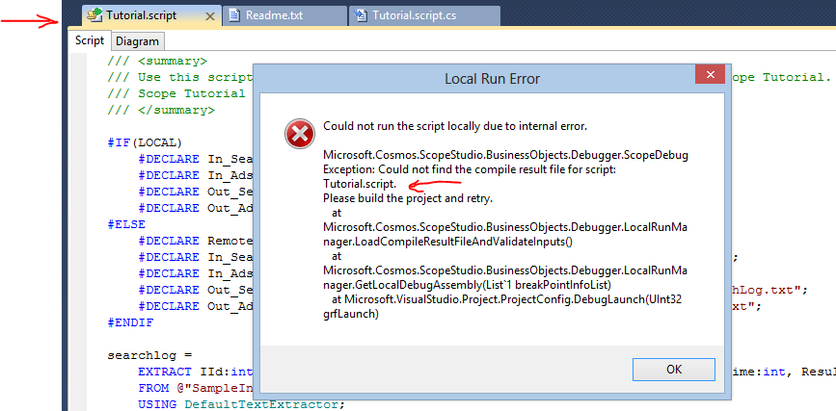

## Scope Studio Videos

We have many videos you can watch that demonstrate various Scope Studio features:

[http://sharepoint/sites/cosmos/Cosmos%20User%20Documentation/ScopeStudio%20Video%20Demo.aspx](http://sharepoint/sites/cosmos/Cosmos%20User%20Documentation/SCOPEStudio%20Video%20Demo.aspx)

## Running a Script Locally and Looking at the Output

Previously we ran an empty script and saw an error. Now that we have the solution open and have sample data, we can try running a script and learn the basic mechanics of using Scope Studio.

Clear out the Test script enter the code below:

searchlog =

EXTRACT UserId : int,

Start : DateTime,

Region : string,

Query : string,

Duration : int,

Urls : string,

ClickedUrls : string

FROM @"/my/SampleData/SearchLog.txt"

USING DefaultTextExtractor();

OUTPUT searchlog

TO @"/my/output.txt";

To run the script, use the **Start** button or hit F5.

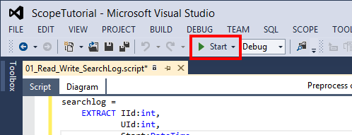

You will see a console window appear briefly. This is expected.

The script should run successfully. Now you will see the **Local Run Results** window.

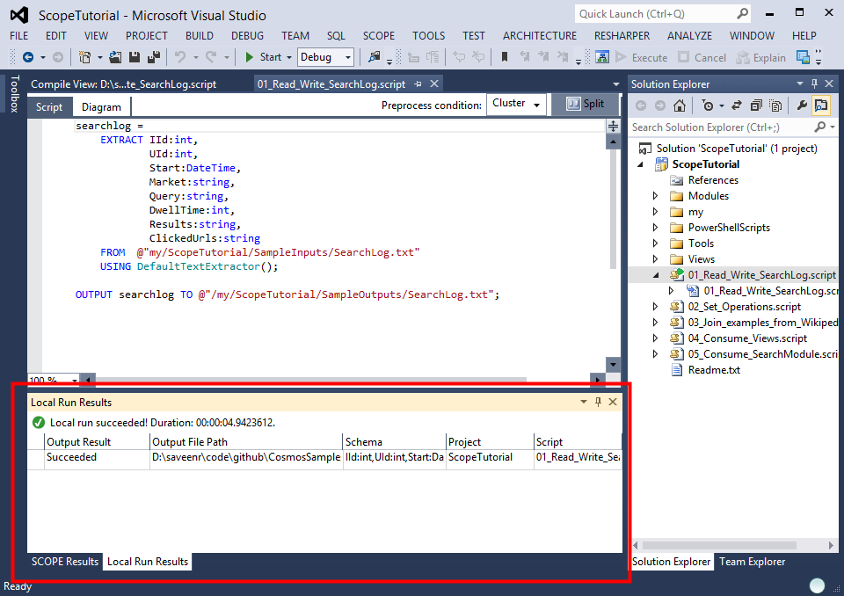

Notice that it indicates if the output was successful (in this case "yes") and where the output file is.

If you want to examine the output, just right-click on the output window and choose either **Preview** or **Open Folder**.

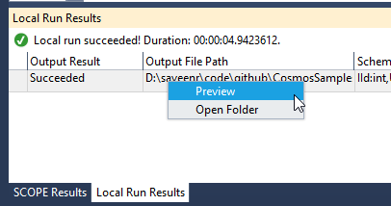

If you click **Preview**, a new Preview window will open.

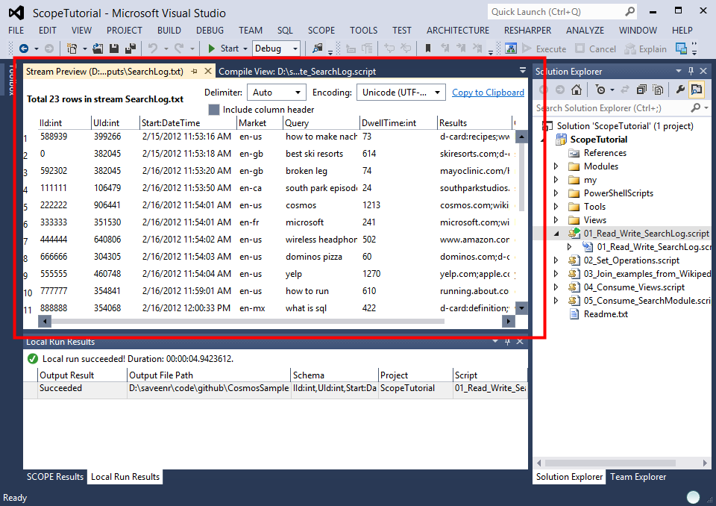

You can copy the preview to the clipboard by clicking **Copy to Clipboard**.

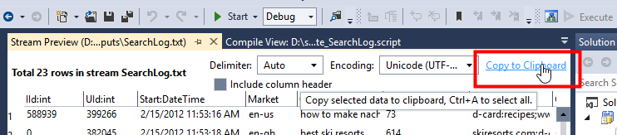

By default the text sent to the clipboard will include the result rows only and NOT the column headers. If you check **Include column headers**, then the text copied to the clipboard will contain the column headers (including type information) at the top.

# Change Log

* 2015-01-21 – Fixed code sample
* 2014-11-17 – Split apart Scope Studio content into its own section