Scope Tutorial > Views

Author: Saveen Reddy

Date: 7/25/2015

# Table of Contents

Table of Contents 1

Overview 1

Creating a simple view 1

Parameterizing Views 2

# Overview

You may have written a complicated scope script to get a useful rowset. Rather than inflict this complexity on others who need the same useful data, you have the ability to define a **View** in Scope.

# Creating a simple view

Let's create the simplest possible view for the **searchlog** rowset we've been using throughout this tutorial. This view is exactly equivalent to that rowset (i.e. it doesn't use any special view features yet).

* Create a text file called **Sear**​​**chLogSimple.view** and place it in a **Views** folder as shown below.

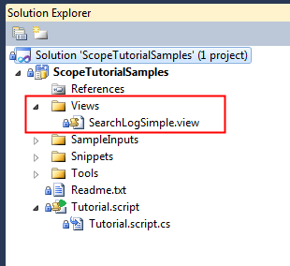

The contents of the **SearchLogSimple.view** file are shown below.

CREATE VIEW SearchLog SCHEMA (

UserId : int,

Start : DateTime,

Region : string,

Query : string,

Duration : int,

Urls : string,

ClickedUrls : string

)

AS BEGIN

searchlog =

EXTRACT UserId : int,

Start : DateTime,

Region : string,

Query : string,

Duration : int,

Urls : string,

ClickedUrls : string

FROM "/my/SampleData/SearchLog.txt"

USING DefaultTextExtractor();

END;

Now we consume that view:

searchlog = VIEW "/Views/SearchLogSimple.view";

# Parameterizing Views

Views can be parameterized to make it easy to filter its contents.

Let's filter this view by the **TimeStamp** so that the view only retrieves those records from a particular time range.

Create a new View called **SearchLogParameterized.View** as shown below:

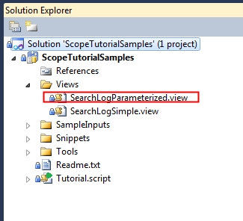

And set the contents of **SearchLogParameterized.View** to this:

CREATE VIEW SearchLog SCHEMA (

UserId : int,

Start : DateTime,

Region : string,

Query : string,

Duration : int,

Urls : string,

ClickedUrls : string

)

**PARAMS (**

**start string,**

**end string**

**)**

AS BEGIN

searchlog = VIEW "/Views/SearchLogSimple.view";

filtered_searchlog =

SELECT * FROM searchlog

**WHERE TimeStamp >= DateTime.Parse(@start) AND TimeStamp <= DateTime.Parse(@end);**

END;

To use this new view:

rs1 = VIEW "/Views/SearchLogParameterized.view"

**PARAMS**

**(start = "2012-02-15",**

**end = "2012-02-16"**

**)**;