

Live Bus Tracking System

(Bus Finder)

Student Name: Cian Doherty
Student Number: 112357861
Supervisor: Dr. Owen Molloy
B.S.c (Hons) Computer & Information Technology

April 2018

Declaration of Originality

I hereby declare that the following thesis is my own original work unless otherwise stated.

Date:

Signature:

Acknowledgments:

I would like to thank Dr. Owen Molloy for giving me the chance to develop this project, as well as all of the help and guidance he provided during both semesters. I would like to extend a thank you to Jalal Madden for lending me the use of hardware devices to test the application on. Finally I would like to thank my family for all the support the have offered me throughout my time working on this project.

Abstract
This thesis describes an application I developed that runs on the android platform in which the main function is the live tracking of buses. The application consists of three separate interfaces. The driver interface allows all drivers to have their locations tracked in real time and be systematically uploaded to the database. The customer interface allows customers to view all available drivers on the map with their locations being updated every couple of seconds. Another noteworthy feature of the customer interface is it’s ability to take a customers request for where they would like to go, processing this information and showing them the most efficient route to their destination. Finally the last interface I developed was the administrator interface which is responsible for uploading route maps and creating new complex routes on the map by selecting multiple points. This will allow customers to know the exact location of their desired bus with satellite accuracy. This could be useful in the context of a customer deciding whether or not to take certain buses to reach their destination. As we know the timetable for city buses are not always exactly accurate, with this project I hope to eliminate this risk.
The most important requirement for this system is that the location of every bus on the map is accurate for the customer to have displayed on their map. This has been developed in such a way as to make it as simple and obvious as possible to enable and be aware of their own tracking which will be uploaded to a database in real time.
The system as a whole is packaged into one single application with a Google database for ease of development. Having the administrator interface allows for easy creation of routes and the ability to upload static route maps. Once these have been added to the database they can only be removed from the database directly and not through the android interface.
For this reason we can assume that the data being viewed by the customer is accurate as only administrators can write to it.

Table of Contents
Declaration of Originality 2
Acknowledgments: 3
Abstract 4
1. Introduction 7
1.1 Background 7
1.2 Objectives 7
1.3 User Stories 8
2. Literature Review 9
2.1 Existing Applications 9
BU Bus Tracker 9
Bus Eireann Real Time Information 9
Moovit 10
3. Technical Review 11
3.1 Overview 11
3.2 Technologies Used 11
Java 11
XML 11
Android 12
Android Studio 12
Firebase 13
Google APIs 13
Build.me 13
4. Implementation 14
4.1 Overview 14
Architecture 15
Design 16
4.2 Firebase Implementation 20
Database Design 20
Authentication 21
Storage 22
4.3 User Interfaces 23
Login & Registration 23
Customer Interface 24
Driver Interface 25
Administrator Interface 26
4.4 Project Management 28
5. Testing & Evaluation 29
5.1 Testing 29
Cross Platform Testing 29
Automated Testing 30
5.2 Results 31
Cross Platform 31
Automated Testing 31
5.3 Evaluation 31
6. Conclusion 32
6.1 To Be Completed 32
Adding Bus Stops to Routes 32
Communication between Driver an Administrator 32
Bus Due time with Stops 32
6.2 References 33
6.3 GitHub 33

1. Introduction

1.1 Background
The idea for this project came about from a problem the developer experienced regularly when catching buses in the city as well as on a country scale. Many of the shown timetables are often inaccurate leaving you unsure if a bus has already left which could result in you arriving late to your desired destination.
In a city such as Galway it is often unclear which bus is necessary to take in order to reach your destination. Another problem is long waiting times for certain buses with some being longer than twenty minutes. This application aims to let Customers see the bigger picture when it comes to the bus system by showing users exactly where all buses are located along with their routes.
With the idea of live bus tracking you can be certain of the location of any bus using the service.
This is the logical next step when it comes to the available information users can receive when it comes to transport. Some companies such as Bus Eireann claim to offer Real Time information, but these systems still work of timetables and not using satellite. An application will be especially useful in a city setting where buses come more often, with many factors likely to obstruct timetables such as traffic.

1.2 Objectives
The main objective of this project was to implement a live tracking system, which allows all bus drivers registered on the application to have their locations recorded using either their mobiles network or GPS. Three separate interfaces will be implemented to allow the different types of users to interact and upload their data.
The application will be developed on the Android platform, which represent up to 85% of the mobile market according to a statistic published (IDC 2017). This surprising lead in android phones in the market made it the obvious choice of platform.
Administrator users will have access to a functionality which allows them to create a bus route by selecting multiple points along a map. These points are then sent to a Google API and the result can then be drawn to a map to be reviewed by an administrator before saving to the database. There is also plans to create functionality to allow an administrator to add and name bus stops to each created route in the database. Finally the administrator will have a functionality to upload static route maps to be viewed by the customer as well as having a messaging system to connect with the driver users if time permits.
From the perspective of the customer user they will have the ability to download all available routes, stops and buses to the map. By clicking on a bus stop it should display information when the next bus is due to arrive as well as the name of the stop. Customers will also be able to view the available routes as a list as well as the static route maps.
This application will hopefully benefit all road users as it will streamline the usage of public transport encouraging more road users to use the public transport rather than cars, which should alleviate traffic.

1.3 User Stories
As a customer I want to open the application and expose the map with possibly one button push.
As a customer I want to be brought to my current location on the map if location is enabled.
As a customer I want to be able to view the buses and routes on the map so that I can weigh my options.
As a customer I want to be able to search through bus routes so that I can find the most direct mode of transport.
As a customer I want to be able to receive promotional codes to incentive app use.
As an administrator I want to have the ability to create/delete bus drivers.
As an administrator I want to be able to edit existing bus routes.
As an administrator I want to be able to create promotional codes as rewards.
As a bus driver I want to be able to have my location tracked.
As a bus driver I want to be able to receive customer codes.

2. Literature Review

2.1 Existing Applications
In order to develop a list of requirements for this project, research was had in the existing market for similar application in the search of further ideas and to make sure that there was not already an identical application out there. By examining these features from different applications a conclusion was made about what was useful, unnecessary and what could be improved upon during the development of this project. The following discusses a number of these applications.

BU Bus Tracker
BU Bus Tracker (gov.ie 2018) is a Boston University tracking application for viewing the live locations, directions and ETA of buses in real time from the Boston University website. This application contains the main feature of development of the project discussed in this document, which is the ability to view multiple buses moving along a map in real time. Clicking on a bus shows a popup window with it’s next destination and ETA. Clicking on this popup will show the user the full schedule of that bus. Finally clicking on a stop on the map will show the ETA to that stop of each bus that is running.
The researcher believed that this application is a good starting point for how the project should be developed. BU Bus Tracker only offered it’s service to a single timetable, whereas the application discussed in this document may be available to any bus company as long as the drivers posses an android smartphone.
An area which this application which could be improved allowing users of the app to search for a desired destination which could then be relayed back to the user after their own location is processed. Another simple feature which BU Bus Tracker was missing was the ability to view static route maps within the application.

Bus Eireann Real Time Information
There is web application on the Bus Eireann website that uses the bus Eireann timetable to show a “real time” representation of the Bus Eireann fleet on the map. This does not appear to be real time in the approach that the researcher was looking for e.g. using satellite or mobile network.

Moovit
Moovit is the worlds largest transit data and analytic company and the #1 transit application. Researching this application was an obvious choice when developing the project as there was surely something to be learned from it’s design. Once again this application did not rely on live bus tracking data to show it’s user. The application works off bus timetables to display it’s information. Upon inspecting the Moovit application the researcher realized that the destination search functionality would be useful for designing the project. The application allows the user to enter their desired destination. This is then compared to their current location and a travel route is created showing the most efficient path (Moovit 2018).
This application followed a similar strategy that the researcher was aiming for, being it’s use of a wider market in comparison to the BU Bus Tracker which is for a specific market in this case Boston University.

3. Technical Review

3.1 Overview
Multiple different technologies were used during the implementation of this project to achieve a range of required functionality. The Android mobile platform was used in conjunction with the Google's mobile platform known as Firebase for the database and authentication.
When developing the mobile application it was important to use the most up to date technologies to secure, intuitive and reliable application.

3.2 Technologies Used

Java
The default development in android studio s mostly in the Java programming language, with functionality related to specific peripherals available on the android platform. Many existing Java libraries are compatible with android and can be implemented with relative ease.
Java is independent of platform and can run on a multitude of different hardware without requiring any change to the code. For this reason Java was a clear choice for developing an android application as well as the fact that this programming language is the focus of the developers study during their time in college.

XML
XML is a software and hardware independent tool for storing and transporting data. XML stands for extensible markup language, which is a markup language similar to HTML. XML was used in conjunction with java in this project for all layout and GUI elements. These GUI and layout features are defined separately to the Java code in XML files. This poses an advantage that using cumbersome java Graphical and layout methods. It is known to be easier to describe a layout in XML than in java directly and it allows the developer to focus on one aspect without worrying specific implementation.

Android
The primary technology used to develop this application was the android mobile operating system. The android operating system was developed by Google, based on a modified version of the Linux kernel and other open source software designed primarily for touchscreen mobile devices such as smartphones and tablets. The first version of Android was released to the public in 2007 (Open Handset Alliance, 2007). Since Google purchased the rights to Android in 2005 the platform has been entirely open source with the exception Google services and Gmail. This means that Android has a wider arsenal of developers exposed to the application with the ability of creating new applications resulting in a wide range being made available. As of December 2017 there are 3,500,000 applications available in the Google Play (Statista, 2017 ) store compared to the 2,000,000 in the Apple App Store (lifewire, 2018) and 669000 in the Windows Store (Windowsreport, 2017).
The application is designed to work with the latest version of android 8.0 “Oreo” and was mainly tested on device running 7.0 “Nougat” as it was conveniently available to the developer. At the moment 6.0 “Marshmallow” is the most widely used at around 25% of devices by March 2018 closely followed by 7.0 “Nougat” (statcounter, 2018)
There may be issues with when the application is run on versions of Android before 6.0 “Marshmallow” as there was an addition of permissions requests at run time, for features including locations.
Due to the fact that android runs on both smartphones and tablets means that there is no need for a change in the code when running different devices such as these. It may be important to take this into account when developing applications as screen size, processing power and memory may vary greatly.

Android Studio
Android Studio is the official integrated Development Environment (IDE) for Android app development based on IntelliJ IDEA editor. With use of IntelliJ’s powerful code editor and developer tools, Android Studio offers even more features and plugins that make it extremely effective for developing Android applications. The platform has built in support for the Google Cloud Platform
Android studio comes with a build system known as Gradle. Gradle is a build system that takes the best features from other build systems and combines them into one. It is a JVM based build system, so you can write your own script which Android Studio makes use of. Gradle allows dependencies to be compiled from various sources, including remote repositories or JAR files and packaged into an APK for deployment (Android Developer, 2018).

Firebase
Firebase is a Google service that provides real time databases and backend as a service, which gives users fast data feeds and stores the data safely on the cloud. Firebase Authentication facility allows for authorization and management system for registration. The Firebase Database uses URL as a REST endpoint, allowing users to append ‘.json’ at the end of the URL and send a request (Firebase Products, 2018). The Firebase platform has the ability to stay responsive even when offline because the RealTime Database SDK persists the users data to disk for when connectivity is reestablished. The researcher realized there are some problems that come along with the use of Firebase during the development of this project like the fact that consistent transactions fro the database are known to be expensive.

Google APIs
Multiple Google APIs were used in the development of this project and Android being a Google product means that for the most part it has been developed with consideration of these Google APIs. The Google Maps API was an important feature to be included in this application along with some other related services. The Google Maps API allows access to the Map view and location services. Some of the service that were used include the Directions API, which can return information about modes of transport, Waypoints and expected travel time. This was especially useful when generating new bus routes from the administrator interface as well as finding available routes for the customer to reach their destination.

Build.me
Build is a User Experience (UX) service that provides design and user experience best practices, tools and e-learning to users looking to implement a design-led and user-centered approach to innovation. This application was used to develop prototypes for the project in order to reach the desired look and feel of the application before the development process was started. Application prototyping allows for exploration of new ideas and early discovery of design solutions in the development process.

4. Implementation

4.1 Overview
The bulk of the development time for this project was spent on the mobile application that was built upon Android Studio. The nature of this project meant that there was no backend application for managing users. Basic administration tasks such as removing users, routes or maps can all be done from the Firebase database directly.
A use case diagram can be seen in figure below, which shows how the different activities and views interact within the system.
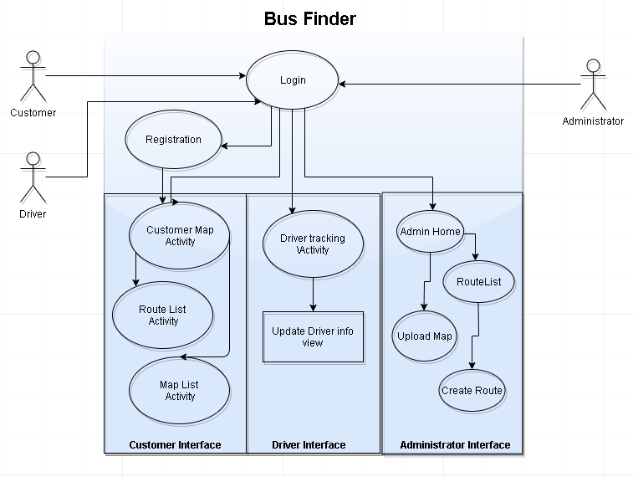
Figure 1: Use Case Diagram showing interfaces and activities

Architecture
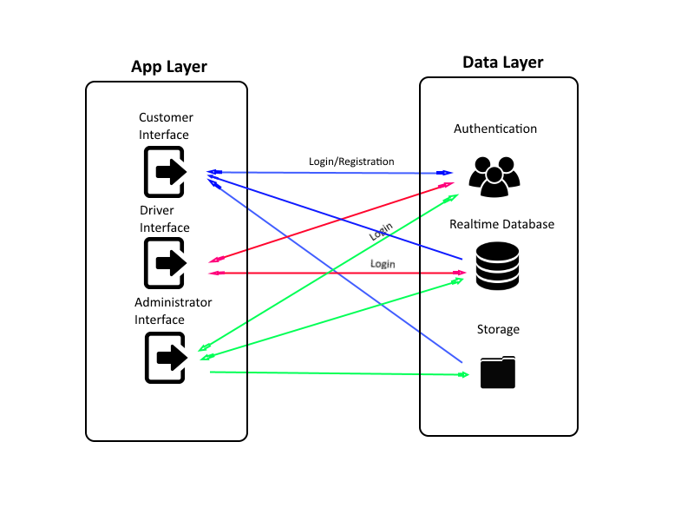
Figure 2: Architecture of the App & Data layer
After deciding to use Firebase for the project the developer had to come up with an architecture for how each interface of the Android application would communicate with the Firebase data layer. Each user type interacts with the Firebase data layer in a different way using their designated interface. As can be seen in figure 2 above the customer interface can login and register from the app layer as apposed to the other two interfaces, who can only login from this level. Both the driver and administrator both have a read/write relationship with the database, while the customer can only read. The final player the interfaces have interactions with is the cloud storage. The administrator writes images to the cloud storage that can then be read from the customer interface.

Design
Firstly a prototype was created in Build.me to form an idea of how the user interface was to be laid out and discover design problems early instead of during development.
The screenshots below show the original prototype that was created in preparation for development for the project

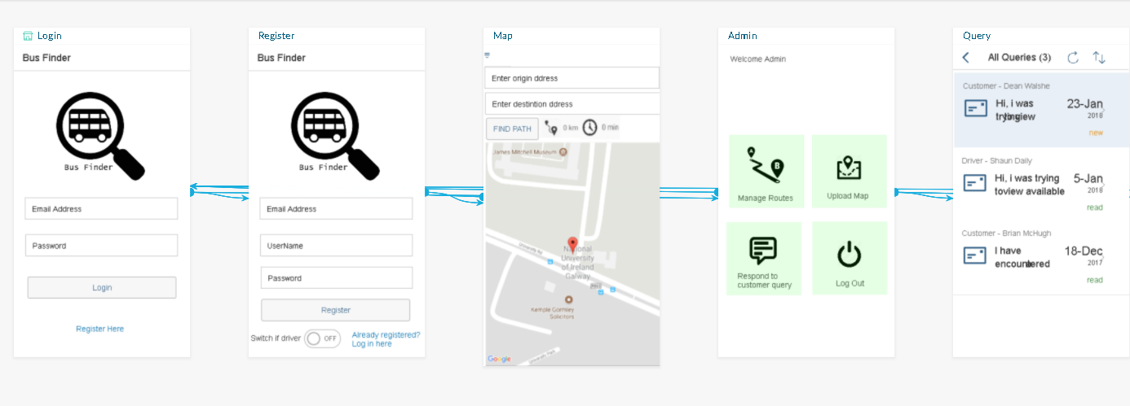
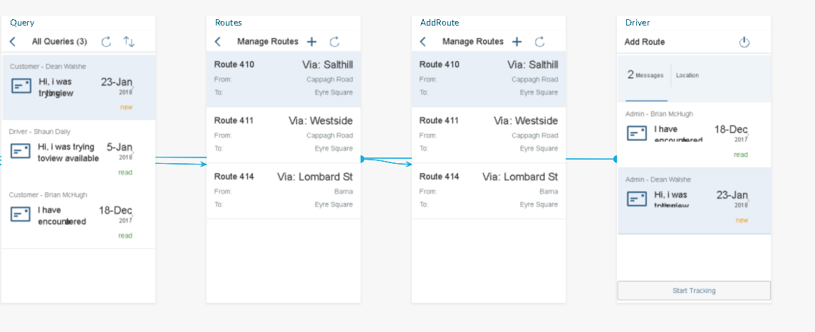
Figure 3: Build.me prototype map 1
Figure 4: Build.me prototype map 2
As can be seen from the screenshots above, after the login/registration is completed the user will enter on of three interfaces depending on what type of user they are. The customer user ca be created on the registration page and the other two users administrator and driver have to be created directly from the database layer.
Figure 5: UML Diagram of Login % Registry Activity
The ‘administrator’ interface which is used creating new bus routes and uploading static route maps to be visible to ‘customers’. The most complex Activity developed for this interface is the CreateRouteActivity. This activity makes use of Googles Map API to allow the administrator to click or tap several points along roads on the map. The LatLng’s are then taken from these points and sent to a Directions API which returns a route along the roads which can then be drawn to the map to be accepted by the administrator and saved to the database.
Figure 6: UML Diagram of Administrator interface
The other two interfaces are not responsible for administrative roles but at least one of them is responsible for supplying the database with constant updates which are vital to the operation of the application as a whole. This is known as the Driver interface, its main function is to allow the driver to toggle the tracking ability which periodically uploads their latitude and longitude to the database to be downloaded by customers. Drivers also have the ability to edit their current bus route or bus name.

Figure 7: UML Diagram of Driver interface

The final interface that was developed for the application is known as the customer interface. This interface holds the main functionality of the application by allowing customers to view the available bus routes, stops and buses moving on the map in real time. Customers can also see a list of available routes with extra information and the ability to view static route maps that have been uploaded by the administrators. Another complex functionality of the customer interface is the ability to search for a destination. The application does this by taking the customers location and desired destinations. Every bus stop is then traversed and the nearest stop to their location as long as its moving in the direction of the destination.
Figure 8: UML Diagram of Customer interface

Apart from the main activities of the application there are also thirteen module classes which are responsible for various different methods that were too big to have inside the activity they work for as well as multiple complex object classes.

Figure 9: UML Diagram showing Module classes

4.2 Firebase Implementation

Database Design

For this project the Firebase RealTime Database was used, which is a NoSQL cloud-hosted database. With this database you can reference JSON data such as “routes/route#/from” to set data or subscribe to data changes. Firebase also offers the ability to write data to the devices local disk so that it can be available while offline.

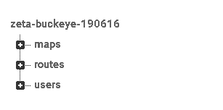
Figure 10 shown to the left is a capture of the JSON database information in it’s collapsed state. As can be seen there are three main storage's. Maps, which contains the links to the static route maps which are stored in the cloud storage. Routes, which contain the bus routes, bus stops and other information relating to the routes and stops. Finally there is the users information.
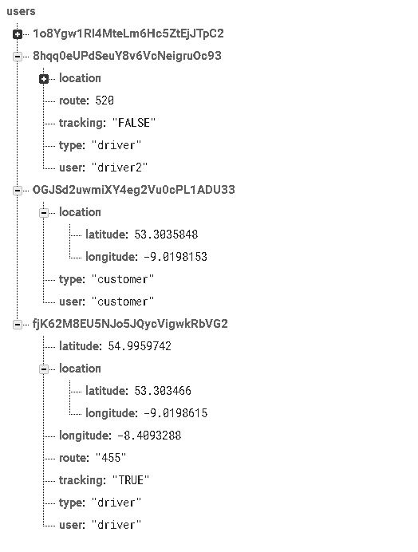
Figure 11: Users JSON in Firebase

The users information is stored as in figure 11 where each use has a unique ID that can only be accessed by the authenticated user. Depending on which type of user is logged in to the application their information will be added to and updated using this ID to locate them in Firebase.

Authentication
Firebase Authentication provides (https://firebase.google.com/docs/auth/) backend services, easy-to-use SDKs and ready-made UI libraries to authenticate users to your application. It supports authentication using passwords, phone numbers, popular federated identity providers like Google, Facebook, Twitter and more. The developer decided to simply implement password authentication. Firebase authentication was easily integrated with the application backend.
When a user first registers using the application they enter their own email and password which is added to Firebase authentication as seen in figure 12 below.
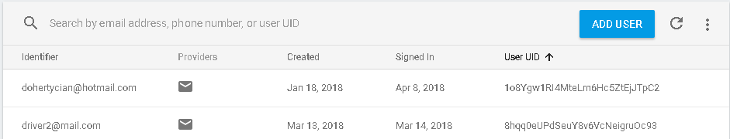
Figure 12: Firebase Authentication
Administrators and driver can be added directly from Firebase using the add user button seen figure 12.

Storage
Firebase has a cloud storage option which was utilized in this project for the storage of static route maps. The storage service allows for the creation of directories to store images and videos, which in this case are accessed from the android application using URL’s to be viewed by the customer user.
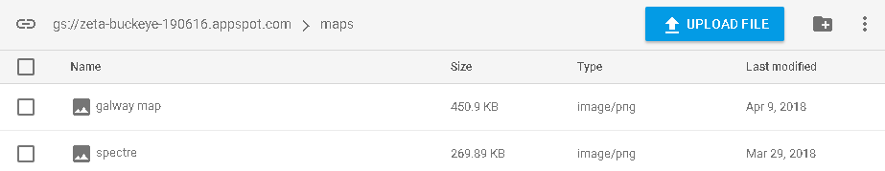
Figure 13: Firebase Storage

4.3 User Interfaces
As mentioned before this application consists of three separate interfaces to be used by three user types. This section describes these user interfaces including the separate functionalities.

Login & Registration
When a customer opens the application for the first time they must register giving their email, username and password. This will be saved in the database as they are authenticated and directed to the customer interface. Any of the other two user types can not be registered from this screen but instead must be added directly from the database by an administrator.
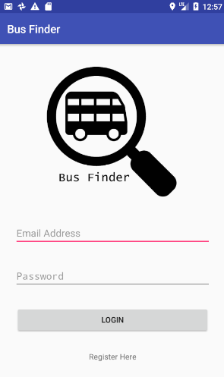
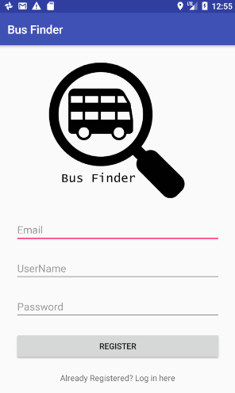
Figure 13: Register Screen Figure 14: Login Screen

All three types of user make use of the Login screen. They simply login using their email and chosen password and are subsequently redirected to their designated interface. The developer was torn between using Google or Facebook accounts when to authenticate with the application, but in the end decided against it to avoid clutter and because Firebase offered a decent alternative. When the user has signed into the application they will be logged in automatically on their return.

Customer Interface
When a customer logs on, they are shown the map opened at their current location. The customer is able to see all the available routes on the map as well as all of the stops placed along these routes. Clicking on a stop brings up the information relating to the stop. Similarly when the customer clicks on a bus they will be shown the bus name as well as it’s current route. If the customer wants to know what the best route is to their destination they have the option of enter their desired destination and the optimum route is then composed for them as shown in the screenshot below.
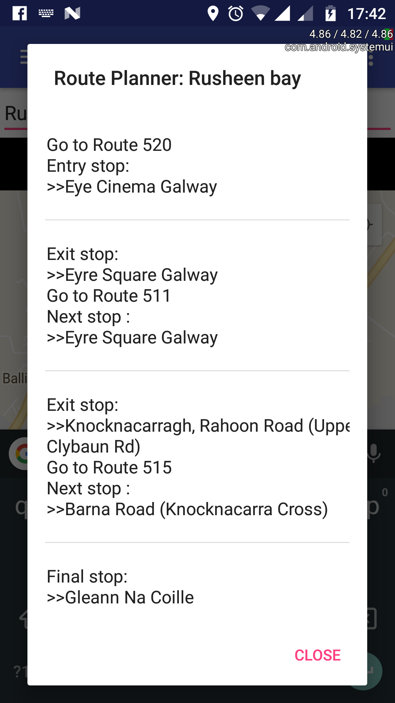
Figure 15: Result of Route Planner

Within the customer interface a DrawerLayout was used to give the customer the option of navigating to two more important activities.
The first being an activity that allows the customer to view all the available routes in a ListView as well as the option of clicking on these routes individually, which shows the customer extra information about these routes such as where the routes begin and finish in terms of general area for customers who are less experienced with the locations.
The next functionality accessible from the DrawerLayout is another ListView that lists static images, which could show route maps. Clicking on one of these list items will open the image in full screen so that It can be seen clearly by the customer.

Driver Interface
The driver interface consists of one single activity which is accessed by the driver user. The main functionality of this interface is to allow the driver to have their location tracked.
The developer initially planned to use a tab layout for this interface, which would of meant using fragments to display the map and another view which would have been used for updating driver information. This could not be implemented successfully due to a problem that was discovered during development. Some of the time information such as driver location was sent to Firebase the activity would be reset causing the tracking to be reset also. The solution to this problem was to store the tracking state in the database and have it pulled down if the activity had been reset. Due to the fact that only a single activity exists it does not disrupt the flow of the application if a post were to cause a resetting of the activity.
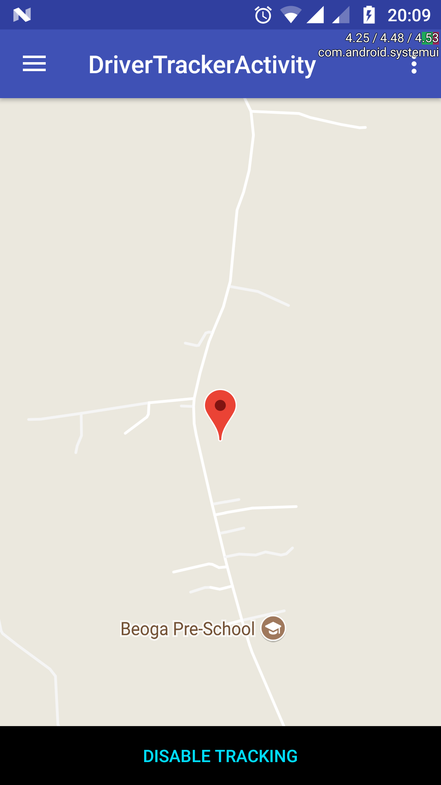
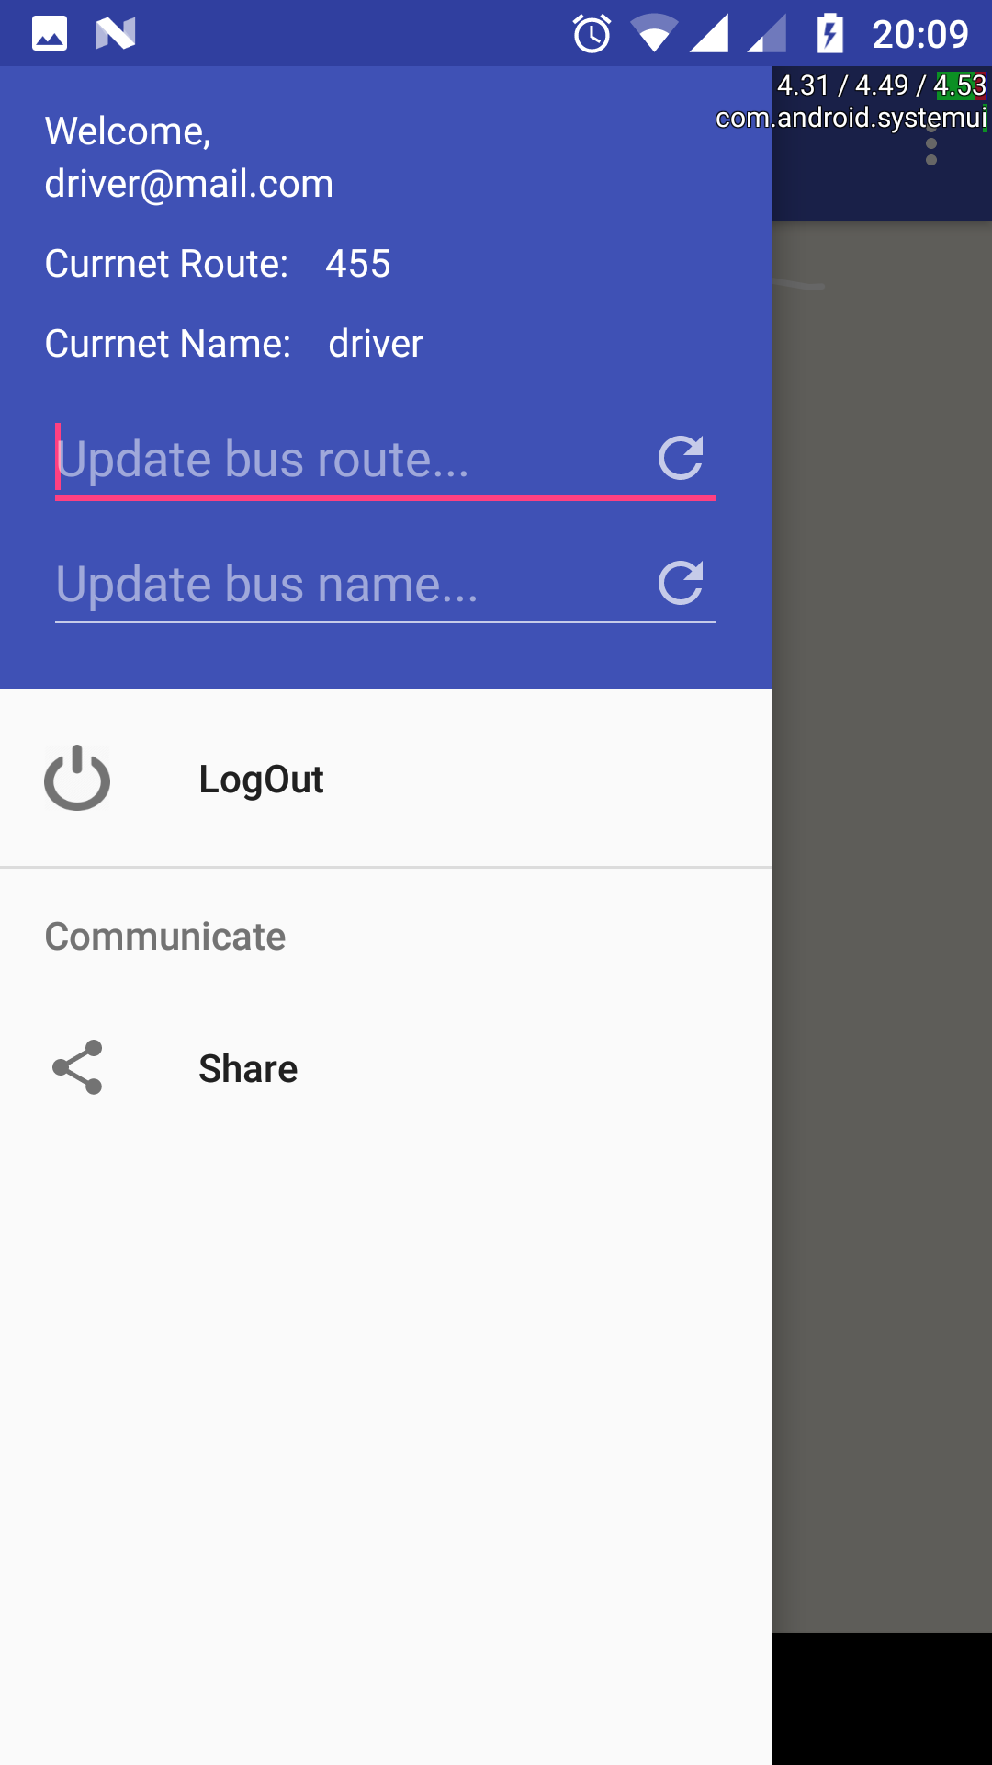
Figure 16: Driver tracking screen Figure 17: Driver information updated

A DrawerLayout was used once again to allow the driver the ability to edit their information that is visible to the customers such as their current route and current bus name.

Administrator Interface
The interface opens to home activity which acts as a starting point where the administrator can chose from a range of three options to navigate to more activities. These available options are presented to the administrator in the form of tiles which consist of manage routes, upload map and logout. As can be seen in figure 18 below there is a tile for another activity titled send notifications, which was going to be for communicating notifications to the driver. In the end there was not enough time to have this implemented so it will have to be left for possible future development.

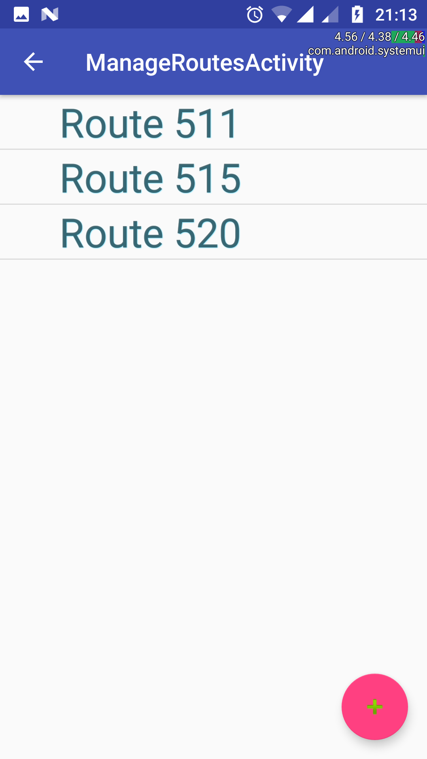
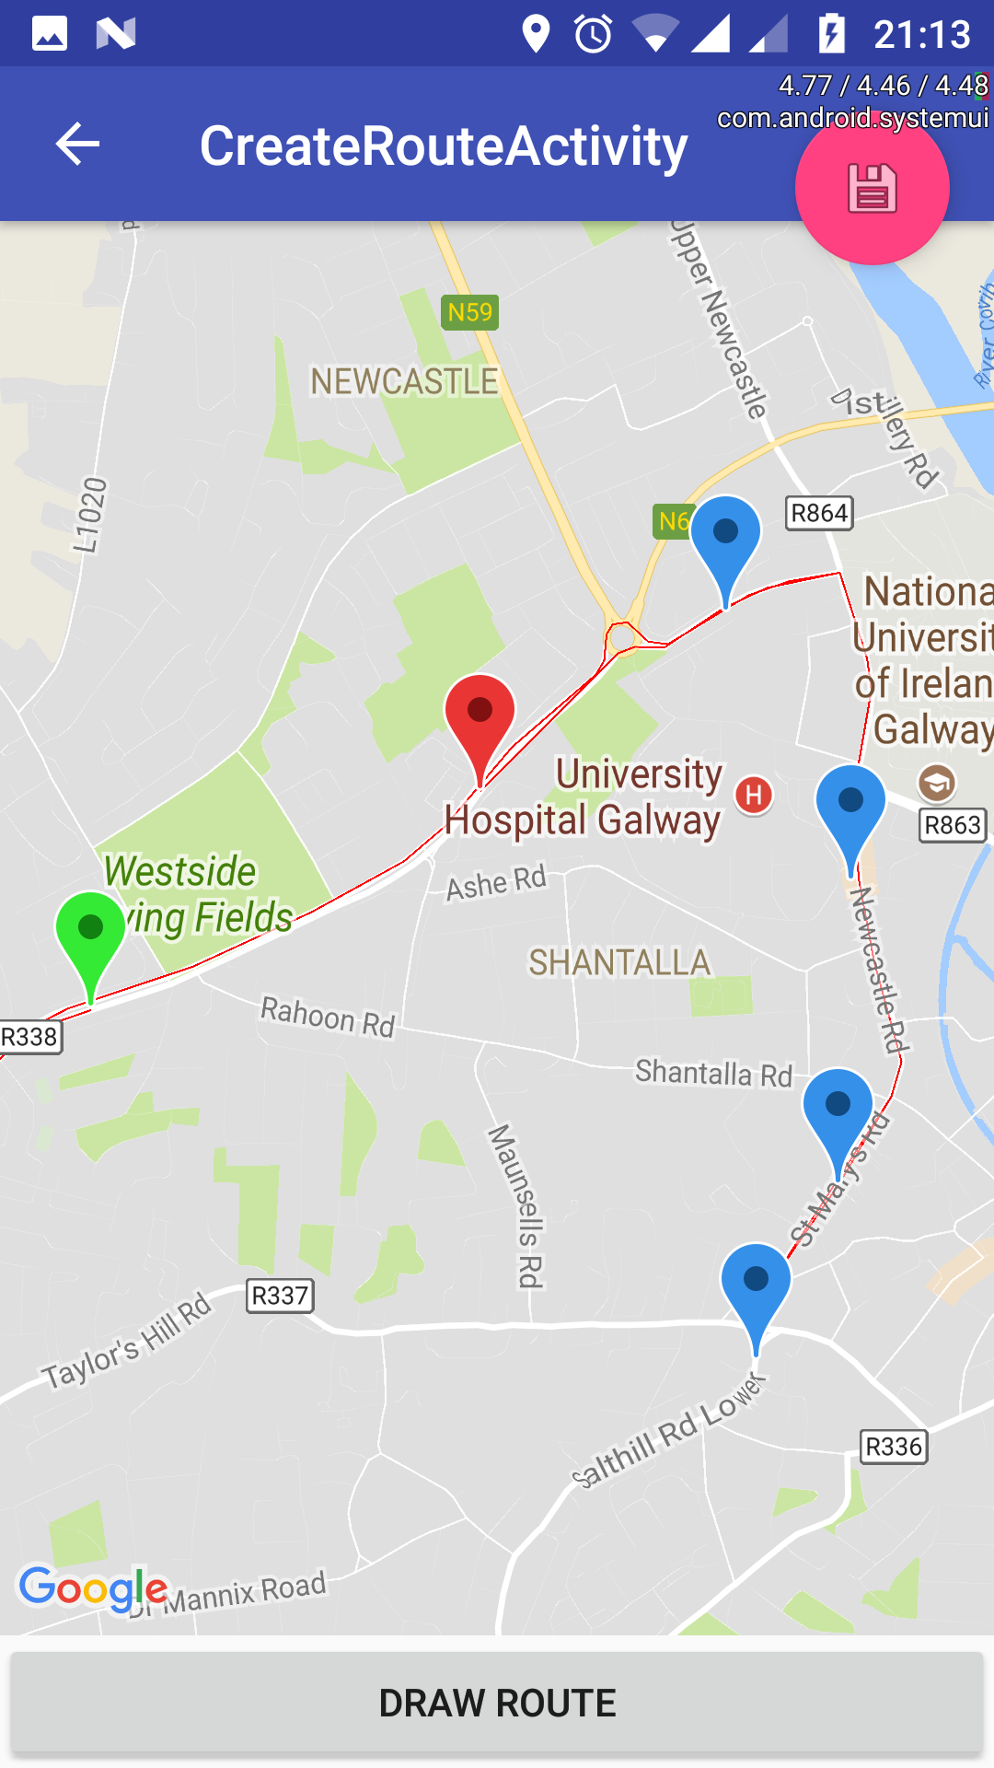
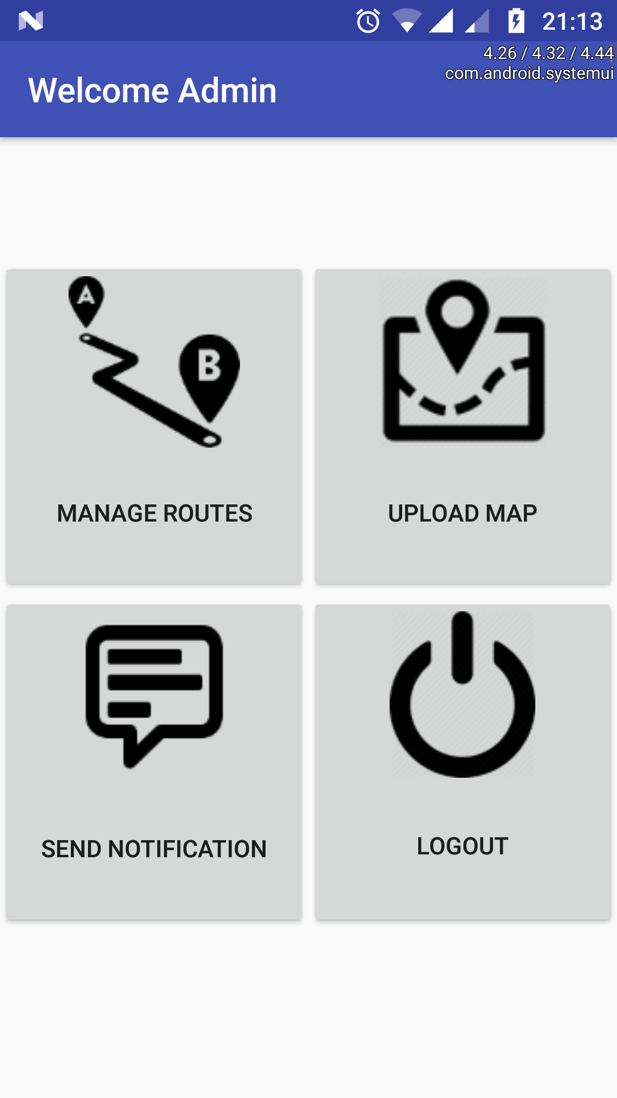 Figure 18. Figure 19. Figure 20.

Figure 19 shows the navigation result of clicking on the manage routes tile. It consists of a list of routes similarly to the list of routes in the customer interface. These routes can also be clicked on to show extra information relating to each route. Clicking on the plus icon at the bottom of the figure 14 screen navigates the administrator to the create route activity seen in figure 20. In this activity the administrator can tap multiple points along the map carefully making sure the points are being placed on the roads or else a route will not be created. If the administrator successfully creates a route but is not happy with the outcome they can remove the route by holding down for a long click, which will clear the map of points and route to be created again. When the administrator is happy with their newly created route they can click on the save icon at the top of the screen to fill in the details of the route and save it to the database, where it can then be downloaded and viewed by customers users.
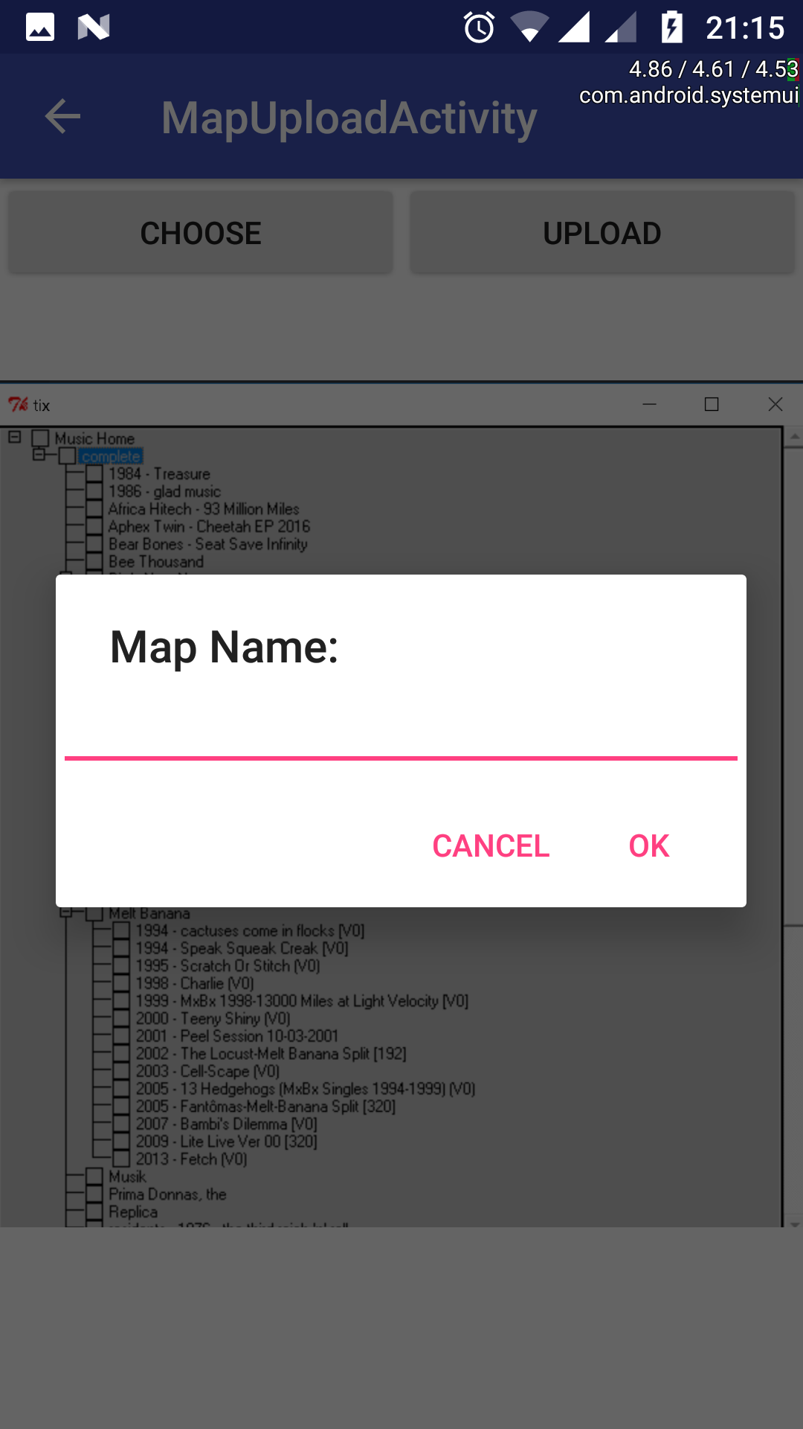
Figure 21: Map Upload
When the upload map tile in figure 18 is clicked the administrator is directed to the map upload activity. From here the administrator is given the option to chose an image from the phones memory. The image will then appear in the application and can be named and uploaded to the database using the upload button. Images uploaded from this activity are sent the Firebase cloud storage, which has the ability to store and serve content such as photos or videos. A direct link to the stored file is also saved to the Firebase database at this instance for retrieval of the files b customers. Images can only be uploaded from here but not deleted. This action will have to be done from Firebase directly, removing the image from storage as well as the link in the database.

4.4 Project Management
In the initial stages of the project the developer had to decide on a methodology for project planning and development of the application. The two main methodologies existing today are known as Agile and Waterfall. In the waterfall methodology there are multiple phases and each phase must be fully completed before moving on to the next so there can be no overlapping phases. Agile on the other hand is an incremental approach which breaks complex projects down into simpler and smaller projects which have better accommodation for change. The developer had some experience with working with the agile methodology in the past and decided it would be the most suitable management strategy to be followed for this project.
Before beginning development the developer compiled as detailed a list of requirements as possible and listed them in order of importance. The developer then planned out the completion of these backlog items over a number of 2 to 4 week sprints. When the developer was making their way through these sprints any new features or bugs discovered would then be added to the backlog to be worked on at the developers convenience.
The approach of working on backlog items in order of importance was a useful practice as it meant that the main functionalities of the application were up and running relatively early in the development cycle, which improved the overall progress.
Using the agile approach meant that when the developer reached the final phases of development there was a reduced number of bugs present due to the iterative nature of agile. This allowed the developer to spend less time testing the application at the end as it had already been thoroughly tested at the end of each sprint.

5. Testing & Evaluation

5.1 Testing
As previously discussed this project was developed using the Agile methodology for planning purposes. This meant that the project was vigorously tested at the end of ever development cycle, known as a sprint. When the developer implemented a new feature it was tested to make sure that it did not disrupt any of the existing functionality.
On completion of all development on the application a range of formal tests were implemented, including testing the application across multiple different platforms.

Cross Platform Testing
The application was entirely developed and debugged from a single device and an emulator. Although the application may run without any issue on these devices there is the possibility that there may be issues when ran on deceives with an older operating system or a different size of screen. For this reason the application was tested on multiple different devices that were available to the developer to improve reliability.
The following devices were used to test the functionality of the application cross platform.
Moto G5 – 1920x1080 5.0” display, Android version 7.0 (Nougat)
M-Horse Power 2 - 720x1281 5.5” display, Android version 7.0 (Nougat)
Sony Xperia E5 - 720X1280 5.0” display, Android version 6.0 (Marshmallow)

The application was also run on multiple different Android versions on emulated device as can be seen following.
6.0 (Marshmallow)
7.0 (Nougat)
8.0 (Oreo)
During the testing periods on the different deceives available to the developer the application was run using sample inputs to make sure the expected outputs and results were given. For this the device was given to a user other than the developer to manually test the UI screens by navigating from one activity to the next and making sure the interface elements appeared without any glitches.
Tests around location involved creating new driver users and having them log in to the application in different locations to see if the location services were operating as expected.

Automated Testing
The developer wanted to preform a quick test on the capabilities of the UI when put under stress. During a research period an Android SDK was discovered. This tool is known as monkeyrunner and provides an API for writing programs that control an Android device or virtual machine from outside of android code(Android Delveloper, 2018). In this case the developer wanted to generate a large number of random events such as touches or clicks on the three different interface to make sure the application did not crash under this kind of stress test.

5.2 Results
In this section the results of the tests completed in the earlier section will be discussed.

Cross Platform
Due to restraints in what the developer had available to test the device on the application could only be tested on the hardware mentioned in the previous section. This meant that the application was not tested on a tablet device or a device with an Android version outside of 6.0 (Marshmallow) and 7.0 (Nougat). The application was able to run as expected on all the hardware that it was tested on.. For the environments that were not available on hardware virtual machines were used. This includes the further testing of Android version 8.0 (Oreo) as well as testing a virtual machine of devices with 5.9” to 7’’ display with successful results.
Location services is used in two of the three interfaces of the application and were working as expected in the different test environments mentioned above.

Automated Testing
The monkeyrunner test was passed successfully on both the virtual and hardware devices with no problems. For these tests a range of 500 too 1500 simultaneous random events were sent to each user interface of the application separately without crashing the application proving a decent level of reliability.

5.3 Evaluation
After seeing the results of this preliminary testing the developer was happy that there was a good standard of usability and stability to the application. If there was to be further testing added to the application at a future date the developer may incorporate the use of unit testing for the java code in the application. In an attempt to increase the overall quality of the code as well as enhancing the design. The inclusion of functional testing in the user interfaces with the Espresso framework available on Android. Having these tests implemented would make consistent testing of UI elements with expected outputs possible across a variety of devices.

6. Conclusion
In conclusion most of the main features that were in the backlog for completion were implemented successfully with a few minor exceptions. All three interface are fully functional and have passed the quality tests they have been subjected to with no ongoing errors. Any features i203n the backlog that were not completed before the deadline was due to the time constraints and can be picked up at the developers convenience.

6.1 To Be Completed
As mentioned above their was a couple of features that were planned to be included in the version of the application that is to be submitted for the Final Year Project module which were not completed in the time allocated. This section will discuss these unfinished features.

Adding Bus Stops to Routes
The idea behind this was that bus stops would be added to specified routes from the administrator interface. During the design phase the developer hoped to create a set of activities to select a route and start adding stops to it by specifying the number then entering the coordinates along with the corresponding names. The way this is achieved currently is the administrators will have to enter these stops directly to the database as a child of the route node.

Communication between Driver an Administrator
Initially there were plans to implement a simple messaging system between the administrator and drivers to alert them of notifications or report errors. The developer was unsure whether or not to allow the customer the ability to report bugs to the administrator also. These features were of low priority and simply were not developed due to time constraints.

Bus Due time with Stops
In the original design the customer would be able to click on a bus stop on the map and they would be shown the name of the stop and when the next bus is due to arrive at this stop. Unfortunately the bus due time was not accomplished in the allocated development time. The developer feels this was quite an important feature to be left out of the final application and it would take a high priority when further work was to be done on the application.

6.2 References
Outside references are listed here in the order they appeared in this document.
- IDC 2017 – ‘Mobile Market Android’: https://www.idc.com/promo/smartphone-market-share/os
- Statistica 2017 – ‘Number of existnig Android apps on Dec 2017’: https://www.statista.com/statistics/266210/number-of-available-applications-in-the-google-play-store/
- Lifewire 2018 – ‘Number of existing IOS apps March 2018’: https://www.lifewire.com/how-many-apps-in-app-store-2000252
- Windowsreport 2017 – ‘Number of existing Windows apps March’: https://windowsreport.com/state-windows-8-apps-windows-store/
- gov.ie 2018 – ‘Bus Eireann RealTime’: http://www.gov.ie/en/bus-eireann-real-time-information
- Moovit Developers 2018 – “Moovit Developers Deeplinking ‘Directions’”: https://www.developers.moovit.com/deeplinking-your-app?utm_medium=Organic&utm_source=company_website
- Open Handset Alliance 2007 - “Industry Leaders Announce Open Platform for Mobile Devices”: http://www.openhandsetalliance.com/press_110507.html
- statcounter 2018 – “Android versions usage statcounter march”: http://gs.statcounter.com/android-version-market-share/mobile-tablet/worldwide
- Firebase 2018 – “Firebase Products”: https://firebase.google.com/products/
- Android Developer 2018 – “monkeyrunner”: https://developer.android.com/studio/test/monkeyrunner/index.html

6.3 GitHub
This section contains the direct link to a GitHub repository containing all of the code for the android application discussed in this document.
https://github.com/14357861/Bus_Finder_FYP_2018

