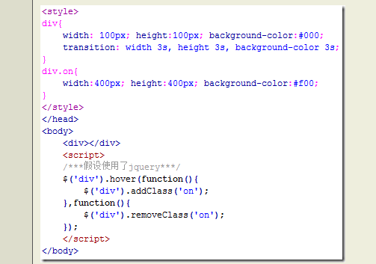

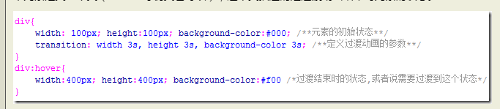

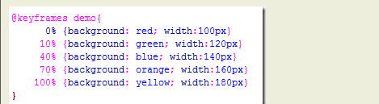

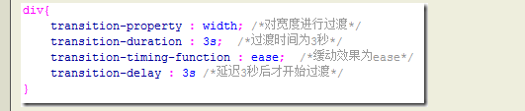

.menuButton {

position: relative;

transition-property: background-color, color;

transition-duration: 1s;

transition-timing-function: ease-out;

text-align: left;

background-color: grey;

left: 5px;

top: 5px;

height: 26px;

color: white;

border-color: black;

font-family: sans-serif;

font-size: 20px;

text-decoration: none;

box-shadow: 2px 2px 1px black;

padding: 2px 4px;

border: solid 1px black;

}

.menuButton:hover {

position: relative;

transition-property: background-color, color;

transition-duration: 1s;

transition-timing-function: ease-out;

background-color:white;

color:black;

box-shadow: 2px 2px 1px black;

}

