EXP- 1
Create a Kanban Board (Jira/Trello)
Aim
To create and simulate a Kanban workflow using Jira or Trello.
Procedure
1. Login to Jira/Trello.
2. Create a new Kanban board.
3. Create columns: To Do, In Progress, Done.
4. Add 2 to 3 tasks.
5. Move tasks across columns to simulate workflow.
6. Observe task progress.
Step:-1
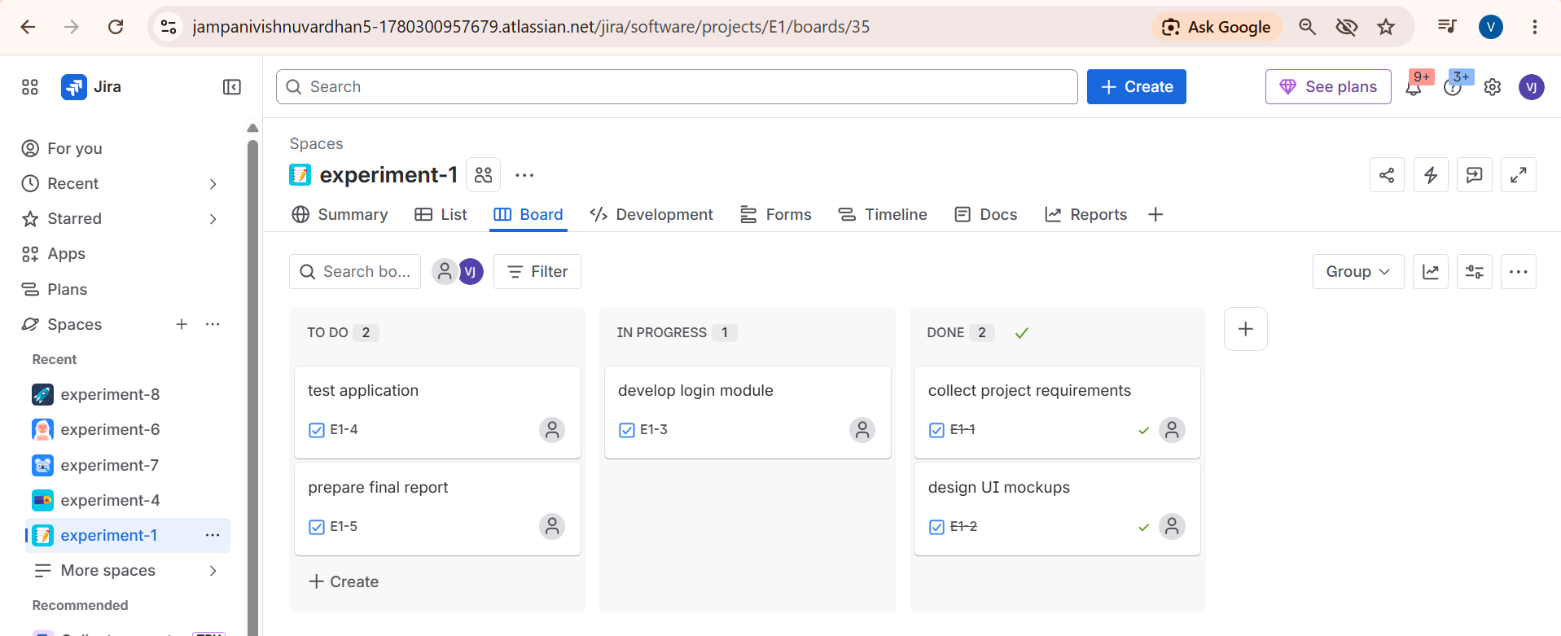
Step:-2
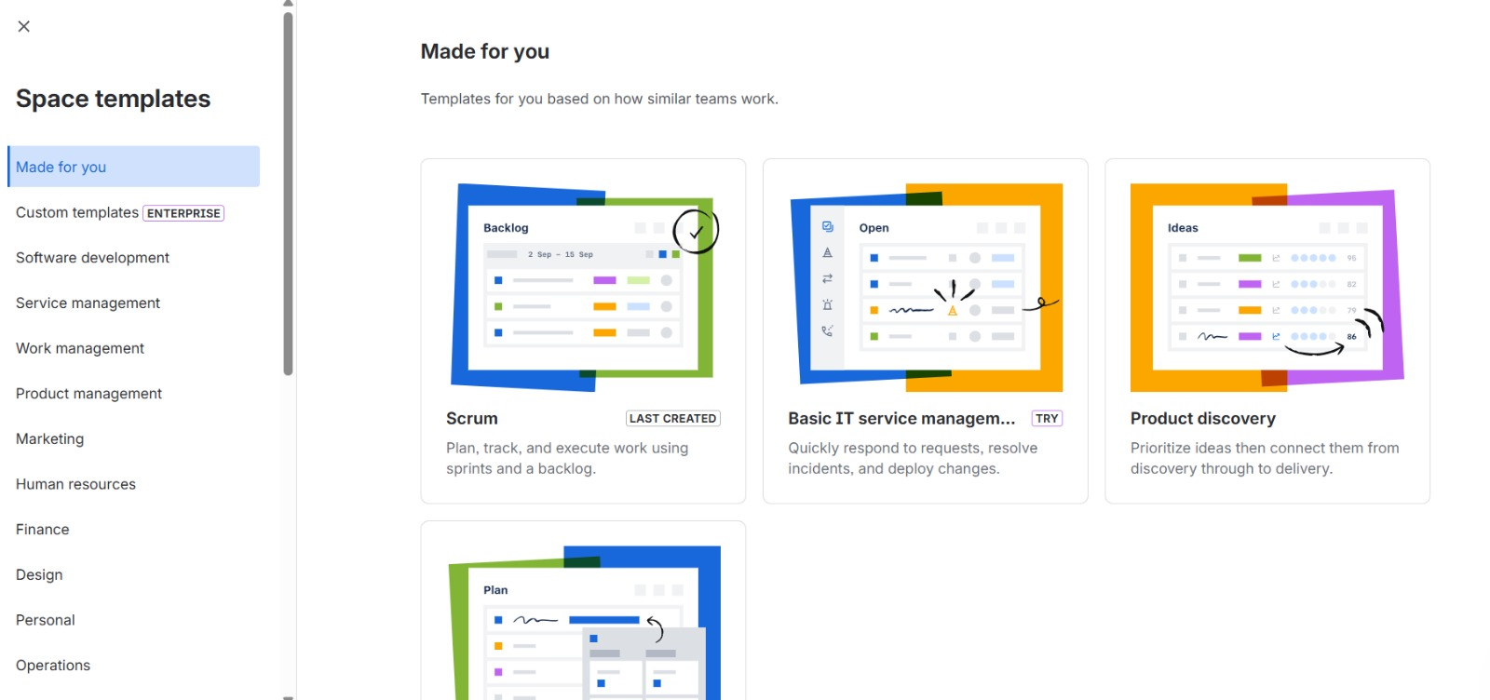
Step:-3

step:-4

step:-5
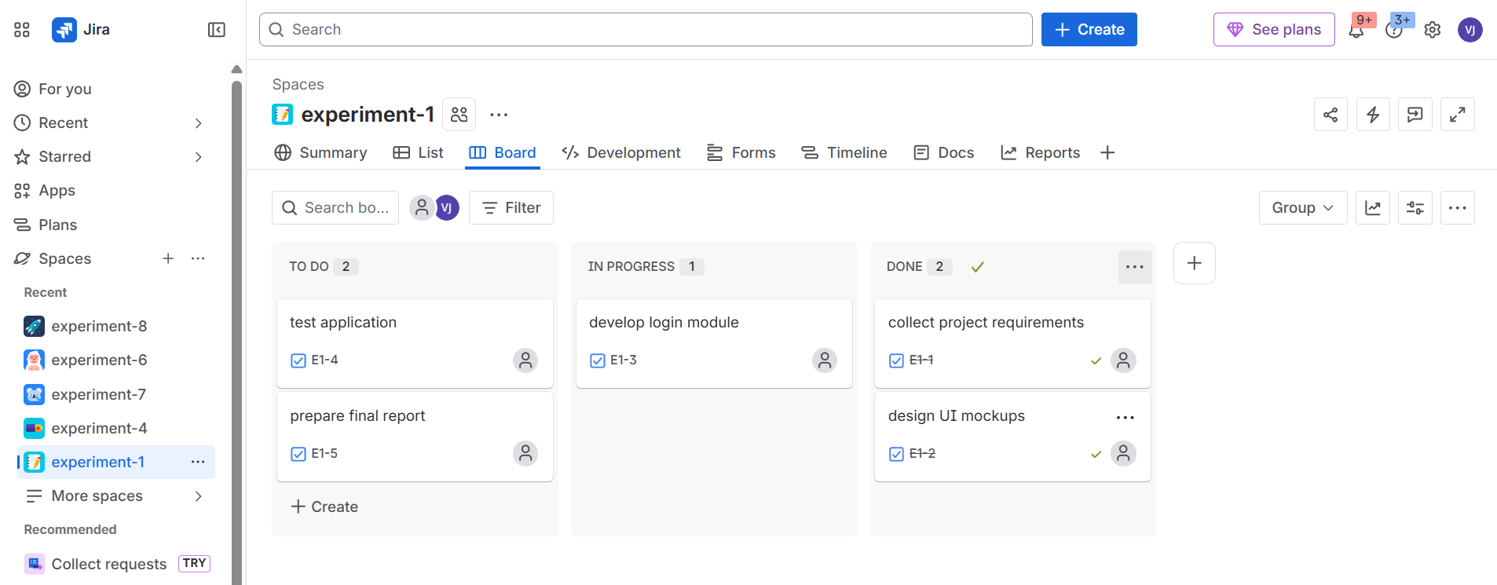
Result: Thus, The Kanban board has created successfully and simulated workflow by moving tasks across stages.

