EXP-6
Link Jira with Confluence
Aim
To integrate Jira with Confluence for project tracking.
Procedure
- Create a jira project and choose scrum template.
- Enter a space name as Library Management System.
- Go to backlog and create 5 tasks in sprint.
- Start the sprint then, tasks will be shown.
- In side bar choose more option & choose confluence .
- Then the confluence page appears then, Create page in confluence.
- Then give any title. In the blank space type ‘/jira’.
- Click on jira legacy type the prompt ‘project=key order by status ASC’.
- Click enter and insert the task.
- Take a screenshot.
Step:-1
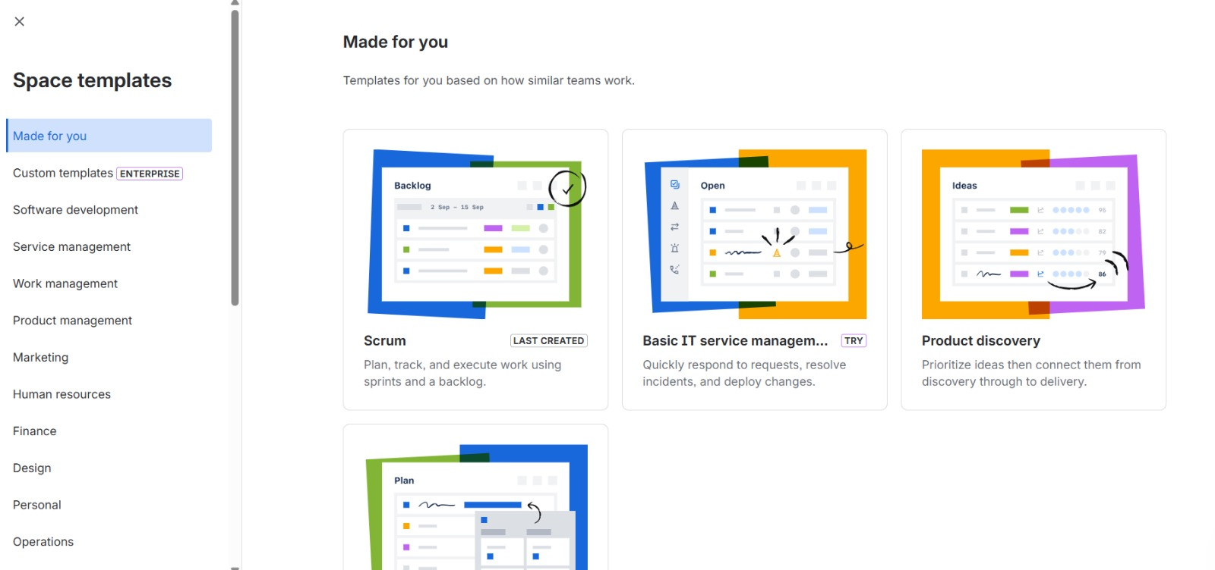
step:-2
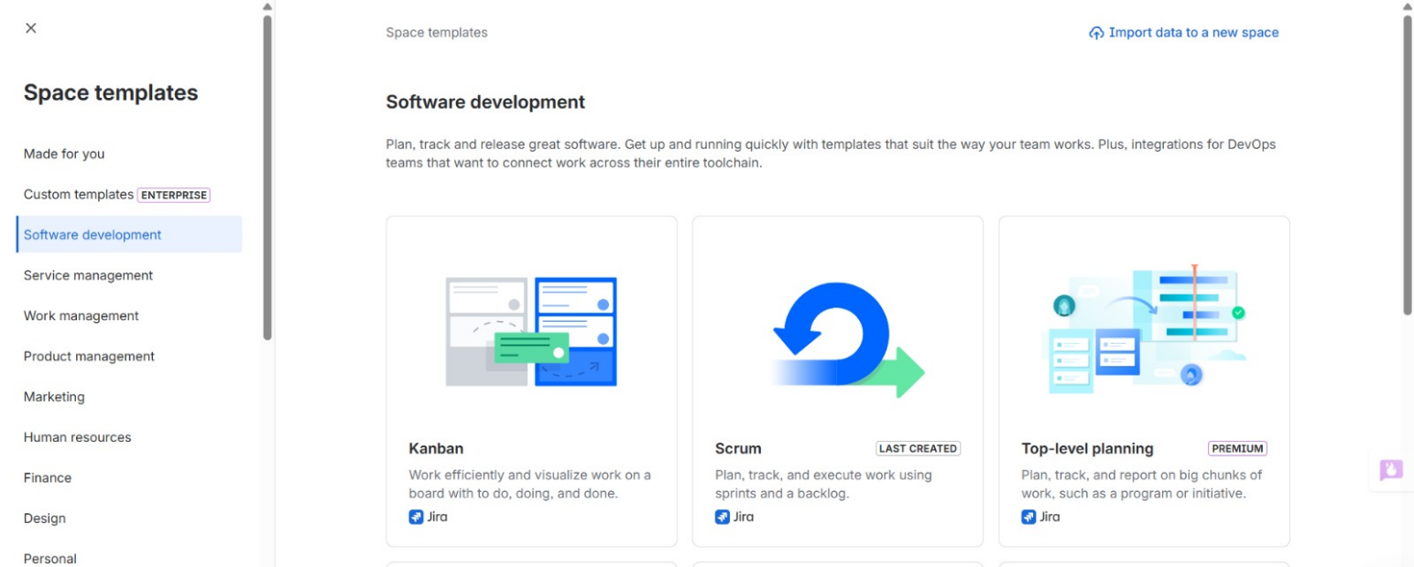
step:-3
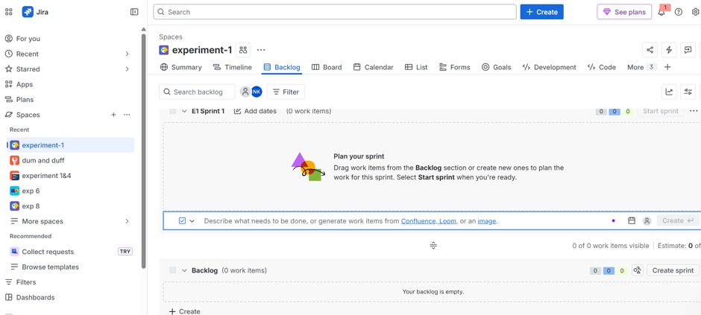
Step:-4
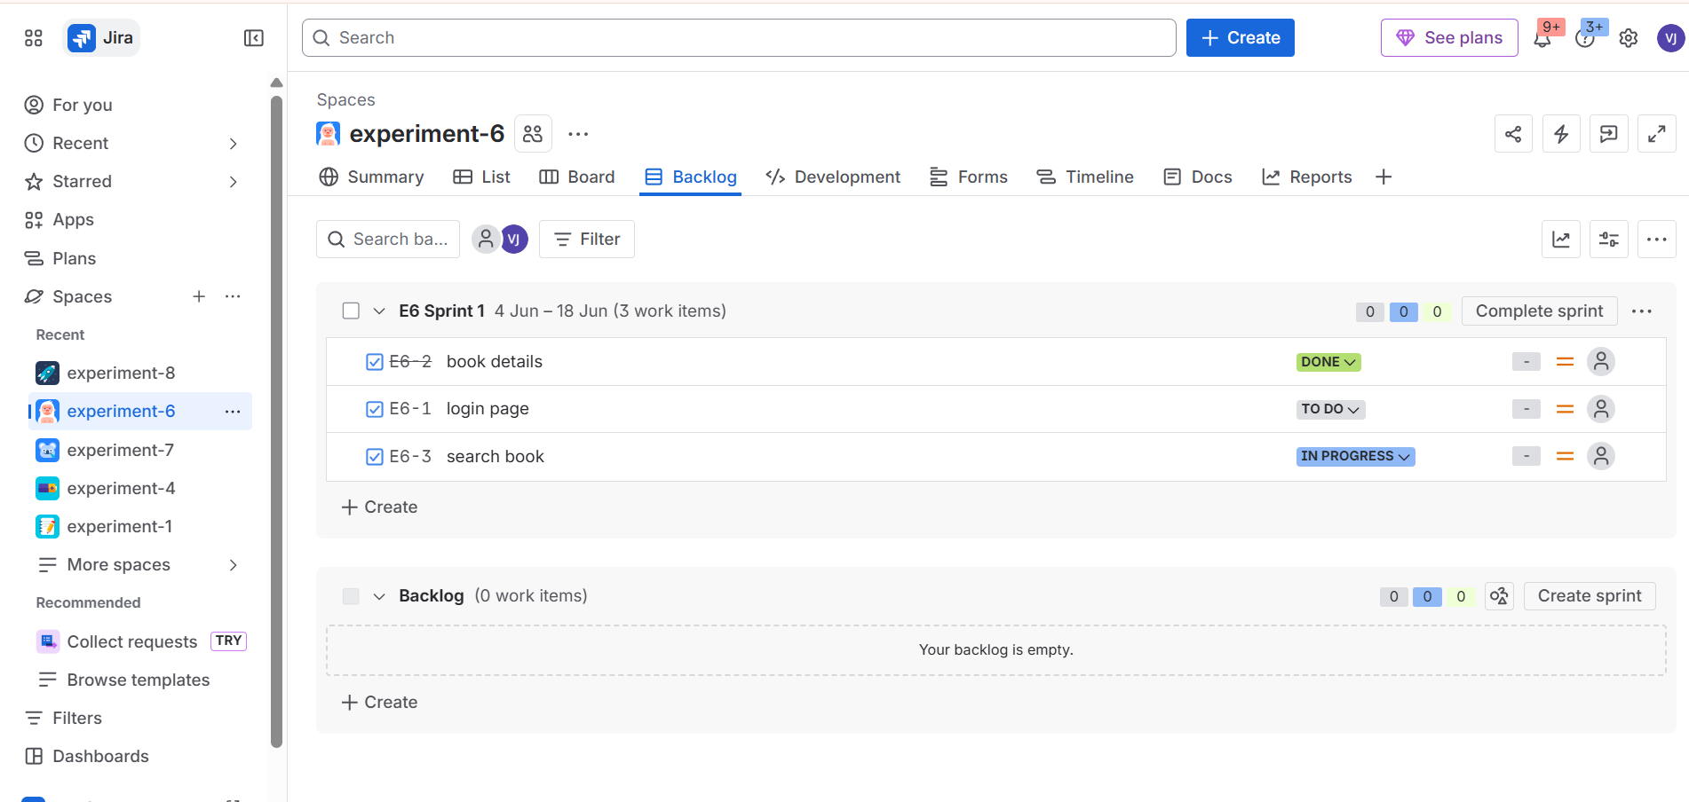
Step:_5
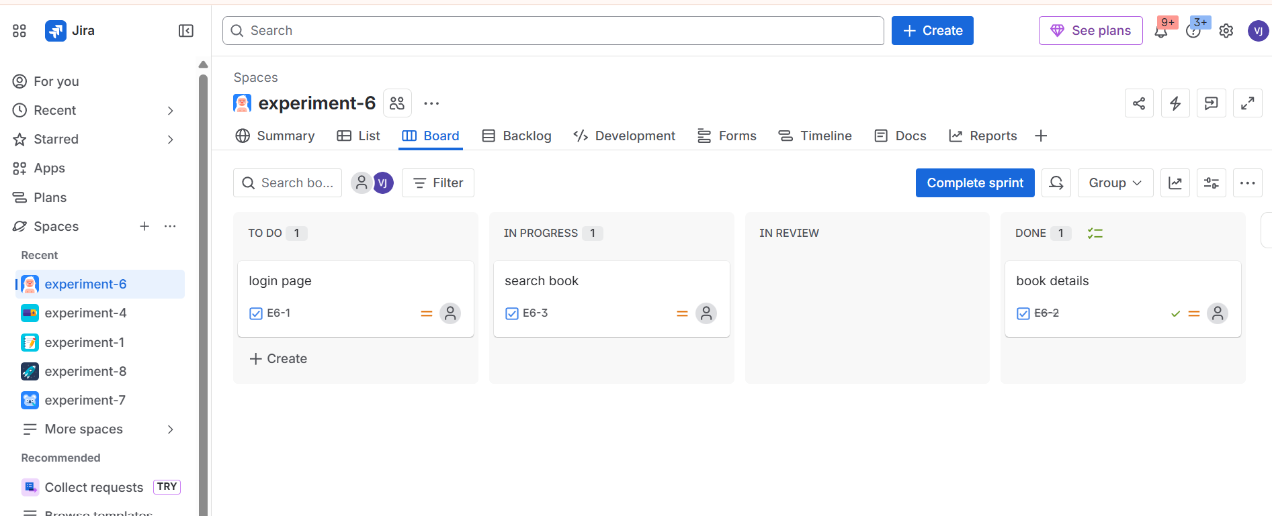
step:-6
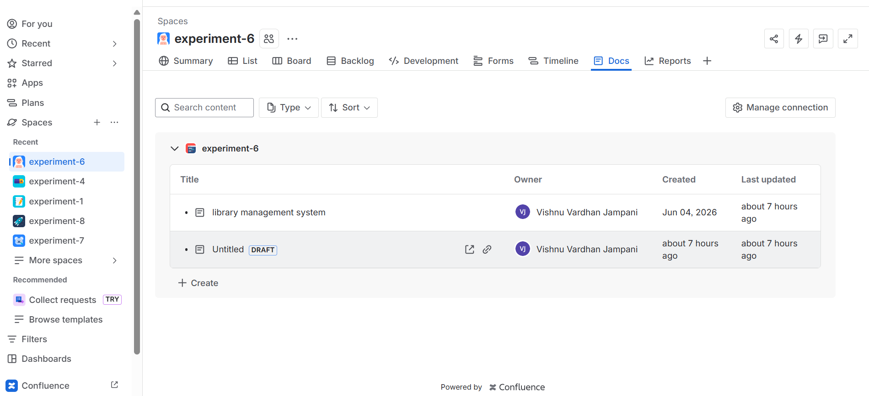
step:-7
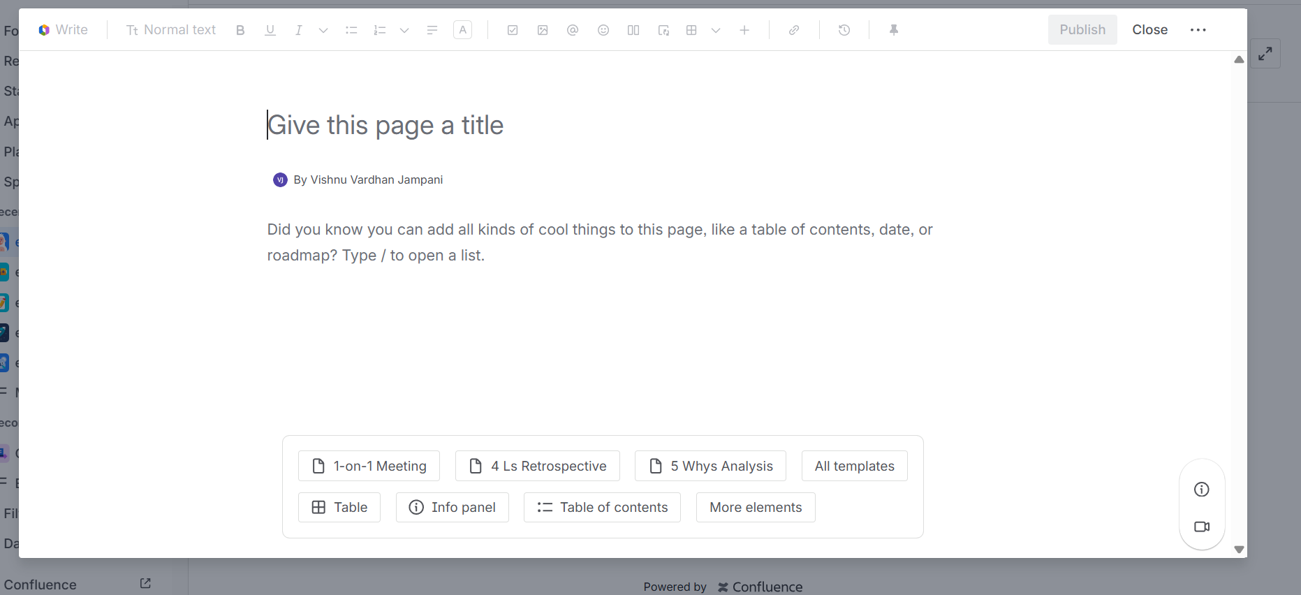
step:-8
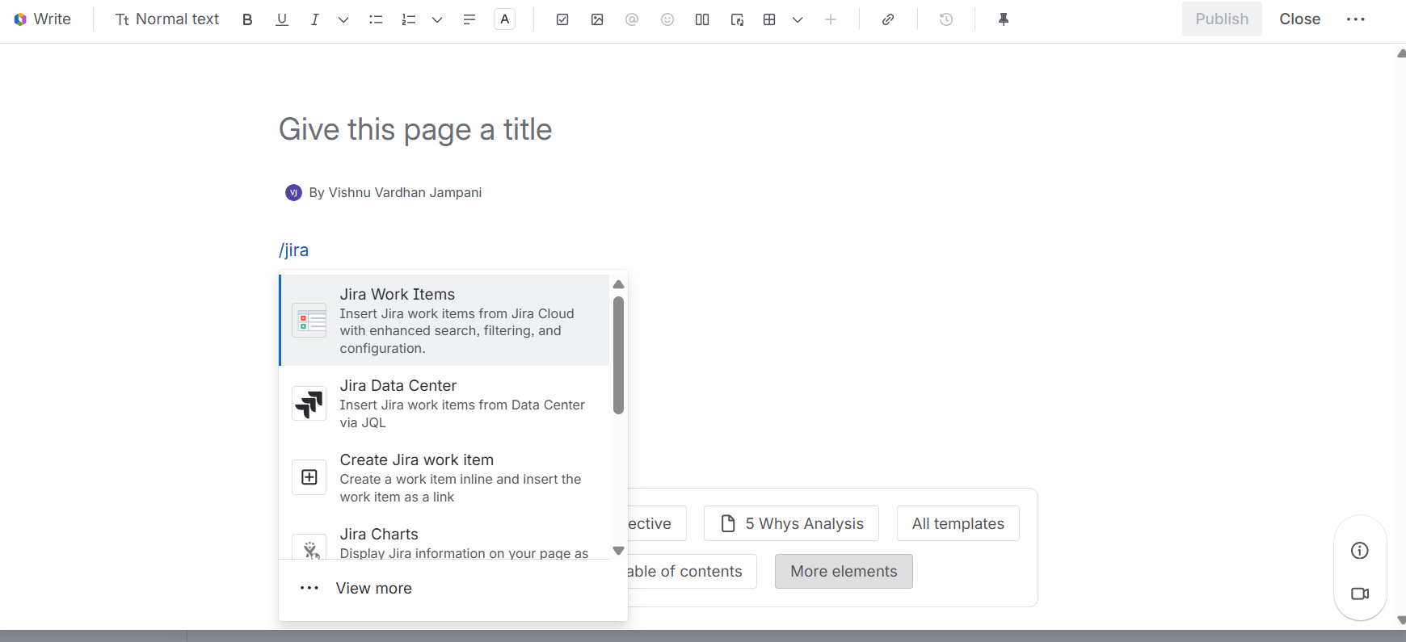
step:-9
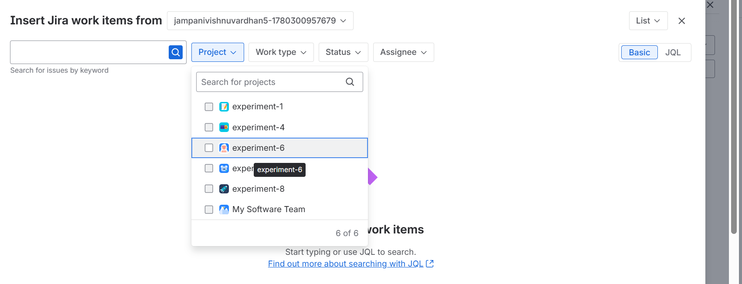
step:_10
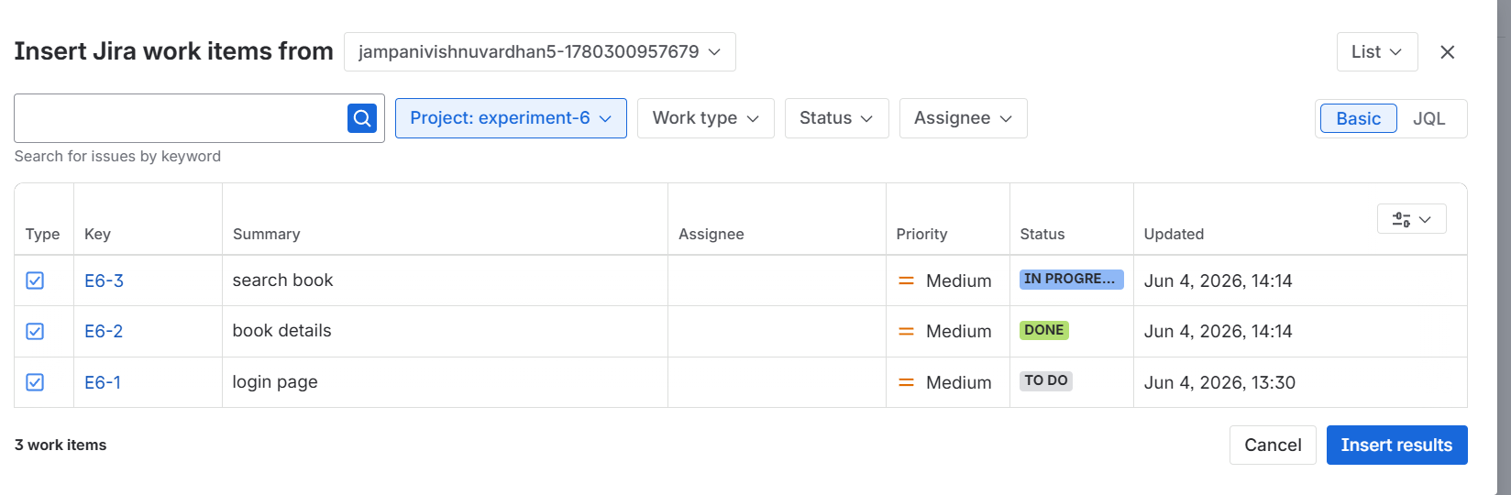
step:-11
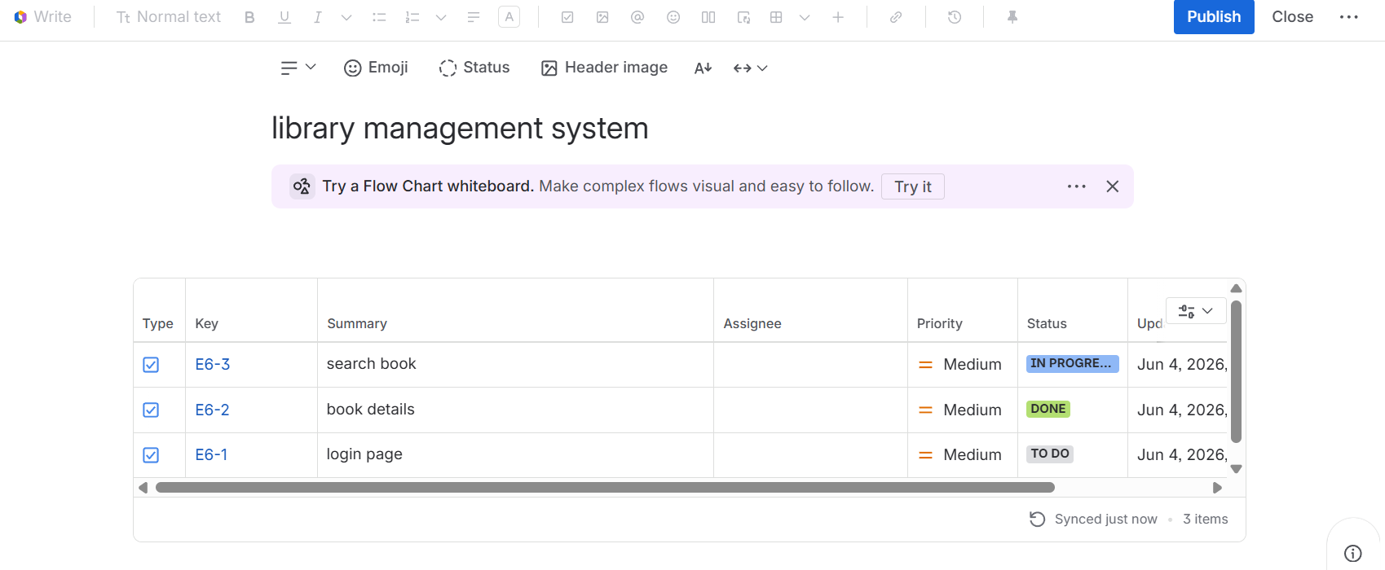
step:-12
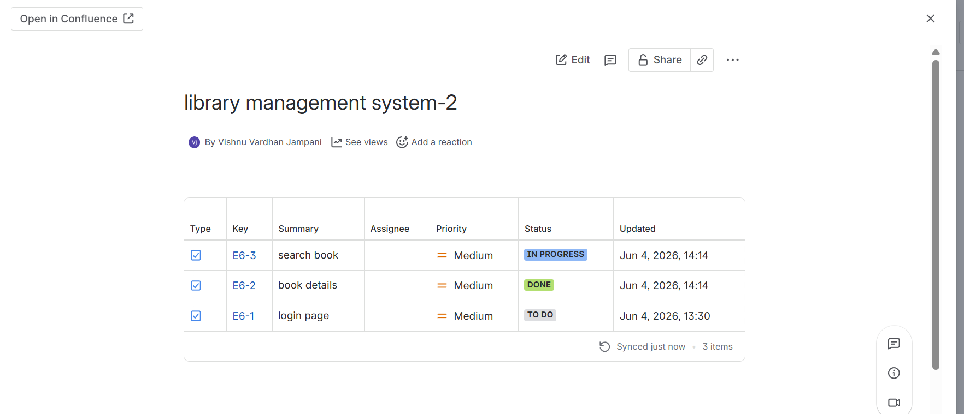
Result: Thus, The Jira issues embedded in Confluence with real- time progress tracking.

