##### MINOR PROJECT – I REPORT

**on**

**“Lexius”**

Submitted to Rajiv Gandhi Proudyogiki Vishwavidyalaya in partial fulfillment of the requirement for the award of the degree of

**Bachelor of Technology**

**in**

##### COMPUTER SCIENCE & ENGINEERING

**Submitted By**

##### ANMOL SHUKLA (206CS221037) ADARSH PANDEY (206CS221014) ABHINANDAN SHUKLA (206CS221006)

**DEPARTMENT OF COMPUTER SCIENCE & ENGINEERING**

### Gyan Ganga Institute of Technology and Sciences



**Jabalpur, Madhya Pradesh**

**Sep - Dec 2024**

##### PREFACE

Minor Project - I report is an integral part of B.Tech. and each and every student has to create the Minor Project - I in the 5th Semester while studying in the Institute.

This record is concerned about our practical Minor Project – I during 5th Semester i.e. 3rd year of B.Tech. course. We have taken our Practical Minor Project -I in **Lexius.** During this Minor Project – I, We got to learn many new things about the technology and its practical implementation. This Minor Project - I proved to be a milestone in our knowledge of present environment. Every say and every moment was an experience in itself, an experience which theoretical study can’t provide.

##### ACKNOWLEDGEMENT

It is our pleasure to be indebted to various people, who directly or indirectly contributed in the development of this work and who influenced our thinking, behavior and acts during the course of study.

We express are sincere gratitude to our principal, **Mr. Krishnanagar** for providing us an opportunity to undergo Minor Project – I in **Lexius**.

We are thankful to *our Head of Department,* ***Mr. Ashok Verma,*** *and All the faculty of our department* for there support, cooperation, and motivation provided to us during the Minor Project for constant inspiration, presence and blessings.

We also extend our sincere appreciation to our ***supervisor Prof Mukhti Pathak*** who provided his valuable suggestions and precious time in accomplishing our Minor Project – I synopsis.

Lastly, we would like to thank the almighty and our parents for their moral support and our friends with whom we shared our day-to day experience and received lots of suggestions that our quality of work.

**ANMOL SHUKLA (0206CS221037) ADARSH PANDEY (0206CS221014) ABHINANDAN SHUKLA (0206CS221006)**

##### DECLARATION

We, **Anmol Shukla (0206CS221037), Adarsh Shukla (0206CS221014), Abhinandan Shukla (0206CS221006)**, B.Tech (Semester- V) of the **Gyan Ganga Institute of Technology and Sciences**, Jabalpur hereby declare that the minor project synopsis report entitled “**Lexius**” is an original work and data provided in the study is authentic to the best of our knowledge. This report has not been submitted to any other Institute for the award of any other degree.

**Date: ANMOL SHUKLA ( 0206CS221037)**

**Place : Jabalpur ADARSH PANDEY (0206CS221014) ABHINANDAN SHUKLA (0206CS221006)**

This is to certify that above statement made by the candidate is correct to the best of our knowledge.

Approved by:

**Project Coordinator Project Supervisor Head of Department**

Prof. Mukhti Pathak, Prof. Sapan Kumar Jain, Mr. Ashok Verma, Professor, Professor, Department of CSE, Department of CSE, Department of CSE, GGITS,JABALPUR

GGITS,JABALPUR GGITS,JABALPUR

**GYAN GANGA INSTITUTE OF TECHNOLOGY AND SCIENCES, JABALPUR (MP)**

**Approved by AICTE New Delhi & Govt. of M.P.**

**(Affiliated to Rajiv Gandhi Prodyougiki Vishwavidhyalaya, Bhopal)**

**Certificate**

This is to certify that the Minor Project-I entitled “**Lexius**” is submitted by **Anmol Shukla, Adarsh Pandey** for the partial fulfillment of the requirement for the award of degree of **BACHELOR OF TECHNOLOGY** in **COMPUTER SCIENCE AND ENGINEERING** from **RAJIV GANDHI PROUDYOGIKI VISHWAVIDYALAYA, BHOPAL (M.P).**

**(Internal Examiner) (External Examiner)**

##### LIST OF FIGURES

|  |  |  |
| --- | --- | --- |
| **Figure No.** | **Figure Name** | **Pg.No** |
| **0** | **Lexius-Logo** | **6** |
| **8.1** | **Lexius-Main Page** | **32** |
| **3.2** | **Elasticsearch Guide** | **38** |
| **13.4** | **Data Flow Diagram** | **51** |
| **14.1** | **Activity Diagram** | **52** |
| **14.2** | **Class Diagram** | **56** |
| **14.3** | **Use Case Diagram** | **57** |
| **14.4** | **Sequence Diagram** | **58** |
| **A.1** | **Code Snippet-Flask** | **71** |
| **A.2** | **Code Snippet-Dockerfile** | **72** |
| **A.3** | **Code Snippet-Node Server** | **73** |
| **A.4** | **Code Snippet-Fuzzy Search** | **74** |

**List of Abbreviations**

* **AI** - Artificial Intelligence
* **NLP** - Natural Language Processing
* **DFD** - Data Flow Diagram
* **UI** - User Interface
* **UX** - User Experience
* **API** - Application Programming Interface
* **AJAX** - Asynchronous JavaScript and XML
* **BERT** - Bidirectional Encoder Representations from Transformers
* **DB** - Database
* **SQL** - Structured Query Language
* **NoSQL** - Not Only Structured Query Language
* **ML** - Machine Learning
* **JSON** - JavaScript Object Notation
* **XML** - eXtensible Markup Language
* **HTTP** - Hypertext Transfer Protocol
* **HTTPS** - Hypertext Transfer Protocol Secure
* **UI/UX** - User Interface/User Experience
* **IDE** - Integrated Development Environment
* **CRUD** - Create, Read, Update, Delete
* **TCP/IP** - Transmission Control Protocol/Internet Protocol
* **SEO** - Search Engine Optimization
* **JWT** - JSON Web Token
* **SDK** - Software Development Kit
* **REST** - Representational State Transfer
* **MVC** - Model-View-Controller
* **CLI** - Command Line Interface
* **SSL** - Secure Sockets Layer
* **TLS** - Transport Layer Security
* **CDN** - Content Delivery Network
* **RDBMS** - Relational Database Management System
* **ORM** - Object-Relational Mapping
* **ELK** - Elasticsearch, Logstash, Kibana (Elastic Stack)
* **CSS** - Cascading Style Sheets
* **JS** - JavaScript
* **SDK** - Software Development Kit
* **OS** - Operating System
* **TCP** - Transmission Control Protocol

Contents

0

1. Title Page i
2. Preface ii
3. Acknowledgement iii
4. Declaration iv
5. Certificate v
6. List of Figures vi
7. List of Abbreviations vii
8. Abstract 5
9. Software Requirement and Specifications 7
10. Introduction 8
    1. Purpose……………………………………………………………….8
    2. Product Scope 8
11. Overall Description 10
    1. Product Perspective… … … … … … … … … … … … … … … . 10
    2. Product Functions 11
    3. Operating Environment………………………………………….. 12
    4. Assumptions and Dependencies 14
12. External Interface Requirements 18
    1. User Interfaces 18
    2. Hardware Interfaces 18
    3. Software Interfaces 19
    4. Communication Interfaces 19
13. Functional Requirements 21
    1. Query Types 21
    2. Filters 21
    3. Read More Functionality 21
14. Other Non-functional requirements 22
    1. Performance Requirements 22
    2. Security and Privacy Requirements 22
    3. Reliability 23
15. Installation Instructions 24
16. Installing dependencies 25
    1. Aptitude (apt-get) dependencies 26
    2. Pip dependencies 27
17. User Manual 26
18. Starting the software 29
19. Main Page 31
    1. Chatbot Interface  31
       1. Queries Type Buttons  31
       2. Search Bar  31
       3. Query for Filters 31
    2. Results  33
       1. Result 33
       2. Read More 33
20. Algorithms 34
21. Searching 35
    1. Introduction 35
    2. Algorithm to Search Database 35
       1. Elasticsearch 35
    3. Algorithm for Auto-Complete 39
       1. Fuzzy Search(Fuse.js) 39
22. BERT 40
    1. Introduction 40
    2. Bert-as-service 40
    3. Sentence Classification Tasks 41
    4. Out-of-memory Issues 41
23. Restricted Boltzmann Machine(RBM) 42

11.1 Introduction 42

* 1. Pre-Processing 42
  2. Feature Vector Extraction 43
  3. Feature Matrix Generation 43
  4. Deep Learning Algorithm 43
  5. Summary Generation 43

1. Gensim 44
   1. Introduction 44
   2. Text Rank Model 44
   3. Keyword Extraction 44
   4. Sentence Extraction 45
2. Architecture and Design 46
3. Architectural Overview 47
   1. System Design 47
   2. Technology Stack 49
   3. Integration Between Components 50
   4. Data Flow Diagram…………………………………………………..51
4. Diagrams 52
   1. Activity Diagram……………………………………………………52
   2. Class Diagram 56
   3. Use Case Diagram 57
   4. Sequence Diagram 58
   5. E-R Diagram………………………………………………………….58
5. Performance and Future Enhancements 59
6. Challenges and Solutions 60
7. Future Enhancements 62
   1. Multilingual Support 62
   2. Integration with External Legal Databases 65
   3. Real-Time Legal Assistance 68

Appendices 70

* Appendix A: Code Snippets. 71
* Appendix B: References and Resources 75

**ABSTRACT**

The Lexius project is an innovative legal assistance platform designed to simplify complex legal research and provide personalized, conversational guidance. By integrating advanced Natural Language Processing (NLP) models like BERT and TensorFlow with Elasticsearch for efficient indexing and retrieval, the system filters and summarizes constitutional articles, legal precedents, and case studies in natural language. Built on a robust tech stack including Flask, Node.js, and Docker for seamless deployment, the platform bridges accessibility gaps in legal knowledge. The Lexius delivers real-time, context-aware responses, enabling users to interact naturally as if consulting a knowledgeable legal expert.

The project features interconnected web and Android applications, offering a unified experience across platforms. Leveraging virtual environments and containerized machine learning components, it ensures high scalability and modularity. With its intuitive interface and multilingual support, the Lexius aims to democratize legal expertise, empowering individuals and professionals to navigate legal complexities efficiently and confidently.

Lexius

(Your Ai-Legal Advisor)



Part I

Software Requirement and Specifications

|  |  |  |
| --- | --- | --- |
|  | Chapter 1 |  |
| Introduction |  |
| 1.1 Purpose |  |
| **Web Application:**   * **Purpose:**   To provide a robust and accessible platform for users to explore legal content  on a wider screen. The web app caters to users who prefer detailed interaction with a structured interface for better readability and research.   * **Key Features for Web:**   1. Advanced search and filter functionality for legal articles.   2. Display large chunks of data in a visually appealing and readable format.   3. Integration with resources like legal databases and case studies for comprehensive research.   4. Support for exporting data or generating reports (e.g., PDFs). |  |
| **Android Application:**   * **Purpose:**   To offer a portable and interactive solution for users who need on-the-go access  to legal information. Designed for convenience and accessibility, it provides essential functionality in a compact interface.   * **Key Features for Android:**   1. Voice-based search for legal queries using AI.   2. Offline mode for accessing saved legal content.   3. Notifications for updates on relevant legal topics or case law.   4. Lightweight and optimized UI for mobile devices. |  |
| 1.2 Product Scope |  |

|  |  |  |
| --- | --- | --- |
|  | **Web Application Scope:**   1. **Target Audience:**    * Legal professionals, law students, and researchers.    * Individuals seeking legal knowledge for personal use. 2. **Features:**    * **Interactive Search:** Advanced filtering and searching of constitutional articles and legal documents.    * **Cross-Referencing:** Display related laws and case precedents in an   organize manner.   * + **Detailed Interface:** Large screens for better visualization of complex legal information.   + **Collaboration:** Features like saving, sharing, or exporting legal data in   various formats.   1. **Use Cases:**    * Quick access to precise legal information for professional work or study.    * Preparing reports or presentations on legal cases and topics. 2. **Scalability:**    * Designed to accommodate high traffic and future enhancements, such as integration with external legal databases or additional features (e.g., multilingual support). |  |
| **Android Application Scope:**   1. **Target Audience:**    * On-the-go users, including legal practitioners and general users seeking instant legal help. 2. **Features:**    * **Voice Assistance:** Voice-enabled search to simplify interaction.    * **Offline Access:** Ability to save and access frequently used legal references offline.    * **Notifications:** Alerts for legal updates, relevant case laws, or important legal changes.    * **Simplified UI:** Mobile-friendly interface with a focus on ease of use. 3. **Use Cases:**    * Accessing legal information during travel or in courtrooms.    * Real-time assistance for urgent legal queries. 4. **Scalability:**    * Lightweight design to support older and newer Android devices.    * Plans to integrate real-time legal advice via chatbots or direct messaging with lawyers. |  |

Chapter 2

Overall Description

## Product Perspective

The **AI Lawyer** project is a cross-platform legal assistant, available as both a **web** and **Android** application, designed to provide fast, reliable legal information through natural language processing (NLP). The product combines advanced machine learning with a user-friendly interface to assist legal professionals, students, and individuals with legal queries.

**Key Features:**

* + - **Natural Language Understanding:** Powered by **BERT** for accurate legal query processing.
    - **Fast Search & Retrieval:** Using **Elasticsearch** to quickly fetch legal content.
    - **Cross-Platform Integration:** Syncs between **web** and **Android** for seamless user experience.
    - **Offline Access (Android):** Allows storing essential legal content for offline use.

**Technology Stack:**

* + - **Frontend (Web):** Node.js, JavaScript, HTML, CSS.
    - **Frontend (Android):** Kotlin.
    - **Backend:** Flask API.
    - **NLP:** TensorFlow, BERT.
    - **Search:** Elasticsearch.
    - **Database:** Stores legal content and user data.

## Product Functions

The product functions offered by the **AI Lawyer** software are as follows:

1. **Query Input:**
   * **Types of Queries:** Users can type queries in the following formats:
     + **Act Names** (e.g., "IT Act, 2000")
     + **Legal or Non-Legal Keywords** (e.g., "data privacy")
     + **Case Title** (e.g., "XYZ v. ABC")
     + **Natural Language Query** (e.g., "What are the legal provisions for data privacy in India?")
2. **Filtration of Data:**
   * The system allows users to apply filters to narrow down the search results based on:
     + **Judge Name**
     + **Date Range** (from and to)
     + **Case Category** (e.g., constitutional, civil, criminal)
     + **Relevant Acts** (e.g., Data Protection Act, IT Act)
3. **Search Results:**
   * The system generates and displays relevant results based on the search input and applied filters. Results are shown in a **tabular format** highlighting the following fields:
     + **List of Cases**
     + **Judgment**
     + **Judge**
     + **Acts Cited**
     + **Case Category**
     + **Date** of the judgment or ruling
4. **Get Summarization:**
   * For each case or document that appears in the search results, users can view a **brief summary** (approximately 100-200 words).
   * Each case result will have a **"Read More"** button, which, when clicked, shows a detailed summary of the case, making it easier for users to understand the case without having to read the full document.

## Operating Environment

The **AI Lawyer** software operates in the following environments:

1. **Web Application:**

* **Operating Systems:**
  + **Linux**
* **Browsers Supported:**
  + **Google Chrome**
  + **Mozilla Firefox**
  + **Safari**
  + **Microsoft Edge**
* **Technology Stack:**
  + **Frontend:** HTML, CSS
  + **Backend:** Flask (Python-based), Node.js
  + **Search Engine:** Elasticsearch
* **Requirements:**
  + Modern web browser with **JavaScript** enabled
  + Stable internet connection for real-time search and content retrieval
  + SSL encryption for secure user interactions

1. **Android Application:**

* **Operating System:**
  + **Android OS** (Version 5.0 and above)
* **Technology Stack:**
  + **Frontend:** Kotlin for Android development
  + **Backend:** Flask (Python-based), Node.js
  + **Search Engine:** Elasticsearch (via API calls)
  + **Libraries/Frameworks:** TensorFlow for BERT (for NLP) and Retrofit for network requests
* **Requirements:**
  + Android smartphone or tablet (Version 5.0 or higher)
  + Stable internet connection for full functionality, with offline capabilities for storing key legal data
  + User permissions for microphone (voice input) and storage (offline access)

1. **Development Environment:**

* **Operating Systems:**
  + **Linux**
* **Software Requirements:**
  + **Python 3.x** for backend services (Flask, TensorFlow)
  + **Kotlin** for Android app development
  + **Node.js** for handling the web application
  + **Elasticsearch** for indexing and searching legal data

1. **Network Environment:**

* **Internet Access:** Required for dynamic search results, legal data retrieval, and syncing across platforms (Web and Android).
* **Offline Mode (Android):** Users can access saved legal content and documents when disconnected from the internet.

**The Database used here is AJAX directly connected to frontend.**

## Assumptions and Dependencies

1. **System Requirements:**
   * The system is assumed to be running a **Debian- based Linux distribution** (e.g., Debian 10/11 or Ubuntu).
   * The architecture is assumed to be **64-bit**, with sufficient resources (CPU, RAM, and disk space) to support both **machine learning models** and **real-time data queries**.
2. **AJAX Communication Assumption:**
   * **AJAX** is used to send asynchronous HTTP requests from the **frontend (web)** to the **backend** without reloading the page. This ensures that search queries, filters, and results are dynamically updated in real-time.
   * **AJAX** is utilized in **JavaScript** on the frontend to communicate with the backend API (written in Flask or Node.js).
3. **Internet Connectivity:**
   * The application assumes an **active internet connection** for retrieving and syncing legal data, as well as making API requests for search results.
4. **NLP Model Size Assumption:**
   * **BERT** and other NLP models are assumed to be pre-trained and ready to use, and the system is assumed to have sufficient resources (like disk space and memory) to store and use the models.
5. **Cross-Platform Communication:**
   * The system assumes that the **web application** and **Android app** will interact with the same **backend**, with the frontend relying on AJAX for real-time

communication and the Android app communicating with the backend using Retrofit/OkHttp.

**Dependencies for AI Lawyer (Linux-Debian 64-bit Architecture)**

1. **Operating System Dependencies:**
   * **Linux-Debian 64-bit** system should have basic tools installed:
     + curl (for interacting with APIs)
     + libssl-dev (for secure communication)
     + libc6 (for necessary libraries)
2. **Backend Dependencies (Python-based - Flask):**
   * **Python 3.x** (3.7 or above):
     + Install using sudo apt install python3
   * **Virtual Environment** (for managing dependencies):
     + Install using sudo apt install python3-venv
   * **Flask** (Web framework for the backend API):
     + Install with pip install Flask
   * **Elasticsearch-py** (Python client for Elasticsearch):
     + Install with pip install elasticsearch
   * **TensorFlow** (for NLP and BERT):
     + Install with pip install tensorflow
     + Install bert with pip install bert serving and bert serving client.

**For my system I have used docker container for bert -as-service by tensorflow that works with clip-as-service and dockerfiles.**

* + **Gensim** (NLP library):
    - Install with pip install gensim
  + **AJAX Handling** on frontend requires **JavaScript**, which is handled by frontend technologies.

1. **Frontend Dependencies (AJAX Integration):**
   * **JavaScript & jQuery** (AJAX is mainly used with jQuery for easy communication):
     + Install with: npm install jquery
   * **Node.js** (for server-side logic if used with frontend):
     + Install with sudo apt install nodejs
   * **npm** (Node Package Manager):
     + Install with sudo apt install npm
2. **Search Engine Dependencies (Elasticsearch):**
   * **Elasticsearch** (for full-text search and indexing legal data):
     + Install via sudo apt install elasticsearch
   * **Java** (required for Elasticsearch):
     + Install **OpenJDK** using sudo apt install openjdk-11-jdk
3. **Android App Dependencies:**
   * **Kotlin** for Android development (typically handled by Android Studio):
     + Install Android Studio (includes Kotlin support).
   * **Retrofit** (for network communication with backend):
     + Add Retrofit to your Android app's build.gradle

file for HTTP requests.

* + **Android SDK** and **Android Studio** for development.

1. **Web Server Dependencies:**
   * **Apache or Nginx** (if using a web server for production deployment):
     + Install with sudo apt install apache2 or sudo apt install nginx
2. **SSL/TLS Encryption:**
   * **SSL/TLS** for secure communication between frontend and backend:
     + Install using sudo apt install openssl

**System Configuration Assumptions:**

1. **Firewall & Security:**
   * The **firewall** on the system is configured to allow communication between the frontend (AJAX requests) and the backend API (Flask/Node.js server), as well as Elasticsearch queries.
   * SSL/TLS encryption is assumed to be set up for secure communication between the client (web or mobile) and the backend.
2. **Cross-Platform Integration:**
   * The **web frontend** (using **AJAX**) communicates with the same backend that serves the **Android app** (using Retrofit), ensuring that both platforms can work together seamlessly.

Chapter 3

External Interface Requirements

## User Interfaces

The **AI Lawyer** interface is designed for ease of use and a seamless experience:

* + 1. **Search Box**: Users can search by keywords and filter by **date**, **case**, **judge**, and **category** by answering chatbot questions.
    2. **Query Type Selection**: Four query types are available via chatbot questions—**Act Names**, **Keywords**, **Case Title**, and **Natural Language** queries.
    3. **Dynamic Results Display**: Search results appear instantly without page reloads. Results include case titles, summaries, judge names, dates, and more.
    4. **Case Summaries**: Each result includes a **"Read More"**

option to view a brief summary of the case.

* + 1. **Smooth Scrolling**: Results load dynamically as users scroll, providing a responsive, interactive experience.

## Hardware Interfaces

The project working or installation may not take much time but the configuration may take. Make sure that you have nvidia graphics,

since it don’t take much time for configuration. For cpu you have to make configuration for it since the released version of software does account much according to it.

## Software Interfaces

**Web Application**:

* **Frontend**: HTML, CSS, JavaScript, AJAX for dynamic UI.
* **Backend**: Flask (Python) or Node.js for API communication.
* **Database**: Elasticsearch for legal data, SQL/NoSQL for user/session data.

**Mobile Application (Android)**:

* **Frontend**: Kotlin for development.
* **API Communication**: Retrofit for RESTful API calls.
* **Database**: Room (optional) for local storage, Firebase for user authentication.

**External Software**:

* **Elasticsearch**: For storing and querying legal data.
* **NLP**: TensorFlow and spaCy for processing natural language queries.
* **Authentication**: OAuth, JWT for secure login and sessions.
* **Cloud**: AWS/Google Cloud for storage, backups, and real-time syncing.

**Other Integrations**:

* **Voice Search**: Google Assistant or Amazon Alexa API.
* **Visualization**: Chart.js or D3.js for displaying legal insights.

## Communication Interfaces

* **Web Interface**: Users interact via browser (HTML, CSS, JavaScript, AJAX).
* **Mobile Interface**: Users interact via Android app (Kotlin, Retrofit for API calls).
* **Voice Search**: Integration with **Google Assistant** or **Amazon Alexa** for voice queries.
* **Authentication**: **OAuth** for secure login, **JWT** for session management.
* **Data Sync**: **Cloud Storage** (AWS/Google Cloud) and **Firebase** for real- time data syncing.
* **Search Results**: **AJAX** ensures instant results and updates without page reload.

Chapter 4

Functional Requirements

## Query Types

There are four questions for selecting the query type: **Act Names**, **Legal/Non- Legal Keywords**, **Case Titles**, and **Natural Language Query**. The user selects the query type and enters their search in the search bar.

## Filters

* + - **Question for Date Filter**: Allows users to set a start and end date for their search.
    - **Question for Other Filters**: Users can filter results by **Judge**, **Category**, and **Acts** using available placeholders.

## Read More Functionality

* + - Each search result is displayed as a **card** with tabular data.
* The **"Read More"** button, when clicked, displays a **summary** of the case, and the button changes to **"Read Less"**. Users can hide the summary again by

clicking **"Read Less"**. ,

Chapter 5

Other Non-functional requirements

## Performance Requirements

* + - The system must provide search results within **2 seconds**, ensuring a seamless user experience.
* **Elasticsearch** is utilized for fast server-side indexing and querying, while **Fuse.js** handles efficient client-side search and filtering for improved responsiveness.

## Security and Privacy Requirements

* + - Since sensitive personal information is not required, the system poses minimal privacy concerns.
    - However, **HTTPS encryption** and secure session management using **JWT** ensure the protection of user interactions and data integrity during communication

# Maintainability and Extensibility

* The system is designed to allow easy updates and integration of new features like additional filters or advanced analytics without major disruptions.
* Modular coding practices enable quick debugging and adaptability for future requirements.

# User Feedback

* In case of no or low-quality matches, the system should provide

**suggestions for alternative queries** to improve user experience and

maintain engagement.

# Reliability

* + - Results must be highly accurate and contextually relevant, with a threshold-based filtering system displaying only those matching the query above a predefined similarity score.
* To enhance reliability, the system incorporates **backup mechanisms** to handle data loss scenarios and ensure consistent availability.

Part II Installation Instructions

Chapter 6

Installing dependencies

**Environment Setup**:

* Create and activate a virtual environment for the backend (e.g., atlantic_venv) to manage dependencies independently.

python -m venv atlantic_venv source atlantic_venv/bin/activate

**Backend Dependencies**:

* Install all required Python libraries using a requirements.txt file to ensure consistent setup across systems.

pip install -r requirements.txt

* Key dependencies:
  + **TensorFlow** for NLP tasks.
  + **Flask** for API services.
  + **Elasticsearch-py** to interact with Elasticsearch.

**Frontend Dependencies**:

* Install Node.js packages for the web application's frontend.

npm install

* Dependencies include:
  + **Fuse.js** for fuzzy search functionality.
  + **AJAX** for real-time dynamic updates.

**Database Setup**:

* Install and configure Elasticsearch for indexing and searching case data.
  + On Linux (Debian-based):

sudo apt install elasticsearch sudo systemctl start elasticsearch

* + For other OS, download from the [official Elasticsearch website](https://www.elastic.co/downloads).

**Testing**:

* Run the backend server to verify API responses.
* Start the frontend application to ensure the UI integrates correctly.
* Check Elasticsearch to confirm that data indexing and queries work properly.

The following packages are supposed to be installed :

## Aptitude (apt-get) dependencies

* + - build-essential
    - python3-dev
    - python3-setuptools
    - python3-pip
    - curl
    - elasticsearch

## Pip dependencies

* + - flask
    - boto3
    - botocore
    - bz2file
    - certifi
    - chardet
    - Click
    - docutils
    - idna
    - itsdangerous
    - jmespath
    - MarkupSafe
    - numpy
    - tensorflow
    - tensorboard
* pkg-resources
* python-dateutil
* requests
* s3transfer
* six
* Keras
* bert-serving-client
* bert-serving-server
* smart-open
* urllib3
* Werkzeug
* gensim
* requests
* Jinja2
* scipy

Part III User Manual

Chapter 7

Starting the software

1. **Start Elasticsearch**
   * Ensure the Elasticsearch service is running to handle database operations:

sudo systemctl start elasticsearch # On Linux

1. **Start Backend Server**
   * Navigate to the backend directory in your terminal and activate the virtual environment:

source atlantic_venv/bin/activate # For Linux/Mac

* + Run the Flask server: python server.py
  + The backend API should now be accessible at **http://localhost:5000**.

1. **Start Frontend (Web Application)**
   * Navigate to the frontend directory and start the Node.js development server:

npm start

* + The frontend will run on a default port (e.g., **http://localhost:8081**) and connect to the backend API.

1. **Start Mobile Application (Android)**
   * Open the Android project in **Android Studio**.
   * Connect a physical device or use an emulator.
   * Click **Run** to deploy the application. Ensure the mobile app points to the backend server's IP address.
2. **Verify and Use**
   * Open the web application in your browser at **http://localhost:8081** or use the Android app.
   * Test features such as search, filters, and case summaries to ensure all components are working together.

Chapter 8 Main Page

Main Page is where all the information of the software resides. The following are the most important areas of the main page:

## Chatbot Interface

The Chatbot Interface contains the tools required to send a search request.Itconsist of the following parts:

#### Query Type Buttons

There are four questions being asked by bot for four types of search queries: Act names, Casetitles, Legal/Non-Legal keywords, and Natural Language query.

#### Search Bar

A prominent input field where users can type their queries. Four **questions** allow users to specify the type of query:

* + - * **Act Names**
      * **Legal/Non-Legal Keywords**
      * **Case Titles**
      * **Natural Language Query**

#### Query for Filters

Users can refine their search results using filters:

* **Date Range**: Set a start and end date.
* **Judge Name**: Filter cases by judge. 31
* **Case Category**: Select from predefined categories.

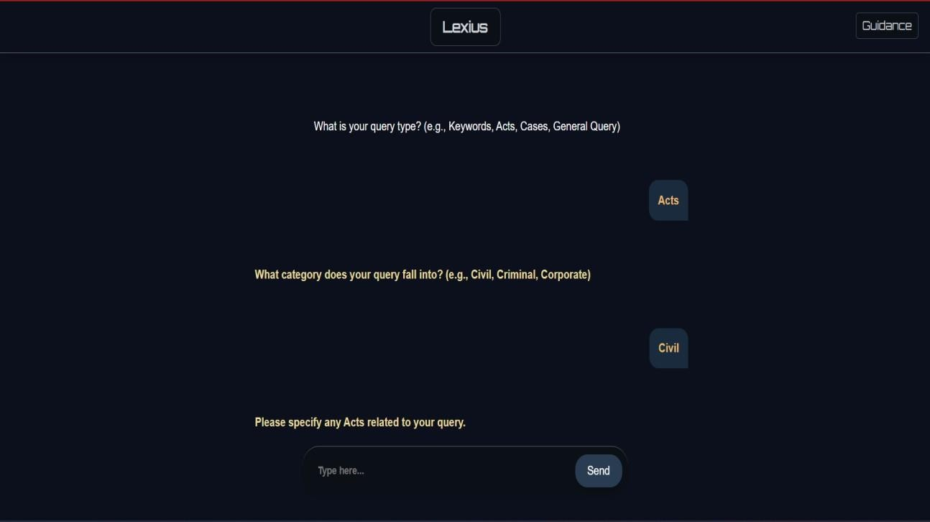

## Result

There are multiple result which are displayed according to the search parameters.Each result card consists of:

#### Results

A table of data is displayed in each result card. For every field, a small number of items are displayed. In case there are several items in a single column, theextra data is truncated, and can be seen as a tooltip on hovering over the column. The table consists of the following fields:

1. Cases Title
2. Case Category
3. The Judge Name
4. Acts cited
5. Judgement Date

#### Read More/Read Less Button

* + - * Each card has a **"Read More"** button to display a brief summary (100- 200 words) of the case.
      * The button toggles to **"Read Less"**, allowing users to collapse the summary.

Part IV Algorithms

Chapter 9 Searching

## Introduction

In this part we apply some efficient search algorithms.

## Algorithm to Search Database

#### Elasticsearch

Elasticsearch is an open-source, RESTful, distributed search and analytics engine built on Apache Lucene.One can send data in the form of JSON doc- uments to Elasticsearch using the API or ingestion tools such as Logstash and Amazon Kinesis Firehose. Elasticsearch automatically stores the original document and adds a searchable reference to the document in the cluster’s index. The motivation to use Elasticsearch is as follows. While one can drive a car by turning a wheel and stepping on some pedals, highly competent drivers typically understand at least some of the mechanics of the vehicle. The same is true for search engines. Elasticsearch provides APIs that are very easy to use, and it will get one started and take one far without much effort.

The various components of Elasticsearch include:

* + - * *Near Real Time (NRT)*: Elasticsearch is a near real time search platform. What this means is there is a slight latency (normally one second) fromthe time you index a document until the time it becomes searchable.
      * *Cluster:* A cluster is a collection of one or more nodes (servers) that together holds the entire data and provides federated indexing and search capabilities across all nodes.
      * *Node*: A node is a single server that is part of the cluster, stores the data, and participates in the cluster’s indexing and search capabilities.

A node can be configured to join a specific cluster by the cluster name. In single cluster, one can have as many nodes as needed.

* + - * *Index:* An index is a collection of documents that have somewhat similar characteristics. For example, we can have an index for customer data, another index for a product catalog, and yet another index for order data.
      * *Type*: Within an index, we can define one or more types. A type is a logical category/partition of the index whose semantics is completely up to the coder. In general, a type is defined for documents that have a set of common fields.
      * *Document*: A document is a basic unit of information that can be indexed. For example, we can have a document for a single customer, another document for a single product, and yet another for a single order. This document is expressed in JSON (JavaScript Object Notation) which is an ubiquitous internet data interchange format.
      * *Shards and Replicas*: Elasticsearch provides the ability to subdivide the index into multiple pieces called shards. When we create an index, we can simply define the number of shards that we want. Each shard is in itself a fully-functional and independent-index that can be hosted on any node in the cluster.

We can have a better idea at -

[https://www.elastic.co/blog/found-elasticsearch-from-the-](https://www.elastic.co/blog/found-elasticsearch-from-the-bottom-up#inverted-indexes-and-index-terms)bottom-up# [inverted-indexes-and-index-terms](https://www.elastic.co/blog/found-elasticsearch-from-the-bottom-up#inverted-indexes-and-index-terms)

Once we have our node (and cluster) up and running, we need to communicate with it. For this, Elasticsearch provides a very comprehensive and powerful REST API that we can use to interact with our cluster. The Elastic Search API for our software runs at localhost:9200 and it generates a JSON output similar to this:

Elasticsearch is built on top of Lucene. Every shard is simply a Lucene index. Lucene index, if simplified, is the inverted index. Every Elasticsearch index is a bunch of shards or Lucene indices. When you query for a document, Elasticsearch will subquery all shards, merge results and return it to you. When you index document to Elasticsearch, the Elasticsearch will calculate in which shard document should be written using the formula.

*shard* = *hash*(*routing*)%(*number of primary shards*)

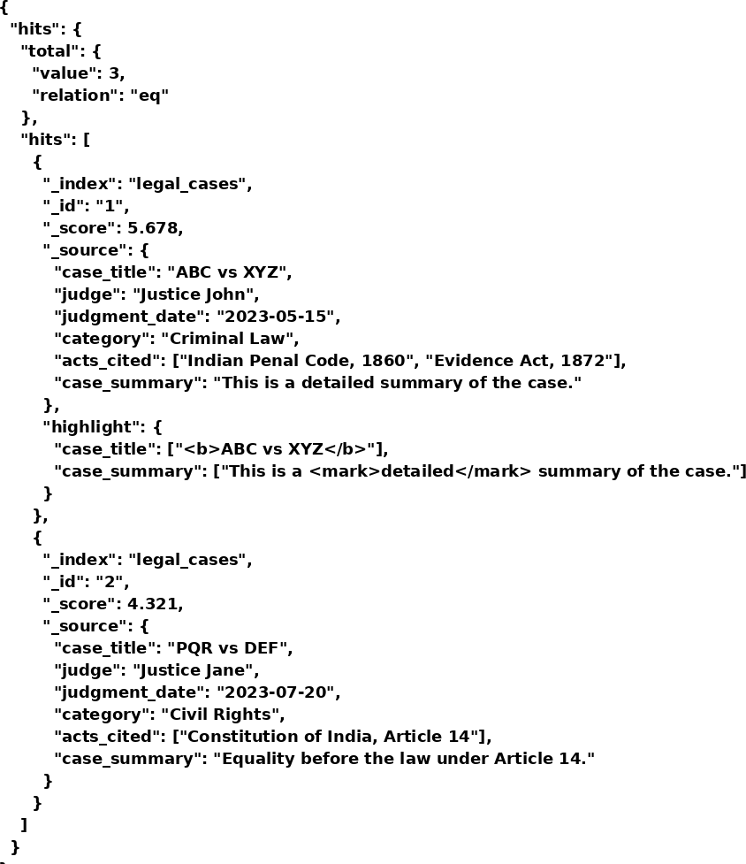

It gives us the list of case files relevant to the query ranked according to the pertinence with the help of scores. Each case file which is returned contains the essential information of the case such the title, citation id, judge and result.

For more information,visit :

[https://www.elastic.co/guide/en/elasticsearch/reference/1.4/getting-](https://www.elastic.co/guide/en/elasticsearch/reference/1.4/getting-started.html)sta [l](https://www.elastic.co/guide/en/elasticsearch/reference/1.4/getting-started.html)

## Algorithm for Auto-Complete

#### Fuzzy Search(Fuse.js)

A fuzzy search is a process that locates Web pages that are likely to be relevant to a search argument even when the argument does not exactly correspond to the desired information. A fuzzy search is done by means of a fuzzy matching program, which returns a list of results based on likely relevance even though search argument words and spellings may not exactly match. Exact and highly relevant matches appear near the top of the list. Subjective relevance ratings, usually as percentages, may be given.

Fuzzy matching programs usually return irrelevant hits as well as relevant ones. Superfluous results are likely to occur for terms with multiple meanings, only one of which is the meaning the user intends. If the user has only a vague or general idea of the topic, or does not know exactly what to look for, the ratio of relevant hits to irrelevant hits tends to be low. (The ratio is even lower, however, when an exact matching program is used in this situation.)

Fuzzy searching is much more powerful than exact searching when used for research and investigation. Fuzzy searching is especially useful when research- ing unfamiliar, foreign-language, or sophisticated terms, the proper spellings of which are not widely known. Fuzzy searching can also be used to locate individuals based on incomplete or partially inaccurate identifying information.

Hence, in our project we have used Fuse.js to provide relevant suggestions based on typed data. Different JSONs were created for different types of queries. When the user selects the type of query, and starts typing, the Fuzzy Search runs on the respective JSON and provides relevant autocomplete op- tions.

For more information,visit :

<https://whatis.techtarget.com/definition/fuzzy-search>

Chapter 10 BERT

## Introduction

BERT, or Bidirectional Encoder Representations from Transformers, is a new method of pre-training language representations which obtains state-of-the- art results on a wide array of Natural Language Processing (NLP) tasks. It is a method of pre-training language representations, meaning that we train a general-purpose ”language understanding” model on a large text corpus (like Wikipedia), and then use that model for downstream NLP tasks that we care about (like question answering). BERT outperforms previous methods because it is the first unsupervised, deeply bidirectional system for pre-training NLP. Unsupervised means that BERT was trained using only a plain text corpus, which is important because an enormous amount of plain text data is publicly available on the web in many languages.

## Bert-as-service

Bert-as-service uses BERT as a sentence encoder and hosts it as a service via ZeroMQ, allowing you to map sentences into fixed-length representations in just two lines of code. It is State-of-the-Art, Fast, Scalable, Reliable and Easy to use.We use this in our project for the autocomplete feature. The results are really accurate. It generates vectors for each word and is more powerful than word2vec and other NLP implementation.

## Sentence Classification Tasks

We run a python code, ’run classifier.py’ for training our sentence classifier.The first run shows an accuracy of about 84.55%. After 3-4 runs, we see results between 84% and 88%.Once we have trained our classifier we can use it in inference mode.

## Out-of-memory Issues

BERT heavily relies on memory. So,it is genreally run on systems which have strong GPUs, and about 6GB or 12GB memory. Since such large amounts of memory are handled, out-of-memory issues are common. The factors that affect memory usage include: max seq length, train batch size, Model type(BERT-Base or BERT-Large), and the Optimizer used.

For more information, visit:

* + - [https://github.com/google-research/bert?fbclid=IwAR2bQ1euL4suq8OAj](https://github.com/google-research/bert?fbclid=IwAR2bQ1euL4suq8OAjZin8RP-BTFK8knjSVAc62ppuJp-iWIyjeSxCgsKFTQ)
    - [https://github.com/hanxiao/bert-as-service?fbclid=IwAR2u](https://github.com/hanxiao/bert-as-service?fbclid=IwAR2uhE1w_ZOieRGDq5m5IanGWM4xjcXT2Us0un0VvLkIA_EXaqvmV-KUUY4)hE1w_ [ZOieRGDq5m5IanGWM4xjcXT2Us0un0VvLkIA_EXaqvmV-KUUY4](https://github.com/hanxiao/bert-as-service?fbclid=IwAR2uhE1w_ZOieRGDq5m5IanGWM4xjcXT2Us0un0VvLkIA_EXaqvmV-KUUY4)

Chapter 11

RestrictedBoltzmann Machine(RBM) for Summarization

## Introduction

Restricted Boltzmann Machine (RBM) is proposed which is a type of unsu- pervised deep learning. In unsupervised learning, the input data is not labeled. It is a type of machine learning algorithm, in which inferences are drawn from datasets consisting of unlabeled input data. There are two types:

* + - Extractive Text Summarization
    - Abstractive Text Summarization

This algorithm uses Extractive text summarization.

In this method, textsummarization based on some features like title simi- larity,term frequency, sentence ranking etc are extracted to form summary.

## Pre-Processing

The text is preprocessed before the algorithm is applied. This is done in or- der to structure the document by applying myriads of techniques by which the density of document is reduced and document is made light weight. This makes the further processing of document easier.This includes stop-word re- moval, part of speech tagging,stemming, punctuation mark removal and so on.

## Feature Vector Extraction

The document which is made light weight in the preprocessing phase is now structured into a matrix. A sentence matrix M of order n*v contains the features for every sentence of a matrix. Here, ‘n’ is the number of sentences in the document and ‘v’ is the number of features. Four features are extracted of a sentence of text document namely Title Similarity, Positional Feature, Term Weight, Sentence Length, Proper Noun Score.

## Feature Matrix Generation

The above calculated features’ values are then stored in a matrix form where the columns represent the features and rows represent the sentences.

## Deep Learning Algorithm

The sentence matrix containing a set of feature vectors is given as an input to the RBM phase as a visible layer. The Deep Learning Algorithm produces a refined matrix after several phases of refining. The refined matrix obtained from the deep learning phase is used for further summary generation phase.

## Summary Generation

Now, in two ways summary can be generated. One is a generalized summary of the whole document and the other way is based on the user query entered by the user(using the sentence score).

In our project, we generate a generalized summary of each case file with 1000 words. This summary file consists of the Case facts in the beginning, followed by the description and then at the end, we have the verdict.

For more information, visit:

* + - <https://thescipub.com/pdf/10.3844/jcssp.2014.1.9>
    - <http://ijsart.com/Content/PDFDocuments/IJSARTV4I623858.pdf>

Chapter 12

Gensim for Summarization

## Introduction

Gensim is a free Python library designed to automatically extract semantic topics from documents. The gensim implementation is based on the popular TextRank algorithm. It is an open-source vector space modelling and topic modelling toolkit, implemented in the Python programming language, using NumPy, SciPy and optionally Cython for performance. We use the summa- rization.summarizer from gensim. This summarising is based on ranks of text sentences using a variation of the TextRank algorithm.

## Text Rank Model

The basic idea implemented by a graph-based ranking model is that of voting or recommendation.

When one vertex links to another one, it is basically casting a vote for that vertex. The higher the number of votes cast for a vertex, the higher the importance of that vertex.

TextRank includes two NLP tasks,namely the Keyword extraction task,Sentence extraction task.

## Keyword Extraction

The task of keyword extraction algorithm is to automatically identify in a text a set of terms that best describe the document.The simplest method is to use frequency criterion,but it yields poor results. The TextRank keyword extraction algorithm is fully unsupervised. No training is necessary.

## Sentence Extraction

To apply TextRank, we first build a graph associated with the text, where the graph vertices are representative for the units to be ranked. The goal is to rank entire sentences, therefore, a vertex is added to the graph for each sentence in the text.

In our project gensim is used for the 200 words summarization. The input files are the original case files. This summarization produces good results with facts and the verdicts of the cases.

For more information, visit:

<https://radimrehurek.com/gensim/summarization/summariser.html>

Part V Architecture

And Design

Chapter 13

Architectural and Design

## System Design

**Overview:**

The system architecture is designed to provide a ChatGPT-like experience for querying legal documents, case laws, and statutory information. It is modular, with each component handling specific responsibilities for efficiency and scalability.

1. **Components:**
2. **Frontend**:
   * Provides an intuitive chat interface for user interaction.
   * Uses AJAX/WebSocket for real-time communication with the backend.
3. **Backend**:
   * Acts as the communication hub between the frontend and other components.
   * Implements routing, query processing, and response formatting.
4. **NLP Module**:
   * Powered by TensorFlow and BERT for natural language understanding.
   * Handles tasks like intent recognition, context extraction, and relevance scoring.
5. **Database and Storage**:
   * **Elasticsearch**: Stores and indexes legal data for fast retrieval.
   * **Relational/NoSQL Database**: Manages user data, query history, and analytics.
6. **APIGateway**:
   * Manages incoming API requests from the frontend and routes them to appropriate services.
   * Encapsulates and standardizes communication with the backend.
7. **Deployment Environment**:
   * All major components, including TensorFlow models, Elasticsearch, Flask, and Node.js, are containerized using Docker for consistent deployment.

13.2 Technology Stack

1 **Frontend:**

* **Framework**: React or Angular for a responsive UI.
* **Languages**: HTML, CSS, JavaScript (with AJAX/WebSocket for dynamic communication).
* **Features**:
  + ChatGPT-like interface with query submission.
  + Real-time response rendering.

1. **Backend:**

* **Frameworks**: Flask (for Python-based API) and Node.js (for additional routing).
* **Responsibilities**:
  + Handling incoming user queries.
  + Integrating with the NLP module and Elasticsearch.

1. **NLP Module:**

* **Framework**: TensorFlow with a fine-tuned BERT model.
* **Capabilities**:
  + Analyzing natural language queries for intent and context.
  + Extracting relevant legal documents based on query.

1. **Database:**

* **Elasticsearch**: Fast, indexed retrieval of legal documents and case laws.
* **SQL/NoSQL Database**: Persistent storage of user profiles, query history, and system logs.

1. **Deployment Tools:**

* **Docker**: Containerizes components for easy deployment and scalability.
* **Load Balancer**: Distributes incoming traffic across multiple backend servers.

13.3 Integration Between Components

**Workflow:**

1. **Frontend Interaction**:
   * The user submits a query via the chat interface.
   * AJAX sends the query asynchronously to the backend.
2. **Backend Processing**:
   * The API Gateway routes the query to the **QueryProcessor**.
   * If the query requires NLP, it is sent to the **NLP Module**.
   * If the query involves retrieving legal data, it is routed to **ElasticSearch**.
3. **Data Retrieval and NLP**:
   * **ElasticSearch** retrieves relevant indexed documents.
   * The **NLP Module** processes the query for context and relevance scoring.
4. **Response Formatting**:
   * The backend compiles the retrieved data into a structured response.
   * Sends the response back to the frontend.
5. **Frontend Update**:
   * The frontend updates the chat interface dynamically with the received response.

13.4 Data Flow Diagram

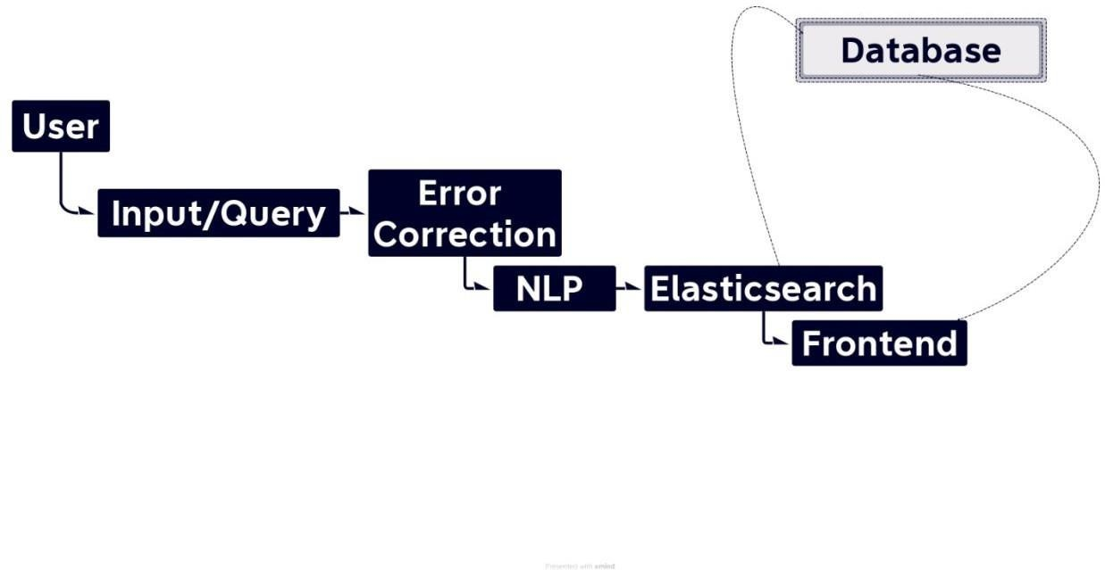 Chapter 14

Diagrams

14.1 Activity Diagram

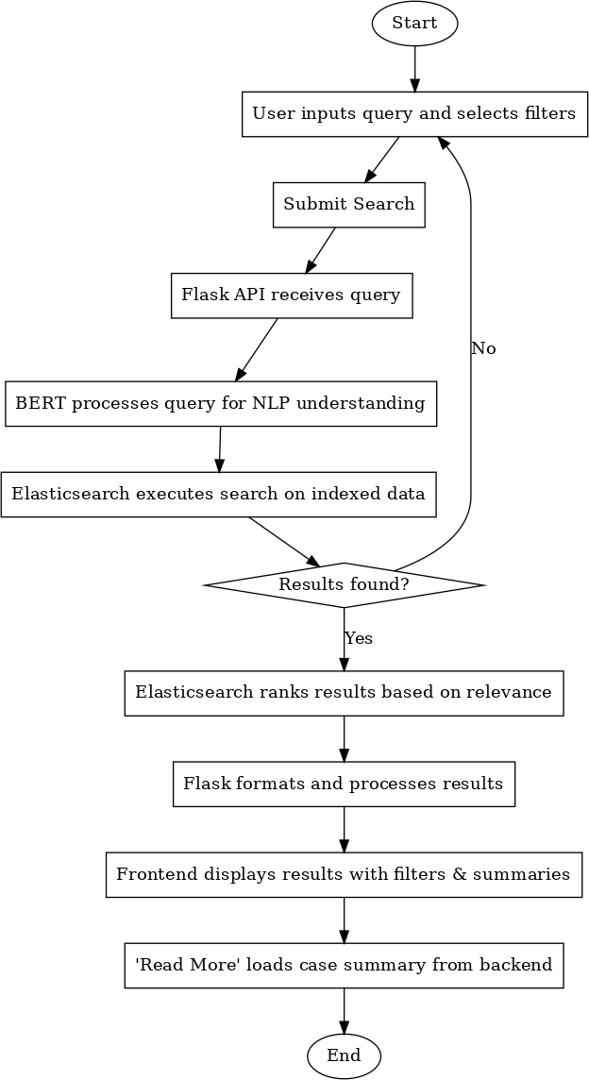

The activity diagram illustrates the **AI Lawyer** system's flow for handling user queries, processing them using Natural Language Processing (NLP) via BERT, and retrieving results through Elasticsearch. It also includes a loop mechanism to handle cases where no results are found.

**Process Overview:**

* + 1. **User Input**:

The process begins when the user enters a query in the search bar and selects appropriate filters, such as Judge Name, Date Range, Category, or Acts. The user then submits the search request.

* + 1. **Backend Processing**:
       - The Flask API receives the query and passes it to the BERT model for NLP processing.
       - BERT converts the natural language query into a structured format, ensuring accurate interpretation.
       - The processed query is sent to Elasticsearch to search for relevant documents in the indexed database.
    2. **Search Execution**:
       - Elasticsearch executes the search and checks whether any results match the query.
       - If **results are found**, they are ranked based on relevance using Elasticsearch's scoring mechanism.
    3. **Formatting and Display**:
       - The Flask API processes the ranked results, formats them, and sends them back to the frontend.
       - The frontend dynamically displays the results in a user-friendly format, with filters and summaries available for each case.
    4. **Case Summary**:
       - Each result has a "Read More" button. Clicking this button retrieves and displays a concise case summary from the backend.
       - The button toggles to "Read Less," allowing the user to hide the summary.
    5. **Handling No Results**:
       - If **no results are found**, the system loops back to the user input stage, prompting the user to refine their query or adjust the filters.

**Loop Explanation:**

The decision node ("Results found?") ensures the system dynamically responds to the presence or absence of results:

* If **results are found**, the workflow proceeds to ranking and display.
* If **no results are found**, the user is looped back to the query input stage. This iterative process ensures the user can refine their search without starting from scratch.

14.2 Class Diagram

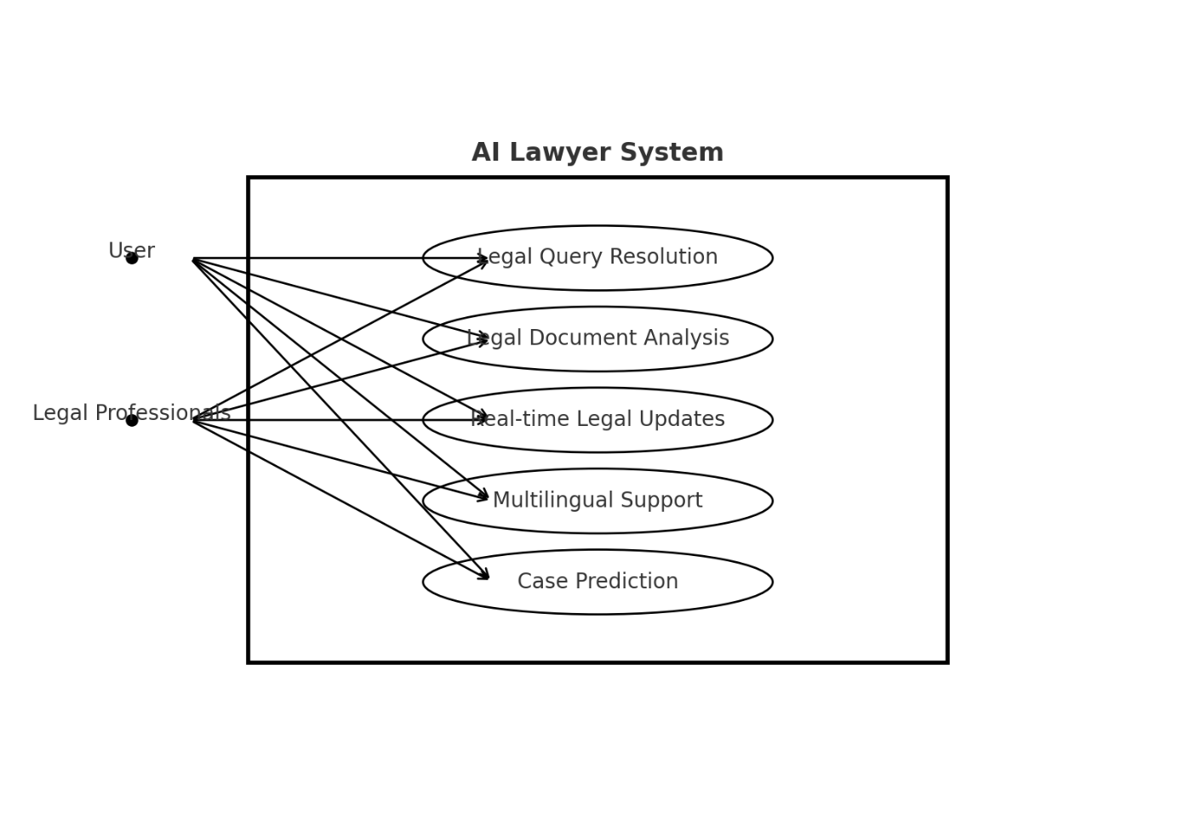

14.3 Use Case Diagram

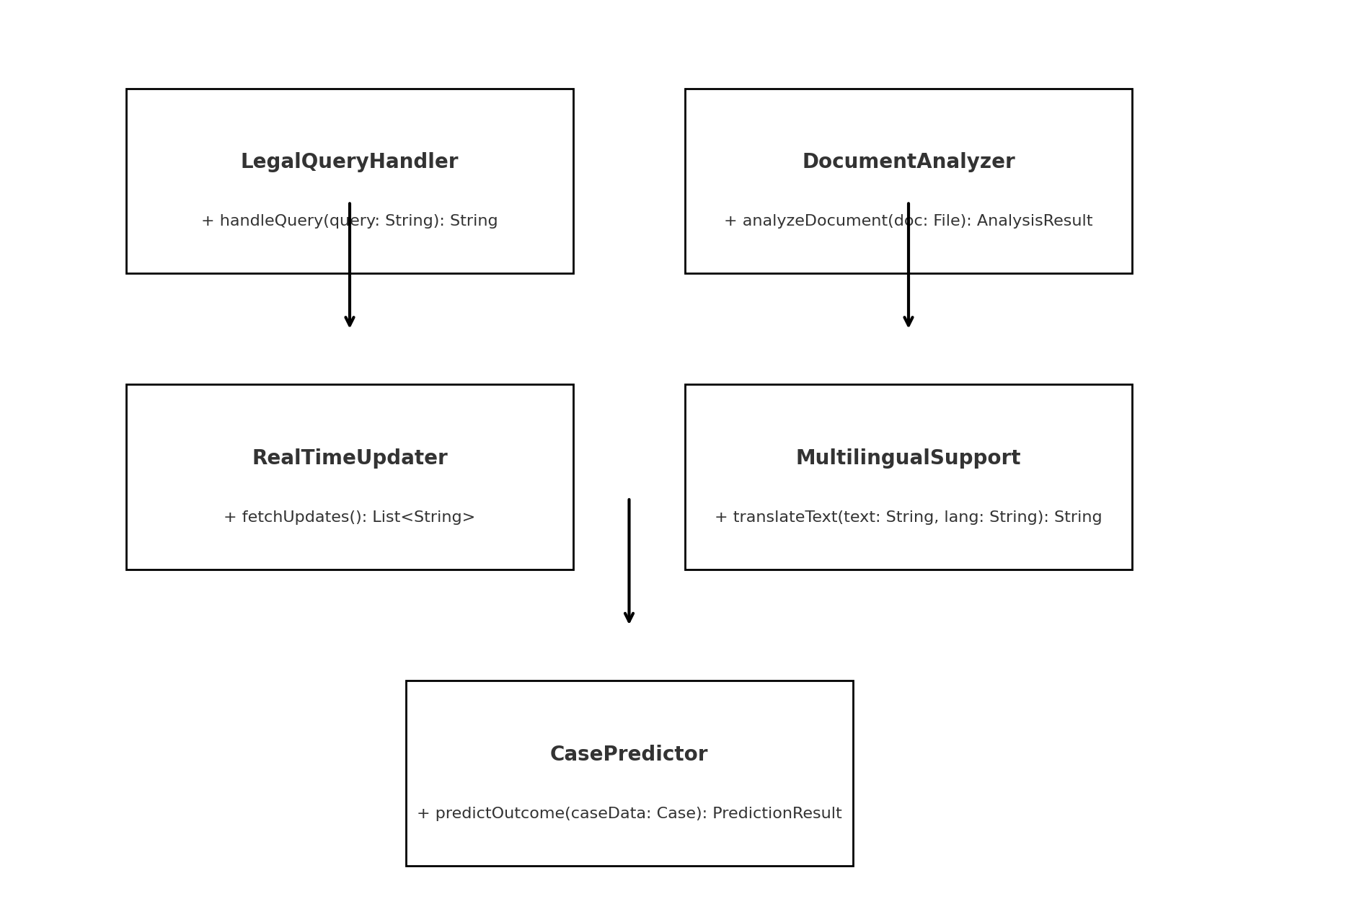

14.4 Sequence Diagram

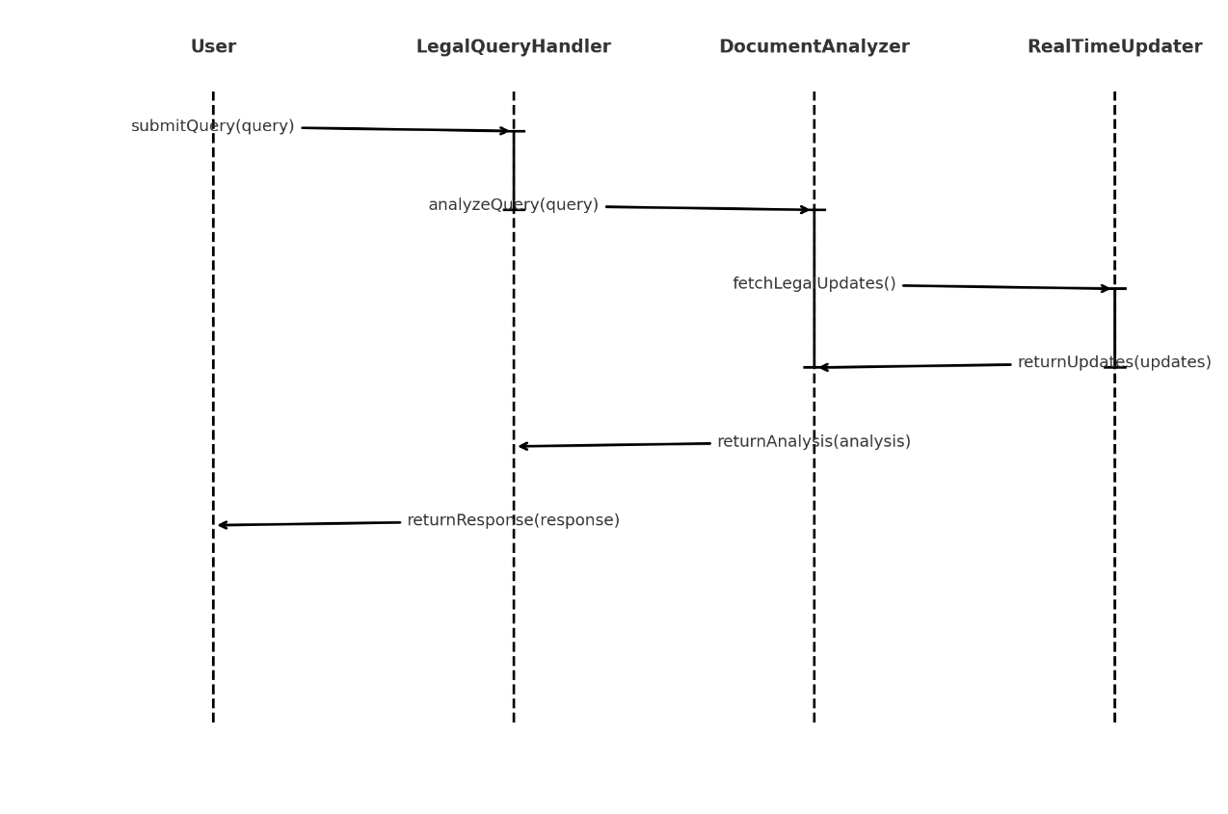

Part VI

Performance and Future Enhancements

Chapter 15

Challenges and Solutions

**1. Integrating AI Concepts with Legal Frameworks**

**Challenge**:  
Legal professionals may not fully understand AI terminologies, while technical teams may lack a deep understanding of legal workflows. This gap can make documentation unclear to one or both groups.

**Solution**:

* Create a **dedicated glossary** of AI and legal terms.
* Use **layered explanations**: Start with high-level summaries and dive deeper into technical/legal details as needed.
* Include **examples** to demonstrate how the AI system applies to real-world legal scenarios.

**2. Capturing Multimodal Functionalities**

**Challenge**:  
The AI Lawyer integrates multiple functionalities such as search, summarization, NLP-based query handling, and multilingual support. Documenting these features cohesively is challenging.

**Solution**:

* Organize features into clear, **separate sections** (e.g., Search, Summarization, Multilingual Support).
* Use **flow diagrams** or screenshots to visually explain how each feature works.
* Include **user workflows** to show how various functionalities are connected.

**3. Highlighting Multilingual and Jurisdictional Flexibility**

**Challenge**:  
Legal systems vary across jurisdictions, and multilingual support adds another layer of complexity.

**Solution**:

* Document how jurisdiction-specific data is handled (e.g., filtering by country-specific databases).
* Provide **localized use case examples** to show how the system adapts to different jurisdictions.
* Highlight multilingual capabilities with screenshots of the interface in different languages.

**4. Explaining AI and Data Processing Workflows**

**Challenge**:  
The system uses advanced AI models like BERT and Elasticsearch, which are complex for non-technical stakeholders to understand.

**Solution**:

* Simplify technical explanations using **visualizations**:
  + Show how data flows from input (query) to processing (NLP) and output (legal information).
  + Include diagrams for AI model architecture and system workflows.
* Add **technical appendices** with detailed descriptions for developers.

**5. Managing Continuous Updates**

**Challenge**:  
Legal databases and AI algorithms are updated frequently. Keeping documentation aligned with these changes can be time-intensive.

**Solution**:

* Use **version-controlled documentation systems** like GitHub or Confluence.
* Develop a **changelog** section to highlight recent updates.
* Assign a team or individual to periodically review and revise documentation.

**6. Ensuring User Accessibility and Engagement**

**Challenge**:  
Complex documentation may deter end-users from engaging with the system fully.

**Solution**:

* Use a **user-centric approach**: Create separate guides for legal professionals, developers, and general users.
* Include **interactive elements** like tooltips, videos, or online tutorials to simplify onboarding.
* Offer a **quick start guide** with common queries and use cases.

Chapter 16

Future Enhancements

16.1 Multilingual Support

**Purpose**

To allow users to query and receive legal assistance in their native language, breaking language barriers and ensuring inclusivity for legal professionals, students, and the general public.

**Key Features**

1. **Natural Language Query Processing**:
   * Support for multiple languages in user queries (e.g., English, Spanish, French, Hindi).
   * Detect language automatically using tools like Google Language Detection API or spaCy.
2. **Legal Document Translation**:
   * Retrieve documents in one language and provide translations in the user’s preferred language using tools like Google Translate API or Microsoft Translator API.
3. **Multilingual Data Indexing**:
   * Store and index legal documents in various languages for efficient retrieval.
4. **Localized User Interface**:
   * Allow users to interact with the platform in their preferred language through localized UI elements (menus, instructions, etc.).

**Implementation Strategy**

1. **Language Detection**:
   * Automatically identify the language of the user’s input using libraries like langdetect or polyglot.
   * Redirect the query to the appropriate language pipeline.
2. **Multilingual NLP Models**:
   * Use models like **mBERT (Multilingual BERT)** or **XLM-R (Cross-lingual Roberta)** for understanding and processing queries in multiple languages.
   * Fine-tune models with domain-specific legal data in different languages.
3. **Database Design**:
   * Create separate indices for each language in Elasticsearch.
   * Example: legal_docs_en for English documents, legal_docs_es for Spanish.
4. **Translation Services**:
   * Use APIs like Google Translate, DeepL, or AWS Translate for translating documents and summaries.
   * Include AI-based translation engines to improve accuracy for legal terminologies.
5. **User Interface Localization**:
   * Use frameworks like **React-i18next** for frontend localization.
   * Provide dropdown options for language selection or auto-detect based on the user’s location.
6. **Search Optimization**:
   * Implement cross-lingual search capabilities where a query in one language retrieves documents in another.
   * Example: A query in French retrieves English and French documents, with translated summaries.

**Workflow**

1. **Input Processing**:
   * User enters a query in their preferred language.
   * The system detects the language and routes it to the appropriate NLP model or translation pipeline.
2. **Query Execution**:
   * The query is processed and searched against the multilingual database.
   * Relevant results are retrieved in the source language or translated into the user’s preferred language.
3. **Output Delivery**:
   * Results are displayed in the user’s language with options to view the original document or translated content.

**Tools and Technologies**

1. **NLP Models**:
   * mBERT, XLM-R, spaCy multilingual pipelines.
2. **Translation APIs**:
   * Google Translate, DeepL, AWS Translate.
3. **Language Detection**:
   * langdetect, polyglot, or Google Language Detection API.
4. **Frontend Localization**:
   * React-i18next, Angular i18n, or Vue i18n.

**Challenges and Mitigations**

1. **Legal Terminology Accuracy**:
   * **Challenge**: Translation tools might misinterpret domain-specific terms.
   * **Mitigation**: Train translation models on legal datasets or use domain-specific APIs like Systran Legal Translator.
2. **Performance Overhead**:
   * **Challenge**: Multilingual processing may increase latency.
   * **Mitigation**: Cache translations and pre-index multilingual documents.
3. **Data Availability**:
   * **Challenge**: Limited legal data in less common languages.
   * **Mitigation**: Collaborate with legal repositories or crowdsource document translations.
4. **UI Complexity**:
   * **Challenge**: Designing an intuitive interface for multilingual users.
   * **Mitigation**: Use language-specific layout testing and user feedback.

**Future Enhancements**

1. **Offline Multilingual Support**:
   * Provide language-specific offline data packs for mobile users.
2. **Speech-to-Text in Multiple Languages**:
   * Enable voice input for legal queries in diverse languages.
3. **Machine Learning-based Terminology Mapping**:
   * Build models to better understand and map legal terminologies across languages.

16.2 Integration with External Legal Databases

**Purpose**

To enhance the system’s functionality by providing real-time access to external legal databases such as LexisNexis, Westlaw, or government-hosted legal repositories. This ensures the platform offers accurate, authoritative, and comprehensive legal information.

**Key Benefits**

1. **Comprehensive Legal Information**:
   * Access to statutes, regulations, case laws, and legal interpretations.
   * Inclusion of historical and jurisdiction-specific legal precedents.
2. **Up-to-Date Content**:
   * Automatic syncing with external databases for the latest legal updates and rulings.
3. **Increased Credibility**:
   * Integration with trusted legal databases enhances the system’s reliability and professional appeal.
4. **Advanced Search Features**:
   * Utilize external database search engines for keyword, citation, and natural language queries.

**Integration Strategy**

1. **API Access**:
   * Many external databases provide APIs for secure data access. Example: RESTful APIs for Westlaw or LexisNexis.
   * **Implementation**:
     + Secure API keys and configure endpoints for query requests and data retrieval.
2. **Data Mapping**:
   * Normalize data formats from external databases for consistency with the platform’s structure.
   * Utilize JSON or XML for seamless data exchange.
3. **Search Optimization**:
   * Leverage the external database’s built-in advanced search functionalities (e.g., Boolean searches, keyword prioritization).
   * Enhance the platform’s Elasticsearch queries to merge results from external sources.
4. **Caching and Performance**:
   * Implement caching mechanisms to store frequently accessed legal documents and reduce latency.
   * Tools: Redis, Memcached.
5. **Data Privacy and Compliance**:
   * Ensure the integration complies with legal and ethical standards for data sharing and usage.
   * Use HTTPS, OAuth, and other secure protocols.

**Technical Workflow**

1. **User Query Input**:
   * User submits a legal query via the system interface.
2. **Backend Processing**:
   * Backend identifies if the query requires external database access.
   * For example, keywords like "precedent," "case law," or "statutory provision" trigger external queries.
3. **API Request to External Databases**:
   * System sends an API request to the external database with query parameters.
4. **Data Retrieval and Merging**:
   * Results from external databases are retrieved, formatted, and merged with internal results.
5. **Display Results**:
   * Results are displayed on the user interface with indicators of the source database.

**Challenges and Mitigations**

1. **API Rate Limits**:
   * **Challenge**: Some databases have restrictions on the number of API calls.
   * **Mitigation**: Optimize queries and implement caching for repetitive requests.
2. **Data Consistency**:
   * **Challenge**: Differences in data structures across databases.
   * **Mitigation**: Develop robust data mapping and validation mechanisms.
3. **Access Costs**:
   * **Challenge**: Licensing fees for accessing premium legal databases.
   * **Mitigation**: Negotiate cost-efficient licensing agreements.
4. **Latency Issues**:
   * **Challenge**: Slower response times when querying large external databases.
   * **Mitigation**: Implement asynchronous API calls and prioritize essential queries.

**Future Enhancements**

* Add support for multilingual legal databases.
* Include AI-based summarization of external results.
* Enable predictive query suggestions based on database search trends.

16.3 Real-Time Legal Assistance

The real-time legal assistance system is an advanced AI-powered platform designed to provide users with immediate and accurate legal advice or information. Below are the key aspects to include in the documentation for this section:

**Purpose**

To provide legal advice in real-time by processing user queries using advanced AI models such as BERT (Bidirectional Encoder Representations from Transformers) and Elasticsearch. This allows users to access legal knowledge conveniently and instantly.

**Features**

1. **Natural Language Query Processing**:
   * Understands and processes questions in natural language.
   * Example: "What is the statute of limitations for fraud in California?"
2. **Real-Time Database Access**:
   * Searches legal case laws, statutes, and precedents instantly.
   * Utilizes Elasticsearch for high-speed query processing and document retrieval.
3. **Cross-Platform Availability**:
   * Web application for detailed searches.
   * Mobile application for on-the-go assistance.
4. **Voice Search Integration**:
   * Enables hands-free legal searches via voice commands.
5. **Case Summarization**:
   * Provides concise summaries of case laws using Gensim or other NLP-based summarization tools.

**Use Cases**

1. **Legal Professionals**: Quickly access relevant laws and cases during court proceedings or client meetings.
2. **Law Students**: Simplify research and preparation for assignments or exams.
3. **General Public**: Empower individuals with knowledge about their legal rights and obligations.

**Workflow Overview**

1. User inputs a legal query via text or voice.
2. The system processes the query using NLP and sends it to the database.
3. Elasticsearch retrieves relevant documents and sends results back.
4. Summarization tools generate concise case summaries, if required.
5. Results are displayed with options to read more or refine the search.

**Technologies Used**

* **NLP Models**: BERT, Gensim.
* **Search Engine**: Elasticsearch.
* **Backend**: Flask/Node.js for handling requests and processing.
* **Frontend**: ReactJS/Kotlin for web and mobile applications.
* **Database**: NoSQL database for storing legal documents and metadata.

Appendices

Appendix A: Code Snippets.

**A.1 Flask Backend Example**

This snippet demonstrates how to set up a basic Flask API for handling user queries in the Lexius project. Flask acts as the backend framework to process HTTP requests from the frontend or mobile app.

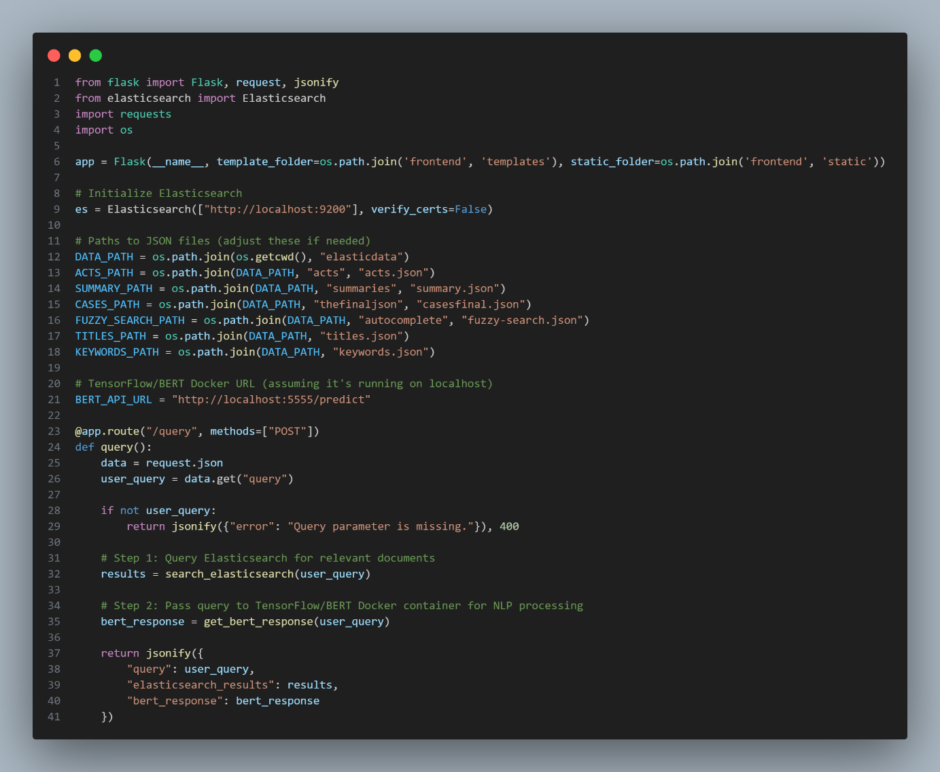

**Explanation:**

1. **search_cases takes an index name and a query string.**
2. **It uses a match query to search for documents matching the content field.**

**A.2 Dockerfile for Bert and Tensorflow**

This snippet demonstrates how to set up a bert and tensorflow through docker for handling user queries in the Lexius project. Docker acts as the container to process bert through the tensorflow.

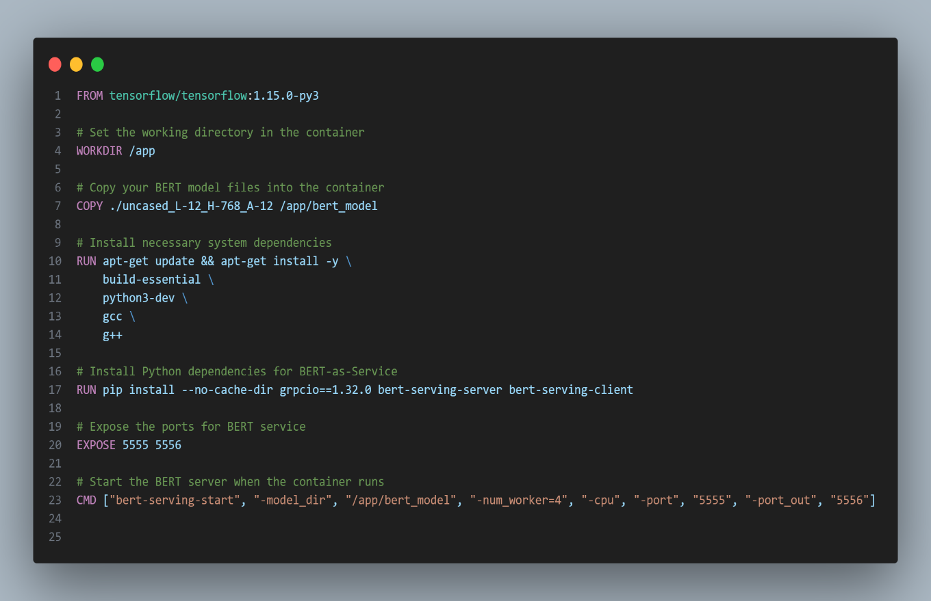

**Explanation:**

1. **This uses a pre-trained BERT model fine-tuned on question-answering tasks.**
2. **process_query takes a question and context, returning the best answer from the context.**

**A.3 Node Server for Backend**

This snippet demonstrates how to set up a basic node js for handling user queries in the Lexius project. Node acts as the backend framework to process HTTP requests from the frontend or mobile app.

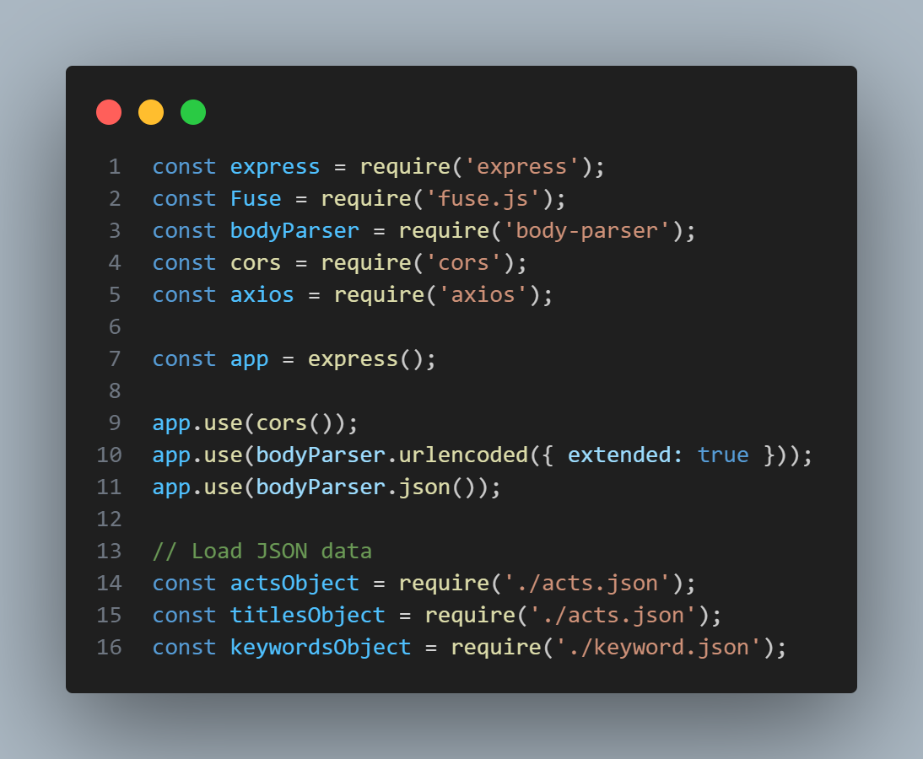

**A.4 Fuzzy Search with Fuse.js**

**Purpose:**  
This snippet shows how Fuse.js enables fuzzy search on the frontend for legal case data.

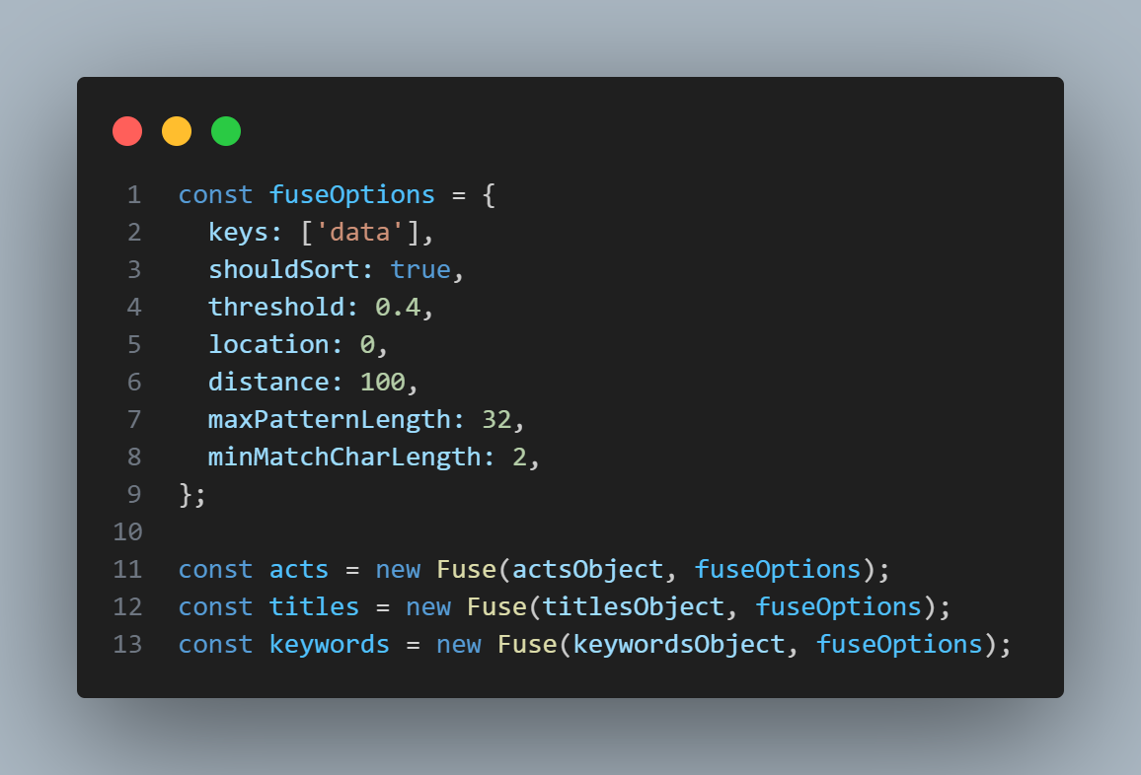

**Explanation:**

1. Fuzzy matching allows the user to find results even with minor typos or mismatches in the query.
2. The threshold controls the sensitivity of the search.

Appendix B: References and Resources

**B.1 Official Documentation**

1. **Flask Framework**:
   * *URL*: https://flask.palletsprojects.com/
   * *Description*: Official Flask documentation for understanding routes, API development, and deployment practices.
2. **Elasticsearch**:
   * *URL*: <https://www.elastic.co/guide/en/elasticsearch/>
   * *Description*: Guide to configuring, indexing, and querying Elasticsearch for full-text search.
3. **BERT (Bidirectional Encoder Representations from Transformers)**:
   * *URL*: <https://github.com/google-research/bert>
   * *Description*: Repository and resources for implementing BERT for natural language processing tasks.
4. **TensorFlow**:
   * *URL*: <https://www.tensorflow.org/>
   * *Description*: TensorFlow documentation for deep learning models and NLP applications.

**B.2 Research Papers and Articles**

1. *Jacob Devlin et al.*: **BERT: Pre-training of Deep Bidirectional Transformers for Language Understanding**
   * *URL*: <https://arxiv.org/abs/1810.04805>
   * *Description*: Research paper introducing the BERT model and its applications.
2. *Elasticsearch Overview*: **The Definitive Guide**
   * *URL*: <https://www.elastic.co/guide/en/elasticsearch/reference/current/index.html>
   * *Description*: Comprehensive overview of Elasticsearch concepts, indexing, and querying.
3. *Gensim*: **Text Summarization Using TextRank Algorithm**
   * *URL*: <https://radimrehurek.com/gensim/>
   * *Description*: Documentation on Gensim's implementation of the TextRank algorithm for text summarization.

**B.3 Online Tutorials and Blogs**

1. **Flask for Beginners**:
   * *URL*: https://realpython.com/flask-by-example/
   * *Description*: Step-by-step tutorials to build REST APIs with Flask.
2. **Working with Elasticsearch**:
   * *URL*: https://logz.io/blog/elasticsearch-tutorial/
   * *Description*: An introductory guide to setting up and using Elasticsearch.
3. **Natural Language Processing with BERT**:
   * *URL*: https://huggingface.co/transformers/
   * *Description*: Tutorials on using Hugging Face's Transformers library for NLP tasks.

**B.4 Tools and Libraries Used**

1. **Fuse.js**:
   * *URL*: <https://fusejs.io/>
   * *Description*: Lightweight JavaScript library for fuzzy searching.
2. **Retrofit**:
   * *URL*: https://square.github.io/retrofit/
   * *Description*: Android library for handling REST API calls.
3. **Docker**:
   * *URL*: https://docs.docker.com/
   * *Description*: Official Docker documentation for containerizing and deploying services.

**B.5 Books and Other Resources**

1. **Deep Learning for NLP** by Palash Goyal, Sumit Pandey, Karan Jain
   * *Description*: Explains key NLP concepts, including embeddings, transformers, and BERT.
2. **Designing Data-Intensive Applications** by Martin Kleppmann
   * *Description*: Comprehensive guide to modern data systems, including search engines like Elasticsearch.

**B.6 Video Tutorials**

1. **Elasticsearch Basics (YouTube)**:
   * *Channel*: *TechWorld with Nana*
   * *URL*: <https://www.youtube.com/playlist?list=PLy7NrYWoggjwVIXhgtZdAtKfYT-C6vwNQ>
2. **Natural Language Processing with TensorFlow**:
   * *Channel*: *TensorFlow*
   * *URL*: <https://www.youtube.com/playlist?list=PLQY2H8rRoyvzDbLUZkbudP-MFQZwNmU4S>