Personal Portfolio Website Plan

# Your Name: Ally Hammond

# Ideas for your website

Determine how you will use your personal portfolio website to showcase your skills.

Idea 1: A website for showcasing my photography.

Idea 2: A personal website displaying the social media and UX work that I did from a romance author.

Idea 3: Showing a combination of all the projects I’ve done in college.

Idea 4: Website dedicated to the work I did for the yearbook.

Idea 5: Website Portfolio of the art that I have done.

# Website Plan

|  |  |  |
| --- | --- | --- |
| Topic | Questions | Answers |
| Purpose of Website | What is the purpose and goal of the website? | Displaying my photography skill and all the picture that I have taken throughout the years. |
| Target Audience | Describe the target audience (age, gender, demographics) | Ages 18+, any gender, older demographic |
| Graphics | What graphics will you use on the website? | My own personal picture as well as graphic I have created to go along with them. |
| Color | What colors will you use within the site to enhance the purpose and brand? | Mostly neutral color and pastels so that it goes with all photograph styles and won’t take away from the pictures. |
| Accessibility | How will the website accommodate people with disabilities? | Adding a feature, the describes the picture for the visually impaired. |
| Project Timeline | Identify the project timeline | 6 weeks |

# Wireframe

Sketch the wireframe for your home page below.

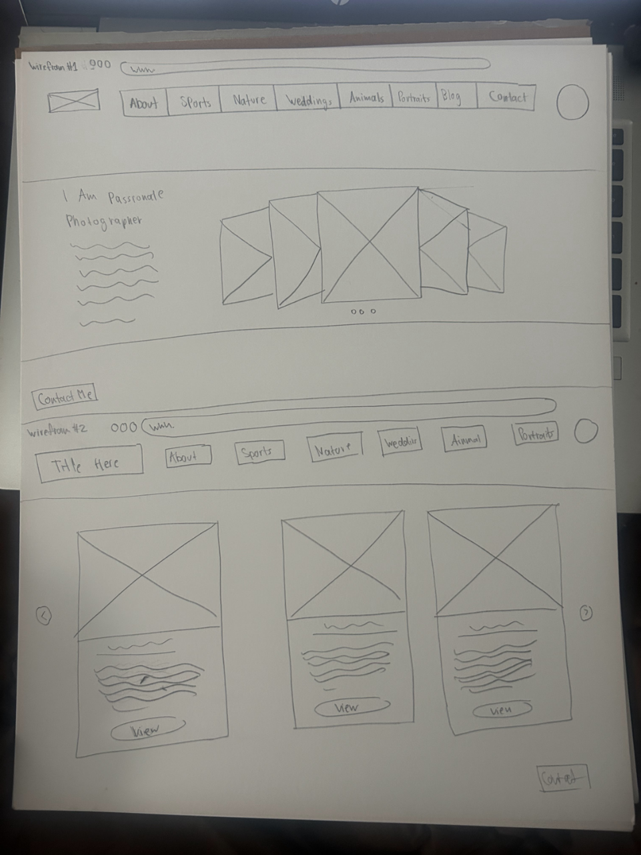

# Site map

Create a site map for the website below.

