Personal Portfolio Website Plan

# Your Name: Aeryn Mitchell

# Ideas for your website

Determine how you will use your personal portfolio website to showcase your skills.

Idea 1: A portfolio to post my work on for job applications in the future. I want to have all of my art organized in one cite that isn’t to cluttered.

Idea 2: I have also created a brand called Tummy Tea in my previous brand identity class I think it would be fun to create a site for that brand

Idea 3: Create I website to sell my art on

Idea 4: Create a website for stomach support from other design classes ( a sight where you can share recipes and alternatives to recipes for people with food allergies)

Idea 5:

# Website Plan

|  |  |  |
| --- | --- | --- |
| Topic | Questions | Answers |
| Purpose of Website | What is the purpose and goal of the website? | To show my personal portfolio from school in an organized way to show to possible employers |
| Target Audience | Describe the target audience (age, gender, demographics) | The audience would be employers in my line of work |
| Graphics | What graphics will you use on the website? | The graphics used will be my personal work whether that be digital or traditional work |
| Color | What colors will you use within the site to enhance the purpose and brand? | I would like to keep the colors pretty muted as to not take away from the work because that is  The purpose of the site |
| Accessibility | How will the website accommodate people with disabilities? | A way I could do this is when hovering over the buttons maybe they read what is said or where it leads to |
| Project Timeline | Identify the project timeline | 6 weeks |

# Wireframe

Sketch the wireframe for your home page below.

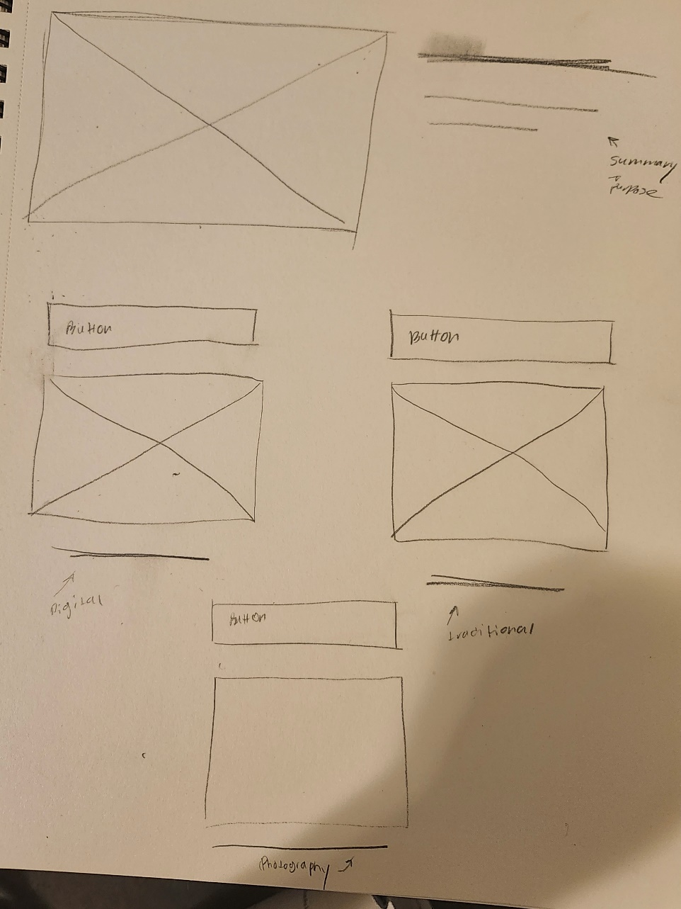

­­

# Site map

Create a site map for the website below.

