Personal Portfolio Website Plan

# Your Name: Jacob Day

# Ideas for your website

Determine how you will use your personal portfolio website to showcase your skills.

Idea 1: Show finished photos/designs that I’ve done in the past.

Idea 2:

Idea 3:

Idea 4:

Idea 5:

# Website Plan

|  |  |  |
| --- | --- | --- |
| Topic | Questions | Answers |
| Purpose of Website | What is the purpose and goal of the website? | The purpose of my website is to showcase my skills, portfolio, and services as a photographer. It should showcase my portfolio, attract clients, describe the service I offer, include my contact info, and possibly tell the reader more about me/my credentials. |
| Target Audience | Describe the target audience (age, gender, demographics) | Either newspaper and magazine companies looking for interns, or potential clients(18-35 year old male and/or female athletes, most likely in the Kansas City Area). |
| Graphics | What graphics will you use on the website? | Portfolio images, slider/slideshow of my favorite works, past event sections, profile picture(s), logos/branding, icons. |
| Color | What colors will you use within the site to enhance the purpose and brand? | Most likely a white page with black section borders and maybe a hint of orange in the logo and on select sections of the page. |
| Accessibility | How will the website accommodate people with disabilities? | Using semantic HTML elements, using readable fonts, descriptive links, provide contact info so users can reach out if having any issues. |
| Project Timeline | Identify the project timeline | I’d like the website to be functional by the end of this class, and as I create more content for it, I can tweak things to my liking. It should be up to date and complete by the time I start applying for jobs in another year or so. |

# Wireframe

Sketch the wireframe for your home page below.

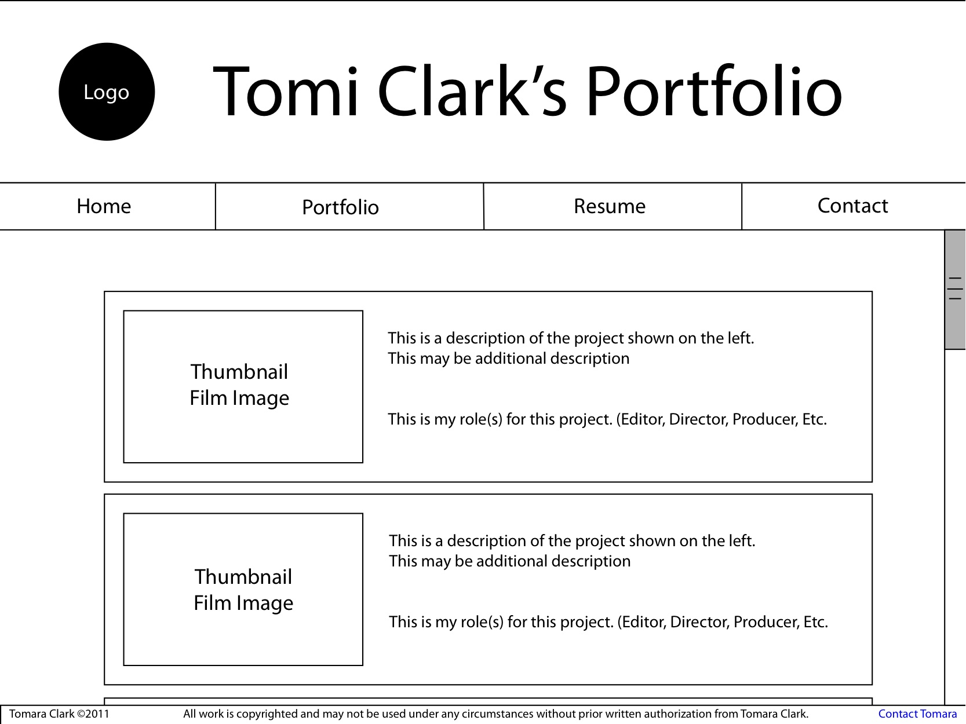

# Site map

Create a site map for the website below.

