Personal Portfolio Website Plan

# Your Name: Brittany Stallo

# Ideas for your website

Determine how you will use your personal portfolio website to showcase your skills.

Idea 1: For Future Employers

Idea 2: Example for future students

Idea 3:

Idea 4:

Idea 5:

# Website Plan

|  |  |  |
| --- | --- | --- |
| Topic | Questions | Answers |
| Purpose of Website | What is the purpose and goal of the website? | For future employers to see my certifications and skills, or an example for my future students |
| Target Audience | Describe the target audience (age, gender, demographics) | 14-60, Students to Boss |
| Graphics | What graphics will you use on the website? | Photos |
| Color | What colors will you use within the site to enhance the purpose and brand? | Pink, Rose Gold, and Gold |
| Accessibility | How will the website accommodate people with disabilities? | Easy to navigate |
| Project Timeline | Identify the project timeline | 6 Weeks |

# Wireframe

Sketch the wireframe for your home page below.

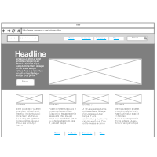

# Site map

Create a site map for the website below.

