Personal Portfolio Website Plan

# Your Name:

Jacen Piatt

# Ideas for your website

Determine how you will use your personal portfolio website to showcase your skills.

Idea 1:

A portfolio section that showcases my previous works.

Idea 2:

An “About me” section that tells the reader about my life and goals.

Idea 3:

A “Contact” section where the reader can get in contact with me.

Idea 4:

There could be a feed of comments to showcase my path, so I can say on my website that I got hired somewhere, graduated, etc

Idea 5:

There needs to be an overview section on the home page where it goes over the basic information about the website

# Website Plan

|  |  |  |
| --- | --- | --- |
| Topic | Questions | Answers |
| Purpose of Website | What is the purpose and goal of the website? | To showcase my skills and talents to other people. |
| Target Audience | Describe the target audience (age, gender, demographics) | Future employers |
| Graphics | What graphics will you use on the website? | Sleek, modern graphics that don’t bombard the whole screen |
| Color | What colors will you use within the site to enhance the purpose and brand? | White, grey, and a primary color I haven’t decided on. |
| Accessibility | How will the website accommodate people with disabilities? | Images will have text built in to them, but otherwise it will be a mostly text based website, so TTS could read it out. |
| Project Timeline | Identify the project timeline | I will work on it as the assignments are due, and hopefully by the end it is fully fleshed out. If not, I will continue to work on it outside of the class on my own time. |

# Wireframe

Sketch the wireframe for your home page below.

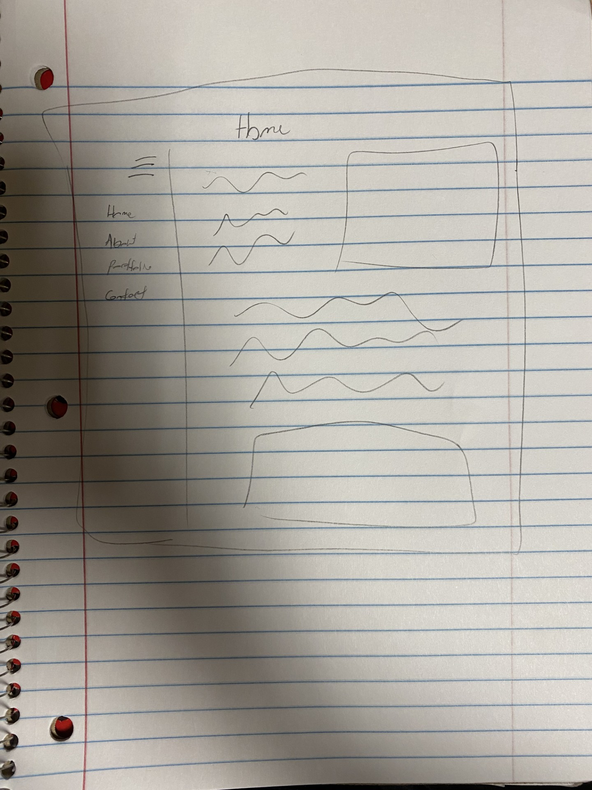

# Site map

Create a site map for the website below.

