Personal Portfolio Website Plan

# Your Name: Demi van Run

# Ideas for your website

Determine how you will use your personal portfolio website to showcase your skills.

Idea 1: To use a mix of photos and videos to let people see what I have done the last few years of my school career.

Idea 2: Show only pictures with only some text underneath it

Idea 3: use videos to let people see how you did.

Idea 4: just a plain old website with some pictures and blog style text

Idea 5: use only text

My favourite idea is idea 1

# Website Plan

|  |  |  |
| --- | --- | --- |
| Topic | Questions | Answers |
| Purpose of Website | What is the purpose and goal of the website? | To let people see what I’ve made so far. And to use as a sort of resume to get new jobs. |
| Target Audience | Describe the target audience (age, gender, demographics) | Mostly the people who will see my LinkedIn, and are more interested will see the site. And the people to whom I will send my site. Also for job applications is this a good use. |
| Graphics | What graphics will you use on the website? | I am thinking about making my portfolio a calm and modern-styled website. I hope that I’m able to make the parts that you can click a hexagon, it makes it more modern but also gives a cool effect |
| Color | What colors will you use within the site to enhance the purpose and brand? | I’m thinking about keeping it with cool colors. Like green, blue, and purple. It’s then keeping the calm style I want for my website. |
| Accessibility | How will the website accommodate people with disabilities? | I will set an alt with the image property. |
| Project Timeline | Identify the project timeline | This project will take 6 weeks to finish |

# Wireframe

Sketch the wireframe for your home page below.

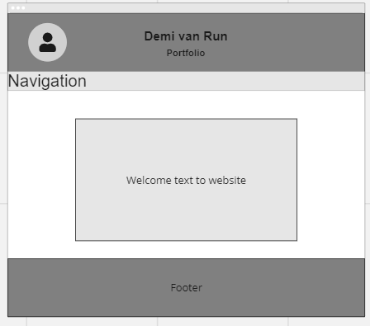 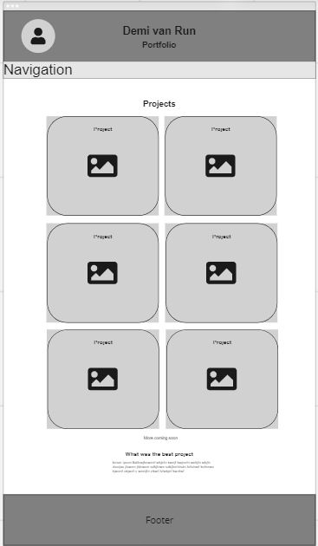

# Site map

Create a site map for the website below.

