Personal Portfolio Website Plan

# Your Name: Jin Fitz

# Ideas for your website

Determine how you will use your personal portfolio website to showcase your skills.

Idea 1: Separate pages showing off all of my different skills. Separate pages for my illustrations, photography, and films.

Idea 2: Having a separate page for my resume so that it’s easily accessible and it can easily display my abilities and qualities.

Idea 3: Easily accessible links to my social media or other ways to find me are probably good for people to have

Idea 4: A simple “About me” page is always good for personal websites because it just pulls the whole thing together in my opinion and makes it more of a “story” and creates a better image of yourself in people’s heads.

Idea 5: Having an obviously aesthetically pleasing site would be good, with great organization and making it have your own personal style is really important for standing out and making yourself impressive to anyone looking at the site.

# Website Plan

|  |  |  |
| --- | --- | --- |
| Topic | Questions | Answers |
| Purpose of Website | What is the purpose and goal of the website? | The portfolio website now is mainly to show employers my skills I’ve developed throughout high school and college, but also for me personally to have a place to display my work |
| Target Audience | Describe the target audience (age, gender, demographics) | Target audience would be employers or people looking to work with me in any way. This would be mostly people older than me, working in most likely an artistic or marketing field. |
| Graphics | What graphics will you use on the website? | The main graphics I use will be my own, as I market myself as an artist. My own illustrations or drawings that can make the pages more appealing or interesting. |
| Color | What colors will you use within the site to enhance the purpose and brand? | My main colours are dark blues and reds, as I think those are likable colours to most people and a likable colour combo for anyone who sees my work. I think it also stands out from many modern websites as well right now. |
| Accessibility | How will the website accommodate people with disabilities? | Descriptions on all my works will be updated and provided, and text will be easy to read |
| Project Timeline | Identify the project timeline | Creating a site map and wireframe, then creating the outline for the whole website, and starting to add projects and works into the site while fine tuning aesthetic things like colour, organization, descriptions, etc. |

Wireframe 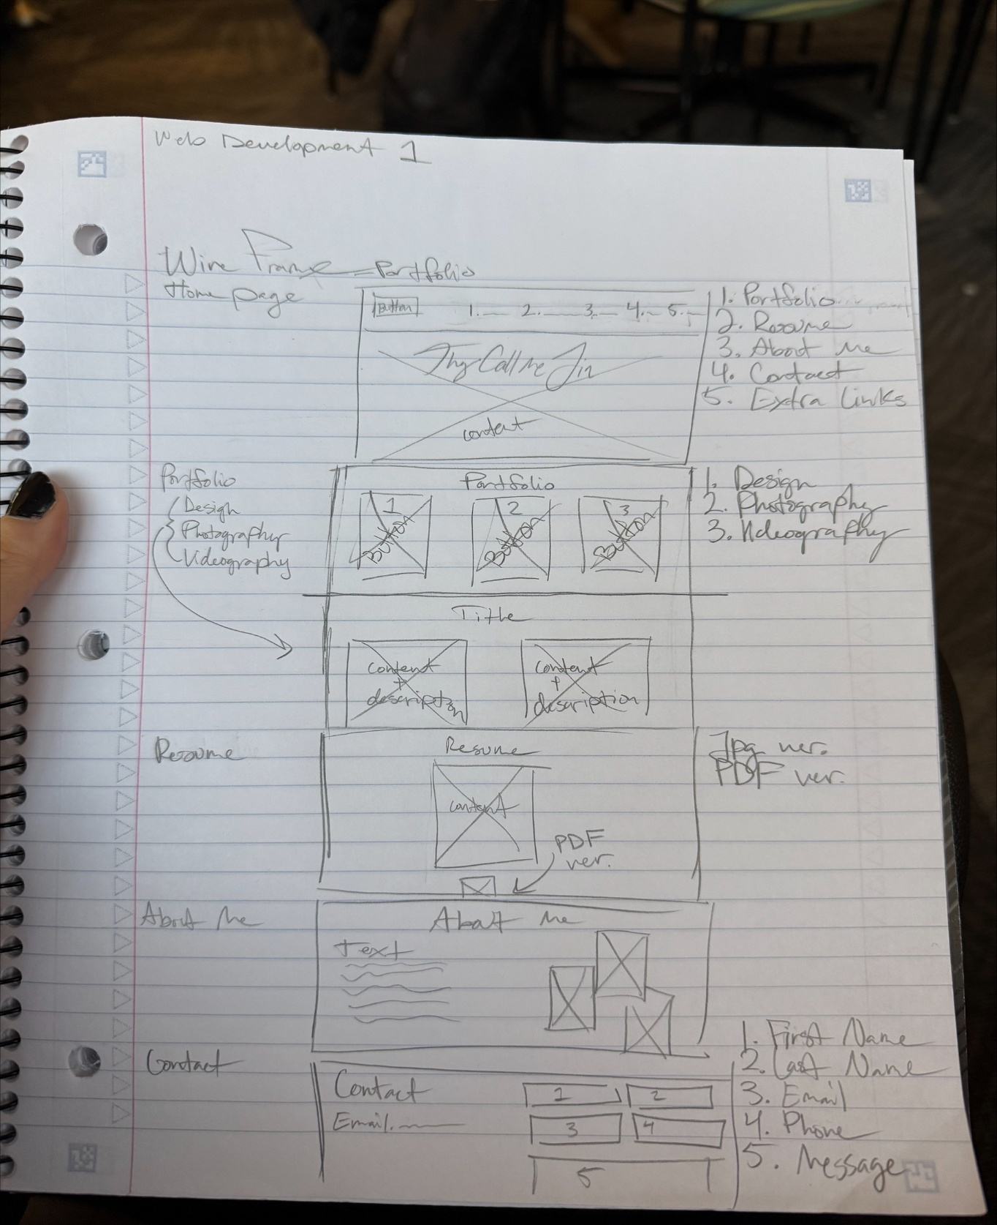

Site map