Personal Portfolio Website Plan

# Your Name: Phillip Motazedi

# Ideas for your website

Determine how you will use your personal portfolio website to showcase your skills.

Idea 1: My personal portfolio website will present my name, About me information, and more in an aesthetically pleasing and visually informative way.

Idea 2: My personal portfolio website will showcase my graphics and art design that I have made, including my radio practicum, fraternity graphics, Student Senate graphics, and anything else.

Idea 3: My personal portfolio website will feature my camera and videography skills that I have utilized during my fraternity experiences and my time in multimedia services. This would include designated pages for each category, whether that be photo, video, etc.

Idea 4: My personal portfolio will feature my social media layouts that I have done, which have presented my organization in a proper and visually exciting way.

Idea 5: My personal portfolio will include my resume and skills, which will allow my potential employer to get a broad scope of my skills that pertain outside of college, like my leadership and time management skills.

# Website Plan

|  |  |  |
| --- | --- | --- |
| Topic | Questions | Answers |
| Purpose of Website | What is the purpose and goal of the website? | To communicate my skills and market myself competitively to future employers. |
| Target Audience | Describe the target audience (age, gender, demographics) | People in media related fields, especially digital. Employers, who are getting to know me as an employee. |
| Graphics | What graphics will you use on the website? | I will use a variety of graphics to fill white space and show off a clean, yet detailed portfolio website. This would include dots, lines, and even pictures of me. |
| Color | What colors will you use within the site to enhance the purpose and brand? | I will stick to a specific color scheme of yellow, blue, black, occasional grey, and white. It is important for my portfolio to look the best it can, as this could communicate to employers my potential style and understanding of design. |
| Accessibility | How will the website accommodate people with disabilities? | I have a couple ideas, but I would make sure they all coincide with the ADA. This could include upping the contrast, providing alt text, and even providing an alt keyboard on screen. |
| Project Timeline | Identify the project timeline | Over the next six weeks, we will be adding HTML and CSS code to help build our portfolio, while also gaining the necessary skills to carry this on to develop websites in the future. |

# Wireframe

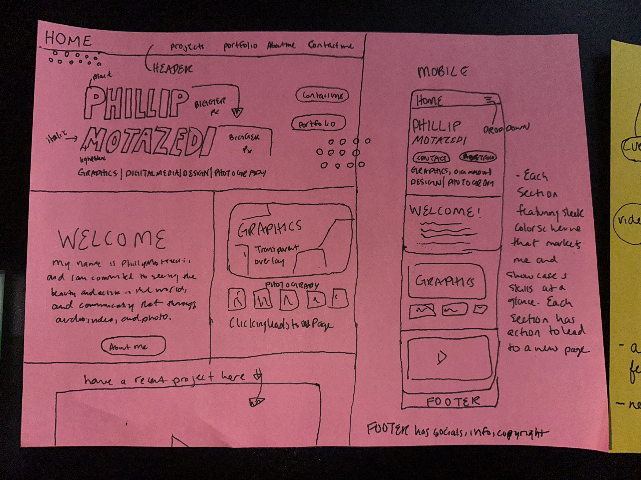Sketch the wireframe for your home page below.

# Site map

Create a site map for the website below

