Dataset Used:

UK-Bank Dataset



1. Created a map of United Kingdom from longitude and latitude. Showed its region in different colors. And displayed UK bank customers.

1. Displayed a pie chart that shows men and women customer of UK bank.

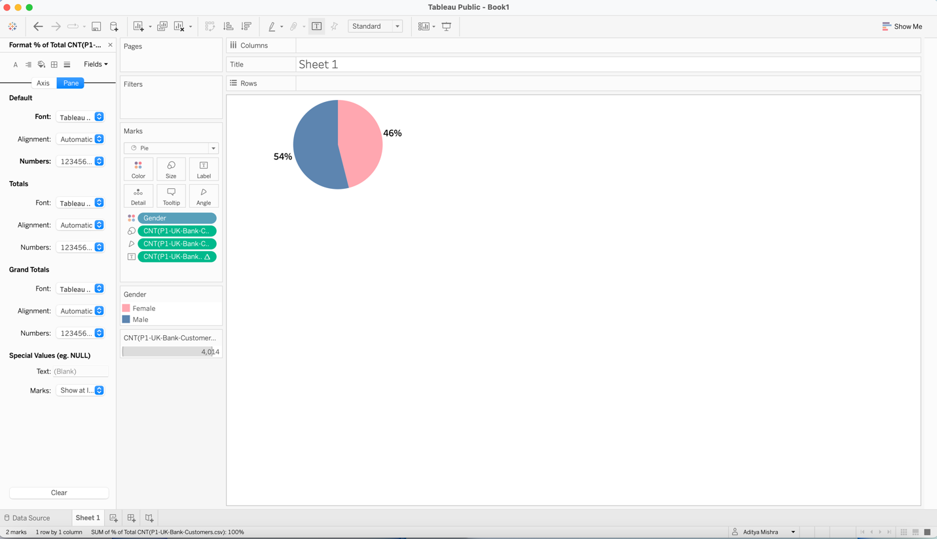

1. Created a bin to display Age of the customer.

1. Created a bin to display Balance of the customer.

1. Created a slider to show balance groups with a range of 5000.

1. Created a slider to show age groups with a range of 5.

1. Displaying the customer details based on region, age, gender, work type, balance in one dashboard.

1. Displaying the customer details based on region, age, gender, work type, balance in one dashboard

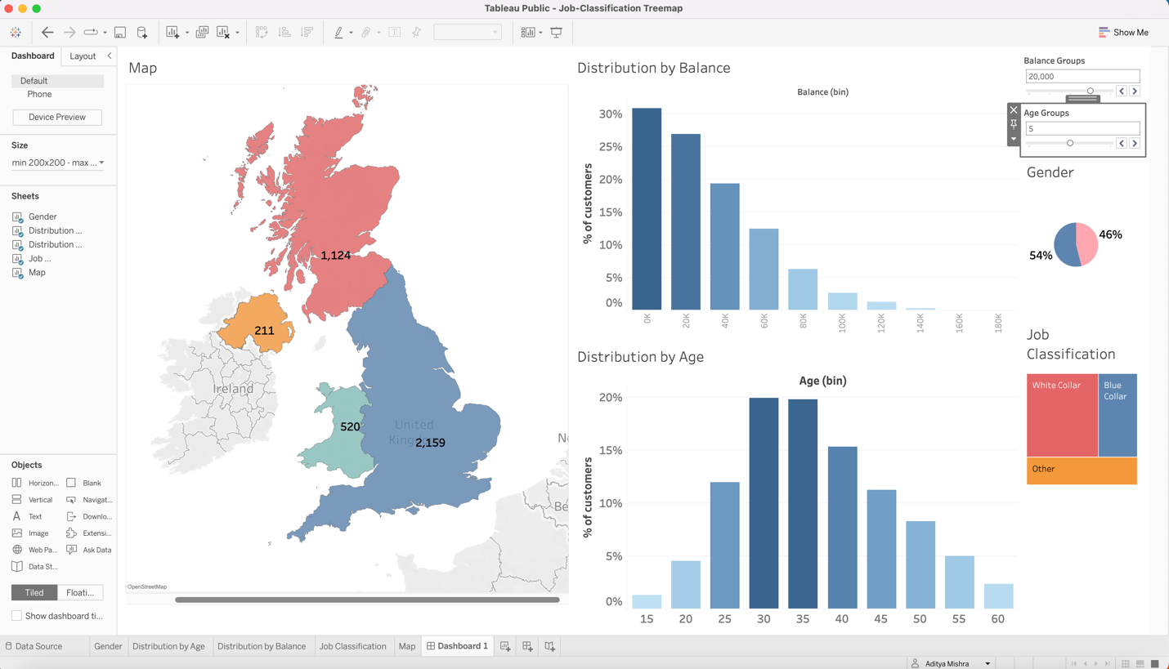

1. Displaying the customer details based on region, age, gender, work type, balance in one dashboard. Then used filter to analyze the customer per region. For example: Wales has 520 people.

1. Displaying the customer details based on region, age, gender, work type, balance in one dashboard. Then used filter to analyze the customer. For example: England has 2159 employee out of them 49% is men and 51% is female and most of them are white color worker.

1. Displaying the customer details based on region, age, gender, work type, balance in one dashboard. Now used filter to analyze the customer based on any kind of details like region or balance or gender or age or worker category. For example: England has 8 female employee who works a white-collar job and makes over 80000 and is aged above 45. It represents 40% of the total worker.

1. Displaying the customer details based on region, age, gender, work type, balance in one dashboard. Now used filter to analyze the customer based on any kind of details like region or balance or gender or age or worker category. For example: Scotland has 95% men who works blue collar job.

1. Displayed the dashboard as a story explain and analyzing the data.

