**Class: CSE 3330-001**

**Project: Project 1-Phase 1**

Semester: **Summer 2022**

**Student Name1: Aditya Mishra**

**StudentID1: 1001663720**

**StudentName2: Jose Aguilar**

**StudentID2: 1001128942**

**Professor Name: Dr. Bhanu Jain**

**I pledge, on my honor, to uphold UT Arlington's tradition of academic integrity, a tradition that values hard work and honest effort in the pursuit of academic excellence.**

**I promise that I will submit only work that I personally create or that I contribute to group collaborations, and I will appropriately reference any work from other sources. I will follow the highest standards of integrity and uphold the spirit of the Honor Code.**

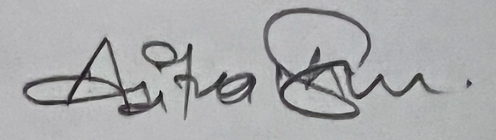

**________________ _______________**

**Aditya Mishra Jose Aguilar**

**Part 1: EER Diagram**

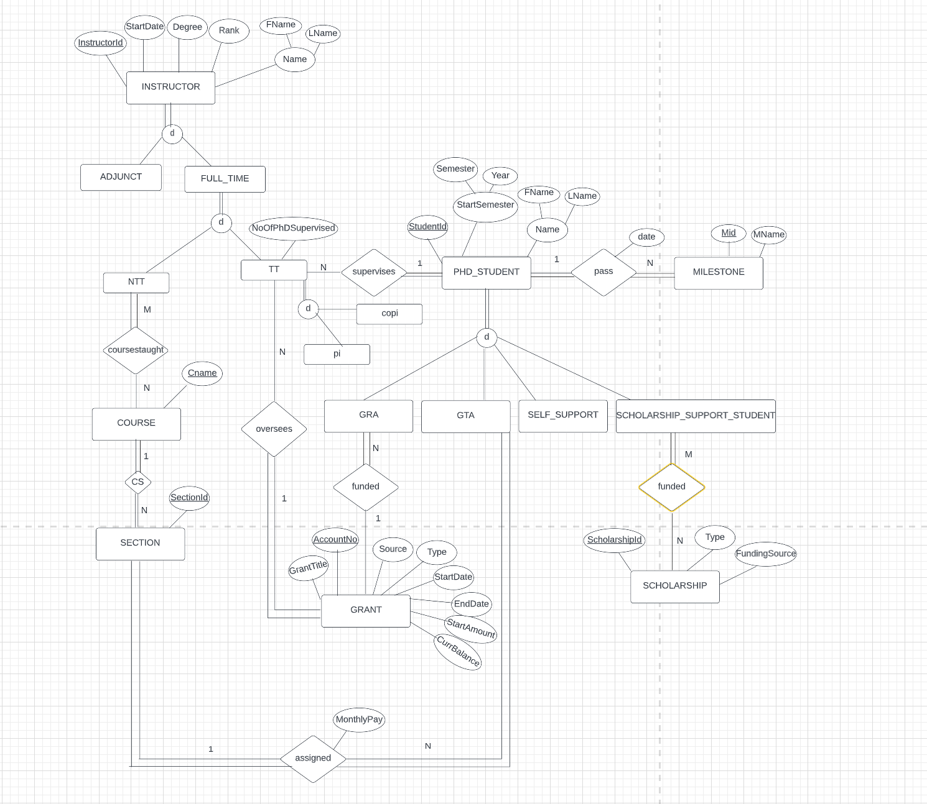

**Fig: EER Diagram**

**Part2: RELATIONAL SCHEMA**

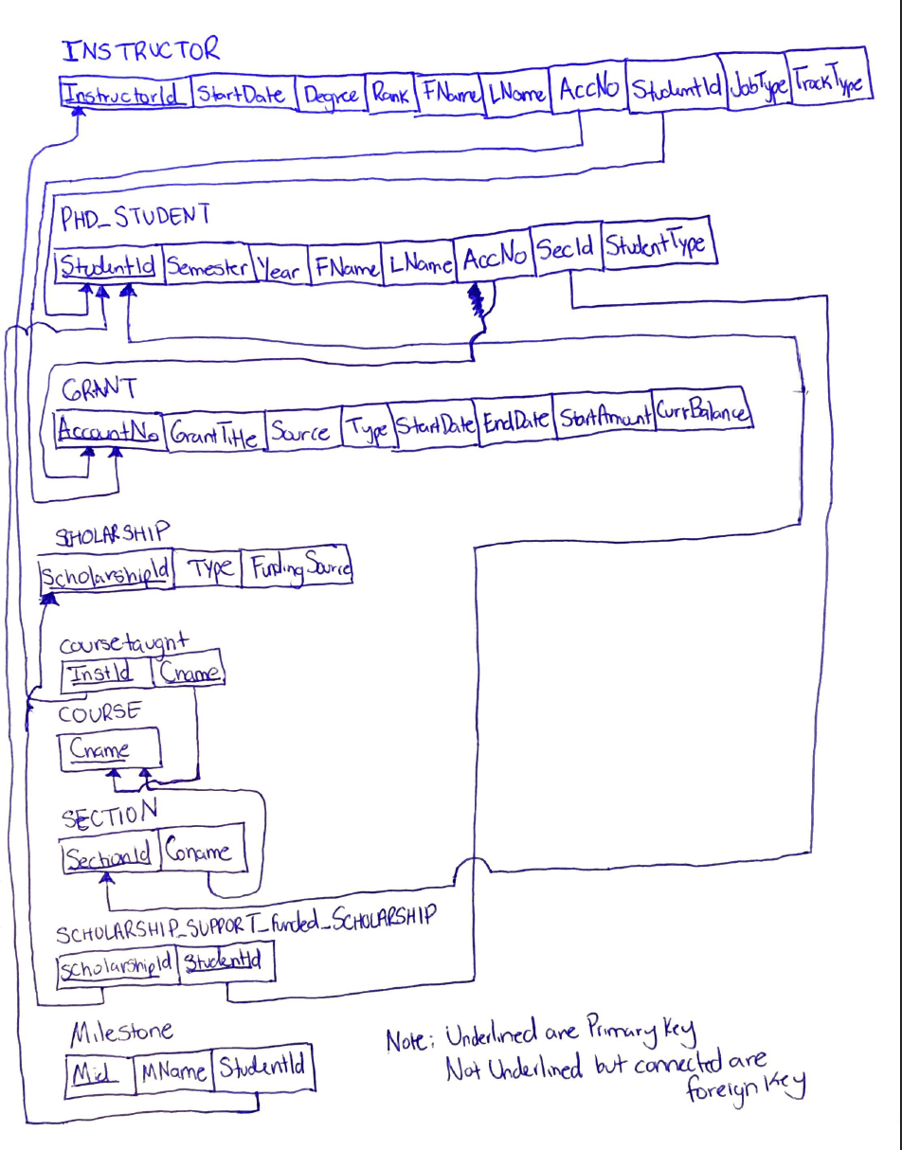

**Fig: Relational Schema**

**Tables:**

**INSTRUCTOR**

|  |  |  |  |  |  |  |  |  |  |
| --- | --- | --- | --- | --- | --- | --- | --- | --- | --- |
| **InstructorId** | **StartDate** | **Degree** | **Rank** | **Fname** | **Lname** | **AccountNo** | **JobType** | **TracKType** | **StudentID** |
| 10011 | 10/18/2008 | PhD in Computer Science | Prof | James | Levi | NULL | FullTim | NTT | 98535 |
| 20021 | 12/14/2012 | PhD in Mathematics | Prof | John | Smith | NULL | FullTime | NTT | 14865 |
| 30031 | 11/21/2018 | M.S. in Computer Science | Asst Prof | Maya | Doe | NULL | FullTime | NTT | 14011 |
| 40041 | 02/13/2019 | M.S in Mathematics | Asst Prof | Craig | Jones | 787291 | FullTime | TT | NULL |
| 50051 | 09/01/2021 | M.S in Computer Science | Lecturer | Jade | Speed | 664842 | FullTime | TT | NULL |
| 60061 | 09/07/1999 | PhD in Computer Science | Prof | Joseph | Aguilar | 545582 | FullTime | TT | NULL |
| 70071 | 04/05/2012 | PhD in Computer Science | Prof | Aditi | Pandey | 545583 | FullTime | TT | NULL |
| 80081 | 05/07/2014 | PhD in Computer Science | Prof | Promisha | Mishra | 545588 | FullTime | TT | NULL |
| 90091 | 08/22/2019 | PhD in Computer Science | Prof | Neha | Verma | NULL | Adjunct | NULL | NULL |
| 90092 | 08/22/2018 | PhD in Computer Science | Prof | Tom | Cruise | NULL | Adjunct | NULL | NULL |

**PHD_STUDENT**

|  |  |  |  |  |  |  |  |
| --- | --- | --- | --- | --- | --- | --- | --- |
| **StudentId** | **Semester** | **Year** | **Fname** | **Lname** | **AccountNo** | **STUDENTTYPE** | **SectionID** |
| 44652 | Fall | 2017 | Josh | Hilton | 888455 | GRA | NULL |
| 84132 | Spring | 2018 | Donovan | Mitch | 332211 | GRA | NULL |
| 78441 | Spring | 2019 | Hector | Muniz | 454561 | GRA | NULL |
| 98535 | Fall | 2020 | Sam | Lee | NULL | GTA | 1 |
| 14865 | Fall | 2021 | Dean | Winchester | NULL | GTA | 2 |
| 14011 | FALL | 2020 | JOE | BIDEN | NULL | GTA | 3 |
| 14012 | FALL | 2020 | DONALD | TRUMP | NULL | Self_support | NULL |
| 14013 | FALL | 2019 | Alexander | Hamilton | NULL | Self_support | NULL |
| 14014 | SPRING | 2020 | George | Washinton | NULL | Scholarship_supportStudent | NULL |
| 14015 | SPRING | 2021 | Thor | Nyet | NULL | Scholarship_supportStudent | NULL |

**SCHOLARSHIPS**

|  |  |  |
| --- | --- | --- |
| **ScholarshipID** | **Type** | **FundingSource** |
| 158157 | John S. Schuchman Outstanding PhD Student Scholarship | UTA |
| 158158 | Full Housing | Dell Corporation |
| 158159 | Books Grant | UTA |

**GRANT**

|  |  |  |  |  |  |  |  |
| --- | --- | --- | --- | --- | --- | --- | --- |
| **AccountNo** | **GrantTitle** | **Source** | **Type** | **StartDate** | **EndDate** | **StartAmount** | **CurrBalance** |
| 888455 | Google PhD Fellowship | Google | Educational | 1/10/2020 | 1/10/2023 | 20000 | 10000 |
| 332211 | NSF GRFP | NSF | Research | 1/12/2020 | 1/12/2023 | 138000 | 50000 |
| 454561 | Microsoft Research PhD Fellowship | Microsoft | Educational | 8/1/2020 | 8/1/2022 | 42000 | 35000 |
| 787291 | Apple PhD Fellowship | Apple | Gift/Research | 1/20/2021 | 1/20/2023 | 90000 | 70000 |
| 664842 | Nvidia Fellowship | Nvidia | Research | 7/23/2021 | 7/23/2022 | 40000 | 20000 |

**Scholarship_SupportStudent_funded_Scholarship**

|  |  |
| --- | --- |
| **ScholarshipID** | **StudentID** |
| 158157 | 14014 |
| 158158 | 14015 |

**MILESTONE**

|  |  |  |
| --- | --- | --- |
| **MId** | **Milestone** | **StudentID** |
| 101 | Form a committee | 98535 |
| 202 | Complete required coursework | 78441 |
| 303 | Complete written and oral examination | 14865 |
| 404 | Get proposed dissertation topic approved | 84132 |
| 505 | Complete Presentation to get PhD granted | 44652 |

**NTT_CourseTaught_Course**

|  |  |
| --- | --- |
| **InstructorId** | **CourseNAME** |
| 10011 | Intro to Programming |
| 20021 | Discrete Structures |
| 30031 | Object-Oriented Programming |

**Fig: Tables for database.**

**Part3: Information and Assumption for our project:**

In this project, we designed our EER diagram based on the information provided by the professor. We started our EER diagram with three major portions, INSTRUCTOR, GRANT and PHD_STUDENT. These entities have various attributes, for example instructor had instructorID, StartDate, Degree, Rank, FName, LName. Similarly, we diagramed GRANT and PHD_STUDENT with their respective attributes. We then proceeded to create smaller entities like MILESTONE and SCHOLARSHIP and checked if these smaller entities shared a relationship with other entities. From the given instruction, we assumed added disjoint and overlapping sets to different branches. ADJUNCT and FULLTIME for INSTRUCTOR cannot overlap and every INSTRUCTOR entity must be at least ADJUNCT or FULLTIME, so its disjoint total. GRA, GTA, SelfSupport and Scholarship_support is also disjoint total. According to this project instance a PHD_STUDENT cannot overlap roles or type of funding and it must be at least one. A GRA is funded by a grant but many GRAs (Graduate Research Assistant) can be funded by one grant (N to 1 relationship). It is total participation because every GRA will be funded by grant but not every GRANT funds a GRA so that’s partial participation. Many GTA can be assigned to one SECTION (N to 1 relationship) or a section can be assigned to many GTA. Every GTA must be assigned a section to fund themselves and every SECTION requires a GTA, total participation on both sides. Many SCHOLARSHIP_SUPPORT_STUDENTs are funded by many SCHOLARSHIPs (M to N relationship). Every SCHOLARSHIP_SUPPORT_STUDENT must be funded by a SCHOLARSHIP, total participation but not every SCHOLARSHIP funds a SCHOLARSHIP_SUPPORT_STUDENT, partial participation. We added different branches like NTT (NON-Tenure Track), TT (Tenure Track). Many TTs can supervise one STUDENT and one student can get supervised by many TTs (N to 1). Every STUDENT must be supervised by a TT, total, but not every TT will supervise a STUDENT, partial. A PHD_STUDENT must pass many MILESTONES (1 to N). Every PHD_STUDENT must pass a MILESTONE and every MILESTONE must be passed by PHD_STUDENT, so total participation on both sides. It is possible many NTTs have many COURSES taught (maximum participation) (M to N). Every NTT has taught a COURSE, total, but not every COURSE has been taught by an NTT. These assumptions were made according to information we were provided for entities, attributes, and relationships.

We created the ERR diagram using the lucid application, making it efficient and clear.

For the Relational Scheme Portion, we used pen and paper to sketch the relational schema. We used the ER-to-Relational Mapping Algorithm as a guideline for our sketch. The relationships in our EER diagram were mainly (1 to N) and (M to N), so we used the rules for mapping 1: N relationship types and M: N relationship types. We sketched the relations along with their attributes while underlining the primary key for each relation. The M: N relations would require us to sketch the relationship type while in the 1: N relations we would add a foreign key to the participating entity. The relation INSTRUCTOR included the foreign keys AccNo and StudentId because in each case there was a 1 to N relation, with INSTRUCTOR being the participating entity of GRANT and PHD_STUDENT. PHD_STUDENT was the participating entity of GRANT and SECTION, so we added AccNo and SecId as foreign keys and pointed arrows towards those entities/relations. The relations GRANT, SCHOLARSHIP, COURSE had no foreign keys, their primary keys are AccountNo, ScholarshipId, and CourseName, respectively. The relation cousetaught was sketched because it is an M to N relationship. The relation cousetaught had two foreign keys InstId (InstructorId) and Cname (course name) that tied it (arrows toward) the primary keys of INSTRUCTOR and COURSE. SECTION was the participating entity and has CoName as a foreign key which pointed an arrow towards primary key, Cname in COURSE (1 to N relation). Another M to N relation which involved the SCHOLARSHIP_SUPPORT__funded_STUDENT relation contained two foreign keys ScholarshipId and StudentId, they pointed towards their respective primary keys. Lastly MILESTONE was the participating entity because it is involved in a 1 to N relation with PHD_STUDENT. MILESTONE contained the foreign key StudentID and its primary key is MId. While creating the relational schema, we have shown primary keys by underlining them and foreign keys with no underline and by connecting them with their respective primary keys. In M to N relations, we underlined both foreign keys, for example in coursetaught.

For Tabular representation, we have assumed some student's names, instructor's names, different scholarship, different IDs, etc. (all the entities in our relational schema) just to show how our database will look like at the end. Our tabular representation is the result of how our data will be saved in the database.

**PART4: Honor Code**

**I pledge, on my honor, to uphold UT Arlington's tradition of academic integrity, a tradition that values hard work and honest effort in the pursuit of academic excellence.**

**I promise that I will submit only work that I personally create or that I contribute to group collaborations, and I will appropriately reference any work from other sources. I will follow the highest standards of integrity and uphold the spirit of the Honor Code.**



**________________ _______________**

**Aditya Mishra Jose Aguilar**