1、查询每种商品的各种规格的价格

SELECT

pi.information_name AS product_name,

ps.specifications_name AS specification_name,

psd.detailed_value AS specification_value,

p.price AS price

FROM

products_information pi

JOIN

products_specifications ps ON pi.id = ps.information_id

JOIN

products_specifications_detailed psd ON ps.id = psd.specifications_id

JOIN

price_combo pc ON psd.id = pc.specifications_detailed_id

JOIN

price p ON pc.price_id = p.id

ORDER BY

pi.id, ps.id, psd.id;

查询结果:

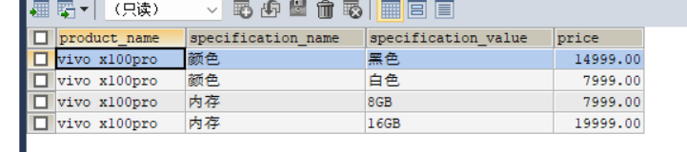

2、