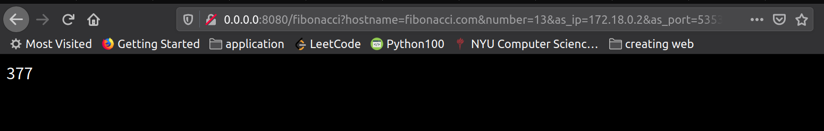
Result:In docker inspect dns I got:
