PHASE 01 — SYSTEM OVERVIEW
1. Abstract
The Art Gallery Management System (AGMS) is a database-driven digital platform designed to streamline the management of artists, artworks, customers, exhibitions, transactions, and gallery operations. The system eliminates traditional manual procedures and introduces a structured, automated environment for managing artwork catalogs, artist registrations, customer purchases, exhibition scheduling, and administrative functions.
This project applies essential database concepts including Entity–Relationship (ER) modeling, schema refinement, normalization, and SQL-based implementation. AGMS adopts a multi-user role-based framework—providing distinct interfaces for administrators, artists, and customers—to ensure data security, operational efficiency, and clear workflow separation.
The report includes system overview, database design, relational schema, SQL queries, normalization steps, progress documentation, and evaluation. AGMS demonstrates how database technologies can improve usability, consistency, accuracy, and scalability in digital gallery environments.

2. Introduction
Art galleries preserve, promote, and exhibit artistic works created by painters, sculptors, and digital artists. Traditionally, these operations are maintained manually using paper-based logs or spreadsheets, leading to inefficiencies and data inaccuracies. Tasks such as storing artwork information, managing artist portfolios, recording sales transactions, and organizing exhibitions become increasingly complex as gallery size grows.
The Art Gallery Management System (AGMS) is developed to address these challenges through a comprehensive and automated solution. Built on a relational database architecture, AGMS manages and organizes artwork data, artist information, customer interactions, and exhibition workflows efficiently. The system enhances accessibility, simplifies operations, reduces redundancy, and ensures data consistency.

3. Purpose of the System
The purpose of AGMS is to streamline and modernize gallery operations through digital automation. The system aims to:
- Provide a centralized database for storing artwork, artist, customer, and exhibition details
- Reduce manual workload and minimize errors
- Enable online browsing and purchasing of artworks
- Facilitate artist registration and portfolio maintenance
- Support administrative control over gallery activities
- Ensure secure and structured data handling
The system ultimately makes gallery management more efficient, transparent, and user-friendly.

4. System Objectives
Functional Objectives
- Provide a seamless platform for customers to browse and purchase artworks
- Enable artists to upload, update, and manage their artwork portfolios
- Allow administrators to monitor system-wide activities
- Support exhibition creation and the participation of artists
- Maintain purchase records, transaction logs, and customer history
Technical Objectives
- Implement a normalized relational database to minimize redundancy
- Use ER modeling for conceptual design
- Apply integrity constraints to ensure data correctness
- Optimize SQL queries for efficient data retrieval
- Maintain role-based secure access

5. Project Scope
The AGMS covers a wide range of gallery-related functionalities:
Admin
- Manage users (artists, customers)
- Moderate artworks
- Set up exhibitions
- View and analyze reports
Artist
- Register as an artist
- Upload artworks
- Manage portfolios
- Track sales and exhibition participation
Customer
- Browse artworks
- Purchase artworks
- Maintain purchase history
Database Scope
- Artwork details (image, title, description, category, price)
- Artist data (biography, contact, portfolio)
- Customer accounts and orders
- Transaction records
- Exhibition and event scheduling
Current System Limitations
- Payment gateway not integrated
- No automated recommendation engine
- Media storage limited to local directory

6. User Types & Roles
The system distinguishes three primary user roles:

1. Admin
Key Responsibilities:
- Approve artist registrations
- Moderate artwork submissions
- Manage exhibitions
- Generate system reports
- Oversee user activity and logs
Privileges:
Full access to the entire system; can modify or delete any record.

2. Artist
Key Responsibilities:
- Register and maintain profile
- Upload and update artworks
- Track purchases made by customers
- Join exhibitions
Privileges:
Can manage only their own artworks and profile.

3. Customer (Buyer)
Key Responsibilities:
- Browse, view, and purchase artworks
- Add items to cart
- Track order history
Privileges:
Limited to browsing and purchasing functionalities.

7. Functional Requirements (High-Level)
Admin Requirements
- Admin authentication
- Artist management
- Artwork moderation
- Exhibition scheduling
- Report generation
Artist Requirements
- Registration & login
- Artwork upload/edit/delete
- Profile management
- Exhibition participation
Customer Requirements
- Browse artwork with filtering
- View artwork details
- Add to cart & checkout
- Maintain order history

8. System Features Overview
Key features implemented in AGMS include:
- Image-based artwork catalog
- Artist portfolio module
- Cart and checkout system
- Order management
- Exhibition module with admin control
- Reporting dashboard
- Secure login and role-based access

9. System Workflow Description
Artist Workflow
Register → Upload Artwork → Artwork Published → Exhibition Participation

Customer Workflow
Browse Artwork → View Details → Add to Cart → Checkout → Order Confirmation
Admin Workflow
Login → Manage Users & Artworks → Create Exhibitions → View Reports → Maintain System

10. Use Case Diagram (Text Explanation)
Actors
- Admin
- Artist
- User
Core Use Cases
- Manage Artist (Admin)
- Manage Artwork (Admin/Artist)
- Manage Exhibition (Admin)
- Browse Artwork (Customer)
- Purchase Artwork (Customer)
- Track Orders (Customer)
Include / Extend Relationships
- “Verify Payment” is included in “Purchase Artwork”
- “View Artwork Details” extends “Browse Artwork”

11. Screens / Page Overview (with Figure Placeholders)
Figure 1: Home Page
The Home Page serves as the main entry point to the Art Gallery Management System, showcasing featured artworks and trending pieces. Users can browse visually rich collections, search for artists or paintings, and navigate to login or sign-up options. It provides an inviting gallery-like experience, encouraging exploration and engagement with the platform.

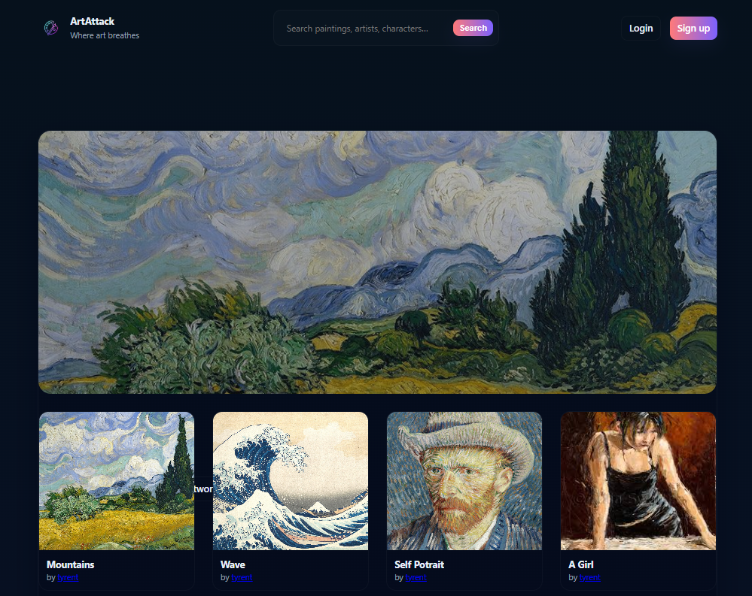

Figure 2: Registration Page
The Sign Up Page allows new users to create an account by providing a username, email, password, and optional bio. It enables role selection, determining whether the user registers as an artist or customer. This page ensures secure onboarding, granting personalized access to platform features such as artwork uploads, browsing, and purchases.

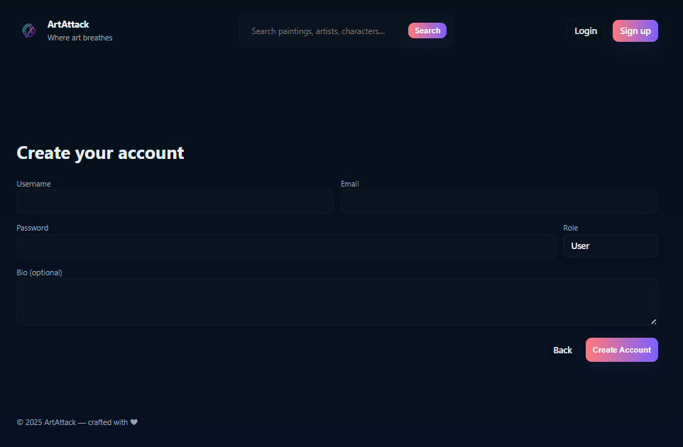

Figure 3: Login Page
The Login Page provides secure access for returning users through email or username and password authentication. It supports a “Remember me” option and links for account creation or password recovery. This page ensures only authorized customers, artists, and admins can access personalized dashboards, upload artworks, manage profiles, or perform system operations.

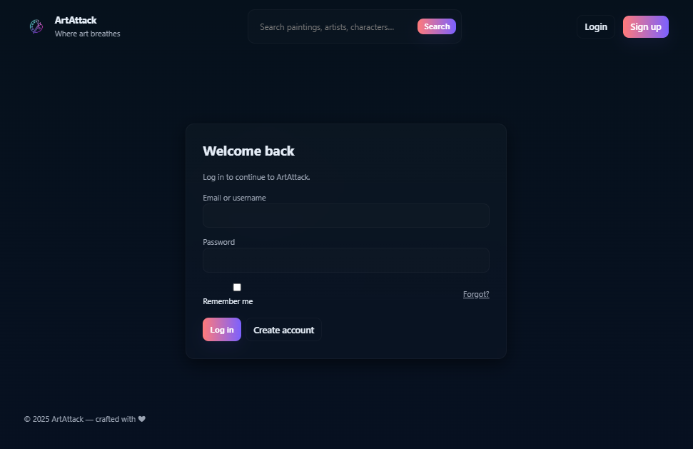

Figure 4: Artwork Upload Page
The Artwork Upload Page enables artists to submit new artworks by providing essential details such as title, description, category, year, price, and image file. It simplifies portfolio management, allowing artists to expand their collections on the platform. The page ensures structured data entry and smooth integration of new artworks into the gallery system.

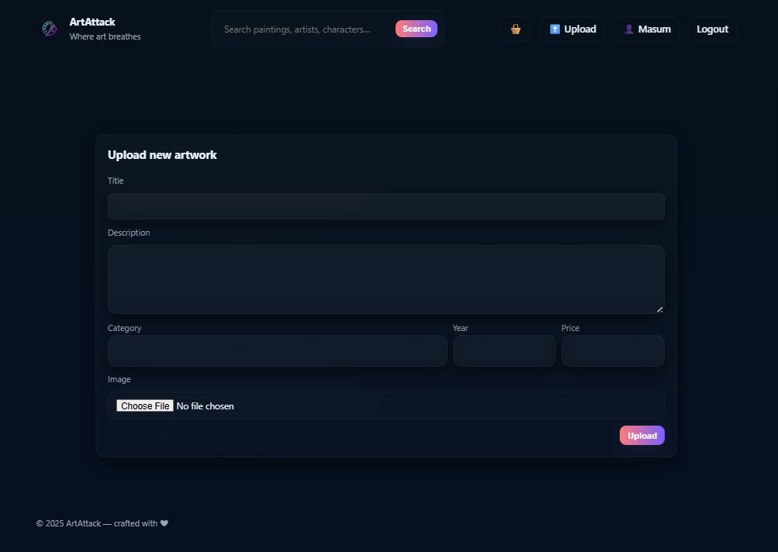

Figure 5: Artwork Browsing Page
The Artwork Browsing Page allows users to explore all available artworks through a visually appealing grid layout. It includes search and category filters to refine results based on title, description, or genre. Users can view artist names, preview artwork details, and seamlessly navigate to individual artwork pages for further information or purchase options.

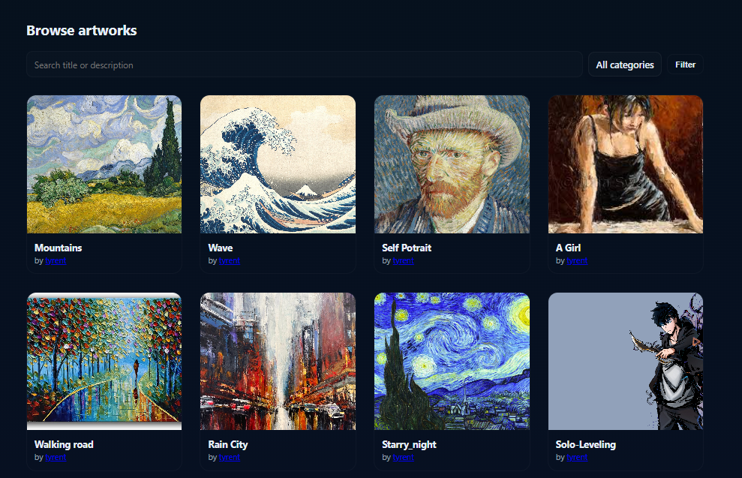

Figure 6: Artwork Details View
The Artwork Details Page provides an in-depth view of a selected artwork, including its image, title, artist, price, and description. Users can like the artwork, add it to their cart, or leave ratings and reviews. The page centralizes interactions, offering a personalized experience while encouraging engagement and potential purchases.

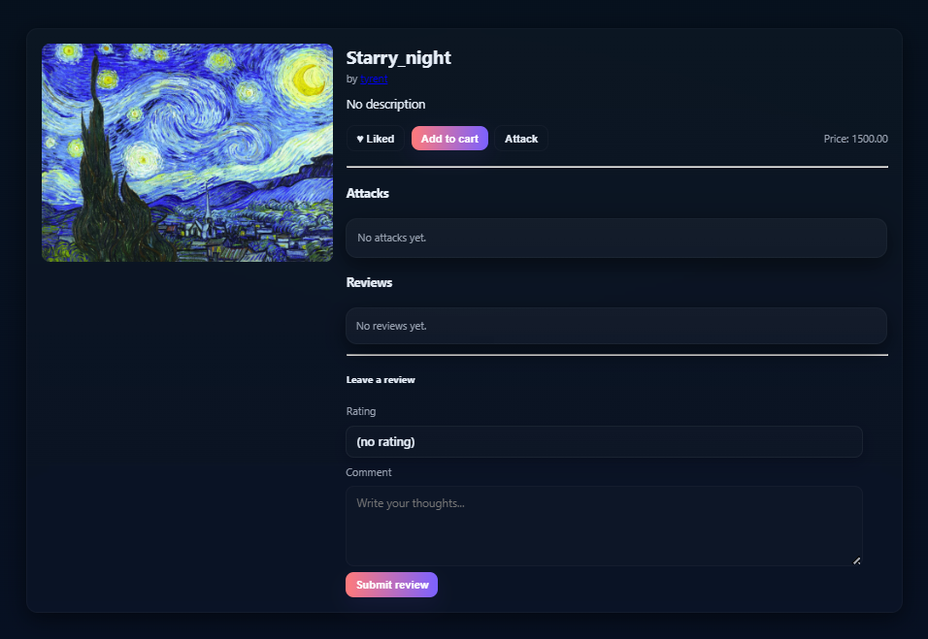

Figure 7: Cart Page
The Cart Page displays artworks selected for purchase, along with their prices, artist names, and thumbnails. Users can remove items, view the subtotal, and enter a delivery address before proceeding to checkout. This page streamlines the purchasing process by summarizing all selected artworks in one place and enabling a smooth transaction flow.

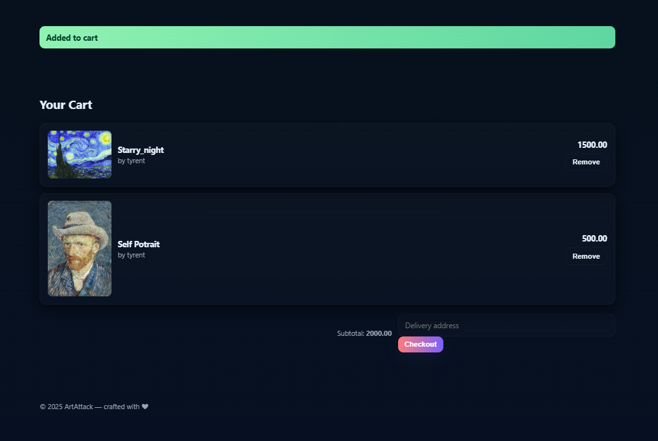

Figure 8: Artists Profile Page
The Artist Profile Page showcases an artist’s personal information, total likes, and sales performance. It displays all artworks uploaded by the artist in a clean gallery layout, each with pricing details. Users can view the artist’s portfolio, while artists can edit their profile, manage uploaded artworks, and interact with viewers through available contact options.

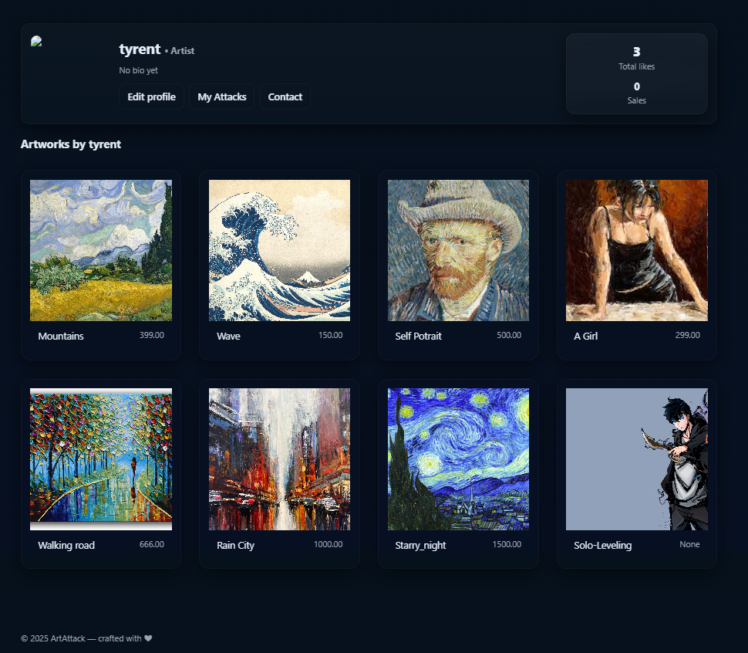

PHASE 02 — DATABASE DESIGN
2.1 Entity–Relationship (ER) Diagram — Conceptual Explanation
The Art Gallery Management System (AGMS) stores and manages a variety of interdependent data related to artists, artworks, customers, transactions, and exhibitions. The ER diagram represents the conceptual model of how these entities relate to one another within the system.

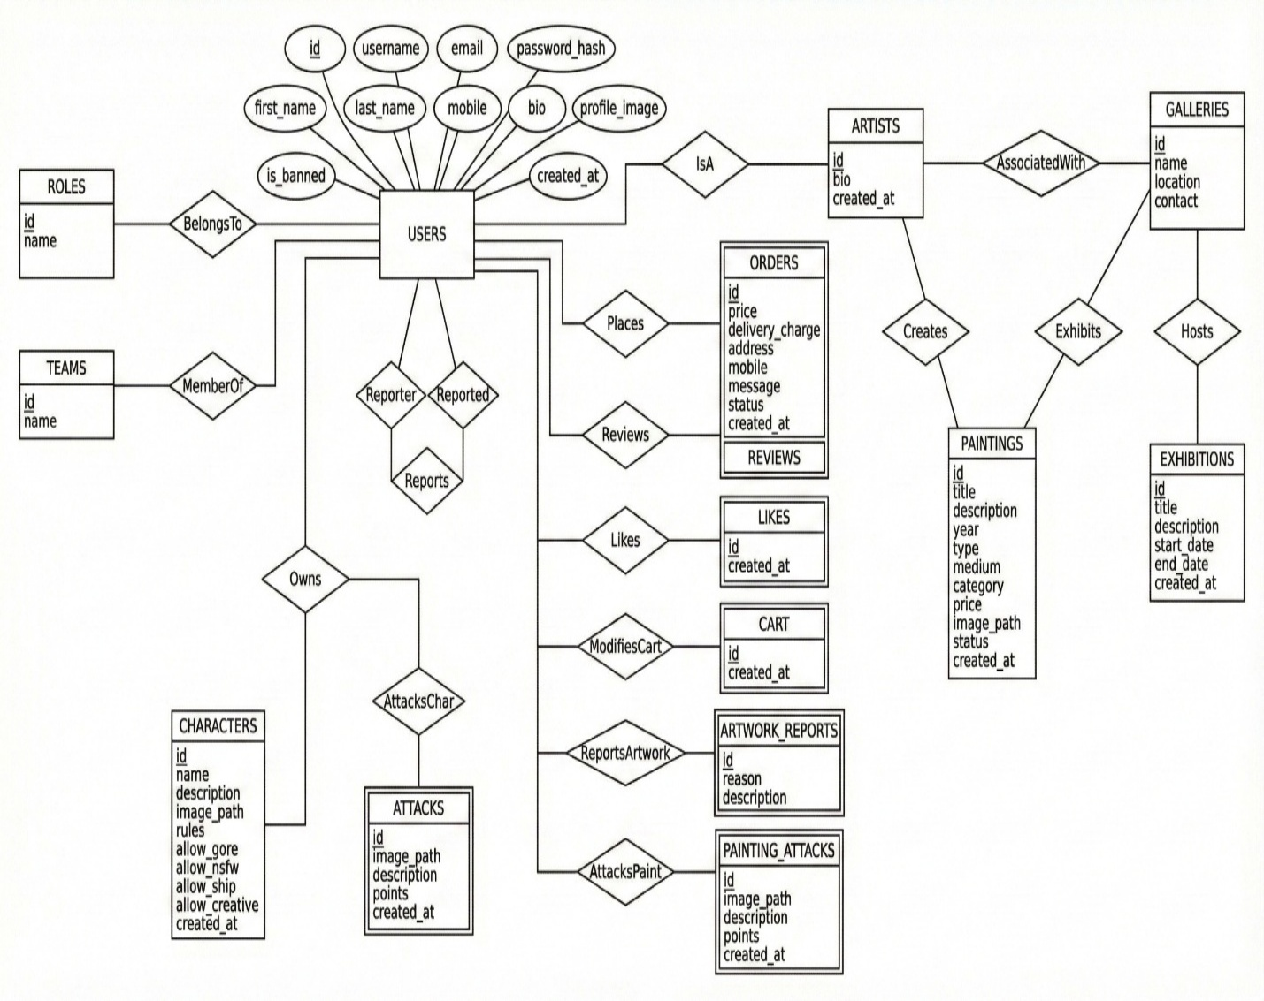
The system contains the following core entities:
- Artist
- Artwork
- Customer
- Orders
- Order_Items (if multiple artworks per order)
- Exhibition
- Exhibition_Artwork (bridge entity)
- Admin
- Category
2.1.1 List of Entities & Their Descriptions
1. Artist
Represents registered artists who upload artworks.
Attribute | Description
Artist_ID (PK) | Unique identifier
Name | Full name
Email | Unique contact email
Password | Encrypted password
Biography | Artist’s description
Profile_Image | Image path
Join_Date | Registration date

2. Artwork
Represents artworks uploaded by artists.
Attribute | Description
Artwork_ID (PK) | Unique artwork ID
Artist_ID (FK) | References Artist
Title | Artwork title
Description | Detailed info
Category_ID (FK) | Artwork category
Year | Creation year
Price | Artwork price
Image_Path | Stored file path
Status | Available/Sold
Upload_Date | Creation timestamp

3. Customer
Attribute | Description
Customer_ID (PK) | Unique buyer ID
Name | Buyer full name
Email | Unique login email
Password | Encrypted password
Address | Delivery address
Phone | Contact number
Join_Date | Registration date
4. Orders
Attribute | Description
Order_ID (PK) | Unique order number
Customer_ID (FK) | Purchase initiator
Order_Date | Date/time of order
Total_Amount | Price total
Status | Pending/Completed/Cancelled

5. Order_Items
Supports multiple artworks per order.
Attribute | Description
Order_Item_ID (PK) | Unique entry
Order_ID (FK) | References Orders
Artwork_ID (FK) | Artwork purchased
Price | Snapshot price
Quantity | Default 1

6. Category
Represents artwork categories (Portrait, Abstract, Landscape, Modern, etc.)
Attribute | Description
Category_ID (PK) | Unique ID
Category_Name | Category name

7. Exhibition
Attribute | Description
Exhibition_ID (PK) | Unique event ID
Title | Exhibition name
Description | Event description
Start_Date | From date
End_Date | To date

8. Exhibition_Artwork (Bridge Entity)
Supports many-to-many relationship between Exhibition and Artwork.
Attribute | Description
Exhibition_ID (FK) | References Exhibition
Artwork_ID (FK) | References Artwork
Composite PK: (Exhibition_ID, Artwork_ID)

9. Admin
Attribute | Description
Admin_ID (PK) | Unique admin ID
Name | Admin full name
Email | Login credential
Password | Encrypted password

2.1.2 Relationships Description
1. Artist → Artwork
Relationship: 1-to-Many
- One artist can upload multiple artworks.
- Each artwork belongs to exactly one artist.
2. Customer → Orders
Relationship: 1-to-Many
- A customer can place multiple orders.
- An order belongs to a single customer.
3. Orders → Order_Items → Artwork
Relationship:
- Orders to Order_Items → 1-to-Many
- Artwork to Order_Items → 1-to-Many
4. Exhibition ↔ Artwork
Relationship: Many-to-Many via Exhibition_Artwork
- An artwork can be displayed in multiple exhibitions.
- An exhibition can include multiple artworks.
5. Admin → System Entities
Admin has supervisory (not relational) authority.
Admin can:
- Approve artists
- Remove artworks
- Manage exhibitions

2.2 Full Relational Schema

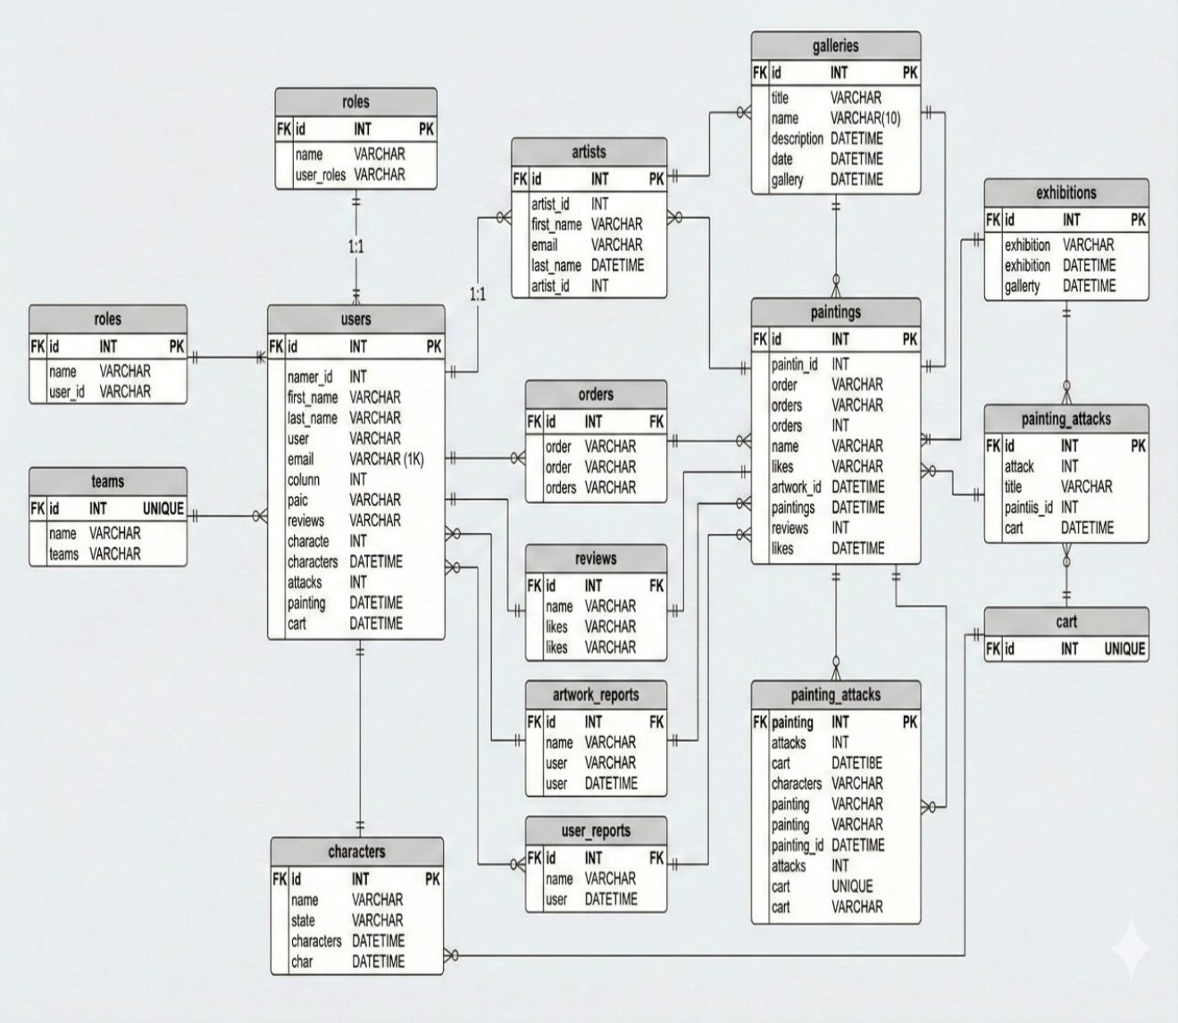

**Admin(
Admin_ID PK,
Name,
Email UNIQUE,
Password
)**

**Artist(
Artist_ID PK,
Name,
Email UNIQUE,
Password,
Biography,
Profile_Image,
Join_Date
)**

**Artwork(
Artwork_ID PK,
Artist_ID FK → Artist.Artist_ID,
Category_ID FK → Category.Category_ID,
Title,
Description,
Year,
Price,
Image_Path,
Status,
Upload_Date
)**

**Customer(
Customer_ID PK,
Name,
Email UNIQUE,
Password,
Address,
Phone,
Join_Date
)**

**Orders(
Order_ID PK,
Customer_ID FK → Customer.Customer_ID,
Order_Date,
Total_Amount,
Status
)**

**Order_Items(
Order_Item_ID PK,
Order_ID FK → Orders.Order_ID,
Artwork_ID FK → Artwork.Artwork_ID,
Price,
Quantity
)**

**Category(
Category_ID PK,
Category_Name
)**

**Exhibition(
Exhibition_ID PK,
Title,
Description,
Start_Date,
End_Date
)**

**Exhibition_Artwork(
Exhibition_ID FK → Exhibition.Exhibition_ID,
Artwork_ID FK → Artwork.Artwork_ID,
PRIMARY KEY (Exhibition_ID, Artwork_ID)
)**
2.3 Integrity Constraints
Primary Key Constraints
- Every entity has a unique primary key.
Foreign Key Constraints
Examples:
Artwork.Artist_ID → Artist.Artist_ID
Artwork.Category_ID → Category.Category_ID
Orders.Customer_ID → Customer.Customer_ID
Order_Items.Order_ID → Orders.Order_ID
Order_Items.Artwork_ID → Artwork.Artwork_ID
Exhibition_Artwork.Exhibition_ID → Exhibition.Exhibition_ID
Exhibition_Artwork.Artwork_ID → Artwork.Artwork_ID

Domain Constraints
- Price > 0
- Quantity >= 1
- Status IN ('Available', 'Sold', 'Pending')
- Email format validation
- Year BETWEEN 1500 AND current_year
Entity Integrity
- No NULL allowed in primary keys
- Non-null required for essential attributes (Name, Email, Title, Price)

Referential Integrity
- Cannot delete Artist if Artwork exists
- Cannot delete Customer if Orders exist
- Cascade deletion optional for:
ON DELETE CASCADE (Order_Items)

2.4 Normalization
1st Normal Form (1NF)
The given relation is in 1st Normal Form because it meets the following criteria:
- All cells contain atomic (indivisible) values.
- Entries in each column are of the same data type.
- Each record is unique; there are no duplicate rows.
- Attribute names are unique and meaningful.

2nd Normal Form (2NF)
The given relation is in 2nd Normal Form because it satisfies these conditions:
- The table is already in 1st Normal Form.
- There is no partial dependency; no subset of a candidate key determines a non-key attribute.
- All non-key attributes are fully dependent on the entire primary key.

3rd Normal Form (3NF)
The given relation is in 3rd Normal Form because:
- The table is already in 2nd Normal Form.
- There is no transitive dependency; a non-prime attribute does not depend on another non prime attribute.
- For every functional dependency, the left-hand side is a key, and the right-hand side is a non-prime attribute.

Thus, all columns are determined only by the primary key and no other non-key attributes.

1. Admin table:
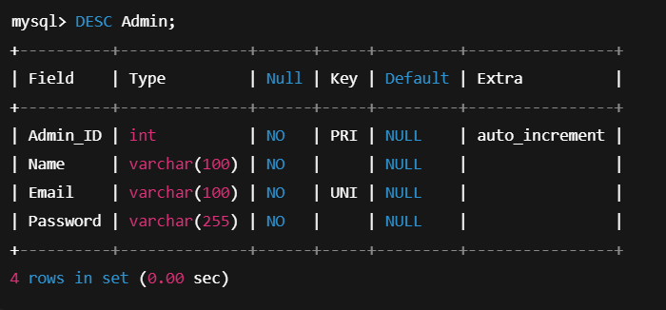
Normalization Check Table for Admin
Normal Form | ✓ / ✗ | Explanation
First Normal Form (1NF) | ✓ | All fields are atomic (no repeating groups). Each column holds a single value (e.g., one Email per row). Each row is uniquely identified by the primary key Admin_ID.
Second Normal Form (2NF) | ✓ | Table is in 1NF and the primary key is a single attribute (Admin_ID). There is no partial dependency because there is no composite key — every non-key attribute (Name, Email, Password) depends on the whole (single) primary key.
Third Normal Form (3NF) | ✓ | Table is in 2NF and has no transitive dependencies. None of the non-key attributes (Name, Email, Password) functionally determines another non-key attribute. They all depend only on Admin_ID. Therefore, 3NF holds.

Conclusion:
The Admin table is in Third Normal Form (3NF).

2. Artist table:
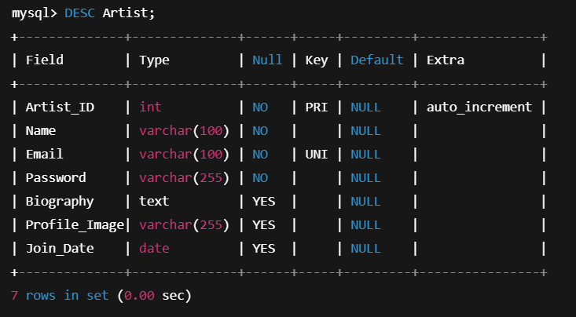
Normalization Check Table for Artist
Normal Form | ✓ / ✗ | Explanation
First Normal Form (1NF) | ✓ | All fields are atomic (no repeating groups). Each column holds a single value (one email, one name, one join date per row). Each row is uniquely identified by the primary key Artist_ID.
Second Normal Form (2NF) | ✓ | The table is in 1NF and the primary key is a single attribute (Artist_ID). There is no partial dependency because there is no composite key; all non-key attributes (Name, Email, Password, Biography, Profile_Image, Join_Date) depend on the whole (single) primary key.
Third Normal Form (3NF) | ✓ | The table is in 2NF and there are no transitive dependencies. None of the non-key attributes (e.g., Email, Biography, Join_Date) functionally determines another non-key attribute. All depend directly on Artist_ID. Therefore, 3NF holds.

Conclusion:
The Artist table is in Third Normal Form (3NF).
3. Customer table:
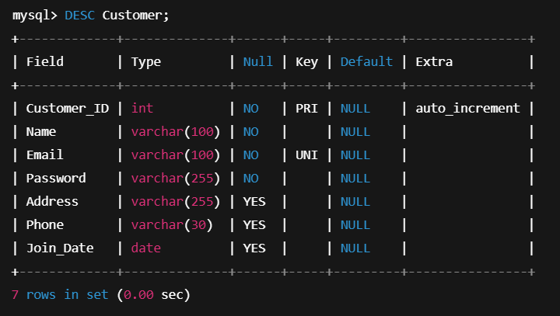
Normalization Check Table for Customer
Normal Form | ✓ / ✗ | Explanation
First Normal Form (1NF) | ✓ | All attributes are atomic (no repeating groups). Each field holds a single value, such as one email, one address, one phone per row. Each row is uniquely identified by Customer_ID.
Second Normal Form (2NF) | ✓ | The table is in 1NF and the primary key is a single attribute (Customer_ID). There is no partial dependency because there is no composite key — all non-key attributes (Name, Email, Password, Address, Phone, Join_Date) depend on the whole (single) primary key.
Third Normal Form (3NF) | ✓ | The table is in 2NF and has no transitive dependencies. No non-key attribute (e.g., Email, Address, Phone) functionally determines another non-key attribute. All depend directly on Customer_ID. Therefore, 3NF holds.

Conclusion:
The Customer table is in Third Normal Form (3NF).
4. Category table:
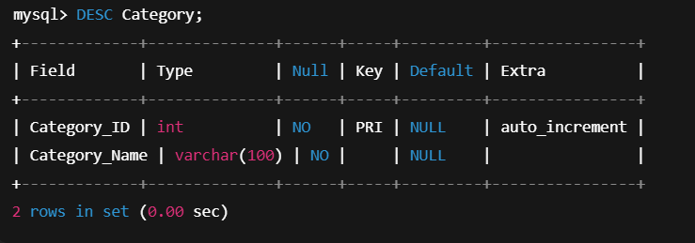
Normalization Check Table for Category
Normal Form | ✓ / ✗ | Explanation
First Normal Form (1NF) | ✓ | All fields are atomic and there are no repeating groups. Each row has a single Category_ID and a single Category_Name. The primary key Category_ID uniquely identifies each category.
Second Normal Form (2NF) | ✓ | The table is in 1NF and the primary key is a single attribute (Category_ID). There is no partial dependency because there is no composite key; the only non-key attribute Category_Name depends on the whole (single) primary key.
Third Normal Form (3NF) | ✓ | The table is in 2NF and has no transitive dependencies. Category_Name does not determine any other non-key attribute (there are none). It depends only on Category_ID. Therefore, 3NF holds.

Conclusion:
The Category table is in Third Normal Form (3NF).

5. Artwork table:
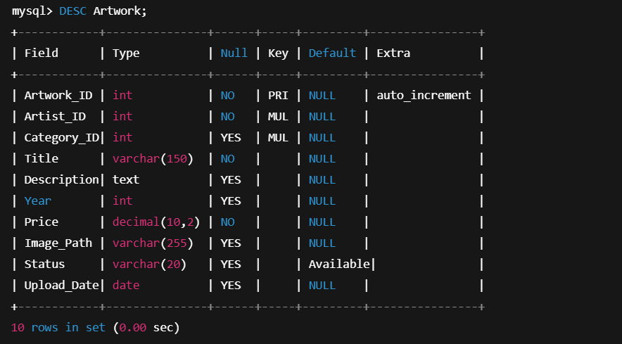
Normalization Check Table for Artwork
Normal Form | ✓ / ✗ | Explanation
First Normal Form (1NF) | ✓ | All fields are atomic and there are no repeating groups. Each row represents one artwork with a single Artist_ID, Category_ID, Title, Price, etc. The primary key Artwork_ID uniquely identifies every row.
Second Normal Form (2NF) | ✓ | The table is in 1NF and the primary key is a single attribute (Artwork_ID). There is no partial dependency because there is no composite key — every non-key attribute (Artist_ID, Category_ID, Title, Description, Year, Price, Image_Path, Status, Upload_Date) depends on the whole (single) primary key.
Third Normal Form (3NF) | ✓ | The table is in 2NF and has no transitive dependencies. Non-key attributes do not determine other non-key attributes: for example, Category_ID or Artist_ID do not store Category_Name or Artist_Name here (those are in separate tables). All non-key attributes depend only on Artwork_ID. Therefore, 3NF holds.

Conclusion:
The Artwork table is in Third Normal Form (3NF).

6. Orders table:
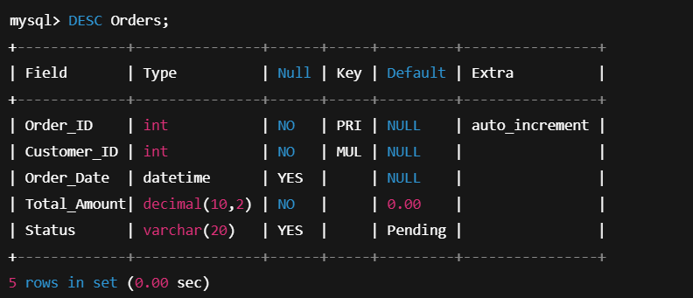
Normalization Check Table for Orders
Normal Form | ✓ / ✗ | Explanation
First Normal Form (1NF) | ✓ | All fields are atomic; there are no repeating groups. Each row stores a single order with one Customer_ID, one Order_Date, one Total_Amount, and one Status. The primary key Order_ID uniquely identifies each order.
Second Normal Form (2NF) | ✓ | The table is already in 1NF and the primary key is a single attribute (Order_ID). There is no partial dependency because there is no composite key. Every non-key attribute (Customer_ID, Order_Date, Total_Amount, Status) depends on the whole (single) primary key.
Third Normal Form (3NF) | ✓ | The table is in 2NF and has no transitive dependencies. Non-key attributes do not determine each other: for example, Customer_ID does not store customer details here (they are in the Customer table). All non-key attributes depend only on Order_ID. Therefore, 3NF holds.

Conclusion:
The Orders table is in Third Normal Form (3NF).

7. Order_Items table:
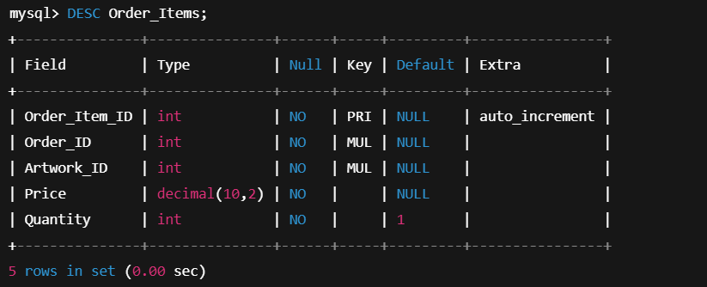
Normalization Check Table for Order_Items
Normal Form | ✓ / ✗ | Explanation
First Normal Form (1NF) | ✓ | All fields are atomic and there are no repeating groups. Each row represents a single line item: one Order_ID, one Artwork_ID, one Price, and one Quantity. The primary key Order_Item_ID uniquely identifies each row.
Second Normal Form (2NF) | ✓ | The table is in 1NF and has a single-attribute primary key (Order_Item_ID). There is no partial dependency, since there is no composite primary key — all non-key attributes (Order_ID, Artwork_ID, Price, Quantity) depend on the whole (single) primary key.
Third Normal Form (3NF) | ✓ | The table is in 2NF and has no transitive dependencies. Non-key attributes do not determine other non-key attributes: for example, Order_ID does not store order details here, and Artwork_ID does not store artwork details here. These are stored in Orders and Artwork tables respectively. Therefore, all non-key attributes depend only on Order_Item_ID, so 3NF holds.

Conclusion:
The Order_Items table is in Third Normal Form (3NF).
8. Exhibition table:
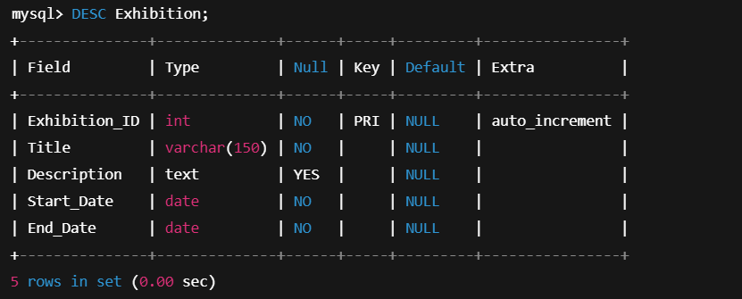
Normalization Check Table for Exhibition
Normal Form | ✓ / ✗ | Explanation
First Normal Form (1NF) | ✓ | All fields are atomic and there are no repeating groups. Each row stores a single exhibition with one Title, one Start_Date, and one End_Date. The primary key Exhibition_ID uniquely identifies each exhibition.
Second Normal Form (2NF) | ✓ | The table is in 1NF and the primary key is a single attribute (Exhibition_ID). There is no partial dependency, because there is no composite key — all non-key attributes (Title, Description, Start_Date, End_Date) depend on the entire (single) primary key.
Third Normal Form (3NF) | ✓ | The table is in 2NF and has no transitive dependencies. Non-key attributes do not determine other non-key attributes; e.g., Title or Start_Date does not functionally determine End_Date within this table. All non-key attributes depend only on Exhibition_ID. Therefore, 3NF holds.

Conclusion:
The Exhibition table is in Third Normal Form (3NF).

9. Exhibition_Artwork table:
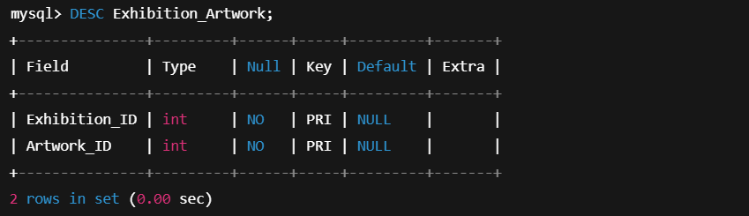
(Primary key is composite: (Exhibition_ID, Artwork_ID), both normally also foreign keys to Exhibition and Artwork.)
Normalization Check Table for Exhibition_Artwork
Normal Form | ✓ / ✗ | Explanation
First Normal Form (1NF) | ✓ | All fields are atomic, with no repeating groups. Each row links one exhibition to one artwork using Exhibition_ID and Artwork_ID. The composite primary key (Exhibition_ID, Artwork_ID) uniquely identifies each row.
Second Normal Form (2NF) | ✓ | The table is in 1NF and the primary key is composite (Exhibition_ID, Artwork_ID). There are no non-key attributes at all, so it is impossible to have a partial dependency of a non-key attribute on part of the key. Therefore, 2NF holds trivially.
Third Normal Form (3NF) | ✓ | The table is in 2NF and has no non-key attributes, so transitive dependencies cannot exist. Every attribute is part of the key itself. Hence, the table satisfies 3NF by definition.

Conclusion:
The Exhibition_Artwork table is in Third Normal Form (3NF).

2.5 SQL Statements
Create Database
CREATE DATABASE AGMS;
USE AGMS;

Admin Table
CREATE TABLE Admin (
Admin_ID INT AUTO_INCREMENT PRIMARY KEY,
Name VARCHAR(100),
Email VARCHAR(100) UNIQUE,
Password VARCHAR(255)
);

Artist Table
CREATE TABLE Artist (
Artist_ID INT AUTO_INCREMENT PRIMARY KEY,
Name VARCHAR(100),
Email VARCHAR(100) UNIQUE,
Password VARCHAR(255),
Biography TEXT,
Profile_Image VARCHAR(255),
Join_Date DATE
);

Category Table
CREATE TABLE Category (
Category_ID INT AUTO_INCREMENT PRIMARY KEY,
Category_Name VARCHAR(100)
);

Artwork Table
CREATE TABLE Artwork (
Artwork_ID INT AUTO_INCREMENT PRIMARY KEY,
Artist_ID INT,
Category_ID INT,
Title VARCHAR(150),
Description TEXT,
Year INT,
Price DECIMAL(10,2),
Image_Path VARCHAR(255),
Status VARCHAR(20),
Upload_Date DATE,
FOREIGN KEY (Artist_ID) REFERENCES Artist(Artist_ID),
FOREIGN KEY (Category_ID) REFERENCES Category(Category_ID)
);

Customer Table
CREATE TABLE Customer (
Customer_ID INT AUTO_INCREMENT PRIMARY KEY,
Name VARCHAR(100),
Email VARCHAR(100) UNIQUE,
Password VARCHAR(255),
Address VARCHAR(255),
Phone VARCHAR(30),
Join_Date DATE
);

Orders Table
CREATE TABLE Orders (
Order_ID INT AUTO_INCREMENT PRIMARY KEY,
Customer_ID INT,
Order_Date DATE,
Total_Amount DECIMAL(10,2),
Status VARCHAR(20),
FOREIGN KEY (Customer_ID) REFERENCES Customer(Customer_ID)
);

Order_Items Table
CREATE TABLE Order_Items (
Order_Item_ID INT AUTO_INCREMENT PRIMARY KEY,
Order_ID INT,
Artwork_ID INT,
Price DECIMAL(10,2),
Quantity INT DEFAULT 1,
FOREIGN KEY (Order_ID) REFERENCES Orders(Order_ID),
FOREIGN KEY (Artwork_ID) REFERENCES Artwork(Artwork_ID)
);

Exhibition Table
CREATE TABLE Exhibition (
Exhibition_ID INT AUTO_INCREMENT PRIMARY KEY,
Title VARCHAR(150),
Description TEXT,
Start_Date DATE,
End_Date DATE
);

Exhibition_Artwork Table
CREATE TABLE Exhibition_Artwork (
Exhibition_ID INT,
Artwork_ID INT,
PRIMARY KEY (Exhibition_ID, Artwork_ID),
FOREIGN KEY (Exhibition_ID) REFERENCES Exhibition(Exhibition_ID),
FOREIGN KEY (Artwork_ID) REFERENCES Artwork(Artwork_ID)
);

2.6 Database tables after inserting info’s
1. Admin Table
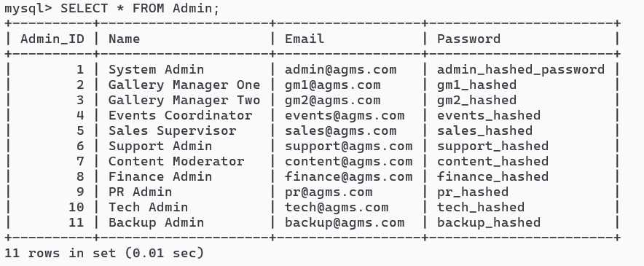

2. Artist Table
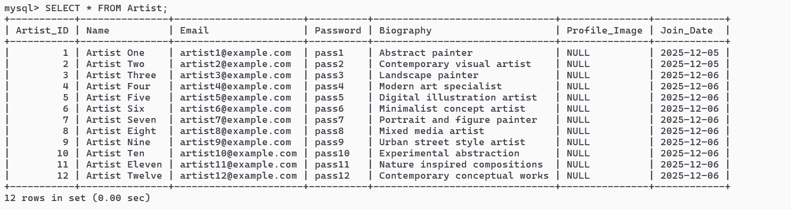

3. Customer Table
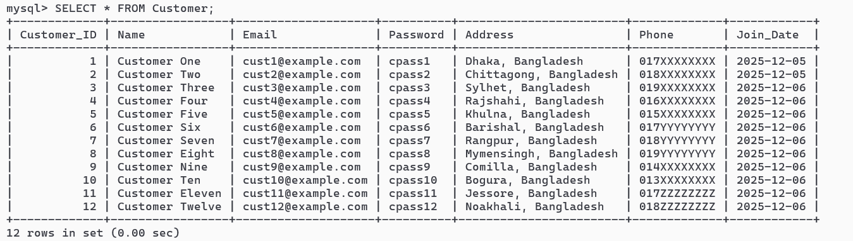

4. Category Table
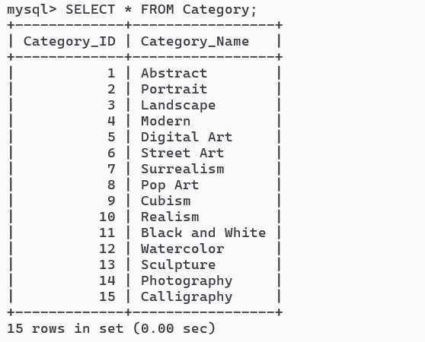

5. Artwork Table
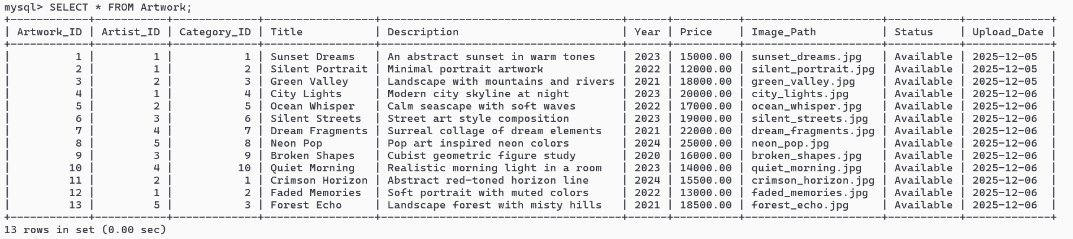

6. Orders Table
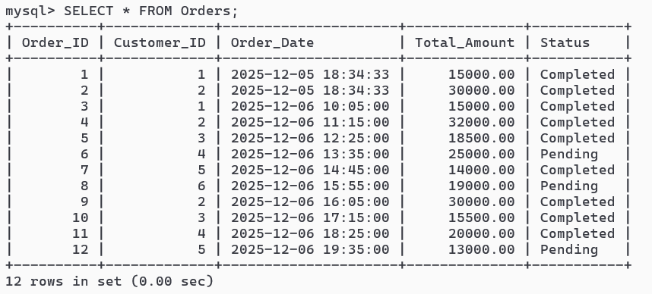
7. Order_Items Table
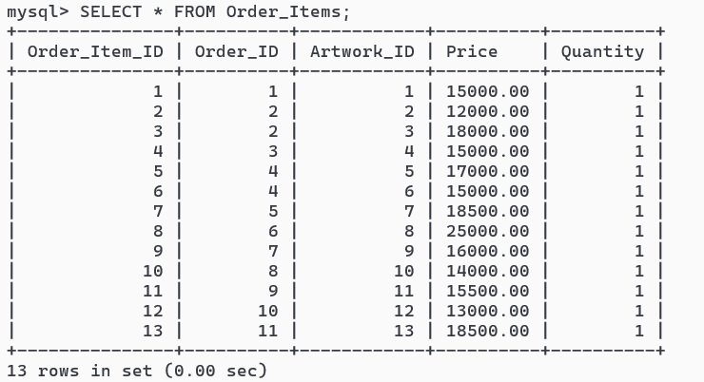

8. Exhibition Table
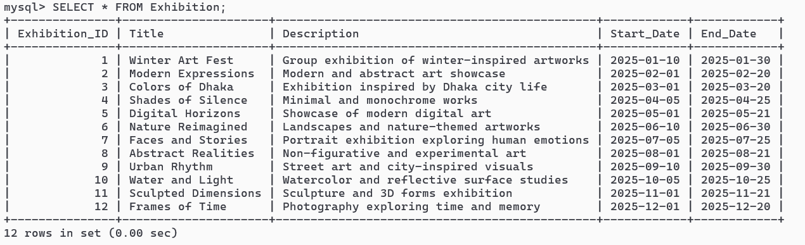

9. Exhibition_Artwork Table
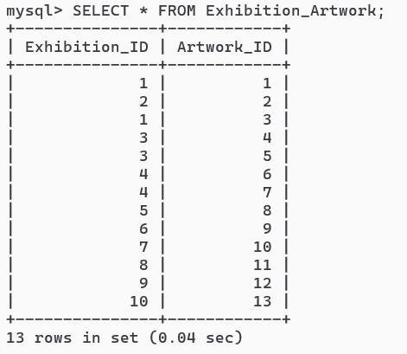

2.7 Pattern Identification Queries
- List all artworks with their artist name and category name.
SELECT
aw.Artwork_ID,
aw.Title,
a.Name AS Artist_Name,
c.Category_Name
FROM Artwork aw
JOIN Artist a ON aw.Artist_ID = a.Artist_ID
LEFT JOIN Category c ON aw.Category_ID = c.Category_ID
ORDER BY aw.Artwork_ID;

- Find total money spent by each customer (only completed orders).
SELECT
c.Customer_ID,
c.Name AS Customer_Name,
SUM(o.Total_Amount) AS Total_Spent
FROM Customer c
JOIN Orders o ON c.Customer_ID = o.Customer_ID
WHERE o.Status = 'Completed'
GROUP BY c.Customer_ID, c.Name
ORDER BY Total_Spent DESC;

- Show customers who placed orders worth more than 25,000 in total.
SELECT
c.Customer_ID,
c.Name,
SUM(o.Total_Amount) AS Total_Spent
FROM Customer c
JOIN Orders o ON c.Customer_ID = o.Customer_ID
WHERE o.Status = 'Completed'
GROUP BY c.Customer_ID, c.Name
HAVING SUM(o.Total_Amount) > 25000;

- For each category, show average price of artworks and only keep categories with average price > 16,000.
SELECT
c.Category_Name,
AVG(aw.Price) AS Avg_Price
FROM Category c
JOIN Artwork aw ON c.Category_ID = aw.Category_ID
GROUP BY c.Category_Name
HAVING AVG(aw.Price) > 16000
ORDER BY Avg_Price DESC;

- List each exhibition with the number of artworks displayed in it.
SELECT
e.Exhibition_ID,
e.Title,
COUNT(ea.Artwork_ID) AS Total_Artworks
FROM Exhibition e
LEFT JOIN Exhibition_Artwork ea
ON e.Exhibition_ID = ea.Exhibition_ID
GROUP BY e.Exhibition_ID, e.Title
ORDER BY Total_Artworks DESC;

- Find each artist’s total number of artworks that have been sold (appear in Order_Items).
SELECT
a.Artist_ID,
a.Name AS Artist_Name,
COUNT(DISTINCT oi.Artwork_ID) AS Artworks_Sold
FROM Artist a
LEFT JOIN Artwork aw ON a.Artist_ID = aw.Artist_ID
LEFT JOIN Order_Items oi ON aw.Artwork_ID = oi.Artwork_ID
GROUP BY a.Artist_ID, a.Name
ORDER BY Artworks_Sold DESC;

- Top 3 best-selling artworks by quantity sold.
SELECT
aw.Artwork_ID,
aw.Title,
SUM(oi.Quantity) AS Total_Quantity_Sold
FROM Order_Items oi
JOIN Artwork aw ON oi.Artwork_ID = aw.Artwork_ID
GROUP BY aw.Artwork_ID, aw.Title
ORDER BY Total_Quantity_Sold DESC
LIMIT 3;

- List artworks that have never been sold in any order.
SELECT
aw.Artwork_ID,
aw.Title,
aw.Price
FROM Artwork aw
WHERE aw.Artwork_ID NOT IN (
SELECT DISTINCT Artwork_ID FROM Order_Items
);

- Find customers who have never placed any order.
SELECT
c.Customer_ID,
c.Name,
c.Email
FROM Customer c
LEFT JOIN Orders o ON c.Customer_ID = o.Customer_ID
WHERE o.Order_ID IS NULL;

- List exhibitions that showcase artworks from more than one artist.
SELECT
e.Exhibition_ID,
e.Title,
COUNT(DISTINCT aw.Artist_ID) AS Distinct_Artists
FROM Exhibition e
JOIN Exhibition_Artwork ea ON e.Exhibition_ID = ea.Exhibition_ID
JOIN Artwork aw ON ea.Artwork_ID = aw.Artwork_ID
GROUP BY e.Exhibition_ID, e.Title
HAVING COUNT(DISTINCT aw.Artist_ID) > 1;

- Show orders that contain two or more different artworks.
SELECT
o.Order_ID,
o.Customer_ID,
COUNT(DISTINCT oi.Artwork_ID) AS Artwork_Count,
o.Total_Amount
FROM Orders o
JOIN Order_Items oi ON o.Order_ID = oi.Order_ID
GROUP BY o.Order_ID, o.Customer_ID, o.Total_Amount
HAVING COUNT(DISTINCT oi.Artwork_ID) >= 2;

- Monthly revenue summary (based on Order_Date).
SELECT
DATE_FORMAT(o.Order_Date, '%Y-%m') AS YearMonth,
SUM(o.Total_Amount) AS Total_Revenue,
COUNT(*) AS Total_Orders
FROM Orders o
WHERE o.Status = 'Completed'
GROUP BY DATE_FORMAT(o.Order_Date, '%Y-%m')
ORDER BY YearMonth;
- For each customer, show their latest order (date and amount).
SELECT
c.Customer_ID,
c.Name,
o.Order_ID,
o.Order_Date,
o.Total_Amount
FROM Customer c
JOIN Orders o
ON o.Customer_ID = c.Customer_ID
WHERE o.Order_Date = (
SELECT MAX(o2.Order_Date)
FROM Orders o2
WHERE o2.Customer_ID = c.Customer_ID
);

- Show total revenue generated by each artist from sold artworks.
SELECT
a.Artist_ID,
a.Name AS Artist_Name,
SUM(oi.Price * oi.Quantity) AS Revenue_From_Sales
FROM Artist a
JOIN Artwork aw ON a.Artist_ID = aw.Artist_ID
JOIN Order_Items oi ON aw.Artwork_ID = oi.Artwork_ID
JOIN Orders o ON oi.Order_ID = o.Order_ID
WHERE o.Status = 'Completed'
GROUP BY a.Artist_ID, a.Name
ORDER BY Revenue_From_Sales DESC;

- For each category, count how many artworks have appeared in at least one exhibition.
SELECT
c.Category_Name,
COUNT(DISTINCT aw.Artwork_ID) AS Artworks_In_Exhibitions
FROM Category c
JOIN Artwork aw ON c.Category_ID = aw.Category_ID
JOIN Exhibition_Artwork ea ON aw.Artwork_ID = ea.Artwork_ID
GROUP BY c.Category_Name
ORDER BY Artworks_In_Exhibitions DESC;
PHASE 03 — PROJECT PROGRESS & CONTRIBUTION
3.1 Project Timeline Overview
The development of the Art Gallery Management System (AGMS) was carried out over multiple weeks during the Database Management System Laboratory course. The work was divided into clearly defined phases:

- Requirement Analysis & Planning
- Database Design (ERD, Schema, Normalization)
- Backend Implementation (MySQL + Python)
- Frontend Development (HTML, CSS, JS)
- Integration & Testing
- Report Writing & Final Refinement
- Making Presentation

3.2 Group Progress Summary
The following table summarizes the overall contributions of the team members:
Sl. No. | Name | ID | Estimated Hours | Actual Hours | Main Responsibilities
1 | Mutasim Billah | 23549009057 | 40 | 46 | Fronted Design, Backend Logic, Testing, DB Management
2 | Abdullah Al Masum | 23549009019 | 40 | 44 | ERD, Report Making, Documentation, Presentation

3.3 Week-wise Progress (Group Level)
Week 1 – Topic Selection & Requirement Analysis
- Selected “Art Gallery Management System” as project topic
- Identified key users: Admin, Artist, Customer
- Listed core features and requirements
- Discussed initial system scope and limitations
Week 2 – Conceptual Design
- Identified entities and attributes
- Designed initial ER Diagram
- Defined relationships between Artist, Artwork, Customer, Orders, Exhibition
- Presented draft model for feedback
Week 3 – Logical Design & Normalization
- Converted ERD into relational schema
- Defined primary keys and foreign keys
- Performed normalization up to 3NF
- Prepared integrity constraints (domain, entity, referential)
Week 4 – Database Implementation & Sample Data
- Implemented tables in MySQL
- Applied constraints (PK, FK, UNIQUE, NOT NULL, CHECK)
- Inserted sample rows for testing
- Executed basic SELECT, JOIN, GROUP BY queries
Week 5 – Application Layer & UI
- Developed basic Flask routes (backend)
- Built HTML/CSS templates for main pages
- Integrated pages with database queries
- Implemented search, browse, login, upload artwork, and cart logic
Week 6 – Testing, Debugging & Reporting
- Tested all major functionalities: registration, login, CRUD operations, orders
- Fixed authentication, validation, and query bugs
- Finalized documentation and report structure
- Prepared the final presentation materials
3.4 Individual Progress Report – Abdullah Al Masum (ID: 23549009019)
3.4.1 Responsibilities
- Idea generation
- Writing SQL scripts (CREATE TABLE, INSERT, pattern queries)
- System testing and debugging
- Writing the report
- Making presentation
3.4.2 Work Summary Table
Time Period | Tasks Performed
Week 1 | Helped analyze requirements, listed entities and attributes
Week 2 | Designed ER Diagram draft, refined entities and relationships
Week 3 | Performed schema refinement and normalization to 3NF
Week 4 | Wrote MySQL CREATE TABLE scripts with constraints; populated sample data
Week 5 | Checked routes for login, registration, artwork upload, cart, checkout
Week 6 | Performed testing, fixed SQL and backend bugs, wrote database design & SQL sections of report
3.4.3 Skills & Learning
- Hands-on experience in ERD, relational schema design, normalization
- Practical understanding of connecting Python backend with MySQL
- Improved debugging skills for SQL and backend logic

3.5 Individual Progress Report – Mutasim Billah (ID: 23549009057)
3.5.1 Responsibilities
- Frontend UI design (HTML, CSS, layout)
- Backend design (Python, MySQL Connector)
- Integration of templates with backend routes
- Writing SELECT, JOIN, and pattern analysis queries
- Designing use case descriptions and screen descriptions
3.5.2 Work Summary Table
Time Period | Tasks Performed
Week 1 | Contributed to requirement analysis and feature listing
Week 2 | Helped finalize ERD; documented entity descriptions and relationships
Week 3 | Assisted in defining relational schema and normalization examples
Week 4 | Designed UI for Home, Login, Register, Browse Artwork, Artwork Details, Cart
Week 5 | Integrated frontend templates with Flask routes, tested page navigation and forms
Week 6 | Wrote functional requirement descriptions, screen overviews, and formatted the report for printing

3.5.3 Skills & Learning
- Improved UI/UX design skills using HTML/CSS
- Gained experience in integrating frontend with backend endpoints
- Learned how to write meaningful SQL queries for analytics

3.6 Challenges Faced
- Handling relational integrity while deleting records (e.g., deleting an artwork that is part of an order or exhibition)
- Debugging SQL syntax and foreign key constraint violations
- Designing a responsive interface that aligns well with database-driven content
- Managing time between lab tasks, project coding, and report writing

3.7 Mitigation Strategies
- Used incremental testing approach (test each module after implementation)
- Added careful foreign key definitions with appropriate cascading where safe
- Conducted cross-checks between ERD and implemented schema
- Divided responsibilities clearly between team members to avoid overlap

3.8 Overall Team Reflection
The team collaborated effectively and frequently discussed design decisions before implementation. Responsibilities were divided logically between database/backend and frontend/documentation. Regular testing after each phase reduced the number of critical issues toward the end. The project provided a realistic experience of how DBMS concepts translate into a fully functional application.

PHASE 04 — FINAL SECTIONS
4.1 Limitations of the System
Although the Art Gallery Management System (AGMS) successfully implements core gallery management functions, several constraints limit the system’s full capabilities in its current prototype form:
Technical Limitations
- Local Image Storage
Artwork images are stored locally; no cloud integration is implemented for scalable storage.
- No Real Payment Gateway
Purchase transactions are simulated. Integration with real-world payment services (e.g., SSLCommerz, Stripe, PayPal) is not included.
- Limited Recommendation System
The system does not currently analyze user behavior to recommend artworks or exhibitions.
- No Multi-Admin Privilege Levels
All admins share the same privilege level instead of having hierarchical access control.
- No Automated Notification System
Users (artists/customers) do not receive automated email/SMS updates about orders or exhibition invitations.
User Experience Limitations
- Basic UI/UX
Although functional, the interface could be more modern and optimized for mobile responsiveness.
- Lack of Advanced Search Filters
Search options are limited; filters such as color theme, era, or multi-criteria sorting are not available.
- Exhibition Virtual Tour Missing
The system does not include a virtual display or AR/VR integration.
Database Limitations
- No Backup/Restore Automation
Database backup must be done manually.
- Limited Transaction Support
The current system does not handle complex rollback-recovery transactions.
- Analytics Are Limited
While basic reporting is available, advanced analytics such as artist ranking trends or customer buying patterns are not implemented.

4.2 Future Improvements
AGMS can be expanded and enhanced significantly. Below are potential upgrades for future versions:
Technical Enhancements
- Cloud Storage Integration for artwork images
- Real Payment Gateway Integration
- AI-Based Artwork Recommendation System
- Role-Based Admin Privileges (Super Admin, Moderator, Exhibition Manager)

User-Oriented Enhancements
- Mobile App Version (Android & iOS)
- Dark Mode & Modern UI Enhancements
- Live Chat Between Artists and Customers
- Wishlist / Favorites Feature
- Review & Ratings System
Gallery & Exhibition Enhancements
- Virtual Gallery Walkthrough (3D / VR)
- Automated Exhibition Scheduling
- Artist Collaboration Modules
Database-Level Enhancements
- Implement Stored Procedures, Triggers, Views, and Transaction Handling
- Automatic database backup & restore utilities
- Advanced BI Dashboards for analytics

4.3 Learning Outcomes
Working on the Art Gallery Management System allowed the team to develop strong practical knowledge in several key areas of database management, application development, and teamwork.
Database Concepts Learned
- Designing an ER Diagram based on real-world requirements
- Converting ER models into normalized relational schemas
- Ensuring data integrity using primary keys, foreign keys, and check constraints
- Writing efficient SQL queries including JOINs, GROUP BY, aggregated queries, and pattern identification queries
- Understanding normalization from 1NF to 3NF

Backend & Application Development Skills
- Connecting Python Flask with a MySQL database
- Implementing CRUD operations using SQL queries in backend routes
- Handling session management, authentication, and user roles
- Validating user inputs and preventing SQL injection
Frontend Development Skills
- Building structured UI layouts using HTML and CSS
- Creating dynamic forms, detail pages, and catalog pages
- Ensuring responsive and user-friendly design
Soft Skills & Team Experience
- Effective communication and task distribution
- Time management across multiple development phases
- Writing formal documentation according to academic standards
- Collaborative debugging and problem-solving

4.4 Conclusion
The Art Gallery Management System (AGMS) provides an effective and structured solution for managing artworks, artists, customers, and exhibition activities. By integrating a relational database with a responsive web interface, AGMS demonstrates how database management systems can support real-world applications through data integrity, consistency, and automation.
Through the phases of requirement analysis, database design, normalization, implementation, testing, and documentation, the project strengthened our understanding of database principles and their role in application development. Although the system has limitations, it establishes a strong foundation for further enhancements such as AI-based recommendations, real payment systems, and cloud integration.
Overall, AGMS successfully meets the intended objectives of the course project by providing a functional, well-designed, and academically structured database-backed application.

