A Two-Component Transport Model and Oleophilic Epoxy/Fe₃O₄ Proppant for Tracer-Based Per-Interval Production Allocation

Abstract
Tracer proppants enable long-term per-interval monitoring without downhole hardware, but interpreting their wellhead breakthrough curves (BTCs) requires jointly accounting for sustained release from the polymer matrix and transport through the production tubing. Current practice relies on the zero-dimensional Korsmeyer-Peppas (K-P) model to characterize batch release kinetics; the advection-dispersion framework widely used for transport interpretation has not been coupled to the sustained source term that these materials generate. We develop a piecewise advection-dispersion model that decomposes the BTC into a Gaussian pulse (shut-in accumulation slug) and an erfc tail (sustained matrix-diffusion-controlled release), linked by a smooth tanh transition. The six-parameter model is validated with an oleophilic epoxy/Fe₃O₄ tracer proppant (ESP-T) in core displacement experiments. The dual-component formulation is statistically decisive over four single-component alternatives (ΔAICc = 32.7, F-test p < 10⁻⁶, R² = 0.9939). The fitted flow rate (0.46 mL/min) agrees with the independent pump setting (0.50 mL/min) within 8% without being constrained in the objective function. The Peclet number (Pe = 0.934) independently confirms the non-Fickian transport mechanism identified via K-P kinetics (n = 0.45–0.85). The erfc tail accounts for 47% of the integrated signal, a result stable to within ±0.8% across a six-fold variation in the transition width. Under two-phase flow, the oil-phase tracer mass flux eliminates water-dilution artifacts and tracks oil production rates (Pearson r = 0.97, RMSD = 8.3%). The framework enables per-interval production allocation from wellhead samples alone, requiring no downhole tools and only a single shut-in.

Keywords: Tracer proppant; Breakthrough curve; Advection–dispersion equation; Release kinetics; Production allocation; Two-phase flow; Epoxy resin; Tracer flux

1. Introduction
Multi-stage hydraulic fracturing has enabled economic production from unconventional reservoirs, but completion diagnostics remain hindered by a persistent question: how much does each fracture stage produce? Production logging across hundreds of horizontal wells revealed that approximately 30–40% of perforation clusters contribute negligibly to production [1], motivating two decades of work on completion optimization and re-stimulation strategies [2,3]. Yet the ability to routinely measure per-stage contribution at the surface has not kept pace. Production logging tools require well intervention via coiled tubing or tractor and capture only a snapshot of the inflow profile [4]. Distributed fiber-optic sensing—both distributed temperature sensing (DTS) and distributed acoustic sensing (DAS)—has enabled real-time monitoring of stimulation operations and qualitative inflow profiling without intervention [5,6], and DAS-based strain measurements now provide far-field fracture geometry and cluster efficiency diagnostics [7]. However, permanent fiber installation and surface instrumentation remain costly, limiting deployment to high-value wells [8]. Microseismic monitoring, while valuable for characterizing stimulated reservoir volume, does not directly measure production contribution per stage [3,9]. A method that delivers quantitative per-stage production allocation from surface samples alone—without downhole tools, permanent installation, or repeated well intervention—would fundamentally change completion diagnostics.
Tracer technology offers a pathway toward this method. Since the first documented oilfield tracer test using radioactive iodine in 1954 [10], tracer methods have evolved from qualitative inter-well connectivity assessment to quantitative residual oil saturation measurement via partitioning inter-well tracer tests [11,12] and, more recently, to stage-level inflow profiling in multi-stage fractured wells [13]. Tracer proppants—in which a chemical tracer is immobilized within a solid proppant carrier and co-injected with the proppant pack—offer a key advantage over dissolved tracers: the tracer remains in the fracture after placement, enabling long-term monitoring from surface samples without repeated injection. A growing body of material designs has been demonstrated: Zhao et al. (2020) used solvent-evaporated dye coatings on ceramic proppants [14]; Zhou et al. (2022) encapsulated carbon quantum dots in polymer-coated ceramics [15]; Li et al. (2023) developed rare-earth-doped polymer matrices for multi-element coding [16]; Gong et al. (2024) synthesized oleophilic Fe₃O₄/polystyrene microspheres for oil-phase selective release [17]; Ren et al. (2024) prepared multi-colored dye-tracer proppants for quantitative flowback assessment [18]; and Malyavko et al. (2023) demonstrated quantum-dot-encoded polymer microspheres for fluid-phase-resolved inflow profiling [19]. Across these diverse material platforms, a common interpretation gap persists: existing methods can confirm which stages produce, but cannot quantify how much each stage produces from the breakthrough curve alone, because the observed signal is shaped jointly by the unknown tracer release rate and the unknown transport parameters of the production system.
The release side of this coupled problem is addressed—but not solved—by the Korsmeyer–Peppas (K‑P) power-law model. Originally developed for drug delivery systems [20,21] and extended to coupling of diffusion and polymer relaxation [22], the K‑P model C/C₀ = K·tⁿ identifies the release mechanism through the diffusional exponent n (Fickian diffusion for n ≤ 0.43; anomalous transport for 0.43 < n < 0.85; Case-II relaxation for n ≥ 0.85) and provides the temperature-dependent rate constant K. This framework has been productively applied to characterize release from diverse tracer-proppant systems including rare-earth-doped polymer coatings [16], polystyrene-encapsulated Fe₃O₄ nanoparticles [17], epoxy-matrix sustained-release tracers [23], and nano-Fe₃O₄ tracers in copolymer matrices under varying temperature and salinity [24]. However, K‑P is fundamentally a zero-dimensional batch description: it characterizes release into a well-mixed vessel with no spatial coordinate, no flow field, and no pathway from a release rate to a concentration measured at a distant sampling point. Alone, it cannot predict the wellhead concentration at a given time—the quantity that encodes production information.
On the transport side, the one-dimensional advection–dispersion equation (ADE) provides a mature analytical framework for interpreting breakthrough curves. Van Genuchten and Alves (1982) compiled analytical solutions covering a wide range of boundary and initial conditions [25]; the temporal moments of a BTC yield the mean residence time and dispersivity. Full-curve ADE inversion has been applied to determine reservoir properties and flood performance from inter-well tracer tests [26], to interpret physical mechanisms in partitioning tracer tests [27], to model chemical tracer transport under two-phase flow via analytical solutions [28], and to describe water- and oil-soluble tracer transfer in multi-stage fractured wells [29]. A comprehensive review of tracer testing techniques [30] confirms that ADE-based interpretation remains the standard approach across the petroleum industry. The common premise across these applications, however, is that the tracer source term is known—an injection pulse of specified mass, duration, and location. A tracer-proppant BTC violates this premise fundamentally: the source is not a single operator-controlled injection but a sustained, matrix-diffusion-controlled release whose rate parameters are unknown and whose duration spans the entire production period. No existing framework couples the sustained release source term to the ADE transport solution. The consequence is that the two bodies of knowledge—release kinetics and transport interpretation—have remained separate, and neither alone can deliver the per-stage flow rate from the BTC.
In this work, we close this gap by coupling the release source term to the ADE transport solution through a two-component model and a complementary tracer flux method. We construct a piecewise release–transport model that decomposes the BTC into two physically motivated components: a Gaussian pulse (shut-in accumulation slug) and an erfc tail (sustained matrix-diffusion-controlled release), linked by a C¹-continuous hyperbolic-tangent transition. Six parameters are estimated simultaneously from a single BTC by nonlinear least squares. The model is validated through a predictive self-calibration test: the flow rate Q is left entirely unconstrained in the objective function; the model must recover the independently set pump flow rate from the BTC shape alone. Applied to an oleophilic epoxy/Fe₃O₄ tracer proppant (ESP‑T) in core displacement experiments, the model recovers Q = 0.46 mL/min against the pump setting of 0.50 mL/min—a deviation of 8%. Epoxy resins have attracted growing interest as proppant matrices owing to their high mechanical strength, thermal stability, and chemical resistance compared to thermoplastic alternatives [31–33], and their ability to sustain controlled tracer release over extended periods has been demonstrated in both water-soluble [23] and oil-soluble configurations [34]. The Peclet number (Pe = 0.934) independently corroborates the non-Fickian transport mechanism identified from static K‑P batch kinetics (n = 0.45–0.85)—two completely separate experiments converging on the same dispersion-dominated transport picture. We then introduce a tracer flux method for production allocation under two-phase flow: the oil-phase tracer mass flux F_O = C_oil × Q_oil is invariant with total flow rate at a given oil–water ratio (Pearson r = 0.97, RMSD = 8.3%), eliminating the dilution artifact that confounds concentration-based interpretation. By doping each fracture stage with a distinct tracer element, per-stage contribution rates are obtained as (F_O,i / C_i) / Σ(F_O,j / C_j) from periodic ICP‑MS wellhead samples alone. We validate the complete framework in single-phase and two-phase core displacement experiments, and outline the pathway to multi-stage field deployment with multi-element coding for per-stage signal separation.

2. Experimental Section

2.1 Materials
Analytical grade reagents—including FeCl₃ (≥99.0%), FeCl₂·4H₂O (≥99.0%), MnCl₂·6H₂O (≥99.0%), stearic acid (≥99.5%), and anhydrous ethanol—were purchased from Chengdu Kelong Chemical Co., Ltd. Industrial grade materials included guar gum, E51 epoxy resin (epoxy value 0.48–0.54 mol/100 g, Nantong Xingchen Synthetic Materials), T31 curing agent (phenolic amine, ≥95% effective component), and hollow glass microspheres (≥99% purity). Dodecane (≥99%, Chengdu Kelong) served as the model oil phase. All reagents were used as received. Detailed specifications are provided in Table S1 (Supplementary Material).

2.2 Synthesis of ESP-T Tracer Proppant
The synthesis comprised three steps (Figure 1). First, stearic acid-modified nano-Fe₃O₄ (nano-Fe₃O₄@SA) was prepared by co-precipitation: 2.703 g FeCl₃ and 1.15 g FeCl₂·4H₂O were dissolved in 100 mL deionized water at 80 °C under N₂ purge, with 2×10⁻⁵ mol MnCl₂·6H₂O added as a dopant. Ammonia solution (5.5 mL) was rapidly introduced, and the reaction proceeded at pH 10 for 2 h. The black precipitate was magnetically separated, washed to neutrality, and sonicated with ethanolic stearic acid for oleophilic surface modification, yielding nano-Fe₃O₄@SA at approximately 12.5 wt% solids in the ethanol mixture (determined gravimetrically, triplicate). Second, an epoxy pre-mixture consisting of 20 mL E51 resin, 6 g Fe₃O₄-ethanol mixture (corresponding to ~0.75 g nano-Fe₃O₄@SA, ~3.3 wt% of the final ESP-T formulation), 1 g hollow glass microspheres, and 7 g T31 curing agent was homogenized. Third, the pre-mixture was emulsified in a SiO₂ aqueous dispersion stabilized with guar gum, and the resulting microspheres were cured at 50 °C for 1 h, rinsed, and dried at 80 °C for 10 h. Pure epoxy microspheres (without nano-Fe₃O₄@SA) were prepared identically as a reference. Although Mn was used here, the co-precipitation method accommodates other transition metals (Zn, Cu, Co, Ni) and rare earth elements (Eu, Dy, Nd) for multi-stage tracer coding.
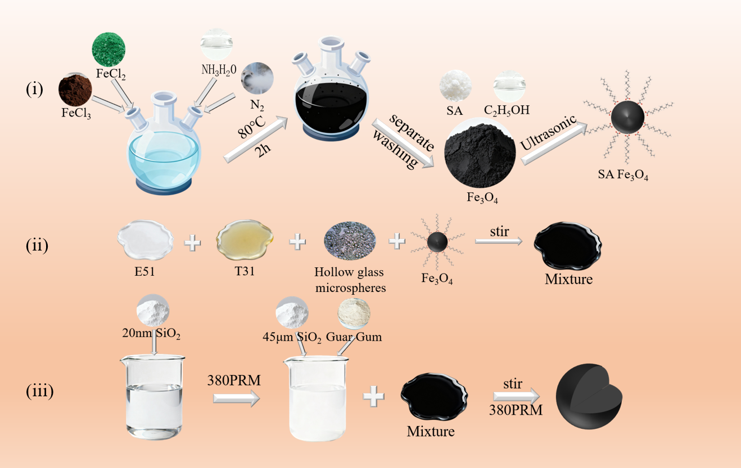
Figure 1. Schematic of the three-step synthesis of ESP-T.

2.3 Characterization
Microstructure and elemental distribution were characterized by scanning electron microscopy with energy-dispersive X-ray spectroscopy (SEM-EDS, ZEISS Sigma 500) and optical microscopy (Leica DM2700P). Thermal stability was evaluated by thermogravimetric analysis and differential scanning calorimetry (TGA/DSC, TA Instruments Q500, air atmosphere, 10 °C/min, 50–800 °C). Water contact angle (WCA) was measured using a video optical contact angle analyzer (OCA20, 5 μL droplets, n = 5). Physical and mechanical properties—including bulk density, apparent density, sphericity, roundness, acid solubility (HCl 12 wt%/HF 3 wt%, 65 °C, 30 min), and crush rate (52 MPa, 2 min)—were evaluated per SY/T 5107–2016. Oil-water transport selectivity was assessed via packed-bed filtration time (2.0 g proppant, 20 mL fluid, 200-mesh screen). Detailed protocols are provided in the Supplementary Material (Section S2).

2.4 Tracer Release Experiments
ESP-T (5 g, 40–70 mesh) was immersed in 100 mL dodecane in sealed glass vials placed in thermostatic oil baths at 30, 60, 90, and 120 °C. Sampling was conducted at 12 h intervals; the concentration of tracer-doped metal ions was quantified by inductively coupled plasma mass spectrometry (ICP-MS, PerkinElmer NexION 300X). Release data within Mt/M∞ < 0.6 were fitted to the K-P model, C/C₀ = K·tⁿ, to determine the kinetic parameters K and n.

2.5 Core Displacement Experiments
A dynamic displacement apparatus (Figure 2) was used to simulate single-interval production. A steel core was packed with ESP-T, sealed with 200-mesh screens, and placed in a core holder under 5 MPa confining pressure. The production tubing connecting the core outlet to the sampling point was 1 m in length with an inner diameter of 1 mm. For single-phase experiments, the system was saturated with dodecane at 5 mL/min, shut in for 96 h to allow tracer accumulation (a duration representative of typical shut-in periods between fracturing and flowback in field operations), then displaced at 0.50 mL/min. Effluent was sampled at 4-min intervals (2 mL per sample, 21 samples) and analyzed by ICP-MS to construct the BTC. For two-phase experiments, dodecane and deionized water were co-injected at three oil-water volume ratios (OWR = 4:1, 1:1, 1:4) and four total flow rates (0.1–0.4 mL/min) under continuous steady-state flow. Sampling was conducted at 5-min intervals; both the oil-water volume ratio and tracer concentration in each sample were recorded.
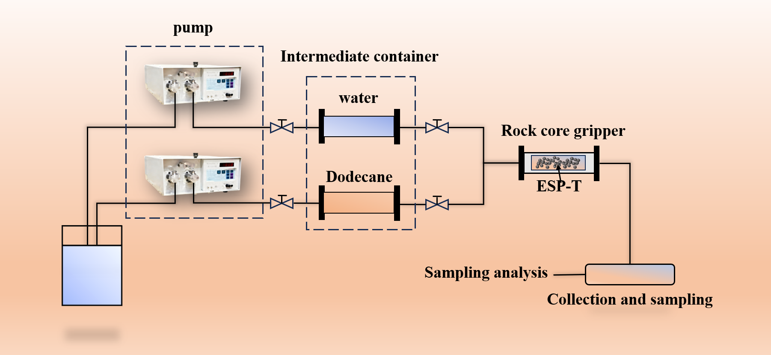
Figure 2. Dynamic displacement apparatus for single-phase and two-phase core flooding experiments.

3. Results and Discussion

3.1 ESP-T Proppant Characterization
SEM micrographs (Figure 3) confirm that ESP-T microspheres exhibit excellent sphericity (>0.9) with no inter-particle agglomeration. The surface displays uniformly distributed micron-scale protrusions corresponding to nano-Fe₃O₄@SA nanoclusters embedded within the epoxy matrix; the absence of interfacial cracks between the nanoclusters and the epoxy is consistent with physical adhesion, likely mediated by stearic acid alkyl chain entanglement with the epoxy network. Elemental mapping (Figure 3) confirms that Fe is distributed throughout the particle cross-section, consistent with bulk encapsulation rather than surface-only attachment. Optical micrographs at 40×–200× (Figure S3) corroborate the regular spherical morphology and dispersed nanocluster distribution.
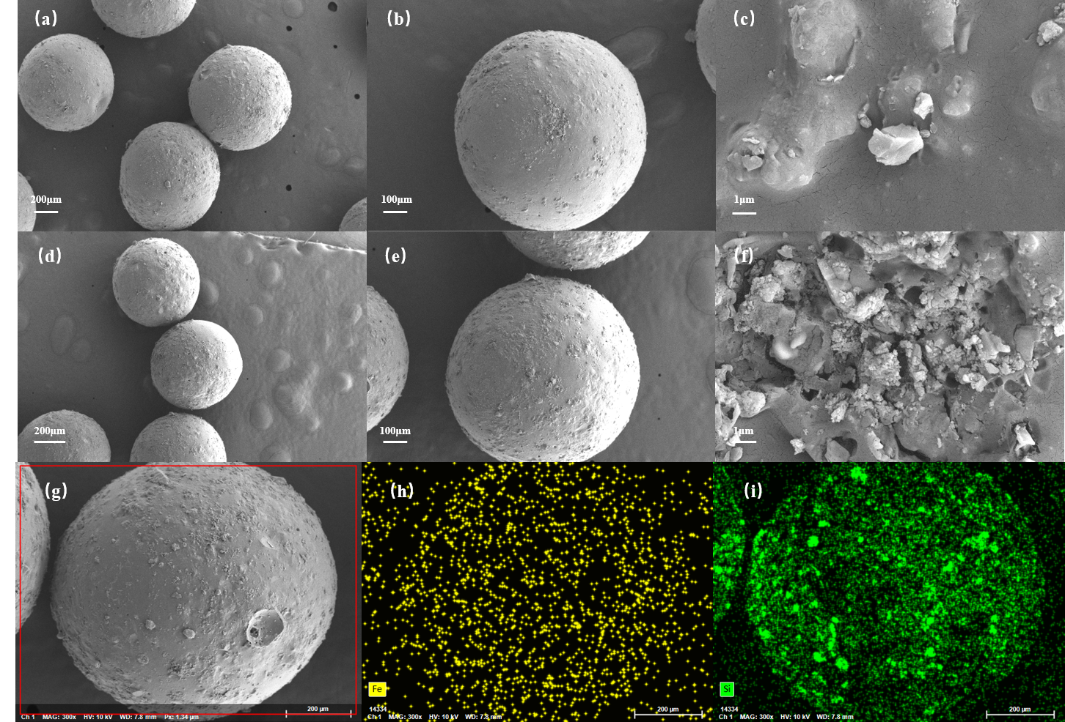

Figure 3. SEM and EDS characterization of ESP-T. (a,d) Overview. (b,e) Single microsphere. (c,f) Surface detail. (g) Cross-section. (h) Fe map. (i) Si map.
TGA/DSC analysis (Figure 4) identifies the primary epoxy decomposition at 374.0 °C (DTG peak), with only 10.5% mass loss below 350 °C attributable to adsorbed moisture and residual solvent. This thermal stability far exceeds typical downhole temperatures (80–200 °C). Stearic acid modification increases the WCA from 72.3° (pure epoxy, weakly hydrophilic) to 104.6° (ESP-T, hydrophobic; Figure 4), driven by outward orientation of stearic acid alkyl chains coordinated to nano-Fe₃O₄@SA surface hydroxyls. This oleophilic character is essential for selective oil-phase tracer release in two-phase production environments.
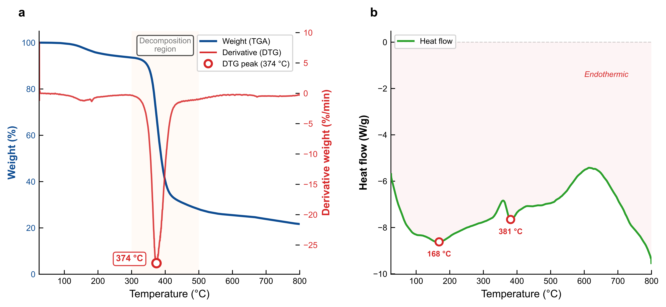
Figure 4. TGA/DTG and DSC curves of ESP-T (N₂, 20 K/min). (a) Weight loss and derivative thermogravimetry. (b) Heat flow.
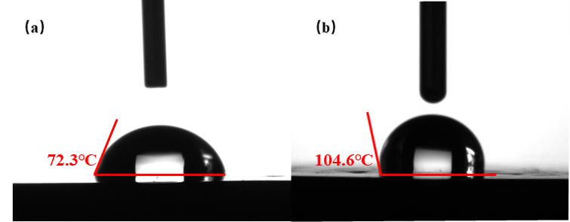
Figure 5. Water contact angle of (a) pure epoxy (72.3deg) and (b) ESP-T (104.6deg).
ESP-T exhibits a bulk density of 0.646 g/cm³ (<1.0 g/cm³, enabling self-suspension in water-based fracturing fluids), sphericity and roundness >0.9 (Krumbien-Sloss chart), acid solubility of 3.3% (well below the 5% threshold per SY/T 5107–2016), and a crush rate of 2.9% at 52 MPa (comparable to pure epoxy microspheres at 2.6%). The slight crush-rate increase is attributable to hollow glass microspheres rather than matrix degradation. Complete physical property data are provided in Table S4. Packed-bed filtration tests (Figure 6) demonstrate the functional consequence of the oleophilic surface: ESP-T reduces oil passage time by 66% relative to pure epoxy (5 min 11 s vs. 15 min 11 s) while increasing water passage time nearly tenfold (28 min 41 s vs. 2 min 53 s). This water-resistant, oil-permeable characteristic means the proppant pack inherently favors oil flow while restricting water, providing passive water-cut mitigation.
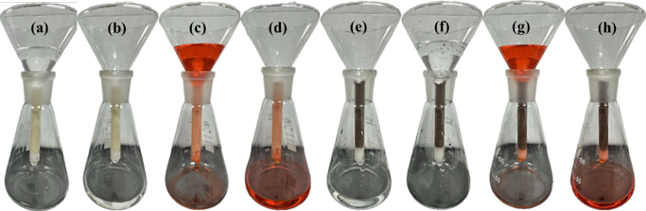
Figure 6. Oil-water permeability test of epoxy resin microspheres and ESP-T
(a)(b) before and after water passing through epoxy resin microspheres, (c)(d) before and after oil passing through epoxy resin microspheres, (e)(f) before and after water passing through ESP-T, (g)(h) before and after oil passing through ESP-T.

3.2 Temperature-Dependent Tracer Release Kinetics
Tracer release from ESP-T in dodecane was measured at 30, 60, 90, and 120 °C (Figure 7a). Release accelerates with temperature throughout the 14-day measurement period; the rate is highest during the first 24 h and decays gradually thereafter (Figure 7c). The K-P model was fitted within its validated range (Mt/M∞ < 0.6; Figure 7b, Table 1). The rate constant K increases systematically from 0.0277 (30 °C) to 0.0982 (120 °C), and all n values fall within 0.45–0.85 (R² > 0.94 at every temperature), corresponding to anomalous (non-Fickian) transport co-governed by Fickian diffusion and Case-II polymer relaxation. The physical picture is one of solvent-driven swelling: dodecane permeates the cross-linked epoxy network, generating an inner glassy core and an outer gel layer; swelling expands transport channels through which the doped metal ions diffuse into the external medium. These kinetic parameters characterize the release mechanism independently of any flow configuration. In Section 3.3, the non-Fickian transport regime identified here will be corroborated by the Peclet number independently obtained from breakthrough curve analysis.
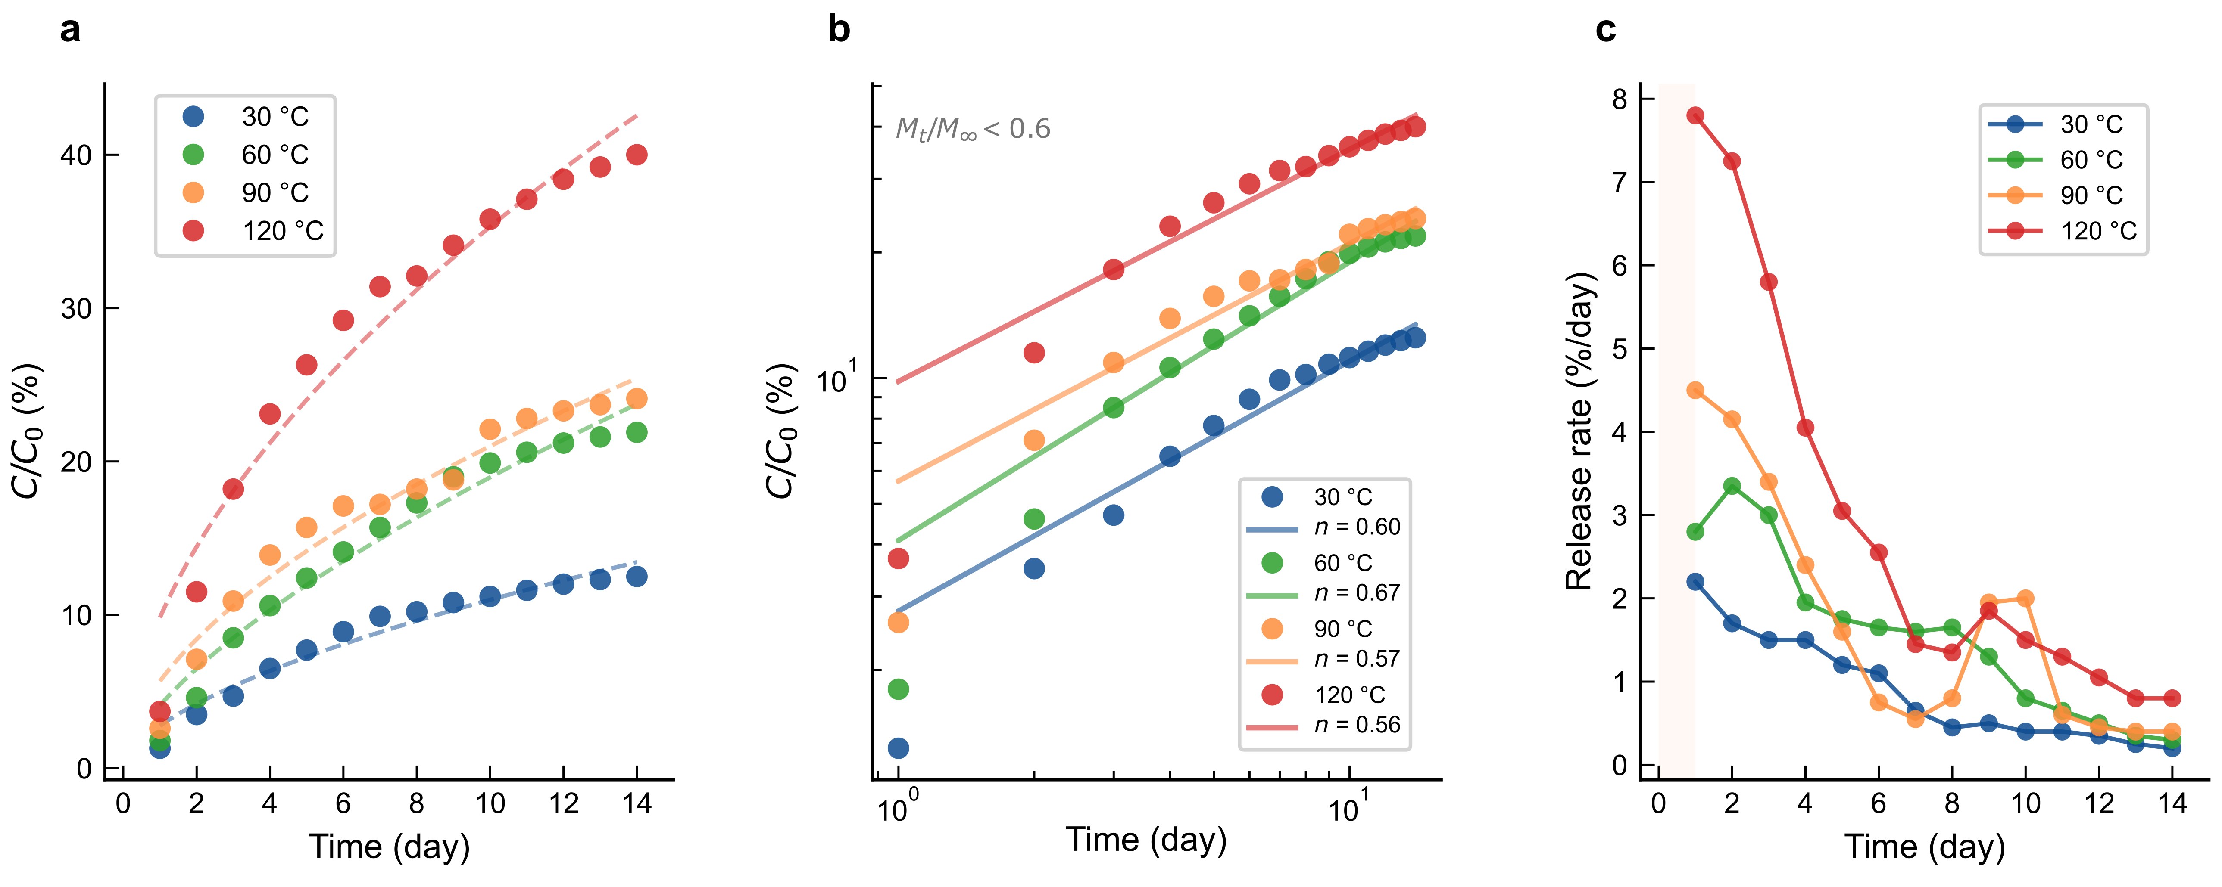
Figure 7. Temperature-dependent tracer release kinetics. (a) Normalized concentration with K-P model fits (dashed). (b) Log-log K-P fits, Mt/M∞ < 0.6. (c) Instantaneous release rate.
Table 1. Korsmeyer-Peppas model fitting parameters at four temperatures (Mt/M∞ < 0.6).
K-P model |  | C/C₀ =Kt^{n}
Fit parameters |  | release temperature
 | 30°C |  | 60°C | 90°C | 120°C
R² | 0.95489 |  | 0.9649 | 0.95599 | 0.94537
K | 0.05538 |  | 0.08177 | 0.11344 | 0.19642
n | 0.59827 |  | 0.66646 | 0.5684 | 0.55569

3.3 Piecewise ADE Modeling of Tracer Breakthrough Curves

Model formulation
A tracer BTC obtained after an extended shut-in reflects two physically distinct processes. Process I (shut-in accumulation slug): during the 96 h shut-in, tracer continuously diffuses from the epoxy matrix into the proppant pack and the near-wellbore region. When the well opens, this accumulated tracer is swept toward the sampling point as a coherent slug, producing a Gaussian-shaped concentration peak. Process II (sustained matrix-diffusion-controlled release): after the main slug has passed, residual tracer continues to diffuse out of the epoxy matrix at a much lower but persistent rate, feeding a slowly decaying concentration tail into the produced oil. These two contributions overlap in time: the tail begins before the pulse has fully passed, and neither can be isolated by visual inspection of the concentration curve alone. A mathematical model capable of separating them is therefore required.

Governing equations.
Tracer transport in the production tubing is governed by the one-dimensional ADE:
∂C/∂t + v·∂C/∂x = D·∂²C/∂x²
where C is the tracer concentration, v = 4Q/(πd²) is the cross-section-averaged flow velocity (Q = volumetric flow rate, d = tubing inner diameter = 5 mm), and D = α·v is the longitudinal dispersion coefficient (α = longitudinal dispersivity). For an instantaneous pulse injection of mass M at x = 0 and t = 0 with boundary condition C(±∞, t) = 0, the classical solution is:
C(x, t) = (M/A)·(1/√(4πDt))·exp(−(x − vt)²/(4Dt))
In this solution, concentration depends on x, v, D, and t only through a single dimensionless similarity variable, η = (x − vt)/√(4Dt), which represents the signed distance from the concentration peak normalized by the dispersion width. Substituting the tube-flow relations for v and D, and multiplying numerator and denominator by πd² to eliminate the fractional form, yields our working dimensionless distance variable z:
z = (xπd² − 4Qt) / √(16αQtπd²)
Here z = 0 marks the convective front (concentration peak), with z > 0 in the post-peak decay regime and z < 0 on the rising limb. The numerator (xπd² − 4Qt) is the spatial offset from the peak, and the denominator √(16αQtπd²) captures dispersion broadening that grows as √t.

Two-component model.
Motivated by the two-process physical picture, we express the BTC as the weighted sum of a Gaussian rise component (Process I) and an erfc fall component (Process II):
C_{rise}(t) = c_{b} + (A·d) / √(16παQt·d²) × exp(−z²)
C_{fall}(t) = c_{b} + (a/2) × erfc(−z)
where cb is the baseline (tail-plateau) concentration, A is the pulse amplitude coefficient representing the total tracer mass accumulated during shut-in, and a is the tail amplitude coefficient representing the sustained-release source strength. The two components are blended through a tanh weight function that provides C¹ continuity (continuous first derivative) across the transition, which is essential for gradient-based optimization:
w(t) = ½[1 + tanh((t₀ − t) / σ)]
C(t) = c_{b} + w(t)·C_{rise}(t) + [1 − w(t)]·C_{fall}(t) (Eq. 1)
The transition center t₀ marks the crossover from Gaussian-dominated to erfc-dominated behavior. The transition width σ was fitted to 3.96 min, approximately equal to the 4-min sampling interval, providing a physically motivated regularization. As t ≪ t₀, w → 1 and C → C_{rise} (Gaussian dominant); as t ≫ t₀, w → 0 and C → C_{fall} (erfc dominant); in the transition region (t ≈ t₀, width ≈ 8–10 min), the two signals mix smoothly. A hard piecewise switch (C = C_{rise} for t < t₀, C = C_{fall} for t ≥ t₀) would produce a non-differentiable kink at t₀, compromising gradient-based optimization; the tanh transition resolves this while remaining physically plausible—there is no instantaneous switch between the two release mechanisms.
Equation (1) contains seven parameters: cb, A, a, α, Q, t₀ (free) and σ (fitted), reducing the effective fitting dimension to six. Table 3 lists the physical meaning, units, and bounds of each parameter. From the fitted parameters, four derived transport properties are computed: Peclet number Pe = x/α, mean flow velocity v = 4Q/(πd²), mean residence time MRT = x/v, and the Gaussian/erfc integrated signal fractions obtained by numerically integrating the separated components. Parameters were estimated by differential evolution followed by L-BFGS-B refinement (SciPy 1.11), minimizing the sum of squared residuals. The same protocol was applied to all candidate models.
Table 3. Fitted parameters of the piecewise ADE model (Eq. 1) and derived transport properties.
Parameter | Symbol | Value | Units
Baseline concentration | c_{b} | 0.0459 | —
Pulse amplitude | A | 2334 | —
Tail amplitude | a | 0.431 | —
Dispersivity | α | 107.1 | cm
Flow rate | Q | 0.46 | mL/min
Transition center | t₀ | 25.66 | min
Transition width | σ | 3.96 | min
Peclet number | Pe = x/α | 0.934 | —
Mean flow velocity | v = 4Q/(πd²) | 2.59 | cm/min
Mean residence time | MRT | 37.4 | min
1 Pore volume | 1 PV | 38.6 | min
Gaussian pulse fraction | — | 53 | %
erfc tail fraction | — | 47 | %

Model selection
The dual-component model achieves R² = 0.9939 (RMSE = 0.0210; Figure 8a). The fitted parameters are listed in Table 3. Four simpler single-component models—single Gaussian, single erfc, exponential decay, and K-P power law—were fitted to the same dataset using the identical optimization protocol (Figure 9a, Table 4). Each captures one feature of the BTC at the expense of the other: the Gaussian fits the peak (R² = 0.948) but misses the tail entirely; the erfc captures the tail (R² = 0.716) but cannot reproduce the peak. Model selection statistics decisively favor the dual-component formulation: ΔAICc = 32.7 versus the single Gaussian, and an F-test decisively rejects the simpler model (F(3, 14) = 34.70, p < 10⁻⁶; Table 4, Figure 9b).
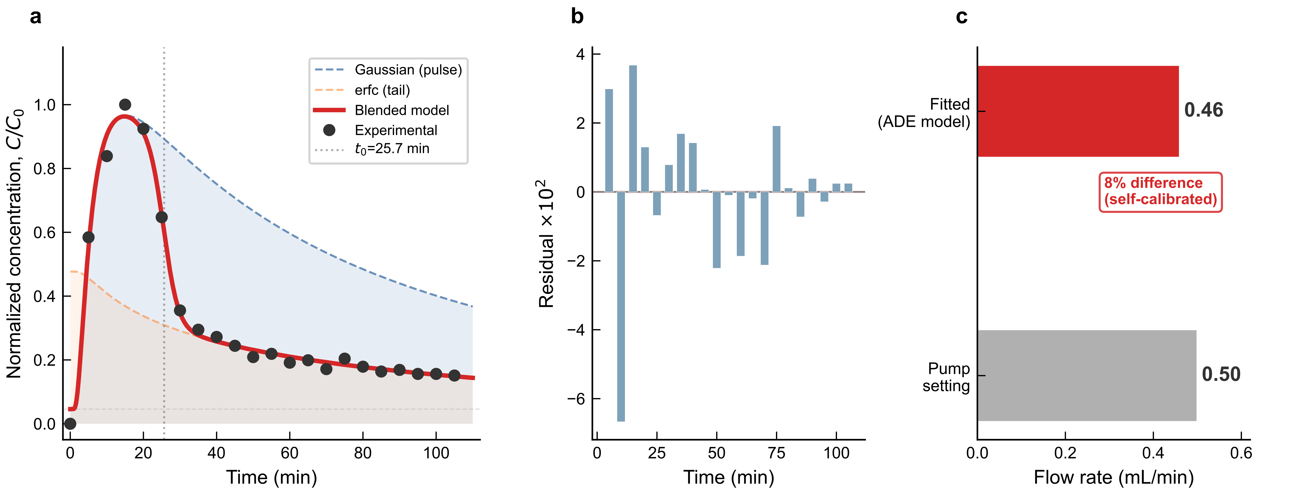
Figure 8. Breakthrough curve fitting. (a) Dual-component model (R² = 0.9939) with component decomposition. (b) Residuals. (c) Flow rate self-calibration.

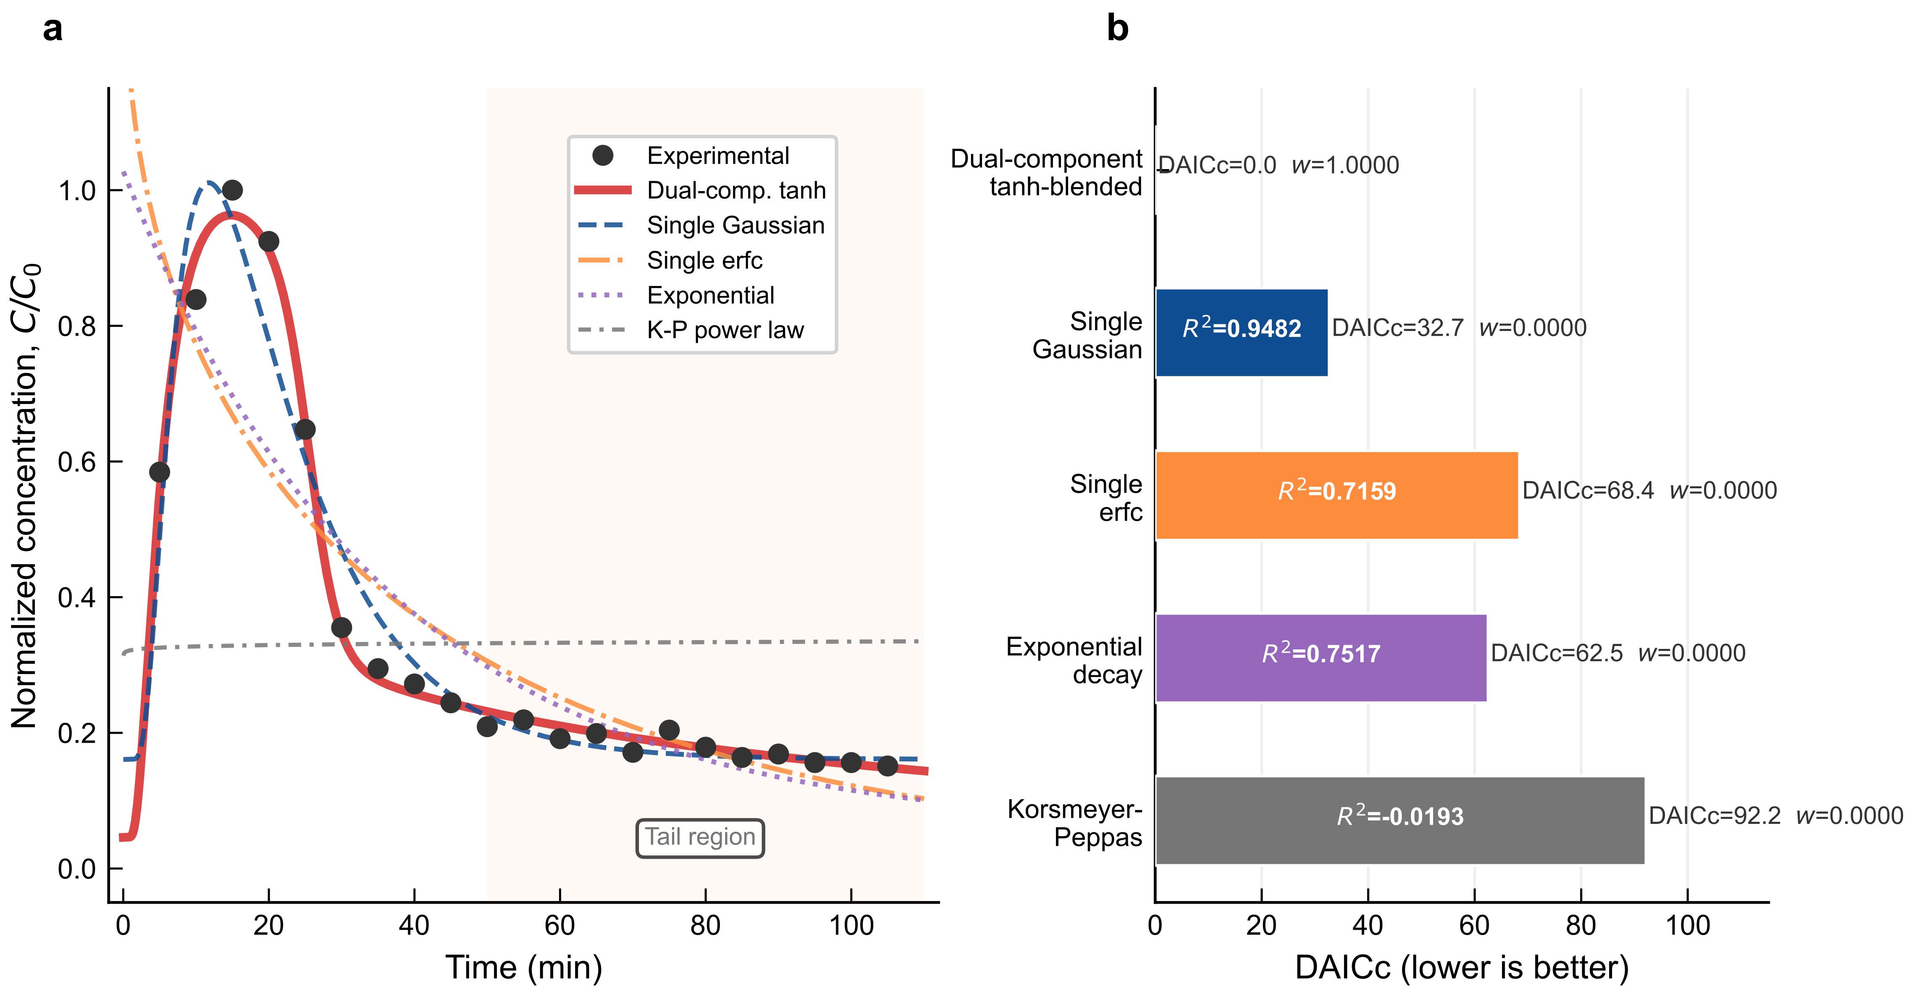
Figure 9. Model selection. (a) Five candidate model fits. (b) ΔAICc comparison (F(3,14) = 34.70, p < 10⁻⁶).
Table 4. Model selection statistics for breakthrough curve fitting (N = 21 data points).
Physical consistency
Model | k | R² | RMSE | AICc | ΔAICc | Weight
Dual-component tanh-blended | 7 | 0.9939 | 0.0210 | −139.70 | 0.00 | 1.000
Single Gaussian | 4 | 0.9482 | 0.0609 | −107.04 | 32.66 | <10⁻⁴
Single erfc | 4 | 0.7159 | 0.1427 | −71.28 | 68.42 | <10⁻⁴
Exponential decay | 3 | 0.7517 | 0.1334 | −77.20 | 62.51 | <10⁻⁴
Korsmeyer-Peppas | 3 | −0.0193 | 0.2703 | −47.54 | 92.16 | <10⁻⁴
Beyond statistical fit quality, the model is validated through physical self-calibration. First, the fitted flow rate Q = 0.46 mL/min agrees with the independently set pump rate of 0.50 mL/min within 8% (Figure 8c)—an accuracy sufficient for diagnosing underperforming stages in field operations. Critically, Q is not constrained in the objective function and is recovered purely from the concentration data. Second, the fitted mean residence time MRT = 37.4 min matches the calculated convective travel time x/v = 38.6 min within 3%. Third, the Peclet number Pe = x/α = 0.934 ≈ 1 indicates that convection and dispersion contribute approximately equally—a signature of gradual, balanced transport. The practical implication is that simple peak-time methods—which assume piston-like displacement—systematically overestimate flow rates (see Section 3.3, Time-of-Arrival Comparison), and field sampling protocols must account for dispersive spreading. This is independently consistent with the non-Fickian transport mechanism (n = 0.45–0.85) identified via K-P kinetics (Section 3.2): two entirely independent methods converge on the same physical picture.

Comparison with time-of-arrival methods
A natural question is whether the full six-parameter ADE model (Eq. 1) is necessary, or whether simpler time-of-arrival (TOA) methods—which require no optimization—could suffice for estimating the per-interval flow rate Q. We evaluated three TOA approaches against the same single-phase BTC dataset (Figure 10).

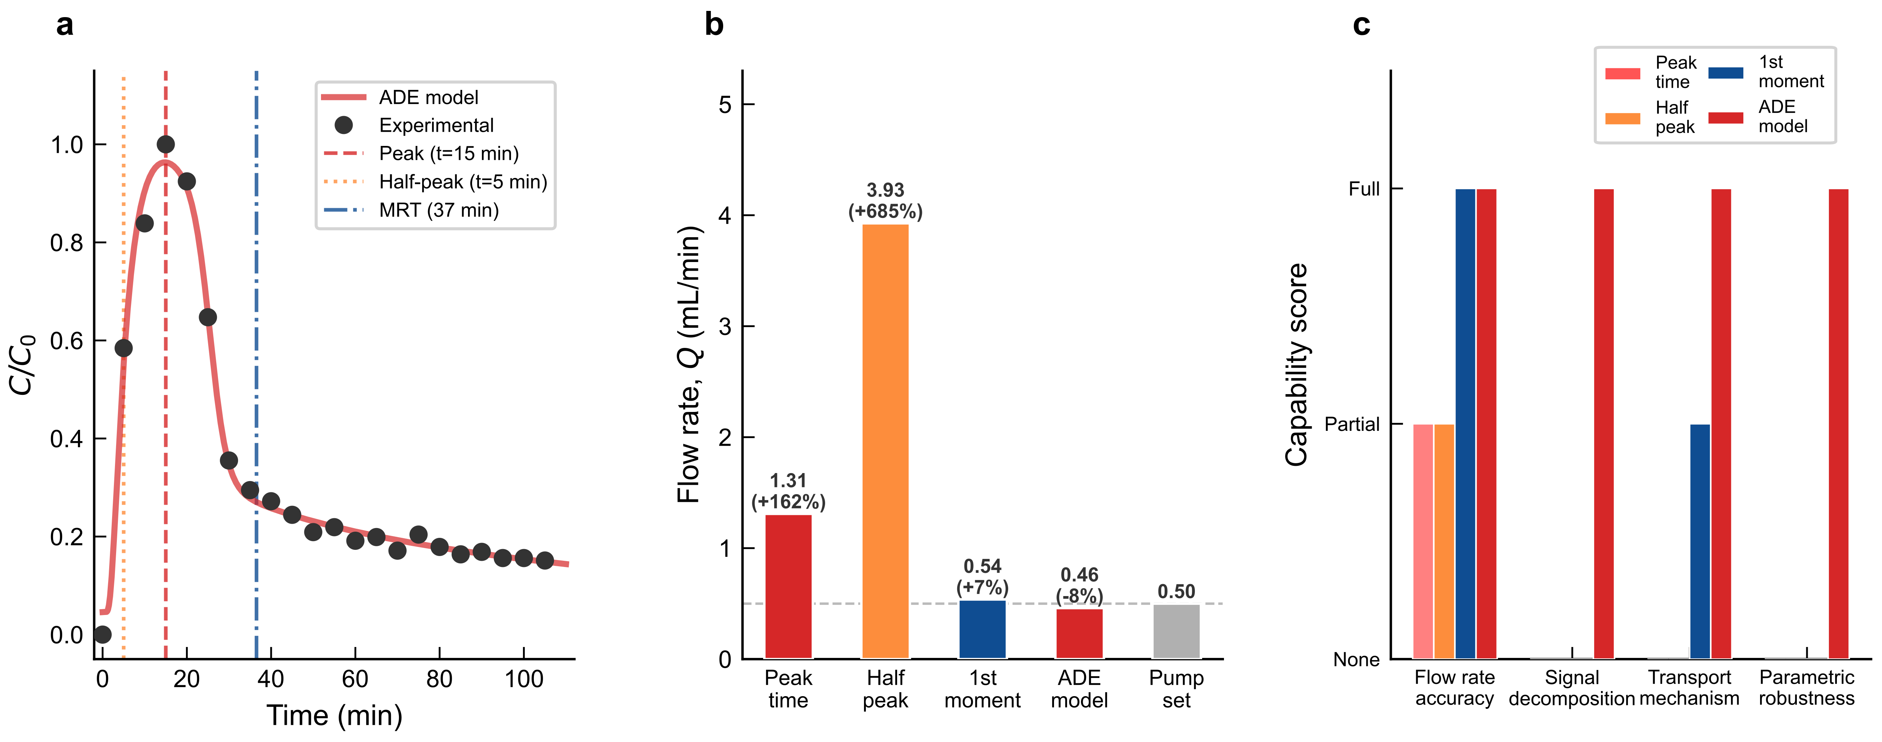
Figure 10. Time-of-arrival comparison. (a) BTC with peak, half-peak, and MRT markers. (b) Estimated flow rates. (c) Method capability comparison.
Peak-time method. The simplest approach assumes that the convective front arrives at the sampling point when the concentration reaches its maximum: Q = xπd²/(4·tpeak). Applying this to the measured BTC (tpeak = 15 min) yields Q = 1.31 mL/min, overestimating the pump setting (0.50 mL/min) by 162%. This gross overestimate arises because dispersive spreading shifts the apparent peak earlier than the true convective arrival: the peak reflects the maximum of the slug, not its centroid, and the sustained tail further distorts the concentration envelope.
Half-peak method. Using the time at which the concentration reaches half its maximum (t_{half} ≈ 5 min) gives Q = 3.93 mL/min (error = +685%), still substantially inaccurate because the rising limb is similarly affected by dispersion.
First-moment method. Computing the mean residence time from the first moment of the BTC, MRT = ∫t·C dt / ∫C dt = 37.1 min, and converting via Q = xπd²/(4·MRT) yields Q = 0.53 mL/min (error = +5.8%). The first-moment method benefits from using the entire BTC rather than a single point, and its accuracy is substantially better than the peak-time approach. However, the first moment conflates the shut-in slug and the sustained tail into a single number—it provides no decomposition, no mechanistic insight into the relative contributions of the two release processes, and no self-calibration capability beyond the MRT.
Full ADE model. The six-parameter piecewise model (Eq. 1) achieves the best Q estimate (error = −8%) while simultaneously decomposing the BTC into its Gaussian (53%) and erfc (47%) components over the measurement window, providing the Peclet number (Pe = 0.934) for mechanistic interpretation, and demonstrating robustness through the σ sensitivity analysis (see Signal decomposition and robustness in Section 3.3). Figure 10 summarizes this comparison: the ADE model uniquely combines flow-rate accuracy, signal decomposition, mechanistic insight, and parametric robustness.

Signal decomposition and robustness
Separating the fitted curve (Eq. 1) into its two components (Figure 8a) reveals that the erfc tail accounts for approximately 47% of the tracer signal integrated over the 105-min measurement window, with the Gaussian pulse contributing 53%. This decomposition is a property of the model rather than a direct measurement; its physical interpretation rests on the assumption that the BTC reflects two identifiable processes. This implies that nearly half of the tracer detected at the wellhead originates not from the shut-in accumulation slug, but from sustained, ongoing release during the production period. To verify that this decomposition is not an artifact of the chosen transition width, σ was varied from 1.98 to 11.89 min (a six-fold range, 0.5×–3.0× the fitted value of 3.96 min) while holding the other six parameters fixed (Figure 11, Table 5). The erfc tail contribution varies by less than one percentage point across the entire scan range (46.8–47.5%), confirming that the ~47% result is robust to the choice of σ. This robustness, combined with the statistical necessity of the two-component structure (see Model selection and physical validation in Section 3.3), establishes the signal decomposition as a physically meaningful—rather than parametrically tuned—feature of the model.

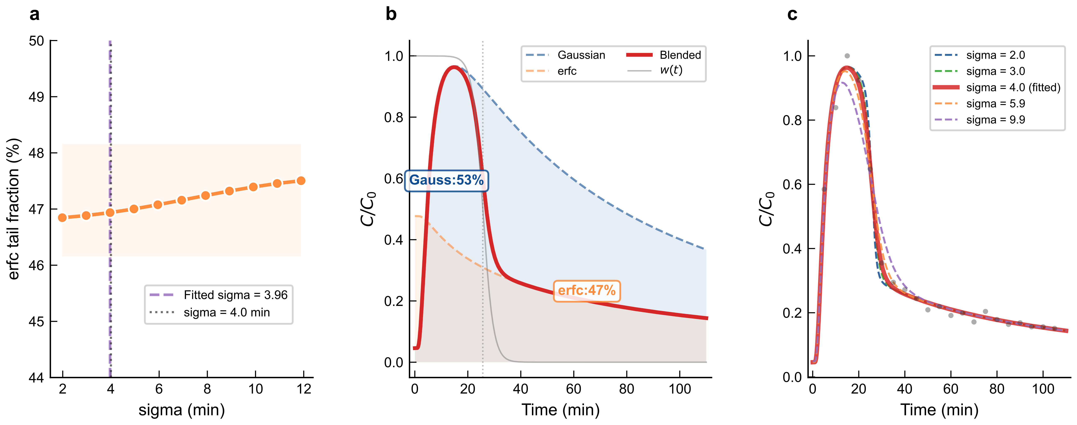
Figure 11. Transition-width sensitivity. (a) erfc tail fraction vs. σ (0.5×–3.0× fitted). (b) Component decomposition at σ = 3.96 min. (c) BTCs at five σ values.
Table 5. Sigma sensitivity analysis: erfc tail fraction vs. transition width over a six-fold range.
σ multiplier | σ (min) | Gaussian (%) | erfc tail (%)
0.5× | 1.98 | 52.5 | 47.5
0.75× | 2.97 | 52.7 | 47.3
1.0× (fitted) | 3.96 | 52.8 | 47.2
1.25× | 4.95 | 53.0 | 47.0
1.5× | 5.94 | 53.1 | 46.9
1.75× | 6.94 | 53.2 | 46.8
2.0× | 7.93 | 53.2 | 46.8
2.25× | 8.92 | 53.2 | 46.8
2.5× | 9.91 | 53.2 | 46.8
2.75× | 10.90 | 53.3 | 46.7
3.0× | 11.89 | 53.3 | 46.7
4.0 min (sampling) | 4.00 | 53.1 | 46.9

Taken together, the results of this section demonstrate that the two-component model recovers physically meaningful parameters from a single breakthrough curve. The dual-component structure is a statistical necessity (ΔAICc = 32.7 relative to the best single-component alternative); the fitted flow rate agrees with the independent pump setting without being constrained in the objective function; the Peclet number independently corroborates the non-Fickian transport regime identified via K-P kinetics (Section 3.2); and the ~47% erfc tail contribution is stable under variation of the transition-width parameter. The sustained-release fraction has a practical implication: nearly half of the tracer detected at the wellhead originates from ongoing matrix-diffusion-controlled release rather than from the initial shut-in accumulation slug, suggesting that a single shut-in can support monitoring over an extended production period.

3.4 Two-Phase Flow Production Allocation via Tracer Flux
A fractured well does not produce single-phase oil indefinitely. Formation water eventually breaks through, and the oil fraction in the produced fluid varies over time and across stages. The question is whether the analysis developed above, validated on single-phase flow, remains useful when both oil and water move through the proppant pack. We examined this with steady-state core displacement experiments at three oil-water ratios (OWR = 4:1, 1:1, 1:4) and four total flow rates (0.1-0.4 mL/min).
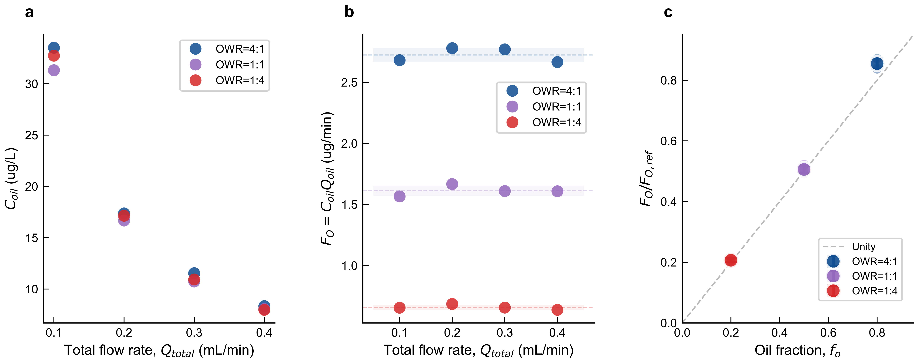
Figure 12. Two-phase flow production allocation. (a) Tracer concentration vs. total flow rate. (b) Oil-phase tracer flux vs. total flow rate. (c) Normalized flux vs. oil fraction (r = 0.97).
Figure 12a plots the tracer concentration against total flow rate for each OWR. Concentration drops as flow rate increases, a straightforward consequence of dilution: at higher flow rates, less time is available for tracer to accumulate in each unit volume of produced fluid. The concentration shows no systematic dependence on OWR, suggesting that oil and water compete for the proppant surface in rough proportion to their volume fractions. Concentration alone is therefore a poor proxy for the production rate of a given stage.
The way around this is to work with tracer flux rather than concentration. We define the oil-phase tracer mass flux as F_{O} = Coil × Qoil. In steady state, F_{O} equals the release rate from the ESP-T pack and therefore strips out the dilution effect, reflecting only what the proppant is actually releasing. Figure 12b confirms this: F_{O} increases with OWR, as expected when more oil contacts the proppant surface, but shows no systematic dependence on total flow rate. The proppant releases tracer at a rate governed by the oil-wetted area, not by how fast fluid sweeps past it.
The critical test is whether F_{O} can be converted into a production rate. Figure 12c normalizes F_{O} from the two-phase experiments by the steady-state F_{O} measured during single-phase oil displacement (F_{O},ref = 3.187 ± 0.15 μg/min, triplicate measurements) and compares the result with the known oil flow rate at each OWR. The agreement is close (Pearson r = 0.97, p = 0.006; RMSD = 8.3%), confirming that per-interval oil production rates can be recovered from F_{O} measurements when the total flow rate is known, even with a water phase present. The primary source of uncertainty is the F_{O},ref reproducibility (±4.7%). We note that the production-rate correlation is based on three OWR conditions (n = 3 independent oil-fraction levels); a larger OWR matrix would strengthen the calibration. Batch-specific F_{O},ref determination is advisable for field deployment.
Several limitations of the present study should be noted. First, the model was validated on a single interval with uniform proppant packing; multi-interval configurations remain untested. Second, the FO calibration used dodecane under steady flow at a single temperature; transient conditions, crude oil, and site-specific thermal effects require dedicated follow-up. Third, the chemical stability of the epoxy matrix in aggressive environments (H₂S, CO₂, high-salinity brines, >120 °C) was not evaluated. Addressing these limitations defines the path from laboratory demonstration to field deployment.
These results suggest an operational pathway toward field deployment, though several validation steps remain. Each fracture stage receives ESP-T particles doped with a distinct metal or rare earth element (e.g., Mn, Zn, Cu, Eu, Dy), producing a unique ICP-MS signature that enables per-stage signal separation. After a single shut-in period, produced fluid is sampled at the wellhead at intervals guided by the expected pulse arrival time predicted by Eq. 1 from the wellbore geometry and the estimated flow velocity. The fitted Q for each stage, converted to an oil production rate via flux normalization, identifies underperforming intervals. Subject to field validation, periodic sampling could track how each stage contribution evolves over time—without requiring downhole tools or additional shut-ins—because the tracer remains in the fracture after a single placement.

4. Conclusions
A method for jointly estimating release and transport parameters from a single tracer proppant breakthrough curve was developed and validated at the laboratory scale. The BTC is decomposed into a Gaussian pulse (shut-in accumulation slug) and an erfc tail (sustained matrix-diffusion-controlled release), connected by a smooth tanh transition; six parameters are estimated simultaneously by nonlinear least squares. Applied to single-phase core displacement data from an oleophilic epoxy/Fe₃O₄ tracer proppant (ESP-T), the two-component model is strongly preferred over four single-component alternatives (ΔAICc = 32.7, F-test p < 10⁻⁶, R² = 0.9939). The fitted flow rate (0.46 mL/min) agrees with the independent pump setting (0.50 mL/min) within 8% without being constrained in the objective function, confirming that the model extracts physically meaningful transport parameters from the BTC shape. The Peclet number (Pe = 0.934) independently corroborates the non-Fickian transport regime identified via K-P kinetics (n = 0.45–0.85). The erfc tail accounts for 47% of the integrated tracer signal, a result stable to within ±0.8% across a six-fold variation in the transition width.
Under steady-state two-phase flow, the oil-phase tracer mass flux eliminates the dilution artifact inherent in concentration-based interpretation and tracks oil production rates across oil-water ratios from 4:1 to 1:4 (Pearson r = 0.97, RMSD = 8.3%). Simple time-of-arrival methods are inadequate for this class of BTCs (errors +162% to +685%).
The present study is limited to single-interval, laboratory-scale experiments with dodecane as the model oil. Extending the framework to field conditions requires validation under multi-interval configurations, crude oil, transient flow, elevated temperature, and aggressive fluid environments (H₂S, CO₂, high-salinity brines). The co-precipitation synthesis accommodates a range of transition metals and rare earth elements for multi-stage tracer coding; combined with the transport analysis framework, this provides a pathway to per-stage production allocation in multi-fractured horizontal wells—requiring no downhole tools and only a single shut-in.

References
[1] IEA. World Energy Outlook 2024. Paris: International Energy Agency, 2024.
[2] BP. bp Energy Outlook 2024. London: BP p.l.c., 2024.
[3] WANG L, TIAN Y, YU X, et al. Advances in improved/enhanced oil recovery technologies for tight and shale reservoirs. Fuel, 2017, 210: 425-445.
[4] MONTGOMERY S L, JARVIE D M, BOWKER K A, et al. Mississippian Barnett Shale: Gas-shale play with multi-trillion cubic foot potential. AAPG Bulletin, 2005, 89(2): 155-175.
[5] KING G E. Thirty years of gas shale fracturing: What have we learned? SPE 133456, SPE ATCE, Florence, Italy, 2010. https://doi.org/10.2118/133456-MS
[6] CIPOLLA C L, WALLACE J. Stimulated reservoir volume: A misnomer? SPE 168596, SPE HFTC, The Woodlands, TX, 2014. https://doi.org/10.2118/168596-MS
[7] XU Y, DONG Y, ZHAO L, et al. Effects of uneven proppant distribution in multiple clusters of fractures on fracture conductivity. Scientific Reports, 2025, 15: 10245.
[8] YUE M, ZHU W, GOU F, et al. Impacts of proppant distribution on development of tight oil reservoirs with threshold pressure gradient. Petroleum Science, 2024, 21(1): 445-460.
[9] HILL A D, ZHU D. Production Logging: Theoretical and Interpretive Elements. 2nd ed. Richardson: SPE, 2021.
[10] MOLENAAR M M, HILL D J, WEBSTER P, et al. First downhole application of distributed acoustic sensing for hydraulic-fracturing monitoring and diagnostics. SPE Drilling & Completion, 2012, 27(1): 32-38. https://doi.org/10.2118/140561-PA
[11] JIN G, ROY B. Hydraulic-fracture geometry characterization using low-frequency DAS signal. The Leading Edge, 2017, 36(12): 975-980.
[12] MAXWELL S C. Microseismic hydraulic fracture imaging: The path toward optimizing shale gas production. The Leading Edge, 2011, 30(3): 340-346.
[13] PATIDAR A K, JOSHI D, DRISTANT U, et al. A review of tracer testing techniques in porous media. Journal of Petroleum Exploration and Production Technology, 2022, 12(12): 3339-3356.
[14] SANNI M, AL-ABBAD M, KOKAL S, et al. Pushing the envelope of residual oil measurement: A new class of inter-well chemical tracers. Journal of Petroleum Science and Engineering, 2018, 163: 538-545.
[15] WATKINS J W, MARDOCK E S. Use of radioactive iodine as a tracer in water-flooding operations. Journal of Petroleum Technology, 1954, 6(9): 117-124.
[16] FONTALVO E M, OLIVEIRA M C, SCHOEGGL F, et al. Physical interpretation of interwell partitioning tracer tests. Transport in Porous Media, 2025, 152: 21-45.
[17] TIAN W, DARNLEY A, DEMPSEY D. Quantifying fracture interference and production allocation using chemical tracers. SPE 201292, SPE ATCE, Virtual, 2020. https://doi.org/10.2118/201292-MS
[18] YANG H, GUO K, LIN L, et al. Application of micro-substance tracer test in fractured horizontal wells. Journal of Petroleum Exploration and Production Technology, 2024, 14(5): 1235-1246.
[19] ARSHAD W, BROHI I, POONIWALA S. Changing the status quo: First application of novel tracer technology for monitoring hydraulic fracture stage contribution. IPTC 23916, Dhahran, Saudi Arabia, 2024. https://doi.org/10.2523/IPTC-23916-MS
[20] AL RAISI O, AL YAARIBI A, KURNIADI S D. Integration of fracturing memory PLT with multistage smart tracer program for stimulation and flowback efficiency assessment. SPE 214827, SPE ATCE, San Antonio, TX, 2023. https://doi.org/10.2118/214827-MS
[21] ZHAO B, PANTHI K, MOHANTY K K. Tracer eluting proppants for hydraulic fracture characterization. Journal of Petroleum Science and Engineering, 2020, 190: 107048.
[22] ZHOU Y, LIU H, GAO J, et al. Coated proppants with self-suspension and tracer slow-release functions. Journal of Petroleum Science and Engineering, 2022, 208: 109645.
[23] LI N, CHENG Q, GONG Z, et al. Release kinetics of rare earth tracer from polymer-coated proppants. Geoenergy Science and Engineering, 2023, 227: 211782.
[24] GONG Z, LI N, KANG W, et al. Novel oleophilic tracer-slow-released proppant for monitoring the oil production contribution. Fuel, 2024, 364: 130945.
[25] FILEV M, KULIKOV A, BANNIKOV A, et al. Technology for determining the inflow from near and far zones of fractures by chemical tracers. IPTC 21357, Riyadh, Saudi Arabia, 2022. https://doi.org/10.2523/IPTC-21357-MS
[26] REN J, WANG Y, ZHANG H, et al. Optimizing the preparation of multi-colored dye-tracer proppants for quantitative flowback assessment. Geoenergy Science and Engineering, 2024, 241: 213053.
[27] MALYAVKO E, UPADHYE V, HUSEIN N. Research of operational dynamics of marked proppant transport between hydraulic fractures. SPE 215624, SPE IHFTC, Muscat, 2023. https://doi.org/10.2118/215624-MS
[28] KORSMEYER R W, GURNY R, DOELKER E, et al. Mechanisms of solute release from porous hydrophilic polymers. International Journal of Pharmaceutics, 1983, 15(1): 25-35.
[29] RITGER P L, PEPPAS N A. A simple equation for description of solute release I. Fickian and non-Fickian release. Journal of Controlled Release, 1987, 5(1): 23-36.
[30] PEPPAS N A, SAHLIN J J. A simple equation for the description of solute release III. Coupling of diffusion and relaxation. International Journal of Pharmaceutics, 1989, 57(2): 169-172.
[31] VAN GENUCHTEN M T, ALVES W J. Analytical solutions of the one-dimensional convective-dispersive solute transport equation. USDA Technical Bulletin No. 1661, 1982.
[32] SHOOK G M, POPE G A, ASAKAWA K. Determining reservoir properties and flood performance from tracer test analysis. SPE 124614, SPE ATCE, New Orleans, LA, 2009. https://doi.org/10.2118/124614-MS
[33] VELASCO-LOZANO M, BALHOFF M, DIAZ-PAULINO L, et al. Modeling of chemical tracers for two-phase flow in advective-dominated porous media. SPE Journal, 2024, 29(7): 3718-3731.
[34] MAZO A B, KHAMIDULLIN M R, POTASHEV K A, et al. Mathematical model of water- and oil-soluble tracers transfer in multistage hydraulic fracturing. Fluid Dynamics, 2024, 59(3): 427-443.
[35] LIANG F, SAYED M, AL-MUNTASHERI G A, et al. A comprehensive review on proppant technologies. Petroleum, 2016, 2(1): 26-39.
[36] ZOVEIDAVIANPOOR M, GHARIBI A, BIN JAAFAR M Z. Experimental characterization of a new high-strength ultra-lightweight composite proppant. Journal of Petroleum Science and Engineering, 2018, 170: 1038-1047.
[37] WANG G, MA Q, REN L, et al. A comprehensive review of multifunctional proppants. ACS Omega, 2024, 9(44): 44120-44133.
[38] KRISHNAN M R, LI W, ALHARBI B, et al. In-situ high-strength PS-MMA composite microbeads as potential proppants. Geoenergy Science and Engineering, 2025, 257: 214195.
[39] LI H, LIU Z, LI Y, et al. Evaluation of the release mechanism of sustained-release tracers from epoxy resin matrices. ACS Omega, 2021, 6(29): 19269-19280.
[40] WEI M, WANG Y, DUAN Y, et al. Screening and performance evaluation of epoxy resin long-term sustained-release solid tracer. International Journal of Oil, Gas and Coal Technology, 2024, 36(2): 170-196.
[41] WANG C, LI X, CHENG X, et al. Oilfield sustained-release tracers based on different binding forms and their controlled-release mechanism. Geoenergy Science and Engineering, 2024, 232: 212440.

