Epoxy Resin Microspheres Encapsulating Oleophilic Fe₃O₄ Nanoparticles as Tracer Proppants for Production Allocation

Abstract: Per-interval production monitoring is essential for evaluating stimulation effectiveness in unconventional reservoirs, yet existing tracer technologies lack durable oil-phase monitoring capability. Here we report an oleophilic tracer proppant (ESP-T) fabricated by encapsulating stearic acid-modified nano-Fe₃O₄ (nano-Fe₃O₄@SA) within an epoxy resin matrix via emulsion polymerization. ESP-T exhibits sphericity exceeding 0.9, maintains structural integrity up to 357.27 °C, and the incorporation of nano-Fe₃O₄@SA raises the water contact angle from 72.3° to 104.6°, yielding a water-resistant, oil-permeable transport characteristic. Tracer release at 30–120 °C follows the Korsmeyer–Peppas model (R² > 0.90) with diffusion exponents of 0.45–0.85, indicating synergistic Fickian diffusion and Case-II relaxation. A piecewise advection–dispersion model with tanh blending achieves R² = 0.9939 for single-phase breakthrough curves, and under steady-state two-phase flow, tracer flux quantitatively tracks oil-phase production rates. ESP-T thus integrates fracture propping with long-term production monitoring, offering a dual-function platform for unconventional reservoir management.

Key words: Unconventional oil and gas reservoirs; Hydraulic fracturing; Tracer proppant; Epoxy resin; Fe₃O₄ nanoparticles; Oil production monitoring; Release kinetics

1 Introduction
Sustained growth in global energy demand has positioned unconventional oil and gas resources at the center of contemporary petroleum development ^{[1-5]}. These resources now account for a dominant share of the world's total hydrocarbon reserves ^{[6,7]}, and their efficient development is critical to global energy security. Hydraulic fracturing, the core stimulation technology for unconventional reservoirs, creates artificial fractures that enhance hydrocarbon seepage pathways and substantially boost productivity in low-permeability and tight formations ^{[8]}.

However, the oil production contribution of each fractured interval varies markedly post-stimulation, and interval productivity declines at varying rates as field development proceeds ^{[9]}. Accurate, per-interval production monitoring is therefore essential: it supplies the data needed for reservoir productivity assessment and guides subsequent development strategy optimization, ultimately improving the overall hydrocarbon recovery factor.

Conventional oil-soluble tracers suffer from poor compatibility with fracturing fluid injection and limited long-term monitoring capability ^{[10-14]}. Tracer proppants, composite materials that integrate fracture propping and tracer functions, address these limitations by immobilizing tracers within a solid carrier, enabling long-term dynamic monitoring upon co-injection with fracturing fluids and eliminating the need for separate tracer injection. Zhao et al. ^{[15]} coated rhodamine 6G onto polyvinyl alcohol-modified ceramic particles via solvent evaporation to retard aqueous release. Zhou et al. ^{[16]} encapsulated carbon quantum dots in polyvinyl alcohol-coated ceramic particles for controlled release. Malyavko et al. ^{[17]} employed monodisperse microspheres doped with fluorescent semiconductor nanocrystals functionalized with gas-philic, oleophilic, and hydrophilic polymer coatings to acquire phase-specific production data. Li et al. ^{[18]} encapsulated rare-earth element tracers with ammonium polymethacrylate to elucidate slow-release mechanisms. Gong et al. ^{[19]} embedded tracers into polystyrene (PS) microspheres via suspension polymerization and investigated their controlled-release behavior.

Despite these advances, conventional coated tracer proppants face persistent challenges: high density impedes transport in fracturing fluids; monitoring ceases once the polymer coating dissolves; and pure PS microspheres exhibit inadequate mechanical strength and thermal stability ^{[20-23]}. Epoxy resin, a high-performance polymer with exceptional mechanical strength, thermal stability, and chemical resistance, offers a compelling alternative. Coating proppants with epoxy resin substantially reduces crush rate, improves compressive strength and acid resistance, and retains low-density advantages ^{[24,25]}. However, coating-based approaches remain constrained by uneven coverage, interfacial debonding risks, and complex multi-step preparation. Direct synthesis of epoxy resin microspheres as proppant matrices overcomes these limitations by enabling low-density tailoring, nanoparticle modification, and in-situ tracer encapsulation within a single synthetic step. Li et al. ^{[26]} explored the release of water-soluble tracers from epoxy resin in aqueous media. Wei et al. ^{[27]} encapsulated water-soluble tracers in epoxy matrices to locate water-producing intervals. However, the use of epoxy resin as an oleophilic release matrix for oil-phase production monitoring remains unexplored.

Here we address this gap by designing and synthesizing an oleophilic Fe₃O₄/epoxy resin tracer proppant (ESP-T). Using epoxy resin as the matrix and stearic acid-modified nano-Fe₃O₄@SA as the oleophilic tracer, we achieve stable tracer-carrier integration via emulsion polymerization. We systematically characterize the microstructure, mechanical properties, thermal stability, wettability, and oil-water permeability of ESP-T; investigate its temperature-dependent tracer release behavior and kinetic mechanisms; and validate its oil production monitoring accuracy through single-phase and two-phase core displacement experiments. This work aims to establish a multifunctional proppant platform that combines low-density suspendability, high compressive resistance, and reliable tracing performance for hydraulic fracturing stimulation and long-term productivity monitoring in unconventional reservoirs.

2 Experiments

2.1 Materials
All chemical reagents used in the experiments were of analytical grade or industrial grade and used without further purification. Analytical Grade (AR) reagents, including ethanol (purity ≥99.7%), ferric chloride (FeCl₃, purity ≥99.0%), ferrous chloride tetrahydrate (FeCl₂·4H₂O, purity ≥99.0%), manganese chloride hexahydrate (MnCl₂·6H₂O, purity ≥99.0%), stearic acid (purity ≥99.5%) and silicon dioxide (SiO₂, purity ≥99.99%), were purchased from Chengdu Kelong Chemical Co., Ltd. Industrial grade reagents included guar gum (purity 90%–95%), E51 epoxy resin (epoxy value meeting industrial standards, purity ≥99%), T31 curing agent (effective component content 95%), and hollow glass microspheres (main component purity ≥99%). The detailed specifications and sources of all materials are summarized in Table 2-1.

Table 2-1 Specifications and sources of experimental materials
Reagents | Purity | Manufacturers
Ethanol | Analytical pure | Chengdu Kelong Chemical Co., Ltd
Ferric chloride | Analytical pure | Chengdu Kelong Chemical Co., Ltd
Ferrous chloride tetrahydrate | Analytical pure | Chengdu Kelong Chemical Co., Ltd
Manganese chloride hexahydrate | Analytical pure | Chengdu Kelong Chemical Co., Ltd
Stearic acid | Analytical pure | Chengdu Kelong Chemical Co., Ltd
Silicon dioxide | Analytical pure | Chengdu Kelong Chemical Co., Ltd
Guar gum
E51 type epoxy resin
T31 type curing agent
Hollow glass microspheres

2.2 Fabrication of stearic acid-modified nano-Fe₃O₄ (nano-Fe₃O₄@SA)
A clean three-necked flask was mounted in a thermostatic water bath and connected to nitrogen purge and mechanical stirring apparatuses. The flask was charged with 100 mL deionized water and heated to 80 °C. Upon reaching the target temperature, 2.703 g (0.01 mol) FeCl₃ was added, and the system was purged with nitrogen for 15 min, followed by the introduction of 1.15 g (0.058 mol) FeCl₂·4H₂O and 2×10⁻⁵ mol MnCl₂·6H₂O. After stirring for 10 min, 5.5 mL ammonia solution was rapidly added, and the reaction proceeded at pH 10 for 2 h. Upon completion, the resulting black suspension was transferred to an Erlenmeyer flask and magnetically separated, with the supernatant discarded. The precipitate was washed with anhydrous ethanol under sonication repeatedly until neutral pH, then collected. Finally, the precipitate was blended with an ethanolic stearic acid solution and subjected to sonication for oleophilic modification. After washing, the product was diluted to 100 mL and stored for subsequent use ^{[28]}.
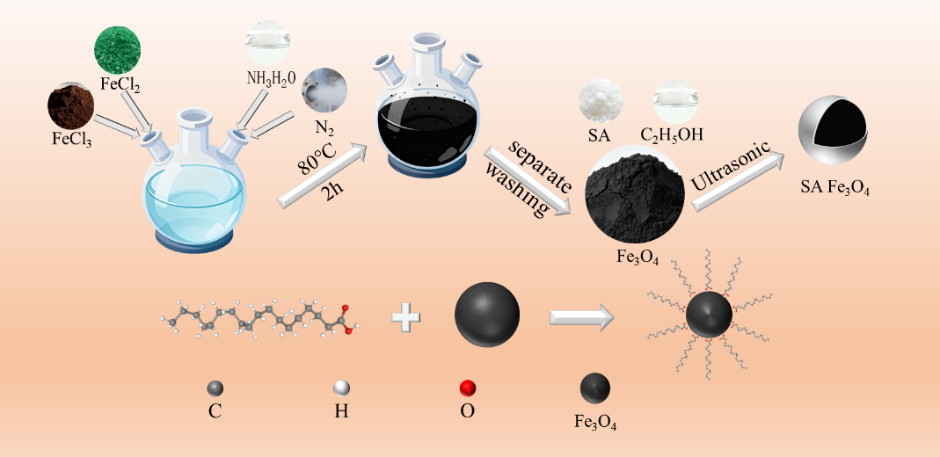
Figure 2-1 Schematic illustration for the preparation of stearic acid-modified metal-doped Fe₃O₄ nanoparticles

2.3 Preparation of Epoxy Resin Microspheres and ESP-T
A SiO₂ aqueous dispersion was prepared by adding 0.3 g of 20 nm SiO₂ to 150 mL deionized water under stirring at 380 RPM. Separately, 0.9 g guar gum and 0.5 g of 45 μm SiO₂ were weighed. An epoxy pre-mixture consisting of 20 mL E51 epoxy resin, 6 g of Fe₃O₄-ethanol mixture, 1 g hollow glass microspheres, and 7 g T31 curing agent was homogenized by manual stirring for 3 min. The pre-mixture was transferred into the SiO₂ dispersion and agitated for 1 min to complete emulsification, followed by the addition of 45 μm SiO₂ and guar gum to stabilize the system. After microsphere formation, the product was cured at 50 °C for 1 h, rinsed with deionized water, and dried at 80 °C for 10 h. For pure epoxy microspheres, 6 g of pure ethanol replaced the Fe₃O₄-ethanol mixture and the guar gum dosage was 0.9 g.

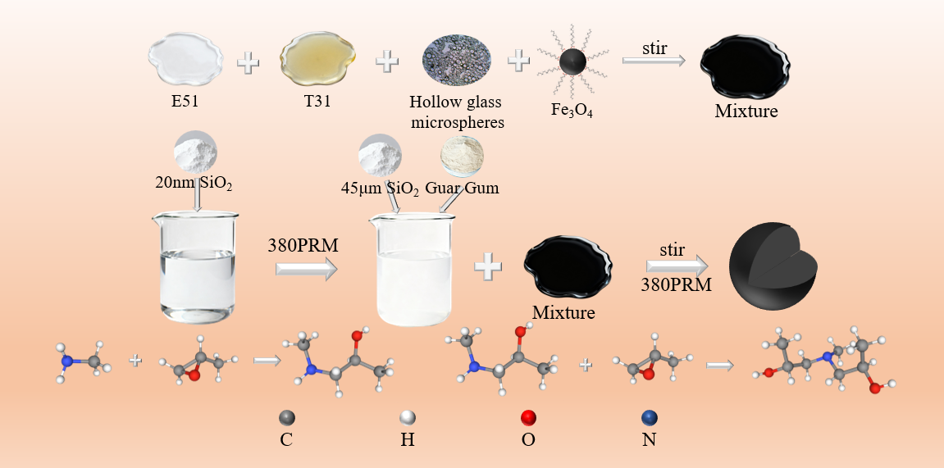
Figure 2-2 Schematic illustration for the preparation of Fe₃O₄-encapsulated epoxy resin proppants

2.4 Characterization Methods
The microstructure, elemental composition and distribution of neat epoxy resin microspheres and ESP-T were analyzed by scanning electron microscopy (SEM, ZEISS-Sigma 500). Samples were sputter-coated with a thin conductive metal layer under vacuum, mounted onto conductive adhesive tape, and observed at magnifications ranging from low power up to 50,000×. Characteristic X-rays were excited by a field-emission electron gun, and two-dimensional elemental mapping was performed over a selected region to visualize the distribution of Fe element in the proppants.

Surface morphology and particle dispersion of neat epoxy resin microspheres and ESP-T were examined using an optical microscope (Leica DM2700P). Thermogravimetric analysis (TGA, TA Instruments Q500, USA) was conducted to evaluate the thermal stability of the two proppants. Tests were performed in an air atmosphere at a heating rate of 10 °C/min over a temperature range of 50–800 °C.

Water contact angle (WCA) measurements were carried out using a video optical contact angle analyzer (OCA20, Germany). Pressed proppant flakes were placed on the test stage, and a 5 μL droplet of deionized water was deposited onto the sample surface. Images were captured after the droplet stabilized, and five replicate measurements were performed for each sample.

The physical and mechanical properties as well as field applicability of the proppants were comprehensively evaluated using roundness, sphericity, bulk density, apparent density, acid solubility, and crush rate. The oil–water conductivity of the proppants was indirectly assessed via filtration time. The bottom of a funnel was blocked with a 200-mesh screen to prevent proppant leakage while allowing water or oil to pass through. A total of 2.0 g of proppant was loaded into the funnel, followed by the addition of 20 mL deionized water or dodecane, and the time required for complete permeation was recorded.

2.5 Tracer Release Behavior at Different Temperatures
Glass vials containing 100 mL dodecane were placed in thermostatic oil baths set at 30 °C, 60 °C, 90 °C, and 120 °C, respectively, followed by the addition of 5 g of 40–70 mesh ESP-T. The vials were then hermetically sealed to prevent dodecane volatilization. Sampling was conducted at 12 h intervals, and the concentration of tracer-doped metal ions in the dodecane medium was quantified via inductively coupled plasma mass spectrometry (ICP-MS, PerkinElmer NexION 300X), from which the time-dependent tracer release curves were plotted.
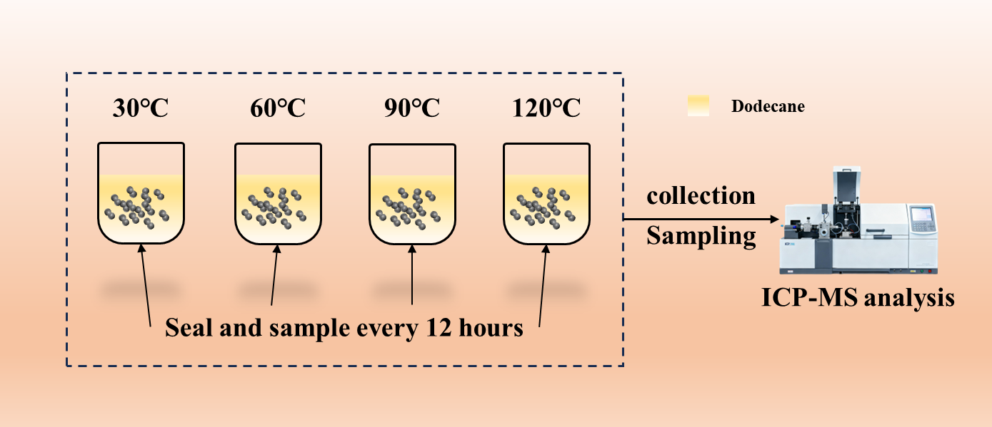
Figure 2-3 Schematic diagram of the tracer release apparatus at different temperatures

2.6 Oil Production Monitoring with ESP-T
For the single-phase oil production monitoring experiment of ESP-T, dodecane was employed to simulate crude oil, with the focus on the steady oil production regime of a single fractured interval. A dynamic displacement apparatus was utilized to mimic the dynamic oil production behavior of horizontal wells, as illustrated in Figure 2-4. First, the pore spaces of a steel core were packed with ESP-T, and both ends of the steel core were sealed with 200-mesh metal screens to prevent proppant migration with the flowing fluid. Subsequently, the proppant-packed steel core was placed into a core holder, and a confining pressure of 5 MPa was applied to simulate reservoir overburden pressure. The inlet of the core holder was connected to a constant-flow pump, and the outlet was linked to a tubing string to replicate the hydraulic fracturing production environment of horizontal wells. Dodecane was then pumped into the system at a flow rate of 5 mL/min until the tubing string was completely saturated with dodecane, after which the displacement was halted and the outlet valve was closed. The system was left undisturbed for 96 h to facilitate sufficient tracer release from ESP-T. Thereafter, dodecane was injected at a flow rate of 0.5 mL/min to displace the fluid within the core, simulating the oil production of the target fractured interval. Sampling was conducted at 4-min intervals, with 2 mL of effluent collected per sample for a total of 20 sets. The concentrations of the labeled elements in the collected samples were quantified via inductively coupled plasma mass spectrometry (ICP-MS).

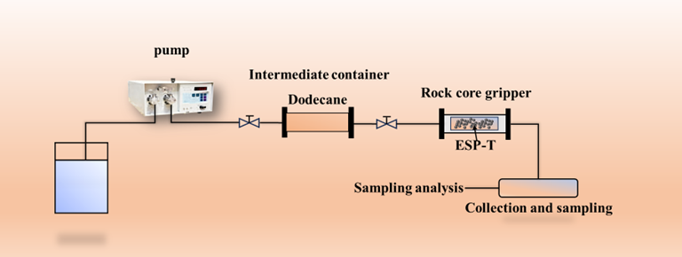
Figure 2-4 Schematic diagram of the single-phase oil flow experimental apparatus

For the oil–water two-phase flow produced fluid monitoring experiment, the tracer was maintained in a stable release regime throughout the steady-flow period (i.e., no well shut-in was implemented during sampling and monitoring, with continuous oil well production sustained). The total two-phase flow rate and oil–water ratio of the displacement fluid were modulated by adjusting the injection rates of dodecane and water, thereby simulating the actual downhole oil–water two-phase flow conditions. The two-phase displacement apparatus is illustrated in Figure 2-5. Three oil–water volume ratios (4:1, 1:1, 1:4) and four total two-phase flow rates (0.1, 0.2, 0.3, 0.4 mL/min) were employed to evaluate the steady-state monitoring performance of the proppant. First, the proppant-packed steel core was placed into a core holder, and a confining pressure of 5 MPa was applied to the system. Subsequently, dodecane and water were co-injected into the core to conduct the flow simulation. Sampling was carried out at 5-min intervals during the multiphase displacement experiment, with 2 mL of effluent collected per sample for a total of 20 sets. The volume ratio of the dodecane phase to the aqueous phase in the collected samples was recorded, and the concentrations of the labeled metal elements were ultimately quantified via inductively coupled plasma mass spectrometry (ICP-MS).

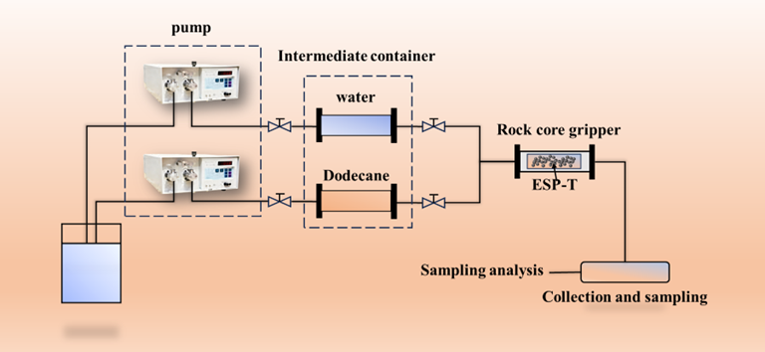
Figure 2-5 Schematic diagram of the oil–water two-phase flow experimental apparatus

3 Results and Discussion

3.1 SEM Characterization
Figure 3-1 presents SEM micrographs of pure epoxy resin microspheres and ESP-T. At low magnification (a, d), both samples show excellent sphericity and high monodispersity, with uniform particle sizes and no inter-particle agglomeration, demonstrating the controllability of the suspension polymerization process. Well-formed spherical microspheres are reproducibly obtained both with and without nano-Fe₃O₄@SA incorporation. Comparing (a) and (d), pure epoxy microspheres feature a relatively smooth surface with minor particulate debris, whereas ESP-T microspheres exhibit a uniformly rough surface topography, confirming incorporation of the nanofiller and its pronounced effect on surface morphology.

At medium magnification (b), pure epoxy microspheres display subtle surface wrinkles and depressions, typical of thermosetting resins, arising primarily from volume shrinkage during epoxy curing. In contrast, ESP-T microspheres (e) are uniformly covered with micro- and submicron-scale convex protrusions. These protrusions exist as well-dispersed island-like structures rather than large agglomerates, confirming that nano-Fe₃O₄@SA disperses as nanoclusters, not as individual nanoparticles, within the epoxy matrix. This morphology demonstrates that stearic acid surface modification effectively suppresses uncontrolled macroscopic phase separation, enabling nanoscale agglomeration with microscale uniformity.

At high magnification, the fine surface microstructure of the microspheres is clearly resolved. Pure epoxy resin microspheres (c) exhibit a relatively dense yet undulating lava-like surface structure, a typical morphological feature of cross-linked epoxy polymer networks. In contrast, ESP-T microspheres (f) display a debris-like surface structure, corresponding to stearic acid-wrapped nanoclusters. The irregular morphology of these nanoclusters stems from the agglomeration of individual nanoparticles and the self-assembly and structural reconstruction of the stearic acid modifier during the epoxy curing process. Notably, no distinct interfacial cracks are observed between these debris-like nanoclusters and the underlying epoxy matrix, with the nanofillers exhibiting an embedded bonding state rather than a simple surface-attached one. This observation indicates that the long alkyl chains of stearic acid form strong physical entanglement and hydrophobic interactions with epoxy resin molecular chains, yielding robust interfacial adhesion between the nanofillers and the epoxy matrix—direct evidence for the successful surface modification of the nanofiller.

These observations suggest the following formation mechanism: the hydrophobically modified nano-Fe₃O₄@SA nanoclusters are uniformly dispersed within epoxy resin droplets after emulsification; as the epoxy cross-linking reaction proceeds, a rigid polymer network forms and immobilizes the nanoclusters in place. During subsequent curing shrinkage, a portion of these nanoclusters is extruded toward the microsphere surface, producing the surface-enriched rough nanostructures observed in Figure 3-1(c) and (f). We note that this mechanism is inferred from post-cure microscopy and does not capture the real-time dynamics of nanocluster migration; in-situ characterization would be required to confirm the kinetic pathway.

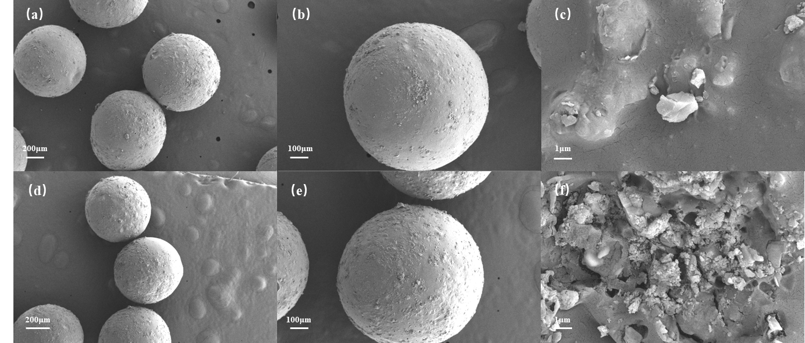
Figure 3-1 SEM images of epoxy microspheres and Fe₃O₄@epoxy proppants. The epoxy microspheres are on the top of the figure, and the Fe₃O₄@epoxy proppants are at the bottom. (a) and (d) are SEM images of multiple whole microspheres, (b) and (e) are SEM images of a single whole microsphere, and (c) and (f) are SEM images of local parts.

SEM elemental mapping (Figure 3-2) visually illustrates the distribution of the primary Fe and Si elements within the proppant. The Fe elemental signal, represented in the yellow mapping image, is dispersed throughout the entire proppant particle, demonstrating the presence of Fe-containing components in the particle’s main matrix and serving as direct evidence for the successful encapsulation of nano-Fe₃O₄@SA within the epoxy resin matrix of the microspheres. Minor inhomogeneities in the Fe signal intensity across the particle indicate a slight non-uniformity in Fe distribution, a phenomenon that may be attributed to the presence of distinct phase domains within the composite. Collectively, these elemental mapping results validate the successful synthesis of the ESP-T proppant.
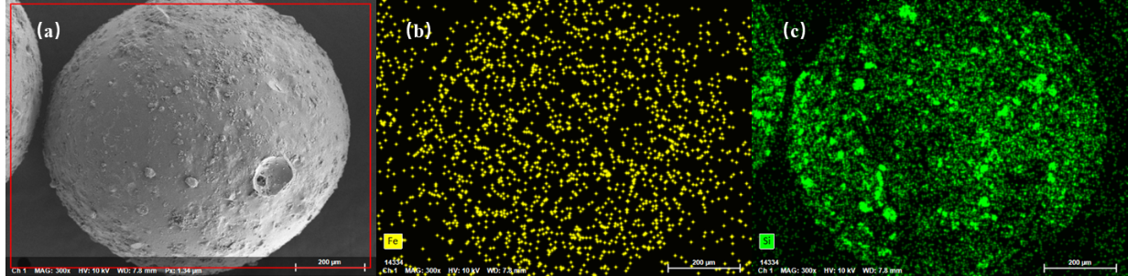
Figure 3-2 Mapping images of Fe₃O₄@epoxy resin proppant. (a) SEM image of Fe₃O₄@epoxy resin proppant, (b) Distribution of Fe element, (c) Distribution of Si element

3.2 Thermal Stability
As depicted in Figure 3-3, thermal analysis of the proppant reveals three distinct decomposition stages. The first stage (50–350 °C) corresponds to a minor weight loss of 5.70%, attributed to the removal of adsorbed surface water and residual ethanol employed as a diluent during synthesis. The second stage (350–400 °C) constitutes the primary thermal decomposition region, arising from cleavage of C–O–C and C–C bonds within the epoxy molecular chains and degradation of the cross-linked network, accompanied by the release of CO₂ and small-molecule hydrocarbons. The DTG curve indicates a maximum weight-loss rate at 357.27 °C, with a mass loss of 72.5%. In the third stage (>400 °C), the residual mass stabilizes; the remaining weight loss originates from oxidative combustion of carbonaceous residues formed in the second stage. The final residue comprises hollow glass microspheres, thermally stable nano-Fe₃O₄@SA, and a minor carbonaceous fraction from epoxy decomposition.

The DSC curve characterizes the endothermic and exothermic behavior of the sample. As bond cleavage during epoxy decomposition is an endothermic process, a distinct endothermic peak appears in the corresponding temperature range. Substantial endothermic decomposition of the epoxy resin initiates at 332.41 °C, peaks at 357.27 °C (corresponding to the maximum decomposition rate and maximum heat absorption), and completes at 371.58 °C. The total endothermic enthalpy of epoxy decomposition is calculated as 99.53 J/g via integration.

The initial decomposition temperature of ESP-T is 357.27 °C, which is far higher than the typical downhole temperature of oil–gas wells (80–150 °C, up to 200 °C for deep wells). Only trace moisture volatilization occurs below 200 °C without any degradation of the epoxy matrix, fully satisfying the thermal stability requirements for long‑term downhole service. This further validates the reliability of ESP-T as a high‑performance fracturing proppant.
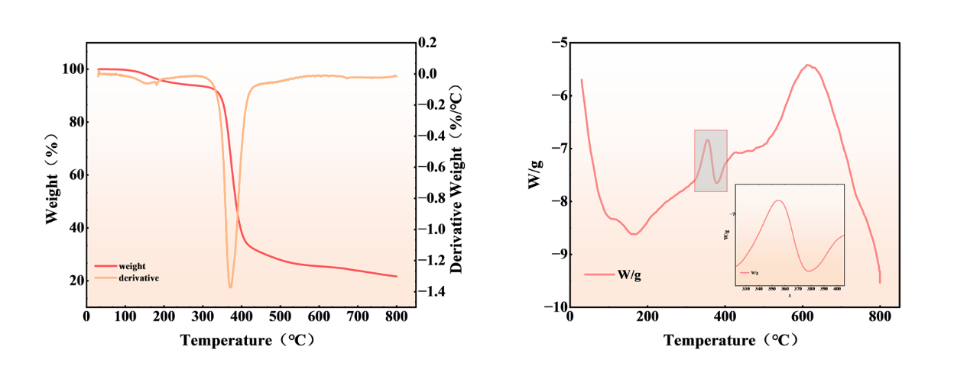
Figure 3-3 TGA/DTG and DSC curves of Fe₃O₄@epoxy resin proppant

3.3 Water Contact Angle (WCA)
Surface wettability of the two proppants was characterized using a video optical contact angle analyzer (OCA20, Germany). Three replicate measurements were conducted for each sample, and the average values were adopted for analysis (Figure 3-4). The average water contact angle (WCA) of neat epoxy resin microspheres is 72.3°, indicative of a weakly hydrophilic surface. This behavior arises from the hydroxyl groups (-OH) on the epoxy molecular chains, which form hydrogen bonds with water molecules and drive partial spreading of water droplets on the surface.
In contrast, the average WCA of ESP-T reaches 104.6°, corresponding to a distinct hydrophobic surface—an increment of 32.3° relative to neat epoxy microspheres, representing a significant wettability transition. This transformation is attributed to the stearic acid modification of nano-Fe₃O₄@SA: the carboxyl groups (-COOH) of stearic acid (C₁₇H₃₅COOH) undergo a coordination reaction with surface hydroxyl groups of nano-Fe₃O₄@SA to form stable chemical bonds, while the long alkyl chains (-C₁₇H₃₅) orient outward from the epoxy matrix, constructing a hydrophobic film on the proppant surface.
The surface enrichment of nano-Fe₃O₄@SA nanoclusters observed via SEM further enhances this hydrophobic effect. The synergistic action of abundant hydrophobic alkyl chains drastically reduces the surface free energy, suppresses water molecule spreading, and ultimately renders the proppant hydrophobic.
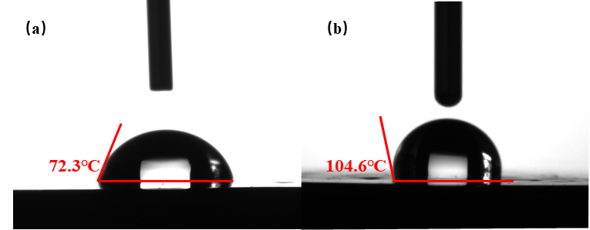
Figure 3-4 (a) WCA of epoxy resin patch (b) WCA of patch after doping with nano-Fe₃O₄@SA

3.4 Bulk Density and Apparent Density
Figure 3-5 presents the bulk density and apparent density results of the two proppants. The average bulk density and apparent density of neat epoxy resin microspheres are 0.6179 g/cm³ and 1.02 g/cm³, respectively, while those of ESP-T are 0.646 g/cm³ and 1.072 g/cm³, respectively. Both density values of ESP-T are higher than those of neat epoxy microspheres, which is attributed to the much higher density of nano-Fe₃O₄@SA (approximately 5.18 g/cm³) relative to epoxy resin (roughly 1.1 g/cm³). Even when dispersed as nanoclusters, nano-Fe₃O₄@SA still leads to a notable increase in the overall density of the proppant.
Notably, the bulk density of both proppants is lower than that of water (1 g/cm³), implying that both can achieve favorable suspension in water‑based fracturing fluids and prevent wellbore blockage resulting from particle sedimentation. Despite the slight increase in bulk density, ESP-T remains within the readily suspendable range without the need for additional suspending agents. The 0.05 g/cm³ increment in the apparent density of ESP-T is associated with the filling of internal pores within the epoxy matrix by nano-Fe₃O₄@SA nanoclusters. The incorporation of nano-Fe₃O₄@SA reduces the internal closed pores of proppant particles, yielding a denser particle structure and providing a solid structural foundation for mechanical integrity. ESP-T also meets other key industry specifications: sphericity and roundness exceed 0.9 (Krumbien-Sloss chart ^{[29]}), acid solubility is 3.3% (≤ 5% standard), and the crush rate at 50 MPa is 2.9%, comparable to that of neat epoxy microspheres (2.6%).
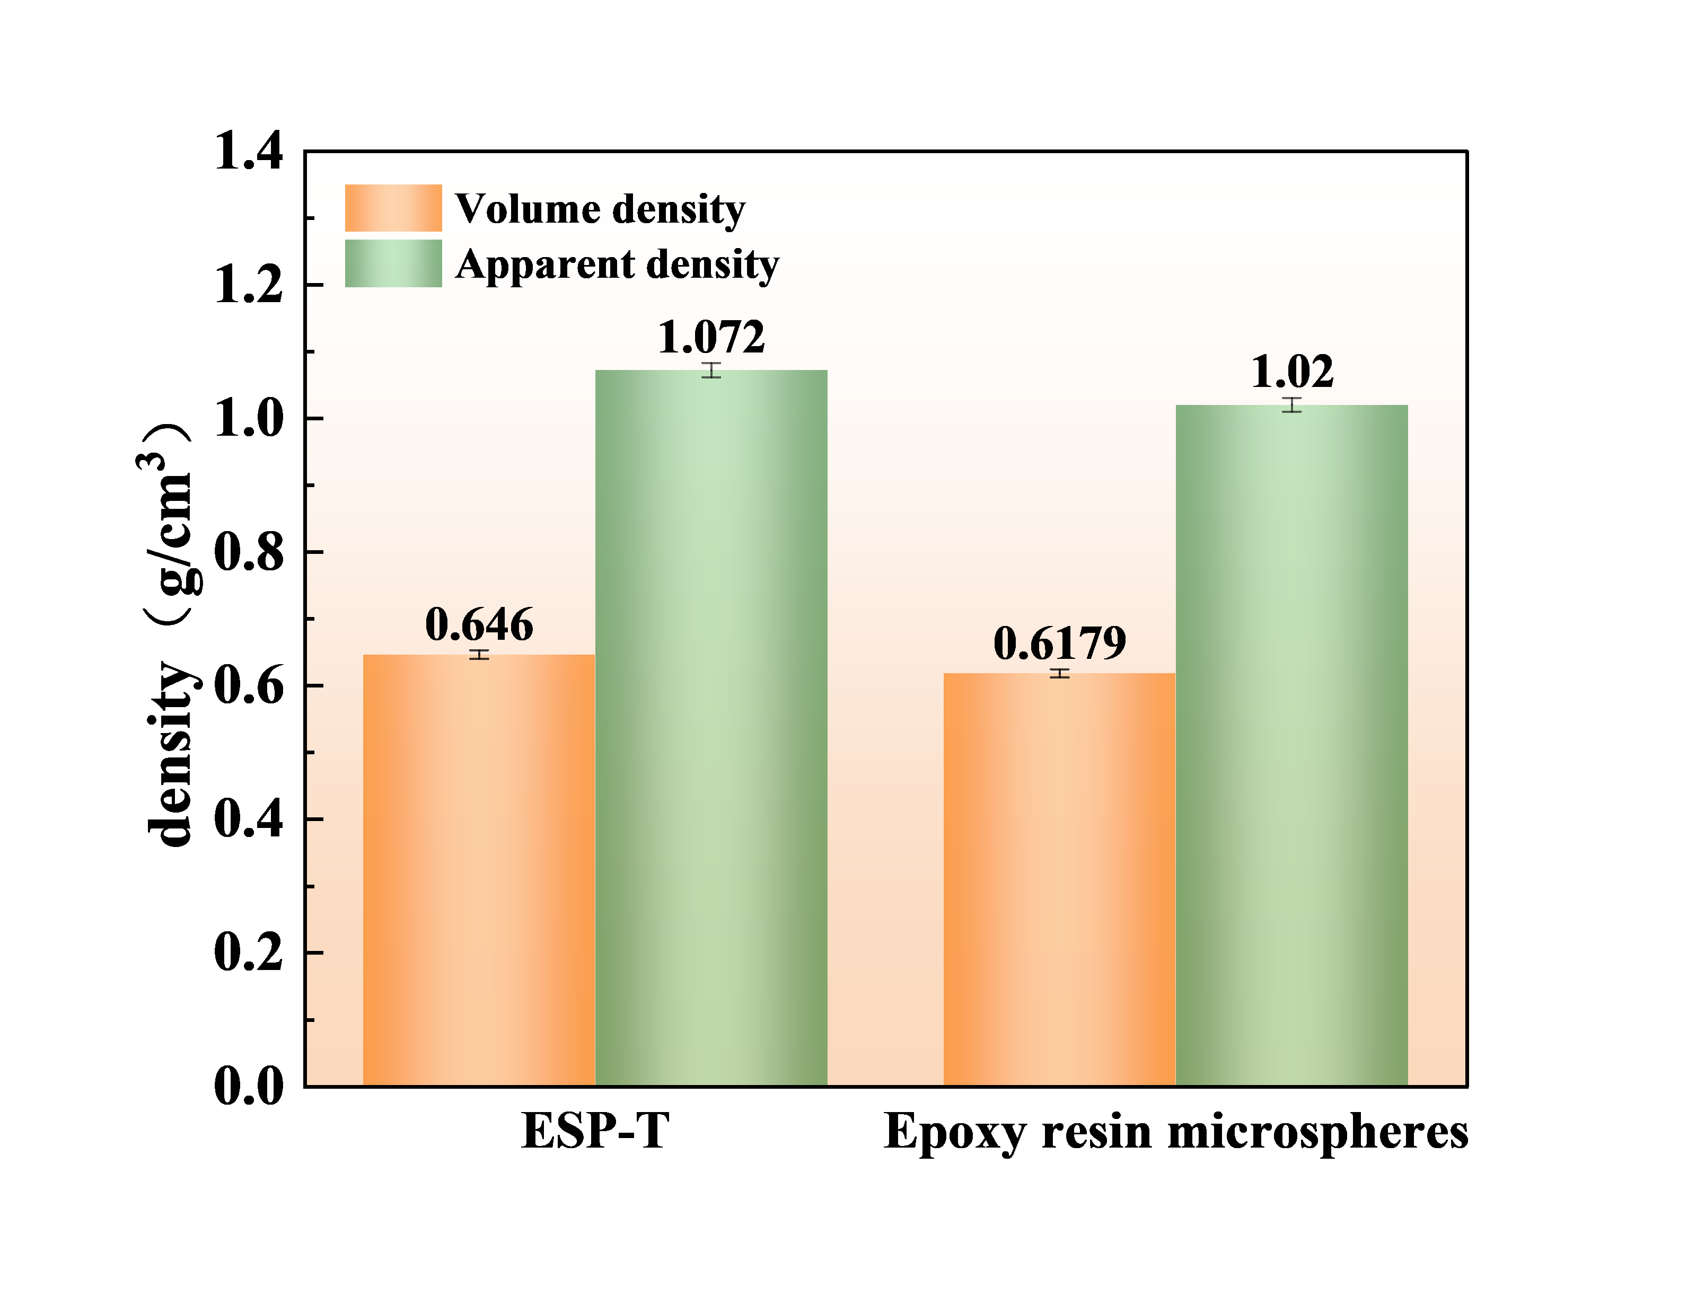
Figure 3-5 Bulk density and apparent density of epoxy microspheres and ESP-T

3.5 Proppant Pack Conductivity
Proppant pack conductivity can be indirectly assessed via oil-water filtration time: shorter filtration times correspond to lower flow resistance and higher conductivity. The water filtration time of neat epoxy microspheres is 2 min 53 s, whereas that of ESP-T is 28 min 41 s. The hydrophobic surface of ESP-T impedes aqueous-phase spreading and flow through inter-particle pores; water molecules must overcome the repulsive force of the hydrophobic surface, increasing flow resistance and prolonging filtration. Conversely, the oil filtration time of neat epoxy microspheres is 15 min 11 s versus 5 min 11 s for ESP-T. The hydrophobic surface is compatible with the oil phase, enabling rapid spreading within proppant pores and markedly reducing flow resistance. ESP-T thus exhibits a water-resistant, oil-permeable characteristic: in formations containing both phases, the proppant pack provides enhanced conductivity to oil, promoting rapid oil flow toward the wellbore, while the increased resistance to the aqueous phase helps mitigate water channeling and improve oil recovery.
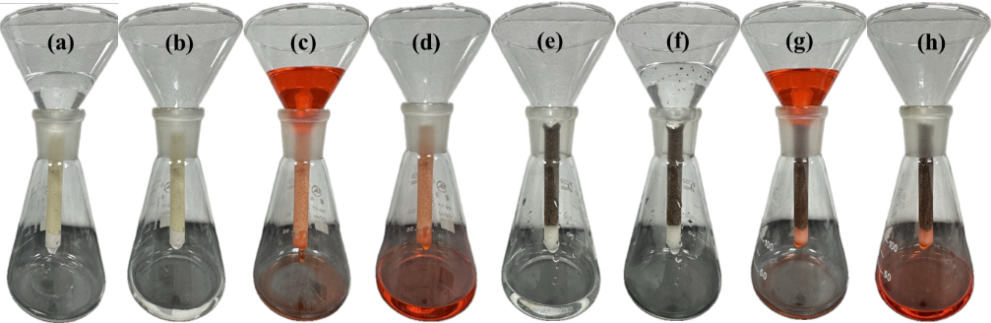
Figure 3-6 Oil-water permeability test of epoxy resin microspheres and ESP-T
(a)(b) before and after water passing through epoxy resin microspheres, (c)(d) before and after oil passing through epoxy resin microspheres, (e)(f) before and after water passing through ESP-T, (g)(h) before and after oil passing through ESP-T.

Table 3-1 Oil and Water Passage Time
 | ESP-T | Epoxy resin microspheres
Water passage time | 28:41 | 2:53
Oil passage time | 5:11 | 15:11

3.6 Tracer Release Behavior at Different Temperatures
In field applications, formation temperature rises with increasing reservoir depth, impacting the expansion of ESP-T and tracer release behavior. The release profiles of ESP-T at various temperatures are presented in Figure 3-7(a), where C/C₀ represents the normalized concentration, C denotes the tracer concentration at a specific time, and C₀ is the maximum release concentration. As indicated by these profiles, the relative release concentration increases over time and with rising temperature, demonstrating that elevated temperature accelerates tracer release. Additionally, Figure 3-7(c) shows that the tracer release rate is high during initial contact with the fluid, then gradually slows and stabilizes. The cumulative tracer release at 120 °C over 14 days remains detectable by ICP-MS, confirming its suitability for long-term stable monitoring. To better understand the release behavior within the carrier and optimize tracer design, the release mechanism and kinetic characteristics of ESP-T were investigated. The Korsmeyer–Peppas (K-P) release kinetic model was used to fit the release curves at different temperatures, and the release behavior of ESP-T was interpreted from the fitted parameters. The K-P model is defined by Eq. (1):
$$\begin{aligned}\frac{C}{C_{0}}=Kt^{n}\#\left(1\right)\end{aligned}$$
where:
C = tracer concentration at time t (mg/L);
C₀ = maximum (equilibrium) release concentration (mg/L);
K = kinetic rate constant;
t = release time (h);
n = diffusion exponent (dimensionless).

The K-P model is a power-law formulation developed by Korsmeyer and Peppas, widely employed to characterize release kinetics from controlled-release systems. It captures two key mechanisms: Fickian diffusion, in which substances migrate from high- to low-concentration regions in accordance with Fick's laws, and Case-II relaxation, in which polymer swelling upon contact with the release medium increases internal porosity and facilitates the escape of entrapped substances. For spherical carriers, the diffusion exponent n determines the dominant mechanism: n ≤ 0.43 corresponds to Fickian-diffusion-controlled release; 0.43 < n < 0.85 indicates anomalous transport co-governed by both mechanisms; and n ≥ 0.85 corresponds to Case-II-relaxation-controlled release.

The K-P fitting results are presented in Figure 3-7(b) and summarized in Table 3-2. The kinetic constant K increases systematically with temperature, consistent with the thermally activated nature of both diffusion and polymer relaxation. All n values fall within 0.45–0.85, confirming that ESP-T release follows an anomalous transport mechanism governed by the synergistic combination of Fickian diffusion and Case-II relaxation. The coefficient of determination (R²) exceeds 0.94 for all test temperatures (Table 3-2), confirming that the K-P model accurately describes ESP-T release kinetics across the studied temperature range.

Based on these results, the release mechanism of ESP-T is inferred as follows: nonpolar solvent molecules (e.g., dodecane) permeate into the cross-linked epoxy network, inducing swelling that generates a dual-state structure consisting of an inner glassy core and an outer gel layer. This swelling reduces polymer chain entanglement, creating expanded transport channels through which tracers diffuse into the external medium. Elevated temperature enhances solvent permeability into the polymer matrix, accelerating the swelling rate and weakening intermolecular forces within the network, thereby enlarging pore dimensions and further promoting tracer diffusion through the matrix.

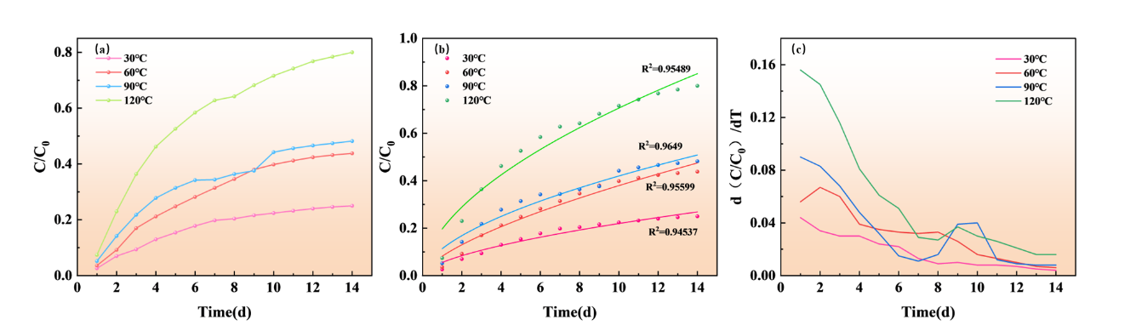
Figure 3-7 (a) Release curves of ESP-T at different temperatures (b) K-P model fitting curves (c) Release rate change curves of ESP-T

Table 3-2 Fitting Parameters of K-P Model
K-P model |  | C/C₀ =Kt^{n}
Fit parameters |  | release temperature
 | 30°C |  | 60°C | 90°C | 120°C
R² | 0.95489 |  | 0.9649 | 0.95599 | 0.94537
K | 0.05538 |  | 0.08177 | 0.11344 | 0.19642
n | 0.59827 |  | 0.66646 | 0.5684 | 0.55569

3.7 Oil Production Monitoring of ESP-T
To highlight the characteristics of the tracer production curve, a well shut-in phase was incorporated into the experimental design to achieve enhanced tracer release. Continuous sampling was employed, with a sample volume of 2 mL, a wellhead flow rate of 0.5 mL/min, and a sampling interval of 4 min. Due to the sample volume effect, the actual arrival time of the tracer concentration peak at the wellhead falls within the range of 20–25 min. Figure 3-9(a) presents the tracer production profile. To facilitate effective analysis of the tracer system’s response time, the concentration data were normalized. As clearly illustrated in the figure, the tracer concentration exhibits the characteristic of “initial rapid rise followed by stabilization,” with a distinct concentration peak corresponding to the high-concentration tracer solution generated by ESP-T during the shut-in period. The initial rapid rise arises from the accelerated release of residual tracers (unreleased during the static period) under fluid shear, while the subsequent stabilization indicates that the concentration enters a steady state. This observation is consistent with the findings in Section 3.6: ESP-T realizes synergistic tracer release via Fickian diffusion and Case-II relaxation, enabling sustained stable tracer signals under constant flow conditions.

The interpretation model is derived from the one-dimensional advection-dispersion equation (ADE): ∂C/∂t + v·∂C/∂x = D·∂²C/∂x², where v = 4Q/(πd²) is the mean flow velocity (cm/min) and D = α·v is the longitudinal dispersion coefficient (cm²/min), with Q the effective oil-phase volumetric flow rate (cm³/min), d the tubing inner diameter (cm), and α the longitudinal dispersivity (cm). The tracer pulse released from ESP-T into the oil phase during the shut-in period is described by the classical ADE analytical solution for an instantaneous slug injection, which yields the Gaussian-form rising component in Eq. (2). The sustained slow release of residual tracer from the epoxy matrix after the main pulse is captured by solving the ADE with a continuous-source boundary condition, yielding the erfc tailing component. The two regimes are blended via a hyperbolic tangent weighting function, producing a smooth, physically continuous breakthrough curve. Accordingly, the tracer breakthrough curve was fitted using the following piecewise advection-dispersion model with smooth transition:$w(t) = 0.5·[1 + tanh((t₀ - t)/σ)]$

$\begin{aligned}C\left(t\right)= w\left(t\right)·C_{rise}\left(t\right)+ \left[1-w\left(t\right)\right]·C_{fall}\left(t\right)\#(2)\end{aligned}$
$C_{rise}\left(t\right)= c_{b} + \frac{A·d}{\sqrt{16αQt}} exp\left[-\frac{{\left(xπd^{2}- 4Qt\right)}^{2}}{16αQtπd^{2}}\right]$
$\begin{aligned}C_{fall}\left(t\right)= c_{b} + \frac{a}{2} erfc\left(\frac{4Qt - xπd^{2}}{\sqrt{16αQtπd^{2}}}\right)\end{aligned}$
$$\begin{aligned}w\left(t\right)= \frac{1}{2} \left[1 + tanh\left(\frac{t_{0}- t}{σ}\right)\right]\end{aligned}$$

where:
c_{b} = background concentration (dimensionless);
A, a = amplitude coefficients for the shut-in slug (A) and sustained matrix release (a);
α = longitudinal dispersivity (cm);
Q = effective oil-phase flow rate (cm³/min);
t₀ = crossover center time (min);
σ = crossover width (min).
In Eq. (2), the rising component C_{rise} captures the advective-dispersive transport of the tracer slug from the proppant-packed section to the sampling point, while the tailing component C_{fall} describes the sustained release of residual nano-Fe₃O₄@SA from the epoxy matrix into the flowing oil. This two-component structure reflects the superposition of two physical processes: a short-duration concentration pulse generated by tracer accumulation during the shut-in period, and a prolonged tail governed by the matrix-diffusion-controlled release kinetics established in Section 3.6.

The fitted curve is shown in Figure 3-8(b) and the fitted parameters are listed in Table 3-3. The model achieves R² = 0.9939 and RMSE = 0.0210, with residuals randomly distributed within ±2σ across the full time range. The fitted flow rate (0.46 mL·min⁻¹) agrees closely with the pump-set rate (0.5 mL·min⁻¹), relative error 8%; and the mean residence time (MRT = 37.4 min) matches the convective travel time (x/v = 38.6 min, ratio 0.967). The Peclet number Pe = x/α = 0.934 (≈1) indicates a transitional transport regime in which advection and dispersion are comparable, consistent with the gradual release expected from a matrix-diffusion-controlled source. Deconvolution of the fitted curve reveals that 47% of the integrated tracer signal originates from the erfc tailing component. This dominant contribution of sustained matrix-diffusion-controlled release—nearly half the total detected signal—provides quantitative confirmation that the non-Fickian mechanism identified in Section 3.6 governs tracer transport under flow conditions, and establishes the physical basis for using ESP-T as a long-term production monitor.
Table 3-3 Fitted Parameters of the Piecewise ADE Model and Derived Transport Properties
Parameter | Value | Unit
R² | 0.9939 | —
RMSE | 0.0210 | —
Fitted flow rate Q | 0.46 | mL·min⁻¹
Pump-set flow rate | 0.50 | mL·min⁻¹
Mean flow velocity v | 2.59 | cm·min⁻¹
Longitudinal dispersivity α | 107.1 | cm
Mean residence time MRT | 37.4 | min
Convective travel time x/v | 38.6 | min
Erfc tail signal fraction | 47 | %
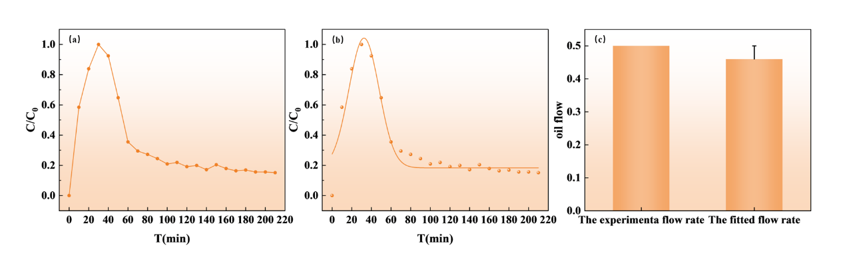
Figure 3-8 (a) Tracer release production curve of ESP-T single-phase flow monitoring (b) Fitting curve of ESP-T tracer release model (c) Comparison of pump set flow rate and fitted flow rate

To explore the influence of oil–water two-phase flow on ESP-T-based oil production monitoring, the system was maintained in a steady-state flow regime to ensure stable tracer release. Direct observation of the effluent after two-phase displacement at an oil–water ratio (OWR) of 1:1 revealed a slightly higher oil phase fraction in the early-stage effluent, consistent with the oil-permeable characteristic established in Section 3.5.
Figure 3-9(a) illustrates the relationship between tracer concentration, total two-phase flow rate, and OWR. As shown, tracer concentration gradually decreases with increasing total two-phase flow rate, with negligible dependence on OWR. This reflects dilution: higher flow rates reduce the contact time per unit volume, lowering the tracer mass released into each volume element.

During steady-state production, tracer concentration remains low, and the production curve typically only reflects concentration data—interpretation of this regime relies on concentration magnitude and trends. To quantify the single-interval oil flow rate, tracer flux (FO) was introduced. FO is defined as the mass of tracer passing through the wellhead sampling point per unit time, which equals the tracer release rate of ESP-T. Figure 3-9(b) shows the variation in FO: it increases with OWR but is independent of total two-phase flow rate. At a constant OWR, the contact area between ESP-T and the oil phase remains unchanged, so FO stays constant regardless of total flow rate. Conversely, increasing OWR expands the oil-phase contact area with ESP-T, leading to higher FO.

Figure 3-9(c) compares the normalized FO with the actual oil-phase flow rate at different OWRs (total two-phase flow rate = 0.1 mL/min). The normalized FO was calibrated against the steady-state FO during single-phase oil displacement (3.187 μg/min). The results demonstrate close agreement between FO and the actual oil-phase flow rate across all OWRs tested. Thus, under steady-state two-phase flow conditions, the oil-phase flow rate in the labeled interval can be quantified from the FO variation curve when the total two-phase flow rate is constant. Several limitations should be noted. First, the piecewise ADE model assumes a single fractured interval and uniform proppant-pack properties; multi-interval interactions and pack heterogeneity may introduce deviations in field applications. Second, the tracer flux calibration relies on steady-state flow; during transient flow regimes (e.g., well start-up, shut-in, or rapid drawdown), the relationship between FO and oil-phase flow rate may not hold. Third, the laboratory-scale validation used dodecane as a model oil; crude oil compositional effects (asphaltene adsorption, viscosity variation) on tracer release kinetics require further investigation. Fourth, at temperatures exceeding 120 °C or in the presence of aggressive formation fluids (high salinity, CO₂, H₂S), the long-term chemical stability of the epoxy matrix and the integrity of stearic acid surface modification warrant additional evaluation. These limitations delineate the current applicability envelope.
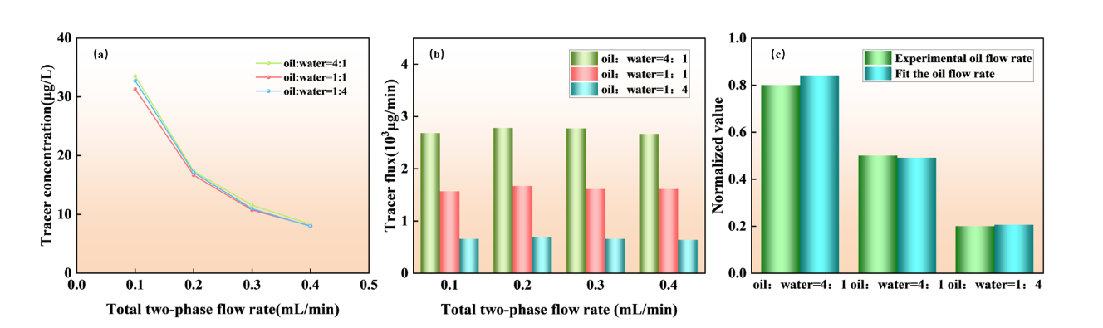
Figure 3-10 (a) Tracer concentration changes with oil-water ratio and total two-phase flow (b) Tracer flux changes with oil-water ratio and total two-phase flow (c) Comparison of tracer flux and actual flow under different oil-water ratios at a flow rate of 0.1 mL/min

4. Conclusions
We synthesized oleophilic nano-Fe₃O₄@SA nanoparticles via coprecipitation with stearic acid modification and fabricated ESP-T via emulsion polymerization. SEM, elemental mapping, and optical microscopy confirmed uniform dispersion of nano-Fe₃O₄@SA as nanoclusters within the epoxy matrix. ESP-T exhibits sphericity and roundness exceeding 0.9, meeting industrial proppant molding standards.

ESP-T demonstrates strong physical, mechanical, and thermal performance: bulk density of 0.646 g·cm⁻³ for favorable suspension; apparent density of 1.072 g·cm⁻³ indicating compact internal packing; crush rate of 2.9% at 50 MPa; acid solubility of 3.3% (meeting the ≤ 5% industry standard); and an initial decomposition temperature of 357.27 °C, far exceeding typical downhole conditions (80–200 °C). The water contact angle increases from 72.3° to 104.6° after nano-Fe₃O₄@SA incorporation, and the oil filtration time of 5 min 11 s is 66.1% shorter than that of pure epoxy microspheres, validating the water-resistant, oil-permeable transport characteristic that facilitates oil production while suppressing water breakthrough.

Tracer release from ESP-T at 30–120 °C follows the Korsmeyer–Peppas (K-P) model (R² > 0.90; diffusion exponent n = 0.45–0.85), governed by synergistic Fickian diffusion and Case-II relaxation of the cross-linked epoxy matrix. Cumulative Fe release at 120 °C exceeds 2.0 mg·L⁻¹ over 14 days, meeting ICP-MS detection limits for long-term downhole monitoring. A piecewise advection–dispersion model with smooth tanh transition was developed to interpret the single-phase tracer breakthrough curve, decomposing the signal into a Gaussian pulse component (shut-in accumulation slug) and an erfc tailing component (sustained matrix-diffusion-controlled release). The model achieves R² = 0.9939; the fitted flow rate (0.46 mL·min⁻¹) closely matches the pump-set rate (0.5 mL·min⁻¹, relative error 8%); and the mean residence time (37.4 min) agrees with the convective travel time (38.6 min, ratio 0.967). The erfc tailing component accounts for 47% of the integrated tracer signal, confirming the dominant role of matrix-diffusion-controlled release in sustaining the long-term monitoring signal. Under steady-state oil–water two-phase flow, tracer flux effectively quantifies per-interval oil-phase production rates across varying oil–water ratios, providing a practical basis for field-scale production allocation.

In summary, ESP-T integrates fracture propping and long-term production monitoring into a single proppant material, suitable for acid fracturing, deep-well, and high-pressure applications. The combination of favorable mechanical properties, thermal stability, and reliable tracer performance makes ESP-T a promising platform for optimizing stimulation strategies and enhancing oil recovery in unconventional reservoirs. We emphasize that the current validation is limited to laboratory-scale single-interval experiments with model fluids; field-scale trials under multi-interval, multiphase conditions are necessary to establish the operational reliability and economic viability of ESP-T-based production monitoring.

References
[1] CHONG Z R, YANG S H B, BABU P, et al. Review of natural gas hydrates as an energy resource: Prospects and challenges [J]. Applied Energy, 2016, 162: 1633-52.
[2] MONTGOMERY S L, JARVIE D M, BOWKER K A, et al. Mississippian Barnett Shale, Fort Worth basin, north-central Texas: Gas-shale play with multi–trillion cubic foot potential [J]. AAPG Bull, 2005, 89(2): 155-75.
[3] ROGNER H-H. AN ASSESSMENT OF WORLD HYDROCARBON RESOURCES [J]. Annu Rev Energy Env, 1997, 22(1): 217-62.
[4] MOHR S H, WANG J, ELLEM G, et al. Projection of world fossil fuels by country [J]. Fuel, 2015, 141: 120-35.
[5] WANG L, TIAN Y, YU X, et al. Advances in improved/enhanced oil recovery technologies for tight and shale reservoirs [J]. Fuel, 2017, 210: 425-45.
[6] IEA. World Energy Outlook 2024 [R]. International Energy Agency, 2024.
[7] HE X, ZHANG P, GAO Y, et al. Challenges and countermeasures for beneficial development of unconventional oil and gas resources in China [J]. China Petroleum Exploration, 2025, 30(1): 28-43.
[8] BARATI R, LIANG J T. A review of fracturing fluid systems used for hydraulic fracturing of oil and gas wells [J]. J Appl Polym Sci, 2014, 131(16).
[9] MEDEIROS F, KURTOGLU B, OZKAN E, et al. Analysis of Production Data From Hydraulically Fractured Horizontal Wells in Shale Reservoirs [J]. SPE Reservoir Evaluation & Engineering, 2010, 13(3): 559-68.
[10] PATIDAR A K, JOSHI D, DRISTANT U, et al. A review of tracer testing techniques in porous media specially attributed to the oil and gas industry [J]. Journal of Petroleum Exploration and Production Technology, 2022, 12(12): 3339-56.
[11] SANNI M, AL-ABBAD M, KOKAL S, et al. Pushing the envelope of residual oil measurement: A field case study of a new class of inter-well chemical tracers [J]. Journal of Petroleum Science and Engineering, 2018, 163: 538-45.
[12] SILVA M, STRAY H, BJøRNSTAD T. Stability assessment of PITT tracer candidate compounds – The case of pyrazines [J]. Journal of Petroleum Science and Engineering, 2019, 182.
[13] WATKINS J W, MARDOCK E S. Use of radioactive iodine as a tracer in water-flooding operations [J]. J Pet Technol, 1954, 6(09): 117-24.
[14] YANG H, GUO K, LIN L, et al. Application of micro-substance tracer test in fractured horizontal wells [J]. Journal of Petroleum Exploration and Production Technology, 2024, 14(5): 1235-46.
[15] ZHAO B, PANTHI K, MOHANTY K K. Tracer eluting proppants for hydraulic fracture characterization [J]. Journal of Petroleum Science and Engineering, 2020, 190.
[16] ZHOU Y, LIU H, GAO J, et al. Coated proppants with self-suspension and tracer slow-release functions [J]. Journal of Petroleum Science and Engineering, 2022, 208.
[17] MALYAVKO E, UPADHYE V, HUSEIN N. Research of Operational Dynamics of a Well with Two Hydraulic Fractures with Use of Marked Proppant Penetrating into One Productive Formation [C]. SPE-215624-MS, SPE International Hydraulic Fracturing Technology Conference and Exhibition, 2023.
[18] LI N, CHENG Q, GONG Z, et al. Release kinetics of rare earth tracer from polymer-coated proppants for hydraulic fracture analysis [J]. Geoenergy Science and Engineering, 2023, 227.
[19] GONG Z, LI N, KANG W, et al. Novel oleophilic tracer-slow-released proppant for monitoring the oil production contribution [J]. Fuel, 2024, 364.
[20] WANG G, MA Q, REN L, et al. A Comprehensive Review of Multifunctional Proppants [J]. ACS Omega, 2024, 9(44): 44120-33.
[21] KRISHNAN M R, LI W, ALHARBI B, et al. In-Situ High-Strength Poly(styrene-methyl methacrylate)-2D Nanofiller Composite Microbeads as Potential Proppants in Hydraulic Fracturing [J]. Geoenergy Science and Engineering, 2025, 257: 214195.
[22] GUO X, WEI K, NI T, et al. Preparation and performance analysis of polyethylene glycol/epoxy resin composite phase change material [J]. Journal of Energy Storage, 2024, 88.
[23] LIANG C, LUO W, YAN C, et al. Ultra-lightweight Proppant Synthesized from PMMA/Pine Bark Composite: Low-cost Material and Outstanding Properties [J]. Chem Lett, 2016, 45(8): 994-6.
[24] ZOVEIDAVIANPOOR M, GHARIBI A, BIN JAAFAR M Z. Experimental characterization of a new high-strength ultra-lightweight composite proppant derived from renewable resources [J]. Journal of Petroleum Science and Engineering, 2018, 170: 1038-47.
[25] SABINS F, APBLETT A, SHAFER R, et al. Epoxy Resin Exhibits Long-Term Durability and Chemical Stability as a Well Sealant [C]. SPE International Conference on Oilfield Chemistry, 2021.
[26] LI H, LIU Z, LI Y, et al. Evaluation of the Release Mechanism of Sustained-Release Tracers and its Application in Horizontal Well Inflow Profile Monitoring [J]. ACS Omega, 2021, 6(29): 19269-80.
[27] WEI M, WANG Y, DUAN Y, et al. Screening and performance evaluation of epoxy resin long-term sustained-release solid tracer [J]. Int J Oil Gas Coal Technol, 2024, 36(2): 170-96.
[28] GONG Z, LI N, QIN M, et al. Magnetic nano-Fe₃O₄-based oleophilic tracer for stability studies of nano-tracer in oilfields condition [J]. Colloids and Surfaces A: Physicochemical and Engineering Aspects, 2024, 683.
[29] KRUMBEIN W C, SLOSS L L. Stratigraphy and sedimentation [M]. LWW, 1951.

