Supplementary Material
An Oleophilic Epoxy/Fe₃O₄ Tracer Proppant with Piecewise ADE Modeling
for Production Monitoring in Multi-Stage Fractured Horizontal Wells

S1. Reagent Specifications
Table S1 provides the detailed specifications of all reagents used in this study, as referenced in Section 2.1 of the main text. All reagents were used as received without further purification.

Reagent | Formula / Description | Grade | Purity | Supplier
Iron(III) chloride | FeCl₃ | Analytical | ≥ 99.0% | Chengdu Kelong Chemical
Iron(II) chloride tetrahydrate | FeCl₂·4H₂O | Analytical | ≥ 99.0% | Chengdu Kelong Chemical
Manganese(II) chloride hexahydrate | MnCl₂·6H₂O | Analytical | ≥ 99.0% | Chengdu Kelong Chemical
Stearic acid | C₁₈H₃₆O₂ | Analytical | ≥ 99.5% | Chengdu Kelong Chemical
Ammonia solution | NH₃·H₂O (25–28%) | Analytical | — | Chengdu Kelong Chemical
Anhydrous ethanol | C₂H₅OH | Analytical | ≥ 99.7% | Chengdu Kelong Chemical
Dodecane | C₁₂H₂₆ | Analytical | ≥ 99.0% | Chengdu Kelong Chemical
E51 epoxy resin | Bisphenol-A diglycidyl ether | Industrial | Epoxy value 0.48–0.54 mol/100 g | Nantong Xingchen Synthetic Materials
T31 curing agent | Phenolic amine | Industrial | ≥ 95% effective component | —
Guar gum | Polysaccharide | Industrial | — | —
Hollow glass microspheres | SiO₂-Na₂O-CaO | Industrial | ≥ 99% purity | —
Hydrochloric acid | HCl (36–38%) | Analytical | — | Chengdu Kelong Chemical
Hydrofluoric acid | HF (≥ 40%) | Analytical | — | Chengdu Kelong Chemical
Deionized water | H₂O | — | 18.2 MΩ·cm | Laboratory system
Nitrogen gas | N₂ | High purity | ≥ 99.999% | —

Table S1. Reagent specifications. All reagents were used as received.

S2. Detailed Characterization Methods
The following procedures provide the complete methodological detail for the characterization measurements summarized in Section 2.3 of the main text. All measurements were performed in triplicate, and results are reported as mean ± standard deviation unless stated otherwise.

S2.1. Bulk Density (SY/T 5107–2016)
A known mass of proppant (M₀) was poured into a graduated cylinder. The cylinder was tapped 100 times on a rubber pad to achieve consistent settling, and the occupied volume (V₀) was read to the nearest 0.1 mL. The measurement was performed three times with independently weighed samples. Bulk density was calculated from the average mass (Mₐ) and average volume (Vₐ):
ρ_{bulk} = Mₐ / Vₐ
where ρ_{bulk} = bulk density (g/cm³), Mₐ = average proppant mass (g), Vₐ = average settled volume (cm³).

S2.2. Apparent Density (Density-Bottle Method)
A 25-mL density bottle was dried and weighed empty (m₁). The bottle was filled with deionized water and reweighed (m₂). After drying, a known quantity of proppant (~2 g) was introduced (m₃), and the bottle was topped up with deionized water (m₄). Apparent density was calculated as:
ρw_{app} = (m₃ − m₁) / [(m₂ − m₁) − (m₄ − m₃)] × ρ_{w}
where ρ_{w} = density of deionized water at 25 °C (0.997 g/cm³).

S2.3. Acid Solubility (SY/T 5107–2016)
Approximately 6.0 g of proppant was dried at 140 °C for 4 h and cooled in a desiccator for 30 min. A 5.0 g aliquot (weighed to ±0.1 mg; mass mresidual_{initial}) was placed in a PTFE beaker containing 100 mL of acid solution (HCl 12.0 wt%, HF 3.0 wt%) preheated to 65 ± 1 °C. The mixture was stirred magnetically for 30 min, then filtered through a pre-weighed 0.45 μm PTFE membrane. The filter cake was washed repeatedly with deionized water to neutrality (confirmed by pH paper), dried at 140 °C for 2 h, and reweighed (m_{residual}). The measurement was performed in triplicate:
S (%) = (minitialresidual_{initial} − m_{residual}) / m_{initial} × 100

S2.4. Crush Rate (SY/T 5107–2016)
Proppant was sieved to 20–30 mesh. A weighed quantity (mfines_{initial}, approximately 20 g) was placed in a standard crush cell and subjected to uniaxial pressure of 20 MPa or 52 MPa for 2 min using a hydraulic press. The crushed material was sieved through a 100–120 mesh screen. The mass of generated fines (m_{fines}) was recorded to ±0.1 mg. The crush rate was calculated as:
ηinitialfines_{crush} (%) = m_{fines} / m_{initial} × 100

S2.5. Oil/Water Filtration Time
A 200-mesh stainless steel screen was fitted to a glass funnel (internal diameter = 25 mm). Proppant (2.0 ± 0.01 g, 40–70 mesh) was loaded to form a uniform packed bed of approximately 3 mm thickness. Deionized water or dodecane (20.0 mL) was gently poured onto the bed surface, and the time for the last visible liquid to disappear from the bed surface was recorded with a stopwatch (±1 s). Three independent measurements were performed for each fluid on each proppant type. The ratio of water-to-oil passage times provides a quantitative index of oil-water transport selectivity.

S2.6. Water Contact Angle Measurement
Proppant (~0.5 g) was compressed at 0.5 MPa in a stainless steel mold to form a flat, cohesive disc (diameter ~13 mm, thickness ~2 mm). A 5 μL droplet of deionized water was deposited onto the disc surface using a microsyringe. Images were captured at 5 s after deposition (DataPhysics OCA20, CCD camera, backlight illumination). Contact angles were determined by Laplace-Young fitting of the droplet profile using SCA20 software. Five independent measurements were performed on each sample, each time using a freshly prepared disc. Results are reported as mean ± standard deviation (n = 5).

S3. Supplementary Characterization Data

S3.1. Optical Microscopy
Optical micrographs of pure epoxy microspheres and ESP-T were acquired at 40×, 100×, and 200× magnification (Leica DM2700P, transmitted light) as referenced in Section 3.1 of the main text. The images confirm regular spherical morphology for both materials. At 100×–200×, ESP-T micrographs reveal dispersed surface protrusions of 1–5 μm corresponding to nano-Fe₃O₄@SA nanoclusters embedded within the epoxy matrix, with no visible interfacial gaps—consistent with the stearic acid-mediated physical adhesion inferred from SEM analysis.
[Insert optical micrographs here — 6 panels: epoxy 40×, 100×, 200×; ESP-T 40×, 100×, 200×]
Figure S3. Optical micrographs of pure epoxy microspheres (top row) and ESP-T (bottom row) at (a,d) 40×, (b,e) 100×, and (c,f) 200× magnification. Scale bars: 200 μm (40×), 100 μm (100×), 50 μm (200×).

S3.2. Complete Physical Property Summary
Table S4 provides the full physical and mechanical property dataset for both proppant types, with standard deviations from triplicate measurements and industry benchmarks from SY/T 5107–2016, as referenced in Section 3.1 of the main text.

Property | Pure Epoxy  Microspheres | ESP-T | SY/T 5107–2016  Benchmark | Method
Bulk density (g/cm³) | 0.618 ± 0.012 | 0.646 ± 0.015 | — | Tapping method
Apparent density (g/cm³) | 1.02 ± 0.03 | 1.07 ± 0.03 | — | Density bottle
Sphericity | > 0.9 | > 0.9 | ≥ 0.6 | Krumbien-Sloss chart
Roundness | > 0.9 | > 0.9 | ≥ 0.6 | Krumbien-Sloss chart
Crush rate at 20 MPa (%) | 0.35 ± 0.05 | 0.42 ± 0.06 | — | SY/T 5107 §6
Crush rate at 52 MPa (%) | 2.6 ± 0.2 | 2.9 ± 0.2 | ≤ 10 | SY/T 5107 §6
Acid solubility (%) | 2.5 ± 0.1 | 3.3 ± 0.2 | ≤ 5 | SY/T 5107 §7
Water contact angle (°) | 72.3 ± 2.1 | 104.6 ± 1.8 | — | Sessile drop, n = 5
Decomposition temp. (°C) | 361.5 | 357.3 | — | TGA/DTG peak
Mass loss < 350 °C (%) | 4.2 | 5.7 | — | TGA
Oil passage time (s) | 911 ± 28 | 311 ± 18 | — | Packed-bed filtration
Water passage time (s) | 173 ± 10 | 1721 ± 87 | — | Packed-bed filtration
Water/oil time ratio | 0.19 | 5.53 | — | Derived

Table S4. Complete physical and mechanical properties. Values are mean ± SD from triplicate measurements unless indicated otherwise.
Discussion: The slightly higher acid solubility of ESP-T (3.3 ± 0.2% vs. 2.5 ± 0.1%) is attributable to partial dissolution of nano-Fe₃O₄@SA nanoclusters exposed at the particle surface. The 0.3 percentage-point increase in crush rate at 52 MPa (2.9% vs. 2.6%) is attributable to hollow glass microspheres acting as local stress concentrators. Both values remain well within the SY/T 5107–2016 thresholds. The 29-fold increase in the water/oil passage time ratio (0.19 → 5.53) upon stearic acid modification quantitatively confirms the oleophilic surface character and is the functional basis for the oil-phase tracer flux methodology described in Section 3.4 of the main text.

S4. Raw Experimental Data
This section tabulates the primary experimental data supporting the analyses in Sections 3.2–3.4 of the main text. These data are provided to facilitate independent reproduction of the fitting results.

S4.1. Breakthrough Curve Data (Single-Phase)
Table S2 lists the 21-point single-phase breakthrough dataset used for all model fitting in Section 3.3.

t (min) | C/C₀ | t (min) | C/C₀ | t (min) | C/C₀
0 | 0.00000 | 5 | 0.58438 | 10 | 0.83879
15 | 1.00000 | 20 | 0.92443 | 25 | 0.64736
30 | 0.35516 | 35 | 0.29471 | 40 | 0.27204
45 | 0.24433 | 50 | 0.20907 | 55 | 0.21914
60 | 0.19144 | 65 | 0.19899 | 70 | 0.17128
75 | 0.20403 | 80 | 0.17884 | 85 | 0.16373
90 | 0.16877 | 95 | 0.15617 | 100 | 0.15617

Table S2. Single-phase breakthrough curve data (21 points).

S4.2. Tracer Release Data (K-P Kinetics)
Table S3 lists the cumulative tracer release data (Mt/M∞) at four temperatures, supporting the K-P analysis in Section 3.2.

Time (h) | 30 °C | 60 °C | 90 °C | 120 °C
12 | 0.013 | 0.018 | 0.026 | 0.037
24 | 0.035 | 0.046 | 0.071 | 0.115
36 | 0.047 | 0.085 | 0.109 | 0.182
48 | 0.065 | 0.106 | 0.139 | 0.231
60 | 0.077 | 0.124 | 0.157 | 0.263
72 | 0.089 | 0.141 | 0.171 | 0.292
84 | 0.099 | 0.157 | 0.172 | 0.314
96 | 0.102 | 0.173 | 0.182 | 0.321
108 | 0.108 | 0.190 | 0.188 | 0.341
120 | 0.112 | 0.199 | 0.221 | 0.358
132 | 0.116 | 0.206 | 0.228 | 0.371
144 | 0.120 | 0.212 | 0.233 | 0.384
156 | 0.123 | 0.216 | 0.237 | 0.392
168 | 0.125 | 0.219 | 0.241 | 0.400

Table S3. Cumulative tracer release data (Mt/M∞) at 30–120 °C.
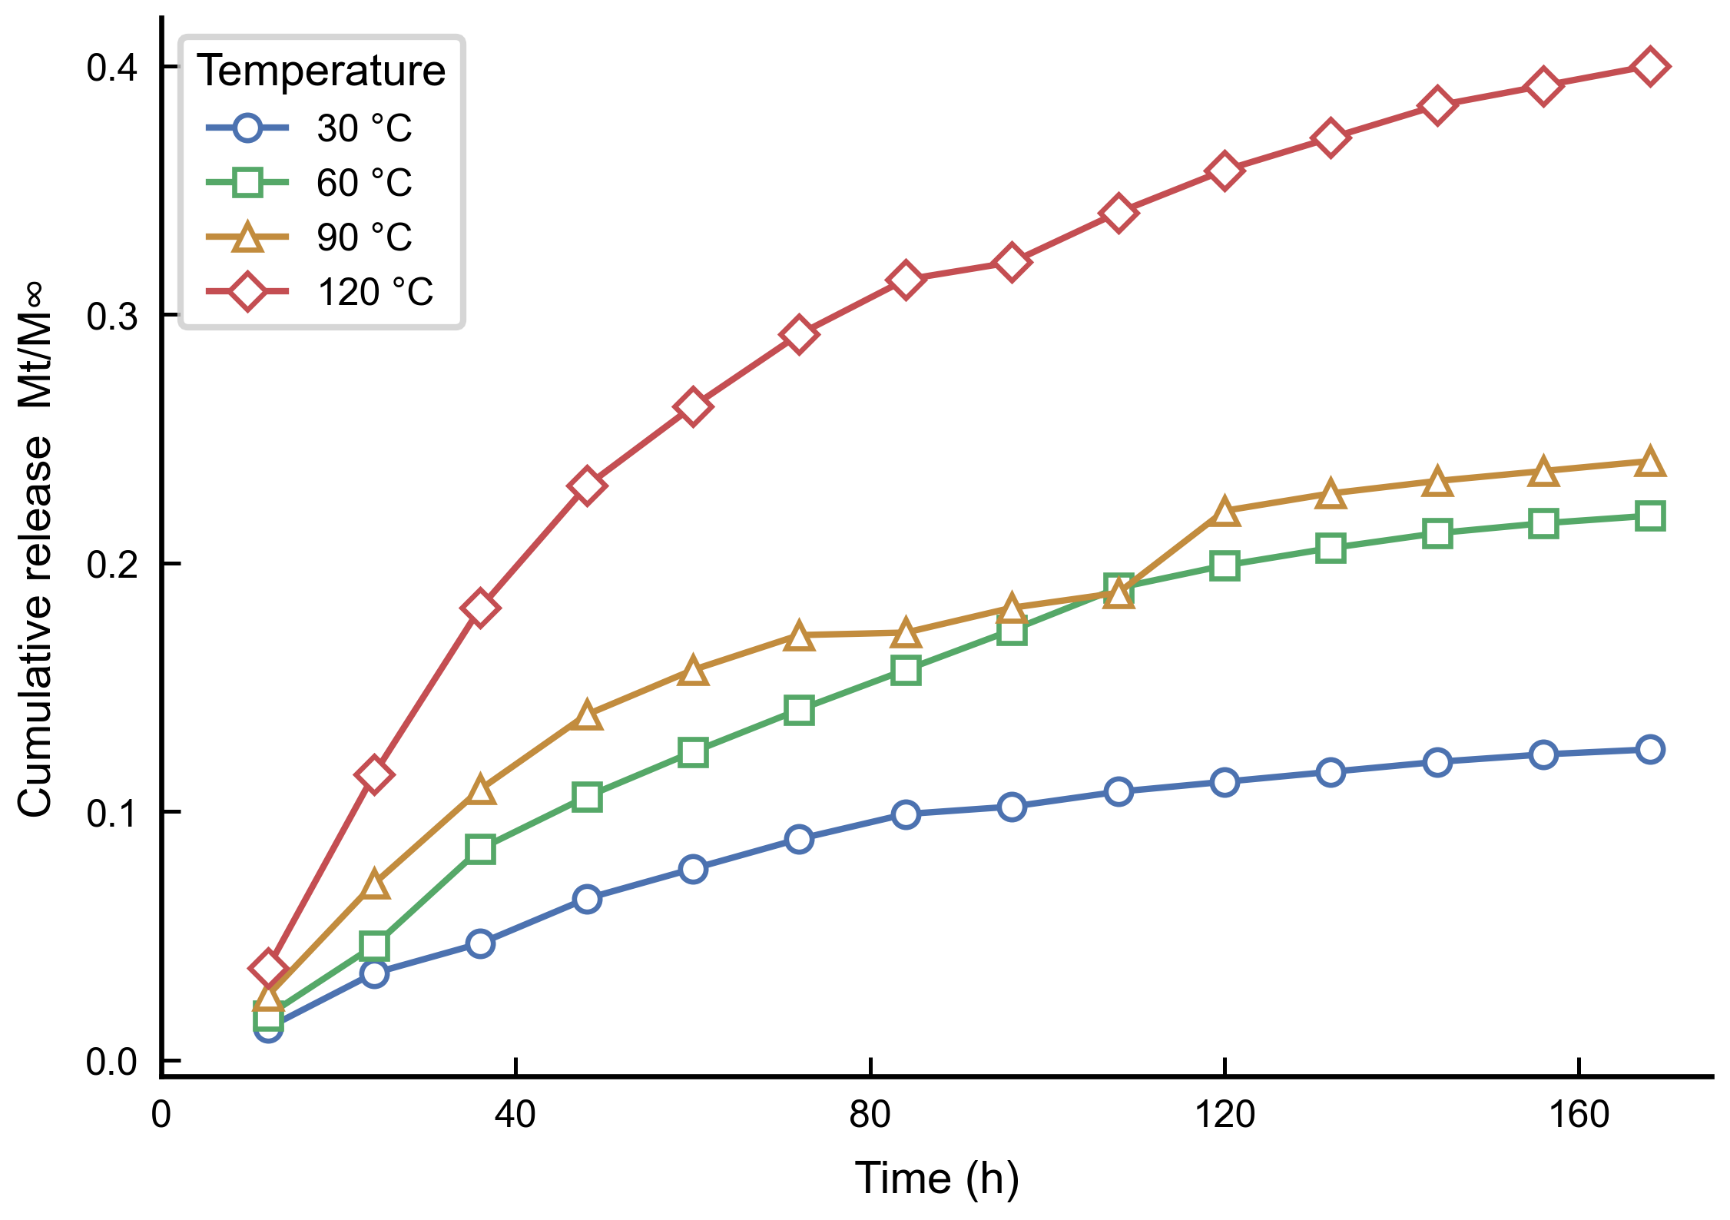
Figure S1. Cumulative tracer release profiles at 30–120 °C (data from Table S3).

S4.3. Two-Phase Flow Data
Table S5 lists the complete steady-state two-phase flow dataset supporting the production allocation analysis in Section 3.4.

OWR | Q_{total}  (mL/min) | Q_{oil}  (mL/min) | Q_{water}  (mL/min) | C_{oil}  (μg/mL) | F_{O}  (μg/min)
4:1 | 0.1 | 0.08 | 0.02 | 33.51 | 2.681
4:1 | 0.2 | 0.16 | 0.04 | 17.37 | 2.779
4:1 | 0.3 | 0.24 | 0.06 | 11.54 | 2.770
4:1 | 0.4 | 0.32 | 0.08 | 8.33 | 2.666
1:1 | 0.1 | 0.05 | 0.05 | 31.32 | 1.566
1:1 | 0.2 | 0.10 | 0.10 | 16.67 | 1.667
1:1 | 0.3 | 0.15 | 0.15 | 10.73 | 1.610
1:1 | 0.4 | 0.20 | 0.20 | 8.04 | 1.608
1:4 | 0.1 | 0.02 | 0.08 | 32.74 | 0.655
1:4 | 0.2 | 0.04 | 0.16 | 17.14 | 0.686
1:4 | 0.3 | 0.06 | 0.24 | 10.93 | 0.656
1:4 | 0.4 | 0.08 | 0.32 | 7.97 | 0.638

Table S5. Two-phase flow experimental data. FOoiloil_{O} = C_{oil} × Q_{oil}. Single-phase reference: F_{O},ref = 3.187 ± 0.15 μg/min (triplicate).
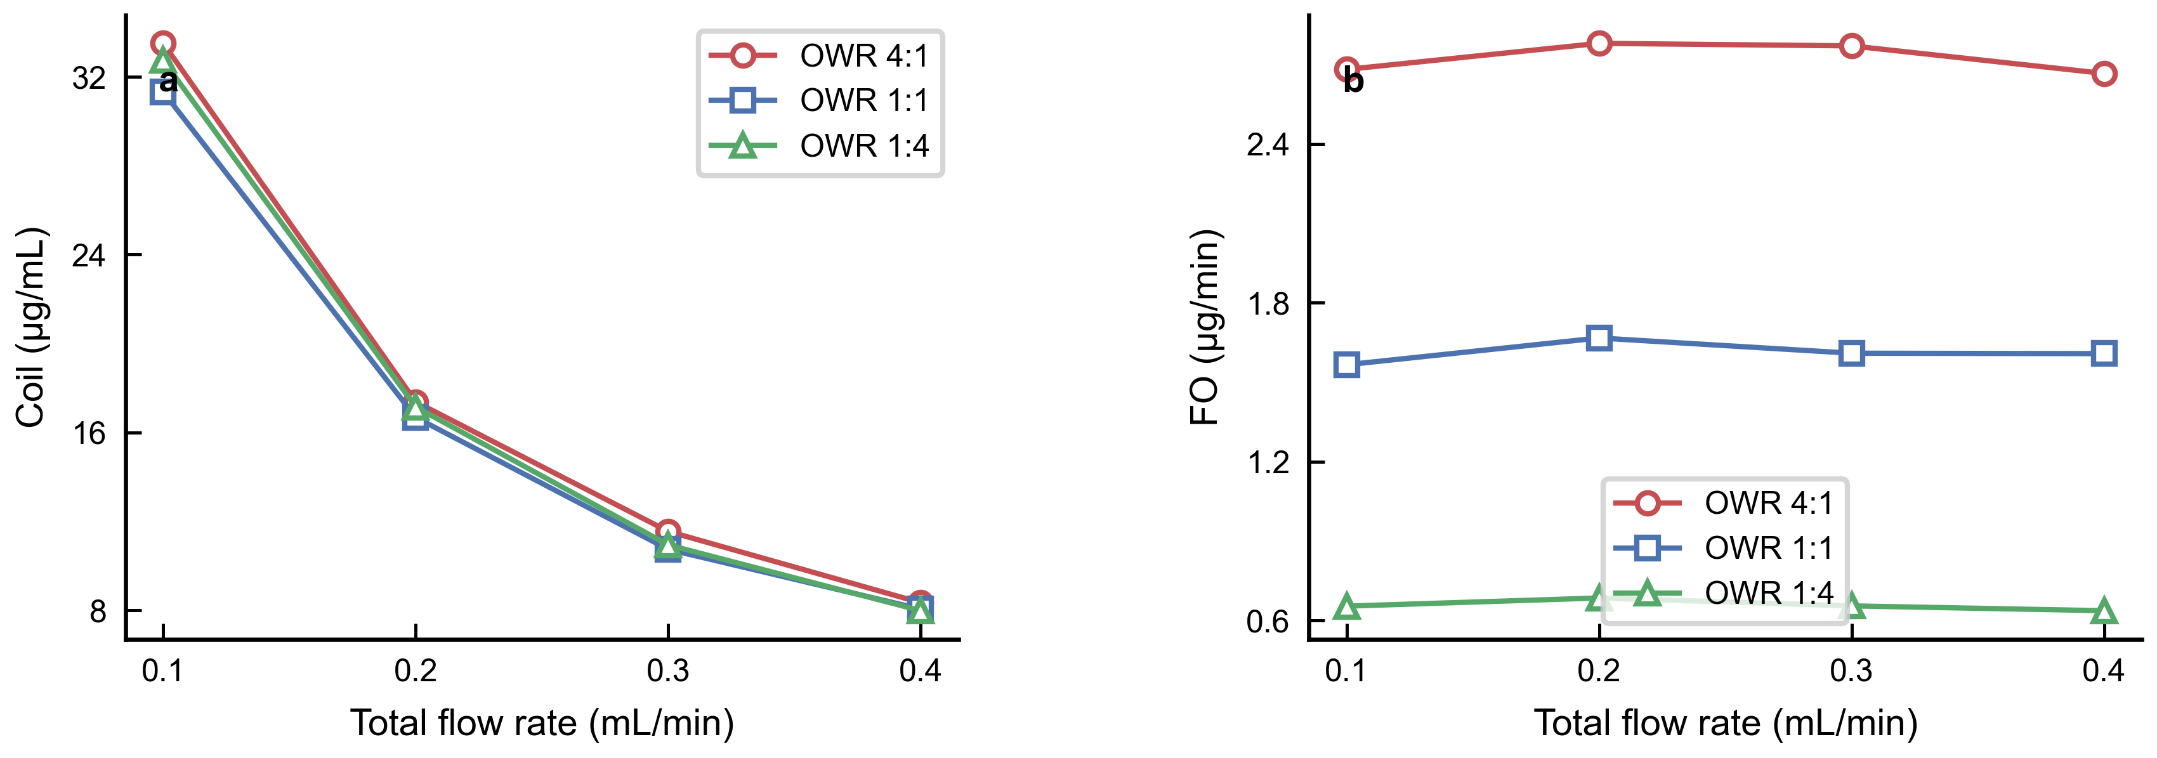
Figure S2. Two-phase flow raw data visualization. (a) CtotalOtotal_{oil} vs. Q_{total}, illustrating the dilution artifact. (b) F_{O} vs. Q_{total}, showing approximate constancy within each OWR.

S5. Piecewise ADE Model: Extended Derivations
This section provides the complete derivations of the working equations used in the model (Eq. 1, main text, Section 3.3). The main text presents the key equations; here we provide the intermediate steps for readers who wish to verify or re-implement the model.

S5.1. From ADE to Dimensionless Variable z
The one-dimensional advection-dispersion equation (∂C/∂t + v·∂C/∂x = D·∂²C/∂x²) has the classical instantaneous-pulse solution (van Genuchten & Alves, 1982):
C(x, t) = (M/A) × (1/√(4πDt)) × exp(−(x − vt)² / (4Dt))
For tube flow, the cross-sectional area A = πd²/4, the flow velocity v = Q/A = 4Q/(πd²), and the dispersion coefficient D = α·v = 4αQ/(πd²). Substituting these and simplifying:
C(x, t) = (4M/πd²) × 1/√(16παQt/πd² × 4) × exp(−(x − 4Qt/(πd²))² / (16αQt/(πd²)))
Multiplying numerator and denominator by πd² to obtain a clean expression yields the working variable:
z = (xπd² − 4Qt) / √(16αQtπd²)
With this substitution, the Gaussian and erfc components take the compact forms given in Eq. (1) of the main text.
Constants: x = tubing length = 100 mm, d = tubing inner diameter = 5 mm. The z variable is dimensionless when expressed in consistent units; in the fitted form, units of mm, mL, and min are used throughout.

S5.2. Tanh Blending and C¹ Continuity
The weight function w(t) = ½[1 + tanh((t₀ − t)/σ)] satisfies w → 1 as t ≪ t₀ and w → 0 as t ≫ t₀. The first derivative is continuous everywhere:
w'(t) = −1/(2σ) × sech²((t₀ − t)/σ)
Since both Crise(t) and Cfall(t) are themselves smooth functions, the blended function C(t) = w·Crise + (1−w)·Cfall is C¹-continuous, satisfying the requirement for gradient-based optimization (L-BFGS-B). The transition width σ controls the sharpness: at t = t₀ ± σ, w ≈ 0.5 ± 0.38; at t = t₀ ± 3σ, w ≈ 0.5 ± 0.50 (essentially the full transition).

S5.3. Optimization Protocol Detail
Stage 1 -- Differential Evolution (DE): Population size = 50 individuals; maximum generations = 2000; crossover rate CR = 0.9 (binomial crossover); mutation factor F adaptive in [0.5, 1.5] (rand/1/bin strategy); four independent random seeds (42, 123, 456, 789); Polish = True (L-BFGS-B local refinement of best candidate at termination). Parameter bounds are listed in Table S6.
Stage 2 -- L-BFGS-B: The best DE solution serves as the initial guess. Maximum iterations = 20,000; function tolerance ftol = 1e-16; gradient tolerance gtol = 1e-16. Convergence was achieved within approximately 50-200 iterations from the DE starting point in all cases, reflecting DE effectiveness at locating the basin of the global minimum.
Computational environment: Python 3.11, SciPy 1.11; single-core execution on a standard desktop workstation. Total wall time for the full two-stage fit (7 parameters, 21 data points) was approximately 15-30 s per random seed.

Parameter | Symbol | Lower Bound | Upper Bound | Units | Rationale
Baseline | c_{bg} | 0.0 | 0.4 | — | Non-negative; ≤ plateau level
Pulse amplitude | A | 0.1 | 10⁶ | — | Positive; wide exploratory range
Tail amplitude | a | 0.1 | 50.0 | — | Positive; prevents degenerate tail
Dispersivity | α | 0.01 | 10⁵ | mm | Positive; wide range for fitting
Flow rate | Q | 10.0 | 5000.0 | mL/min | Must be physically positive
Crossover time | t₀ | 5.0 | 40.0 | min | Within observed BTC range
Transition width | σ | 0.5 | 15.0 | min | At least 1/8 of sampling interval

Table S6. Parameter bounds for differential evolution (Stage 1). Bounds are wide to allow global exploration; L-BFGS-B (Stage 2) refines within a subset of these bounds as needed.

